SM Energy FE102M Energy Monitor

Technical User Manual
Version 1.0

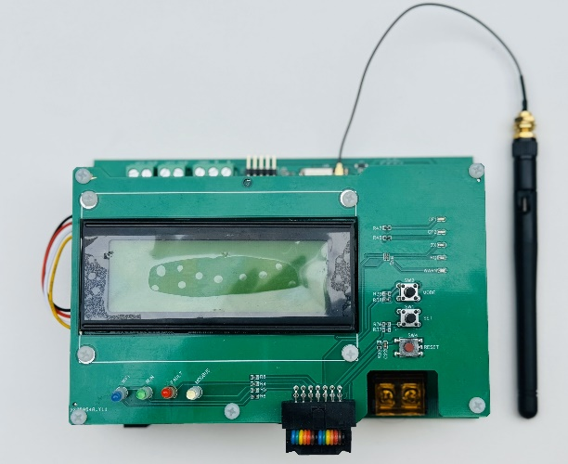

Table of Contents
- Introduction
- Product Overview
- Technical Specifications
- Hardware Installation
- Software Configuration
- ESP32 Pin Configuration
- ATM90E26 Energy Monitor IC
- Current Transformer Selection
- Calibration Procedure
- Arduino Library Implementation
- Programming Examples
- MODBUS Implementation
- WiFi Connectivity
- LCD Integration
- Troubleshooting
- Technical Support

Introduction
Thank you for purchasing the SM Energy FE102M Energy Monitor. This device is designed to provide accurate energy measurement capabilities for a wide range of applications, from home energy monitoring to industrial power management.
This technical manual provides comprehensive information on hardware installation, software configuration, calibration procedures, and programming examples to help you get the most out of your Energy Monitor.

Product Overview
The SM Energy FE102M Energy Monitor is built around the ESP32 WROOM 32 microcontroller and ATM90E26 energy monitoring IC. It offers high-precision measurement of electrical parameters including voltage, current, power (active, reactive, and apparent), energy consumption, power factor, and frequency.

Key Features:
High Accuracy: ±0.1% for active energy and ±0.2% for reactive energy
Wide Dynamic Range: 6000:1 measurement capability
Multiple Communication Protocols: WiFi, Bluetooth, and MODBUS (RS485)
Current Measurement: Compatible with various CT clamps
Environmental Sensing: Onboard DHT22 temperature and humidity sensor
Display Capabilities: I2C 20x4 LCD module interface
Programmable Functionality: Arduino ESP32 compatible
Flexible Integration: Energy pulse outputs, status LEDs, and user buttons
The device is fully compliant with IEC62052-11, IEC62053-21, and IEC62053-23 standards, ensuring reliable and accurate energy measurements.

Technical Specifications
Electrical Characteristics
Connectivity

Physical Characteristics

Environmental Conditions

Hardware Installation

Safety Precautions
WARNING: Working with electrical systems can be dangerous. Always disconnect power before installation and ensure all connections are secure before restoring power.
Always use appropriate safety equipment when working with electrical installations Ensure the device is properly grounded
Do not exceed the maximum rated voltage (250V AC)
For current measurement, only use properly rated CT clamps

Mounting Instructions
  - Select a suitable location for mounting the Energy Monitor that provides: Easy access for wiring and viewing the display
Protection from dust and moisture
Adequate ventilation to prevent overheating

  - Mount the device using the provided mounting holes.

Wiring Connections

Power Supply
Connect a 9-12V DC power supply to the DC input terminals. Polarity must be observed (marked as + and - on the PCB).

Voltage Measurement
Connect the AC line voltage (< 250V) to the Line Input terminals. For single-phase measurement, connect Line and Neutral.

Current Measurement
- Identify the appropriate CT clamp for your application (see Current Transformer Selection).
- For voltage output type CT sensors (SCT-013-030, SCT-013-050): Ensure JP1 and JP2 jumpers are OPEN.
- For current output type CT sensors:
Ensure JP1 and JP2 jumpers are SHORTED.
- Install the CT clamp around the conductor to be measured.
Ensure the CT is installed in the correct orientation (arrow pointing toward the load).
- Connect the CT clamp to the appropriate CT input terminals on the Energy Monitor.

Communication Connections
- For USB programming and debugging, connect a USB cable to the USB connector. For MODBUS communication, connect to the MODBUS connector (GND, B, A).
- WiFi and Bluetooth are provided by the built-in ESP32 module.

Software Configuration

Setting Up the Arduino IDE
  - Install the Arduino IDE from arduino.cc.
  - Add ESP32 board support:
Open Arduino IDE
Go to File > Preferences
Add
https://dl.espressif.com/dl/package_esp32_index.json

to the "Additional Boards Manager URLs" field
Go to Tools > Board > Boards Manager
Search for "ESP32" and install the package
  - Select the correct board:
- Go to Tools > Board > ESP32 Arduino
- Select "ESP32 Dev Module" or "WEMOS D1 MINI ESP32" (or similar)
- Set Flash Frequency to 80MHz
- Set Upload Speed to 921600 for faster uploaded
- Set CPU Frequency to 240MHz

Required Libraries
Install the following libraries through the Arduino Library Manager (Tools > Manage Libraries):
- SPI.h - Standard Arduino SPI library (included with ESP32 board package)
- Wire.h - Standard Arduino I2C library (included with ESP32 board package)
- DHT.h - Adafruit DHT sensor library
- LiquidCrystal_I2C.h - For I2C LCD displays
- WiFi.h - For WiFi connectivity (included with ESP32 board package)
- ModbusMaster.h - For MODBUS communication

Initial Connection
- Connect the FE102M Energy Monitor to your computer using a USB cable.
- Select the correct COM port in the Arduino IDE (Tools > Port).
- Upload a test sketch to verify communication.
Note: The Energy Monitor requires an external 12V DC power supply for full functionality, even when connected via USB.

ESP32 Pin Configuration
The SM Energy FE102M Energy Monitor utilizes the following ESP32 pin assignments:

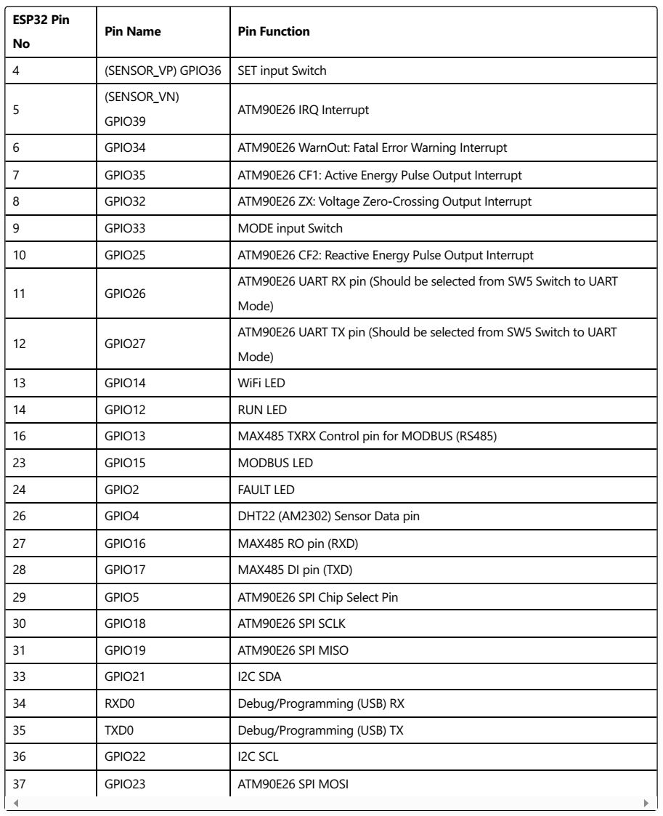
Front Panel Controls and Indicators

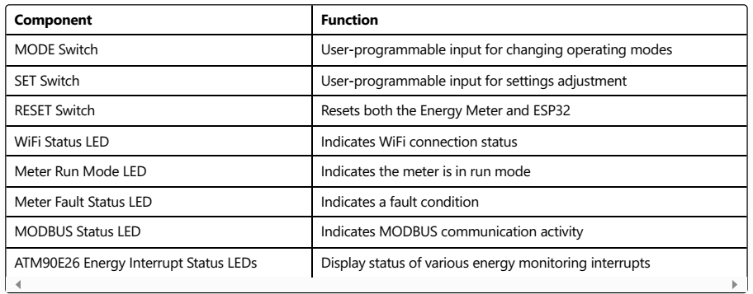

ATM90E26 Energy Monitor IC
The ATM90E26 is a high-precision energy monitoring IC that forms the heart of the FE102M Energy Monitor. It provides accurate measurements of various electrical parameters.

Key Features of the ATM90E26
Single-phase active and reactive energy metering
Measurement of voltage, current, power, frequency, and power factor High accuracy (±0.1% for active energy, ±0.2% for reactive energy)
Dynamic range of 6000:1
Temperature compensation (6 ppm/℃ typical)
Energy pulse output for active and reactive energy Voltage sag detection
Zero-crossing detection
SPI interface for communication

Register Map
ATM90E26 is controlled and read through a series of registers. The most important registers are:

System Control Registers

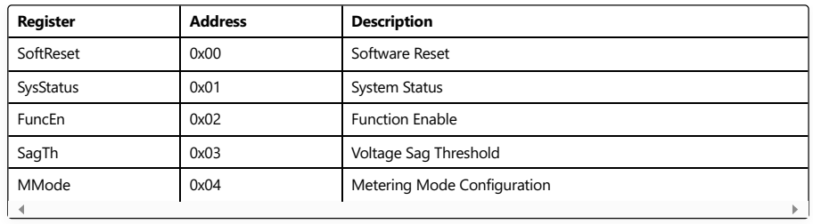

Calibration Registers

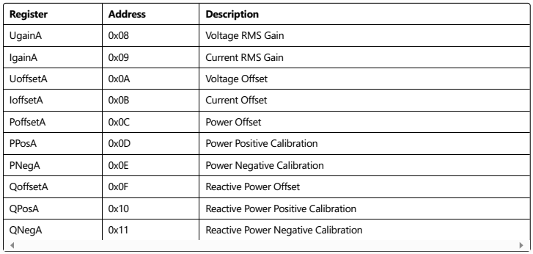
Measurement Registers
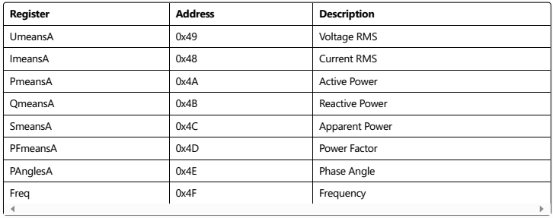

Energy Registers
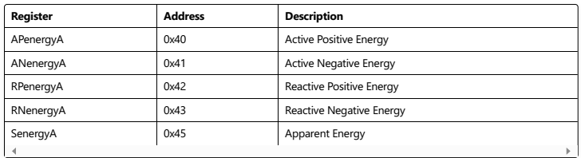

Power Modes
The ATM90E26 has four power modes:

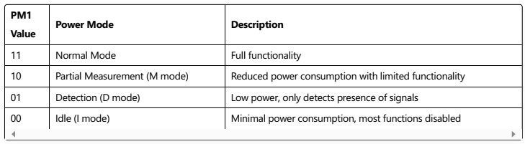

Current Transformer Selection
The FE102M Energy Monitor is compatible with a variety of current transformers (CT clamps). Select the appropriate CT based on your application's current range requirements.

Compatible Current Transformers

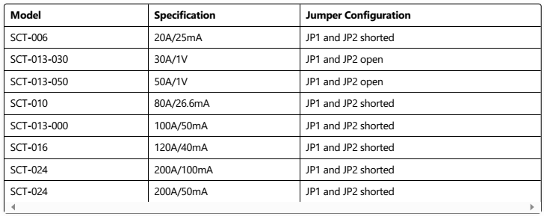

CT Types and Jumper Settings
The FE102M Energy Monitor supports two types of CT sensors:
  - Current Output Type: These CTs output a current proportional to the measured current.
Examples: SCT-006, SCT-010, SCT-013-000, SCT-016, SCT-024
Jumper Configuration: JP1 and JP2 should be SHORTED
  - Voltage Output Type: These CTs include a burden resistor and output a voltage proportional to the measured current.
Examples: SCT-013-030, SCT-013-050
Jumper Configuration: JP1 and JP2 should be OPEN

Important Note: Incorrect jumper configuration can result in inaccurate measurements or damage to the device.

CT Installation Guidelines
Install the CT around a single conductor (Line or Neutral, but not both) Ensure the CT is oriented correctly (arrow pointing toward the load)
Do not install CTs on conductors that exceed the CT's rated current Ensure the CT is fully closed and securely latched
Keep the CT away from strong magnetic fields that could interfere with measurements

Calibration Procedure
To achieve the specified accuracy, the FE102M Energy Monitor requires proper calibration. This section outlines the calibration procedure for voltage, current, and power measurements.

Equipment Required
Precision voltage source (AC)
Precision current source or known load
Reference energy meter or power analyzer Digital multimeter
Variable load (resistive, inductive, and capacitive)

Calibration Steps

Voltage Calibration
  - Connect a known reference voltage to the AC voltage input.
  - Measure the voltage with your reference meter.
  - Read the uncalibrated voltage from the FE102M.
  - Calculate the voltage gain calibration factor:
  - Update the UgainA register with the new value.
  - Verify the calibration by comparing the FE102M reading with your reference meter.

Current Calibration
  - Connect a known current through the CT clamp.
  - Measure the current with your reference meter.
  - Read the uncalibrated current from the FE102M.
  - Calculate the current gain calibration factor:

  - Update the IgainA register with the new value.
  - Verify the calibration by comparing the FE102M reading with your reference meter.

Power Calibration
  - Connect both voltage and current inputs with a known power factor load.
  - Measure the active power with your reference meter.
  - Read the uncalibrated active power from the FE102M.
  - Calculate the power gain calibration factor:

  - Update the PPosA register with the new value.
  - For reactive power calibration, repeat with an inductive or capacitive load.

Saving Calibration Values
Calibration values should be saved to the onboard EEPROM to ensure they persist after power cycles. The example code in the Programming Examples section includes functions for saving and loading calibration values.

Default Calibration Values
If you need to restore default calibration values, use the following starting points and adjust as needed:

cpp

#define DEFAULT_UGAIN 0xF709
#define DEFAULT_IGAIN 0x7DFB
#define DEFAULT_LGAIN 0x1D39
#define DEFAULT_CRC1 0xAE70
#define DEFAULT_CRC2 0x3D1D
Note: These values are only starting points. Proper calibration is required for accurate measurements.

Arduino Library Implementation
The FE102M Energy Monitor can be programmed using Arduino IDE and C++. This section provides an overview of the library structure and implementation.

Library Overview
The FE102M Energy Monitor uses a customized library for the ATM90E26 energy monitor IC. The library provides functions for initializing the IC, reading measurements, and calibrating the device.

Library Files

EnergyATM90E26.h
cpp
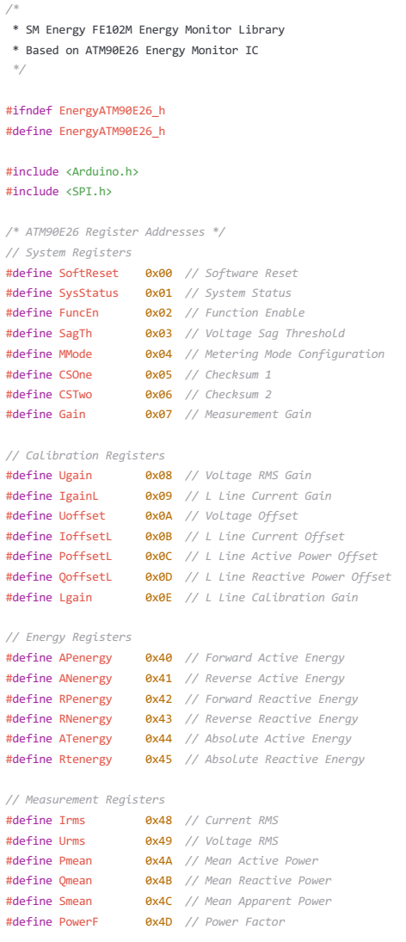
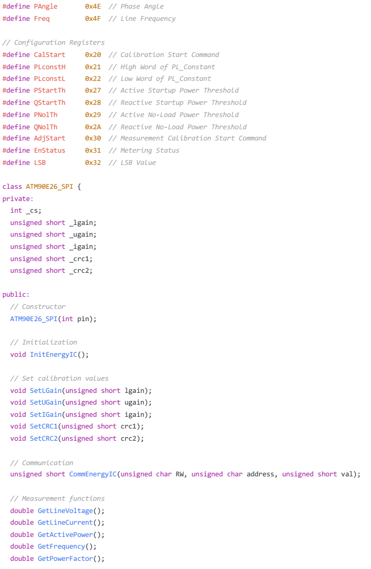
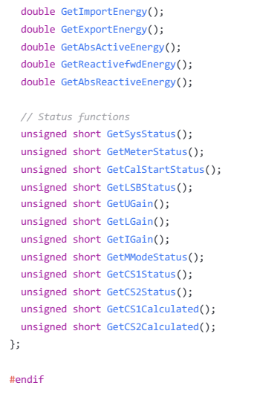

EnergyATM90E26.cpp
This file contains the implementation of the functions declared in the header file. It provides methods for communicating with the ATM90E26 IC, reading measurements, and setting calibration values.
See the attached EnergyATM90E26.cpp file for the complete implementation.

Defaults and Calibration
The FE102M_Defaults.h file contains default calibration values and initialization routines. These values
provide a starting point for calibration.
See the attached FE102M_Defaults.h file for the complete implementation.

Programming Examples
This section provides example code for common tasks with the FE102M Energy Monitor.

Basic Energy Monitoring
cpp
/*
- FE102M Energy Monitor - Basic Energy Monitoring Example
*
- This example demonstrates basic energy monitoring using the SM Energy FE102M
- Energy Monitor with ESP32 and ATM90E26 energy monitoring IC.

- Reads and displays voltage, current, power, energy, and other electrical parameters.
*/

#include <SPI.h>
#include <Wire.h>
#include "EnergyATM90E26.h"

// Define chip select pin
#define CS_PIN 5 // GPIO5 - ATM90E26 SPI Chip Select

// Create an instance of the ATM90E26_SPI class
ATM90E26_SPI energy(CS_PIN);

void setup() {
// Initialize serial communication
Serial.begin(115200);
Serial.println("FE102M Energy Monitor - Basic Example");

// Initialize SPI for ATM90E26 communication
SPI.begin();

// Initialize the ATM90E26 IC
energy.InitEnergyIC();

// Check system status
unsigned short systemStatus = energy.GetSysStatus(); Serial.print("System Status: 0x"); Serial.println(systemStatus, HEX);

if (systemStatus & 0xC000) { Serial.println("Checksum 1 Error!");
}

if (systemStatus & 0x3000) { Serial.println("Checksum 2 Error!");
}
}

void loop() {
// Read energy parameters
float voltage = energy.GetLineVoltage();
float current = energy.GetLineCurrent();
float power = energy.GetActivePower();
float frequency = energy.GetFrequency();
float pf = energy.GetPowerFactor();
float importEnergy = energy.GetImportEnergy();
float exportEnergy = energy.GetExportEnergy();

// Print results
Serial.println("\n--- Energy Monitor Readings ---");
Serial.print("Voltage: ");
Serial.print(voltage, 2);
Serial.println(" V");

Serial.print("Current: ");
Serial.print(current, 3);
Serial.println(" A");

Serial.print("Active Power: ");
Serial.print(power, 2);
Serial.println(" W");

Serial.print("Frequency: ");
Serial.print(frequency, 2);
Serial.println(" Hz");

Serial.print("Power Factor: ");
Serial.println(pf, 3);

Serial.print("Import Energy: ");
Serial.print(importEnergy, 4);
Serial.println(" kWh");

Serial.print("Export Energy: ");
Serial.print(exportEnergy, 4);
Serial.println(" kWh");

Serial.println(" ");

// Wait before next reading
delay(2000);
}

LCD Display Implementation
cpp
/*
- FE102M Energy Monitor - LCD Display Example
*
- This example demonstrates how to display energy monitoring data
- on a 20x4 LCD screen using I2C communication.
*/

#include <SPI.h>
#include <Wire.h>
#include <LiquidCrystal_I2C.h>
#include "EnergyATM90E26.h"

// Define pins
#define CS_PIN 5 // GPIO5 - ATM90E26 SPI Chip Select

// Create instances
ATM90E26_SPI energy(CS_PIN);
LiquidCrystal_I2C lcd(0x27, 20, 4); // I2C address 0x27, 20x4 LCD

void setup() {
// Initialize serial communication
Serial.begin(115200);
Serial.println("FE102M Energy Monitor - LCD Example");

// Initialize SPI for ATM90E26 communication
SPI.begin();

// Initialize I2C LCD
Wire.begin();
lcd.init();
lcd.backlight();
lcd.clear();
lcd.setCursor(0, 0);
lcd.print("FE102M Energy Monitor");
lcd.setCursor(0, 1);
lcd.print("Initializing...");

// Initialize the ATM90E26 IC
energy.InitEnergyIC();

// Check system status
unsigned short systemStatus = energy.GetSysStatus();

if ((systemStatus & 0xC000) || (systemStatus & 0x3000)) { lcd.setCursor(0, 2);
lcd.print("Checksum Error!");
Serial.print("System Status: 0x"); Serial.println(systemStatus, HEX); delay(3000);
}

lcd.clear(); lcd.setCursor(0, 0);
lcd.print("FE102M Energy Monitor");
}

void loop() {
// Read energy parameters
float voltage = energy.GetLineVoltage();
float current = energy.GetLineCurrent();
float power = energy.GetActivePower();
float frequency = energy.GetFrequency();
float pf = energy.GetPowerFactor();
float importEnergy = energy.GetImportEnergy();

// Update LCD display
// Line 1 - Title (already set in setup)

// Line 2 - Voltage and Current
lcd.setCursor(0, 1);
lcd.print("V:");
lcd.print(voltage, 1);
lcd.print("V I:");
lcd.print(current, 3);
lcd.print("A ");

// Line 3 - Power and Frequency
lcd.setCursor(0, 2);
lcd.print("P:");
lcd.print(power, 0);
lcd.print("W F:");
lcd.print(frequency, 1);
lcd.print("Hz ");

// Line 4 - Power Factor and Energy
lcd.setCursor(0, 3);
lcd.print("PF:");
lcd.print(pf, 2);
lcd.print(" E:");
lcd.print(importEnergy, 3);
lcd.print("kWh");

// Wait before next update

delay(1000);
}

WiFi Data Logging Example
cpp
/*
- FE102M Energy Monitor - WiFi Data Logging Example
*
- This example demonstrates how to log energy monitoring data
- to a web server using the ESP32's WiFi capabilities.
*/

#include <SPI.h>
#include <Wire.h>
#include <WiFi.h>
#include <HTTPClient.h>
#include "EnergyATM90E26.h"

// Define pins
#define CS_PIN 5 // GPIO5 - ATM90E26 SPI Chip Select
#define WIFI_LED 14 // GPIO14 - WiFi Status LED

// WiFi credentials
const char* ssid = "YourWiFiSSID";
const char* password = "YourWiFiPassword";

// Web server details
const char* serverName = "http://example.com/api/energy_data";

// Create an instance of the ATM90E26_SPI class
ATM90E26_SPI energy(CS_PIN);

// Variable to track last upload time
unsigned long lastUploadTime = 0;
const unsigned long uploadInterval = 60000; // 1 minute interval

void setup() {
// Initialize serial communication
Serial.begin(115200);
Serial.println("FE102M Energy Monitor - WiFi Example");

// Initialize SPI for ATM90E26 communication
SPI.begin();

// Initialize WiFi LED
pinMode(WIFI_LED, OUTPUT);
digitalWrite(WIFI_LED, LOW); // LED off initially

// Initialize the ATM90E26 IC
energy.InitEnergyIC();
// Connect to WiFi
WiFi.begin(ssid, password);
Serial.print("Connecting to WiFi");

while (WiFi.status() != WL_CONNECTED) {
delay(500);
Serial.print(".");
digitalWrite(WIFI_LED, !digitalRead(WIFI_LED)); // Toggle LED
}

Serial.println();
Serial.println("Connected to WiFi");
Serial.print("IP address: ");
Serial.println(WiFi.localIP());

// WiFi connected, keep LED on
digitalWrite(WIFI_LED, HIGH);
}

void loop() {
// Read energy parameters
float voltage = energy.GetLineVoltage();
float current = energy.GetLineCurrent();
float power = energy.GetActivePower();
float frequency = energy.GetFrequency();
float pf = energy.GetPowerFactor();
float importEnergy = energy.GetImportEnergy();

// Print to serial
Serial.println("\n--- Energy Monitor Readings ---");
Serial.print("Voltage: ");
Serial.print(voltage, 2);
Serial.println(" V");
Serial.print("Current: ");
Serial.print(current, 3);
Serial.println(" A");
Serial.print("Power: ");
Serial.print(power, 2);
Serial.println(" W");

// Check if it's time to upload data
if (millis() - lastUploadTime >= uploadInterval) { lastUploadTime = millis();
uploadData(voltage, current, power, frequency, pf, importEnergy);
}

delay(1000); // Wait 1 second between readings
}

void uploadData(float voltage, float current, float power, float frequency, float pf, float ene
// Check WiFi connection status
if (WiFi.status() == WL_CONNECTED) { HTTPClient http;

// Begin HTTP connection
http.begin(serverName);

// Specify content-type header
http.addHeader("Content-Type", "application/x-www-form-urlencoded");

// Prepare data to send
String httpRequestData = "voltage=" + String(voltage) +
"&current=" + String(current) + "&power=" + String(power) + "&frequency=" + String(frequency) + "&pf=" + String(pf) +
"&energy=" + String(energy);

// Send HTTP POST request
int httpResponseCode = http.POST(httpRequestData);

// Check response
if (httpResponseCode > 0) { Serial.print("HTTP Response code: "); Serial.println(httpResponseCode); String payload = http.getString(); Serial.println(payload);

digitalWrite(WIFI_LED, HIGH); // Success, keep LED on
} else {
Serial.print("Error code: "); Serial.println(httpResponseCode);

// Indicate error with LED digitalWrite(WIFI_LED, LOW); delay(200); digitalWrite(WIFI_LED, HIGH);
}

// Free resources
http.end();
} else {
Serial.println("WiFi Disconnected");
// Try to reconnect

WiFi.reconnect();

// Indicate disconnection with LED
digitalWrite(WIFI_LED, LOW);
}
}

MODBUS RTU Implementation
cpp

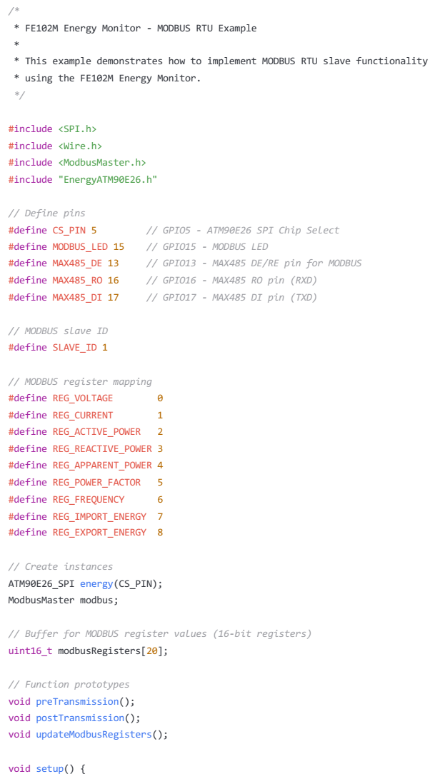
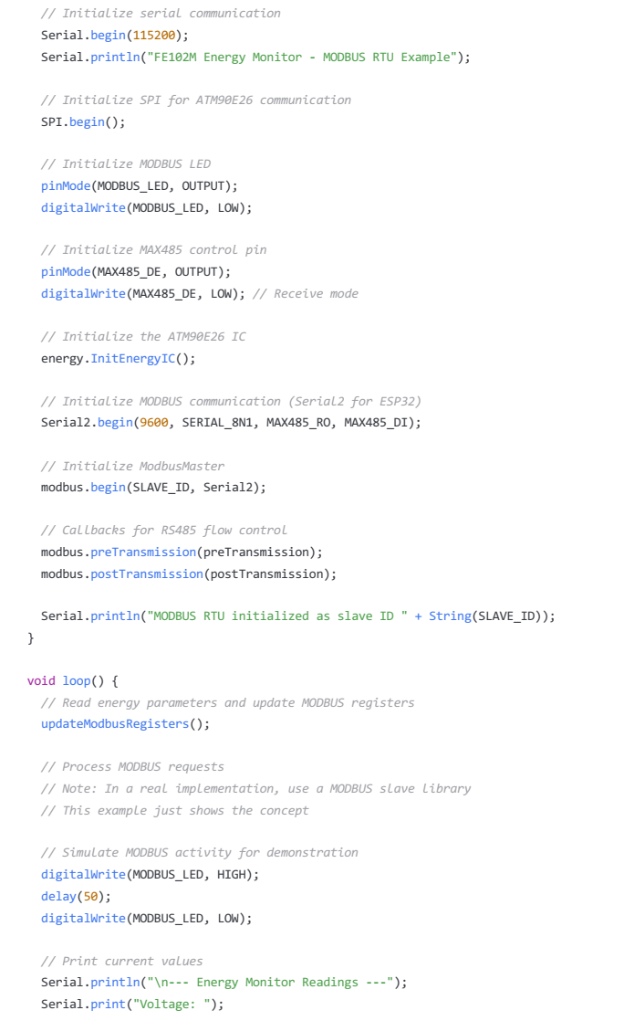
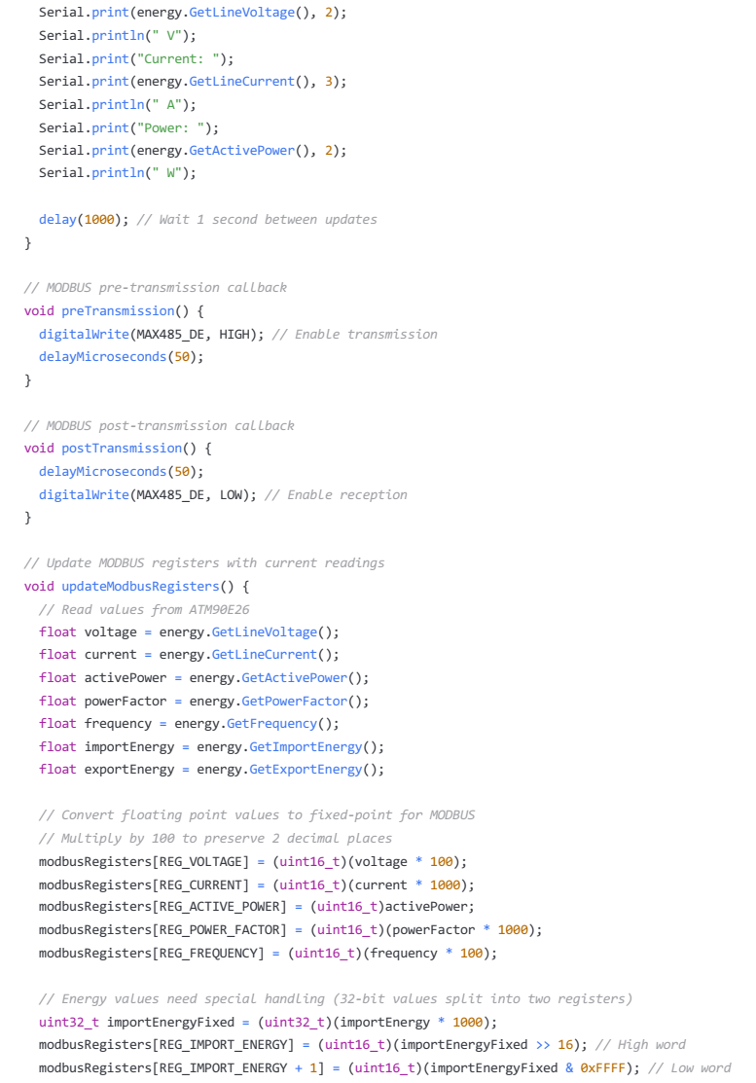
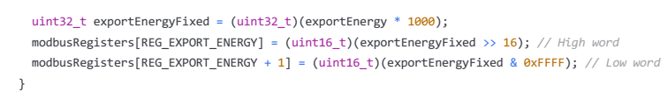

EEPROM Calibration Storage
cpp
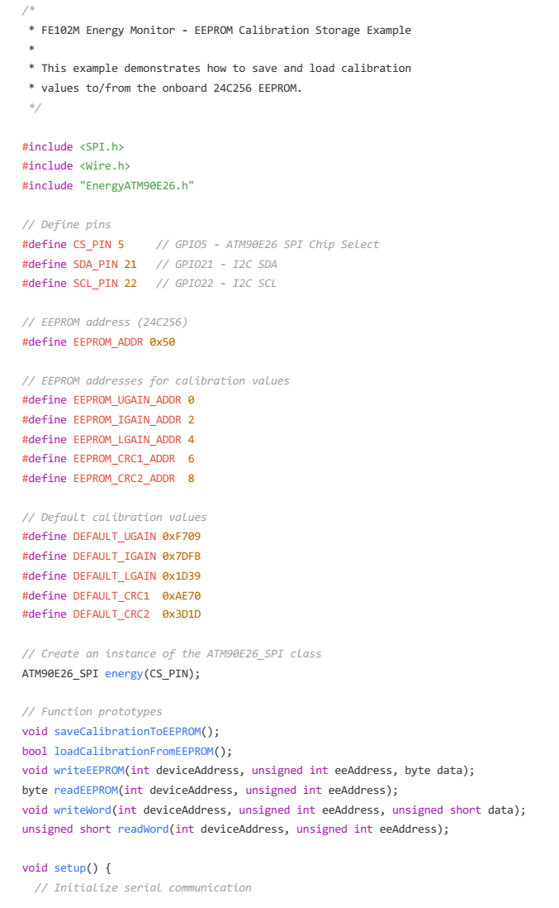
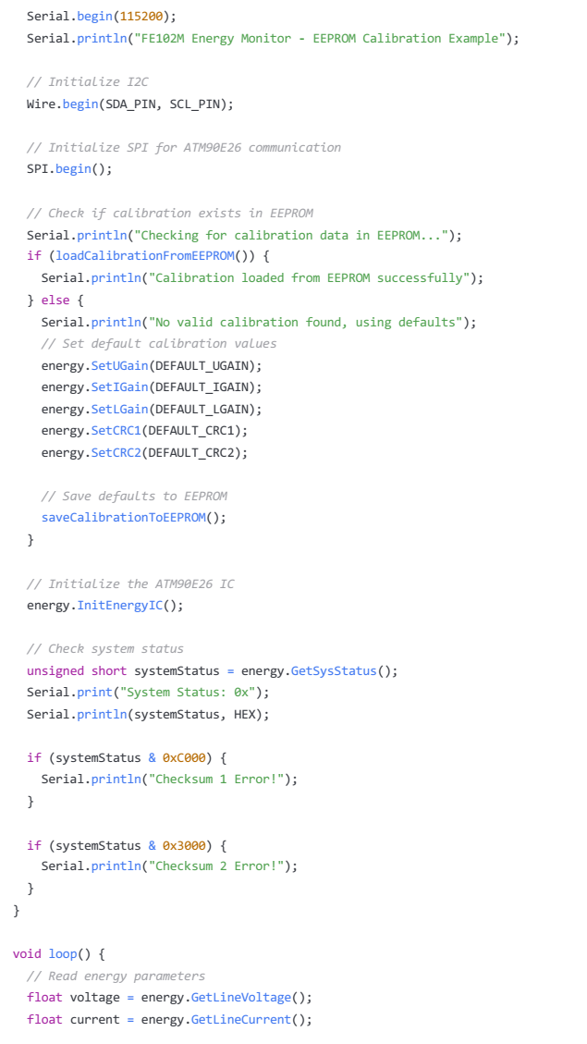
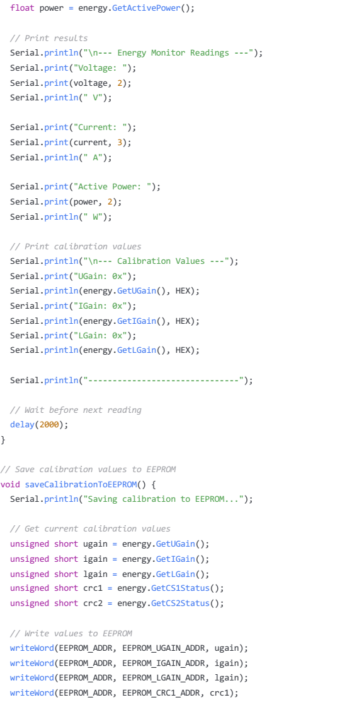

MODBUS Implementation
The FE102M Energy Monitor includes built-in MODBUS RTU capability through the RS485 interface. This allows for integration with industrial automation systems, building management systems, and other MODBUS-enabled devices.

MODBUS Hardware Interface
The RS485 interface is implemented using a MAX485 transceiver chip with the following connections:
GPIO13 (MAX485 DE/RE pin): Transmit/receive enable control
GPIO16 (MAX485 RO pin): Receive data
GPIO17 (MAX485 DI pin): Transmit data
GPIO15 (MODBUS LED): Indicates MODBUS communication activity

MODBUS Register Map
The following table defines the MODBUS register map for accessing energy monitoring data:

Register Address | Description | Format | Unit | Access
0x0000-0x0001 | Voltage RMS | 32-bit float | V | Read
0x0002-0x0003 | Current RMS | 32-bit float | A | Read
0x0004-0x0005 | Active Power | 32-bit float | W | Read
0x0006-0x0007 | Reactive Power | 32-bit float | VAR | Read
0x0008-0x0009 | Apparent Power | 32-bit float | VA | Read
0x000A-0x000B | Power Factor | 32-bit float | - | Read
0x000C-0x000D | Frequency | 32-bit float | Hz | Read
0x000E-0x000F | Active Import Energy | 32-bit float | kWh | Read
0x0010-0x0011 | Active Export Energy | 32-bit float | kWh | Read
0x0012-0x0013 | Reactive Import Energy | 32-bit float | kVARh | Read
0x0014-0x0015 | Reactive Export Energy | 32-bit float | kVARh | Read
0x0016-0x0017 | Apparent Energy | 32-bit float | kVAh | Read
0x0018 | System Status | 16-bit uint | - | Read
0x0019 | Device Control | 16-bit uint | - | R/W
0x001A | MODBUS Address | 16-bit uint | - | R/W
0x001B | Reset Energy Counters | 16-bit uint | - | Write

MODBUS Configuration
The default MODBUS configuration is:
Slave Address: 1 (configurable) Baud Rate: 9600
Data Bits: 8 Parity: None Stop Bits: 1
Mode: RTU
To change the MODBUS configuration, use the programming examples provided or modify the MODBUS settings through the device's user interface.

MODBUS Implementation Notes
- The device responds to standard MODBUS function codes:
- 0x03 (Read Holding Registers)
- 0x04 (Read Input Registers)
- 0x06 (Write Single Register)
- 0x10 (Write Multiple Registers)
- 32-bit float values are stored in IEEE-754 format with most significant register first.
- Reading energy values too frequently may impact the overall performance of the device. For optimal performance, limit MODBUS requests to once per second or less.

WiFi Connectivity
The FE102M Energy Monitor includes built-in WiFi connectivity through the ESP32 microcontroller. This allows for remote monitoring, data logging to cloud services, integration with home automation systems, and over-the-air firmware updates.

WiFi Configuration
The device can be configured to connect to your WiFi network using the Arduino code examples provided. The WiFi connection status is indicated by the WiFi LED (GPIO14).

Web Server Implementation
The ESP32 can be programmed to function as a web server, providing a web interface for monitoring energy data and configuring the device. The WiFi Data Logging Example shows how to implement basic WiFi connectivity and data transmission.

Cloud Integration
The FE102M Energy Monitor can be integrated with various cloud platforms for data logging and analytics, including:
ThingSpeak Adafruit IO AWS IoT
Google Cloud IoT Home Assistant
Node-RED
Example code for these integrations can be found in the GitHub repository.

Over-the-Air (OTA) Updates
The ESP32 supports over-the-air firmware updates, allowing you to update the device's firmware remotely without physical access. This is particularly useful for devices installed in hard-to-reach locations.

WiFi Security Considerations
Always use WPA2 or higher encryption for your WiFi network Change default passwords and credentials
Use TLS/SSL for secure data transmission
Consider implementing a firewall or VLAN for IoT devices
Regularly update firmware to address security vulnerabilities

LCD Integration
The FE102M Energy Monitor includes a connector for an I2C 20x4 LCD module, allowing for real-time display of energy monitoring data without requiring a computer or network connection.

LCD Hardware Connection
The LCD module connects to the following pins:
- GPIO21 (I2C SDA)
- GPIO22 (I2C SCL)
- 5V power supply
- GND

LCD Display Layout
The default LCD display layout is as follows:

FE102M Energy Monitor V:230.0V I:1.200A P:276W F:50.0Hz PF:0.98 E:42.5kWh
This layout provides a comprehensive overview of the most important electrical parameters: Line 1: Device identification
Line 2: Voltage and current readings
Line 3: Active power and frequency
Line 4: Power factor and energy consumption

Custom LCD Display
You can customize the LCD display layout and content by modifying the Arduino code. The LCD Display Implementation example shows how to configure and update the LCD display.

Troubleshooting
This section provides solutions to common issues that may be encountered when using the FE102M Energy Monitor.
Power and Startup Issues

Problem | Possible Cause | Solution
Device doesn't power on | Incorrect power  supply | Ensure 9-12V DC power supply is connected with correct  polarity
RUN LED not  illuminated | Initialization failure | Check power supply voltage, press RESET button
FAULT LED illuminated | ATM90E26 error | Check system status register, verify calibration values
Measurement Issues

Problem | Possible Cause | Solution
Voltage reading incorrect | Incorrect calibration | Perform voltage calibration procedure
Current reading incorrect | Incorrect CT type or  orientation | Verify CT type matches jumper settings, check CT  orientation
Power reading zero or very  low | CT not detecting current | Ensure CT is properly installed around conductor
Erratic readings | Electrical noise | Check grounding, add filtering, keep away from noise  sources
Communication Issues
Problem | Possible Cause | Solution
WiFi connection fails | Incorrect credentials or weak  signal | Verify SSID and password, check signal strength
MODBUS communication  fails | Incorrect wiring or settings | Verify RS485 wiring, check MODBUS settings
USB connection fails | Driver issue | Install proper USB-UART driver for CP2102
I2C LCD not working | Incorrect address or wiring | Check I2C address (usually 0x27 or 0x3F), verify  wiring

Software Issues

Problem | Possible Cause | Solution
Upload fails | ESP32 in boot loop | Hold BOOT button while initiating upload
Checksum errors | Invalid calibration values | Restore default calibration values
Energy values reset | Power cycle without saving | Use EEPROM to store energy values
ESP32 crashes | Memory issues or watchdog timer | Check for memory leaks, implement watchdog reset
Diagnostic LEDs
The status LEDs on the front panel provide valuable diagnostic information:
WiFi LED: Indicates WiFi connection status
RUN LED: Indicates normal operation
FAULT LED: Indicates error condition
MODBUS LED: Indicates MODBUS communication activity
ATM90E26 Status LEDs: Indicate specific energy monitor interrupt states

Factory Reset
To restore the device to factory settings:
- Power off the device
- Press and hold both SET and MODE buttons
- Power on the device while holding the buttons
- Continue holding both buttons for 5 seconds
- Release the buttons when all LEDs flash

Technical Support

Documentation and Resources
GitHub Repository: FE102M-Energy-Monitor
Wiki: Detailed technical documentation and guides
Issues Tracker: Report bugs and request features
Discussion Forum: Community support and discussions

Contact Information
For technical support, please contact:
Chamil Vithanage
Microcode Embedded Solutions, Australia
Email: microcode-eng@outlook.com
Website: www. microcodeeng.com

Warranty Information
The FE102M Energy Monitor comes with a limited 1-year warranty covering manufacturing defects and component failures. This warranty does not cover:
- Damage due to improper installation or use
- Damage from power surges or incorrect power supply
- Modifications or repairs by unauthorized personnel
- Normal wear and tear
For warranty claims, please contact the manufacturer with your purchase information and a description of the issue.

Note: All example code provided is open source and may be freely used or modified as needed. It is distributed on an "AS IS" BASIS, WITHOUT WARRANTIES OR CONDITIONS OF ANY KIND, either express or implied. Always ensure proper testing before deployment in critical applications.

