Executive summary

- The purpose of this document is to present a detailed description of the Class Management System for Akura Institution. It will explain the purpose and features of the system, the interfaces of the system will do, the constraints under which it must operate and how the system will react to external stimuli. This document is intended for both stakeholders and developers of the system.Also this “Class Management system” can some specific details about a student. The details include institution details, Students’ personal details, Academic details,payment details etc. It provides capabilities for registering students in courses , admitting students, tracking student attendance and fee payment . Is ensures data integrity, privacy, and security in a standalone environment. As a whole class management system is a system for Akura institution to manage student data, user data and class data.

Acknowledgement

In making our project a successful one many parties helped us in different ways.Specially the supervisor of our group Dr.Sutharkar supplied us the necessary guidance by showing the mistaked we did and by pointing out what should we do next and how the work to be shared with group members.Also our head of the department Dr.Ramanan gave us the correct motivation and how to dedicate in order to meet the deadlines.Our Instructor Mrs.Thulasika and mentor Mr.Indrajith Kumara also gave us advices of how to create the necessary structures that help to succeed the work.What was most important was the dedication of group members and our friends who also showed us our erros in certain instances.So as a group we all are very much thankful you all who helped us in different ways.

Contribution of each member

Ayodhya Manewa(Group Leader)
Normalized the tables of fields and created the database. Entered data into the database and did the coding of the Enrolment that accomplish add,remove,search student options and so on. Created the ER diagram that structurally displays how the system expands.

Sewmi Herath
Draw the Use case diagram and modifications for ER diagram and use case according to the changing needs of the client. Designed the interfaces and building the front end with connecting windows and did the coding of student details,add student,login,change password with sendMail API for password recovery,user details,add user that with the options of add,remove and search. Password encryption to ensure the security of the password of user. Created reports to analyze the details of the system. Detected the bugs of the above interfaces and fix them.

Shalintha Subashana
Designed the interfaces and did the coding of add subject,add course and details,add record and detected some bugs related to the interfaces and fix them.

Shevindi Rodrigu
Normalized the tables of fields and did the interface coding of Attendance that accomplishes finding the attendance details of the students. Entered data into the database.

N.K.Weerasinghe
Did the initial documentation and giving ideas for Use-case class diagrams and did the connection part of the interfaces to the database. Entered data into the database.

Consent of the client

Client’s Name : Mr H.M Abaywardhana

Address : Akura Educational Institution,
Nuwana Road,
Nikawaratiya.

T.P : 0726518701

The Director,
Akura Educational institute,
Nuwana Road,
Nikaweratiya.

H.M.S.S.Herath,
Faculty of Science,
University of Jaffna,
Jaffna.
Consent For Class Management System.
I’m H.M.Abayawardhana, Director of Akura Educational Institute do hereby author H.M.S.S.Herath and her team to finalize the project of creating a Class Management System for my institute. I hope that system will be finished according to the requirements that we have discussed with them.I hope to implement it in my institute to get the efficient results.
I have informed my staff to be available to assist H.M.S.S.Herath and her team in need full information they might seek from us to make their task success.
Please contact us if there is any favor we can done for you.
Yours faithfully,
H.M.Abayawardhana
(H.M.Abayawardhana)

Comments from Supervisor

Table of Contents

List of Figures

Product Perspective

Introduction

• Purpose of the project

The purpose of this document is to present a detailed description of the Class Management System for Akura Institution. It will explain the purpose and features of the system, the interfaces of the system will do, the constraints under which it must operate and how the system will react to external stimuli. This document is intended for both stakeholders and developers of the system…
Stakeholders are tutors
Developers are the administrator and the manager of the institution.

• Scope of the project

Manage details of the students,users of the system, details of the courses .In addition, enrollment of the students to the courses,mark the attendance of the students,make payments for each course are major functionality of the system.
Build standard reports to view the financial status of the institute and the attendance of the students using the attendance and payments data are as well under the scope of the system.

• Overview of the Document

The Overall Description section of this document gives an overview of the functionality of the product. It describes the informal requirements and is used to establish a context for the technical requirements specification..
Also Requirements Specification section, of this document is written primarily for the developers and describes in technical terms the details of the functionality of the product.
Both sections of the document describe the same software product in its entirety, but are intended for different audiences and thus use different language

Requirement Engineering

• Techniques used for requirements gathering

The system must run in windows operating system.
Java environment
xampp as a cross-platform

• Functional requirements

Creating Courses
Integration with registration system
The system shall periodically upload the latest registrar’s classes list to determine courses that offered in the current term. The system shall generate course for each class that registered and determine the current set of students that enrolled in that class.

• Non-functional requirements

Response Time
Average response time shall be less than 2 second.
Throughput
The system shall accommodate 1000 booked per minute.
Recovery Time
In case of a system failure, redundant system shall resume operations within 30 seconds. Average repair time shall be less than 1 hour.
Start-up/Shutdown Time
The system shall be operational within 1 minute of starting-up.

• Domain requirements

Reliability
The system shall not be down more 2 times in year.
Scalability
Scaling the system to large number of users: large courses will have hundreds of students.

• Challenges

Software Design
- Software design approach

- Context Diagram

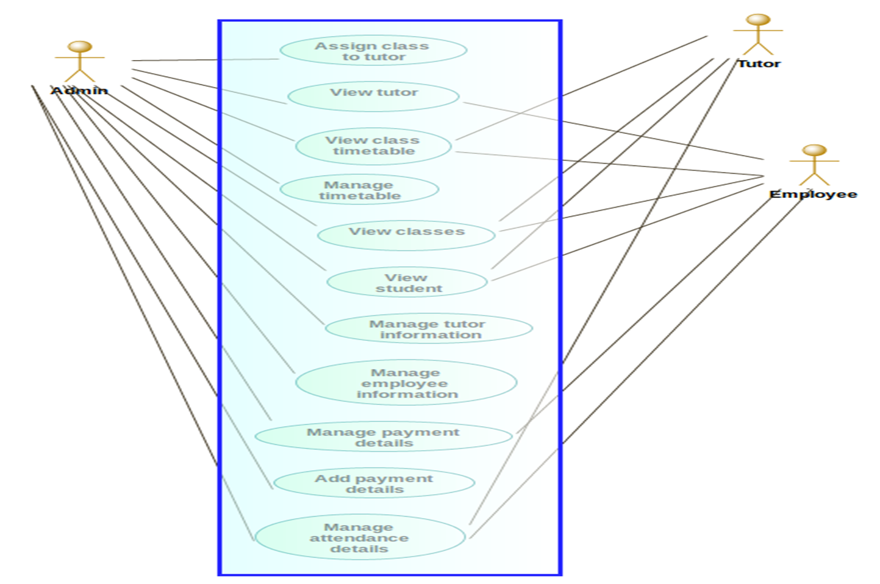

- E-R Diagram
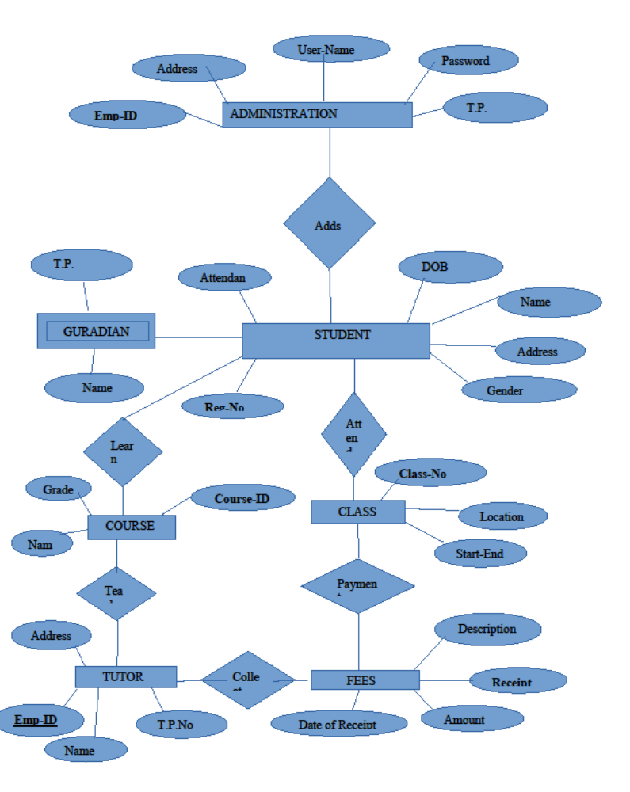

- Behavioural Diagram

(sequence diagram)

Implementation

• Tools and Techniques, and justifications

- We used Netbeans as a IDE.
- We used Navicat for mysql database to save the data of students.
- Jaspersoft Studio for creating reports.

• Special features

The institution gets all the resources required by the client.
All important stakeholders play a major role.
Also the constraints are limitations imposed on the project such as the limitation of cost,schedule or resources and you have to work within the boundaries restricted by these constraints which are defined and identified at the beginning of the project.

Testing

Tested the front-end as a initial step and built it successfully without errors. Did the back end testing initially by running the each window with it's functions. Finally run the system as complete system and entered some dummy data to check whether the system achieve it's user goals.

Discussion and Conclusion

Through the system it collects the details of student and the system users(tutor and admin)and analyses them according to the client requirement. The system provide facility to enter,edit and remove the data and viewing according to the actor's privileges. This will be a support to the user for managing the information of his workplace.

References

- https://www.youtube.com/watch?v=c0UV3c_iR74
- https://www.javatpoint.com/
- https://www.tutorialspoint.com/
- https://stackoverflow.com/
- https://icons8.com/

