1. Networks connect us
Communication is almost as important to us as our reliance on air, water, food and shelter
2. What is a network?
A network is a collection of two or more devices that are connected together to share resources, exchange data, and communicate with each other.

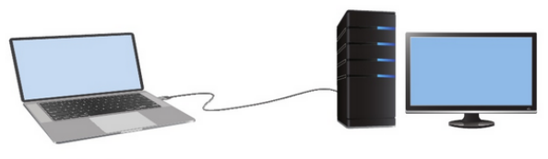
3. Host / End Device?
All devices that are connected to a network and participate directly in network communication are classified as hosts.
Hosts are also called end devices.
Example: Computers, Servers, Smartphones, Printers, and etc.
4. Client?
A client is a type of host that requests services from another device. Clients use software to request and display information received from servers.
5. Server?
A server is a type of host that provides services to other devices. Servers run software that allows them to provide information and services, often to multiple clients simultaneously.

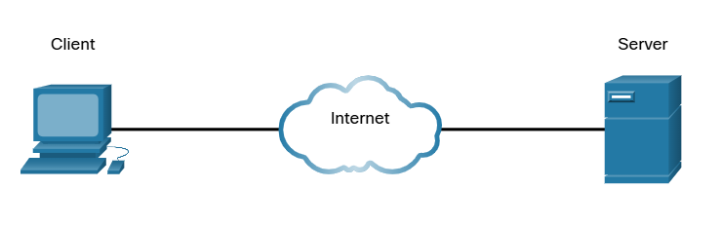
Example:
When you open a website on your phone, your phone acts as a client. It sends a request over the network to a server where the website is hosted. The server receives this request, processes it, and sends back the required data, such as text, images, and videos. Your phone then displays this information on the screen through a web browser.
6. Intermediary devices
Network devices that connect hosts and help manage the flow of data across the network.
They do not generate or consume data like end devices, but instead forward, direct, and control data traffic between devices.
Examples:
- Routers
- Switches
- Wireless Access Points (WAPs)
- Firewalls
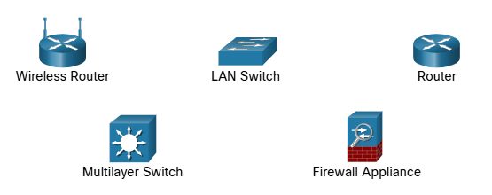
Intermediary devices:
- Forward data to the correct destination
- Determine the best path for data to travel
- Filter and secure traffic (Ex: firewalls)
- Connect different networks together
Important:
If hosts (end devices) are like people sending messages, intermediary devices are like the post office or traffic system that ensures the message reaches the correct destination efficiently.
7. Components of Data Communication System
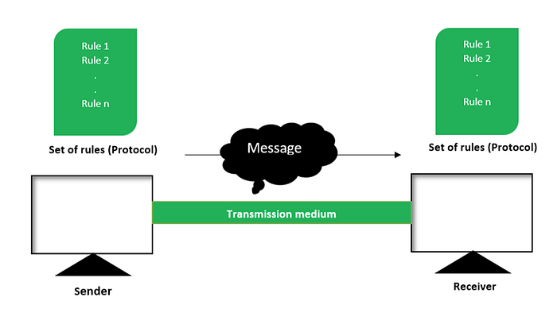
- Sender:
The device that initiates (sends) the data.
- Receiver:
The device that receives the data.
Question:
Is the client always the sender and the server always the receiver?
No
A client and a server can both act as sender or receiver depending on the direction of communication. For example, when a client request data, it is the sender and the server is the receiver. When the server sends the requested data back, the server becomes the sender and the client becomes the receiver.
- Transmission medium:
The pathway through which the message travels from the sender to the receiver.
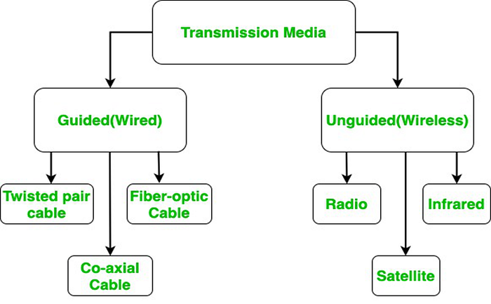
Guided Media (Wired): Data travels through a physical path such as cables.
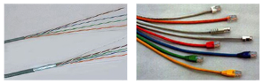
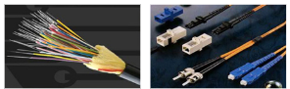
Unguided Media (Wireless): Data travels through the air (no physical connection) using electromagnetic waves.
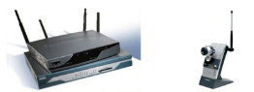

Question:
What is NIC?
NIC (Network Interface Card) is the hardware component that allows a device to connect to a network.
It acts as an interface between the device and the network, enabling the device to send and receive data.
NIC can be wired (Ethernet) or wireless (WNIC).
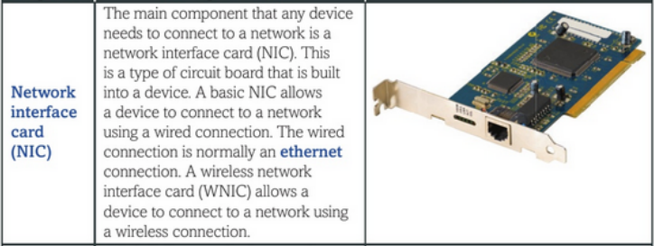
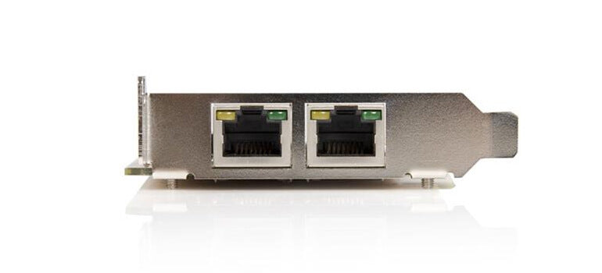
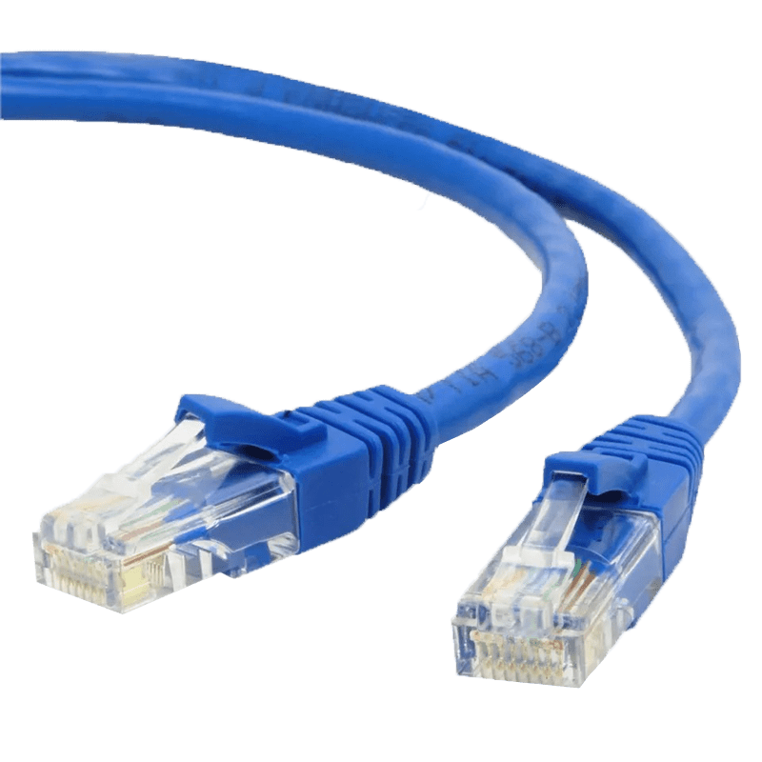
Modern computers usually have NICs built into the motherboard, Can add one if needed.
Every NIC has a unique identifier (MAC Address).
- Message:
The actual data or information that is being communicated between the sender and the receiver. It can be in a text, images, audio, video files, depending on the type of communication.
Question:
How data like text, images, or videos are send over a network?
All types of data whether text, images, audio, or video are represented and stored as binary (1s and 0s) inside a computer. When this data is transmitted over a network, the binary bits are encoded into physical signals. In wired networks, they travel as electrical or light signals, and in wireless networks, they travel as radio waves. Every message we send is a stream of binary data transmitted as signals.
Cables: Data is encoded into electrical impulses.
Fiber-Optic: Data is encoded into pulses of light.
Wireless transmission: Data is encoded via modulation of specific frequencies of electromagnetic waves.
Question:
What is Bandwidth?
Bandwidth is the maximum capacity of a channel.
Maximum amount of data that can be transmitted per second.
Question:
What is Throughput?
Throughput is the actual amount of data successfully transmitted per second.
Question:
Why Throughput < Bandwidth?
In real networks, we never achieve full bandwidth due to:
- Network congestion (too many devices)
- Packet loss & retransmissions
- Protocol overhead (headers, control data)
- Delays and interference
Actual data transfer (throughput) is always less than theoretical maximum (bandwidth).
Question:
In wireless networks, throughput is much lower. Why?

- Protocol
Set of rules both sender and receiver must follow to ensure successful communication.
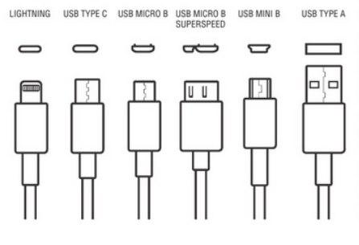

Network Components | Building blocks
A network can contain a range of different components, with each having a defined role in the network.

Ethernet is the most common type of wired network connection.
NIC – A piece of hardware that is built into a device. It allows it to have a wired or wireless connection.

Inside the organization

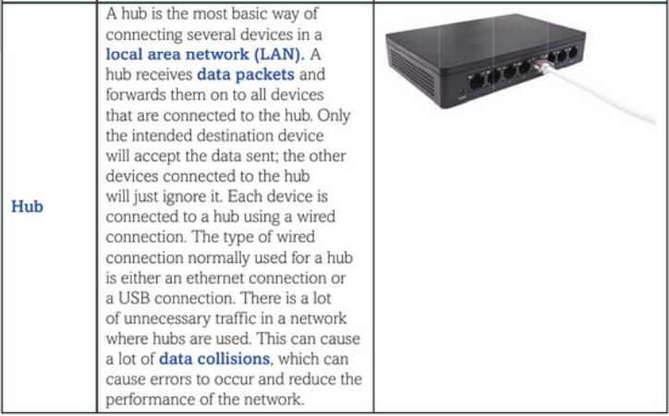

LAN – Type of network that is located within a single building or site
Data packet – The unit of data that contains the information to be transmitted across a network
Data collision – When two devices on a network send data simultaneously the data packets can collide

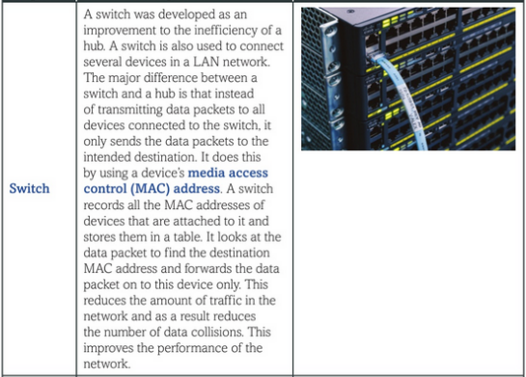

Outside the organization

MAC (Media access control) Address – A unique address that is given to the NIC in each device at the point of manufacture

IP Address – A unique address that is given to a device when it connects to a network

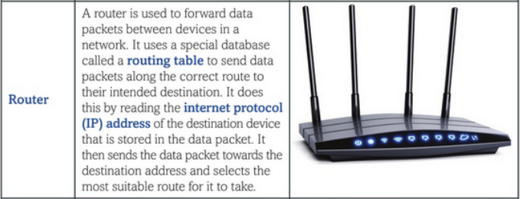

Allows us to communicate to a WAN (Wider area network)

Is the dividing line between your network and the other network

Router – Network hardware that reads IP addresses to send data to the correct network or device
Routing table – A database that stores all the known routes across a network to different devices.

Wireless Communication

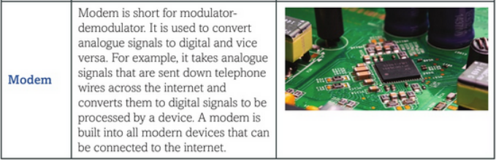

Modem – Network hardware that converts between analogue and digital signals.A

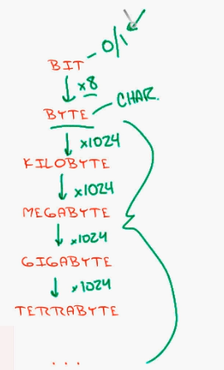

Speed – Bits / Second

OSI Model

