EDUSCORE
WEB PROJECT REPORT

Prepared on: July 22, 2026
Project Version: 0.1.0
Technology Stack: Next.js, TypeScript, Supabase
Developer: AuravexonFlow (EduScore)

TABLE OF CONTENTS

1. Executive Summary
2. Screenshots
3. Project Architecture
4. Complete Route Map
5. Core Features
6. Database Schema
7. Component Inventory
8. Utilities & Libraries
9. Testing
10. Scripts
11. Environment Variables
12. Development Status
13. Security Considerations
14. Performance Metrics
15. Deployment
16. Repository Status
17. Contact & Support

Executive Summary

EduScore is a comprehensive school grading, evidence review, and quality assessment web application aligned with the Sri Lankan Ministry of Education's School Quality Standard (SQS) framework (Process.pdf, 2014 edition). The system enables schools to submit evaluations across 8 quality perspectives with a multi-tier approval workflow (Lead → VP → Principal), automated grading engine, bilingual support (English & Sinhala), and rich analytics dashboards.

Attribute | Value
Framework | Next.js 16.2.4 (App Router + Turbopack)
Language | TypeScript 5
UI | React 19.2.4, Tailwind CSS 4, Recharts, Lucide Icons
Database | Supabase (PostgreSQL) via @supabase/ssr + @supabase/supabase-js
Auth | Supabase Auth (primary), Firebase (secondary)
Email | Resend
PDF | pdf-parse
Testing | Node.js built-in test runner + tsx
Languages | English + Sinhala (සිංහල)
Deployment | Vercel / Firebase Hosting

2. Screenshots

2.1 Homepage (Public)
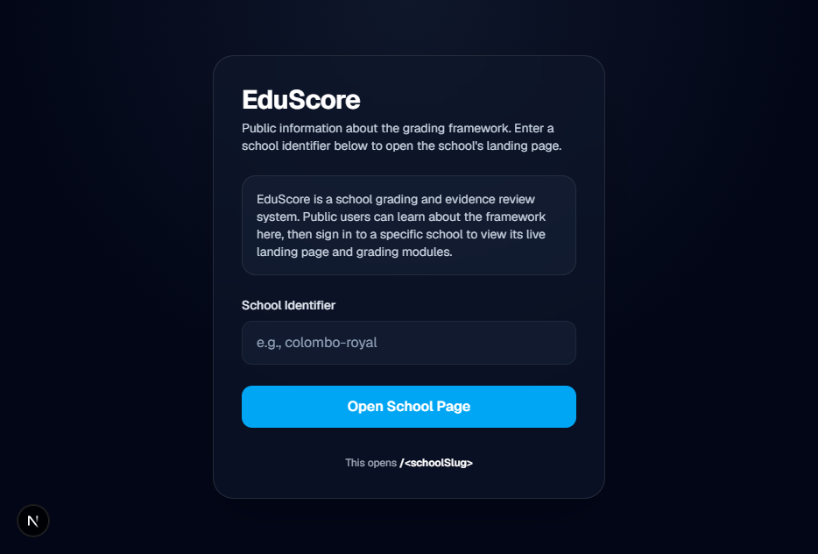
The public homepage serves as the entry point. Users enter a school identifier (slug) to navigate to the school's landing page. Features a clean, dark-themed UI with radial gradient backgrounds and glass-morphism effects.

2.2 School Landing Page
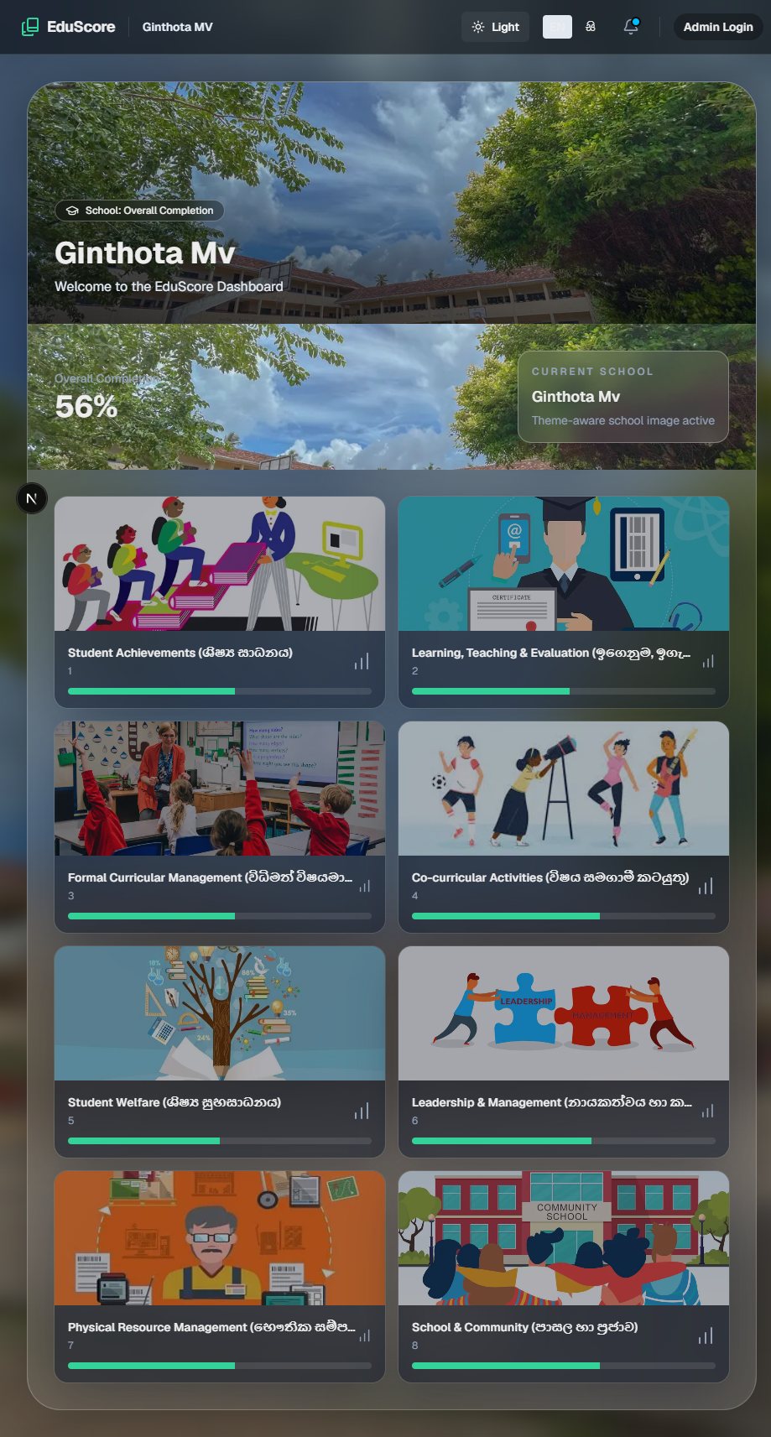
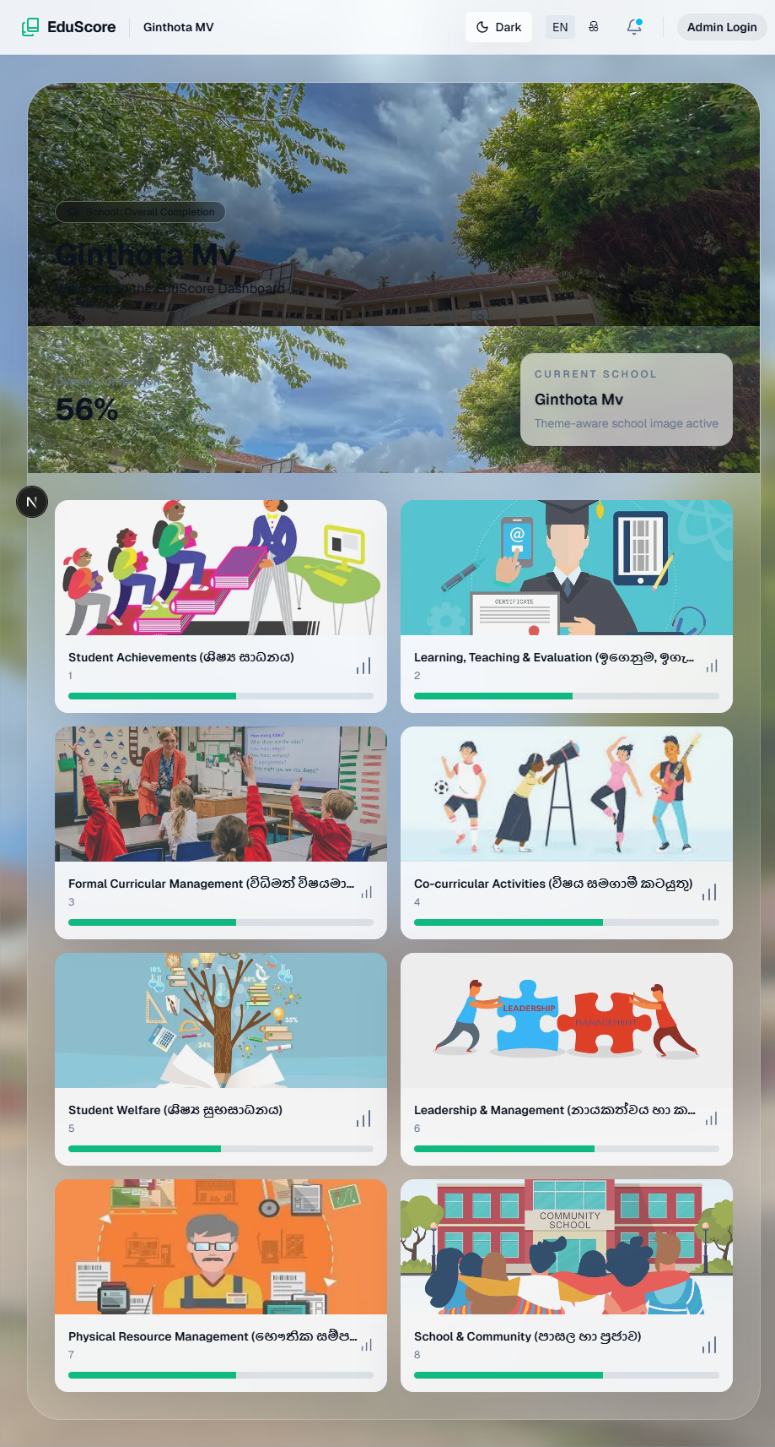

The school-specific dashboard displays:
- Hero section with campus image and overall completion percentage (56%)
- 8 perspective cards with images, bilingual titles (English + Sinhala), and progress indicators
- Circular progress ring showing overall school completion
- Navigation bar with breadcrumbs, theme toggle, language toggle, and admin login link

2.3 All Perspectives Dashboard

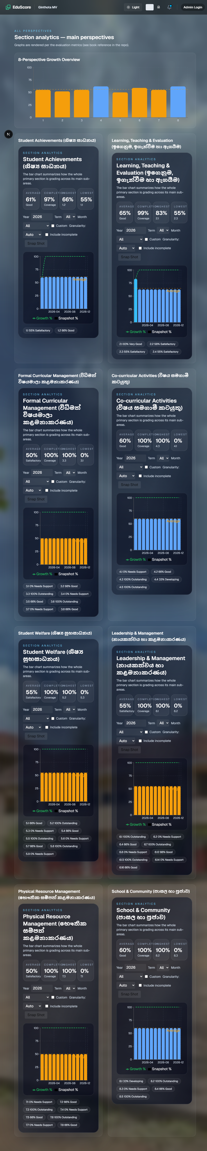
A comprehensive analytics view showing:
- Bar chart comparing all 8 perspectives with growth % and snapshot %
- Per-perspective section metrics with time-series charts
- Period filters (year, term, month, custom) and granularity controls
- Legend distinguishing growth vs. snapshot metrics

2.4 Single Perspective Detail

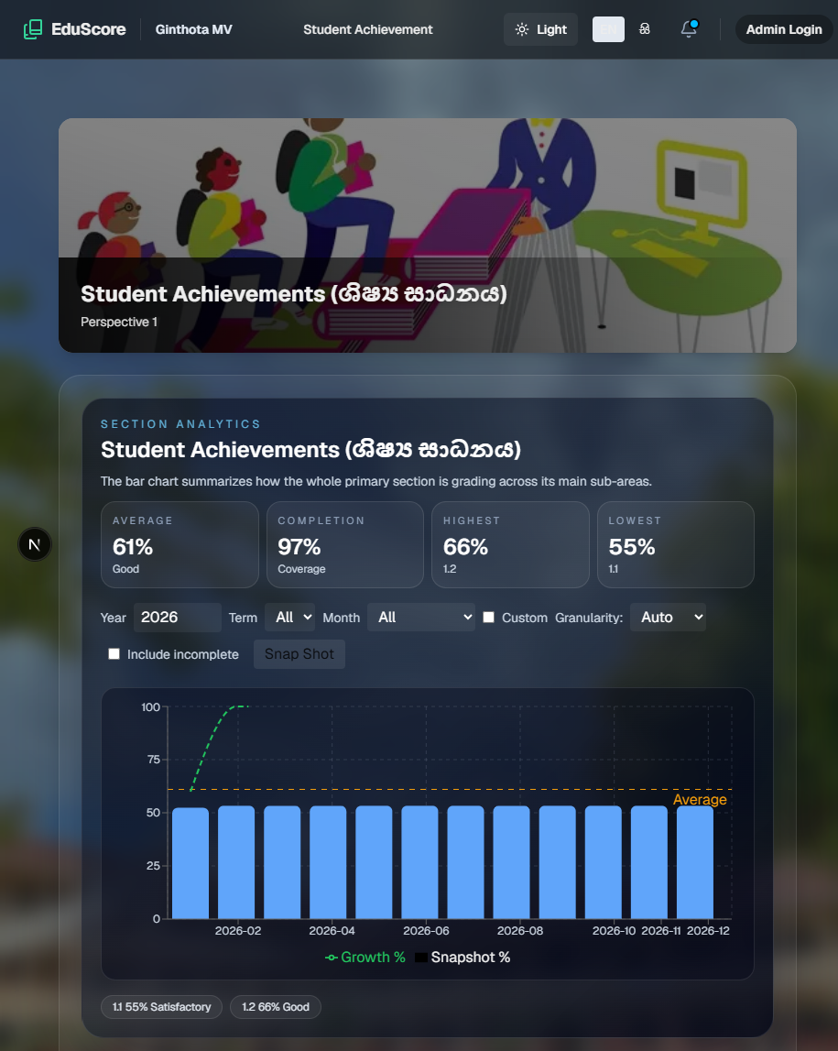
Individual perspective view (e.g., Student Achievements) showing:
- Hero image with perspective title and bilingual subtitle
- Section analytics with average score, completion %, highest/lowest sub-areas
- Time-series chart with growth and snapshot lines
- Period controls (year, term, month, granularity, custom range, include incomplete)
- Sub-perspective cards (e.g., Primary Section 1.1, Secondary Section 1

3. Project Architecture

3.1 Technology Stack

Frontend
Technology | Version | Purpose
Next.js | 16.2.4 | React framework with App Router + Turbopack
React | 19.2.4 | UI library
TypeScript | 5 | Type safety
Tailwind CSS | 4 | Utility-first CSS framework
Recharts | 3.8.1 | Charting library (bar, line, area, composed charts)
Lucide React | 1.8.0 | Icon library

Backend & Database
Technology | Purpose
Supabase (PostgreSQL) | Primary database with RLS policies
@supabase/ssr | Server-side rendering integration
@supabase/supabase-js | Browser-side database client
Firebase | Secondary auth provider
Resend | Transactional email service

Development Tools
Tool | Purpose
ESLint | Code linting
PostCSS | CSS processing
tsx | TypeScript execution for tests
Node.js test runner | Unit testing

3.2 Project Structure

edu-score/
├── app/ # Next.js App Router
│ ├── globals.css # Global styles (dark/light themes)
│ ├── layout.tsx # Root layout with providers
│ ├── page.tsx # Public homepage (school slug entry)
│ ├── [schoolSlug]/ # School-specific routes
│ │ ├── layout.tsx # School layout with Navbar
│ │ ├── page.tsx # School landing/dashboard
│ │ ├── dashboard/ # Redirects to /[schoolSlug]
│ │ ├── perspective/ # All perspectives analytics
│ │ │ └── [id]/ # Single perspective detail
│ │ ├── evaluate/[standardId]/ # Per-standard evaluation
│ │ ├── report/ # SQS Process Report
│ │ ├── admin/ # School admin panel
│ │ │ └── report/ # Admin report with export
│ │ └── admin-login/ # Admin authentication
│ ├── api/ # API Route Handlers
│ ├── auth/ # Auth gateway (role-based redirect)
│ ├── god-admin/ # System admin dashboard
│ ├── reset-password/ # Password reset flow
│ └── backfill-audit/ # Audit view page
├── components/ # React Components (30+)
├── lib/ # Core Libraries
├── utils/ # Utilities
├── supabase/ # Database Migrations
├── scripts/ # Database & Utility Scripts
├── tests/ # Unit Tests
└── public/ # Static Assets

4. Complete Route Map

4.1 Public Routes
Route | Description
/ | Public Hub — School slug entry form with validation against schools table
/auth | Auth Gateway — Role-based redirect (GOD_ADMIN → /god-admin, signed-out → /)
/reset-password | Password Reset — Supabase recovery token handler (min 8 chars)
/backfill-audit | Admin Audit View — Tabular display of backfill audit data

4.2 School Routes (`/[schoolSlug]/`)
Route | Component | Description
/[schoolSlug] | SchoolLandingClient | School dashboard — hero, overall completion, 8 perspective cards
/[schoolSlug]/perspective | AllPerspectivesDashboard | All 8 perspectives analytics — bar chart, section metrics
/[schoolSlug]/perspective/[id] | PerspectivePageClient | Single perspective — hero, sub-cards, analytics, events
/[schoolSlug]/evaluate/[standardId] | Server Component | Per-standard evaluation — fetches data from Supabase
/[schoolSlug]/report | ProcessReportClient | SQS Process Report — criteria totals, field %, SEQI
/[schoolSlug]/admin | SchoolAdminClient | Admin panel — submissions, approvals, roles, attachments
/[schoolSlug]/admin/report | SchoolReportClient | Admin report — activities, status badges, PDF export
/[schoolSlug]/admin-login | Server Component | Admin login — Supabase email/password auth

4.3 God Admin Routes
Route | Description
/god-admin | God Admin Dashboard — Confidential user management (GOD_ADMIN or ADMIN role)
/god-admin/login | God Admin login page

4.4 API Endpoints
Endpoint | Method | Description
POST /api/submissions | POST | Create evaluation submission (file URLs, hosted dates)
PATCH /api/evaluations/[id]/transition | PATCH | Status transition (PENDING→VP_APPROVED→FINALIZED)
POST /api/grading/submit | POST | Submit grading data (requires canApprove)
GET /api/perspective-evaluations | GET | Fetch evaluations by school + perspective/indicator
GET /api/school-report | GET | Full school report data
GET /api/notifications | GET | User notifications for a school
GET/PATCH /api/admin/users | GET/PATCH | List/update users (profiles, roles)
PATCH /api/admin/users/role | PATCH | Assign role to user
POST /api/admin/user-management | POST | Master-credential user management with audit
GET /api/admin/recent-activities | GET | Recent evaluation activities

5. Core Features

5.1 Multi-Perspective Evaluation System (SQS Framework)
The system evaluates schools across 8 quality perspectives with 78 total perspectives/criteria:
# | Perspective | Sinhala | Top-Level ID | Key Sub-areas
1 | Student Achievements | ශිෂ්‍ය සාධනය | 1 | Primary competencies, Grade 5 Scholarship, O/L & A/L results, term test marks (Grades 6-13), SBA progress
2 | Learning, Teaching & Evaluation | ඉගෙනුම, ඉගැන්වීම හා ඇගයීම | 13 | Lesson planning, quality of teaching, assessment, teacher personality
3 | Formal Curricular Management | විධිමත් විෂයමාලා කළමනාකරණය | 27 | National goals, primary learning, assessment process, resources, special needs
4 | Co-curricular Activities | විෂය සමගාමී කටයුතු | 36 | Planning, primary programs, sports, creativity, ethics/values
5 | Student Welfare | ශිෂ්‍ය සුභසාධනය | 43 | Counseling, attendance, health, sanitation, child protection
6 | Leadership & Management | නායකත්වය හා කළමනාකරණය | 53 | Vision/mission, strategic planning, finance, staff development
7 | Physical Resource Management | භෞතික සම්පත් කළමනාකරණය | 63 | Grounds, buildings, labs, library, IT
8 | School & Community | පාසල හා ප්‍රජාව | 72 | Parental participation, community contribution, SDS

5.2 Automated Grading Engine
Aligned with the Ministry of Education Process.pdf (2014):
Function | Description
percentageToBand() | Universal mapping: ≥90→6(Excellent), ≥75→5, ≥60→4, ≥45→3, ≥25→2, <25→1
calculateIndicatorScore() | Type-specific calculators (percentage-band, direct-rating, custom-1_2_2, custom-1_2_3, teacher-evaluation)
calculateCriteriaTotal() | Sums indicator scores per criteria, computes percentage vs max
calculateFieldPercentage() | Field-level percentage across all indicators
calculateSEQI() | School Education Quality Index (average of field percentages)
seqiToOverallBand() | SEQI→label mapping (≥80 Excellent, ≥77 Very Good, etc.)

5.3 Role-Based Access Control (RBAC)
11 Canonical Roles:
Role | Scope | Permissions
PRINCIPAL | School-wide | Final approval, all perspectives, user management
VP_ACADEMIC | Perspectives 1-4 | Approve evaluations, manage academic staff
VP_ADMIN | Perspectives 5-8 | Approve evaluations, manage admin staff
LEAD_PERSPECTIVE_01–08 | Single perspective | Create/edit evaluations for assigned perspective
GOD_ADMIN | System-wide | Full access, user management, audit logs

3-Tier Approval Workflow:
PENDING → VP_APPROVED → FINALIZED
↓
REJECTED (with reason + notification)

5.4 Dynamic Evaluation Forms
Per-indicator custom forms supporting multiple field types:
- Percentage — Numeric input with automatic band calculation
- Rating 1-6 — Direct rating scale
- Grade Columns — Multi-column grade entry
- Teacher Marks — 4 teachers × 1-6 marks with average calculation
- Number — Generic numeric input
- Text — Free text input
- Readonly — Display-only fields

5.5 Analytics & Dashboards
Chart Type | Component | Description
Radar Chart | PerformanceRadar | Multi-axis performance comparison
Bar Chart | AllPerspectivesDashboard | 8-perspective growth comparison
Time-Series | PerspectiveAnalytics | Line/area/composed charts with period filters
Section Metrics | SectionMetricsPanel | Per-perspective bar charts with grade bands
Circular Progress | CircularProgress | SVG progress ring (red/yellow/green)

Time Period Controls:
- Year, Term, Month filters
- Custom date ranges
- Granularity: Auto/Year/Term/Month/Week/Day
- Include incomplete option
- Snapshot mode

5.6 Notifications & Email
Feature | Description
In-app notifications | Real-time notification bell with read/unread status
Email notifications | Via Resend with templates for: submitted, approved, finalized, rejected
Reviewer alerts | Auto-notify VP + Principal on new submissions
Override-to | Test mode: redirect all emails to a test address

5.7 Evidence Submission
- File upload to Supabase Storage
- Attachment management in admin panel
- PDF text extraction via pdf-parse
- Hosted date tracking (from/to)

5.8 Internationalization (i18n)
Feature | Description
Languages | English (en) + Sinhala (si)
Translation keys | 50+ keys covering UI labels, status text, form labels, errors, navigation
Auto-detection | Browser language detection on first visit
Persistence | localStorage + cookie for language preference
Component | LanguageProvider with useI18n() hook

5.9 Theme System
Mode | Description
Dark (.dark) | Deep slate gradients, glass-morphism cards, animated blobs
Light (.inverted) | White backgrounds, dark text, same glass effects
Auto | Detects prefers-color-scheme on first visit
Design Elements:
- Radial gradient backgrounds
- Backdrop-blur glass-morphism
- Liquid glass gradient overlays
- Animated blob backgrounds
- 20+ CSS custom properties

5.10 God Admin Panel
- Confidential user CRUD (list, edit, reset passwords)
- Master credential fallback (MASTER_ADMIN_EMAIL/MASTER_ADMIN_PASSWORD)
- Audit logging for all admin activities
- Batch password reset capability
- Easter egg trigger: typing aurabyravindu798 on keyboard opens modal globally

6. Database Schema

6.1 Core Tables (Pre-existing)
Table | Key Columns | Description
schools | id, name, slug | School registry
evaluations | id, school_id, title, description, perspective_number, status, files, academic_year, term, submitter_id, evaluator_id | Evaluation records
user_profiles | id, full_name, roles TEXT[], school_id, email, assigned_sidebar_items | User profiles
standards | id, name_en, name_si | SQS standards
scores | id, evaluation_id, updated_at, notes | Evaluation scores

6.2 Migration History
Migration | Table/Column | Purpose
001 | admin_user_audit | Audit trail (performed_by, target_user_id, action, details JSONB)
002a | evaluations.hosted_from/to | Hosted date range tracking
002b | evaluations.submitter_role | Role of the submitter
003 | evaluations + notifications | Rejection workflow (rejection_reason, rejected_by, rejected_at) + notification system
004 | evaluations | Edit history (previous_snapshot JSONB, edited_by, edited_at)
005 | user_profiles.assigned_sidebar_items | Principal-assigned sidebar items per user
006 | evaluations | Form data storage (form_data JSONB, indicator_code, score, completion) + indexes

7. Component Inventory

7.1 Page/Container Components
Component | Purpose
SchoolLandingClient | School dashboard — hero image, perspective cards, overall completion
AllPerspectivesDashboard | 8-perspective bar chart + per-perspective section metrics
PerspectivePageClient | Single perspective view with hero, sub-cards, analytics
PerspectiveDetailClient | Event list + analysis toggle, event viewer with attachments
SchoolAdminClient | Full admin panel: submissions, approvals, roles, attachments
SchoolReportClient | Admin report with activity list, status badges, PDF export
ProcessReportClient | SQS Process Report: criteria totals, field %, SEQI
EvaluationForm | Dynamic per-indicator evaluation form with auto-score
GodAdminUserManagement | Confidential user CRUD with audit logging
PerspectiveAnalytics | Time-series charts with period filters
SectionMetricsPanel | Per-perspective metrics with bar charts

7.2 Form/Input Components
Component | Purpose
SubmissionForm | Evidence submission with file upload
MockSubmissionForm | Mock version for testing
FormInput | Styled input field
RoleAssignmentForm | Admin role assignment UI

7.3 UI/Display Components
Component | Purpose
Navbar | Top navigation with breadcrumbs, logo, toggles, notifications
Hero | Generic hero header with image, title, subtitle
PerspectiveCard | Card with image, title, progress bar, click-to-navigate
CircularProgress | SVG circular progress ring (color-coded)
StatusBadge | Color-coded status tag (Approved/Pending/Needs Revision)
Modal | Generic modal dialog with backdrop blur
PerspectiveToggle | Toggle between Event View and Analytical Mode

7.4 Theme/i18n Components
Component | Purpose
ThemeToggle | Dark/Light mode toggle (persists to localStorage)
LanguageToggle | EN/සි language switch
LanguageProvider | React Context for i18n with useI18n() hook

8. Utilities & Libraries

8.1 Supabase Clients
File | Purpose
utils/supabase/server.ts | Server-side client with cookie-based session
utils/supabase/client.ts | Browser-side client (createBrowserClient)
utils/supabase/admin.ts | Service-role client (bypasses RLS)
utils/supabase/middleware.ts | Middleware client for session refresh

8.2 Authorization
- Roles: PRINCIPAL, VP_ACADEMIC, VP_ADMIN, LEAD_PERSPECTIVE_01–08, GOD_ADMIN
- Statuses: PENDING, VP_APPROVED, FINALIZED
- Key functions: getUserRole(), getUserRoles(), canCreateOrEdit(), canApprove(), canFinalize(), validateStatusTransition()
- Resolution: app_metadata.roles → user_profiles.roles fallback chain

8.3 Other Utilities
File | Purpose
utils/submitter.ts | Seeded role map (11 test accounts), canonical submitter ID/role
utils/sidebarPermissions.ts | 8 perspective titles (EN+SI), role→sidebar mapping
utils/statusNotify.ts | In-app + email notifications on approval/finalization
utils/rejection.ts | Rejection workflow (notification + email)
utils/recipients.ts | Email recipient resolution (seeded map → user_profiles → auth admin)
utils/email.ts | Resend integration with templates
utils/qualityPayload.ts | Perspective One quality data serialization

9. Testing
Test File | Purpose | Status
tests/aggregation.test.ts | Time-series aggregation logic | ✅ Passing
tests/qualityBands.test.ts | Quality band calculation | ✅ Passing

Run command:
node --test --import tsx tests/aggregation.test.ts tests/qualityBands.test.ts

10. Scripts
Script | Purpose
seedRoles.js | Seed 11 role-based test accounts for Ginthota MV
apply_migration.ps1 | Apply Supabase migrations
applyMigration006.js | Apply migration 006 (form_data)
backfillSubmitters.js | Backfill submitter IDs on existing evaluations
exportBackfillAudit.js | Export backfill audit to CSV
extract_pdf_text.js | Extract text from PDF documents (pdf-parse)
extract_pdf_text_pdfjs.js | Extract text via pdf.js
getSchools.js | List all schools
queryEvaluations.js | Query evaluations data
check_submitter_column.js | Verify submitter column exists
checkProfilesByEmail.js | Check user profiles by email
attach_notification_school.js | Attach school_id to notifications

11. Environment Variables
Variable | Purpose | Required
NEXT_PUBLIC_SUPABASE_URL | Supabase project URL | ✅
NEXT_PUBLIC_SUPABASE_PUBLISHABLE_KEY | Supabase anon/publishable key | ✅
SUPABASE_SERVICE_ROLE_KEY | Supabase service role (admin operations) | ✅
RESEND_API_KEY | Resend email API key | Optional
EMAIL_FROM | Sender email address | Optional
EMAIL_OVERRIDE_TO | Test mode: redirect all emails here | Optional
EMAIL_ENABLED | Enable/disable email (default: true) | Optional
MASTER_ADMIN_EMAIL | God Admin master email | Optional
MASTER_ADMIN_PASSWORD | God Admin master password | Optional
NEXT_PUBLIC_MASTER_ADMIN_EMAIL | Client-side master admin email | Optional

12. Development Status

✅ Completed Features (Phase 1-3)
Phase | Features | Status
Phase 1: Navigation | Navbar, breadcrumbs, logo, theme toggle, notifications, login link | ✅ Complete
Phase 2: Dashboard | Hero section, perspective cards with icons, circular progress rings | ✅ Complete
Phase 3: Perspective View | Contextual header, modal event form, color-coded status tags | ✅ Complete
Post-Implementation | Responsiveness review, mock data cleanup, final report | ✅ Complete

✅ Fully Operational Features

- Multi-tenant school system with slug-based routing
- Complete SQS indicator framework (78 perspectives)
- Dynamic evaluation forms (percentage, rating, grade-columns, teacher marks)
- Automated grading engine (percentage→band, criteria totals, SEQI)
- 3-tier approval workflow (PENDING → VP_APPROVED → FINALIZED)
- Role-based access control (11 seeded accounts)
- Evidence submission with file upload
- In-app + email notifications via Resend
- Analytics dashboards (radar, bar, time-series charts)
- Bilingual UI (English + Sinhala)
- Dark/Light themes with glass-morphism design
- God Admin panel with confidential user management
- Password reset flow via Supabase recovery tokens
- Process report generation aligned with Ministry of Education

⚠️ Known Issues
Issue | Severity | Description
Image sizes prop missing | Low | 8 perspective images need sizes prop for performance
LCP image missing loading="eager" | Low | School campus image detected as LCP without eager loading
Chart dimensions warning | Low | Recharts reports width/height -1 on initial render
Hydration mismatch (ThemeToggle) | Medium | Dark/Light toggle causes SSR/client mismatch on admin-login
Report page 500 error | Medium | /report returns 500 when Supabase is unavailable

📝 Potential Enhancements
- Enhanced reporting and export capabilities (PDF, Excel)
- Real-time collaboration features
- Mobile app development
- Advanced analytics and predictive metrics
- Integration with school management systems (EMIS)
- Batch processing for large-scale evaluations
- Custom perspective templates
- Workflow automation
- Add missing sizes props to Next.js Image components
- Fix ThemeToggle hydration mismatch with useEffect pattern

13. Security Considerations

- Role-Based Access Control (RBAC) — Enforced through Supabase RLS policies
- Audit Trail — Admin activities logged in admin_user_audit table
- Database Migrations — Structured database changes with version control
- Environment Variables — Sensitive data stored securely in .env.local
- TypeScript — Type safety reduces runtime errors
- Service Role Isolation — Admin operations use separate service-role client
- Master Credential Pattern — God Admin fallback with server-side validation

14. Performance Metrics

Metric | Value | Notes
Bundle Size | Next.js optimized | Turbopack for fast dev builds
Image Optimization | Next.js Image component | Auto WebP/AVIF, lazy loading
CSS Framework | Tailwind CSS 4 | Purged unused styles
Charting | Recharts 3.8.1 | SVG-based, client-side rendering
Database | Supabase (PostgreSQL) | Connection pooling, RLS

15. Deployment

Development
npm install
npm run dev

Production Build
npm run build
npm start

Testing
npm test

Linting
npm run lint

16. Repository Status
Metric | Value
GitHub | [AuravexonFlow/ede-score-1](https://github.com/AuravexonFlow/ede-score-1)
Latest Commit | f80282f — Jun 12, 2026 — "Add production build and update translations"
Contributors | 2 (WRavindu, AuravexonFlow)
Languages | TypeScript 86.6%, JavaScript 8.8%, HTML 2.8%, CSS 1.1%
Local Status | 310 files modified after latest commit (ahead of GitHub)

17. Contact & Support

- Project README: README.md
- Supabase Docs: https://supabase.com/docs
- Next.js Docs: https://nextjs.org/docs
- Database Migrations: supabase/migrations/
- Project TODO: todo.md

