Test case ID | SEC-01
Test objective | Login with valid credentials
Test data | Email: pasi@gmail.com Password: 12345678
Expected result | Access to role-specific dashboard.
Actual result | Same as expected result
Screenshot | 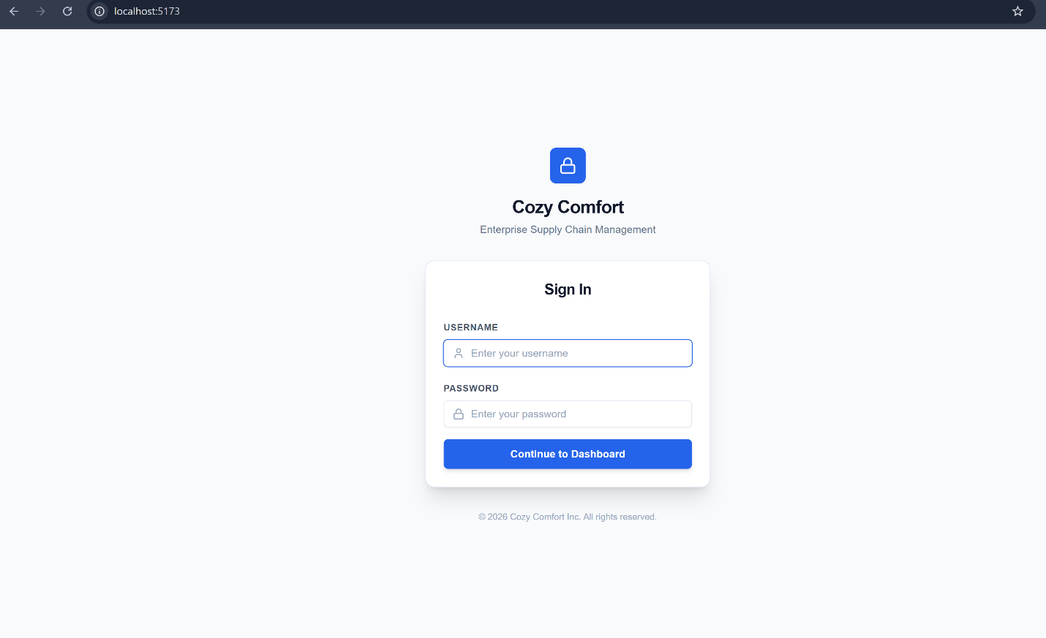  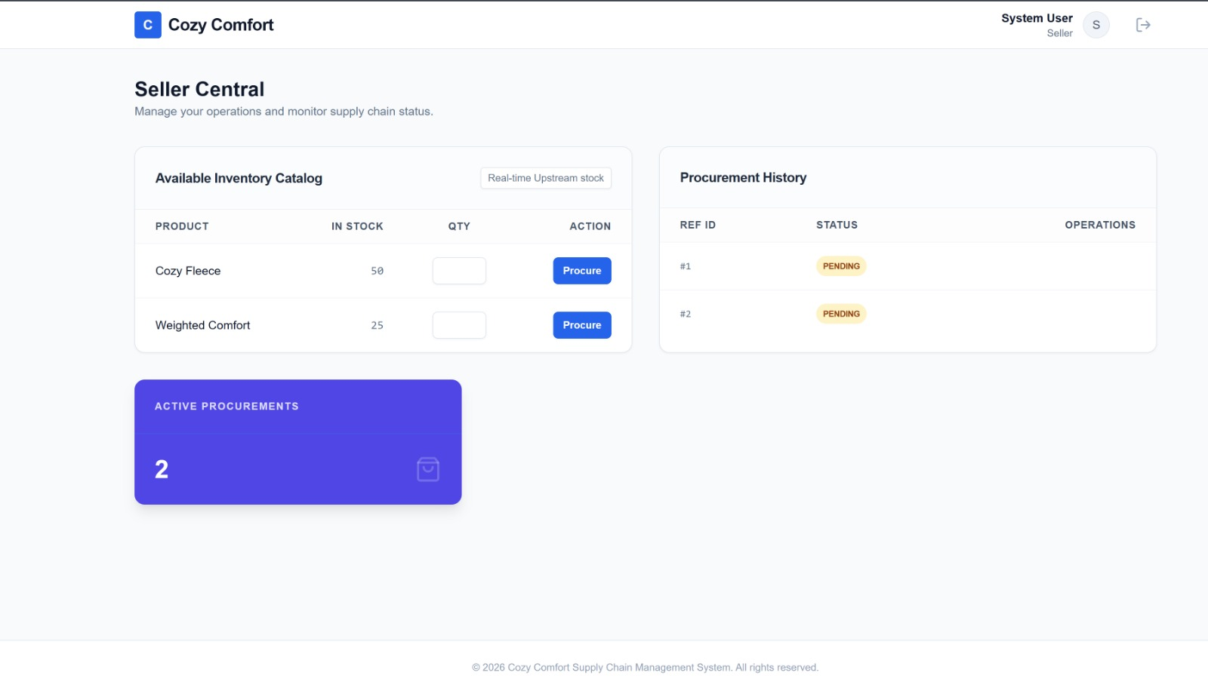
Conclusion | Function works properly

