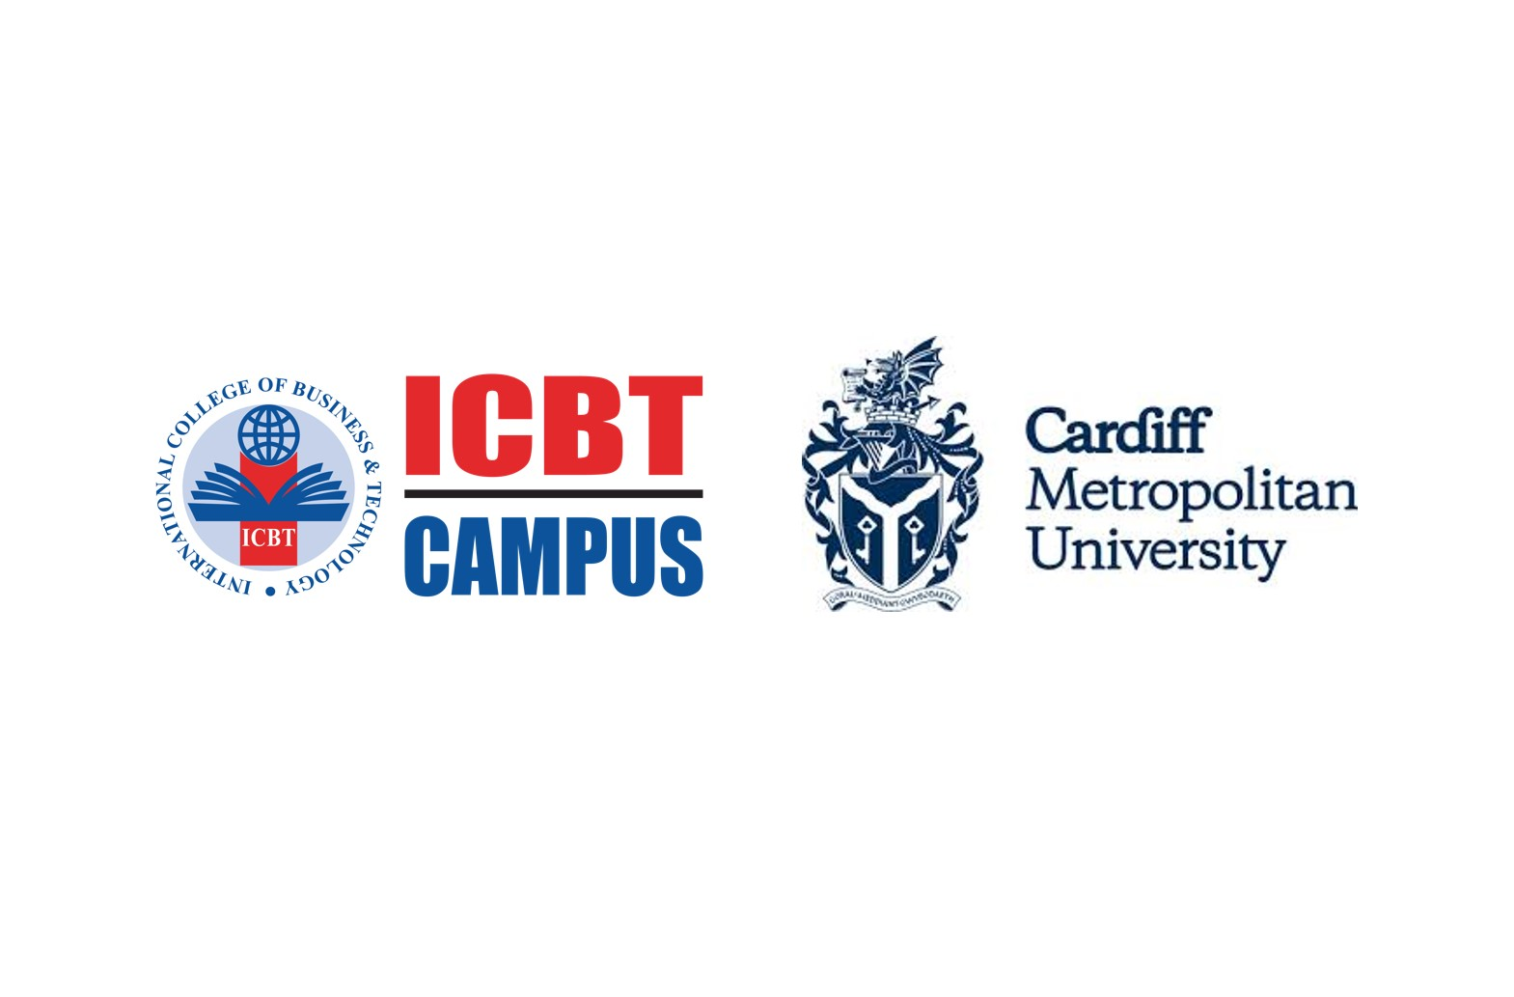
Qualification |  | Module Number and Title
HD in Computing and Software Engineering |  | CSE 5012  Project Management
Student Name & No. |  | Assessor
K.D Senira Dahamsath Kumarasiri  CL/HDCSE/CMU/127/03  CL/HDCSE/CMU/127/09- D. Pasindu Gimhana Gunasekara  CL/HDCSE/CMU/127/22- Sinha Abhisheka Bandara Rajapaksha  CL/HDCSE/CMU/127/24- Marooshan Balasree  CL/HDCSE/CMU/127/32 – M.A Chamindu Minusha |  | Ms.Yasiri
Hand over date |  | Submission Date
07– 08 - 2025 |  | 20-10-2025
Assessment type | Duration/Length of Assessment Type | Weighting of Assessment
Coursework | 1500 words | 100%

Learner declaration
We,
K.D Senira Dahamsath Kumarasiri
CL/HDCSE/CMU/127/03
CL/HDCSE/CMU/127/09- D. Pasindu Gimhana Gunasekara
CL/HDCSE/CMU/127/22- Sinha Abhisheka Bandara Rajapaksha
CL/HDCSE/CMU/127/24- Marooshan Balasree
CL/HDCSE/CMU/127/32 – M.A Chamindu Minusha
Certify that the work submitted for this assignment is our own and research sources are fully
acknowledged.

Marks Awarded
First assessor
IV marks
Agreed grade
Signature of the assessor |  | Date

FEEDBACK FORM
INTERNATIONAL COLLEGE OF BUSINESS & TECHNOLOGY

Module: Project Management
Student ID:127/03, 127/09, 127/22, 127/24, 127/32
Assignment: Writ1

Marks Allocated | Task 1  25 | Task 2  (a)  15 | Task 2  (b)  15 | Task 2  (c)  10 | Task 2  (d)  5 | Task 2  (e)  5 | Task 3  25 | Total marks  100
Marks Awarded

Task | Feedback
1
2
3
General Comment
Assessor Name |  | Signature | Date

