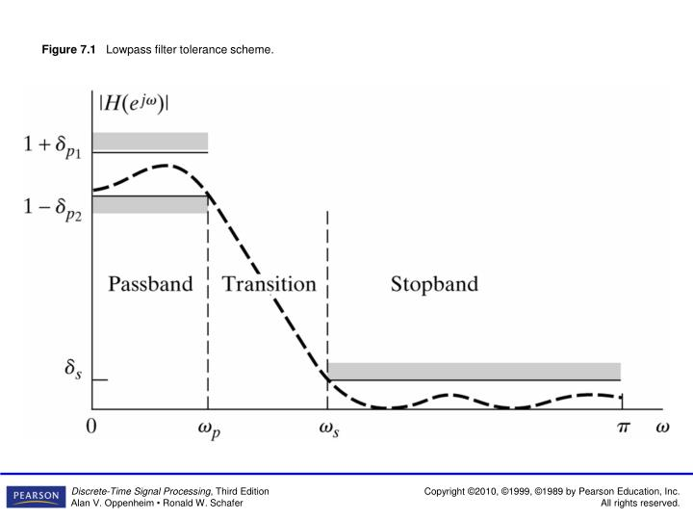

$$1+δ_{p_{1}}$$

$$1-δ_{p_{1}}$$

$$δ_{s}$$

$$0$$

$$\left|H(e^{jω})\right|$$

Transition band

Passband

Transition band

Stop band

Stop band

$${ω_{s}}_{L}$$

$${ω_{p}}_{L}$$

$${ω_{p}}_{U}$$

$${ω_{s}}_{U}$$