Intrinsic Fisher-Rao Curvature of Transformer Representations: Curvature Carries Learned Structure, the Spectrum Carries Entropy

Abstract— This article computes the intrinsic Riemannian curvature of the Fisher–Rao metric pulled back onto the hidden states of transformer language models, and establishes what that curvature measures. The pullback metric has been derived before and used for activation steering, but the curvature tensor itself has not been formed for a transformer: existing geometric readings either measure curvature under a flat Euclidean metric or substitute a local-PCA residual for it. Christoffel symbols, the Riemann tensor, and sectional and scalar curvature are computed here directly, on a subspace obtained by quotienting out the exact null directions of the normalization layer. Across four architectures and 456 sampled states the median sectional curvature lies between +0.2548 and +0.2738, a spread of 0.019 about the ambient simplex value of +1/4. The principal finding is a separation between geometric quantities. A paired scramble that destroys the learned token-to-direction assignment, while holding the predictive distribution, the conditioning and the retained direction set exactly fixed, collapses sectional curvature from 0.2546 to 0.0109 (201 of 221 states, sign test z = +12.18), yet reproduces the layer-wise log-volume profile at Spearman rho = +0.957 and the effective-dimension profile at rho = +0.991 over 360 states, with the same minimum layer in each case. Quantities derived from the metric's spectrum therefore track predictive concentration, while curvature tracks the learned assignment. A seven-rung validation ladder, a Kullback–Leibler Hessian identity, and agreement with an independent information-geometry library support the measurements.
Index Terms— information geometry, Fisher–Rao metric, Riemannian curvature, transformer representations, interpretability, intrinsic dimension

Introduction
The hidden state of a transformer language model [1] is ordinarily treated as a point in flat Euclidean space. Distances are cosine or L2, directions are compared by inner product, and the geometry of the space is taken to be the geometry of the coordinates in which it happens to be written. That is a modelling choice, and a different one is available. A transformer with hidden state h and unembedding matrix U defines a distribution over the next token, p(h) = softmax(U · norm(h)). The map h → p(h) carries hidden states into the interior of the vocabulary simplex, which is a statistical manifold. On such a manifold one Riemannian metric is distinguished: Čencov's theorem [2] establishes that the Fisher information metric is, up to scale, the only metric on a space of probability distributions invariant under sufficient statistics [3]. Pulling it back through h → p(h) yields a metric on hidden-state space derived from the model's own predictive behavior rather than imposed by the coordinate system. The pullback itself is established, and has been used both to steer activations and to analyze the scaling of sparse autoencoders. What has not been done is the step after it. A metric supplies lengths, angles and volumes; curvature requires the second derivatives of the metric, and it is curvature, not the metric, that distinguishes a manifold which is intrinsically bent from one merely written in curvilinear coordinates.
Section II sets out what has been measured to date, and the gap it leaves is precise: the pullback metric has been derived, and layer-wise curvature has been measured under flat metrics, but the intrinsic Riemannian curvature of the state-dependent Fisher–Rao metric Christoffel symbols through Riemann tensor to sectional and scalar curvature has not been computed for a transformer at any scale or any layer. This article computes it, and then asks the more useful question: once computed, what does curvature measure that cheaper quantities do not? Three quantities are put through a single control. Two of them the log volume element and the effective dimension of the metric are reproduced almost exactly when all learned structure is destroyed. Sectional curvature is not. The article makes three contributions. (i) It computes the intrinsic Riemannian curvature of the Fisher–Rao pullback metric on transformer hidden states, validated on a seven-rung ladder of manifolds with analytically known curvature and measured at +1/4 across four architectures. (ii) It establishes a separation result, in which one paired control divides three geometric quantities into those that read predictive concentration and the one that reads learned structure; the division is prescriptive, since it identifies which geometric quantities repay the cost of computing. (iii) It calibrates the near-flat reading already in the literature, by showing that the estimator producing 10⁻⁵ reports, at the threshold that produces that value, a unit 3-sphere as flat to 10⁻³¹.

Related Work
The pullback of the Fisher–Rao metric onto hidden-state space has been derived before and put to work: it has been applied to activation steering [4] and to the analysis of sparse autoencoder scaling [5]. Both stop at the metric itself; neither forms its curvature. Existing geometric readings of transformers stop short of the curvature step in one of two ways. (i) Curvature is measured under a flat metric, as in a Frenet-style curvature of residual-stream trajectories [6] and an angular curvature between successive difference vectors [7]. Both report that curvature varies with semantic content and predictive uncertainty, which is good evidence that geometry carries signal; but both compute the quantity in Euclidean coordinates, so what varies is a property of the coordinate chart together with the trajectory rather than an invariant of a manifold. (ii) A local-PCA residual on the ambient activation cloud is reported as a curvature of order 10⁻⁵ and read as near-flatness [8]. Section VI.G returns to that reading with the same estimator. Intrinsic Riemannian curvature has been computed for neural representations under a data-induced metric [9], which establishes that the machinery is tractable, but the metric there is not Fisher–Rao and the models are not transformers. Outside the curvature literature, a parallel line of work measures intrinsic dimension across depth and reports a characteristic profile with a minimum roughly one third of the way through the network [10], usually estimated by a nearest-neighbor method [11] and more recently given a manifold-theoretic account [12]. Section VI.B shows that the analogous profile under the Fisher–Rao metric is reproduced almost exactly by a control containing no learned structure, which raises a testable question for that literature.

Methodology

The pullback
Write norm for the model's final normalization layer and A(h) for its Jacobian. With J = U · A(h) and p = p(h), the Fisher information metric on the simplex pulls back to
G(h) = Jᵀ (diag(p) − p pᵀ) J. (1)
This is a d × d matrix, available in closed form and inexpensive to evaluate. It is distinct from the parameter-space Fisher matrix used in second-order optimization [13], which is intractable at this scale. Equation (1) is the metric of the model's output distribution expressed in the coordinates of its hidden state, and every quantity in this article derives from it. G(h) is the Hessian of the Kullback–Leibler divergence at zero displacement, which supplies a falsification test independent of how (1) is implemented:
KL(p(h) ‖ p(h + εv)) = ½ ε² vᵀ G(h) v + O(ε³). (2)
Two evaluation choices matter here. The sum in (1) is taken over the 512 tokens of highest probability, renormalized, rather than over the whole vocabulary; measured on SmolLM2-135M against its full 49 152 tokens, the relative error of the truncated metric is 3.2 × 10⁻³ at 500 retained tokens and 8.8 × 10⁻⁴ at 2000. That index set is then frozen at the base point before any derivative is taken. Were it re-selected at each evaluation, membership would change discretely as h moves, G(h) would be only piecewise smooth, and its second derivatives meaningless.

Exact null directions
- NULL-DIRECTION FALSIFICATION TEST
model | norm | null dirs (exp.) | KL along null | KL along random
SmolLM2-135M | RMSNorm | 1 (1) | 2.8 × 10⁻¹⁵ | 3.76
LLaMA-160M | RMSNorm | 1 (1) | 3.8 × 10⁻¹⁶ | 2.96
Pythia-70M | LayerNorm | 2 (2) | 1.6 × 10⁻¹³ | 13.41
Pythia-160M | LayerNorm | 2 (2) | 2.0 × 10⁻¹³ | 7.79
GPT-2 | LayerNorm | 2 (2) | 1.2 × 10⁻¹⁵ | 3.70
GPT-Neo-125M | LayerNorm | 2 (2) | 9.7 × 10⁻¹⁶ | 32.31

Both normalization layers annihilate directions exactly. RMSNorm [14] has Jacobian A = diag(g)(1/r)(I − ĥĥᵀ) and one null direction, h itself. LayerNorm [15] additionally subtracts the mean and so annihilates two: the radial direction and the all-ones direction. G(h) is therefore singular by construction, with rank at most d − 1 or d − 2. Suppressing this with a pseudo-inverse would return a plausible wrong answer. The null space is instead quotiented explicitly: with N an orthonormal basis of the null directions and P = I − N Nᵀ, curvature is computed on the span of the top-k eigenvectors of P G P. This construction is falsifiable, and Table I reports the test. On every architecture examined the number of null directions found matches the theoretical prediction, and the model's prediction is unmoved along them: stepping by ‖h‖, which doubles the hidden state, changes the output distribution by a Kullback–Leibler divergence of 10⁻¹³ or less, while a random step of identical size changes it by 3 to 32 nats a separation of thirteen to sixteen orders of magnitude. The directions the metric calls null are exactly the directions the model cannot see, which establishes that the metric measured is the model's own.

Curvature and the working subspace
On the retained k-dimensional subspace, Christoffel symbols and the Riemann tensor are formed by nested reverse-mode differentiation of (1), and the sectional curvature of the plane spanned by u, v follows in the standard way [16]. All differentiation is reverse-mode automatic differentiation in double precision [17]. The cost of the Riemann tensor grows by a factor of about 2.7 per unit increase in k, which places a hard ceiling at k ≤ 8 on the hardware used. All curvature results below are computed at k = 4, 5 and 6, with k = 5 as the default, and the retained subspace holds a median 96 % of the quotiented metric's trace at k = 5 (mean 91 %, measured over 60 states). The reported curvature is accordingly that of a k-dimensional slice under the induced metric, and the stability of the central result across the accessible range of k is reported explicitly in Section VI.B. In absolute terms the cost is modest at the working dimension and rises steeply beyond it: a full sectional-curvature evaluation takes about 2.6 s per state at k = 5 and about 46 s at k = 8, which is why the sweep is reported at k = 4 to 6. The metric itself, being closed-form, is negligible by comparison; the expense is entirely in the second derivatives. This matters for the recommendation in Section VII, since it is precisely the expensive quantity that turns out to carry the signal. Sectional curvature is a property of a 2-plane rather than of a point, so the value reported at a state is the median over 16 random 2-planes drawn in the retained subspace, with 32 planes where the tail of that distribution is the quantity of interest.

Models and data
Measurements are taken on GPT-2 [18], Pythia-70M and Pythia-160M [19], LLaMA-160M and SmolLM2-135M, spanning both normalization schemes, tied and untied embeddings, depths from 6 to 30 layers and widths from 512 to 768. Text is drawn from WikiText-2 [20] and from hand-written probe sentences; the sense-disambiguation probe of Section VI.F follows the design of the word-in-context task [21]. States are sampled at nine relative depths in each network and at token positions drawn uniformly from the corpus sentences. The cross-architecture sweep of Section VI.A gives 101 to 130 states per model and 456 in all; the paired control of Section VI.B is applied at 221 states for curvature and, for the two spectral quantities, at 40 states in each of nine layers, giving 360.

Validation
Intrinsic curvature is expensive, silent when wrong, and plausible either way. Validation therefore precedes results and is reported in full.

The ladder
Seven manifolds with analytically known curvature are run through the same code path used for the transformer. Table II reports the outcome. Errors are worst-case over twelve random base points and random 2-planes per rung. Rungs 4 and 5 have no closed-form constant, so the starred entries are worst-case disagreement with the independent library of Section IV.B rather than with an analytic value; the claim tested for those two families is that the curvature is everywhere negative, and it is. Rung 3 is load-bearing: the categorical simplex under the full Fisher–Rao metric is isometric to the positive orthant of a radius-2 sphere and so has constant K = +1/4. It is the same metric family as the object under study. Rung 7 validates the assembly of (1) specifically, which no other rung does. With a synthetic linear model p(h) = softmax(U h) and d = N − 1, the map h → p is a diffeomorphism onto the simplex interior, so the pullback metric is the simplex metric in different coordinates and the curvature must be exactly +1/4 for every valid U. Three further checks accompany it: reparameterization invariance under U → UM, to which curvature must be blind (worst error 1.9 × 10⁻¹¹); scalar curvature R = k(k−1)/4 recovered through the pullback (4.9 × 10⁻¹²); and a deliberately broken assembly, with the outer-product term of (1) dropped, which must fail and does, at 0.263. A test that cannot fail carries no information.
- VALIDATION LADDER
rung | manifold | expected | measured | worst error
1 | Sphere, radius 2 | K = +1/4 | +0.250000 | 1.8 × 10⁻¹⁵
2 | Poincaré half-plane | K = −1 | −1.000000 | 1.0 × 10⁻¹³
3 | Categorical simplex | K = +1/4 | +0.250000 | 6.6 × 10⁻¹⁰
4 | Gamma family | negative | −0.463903 | 2.3 × 10⁻¹³ *
5 | Beta family | negative | −0.456795 | 4.9 × 10⁻¹⁴ *
6 | Univariate Gaussian | K = −1/2 | −0.500000 | 2.6 × 10⁻¹⁵
7 | Synthetic pullback | K = +1/4 | +0.250000 | 9.7 × 10⁻¹²

The Hessian identity and an independent implementation
Equation (2) was verified on a real model through a separate code path. Sweeping ε produces the expected plateau at relative error 8.7 × 10⁻⁶, confirming that the assembled G(h) is the Hessian of the model's own divergence rather than an unrelated quadratic form. Rungs 2 to 6 were additionally re-run against the information_geometry module of an independently implemented, peer-reviewed library [22] on identical inputs. Three families agree at machine precision across eight comparisons: univariate normal to 2.2 × 10⁻¹⁶, gamma to 2.3 × 10⁻¹³ and beta to 4.9 × 10⁻¹⁴ at worst, the last two being exactly the rungs added for this cross-check. On the two families where the libraries differ, the diagnostic applied was to compare the metrics rather than the curvatures: in both cases the metrics agree exactly, to 1 × 10⁻¹² and 7 × 10⁻¹⁵, so the difference is localized to a curvature routine rather than a parameterization convention. The +1/4 reported here is independently corroborated three ways — by the analytic radius-2 sphere isometry, by rung 3, and by rung 7's separate code path — and the remaining discrepancy is recorded as open.

Experimental Control
The central result rests on one control, so its construction is given precisely. Let idx be the indices of the vocabulary rows retained at a given state. The paired within-set scramble replaces idx by idx[randperm(len(idx))]: the same rows are used, permuted in their assignment to probabilities. Four quantities are thereby held fixed exactly, namely (i) the predictive distribution p, and therefore the entropy, to machine precision, (ii) the multiset of retained unembedding rows, and therefore their norms and their spectrum, (iii) the conditioning of the retained subspace, and (iv) the working dimension k. What it destroys is only which probability sits on which direction the learned assignment. Because the comparison is paired at the same state, and every confound is held fixed by construction rather than by matching, any surviving difference is attributable to that assignment alone.

Results

Curvature sits at the simplex value across architectures
Fig. 1 shows sectional curvature at 456 sampled states across four architectures. Median values are +0.2599 for GPT-2, +0.2738 for Pythia-160M, +0.2559 for LLaMA-160M and +0.2548 for SmolLM2-135M a spread of 0.019 across models differing in normalization scheme, embedding tying, depth and width. The representation manifold under this metric is strongly positively curved, at the ambient simplex value, and consistently so across architecture. This is a direct measurement of the quantity, and it is a large number: the manifold is about as curved as the simplex it predicts into. The deviation from exactly +1/4 is not advanced as a model-specific signal. It varies with k and its layer ranking does not survive resampling, so the informative quantity is not the absolute magnitude but the response to the control that follows.
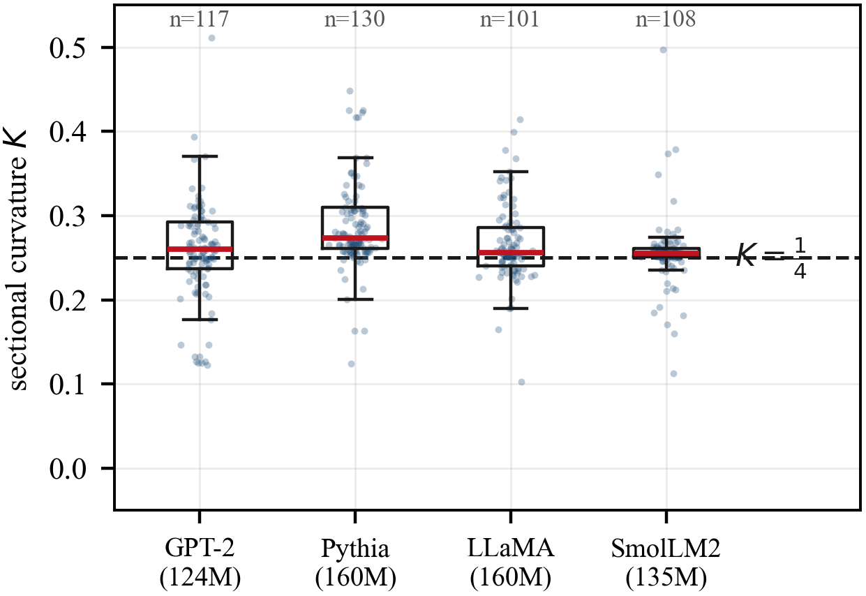
- Sectional curvature across four architectures. Dashed line, +1/4; boxes, quartiles; bars, medians.

The separation
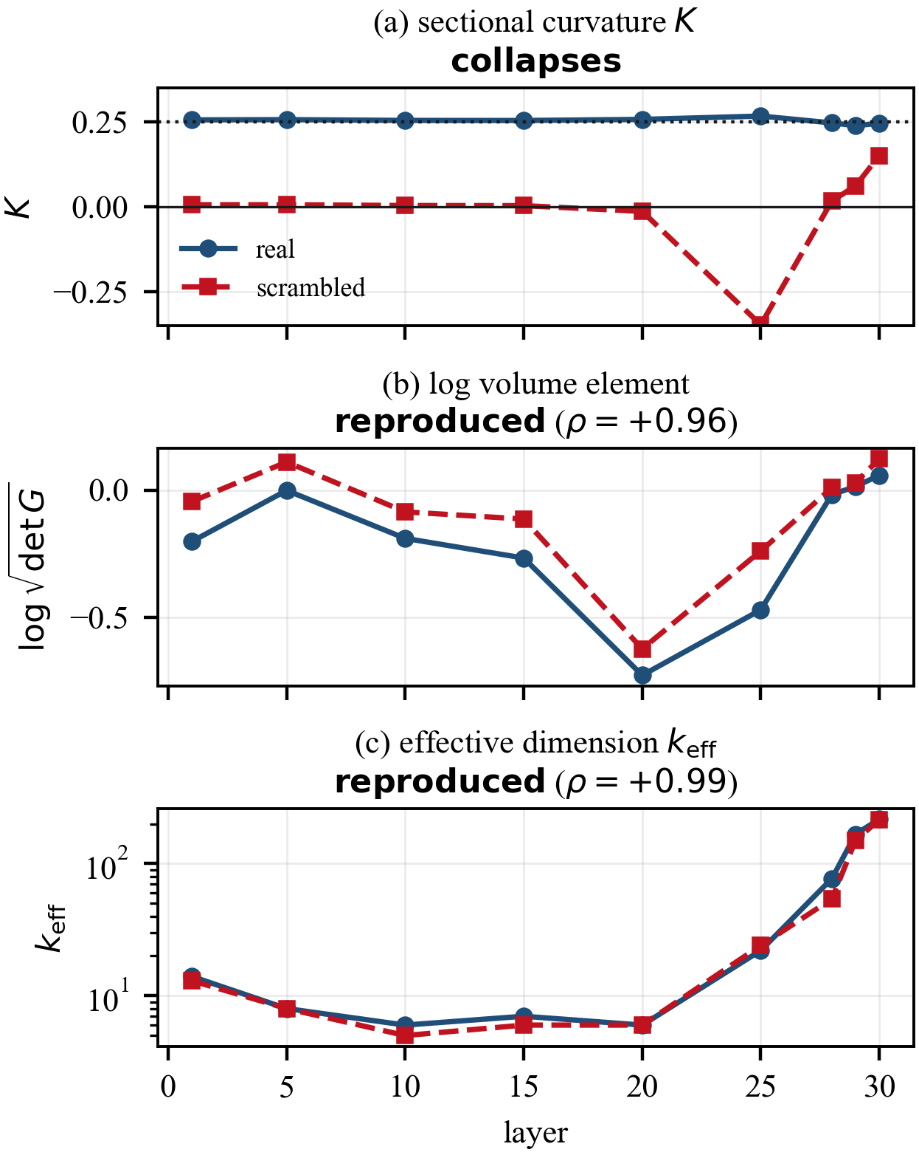
- (a) sectional curvature, (b) log volume element, (c) effective dimension, across depth. Solid, real; dashed, scrambled.
Fig. 2 presents the central result: one control, three quantities, two outcomes. Table III gives the numbers. Sectional curvature falls from a median of 0.2546 to 0.0109 and retains 4 % of its value, while the log volume element is reproduced at rho = +0.957 and the effective dimension at rho = +0.991, retaining 96 % and 99 % respectively. Throughout, rho is a Spearman rank correlation across states, and z is a normal-approximation test statistic, from a paired sign test except where another test is named. The curvature collapse runs in the same direction at 201 of 221 states, z = +12.18, and it is stable across the accessible range of k: at k = 4 the median falls from 0.2543 to 0.0137 (63 of 69, z = +6.86), and at k = 6 from 0.2532 to 0.0512 (58 of 69, z = +5.66). This is the one Riemann-derived quantity in this work that is insensitive to the choice of k, which is precisely what makes it usable. The two spectral quantities behave in the opposite way. The scrambled log-volume profile places its minimum at the same layer as the real one, and the scrambled effective-dimension profile does likewise, retaining 99.5 % of the real profile's range. Table IV gives that profile in full.
- ONE CONTROL, THREE QUANTITIES
quantity | real | scrambled | retained
sectional curvature K (n = 221) | 0.2546 | 0.0109 | 4 %
log volume element (n = 360) | rho = 1 by definition | rho = +0.957 | 96 %
effective dimension (n = 360) | rho = 1 by definition | rho = +0.991 | 99 %

- EFFECTIVE DIMENSION BY LAYER, REAL AND SCRAMBLED
layer | 1 | 5 | 10 | 15 | 20 | 25 | 28 | 29 | 30
real | 14 | 8 | 6 | 7 | 6 | 22 | 77 | 167 | 217
scrambled | 13 | 8 | 5 | 6 | 6 | 24 | 54 | 150 | 215

The characteristic dip near one third of the way through the network the "hourglass" is present in both rows, at the same layer, with the same range. A control containing no learned structure at all reproduces it. The interpretation is direct. Quantities computed from the spectrum of G(h) its determinant, its eigenvalue decay are recovered by a structure-free control at matched entropy, so they largely restate the predictive concentration profile. Curvature requires the second derivatives of the metric, and it is the quantity that responds to the assignment.

Where in the network the assignment does its work
The collapse is not uniform across depth. Table V gives the fraction of the real curvature that survives the control at each layer, with the paired sign count.

- CURVATURE RETAINED UNDER THE CONTROL, BY LAYER
layer | 1 | 5 | 10 | 15 | 20 | 25 | 28 | 29 | 30
retained | 2.3 % | 2.3 % | 1.5 % | 1.7 % | −5.3 % | −95.5 % | 7.0 % | 25.8 % | 61.4 %
sign | 19/21 | 17/17 | 22/25 | 23/24 | 28/29 | 20/20 | 20/23 | 30/35 | 22/27

The learned assignment does nearly all of the work through the first two thirds of the network: under 3 % of the curvature survives its destruction at every layer up to 15, and at layers 20 and 25 the scrambled value is driven negative outright. It does least at the two ends. That pattern matches what the two ends are doing: at layer 1 the context has barely been integrated, so there is less learned assignment to destroy, while by layer 30 the prediction is close to committed and concentration alone fixes much of the geometry. The direction of the effect is unanimous or near-unanimous at every layer, so the depth dependence is one of magnitude rather than of sign.

The assignment stabilises curvature, it does not merely add it
Resolving the same 221 states by predictive entropy sharpens the finding considerably. Table VI reports both conditions across five entropy bands.
- CURVATURE BY PREDICTIVE ENTROPY
entropy (nats) | n | real | scrambled | sign
[0, 0.5) | 38 | 0.2750 | −1.2756 | 35/38
[0.5, 1) | 37 | 0.2587 | −0.1165 | 36/37
[1, 2) | 68 | 0.2555 | +0.0110 | 66/68
[2, 4) | 36 | 0.2528 | +0.1310 | 31/36
[4, ∞) | 42 | 0.2064 | +0.1238 | 33/42

The real curvature is close to constant across the full range: from a near-deterministic prediction to a highly diffuse one, the median moves only from 0.275 to 0.206, staying at the simplex value throughout. The scrambled curvature does nothing of the kind it swings across roughly 1.4 units, from strongly negative where the prediction is concentrated to mildly positive where it is diffuse. This is the most informative single comparison in the study. The learned assignment does not simply contribute curvature on top of whatever concentration provides; it holds the manifold at the ambient simplex value irrespective of how concentrated the prediction is. Concentration alone produces a geometry that varies wildly with predictive entropy, and the trained assignment removes that dependence. The effect is strongest where it should be if this reading is correct in the low-entropy bands, 35 of 38 and 36 of 37 because a concentrated p gives the assignment the most to encode.

The instruments measure different things
If the intrinsic curvature and the published proxies were reading the same underlying property, they would correlate. Computed at 360 sampled states, pairwise complete, they do not: the largest absolute rank correlation between any two different instrument families is 0.248, and the pairs involving intrinsic curvature fall at or below 0.144. By contrast the two intrinsic quantities computed here, sectional K and scalar R, correlate with each other at +0.69 to +0.74. That is what internal consistency looks like, and the cross-family pairs do not exhibit it. Corpus stability discriminates further. Moving from hand-written probe sentences to WikiText-2 across 653 states, the intrinsic instrument's correlation with predictive entropy moves by 0.028 for sectional curvature and 0.034 for scalar curvature, while the three proxies move by 0.104, 0.126 and 0.194 respectively, the last of them changing sign. The intrinsic instrument returns essentially the same reading on both corpora; the proxies do not. An instrument whose reading depends this strongly on the text it is given is measuring a property of the text.

A behavioural probe
If the metric tracks the model's predictive state, distance under it should respond to a change in word sense. On 32 polysemous words, each compared against a same-sense control built to an identical syntactic frame, the two arms are matched for lexical overlap 0.250 for the sense-change arm against 0.235 for the same-sense arm so the sense arm is not simply the more lexically distant one. Table VII reports three metrics on the same pairs. The Fisher–Rao geodesic distance separates a sense change from a matched context change by a factor of 2.03 at 30 of 32 pairs, and considerably more reliably than the unembedding metric used in the comparison literature, which reaches 1.71× at 23 of 32. On this probe a plain Euclidean distance performs comparably to Fisher–Rao. The probe therefore establishes that the metric is behaviorally meaningful; separating it from Euclidean distance requires the causal experiment named in Section VII
- SENSE CHANGE VERSUS MATCHED SAME-SENSE CONTROL
metric | same sense | sense change | ratio | sign | z
Fisher–Rao geodesic | 0.754 | 1.532 | 2.03× | 30/32 | +4.95
Euclidean | 260.0 | 552.5 | 2.13× | 32/32 | +5.66
Unembedding UᵀU | 10459 | 17838 | 1.71× | 23/32 | +2.47

Magnitude is not the only axis. Half-separation depth is the first layer at which a pair reaches half of its final separation; over 64 hand-written different-sense pairs the Fisher–Rao distance places it at layer 4.5 while the Euclidean and unembedding distances place it at 26.6 and 26.3. The paired gap against the unembedding metric is 21.8 layers, 95 % bootstrap interval [20.5, 22.9], with Fisher–Rao earlier in 64 of 64 pairs. It reproduces on the 163 different-sense pairs of the word-in-context set whose target is the same token in both sentences, at 6.7 against 26.6 for both flat measures. The mechanism is scale invariance rather than Fisher–Rao specifically: dividing the Euclidean distance by the residual norm at each layer moves its half-depth from 26.6 to 5.2. Fisher–Rao gets that invariance by construction, from the null direction of Section III.B.

A near-zero reading is not evidence of flatness
The published value of order 10⁻⁵ reproduces exactly, and Fig. 3(a) shows it: with a tight retained-variance threshold the local-PCA residual on GPT-2 falls below 10⁻⁵ and continues falling until it underflows. What that number licenses is a separate question.Fig. 3(b) applies the same estimator, at the same thresholds, to a unit 3-sphere embedded in 12 dimensions a manifold whose sectional curvature is exactly +1 everywhere and to a flat 3-plane, whose curvature is exactly 0. At loose thresholds the estimator separates them cleanly. At the threshold that produces the published value it does not: the sphere's residual falls to order 10⁻³¹, numerically indistinguishable from the plane's exact zero. An estimator that reports a unit sphere as flat to 10⁻³¹ cannot support the inference from "the residual is 10⁻⁵" to "the manifold is flat"; the residual is a function of the threshold at least as much as of the geometry. Measured intrinsically, the same states give K ≈ +1/4. The original observation replicates exactly; the reading that follows from it is that the representation manifold is strongly curved, and that the apparent flatness is a property of the estimator's operating point.
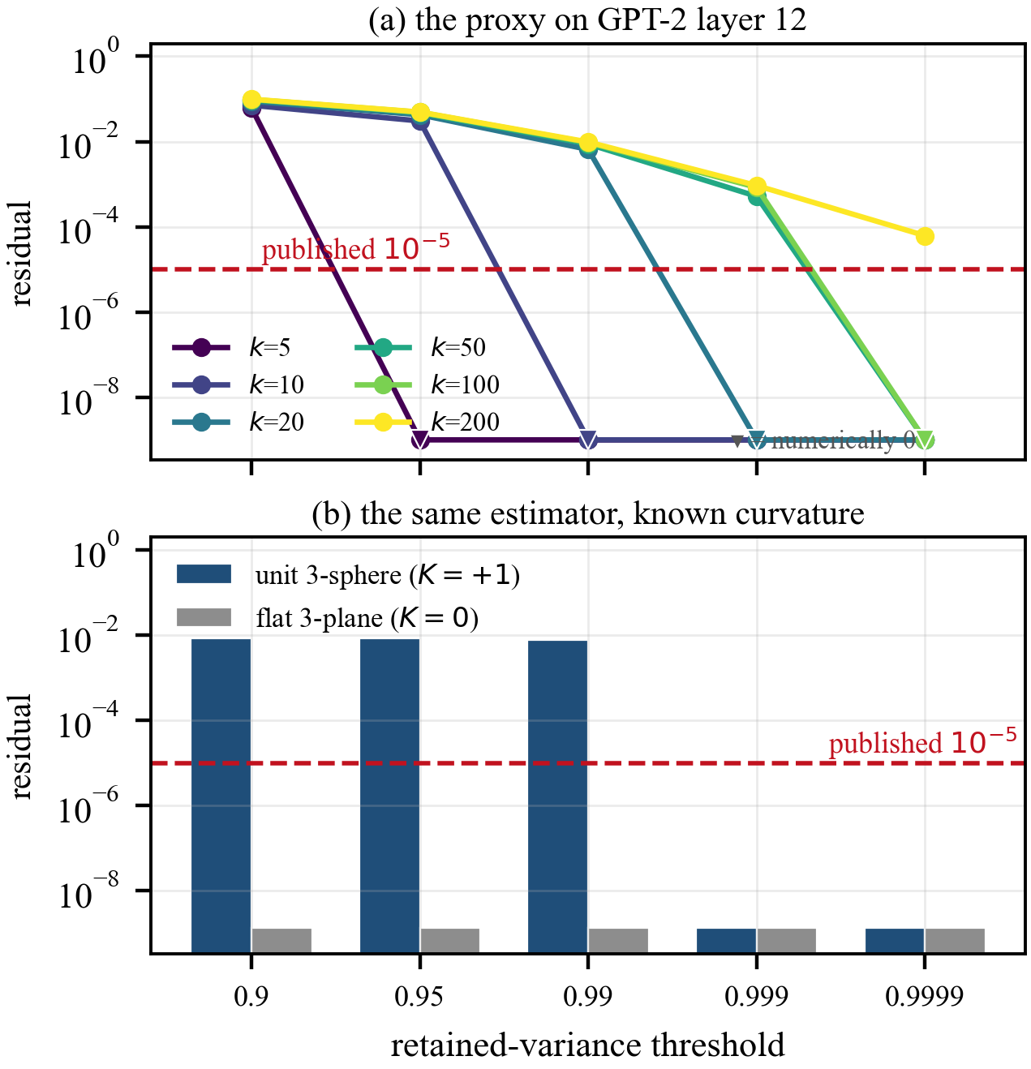
- (a) The local-PCA residual on GPT-2 layer 12 against its retained-variance threshold, several neighbourhood sizes. (b) The same estimator on manifolds of known curvature; bars at the axis floor are numerically zero.

A causal probe, and where it stops
Equation (2) has one further use. If two directions are scaled to the same Fisher norm, vᵀG(h)v = 1, the metric predicts the same change in the output distribution along both to leading order, so any systematic difference at a larger step is beyond what the metric alone encodes, and is where curvature has room to act. The prediction tested is that directions of high Ricci curvature, taken from the generalized eigenproblem Ric v = λ G v, leave the quadratic sooner than directions of low Ricci curvature. Over 14 runs on six models at k = 4 to 6, a paired sign test at a unit Fisher step supports it on both GPT-NeoX models at every k tested, at z = +4.75, +4.54 and +3.86 on Pythia-160M and +3.65 on Pythia-70M, while the other four models are k-dependent or at chance. The same 14 runs confirm the null-direction prediction of Table I without exception. What separates the two groups of models is not established here, and the result is reported as a hypothesis.

Discussion
Three findings stand, in decreasing firmness. First, the representation manifold is strongly positively curved, at the ambient simplex value: four models agree to within 0.019 across both normalization schemes and embedding regimes; Section VI.G accounts for the earlier near-flat reading without contradicting it. Second, only curvature reads the model while the spectrum reads concentration: under one control, sectional curvature collapses to 4 % while log-volume and effective dimension are reproduced at rho = +0.957 and +0.991. It is the most useful result because it is actionable: it says which quantities are worth computing, from a control rather than an argument. It also puts a testable question to the intrinsic-dimension literature, the characteristic depth profile being reproduced by a structure-free control at matched entropy, so applying it to an ambient nearest-neighbor estimate would test whether the published profile has the same character. Third, the metric is demonstrably the model's own: its null directions are ones the model is exactly invariant to, on six architectures, at a step that doubles the hidden state, so curvature is measured on the model's predictive geometry, not a quadratic form fitted to activations, and Equation (2) confirms this through an independent code path. Future work follows from the separation: the decisive experiment is causal, perturbing a state along its high-curvature directions at the layer where a sense resolves, testing whether it flips. A second line is the minority carrying a negatively curved plane, modest but real: 49 of 456, 10.7 %, median effective dimension twice the rest, 248 against 122 (Mann–Whitney area under the curve 0.618, z = +2.69), while neither entropy, 1.91 against 1.95 nats, nor conditioning separates them (z = −0.45, −1.39); the one place where absolute curvature, rather than its response to a control, appears to carry model-specific information. Several claims were revised as samples grew and controls tightened, each caught by a purpose-built check, so a result at one sample size, one k, or one control is a hypothesis until it survives the second; the separation of Section VI.B survives all three.

Limitations
Five limitations bound what has been established here. (i) Scale: the models examined range from 70M to 160M parameters, and nothing reported here rules out the geometry changing at 1B parameters and above. (ii) The k ≤ 8 ceiling: Riemann-derived quantities are computed on a slice of dimension 4 to 6, holding a median 92 % to 97 % of the metric's trace, and although the central result is stable across that range, the slice remains a slice. (iii) Cell sizes: pooled samples run from 221 to 653 states, per-layer cells are smaller than that, and the pooled figures are accordingly the ones to rely on. (iv) Corpora: two were used, both of them English edited prose. (v) One validation arm remains open, in that the independent library agrees on three Fisher–Rao families and differs on two, with the metrics themselves agreeing exactly in both of the differing cases, as reported in Section IV.B.

Conclusion and Future Work
The intrinsic Riemannian curvature of the Fisher–Rao pullback metric on transformer hidden states is computable at practical cost, validates against seven manifolds of known curvature, and sits at the ambient simplex value of +1/4 across four architectures. The representation manifold is not flat; it is about as curved as the simplex it predicts into. The result expected to be most useful is the separation. A single control destroying the learned token-to-direction assignment while holding entropy, conditioning and the direction set exactly fixed collapses sectional curvature from 0.2546 to 0.0109 while reproducing the layer-wise log-volume profile at rho = +0.957 and the effective-dimension profile at rho = +0.991. Stability and informativeness proved to be different axes, pointing in opposite directions: the well-conditioned, k-robust, cheaply computed spectral quantities largely restate the predictive entropy profile, while the more delicate curvature is the quantity carrying learned structure. For anyone choosing a geometric probe of a language model, that is a concrete instruction about where the signal is. Future work divides into three lines. The first is scale: the geometry reported here is measured between 70M and 160M parameters, and the cheapest decisive test is to repeat the four-architecture sweep an order of magnitude above that. The second is the causal line of Section VI.H, whose boundary is unexplained: the curvature ranking predicts behavior on the GPT-NeoX models and not on the rest of the set, and separating family from training corpus from embedding regime requires models chosen to break those pairings. The third is the control this work puts to the intrinsic-dimension literature: applying a matched-entropy scramble to an ambient nearest-neighbor estimate would establish whether the published depth profile is reproduced by structure-free data in the way the Fisher–Rao profile is.

References
- A. Vaswani, N. Shazeer, N. Parmar, J. Uszkoreit, L. Jones, A. N. Gomez, Ł. Kaiser, and I. Polosukhin, "Attention is all you need," in Proc. Adv. Neural Inf. Process. Syst. (NeurIPS), 2017, pp. 5998–6008.
- N. N. Čencov, Statistical Decision Rules and Optimal Inference. Providence, RI, USA: American Mathematical Society, 1982.
- S. Amari and H. Nagaoka, Methods of Information Geometry. Providence, RI, USA: American Mathematical Society, 2000.
- Y. Wang and L. Zhao, "FishBack: Pullback Fisher geometry for optimal activation steering in transformers," arXiv:2605.17231, 2026.
- A. Zaher, M. Trzaskowski, D. Nguyen, and F. Roosta, "The geometric wall: Manifold structure predicts layerwise sparse autoencoder scaling laws," arXiv:2605.09887, 2026.
- R. Manson, "Curved inference: Concern-sensitive geometry in large language model residual streams," arXiv:2507.21107, 2025.
- M. King, E. Fedorenko, and E. A. Hosseini, "Representational curvature modulates behavioral uncertainty in large language models," arXiv:2604.23985, 2026.
- M. A. Mabrok, "Latent semantic manifolds in large language models," arXiv:2603.22301, 2026.
- J. A. Zavatone-Veth, S. Yang, J. A. Rubinfien, and C. Pehlevan, "How does training shape the Riemannian geometry of neural network representations?," arXiv:2301.11375, 2025.
- L. Valeriani, D. Doimo, F. Cuturello, A. Laio, A. Ansuini, and A. Cazzaniga, "The geometry of hidden representations of large transformer models," in Proc. Adv. Neural Inf. Process. Syst. (NeurIPS), 2023.
- E. Facco, M. d'Errico, A. Rodriguez, and A. Laio, "Estimating the intrinsic dimension of datasets by a minimal neighborhood information," Sci. Rep., vol. 7, no. 1, p. 12140, 2017.
- A. Modell, P. Rubin-Delanchy, and N. Whiteley, "The origins of representation manifolds in large language models," arXiv:2505.18235, 2025.
- J. Martens and R. Grosse, "Optimizing neural networks with Kronecker-factored approximate curvature," in Proc. Int. Conf. Mach. Learn. (ICML), 2015, pp. 2408–2417.
- B. Zhang and R. Sennrich, "Root mean square layer normalization," in Proc. Adv. Neural Inf. Process. Syst. (NeurIPS), 2019.
- J. L. Ba, J. R. Kiros, and G. E. Hinton, "Layer normalization," arXiv:1607.06450, 2016.
- M. P. do Carmo, Riemannian Geometry. Boston, MA, USA: Birkhäuser, 1992.
- A. Paszke et al., "PyTorch: An imperative style, high-performance deep learning library," in Proc. Adv. Neural Inf. Process. Syst. (NeurIPS), 2019, pp. 8026–8037.
- A. Radford, J. Wu, R. Child, D. Luan, D. Amodei, and I. Sutskever, "Language models are unsupervised multitask learners," OpenAI Tech. Rep., 2019.
- S. Biderman et al., "Pythia: A suite for analyzing large language models across training and scaling," in Proc. Int. Conf. Mach. Learn. (ICML), 2023, pp. 2397–2430.
- S. Merity, C. Xiong, J. Bradbury, and R. Socher, "Pointer sentinel mixture models," in Proc. Int. Conf. Learn. Represent. (ICLR), 2017.
- M. T. Pilehvar and J. Camacho-Collados, "WiC: The word-in-context dataset for evaluating context-sensitive meaning representations," in Proc. NAACL-HLT, 2019, pp. 1267–1273.
- A. Le Brigant, J. Deschamps, A. Collas, and N. Miolane, "Parametric information geometry with the package Geomstats," ACM Trans. Math. Softw., vol. 49, no. 4, pp. 1–26, 2023.

