A Coupled Human–Machine Digital Twin Framework for Human-Centric and Sustainable Task Allocation in Industry 5.0
Chamini Maduwanthi
[Department]
[Institution]
[City], Sri Lanka
chaminimaduwanthi97@gmail.com

Abstract—This article presents a digital twin framework for production task allocation in which the state of the machine and the state of the operator are modelled together, and in which the physiological limits of the operator are enforced as hard constraints rather than as penalty terms. Industry 5.0 places human well-being alongside sustainability and productivity, yet digital twin research remains asset-centric: operators are represented by static profile attributes rather than by evolving physiological state, and the studies that do quantify operator state use it for monitoring rather than for allocation. Of 46 studies published between 2018 and 2026 reviewed for this work, none couples a quantified human twin, a machine twin and measured sustainability objectives within a single decision framework. The framework proposed here joins the two twins through five explicitly defined bidirectional coupling points. Operator fatigue evolves as an exponential function of metabolic demand, with per-operator bounds obtained from published anthropometric equations, so that protection differs between individuals without being prescribed. Evaluation uses a co-simulation of a five-machine, three-operator machining cell driven by three public benchmark datasets, over 270 runs spanning three allocation policies, three operating scenarios and thirty random seeds. Relative to an Industry 4.0 baseline under high demand, mean operator fatigue falls by 27.0% and energy per unit by 30.8%, all 79.5 constraint breaches per shift are eliminated, and the accompanying change in throughput of 1.8% is not statistically significant.
Keywords—Industry 5.0, human digital twin, sustainable manufacturing, multi-objective scheduling, human-centric design

Introduction
The Industry 5.0 agenda of the European Commission sets human-centricity, sustainability and resilience alongside productivity as the goals of industrial transformation [1]. Where Industry 4.0 concentrated on digitalisation, connectivity and autonomy, Industry 5.0 asks what that capability is for, and answers that it must serve the operator and the environment as well as output [2]. Production scheduling sits directly on that question: every allocation of a task to a person and a machine distributes physical load, energy consumption and quality risk at the same moment [3].
Digital twin technology is the natural instrument for such decisions, because it maintains a live and computable representation of the system being scheduled. In practice that representation has remained asset-centric. Human digital twin frameworks model the operator through biographic attributes, capabilities and preferences rather than through physiological state; in one prominent framework, fatigue modelling and ergonomic assessment are identified by the authors themselves as remaining unaddressed [4]. Others offer architectures without computable human parameters or experimental validation [5]. Recent reviews confirm both the pattern and the terminological fragmentation that accompanies it [6], [7].
A complementary body of work does quantify operator state, but stops short of the decision. Biomechanical fatigue has been detected from joint-angle dynamics with considerable rigour, yet the resulting estimate serves monitoring only and never re-enters task allocation [8]. Ergonomic indices computed inside a human digital twin inform manual decision support rather than automated optimisation [9]. Where operator fatigue does drive scheduling, no machine-side twin exists, so machine health, energy consumption and quality risk cannot participate in the allocation [10]. The most closely related formulations optimise economic, ecological and social objectives together [11], [12], but represent the operator through static per-task multipliers: strain attaches to the operation rather than accumulating in the person, and recovery is a fixed allowance rather than a process.
Of 46 studies published between 2018 and 2026 reviewed for this work — 31 assessed at abstract level or beyond, and the nine most closely related read in full — none couples a quantified human twin, a machine twin and measured sustainability objectives within a single decision framework. This article addresses that gap.
The contributions of this article are threefold:
(i) A layered architecture that couples a machine digital twin to a human digital twin through five explicitly defined bidirectional coupling points, each realised as a named term in a state equation rather than as an abstract interface.
(ii) A quantified human digital twin in which operator fatigue evolves as a physiological state, with per-operator resting expenditure and acceptable work level derived from published anthropometric equations, and in which fatigue, competence and ergonomic risk filter the candidate set before optimisation rather than entering the objective as penalties.
(iii) Empirical evidence from a 270-run co-simulation showing that this reduces mean operator fatigue by 27.0% and energy per unit by 30.8% and removes every constraint breach, at no statistically detectable cost in throughput under high demand.
Section II reviews the relevant literature and positions the contribution. Section III presents the framework. Section IV describes the implementation and the experimental protocol. Section V reports and discusses the results. Sections VI and VII state the limitations and conclude.

Related Work

Industry 5.0 and Human-Centric Manufacturing
Industry 5.0 is defined by three pillars — human-centricity, sustainability and resilience — and is positioned as a values-driven complement to the technology-driven Industry 4.0 rather than as its successor [1], [2]. Surveys of scheduling under this agenda confirm that human and environmental factors are entering formulations that were previously economic alone [3]. Architectural proposals for human-centric collaboration exist [5], but tend to remain conceptual, offering neither computable operator parameters nor experimental validation.

Digital Twins in Manufacturing
The digital twin concept is well established for physical assets, spanning product design, manufacturing and service [13], with recognised value in predictive maintenance and process optimisation [14]. Twins of human–robot collaboration model the workspace and the interaction within it [15], yet the human in that workspace is typically represented geometrically or kinematically rather than physiologically. The operator appears as a user of the twin, not as an entity the twin models.

Human Digital Twins
Dedicated human digital twin research has grown quickly [6], [7]. The requirement that such applications carry a bidirectional flow of information, with data, models and simulations of machines as well as humans, has been stated explicitly [16], but that work presents an architecture without implementation, optimisation or sustainability objectives. Where operator state is quantified, the estimate is used for detection [8] or for decision support [9] rather than for allocation. Assembly-oriented work that invokes sustainability observes the operator unidirectionally, through task duration, and reports no energy or carbon accounting [17].

Sustainable and Multi-Objective Scheduling
Fatigue-conscious scheduling has been formulated as a multi-objective problem and solved with evolutionary methods [10], [18], but without a machine-side twin the allocation cannot reason about equipment health, energy or defect risk. The closest formulations to the present work optimise the three sustainability pillars simultaneously, and extend to dynamic rescheduling under disruption and to carbon accounting [11], [12]. Their treatment of the operator, however, is a static index attached to an operation–machine pair, with rest granted as a fixed proportion of working time. Strain therefore neither accumulates within a shift nor dissipates during rest, and the same worker is modelled identically at the start and at the end of the day.
- TABLE I
POSITIONING AGAINST REPRESENTATIVE STUDIES
Study | Machine twin | Human state quantified | Drives decision | Sustainability measured
Modoni and Sacco [4] | Yes | No | Partly | No
Tóth et al. [5] | No | No | No | No
Löcklin et al. [16] | Stated | No | No | No
Sharotry et al. [8] | No | Yes | No | No
Greco et al. [9] | No | Yes | Partly | No
Crnjac Žižić et al. [17] | Partly | No | Partly | Rhetorical
Tan et al. [10] | No | Yes | Yes | No
Destouet et al. [11], [12] | No | Static index | Yes | Yes
This article | Yes | Yes, dynamic | Yes, as constraint | Yes
- Partly denotes decision support without automated allocation. Static index denotes a per-task multiplier that neither accumulates nor recovers.
The pattern is a field divided in two. Studies that build twins represent the operator statically; studies that quantify the operator omit the twin; and environmental performance is co-optimised with human well-being in neither group. No reviewed study occupies the final row of Table I.

Proposed Framework

Scope and Assumptions
The framework is developed for a machining cell in which arriving jobs must be assigned to an operator and a machine at each decision epoch. Five assumptions bound the model. First, operator fatigue follows a published exponential accumulation and recovery form [19], [20]. Second, competence is constant within a shift, so learning effects are excluded. Third, machine degradation follows the pattern of a benchmark maintenance dataset. Fourth, every operator begins the shift rested. Fifth, processing times are deterministic and sequence-dependent setup is excluded.

Architecture
Fig. 1 shows the layered organisation. A physical layer emits machine and task events; a data layer time-aligns them into state vectors; a digital twin layer maintains the machine twin and the human twin and applies the couplings between them; and a decision layer filters candidate assignments against the human and machine constraints before optimising over whatever survives. A fifth layer, providing explanation and operator override, is specified in the architecture but is not implemented in this study; the results reported below come from the first four layers.
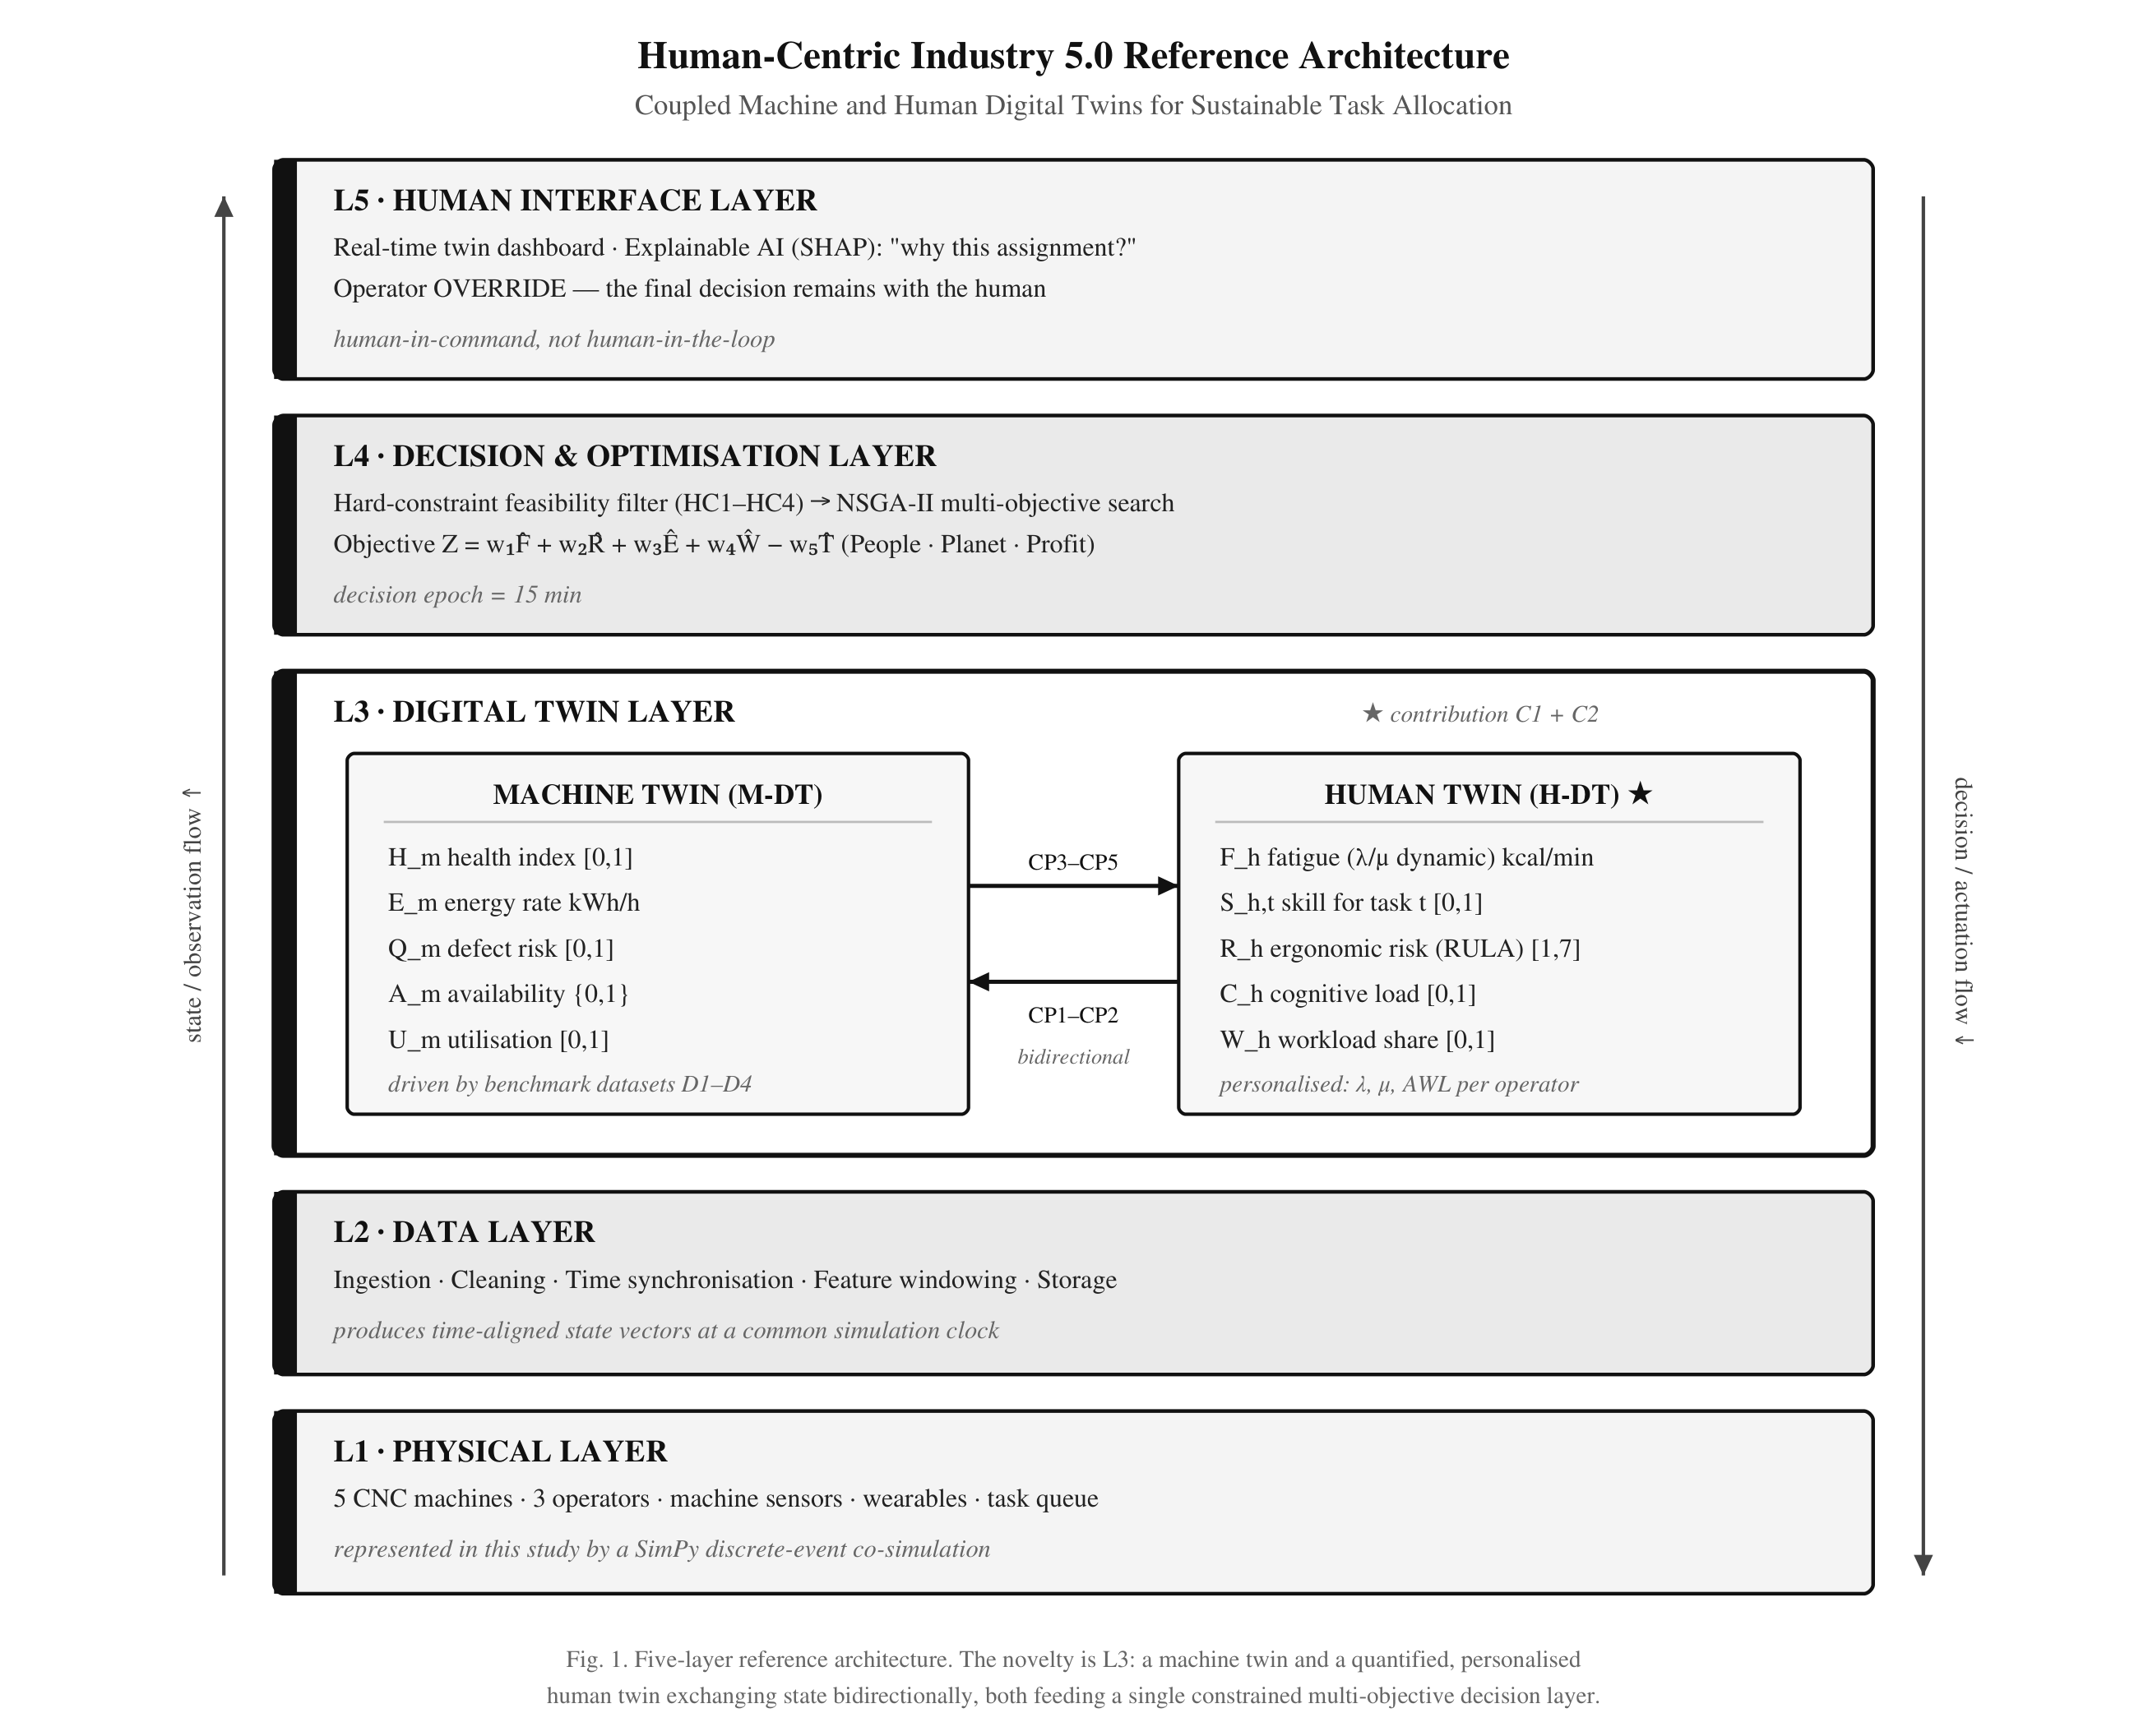
- Fig. 1. Layered organisation of the framework. The digital twin layer maintains both twins and the couplings between them; the decision layer filters before it optimises. The fifth layer is specified but not implemented in this study.

Machine Digital Twin
The machine twin carries health, energy rate, defect risk, availability and utilisation. Health falls in proportion to elapsed busy time and to the severity of the task being processed,
H(t+Δt) = max(0, H(t) − Δt · κᵩ / L⁰) (1)
where κ is the severity of task type τ and L⁰ the nominal life in busy minutes, estimated from tool-wear failures in a public maintenance dataset [21]. An idle machine does not degrade, and maintenance restores health. Energy is an idle draw plus a task-dependent increment, both estimated by load category from an industrial energy dataset [22]; carbon is the product of energy and a national grid emission factor [23]. A machine is available while its health exceeds a floor and it is not under maintenance.

Human Digital Twin
The human twin is the element that distinguishes this framework, and it is stated in physiological units rather than as an abstract index. Fatigue F is an energy expenditure rate in kcal per minute that relaxes exponentially towards whatever the current activity demands,
F(t+Δt) = E* + (F(t) − E*) exp(−ρ Δt) (2)
where E* is the metabolic demand of the task while working and the resting expenditure while at rest, and ρ is the accumulation rate λ when demand exceeds the current state and the recovery rate μ otherwise [19], [20]. Task demand follows the metabolic classes of ISO 8996 [24]. A light task therefore never exhausts an operator, because the asymptote towards which it drives fatigue is its own modest demand.
Two per-operator constants make the model personal rather than generic. Resting expenditure follows the Mifflin–St Jeor equation [25], and the acceptable work level — the expenditure sustainable across a full shift — follows established relaxation-allowance and aerobic-capacity relations [26], [27]. Normalised fatigue is the position between the two,
F̂ = clip[ (F − Eᵣ) / (AWL − Eᵣ), 0, 1 ] (3)
so that a value of 0.80 means eighty per cent of that individual's own sustainable band rather than eighty per cent of an arbitrary scale. Because acceptable work level depends on age, sex and body mass, the three synthetic operators of the case study receive different protection without any rule prescribing it: for one of them the demand of a medium task already exceeds the sustainable level, so rest must be interleaved to keep that operator inside the band, while for another it does not.
Ergonomic risk extends a posture score with the fatigue state and the pace of the assigned machine,
R = clip[ R₀(τ) + ψ₁F̂ + ψ₂v̂, 1, 7 ] (4)
with R₀ the baseline posture score for the task type [28]. Cognitive load is tracked on a task-load proxy [29] and reported, although it does not enter the allocation rule.

Twin Coupling
Five coupling points carry state between the twins, shown in Fig. 2. Competence and fatigue raise defect risk on the machine side; machine health raises cognitive load; task intensity sets the asymptote of the fatigue equation; and machine pace raises ergonomic risk. The first two enter the quality model, which is where the two twins meet most directly,
Q = σ( β₀ + β₁(1−H) + β₂(1−S) + β₃F̂ + β₄κᵩ ) (5)
with σ the logistic function, S the competence of the operator at the task, and β₂ and β₃ constrained positive. The intercept is anchored on the defect rate of a semiconductor process dataset [30]; because that dataset carries no operator attributes, β₂ and β₃ are calibrated rather than fitted, and their influence is quantified by ablation in Section V.
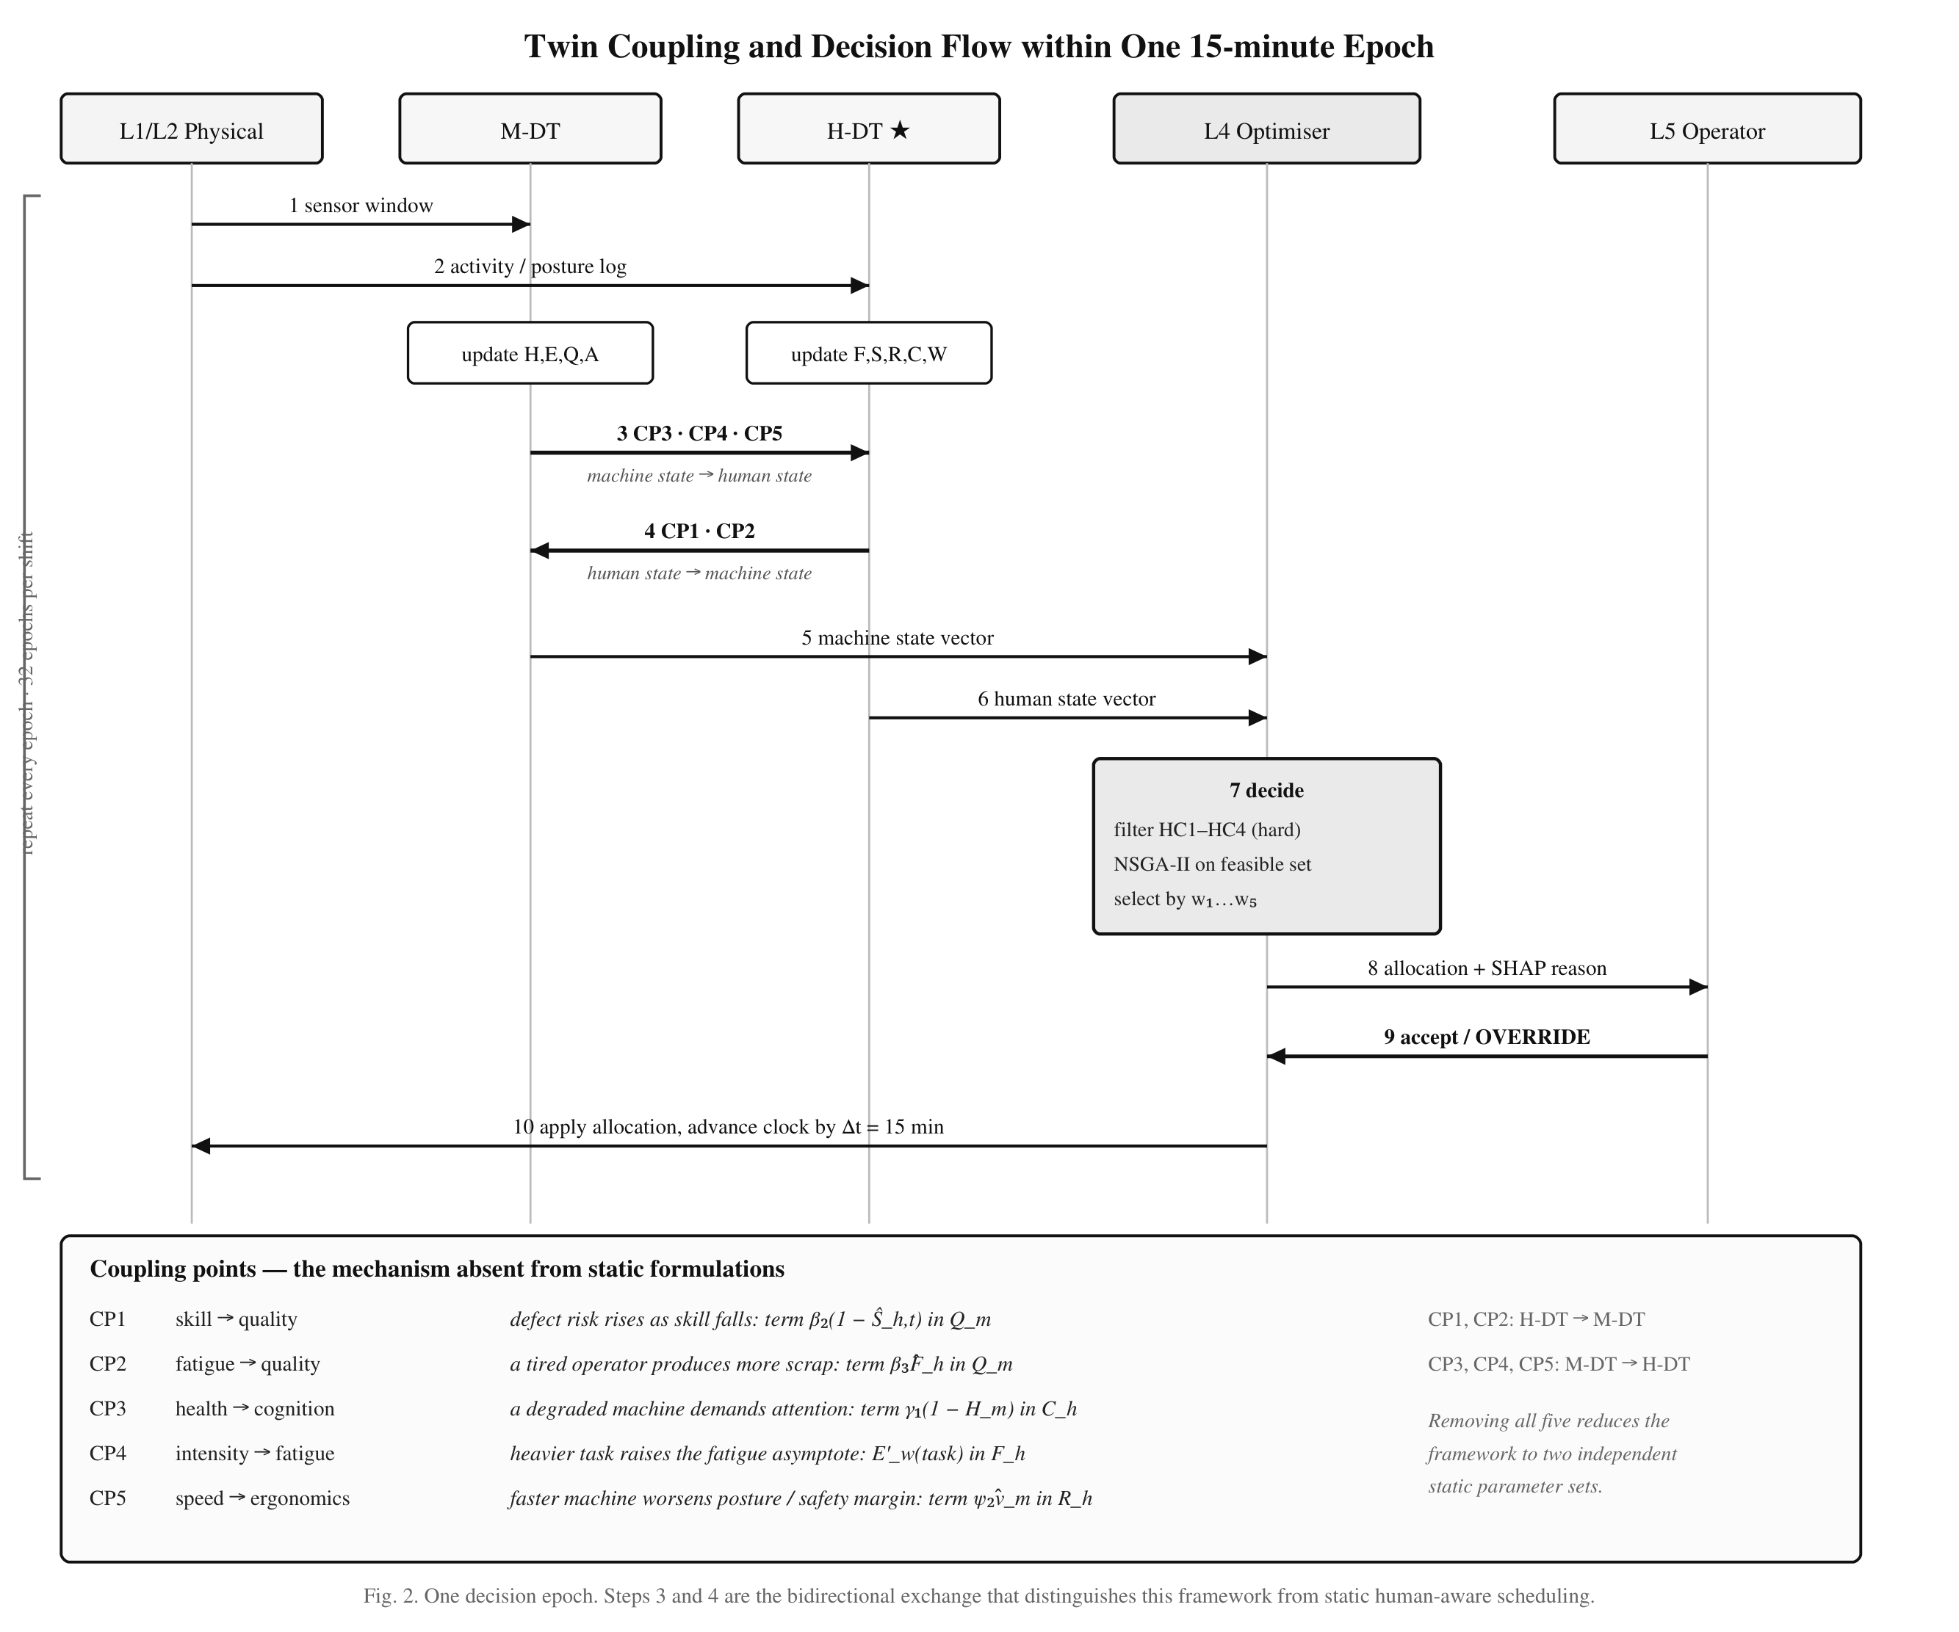
- Fig. 2. The five coupling points. Each is a named term in a state equation, so a coupling can be disabled individually and its contribution measured.

Objective and Constraints
The allocation objective aggregates the three pillars over normalised terms,
Z = w₁F̂ + w₂R̂ + w₃Ê + w₄Ŵ − w₅Ť (6)
covering fatigue and ergonomic risk, energy and waste, and throughput. Four weightings are examined in Section V.
Four constraints are enforced as filters applied before the objective is evaluated: normalised fatigue below 0.80, competence at or above a floor, ergonomic risk at or below an action level, and machine health above a floor. A hysteresis band holds an operator at rest until fatigue falls to 0.60, which prevents alternation across the threshold at successive epochs. When no admissible pairing exists, the work is left in the queue and the deferral is recorded rather than absorbed.
The ordering is the substantive claim of the framework. The distinction between Industry 4.0 and Industry 5.0 optimisation is, in this formulation, precisely the distinction between treating operator state as a soft penalty and treating it as a hard constraint. Under the former, a sufficient efficiency gain will always justify operator strain; under the latter, it never can.

Implementation and Experimental Setup

Co-Simulation Environment
No public dataset carries machine and operator state together, so a hybrid co-simulation is adopted. Machine-side dynamics are driven by public benchmark datasets, operator-side dynamics by the literature-derived models of Section III, and both advance on a single discrete-event clock implemented in SimPy. State is exchanged across the coupling points at every decision epoch. The modelled cell has five machines, three operators and three task types over an eight-hour shift divided into fifteen-minute epochs, with a scheduled break after four hours. Table II lists the parameters and their sources.
- TABLE II
SIMULATION PARAMETERS AND THEIR SOURCES
Parameter | Value | Source
Machines / operators / task types | 5 / 3 / 3 | Case definition
Shift length, decision epoch | 480 min, 15 min | Case definition
Nominal machine life L⁰ | 216 busy-min | AI4I 2020 [21]
Idle draw, task increment | estimated by load class | Steel energy [22]
Baseline defect rate | 6.6% | SECOM [30]
Grid emission factor | 0.33 kg CO₂/kWh | Ember [23]
Task metabolic demand | 2.58 / 4.26 / 5.94 kcal min⁻¹ | ISO 8996 [24]
Resting expenditure Eᵣ | per operator | Mifflin–St Jeor [25]
Acceptable work level | per operator | [26], [27]
Fatigue rates λ, μ | 0.020, 0.046 min⁻¹ | Calibrated; see §VI
Fatigue limit, hysteresis | 0.80, release at 0.60 | Design choice
Runs | 3 × 3 × 30 = 270 | Protocol

Data and Parameter Estimation
Twin parameters are estimated directly from the benchmark data rather than learned. Nominal machine life comes from the tool-wear failures of the AI4I 2020 dataset [21]; idle and per-task energy draw from the load categories of an industrial steel energy dataset [22], whose fifteen-minute sampling interval coincides with the decision epoch; and the baseline defect rate from a semiconductor process dataset [30]. Only the ratios between load categories are carried into the simulation, with the absolute level rescaled to the modelled cell, so that the comparison between policies is unaffected by the scale of the source plant. The AI4I dataset is synthetic by construction, reproducing the statistics of industrial maintenance data rather than recording them; the other two are operational measurements.

Allocation Policies
Three policies are compared. A random policy assigns admissible pairs without preference and serves as a sanity floor. An Industry 4.0 baseline retains the machine twin at full strength, including the machine-health constraint, and selects the fastest available pairing; the human twin continues to run and is reported, but does not enter the decision. The proposed policy adds the human constraints and the multi-objective score. The baseline is the same simulator under restriction rather than separate code, and the physical couplings remain active for it: a tired operator still produces more defects under the baseline, because that occurs in the cell whether or not the scheduler models it.

Scenarios and Evaluation Protocol
Three scenarios are used: normal demand, high demand at 150% of nominal, and a disruption scenario in which two machines fail mid-shift. Each policy is run under each scenario with thirty random seeds, giving 270 runs in total; a seed fixes the order book and the disruption pattern, so the three policies face identical conditions. Comparisons use the Mann–Whitney U test with Cliff's delta as the effect size, Bonferroni-corrected across the eleven indicators reported per scenario. Rank tests are used throughout because thirty runs is not a large sample, several indicators are bounded, and one is identically zero under the proposed policy; normality is tested and reported but never relied upon. Re-running the full matrix reproduces every reported value.

Results and Discussion

Overall Comparison
Table III reports the eleven indicators under high demand, the scenario in which demand exceeds what three operators can absorb comfortably and in which protecting them therefore has to cost something. Relative to the Industry 4.0 baseline, the proposed policy reduces mean operator fatigue by 27.0% and energy per unit by 30.8%, reduces mean ergonomic risk by 14.6%, and eliminates all 79.5 constraint breaches per shift that the baseline incurs. Each of these carries the maximum effect size at p < 0.001 after correction. The accompanying change in throughput is 1.8% and is not statistically significant (p = 0.148).
That is the central finding. At the point where a throughput-driven scheduler pushes hardest, holding every operator inside their own sustainable band cost no measurable production. Fig. 4 shows the same comparison across the three pillars. Under normal and disrupted demand the picture is different and is reported as such: throughput falls by 10.0% and 12.7% respectively, both significant. Those are not incidental losses but the throughput the framework declines to extract once an operator would pass their own limit, and the quantity is reported directly — work was deferred in 11.0% of decision epochs under high demand, and in 24.0% and 19.0% under the other two scenarios. A framework that never gave anything up would not be enforcing anything.
- TABLE III
KPI COMPARISON UNDER HIGH DEMAND (S2)
Indicator | B1 random | B2 Industry 4.0 | B3 proposed | Δ vs B2 | δ
Mean fatigue | 0.745 ± 0.030 | 0.741 ± 0.031 | 0.541 ± 0.027 | -27.0%* | -1.00
Peak fatigue | 1.000 ± 0.000 | 1.000 ± 0.000 | 0.781 ± 0.010 | -21.9%* | -1.00
Mean RULA | 4.799 ± 0.149 | 4.718 ± 0.144 | 4.028 ± 0.100 | -14.6%* | -1.00
Constraint breaches | 81.200 ± 10.943 | 79.500 ± 10.909 | 0.000 ± 0.000 | -100.0%* | -1.00
Workload Gini | 0.005 ± 0.003 | 0.005 ± 0.002 | 0.024 ± 0.010 | +0.019* | +0.98
Energy per unit | 1.343 ± 0.124 | 1.321 ± 0.133 | 0.915 ± 0.063 | -30.8%* | -1.00
CO2e | 40.438 ± 2.241 | 39.880 ± 2.274 | 27.181 ± 1.304 | -31.8%* | -1.00
Scrap rate | 0.124 ± 0.040 | 0.132 ± 0.046 | 0.122 ± 0.041 | -7.9% | -0.13
Throughput | 91.533 ± 3.702 | 91.900 ± 4.245 | 90.233 ± 3.857 | -1.8% | -0.22
Downtime | 1.550 ± 0.190 | 1.858 ± 0.193 | 1.358 ± 0.126 | -26.9%* | -0.94
OEE | 0.674 ± 0.037 | 0.667 ± 0.039 | 0.684 ± 0.035 | +2.6% | +0.24
- Mean ± standard deviation over 30 runs. Δ is the change of the proposed policy relative to the Industry 4.0 baseline; for workload balance, which sits near zero, the absolute difference is given. Mann–Whitney U, Bonferroni-corrected at α = 0.0045; δ is Cliff's delta.
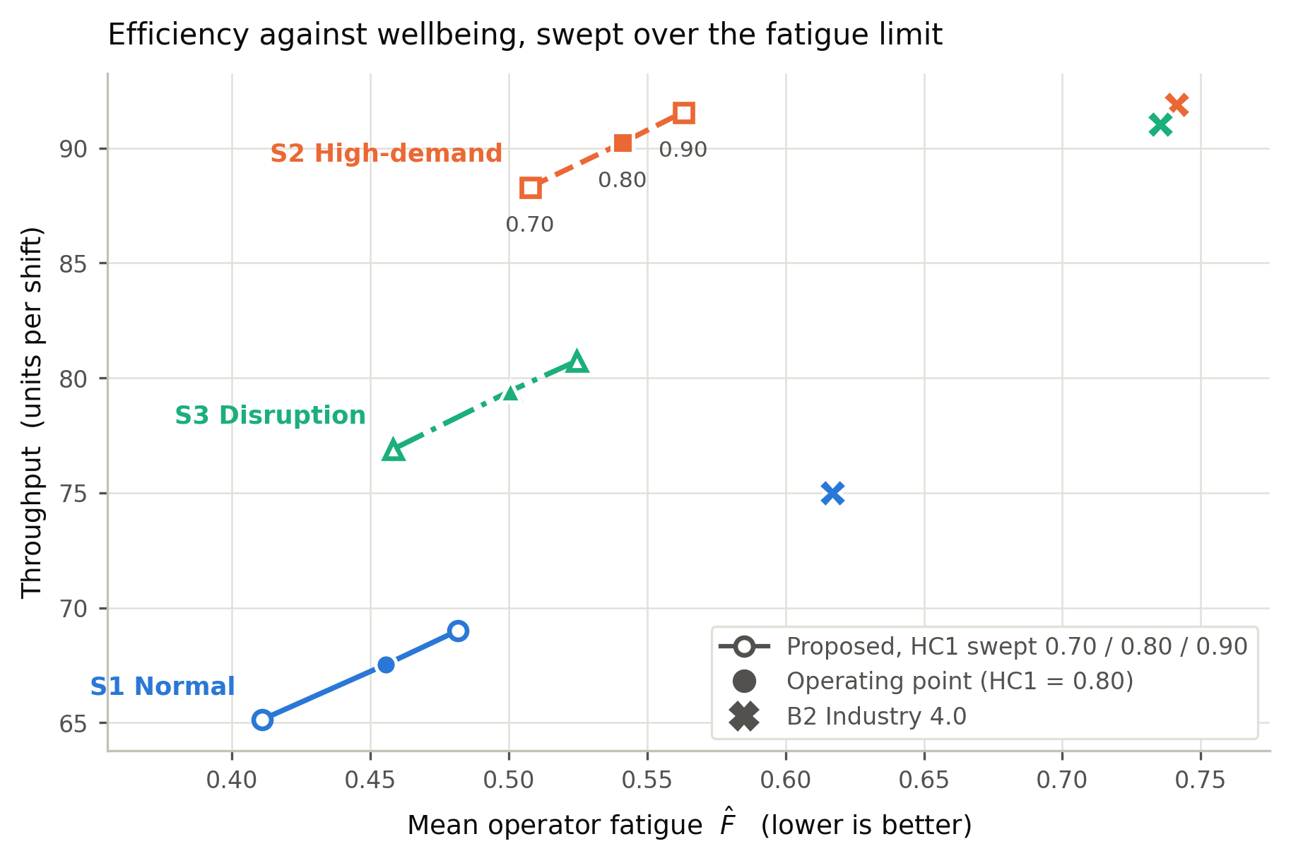
- Fig. 3. Throughput against mean operator fatigue as the fatigue limit is swept across 0.70, 0.80 and 0.90. Filled markers are the operating point; crosses are the Industry 4.0 baseline for the same scenario.

The Efficiency–Well-Being Trade-Off
Fig. 3 traces the trade-off by sweeping the fatigue limit across 0.70, 0.80 and 0.90 rather than by re-weighting the objective. Peak fatigue tracks each limit from just below it and throughput rises monotonically with it, so the curve is a genuine frontier and the operating point is a choice along it rather than a fixed property of the method. The practical implication is that the dial which moves this system is the limit an organisation is willing to set on its people, not the priority it declares in an objective function.

Robustness
Three parameters are calibrated rather than measured: the fatigue accumulation and recovery rates, and the fatigue limit expressed as a fraction of the acceptable work level. Each was varied and the comparison repeated. Scaling both rates by 0.5, 1 and 2 — a fourfold span — preserved the ordering of the two policies on every human-centric indicator. The advantage grew with the rate, from 25.4% to 27.0% to 33.1% less mean fatigue, and so did the cost, from 0.8% to 1.8% to 5.9% of throughput, which is the behaviour the model implies. Varying the limit across 0.70, 0.80 and 0.90 likewise preserved the ordering in all three scenarios. The conclusions therefore rest on the framework rather than on the values chosen for its free parameters.

What Steers the Framework
The four weightings of the objective proved indistinguishable: mean fatigue spans 0.541 to 0.542 and throughput 90.2 to 90.3 units, across weightings that differ sevenfold on the human terms. The cause lies upstream of the objective. After the constraints filter the candidate set, 95.7% of the 45,754 decisions taken under high demand face either no admissible pairing or exactly one, so there is nothing left to weigh; among the remaining 4.3%, the best and worst admissible options differ by a median of 0.015 on the objective's own scale.
This is a design property rather than a defect. A framework whose human protections could be tuned away by re-weighting an objective would not be offering protection. It also sharpens the relationship to Industry 4.0: the profit-weighted configuration does converge on the baseline's throughput, to within 1.8%, but it cannot converge on the baseline's fatigue or breach count, because driving every human weight to zero still leaves the fatigue limit, the competence floor and the ergonomic ceiling filtering before the objective is consulted. Industry 4.0 is the limit of the objective, not of the framework.

Contribution of the Couplings
Each coupling was removed from the scheduler's view while remaining active in the simulated cell, so that only the scheduler's sight of it changed. One of the three couplings that can be ablated in this way changes decisions. With machine pace hidden from the ergonomic score, the scheduler admits pairings that breach the ergonomic limit in fact, producing 5.3 genuine breaches per shift against zero for the full framework. Hiding competence-to-quality or fatigue-to-quality changed fatigue, throughput and scrap by less than run-to-run variation.
The reason is redundancy rather than irrelevance, and the distinction matters. Competence already reaches the decision through processing time, through the skill-matching preference and through the competence floor; fatigue reaches it through the fatigue limit and through the objective's fatigue term. Machine pace has exactly one route into the decision, the ergonomic score, which is why it is the only ablation that bites. The coupled twin therefore does less work through the quality equation than the design anticipated, and more through the constraint set.

Hypotheses and Discussion
Two hypotheses were stated before the experiments. The first held that including a human digital twin in the decision would reduce operator fatigue and ergonomic risk by at least 20% for a throughput cost of at most 10%. It is only partly supported. The fatigue target is met in all three scenarios, at 26.2%, 27.0% and 31.9%. The ergonomic target is not met in any: the reductions are 13.2%, 14.6% and 14.3%. The arithmetic explains why. Mean ergonomic risk cannot fall below 2.90 for the task mix used, because the baseline posture scores of the task types floor it, so at most a 38% reduction was ever available; of the 1.13 points that remain above that floor under the proposed policy, 1.08 are the fatigue term. The hypothesis set a target on a bounded index without accounting for its floor, and the part of the index that is actually controllable is the part the framework moves. The throughput condition is met under normal and high demand but not under disruption, where the cost reaches 12.7%.
The second hypothesis held that protecting the operator would also reduce machine downtime, on the argument that a fatigued operator generates defects and stress that the equipment ultimately absorbs. It is supported under normal and high demand, where downtime falls by 28.3% and 26.9% respectively at p < 0.001, and is not supported under disruption, where unplanned repairs dominate downtime and no policy can avoid them (p = 0.906). The supported half is the more useful one: it says that human-centric allocation is not purchased at the expense of the equipment, and speaks to an Industry 4.0 audience in its own terms.
Two indicators showed no significant effect. Scrap rate and overall equipment effectiveness differed by −7.9% and +2.6% under high demand, neither reaching significance after correction. The appropriate reading is that the human-centric and environmental gains were achieved without degrading product quality or equipment effectiveness, and no claim of improvement in either is made.
One result runs against the framework and is reported rather than omitted. Work was distributed less evenly under the proposed policy than under the baseline. The mechanism is direct: hard constraints remove operator–task pairings from the feasible set, so the remaining work concentrates on whoever is still eligible. Increasing the fairness preference eightfold changed the distribution by less than 0.3%, since a preference can only choose among eligible pairings. The cause lies in the workforce rather than in the scheduler: the operator with the highest sustainable work level is the only one excluded from heavy tasks, his competence at them falling below the floor, so heavy work falls to the two operators least able to sustain it. Because the framework models both the equipment and the person, it can localise that and price it: raising that single competence past the floor closes roughly two thirds of the gap in every scenario and raises throughput in every scenario, with breaches still at zero. This is reported as a diagnosis and not applied as a fix; the results above stand on the configuration that was actually run. A machine-only twin could not pose the question, because the constraint it would have to reason about does not exist in its model.

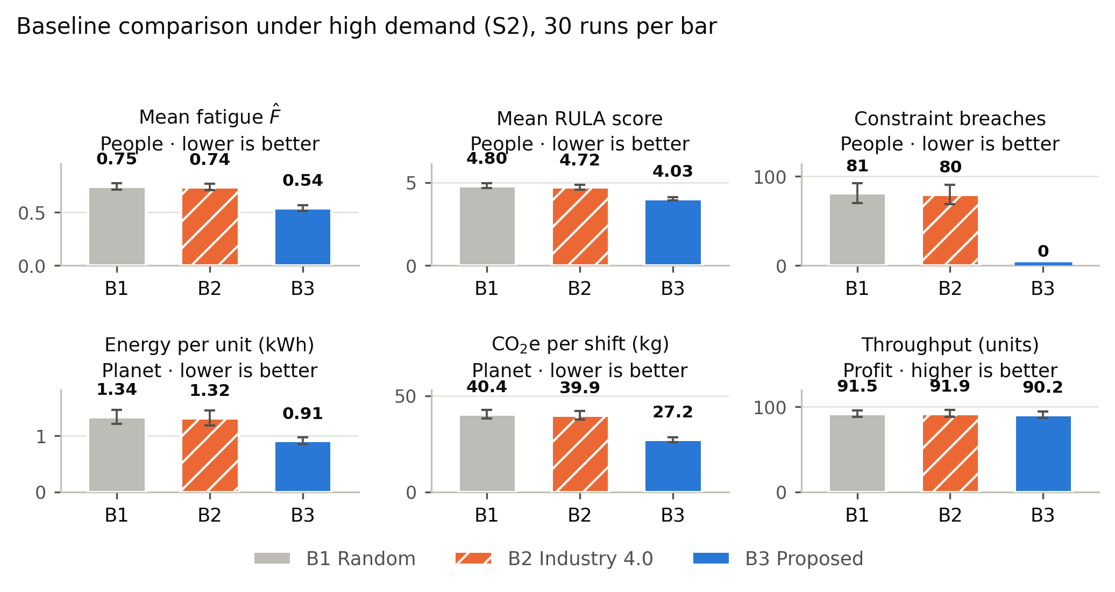
- Fig. 4. The three policies on six indicators under high demand, two per sustainability pillar. Error bars are one standard deviation over 30 runs. The proposed policy records zero constraint breaches, marked by the stub on the baseline.

Limitations and Future Work
The fatigue accumulation and recovery rates are calibrated rather than measured; operator-specific values would require physiological data collection that a simulation study does not include. Both are held inside the range implied by published exponential work–recovery models, with the recovery rate kept below the localized-muscle bound reported for manual work [31]. Their influence is further bounded by the sensitivity analysis of Section V. The two coupling coefficients linking competence and fatigue to defect risk are likewise calibrated, because no available dataset carries operator attributes alongside process outcomes; their influence is bounded by the ablation. The deferral rate exceeds the 15% guard adopted during design in two scenarios, at 24% and 19%; removing the fatigue limit entirely moves that rate by less than one point, which locates the cause in the ergonomic ceiling and the competence floor rather than in fatigue, and neither can be relaxed without permitting the outcomes the framework exists to prevent.
Three elements of the specification are not implemented. The decision layer uses a weighted sum rather than the multi-objective search the architecture allows, so no Pareto front is claimed; the trade-off in Fig. 3 is a constraint sweep. The explanation and override layer is specified but not built, so no claim is made about operator acceptance or oversight in practice. Twin parameters are estimated from data rather than learned by predictive models. Finally, one of the three datasets is synthetic, the operator profiles are synthetic, and the cell is small at five machines and three operators; validation in an operating facility remains future work, as do the multi-objective search [18] and the explanation layer [32], and the privacy and ethical questions that arise once a twin models a named person [33].

Conclusion
This article has presented a task allocation framework in which a machine digital twin and a human digital twin are coupled through five explicitly defined bidirectional interfaces, and in which operator fatigue, competence and ergonomic risk filter the candidate set before optimisation rather than entering the objective as penalties. Fatigue is modelled as a physiological state with per-operator bounds derived from published anthropometric equations, so that protection differs between individuals as their physiology differs, without any rule prescribing the difference.
Across 270 runs of a co-simulated machining cell, the framework reduced mean operator fatigue by 27.0% and energy per unit by 30.8% relative to an Industry 4.0 baseline under high demand, and eliminated every constraint breach, at a throughput difference that was not statistically significant. Machine downtime fell as well under normal and high demand, which suggests that protecting the operator is not paid for by the equipment. The weighting of the objective proved almost irrelevant to the outcome: after the constraints filter, most decisions have nothing left to weigh. That is the central lesson. In a human-centric formulation the protection has to live in the feasible set rather than in the objective, because only there can it not be traded away.

References
- [1] M. Breque, L. De Nul, and A. Petridis, “Industry 5.0: Towards a Sustainable, Human-Centric and Resilient European Industry,” European Commission, Directorate-General for Research and Innovation, 2021. doi: 10.2777/308407.
- [2] X. Xu, Y. Lu, B. Vogel-Heuser, and L. Wang, “Industry 4.0 and Industry 5.0–Inception, Conception and Perception,” Journal of Manufacturing Systems, vol. 61, pp. 530–535, 2021. doi: 10.1016/j.jmsy.2021.10.006.
- [3] C. Destouet, H. Tlahig, B. Bettayeb, and B. Mazari, “Flexible Job Shop Scheduling Problem under Industry 5.0: A Survey on Human Reintegration, Environmental Consideration and Resilience Improvement,” Journal of Manufacturing Systems, vol. 67, pp. 155–173, 2023. doi: 10.1016/j.jmsy.2023.01.004.
- [4] G. E. Modoni, and M. Sacco, “A Human Digital-Twin-Based Framework Driving Human Centricity towards Industry 5.0,” Sensors, vol. 23, no. 13, pp. 6054, 2023. doi: 10.3390/s23136054.
- [5] A. Toth, L. Nagy, R. Kennedy, B. Bohu\v s, J. Abonyi, and T. Ruppert, “The Human-Centric Industry 5.0 Collaboration Architecture,” MethodsX, vol. 11, pp. 102260, 2023. doi: 10.1016/j.mex.2023.102260.
- [6] B. Wang et al., “Human Digital Twin in the Context of Industry 5.0,” Robotics and Computer-Integrated Manufacturing, vol. 85, pp. 102626, 2023. doi: 10.1016/j.rcim.2023.102626.
- [7] B. Gaffinet, J. Al Haj Ali, Y. Naudet, and H. Panetto, “Human Digital Twins: A Systematic Literature Review and Concept Disambiguation for Industry 5.0,” Computers in Industry, vol. 166, pp. 104230, 2025. doi: 10.1016/j.compind.2024.104230.
- [8] A. Sharotry, J. A. Jimenez, F. A. Mendez Mediavilla, D. Wierschem, R. M. Koldenhoven, and D. Valles, “Manufacturing Operator Ergonomics: A Conceptual Digital Twin Approach to Detect Biomechanical Fatigue,” IEEE Access, vol. 10, pp. 12774–12791, 2022. doi: 10.1109/ACCESS.2022.3145984.
- [9] A. Greco, M. Caterino, M. Fera, and S. Gerbino, “Digital Twin for Monitoring Ergonomics during Manufacturing Production,” Applied Sciences, vol. 10, no. 21, pp. 7758, 2020. doi: 10.3390/app10217758.
- [10] W. Tan, X. Yuan, J. Wang, and X. Zhang, “A Fatigue-Conscious Dual Resource Constrained Flexible Job Shop Scheduling Problem by Enhanced NSGA-II: An Application from Casting Workshop,” Computers & Industrial Engineering, vol. 160, pp. 107557, 2021. doi: 10.1016/j.cie.2021.107557.
- [11] C. Destouet, H. Tlahig, B. Bettayeb, and B. Mazari, “Multi-Objective Sustainable Flexible Job Shop Scheduling Problem: Balancing Economic, Ecological, and Social Criteria,” Computers & Industrial Engineering, vol. 195, pp. 110419, 2024. doi: 10.1016/j.cie.2024.110419.
- [12] C. Destouet, H. Tlahig, B. Bettayeb, and B. Mazari, “Machine Learning-Driven Solutions for Sustainable and Dynamic Flexible Job Shop Scheduling under Worker Absences and Renewable Energy Variability,” Computers & Operations Research, vol. 186, pp. 107323, 2026. doi: 10.1016/j.cor.2025.107323.
- [13] F. Tao, J. Cheng, Q. Qi, M. Zhang, H. Zhang, and F. Sui, “Digital Twin-Driven Product Design, Manufacturing and Service with Big Data,” International Journal of Advanced Manufacturing Technology, vol. 94, no. 9--12, pp. 3563–3576, 2018. doi: 10.1007/s00170-017-0233-1.
- [14] A. Rasheed, O. San, and T. Kvamsdal, “Digital Twin: Values, Challenges and Enablers from a Modeling Perspective,” IEEE Access, vol. 8, pp. 21980–22012, 2020. doi: 10.1109/ACCESS.2020.2970143.
- [15] A. A. Malik, and A. Bilberg, “Digital Twins of Human Robot Collaboration in a Production Setting,” Procedia Manufacturing, vol. 17, pp. 278–285, 2018. doi: 10.1016/j.promfg.2018.10.047.
- [16] A. Locklin, T. Jung, N. Jazdi, T. Ruppert, and M. Weyrich, “Architecture of a Human-Digital Twin as Common Interface for Operator 4.0 Applications,” Procedia CIRP, vol. 104, pp. 458–463, 2021. doi: 10.1016/j.procir.2021.11.077.
- [17] M. Crnjac \v Zi\v zic, N. Gjeldum, M. Mladineo, B. z. Bilic, and A. Aljinovic Me\v strovic, “Towards Sustainable Personalized Assembly Through Human-Centric Digital Twins,” Sensors, vol. 25, no. 18, pp. 5662, 2025. doi: 10.3390/s25185662.
- [18] K. Deb, A. Pratap, S. Agarwal, and T. Meyarivan, “A Fast and Elitist Multiobjective Genetic Algorithm: NSGA-II,” IEEE Transactions on Evolutionary Computation, vol. 6, no. 2, pp. 182–197, 2002. doi: 10.1109/4235.996017.
- [19] M. Calzavara, A. Persona, F. Sgarbossa, and V. Visentin, “A Model for Rest Allowance Estimation to Improve Tasks Assignment to Operators,” International Journal of Production Research, vol. 57, no. 3, pp. 948–962, 2019. doi: 10.1080/00207543.2018.1497816.
- [20] F. Sgarbossa, and V. Vijayakumar, “Reducing Fatigue Level through Tasks and Breaks Assignment in Order Picking System,” in Preprints of the 21st IFAC World Congress, pp. 10758–10761, 2020.
- [21] S. Matzka, “AI4I 2020 Predictive Maintenance Dataset,” UCI Machine Learning Repository, dataset 601, 2020.
- [22] V. E. Sathishkumar, C. Shin, and Y. Cho, “Steel Industry Energy Consumption Dataset,” UCI Machine Learning Repository, dataset 851, 2021.
- [23] Ember, “Yearly Electricity Data: Carbon Intensity of Electricity, Sri Lanka,” Dataset, accessed via Our World in Data, 2025.
- [24] International Organization for Standardization, “ISO 8996: Ergonomics of the Thermal Environment – Determination of Metabolic Rate,” Standard, 2021.
- [25] M. D. Mifflin, S. T. St Jeor, L. A. Hill, B. J. Scott, S. A. Daugherty, and Y. O. Koh, “A New Predictive Equation for Resting Energy Expenditure in Healthy Individuals,” The American Journal of Clinical Nutrition, vol. 51, no. 2, pp. 241–247, 1990. doi: 10.1093/ajcn/51.2.241.
- [26] A. D. F. Price, “Calculating Relaxation Allowances for Construction Operatives – Part 1: Metabolic Cost,” Applied Ergonomics, vol. 21, no. 4, pp. 311–317, 1990. doi: 10.1016/0003-6870(90)90202-9.
- [27] C. G. de Souza e Silva, B. A. Franklin, D. E. Forman, and C. G. S. de Araújo, “Influence of Age in Estimating Maximal Oxygen Uptake,” Journal of Geriatric Cardiology, vol. 13, no. 2, pp. 126–131, 2016. doi: 10.11909/j.issn.1671-5411.2016.02.010.
- [28] L. McAtamney, and E. N. Corlett, “RULA: A Survey Method for the Investigation of Work-Related Upper Limb Disorders,” Applied Ergonomics, vol. 24, no. 2, pp. 91–99, 1993. doi: 10.1016/0003-6870(93)90080-S.
- [29] S. G. Hart, and L. E. Staveland, “Development of NASA-TLX (Task Load Index): Results of Empirical and Theoretical Research,” in Human Mental Workload, vol. 52, pp. 139–183, 1988. doi: 10.1016/S0166-4115(08)62386-9.
- [30] M. McCann, and A. Johnston, “SECOM,” UCI Machine Learning Repository, dataset 179, 2008.
- [31] C. Yi, F. Tang, K. W. Li, H. Hu, H. Zuo, and C. Zhao, “Modeling and Validation of Fatigue and Recovery of Muscles for Manual Demolition Tasks,” International Journal of Environmental Research and Public Health, vol. 19, no. 2, pp. 930, 2022. doi: 10.3390/ijerph19020930.
- [32] S. M. Lundberg, and S. I. Lee, “A Unified Approach to Interpreting Model Predictions,” in Advances in Neural Information Processing Systems (NeurIPS), vol. 30, 2017. doi: 10.48550/arXiv.1705.07874.
- [33] O. Cardin, and D. Trentesaux, “Design and Use of Human Operator Digital Twins in Industrial Cyber-Physical Systems: Ethical Implications,” IFAC-PapersOnLine, vol. 55, no. 2, pp. 360–365, 2022. doi: 10.1016/j.ifacol.2022.04.220.

