EXPLAINABLE DEEP LEARNING FRAMEWORK FOR PNEUMONIA DETECTION AND CLASSIFICATION USING TRANSFER LEARNING AND GRAD-CAM

G. C. M. Sewwandi

Bachelor of Science (Honours) in Computer Science

Department of Computer and Data Science
NSBM Green University
Sri Lanka

October 2026

EXPLAINABLE DEEP LEARNING FRAMEWORK FOR PNEUMONIA DETECTION AND CLASSIFICATION USING TRANSFER LEARNING AND GRAD-CAM

A thesis submitted to NSBM Green University for the degree of
Bachelor of Science (Honours) in Computer Science

By

G. C. M. Sewwandi

Department of Computer and Data Science
Faculty of Computing
NSBM Green University
Sri Lanka

October 2026

DECLARATION
I declare that the content of this undergraduate thesis titled “Explainable Deep Learning Framework for Pneumonia Detection and Classification Using Transfer Learning and Grad-CAM” is my own work and this dissertation does not incorporate without acknowledgement any material previously submitted for any other degree in any university or institution of higher learning.
Signature ……………………………………………………………………
Name: G. C. M. Sewwandi Date: ……………………
Signature of the Supervisor
……………………………………………………………………
Ms. R. W. K. T. Rajapaksha
Principal Supervisor
Lecturer
Department of Computer and Data Science,
NSBM Green University
Date ……………………

ACKNOWLEDGEMENT
I would like to express my sincere gratitude to my supervisor for their guidance, patience, and constructive feedback throughout the course of this research. Their willingness to challenge assumptions and emphasize evidence over intuition played an important role in shaping this project at every stage. I am also deeply grateful to the academic staff of the Department of Computer Science at NSBM Green University for the knowledge, guidance, and support that contributed to making this research possible. I would also like to thank the assessment panel for their valuable time and effort in reviewing and evaluating this work. Finally, I extend my heartfelt thanks to my family and friends for their continuous encouragement, understanding, and support throughout the demanding months of this project. Any errors or shortcomings that remain in this thesis are solely my responsibility.

ABSTRACT
Chest radiography is the first line investigation for suspected pneumonia, but interpretation is difficult because the appearances of COVID-19, bacterial and viral pneumonia overlap and radiologist availability is uneven. Two weaknesses recur in reported systems. Most are binary, so they cannot support the antibiotic decision, which depends on separating subtypes, and, more seriously, softmax is a closed world function that redistributes probability across its trained classes for every input, so an image that is not a chest radiograph still receives a confident label. This thesis designs and evaluates an explainable framework for four class chest radiograph classification into Normal, COVID-19, bacterial and viral pneumonia, aware of inputs outside its training distribution and delivered as a working decision support platform. DenseNet121, EfficientNetV2B3 and EfficientNetV2S were fine tuned by two stage transfer learning on a stratified split of 9,209 radiographs and evaluated on a held out test set of 1,382 images. A post hoc safeguard was added without retraining, combining a Mahalanobis distance in the penultimate feature space with energy and maximum softmax signals, while Grad-CAM explanations were computed from pre softmax logits, restricted to an estimated lung field and reported with the unmasked in lung attention fraction. DenseNet121 reached 85.31 per cent test accuracy, EfficientNetV2B3 84.30 per cent and EfficientNetV2S 80.54 per cent, and between 69 and 76 per cent of the errors of every model were bacterial and viral confusions. The safeguard retained 92.5 per cent of held out genuine scans while flagging every image of a synthetic far probe, with a Mahalanobis AUROC of 1.000 against 0.539 for energy, showing that the usable signal lies in feature space rather than output confidence. The lung restricted explanations fell on the regions clinically associated with each class, and the share of attention inside the lung field is disclosed per scan.
Keywords: chest radiograph classification, clinical decision support, explainable artificial intelligence, Grad-CAM, out of distribution detection, transfer learning.

TABLE OF CONTENTS
DECLARATION ii
ACKNOWLEDGEMENT iii
ABSTRACT iv
TABLE OF CONTENTS v
LIST OF FIGURES viii
LIST OF TABLES x
LIST OF ABBREVIATIONS xi
1 INTRODUCTION 1
1.1 Background 1
1.2 Problem statement 1
1.2.1 General problem 1
1.2.2 Specific problem 1
1.3 Research questions 2
1.4 Research motivation and significance 2
1.5 Overview of the proposed solution 2
1.6 Scope and delimitations 3
1.7 Resource requirements 4
1.7.1 Hardware 4
1.7.2 Software 4
1.8 Structure of the thesis 4
2 OBJECTIVES 5
2.1 General objective 5
2.2 Specific objectives 5
3 LITERATURE REVIEW 6
3.1 Conceptual map of the literature 6
3.2 Domain overview 6
3.3 Existing systems, frameworks and designs 7
3.4 Technological analysis 8
3.4.1 Algorithmic analysis 8
3.4.2 Design analysis 9
3.4.3 Workflow analysis 9
3.5 Reflection and derived requirements 10
4 METHODOLOGY 12
4.1 Research paradigm 12
4.2 Research approach 12
4.3 Research strategy 12
4.4 Data collection and data sources 12
4.5 Research methodology execution workflow 13
4.5.1 Problem identification 14
4.5.2 Relevance justification 14
4.5.3 Comparative analysis and gap justification 14
4.5.4 Define and finalise objectives 14
4.5.5 Design, development and data management 14
4.5.6 Evaluation and communication 15
4.6 Project management methodology 15
4.6.1 Project timeline 15
4.6.2 Ethical considerations 15
4.7 Stakeholder analysis 16
4.8 Operationalisation process 16
4.9 System and model analysis 16
4.9.1 Use case analysis 16
4.9.2 Class analysis 17
4.9.3 Activity analysis 17
4.9.4 Sequence analysis 18
4.9.5 State analysis of the result view 19
4.10 Proposed system architecture 19
4.11 Functional and non functional requirements 20
4.12 Implementation of the framework 21
4.12.1 Algorithms and core logic 21
4.12.2 Pipeline workflow 23
4.13 Significant implementation attempts 24
4.14 Evaluation design and test plan 25
4.14.1 Testing and evaluation workflow 27
4.14.2 Justification of the selected evaluation strategies 27
5 RESULTS 28
5.1 Classification performance and error structure 28
5.2 Input validity detection 28
5.3 Explanation localisation 29
5.4 Error analysis 30
5.5 System and performance test results 31
5.5.1 Non functional test results 31
5.5.2 Functional test results 31
6 DISCUSSION AND CONCLUSIONS 34
6.1 Discussion of the findings 34
6.2 Achievement of the research objectives 34
6.3 Limitations and threats to validity 35
6.4 Practical implications 36
6.5 Recommendations for future work 36
6.6 Conclusions 37
REFERENCES 38

LIST OF FIGURES
Figure 1.1: Rich picture of the proposed solution, showing the single forward pass from which the classification, the input validity assessment and the explanation are jointly derived. 3
Figure 3.1: Conceptual map of the reviewed literature, showing how the capability strand and the safety strand converge on the research gap addressed by this thesis. 6
Figure 4.1: Research methodology execution workflow, showing the order of the phases and the point at which the artefact was frozen for evaluation. 13
Figure 4.2: Use case diagram of the delivered platform. 16
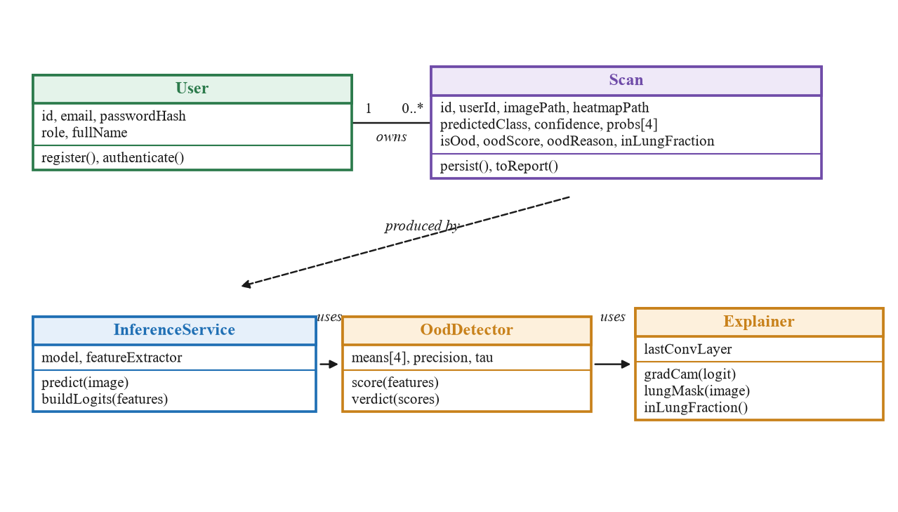Figure 4.3: Class diagram of the core domain and service classes. 17
Figure 4.4: Activity diagram of the analysis workflow. 18
Figure 4.5: Sequence diagram for the upload and analyse use case. 18
Figure 4.6: Proposed deployment architecture, showing the three tiers, the data store and the location of the research contribution. 20
Figure 4.7: Inference pipeline block diagram, showing the single forward pass from which the classification, the validity verdict and the explanation are all derived. 24
Figure 5.1: DenseNet121 confusion matrix. 30
Figure 5.2: EfficientNetV2B3 confusion matrix. 30
Figure 5.3: EfficientNetV2S confusion matrix. 30
Figure 5.4: Per class F1 for the three architectures, showing a consistent difficulty ordering across models. 31
Figure 5.5: Execution evidence for FR4. The analysis view of the running platform after a synthetic noise image was submitted, showing the withheld diagnosis and the reason in place of any diagnostic content. 33
Figure 5.6: Execution evidence for FR2, FR5 and FR6. The analysis view after a frontal radiograph was submitted, showing the predicted class, the original image and the lung restricted Grad-CAM overlay. 33

LIST OF TABLES
Table 1.1: Project scope and delimitations. 3
Table 3.1: Representative prior systems against the requirements of this study. 7
Table 3.2: Candidate architectures compared. 8
Table 3.3: Literature findings mapped to derived requirements. 11
Table 4.1: Realised dataset composition and stratified split. 13
Table 4.2: Functional requirements. 20
Table 4.3: Non functional requirements and acceptance criteria. 21
Table 4.4: Realised training configuration. 25
Table 4.5: Evaluation design mapped to objectives. 25
Table 4.6: Test cases. 26
Table 5.1: Test set performance on the shared split, with N equal to 1,382. 28
Table 5.2: Per class performance of DenseNet121. 28
Table 5.3: Out of distribution detection results. 29
Table 5.4: Concentration of errors in the bacterial and viral pair. 30
Table 6.1: Objective achievement against reported evidence. 35

LIST OF ABBREVIATIONS
Abbreviation | Description
AUROC | Area Under the Receiver Operating Characteristic curve
CAM | Class Activation Mapping
CDSS | Clinical Decision Support System
CNN | Convolutional Neural Network
Grad-CAM | Gradient weighted Class Activation Mapping
ID | In Distribution
JWT | JSON Web Token
MSP | Maximum Softmax Probability
OOD | Out of Distribution
PWA | Progressive Web Application
REST | Representational State Transfer
RO | Research Objective
RQ | Research Question
XAI | Explainable Artificial Intelligence

1 INTRODUCTION

1.1 Background
Pneumonia is among the leading causes of mortality worldwide and falls disproportionately on children under five and on elderly patients [1]. Its bacterial, viral and COVID-19 aetiologies demand different responses, since bacterial pneumonia normally requires antibiotics, viral pneumonia normally does not, and COVID-19 additionally triggers isolation. Chest radiography is the standard first line investigation because it is inexpensive and available in resource constrained settings, but interpretation is demanding: the findings overlap across aetiologies and radiologist availability varies sharply between institutions [1], [2]. Convolutional neural networks now dominate medical image analysis because they learn hierarchical representations directly from pixels [3], [4]. ChestX-ray8 [5] and CheXpert [6] accelerated the field, dedicated COVID-19 collections enabled development during the pandemic [7], [8], and CheXNet matched practising radiologists on a single pneumonia label [9]. Capability is therefore no longer the binding constraint, which is what makes the deficiencies stated next the ones worth addressing.

1.2 Problem statement
Accuracy alone does not make a chest radiograph model safe to place in front of a user. Two deficiencies persist across the reported systems, one general and one specific to this discipline.

1.2.1 General problem
Automated diagnostic support is trusted in proportion to how confident it appears rather than to how reliable it is. Networks assign near certain labels to inputs unrecognisable to a human observer [10] and are systematically overconfident even on their own distribution [11], so a user offered a probability of 0.98 cannot tell a competent prediction from an incompetent one. The consequence is a system whose most dangerous errors are also its least visible, which transfers risk to the patient while appearing to reduce it.

1.2.2 Specific problem
Within chest radiograph interpretation this takes two forms. The first is diagnostic granularity: most published systems are binary [12], [13], [14], and a binary output cannot inform the antibiotic decision because it does not separate bacterial from viral aetiology. The second is that softmax is closed world, so a photograph or a radiograph of an untrained condition is returned as a confident diagnosis. Post hoc detection methods are mature [15], [16], [17], [18] and shortcut learning has been demonstrated directly [19], yet neither has been carried into an evaluated chest radiograph system.

1.3 Research questions
Main research question. To what extent can a post hoc and explainable framework that is aware of out of distribution inputs improve the clinical safety of automated four class pneumonia classification from chest radiographs, without retraining the underlying classifier? RQ1. What classification performance, and what per class error structure, do DenseNet121, EfficientNetV2B3 and EfficientNetV2S achieve under a common dataset and split? RQ2. Can inference time signals from an already trained classifier detect out of distribution inputs reliably enough to justify withholding a diagnosis, and at what cost to genuine scans? RQ3. Do the Grad-CAM explanations fall on the lung fields and on the regions clinically associated with each class?

1.4 Research motivation and significance
Academically the study contributes evidence rather than a new architecture: a per class characterisation of the four class task on a common split, the transfer of established post hoc detection methods [15], [16], [17] into a clinical setting where they are actually evaluated, and an explanation path that restricts Grad-CAM to the lung fields and discloses how much attention lies there [19]. Practically, the safeguard converts a silent failure mode into a visible one, and the platform reports in three languages.

1.5 Overview of the proposed solution
Figure 1.1 gives the high level view of the proposed solution, a three tier decision support platform. A browser and mobile accessible client accepts a radiograph upload, a REST application layer authenticates, persists and orchestrates, and a dedicated inference service executes a single forward pass yielding the penultimate feature vector, the pre softmax logits, the class probabilities and the convolutional feature maps required for Grad-CAM.
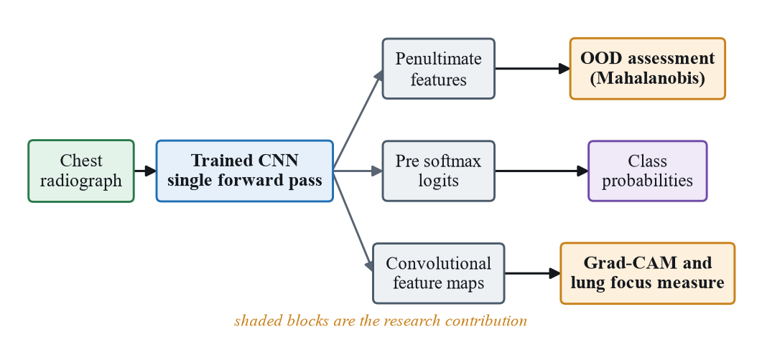
Figure 1.1: Rich picture of the proposed solution, showing the single forward pass from which the classification, the input validity assessment and the explanation are jointly derived.
The contribution sits between the forward pass and the interface. Instead of returning the softmax result directly, the service first assesses whether the input belongs to the distribution the model was trained on, using statistics fitted once on its own training data. If it falls outside, the diagnosis is withheld and the reason recorded; if accepted, a Grad-CAM explanation is computed from the logits, restricted to an estimated lung field, and reported with the attention measured there before masking.

1.6 Scope and delimitations
Table 1.1: Project scope and delimitations.
In scope | Out of scope
Four class classification of Normal, COVID-19, bacterial and viral pneumonia | Other pathologies such as tuberculosis, effusion or nodules
Frontal chest radiographs from a curated public dataset | Lateral views, computed tomography, other modalities
Comparison of the three named architectures | Novel architecture design or training from scratch
A post hoc safeguard calibrated without retraining | Retraining or architectural modification for robustness
Grad-CAM with lung restriction and measurement | Lesion segmentation or automated reporting
Held out test split and a synthetic probe | Clinical trial or validation across hospitals
Web platform with authentication and reporting | Integration with hospital systems or records

The study covers four class classification of frontal chest radiographs, comparison of three architectures under one protocol, a post hoc input validity safeguard, Grad-CAM with lung field restriction and localisation measurement, and an end to end platform. Adjacent problems are excluded on feasibility. Table 1.1 sets out the resulting boundary. The most significant delimitation is the single curated dataset. External validation across hospitals, devices and demographic groups is necessary before any clinical claim can be made, and is identified as future work in Section 6.5.

1.7 Resource requirements

1.7.1 Hardware
Training, calibration and deployment ran on a single consumer workstation without a dedicated accelerator, which was the principal constraint on the study: it limited the number of architectures to three, prevented repeated runs under different seeds, and restricted calibration to a per class subsample. A complete analysis takes about three seconds per image, as measured in Section 5.5.1.

1.7.2 Software
The model work uses Python with TensorFlow and Keras, NumPy for the linear algebra of the detector and OpenCV for the lung field estimator. The inference service uses FastAPI, the application tier is a PHP REST interface over MySQL, and the client is a Next.js application. All are open source and permit academic research use, as do the dataset licences.

1.8 Structure of the thesis
The remainder of this thesis is organised into five sections: Section 2 the objectives, Section 3 the literature review and the nine requirements derived from it, Section 4 the research design, implementation and evaluation design, Section 5 the results, and Section 6 the discussion and conclusions.

2 OBJECTIVES

2.1 General objective
The aim is to design, implement and evaluate an explainable deep learning framework for four class pneumonia classification from chest radiographs that is aware of out of distribution inputs, to deliver it as a working clinical decision support platform, and to produce evidence about its classification performance, its input validity behaviour and where its explanations place their attention.

2.2 Specific objectives
RO1. To identify, through a critical review of the literature, the limitations of existing chest radiograph classification systems with respect to diagnostic granularity, input validity and explanation quality, and to derive design requirements from them.
RO2. To analyse and comparatively evaluate DenseNet121, EfficientNetV2B3 and EfficientNetV2S under a common dataset, split and transfer learning protocol, reporting per class metrics and error structure.
RO3. To design and develop a post hoc safeguard that assesses input validity without retraining the deployed classifier, and to integrate it into an end to end platform that withholds unreliable diagnoses.
RO4. To evaluate the safeguard and the explanation mechanism, measuring in distribution retention and out of distribution separability, and examining where the explanations place their attention.
RO5. To derive evidence based recommendations on the conditions under which such a framework is, and is not, suitable for clinical screening and triage support.

3 LITERATURE REVIEW
The review is a structured critical review, not a systematic review, and no PRISMA protocol was followed. Sources came from IEEE Xplore, ScienceDirect, SpringerLink, PubMed, arXiv and Google Scholar along two strands: the task terms chest radiograph, pneumonia and COVID-19 with the method terms deep learning and convolutional neural network, and the input validity vocabulary of out of distribution, novelty detection, Mahalanobis and energy with the same clinical terms. Inclusion required a peer reviewed publication or widely cited preprint reporting an evaluated method. Thirty three sources are cited.

3.1 Conceptual map of the literature
Figure 3.1 organises the reviewed literature. The argument runs from capability to safety. The left branches establish that accurate four class classification is achievable with existing architectures and transfer learning; the right branches establish that accuracy is not sufficient, because both the explanation and the input validity assumptions can fail silently. The gap sits where they meet.
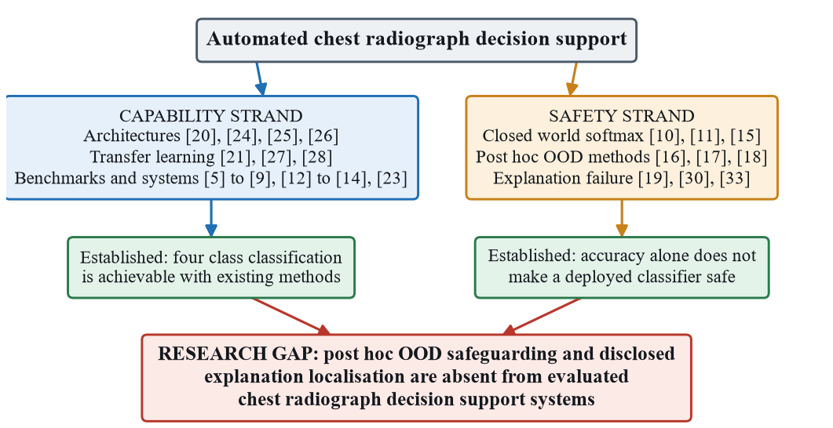
Figure 3.1: Conceptual map of the reviewed literature, showing how the capability strand and the safety strand converge on the research gap addressed by this thesis.

3.2 Domain overview
Deep convolutional networks learn a hierarchy of representations without handcrafted features [3], and residual learning made very deep networks trainable through identity shortcuts [20]. For radiography the relevant property is sensitivity across scales, because the discriminative findings occupy different spatial extents within one image. Two foundations are used directly here: transfer learning [21]; and the closed world nature of softmax, whose output expresses relative preference among trained classes and never the absence of evidence for all of them.

3.3 Existing systems, frameworks and designs
CheXNet applied a 121 layer densely connected network to ChestX-ray14 and exceeded practising radiologists on the F1 metric [9]. It established DenseNet121 as a default backbone and framed the task as single label detection, a framing subsequent work inherited. ChestX-ray8 [5] and CheXpert [6] reinforced it, but neither is organised around pneumonia aetiology, so neither supports the distinction that drives the antibiotic decision. The pandemic produced a large body of COVID-19 work [12], [13], [14]. Chowdhury et al. assembled a widely reused public collection [7], [8], Kermany et al. contributed the paediatric collection supplying the bacterial and viral labels [22], and Huang and Liao stacked EfficientNetV2 models with attention modules [23]. These share three limitations: class formulations differ, so the numbers are not comparable; the datasets are small and heterogeneous in source; and evaluation is dominated by overall accuracy. Table 3.1 compares them against the requirements of this study.
Table 3.1: Representative prior systems against the requirements of this study.
Study | Classes | Explainability | Input validity check | Deployed
Rajpurkar et al. [9] | Pneumonia against rest | CAM heatmaps, qualitative | None reported | No
Apostolopoulos and Mpesiana [12] | Binary and three class | None reported | None reported | No
Ozturk et al. [13] | Binary and three class | Heatmaps, qualitative | None reported | No
Narin et al. [14] | Binary COVID-19 | None reported | None reported | No
Chowdhury et al. [7] | Normal, viral, COVID-19 | Score-CAM, qualitative | None reported | No
Huang and Liao [23] | Multi class chest disease | Limited | None reported | No
This study | Four class, bacterial against viral | Grad-CAM from logits, lung restricted, quantified | Post hoc Mahalanobis, energy and MSP, evaluated | Yes, full platform
Three observations follow. Where explanation is offered it is qualitative, so no reviewed system can distinguish a model reasoning from pathology from one exploiting an artefact. Prior systems are evaluated as models rather than deployed tools, so the question of what happens to an unexpected input is not asked. And the COVID-19 collections [7], [8] draw their classes from different repositories, so a classifier can exploit acquisition site without learning anything about pathology [19]. This study inherits that weakness and adds a measurement rather than a remedy.

3.4 Technological analysis

3.4.1 Algorithmic analysis
DenseNet connects each layer to every preceding layer within a dense block, so early features remain available to the classifier [24], which suits radiography because fine grained texture is not discarded before the decision. EfficientNet introduced compound scaling of depth, width and resolution [25], and EfficientNetV2 revised the family with fused blocks and progressive learning [26]. Table 3.2 compares the three candidates, with figures read from the models actually trained here.
Table 3.2: Candidate architectures compared.
Property | DenseNet121 | EfficientNetV2B3 | EfficientNetV2S
Structural idea | Dense connectivity within each block [24] | Compound scaling, fused blocks early [25], [26] | Same family at greater capacity [26]
Backbone layers | 427 | 409 | 513
Input resolution | 224 by 224 | 300 by 300 | 300 by 300
Penultimate width | 256 | 320 | 256
Saved artefact size | 54.9 MB | 123.4 MB | 239.7 MB
Precedent on radiography | Direct, through CheXNet [9] | Indirect, chest disease ensembles [23] | Limited
Role in this study | Cross family baseline, deployed | Efficiency candidate | Within family capacity comparison
Selection followed project specific criteria rather than general superiority: demonstrated use on chest radiography, ImageNet weights in the deployment framework, and inference cost compatible with serving without an accelerator. Pan and Yang formalised transfer learning [21] and Tajbakhsh et al. showed that fine tuning outperforms training from scratch on small medical datasets [27]; ImageNet [28] remains the standard source domain, which motivates the two stage protocol, and Litjens et al. caution about dataset bias [4]. For input validity the options divide by where they read the network. Hendrycks and Gimpel showed that the maximum softmax probability is weakly informative but unreliable alone, because networks are confidently wrong [15]. Lee et al. fit class conditional Gaussians to the penultimate features with a shared covariance and score an input by its minimum Mahalanobis distance [16]. Liu et al. proposed the energy score, the negative log sum exp of the logits [17]. Yang et al. distinguish the far regime from the near regime, where the input is the right modality but an unseen class [18]. All three are post hoc.

3.4.2 Design analysis
The first design question is how the classifier head is built, because it determines whether a feature space detector is possible at all. A network pooling straight into a four unit softmax offers no intermediate representation in which to fit Gaussians, whereas a head passing through a narrow dense layer provides one, and that width is a trade off: large enough to remain discriminative, small enough for a covariance matrix to be estimated stably. The second is how explanation enters the output. Class activation mapping localises discriminative regions without bounding box supervision [29], and Grad-CAM generalised it by weighting feature maps with the gradients of a class score [30]. Interpretability is argued to be a precondition for clinical acceptance [2], [31], [32]. Two details are neglected: Grad-CAM is defined on the score before the softmax, and differentiating the probability instead makes gradients vanish when the model is confident; and a plausible heatmap is not evidence that lung tissue was used [33].

3.4.3 Workflow analysis
The reviewed systems share one workflow: an image is resized and normalised, one forward pass produces a softmax vector, the largest entry is reported as the diagnosis with its probability as confidence. Three limitations matter here. There is no gate between the forward pass and the output, so the pipeline has no state in which it declines to answer. The explanation is terminal rather than measured. And the workflow ends at the prediction, so a decision taken inside the model does not survive persistence, reopening or export. The evaluation workflow shows the same pattern. Overall accuracy is inadequate under class imbalance, and per class precision, recall and F1 with the confusion matrix are what expose this. For input validity the quantities differ again, since AUROC measures threshold free separability [15], [17] while the operating point must also be reported as the proportion of genuine scans retained. Across Table 3.1 no reviewed system reports either an input validity metric or an explanation localisation metric.

3.5 Reflection and derived requirements
Three things are consistently established and are adopted rather than re tested, because they define the method and not the contribution: transfer learning from ImageNet is appropriate at these dataset sizes [21], [27], [4]; densely connected and compound scaled backbones are both credible with no decisive winner [24], [26], [23]; and explainability is necessary for clinical acceptance [2], [31], [32]. The studies are not comparable on performance, since accuracies vary widely [12], [13], [14] while class definitions, dataset sizes and splits vary at the same time. Two things remain under evaluated and together are the research gap. The first is explanation localisation, since the shortcut learning [19] and lung segmentation [33] results together imply that unquantified Grad-CAM cannot support a claim of clinical relevance. The second, and principal, is input validity: the detection literature [15], [16], [17], [18] establishes that the failure mode is real and that post hoc remedies exist, while the applied literature [7], [9], [12], [13], [14], [23] deploys classifiers without them. The review constrains the design rather than decorating it. Table 3.3 records the mapping, and every derived requirement is traced to a design decision in Section 4 and a verification location in Section 5. Three distinguish this design from the systems in Table 3.1: DR4 requires that the system be able to refuse to answer, DR5 that several signals be compared rather than one adopted on authority, and DR8 that explanation localisation be disclosed.
Table 3.3: Literature findings mapped to derived requirements.
Literature finding | Design implication | Derived requirement
Binary formulations cannot inform the antibiotic decision [12], [13], [14] | The output space must separate bacterial from viral | DR1: four class output with per class metrics
Cross study results are not comparable [12], [13], [14], [23] | Architectures must share dataset, split and protocol | DR2: one stratified split reused by all three models
Class imbalance biases classifiers [4] | Imbalance must be addressed in loss and split | DR3: stratified sampling and a class weighted loss
Softmax is closed world and overconfident [15], [11], [10] | Input validity must be assessed outside the softmax | DR4: a post hoc safeguard that can withhold a diagnosis
Feature and output space signals differ [16], [17], [18] | Several signals must be computed and compared | DR5: Mahalanobis, energy and MSP all reported
A safeguard that rejects real scans is unusable | The operating point must be calibrated on genuine data | DR6: threshold calibrated to a stated retention target
Softmax saturation destroys Grad-CAM gradients [30] | The explanation must differentiate logits | DR7: Grad-CAM computed from pre softmax logits
Models exploit shortcuts outside the lungs [19], [33] | Explanation localisation must be measured | DR8: an in lung attention fraction computed and shown
Interpretability must sit in the workflow [2], [31] | The safeguard must reach the end user | DR9: verdict, reason and heatmap persisted

4 METHODOLOGY

4.1 Research paradigm
The study adopts a post positivist position. Accuracy, per class recall, AUROC and in lung attention are objective quantities that can be estimated but not known exactly, being subject to sampling error, label noise and the random initialisation of a run. The position constrains three later decisions: every measurement is reported with its sample size, differences smaller than the resolution the design supports are declared inconclusive, and a disconfirming measurement is reported in the same terms as a confirming one.

4.2 Research approach
The reasoning is predominantly deductive. The closed world property of softmax [15] and the feature space method of Lee et al. [16] yield the testable expectation that a Mahalanobis signal will separate invalid inputs on this model, which was operationalised into thresholds and measured. An inductive element enters at analysis, since the dominant error mode and the failure of the energy signal emerged from the measurements rather than being predicted, and the two are kept separate in the reporting.

4.3 Research strategy
The strategy is design science, in which knowledge is produced by constructing an artefact and evaluating it rigorously. It was selected because the research question asks to what extent a post hoc safeguard can improve the safety of a deployed classifier, and that quantity does not exist until the safeguard has been built. Within it the evaluation is experimental: three architectures are trained under a shared protocol and measured on a held out test set, and the safeguard is calibrated on genuine data and measured against held out data and a probe.

4.4 Data collection and data sources
The unit of analysis is a single frontal chest radiograph with its label, and the population of interest is frontal radiographs of patients with suspected respiratory infection. The study uses secondary data, a curated collection of 9,209 labelled radiographs from public research repositories [5], [7], [9], [22], released for research use and carrying no patient identifiers. Selection criteria were applied before the split was drawn. An audit removed duplicate, corrupted and low resolution files, since a duplicate spanning a partition boundary is a direct route to leakage. Sampling then used stratified random splitting at approximately 70, 15 and 15 per cent, and the realised split was reused by all three architectures and by calibration. Four instruments generate the evidence: the training pipeline records per epoch accuracy, loss, precision, recall and area under the curve; the evaluation routine produces the test confusion matrix, from which every per class metric in Section 5 is derived arithmetically; the calibration utility fits the Gaussians and sets thresholds; and the deployed service records the verdict, score and reason for every scan.
Table 4.1: Realised dataset composition and stratified split.
Class | Total | Train | Validation | Test
COVID-19 | 1,281 | 897 | 192 | 192
Normal | 3,271 | 2,289 | 491 | 491
Bacterial pneumonia | 3,001 | 2,101 | 450 | 450
Viral pneumonia | 1,656 | 1,159 | 248 | 249
Total | 9,209 | 6,446 | 1,381 | 1,382

4.5 Research methodology execution workflow
Figure 4.1 shows the sequence in which the research was executed and the point at which the artefact was frozen. Calibration follows model selection and uses only training and validation data, and evaluation follows the freeze, so no result in Section 5 was used to adjust the artefact that produced it. What the figure fixes is the position of the freeze point rather than the absence of iteration.
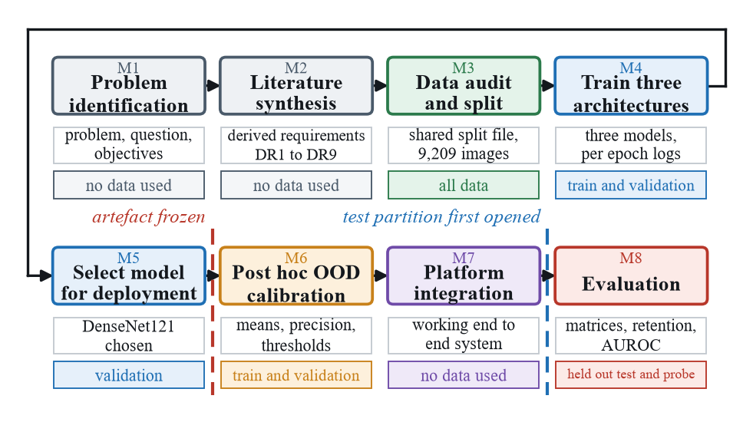
Figure 4.1: Research methodology execution workflow, showing the order of the phases and the point at which the artefact was frozen for evaluation.

4.5.1 Problem identification
The problem was defined from evidence. The differing treatment paths of the three aetiologies and the unevenness of radiologist availability establish that automated triage support has a use, while the overconfidence results [11], [10] establish that a softmax classifier cannot signal when it is out of its depth.

4.5.2 Relevance justification
Solving the problem is timely because deployment, not accuracy, is the binding constraint. Classifiers of adequate accuracy are widely available, and the obstacle to placing one in front of a user is that it cannot decline to answer and cannot evidence what it looked at. Both remedies consume signals a trained classifier already produces, so the cost of not applying them is an attention cost.

4.5.3 Comparative analysis and gap justification
The comparison in Section 3, in Table 3.1 and Table 3.2, shows what is missing rather than only what exists: no reviewed system reports an input validity metric and none reports an explanation localisation metric.

4.5.4 Define and finalise objectives
Each objective was linked to the problem and to its planned evaluation before any measurement was taken. The reporting location of every result was fixed before that result existed, which removes the later freedom to relocate an inconvenient finding, and it makes visible which constructs are measured directly and which by proxy. It also exposes RO4a, whose construct cannot be fully operationalised because it is measured against a constructed probe.

4.5.5 Design, development and data management
The artefact was developed as five working increments, each exercisable end to end: the platform skeleton against a placeholder predictor; the real inference service and trained models replacing it; the explanation redesign, moving Grad-CAM to logits and adding lung restriction and measurement; the safeguard, its calibration and the withholding behaviour; and reporting. Augmentation was applied to the training partition only.

4.5.6 Evaluation and communication
Classification results are analysed from the confusion matrix rather than from summary accuracy, with macro averaging for the headline, and errors analysed structurally by identifying which off diagonal cells carry the mass. Input validity uses AUROC with retention at the operating point, reported both where the threshold was set and where it was not. No significance testing is performed, since a single run per architecture gives one measurement per condition.

4.6 Project management methodology
An iterative and incremental method was selected rather than a formal framework. With a single developer the ceremonies of SCRUM would have no one to perform them and the governance of PRINCE 2 would be disproportionate. The project does have uneven technical uncertainty: the platform layers are conventional, whereas the behaviour of the validity signals on this model could only be discovered by building and measuring, and an iterative method lets that discovery change the design without invalidating completed work.

4.6.1 Project timeline
The schedule was governed by dependencies rather than by the calendar: model selection could not begin before the shared split file existed, calibration could not begin before the weights stopped changing, and the evaluation window opened only once the artefact was frozen.

4.6.2 Ethical considerations
The study uses publicly released, de identified research images and involves no human participants, so institutional ethics approval was not applicable, and the licences permit academic research use. The platform does handle personal data, so access is authenticated with signed tokens and authorised by role, upload directories are protected against execution and browsing, and deleting an account removes its scan records. The most substantial issue is safety of use rather than privacy: the design withholds the diagnosis, discloses low in lung attention and states that the output is decision support. Fairness could not be evaluated, because the collections carry no demographic attributes.

4.7 Stakeholder analysis
Four user roles are enforced and a fifth stakeholder is affected without using the system. What matters is not what each role would like, which produces a feature list, but what each role requires in order not to be misled.

4.8 Operationalisation process
Each objective was converted into a construct, an instrument and a metric with a fixed reporting location before any requirement was written. Requirements originate from the literature review, the measured properties of the dataset and the objectives themselves. None originates in a stakeholder interview, which is a weaker source of user insight but a stronger source of evidential traceability.
Two rules governed the derivation. Prioritisation follows evidential weight rather than implementation convenience, and each requirement was written to be verifiable before it was written to be implementable, which is why the criteria in Table 4.3 are numeric wherever a number was available.

4.9 System and model analysis

4.9.1 Use case analysis
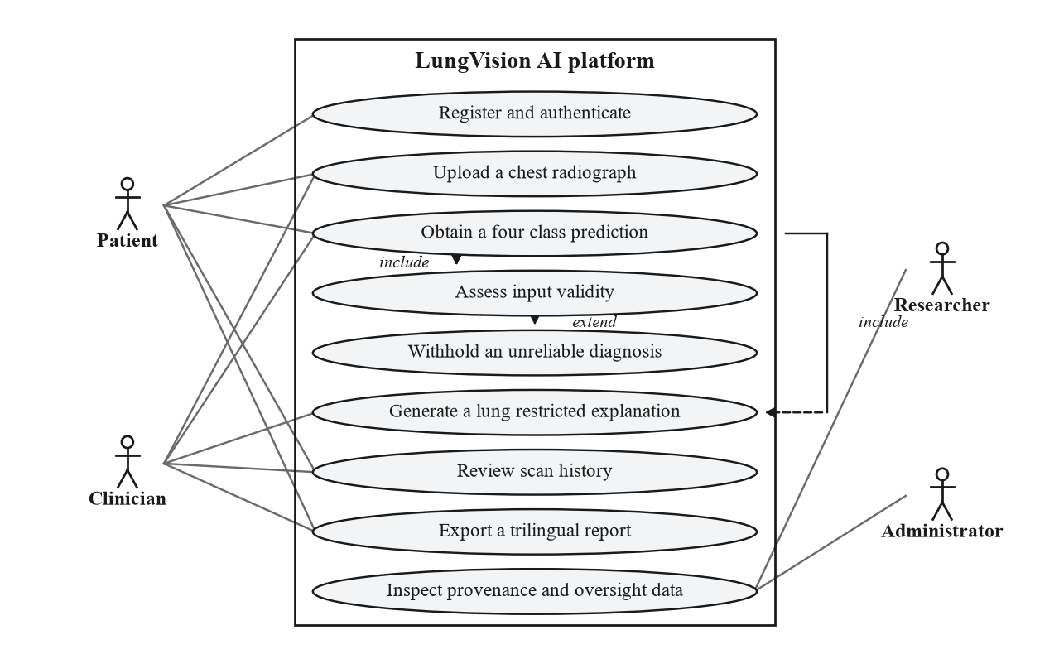
Figure 4.2: Use case diagram of the delivered platform.

Figure 4.2 shows the use cases and the four roles that reach them. Two relationships carry the contribution: obtaining a prediction includes assessing input validity, so no caller can obtain a classification without the assessment having run, and assessing validity extends into withholding an unreliable diagnosis.

4.9.2 Class analysis
Figure 4.3 shows the core classes. The scan entity stores all four probabilities rather than only the winning one, which makes retrospective error analysis possible, and stores the verdict, score and reason as persisted columns, since a verdict living only in the response would be lost on reload and the record would revert to showing a diagnosis the system had declined to make.
Figure 4.3: Class diagram of the core domain and service classes.

4.9.3 Activity analysis
Figure 4.4 shows the analysis workflow. Two decision nodes are its substance: the first gates the diagnosis on the Mahalanobis comparison and routes a flagged input to a branch producing no diagnostic content, the second gates the caution on the measured in lung fraction. Both converge on the same persistence step.
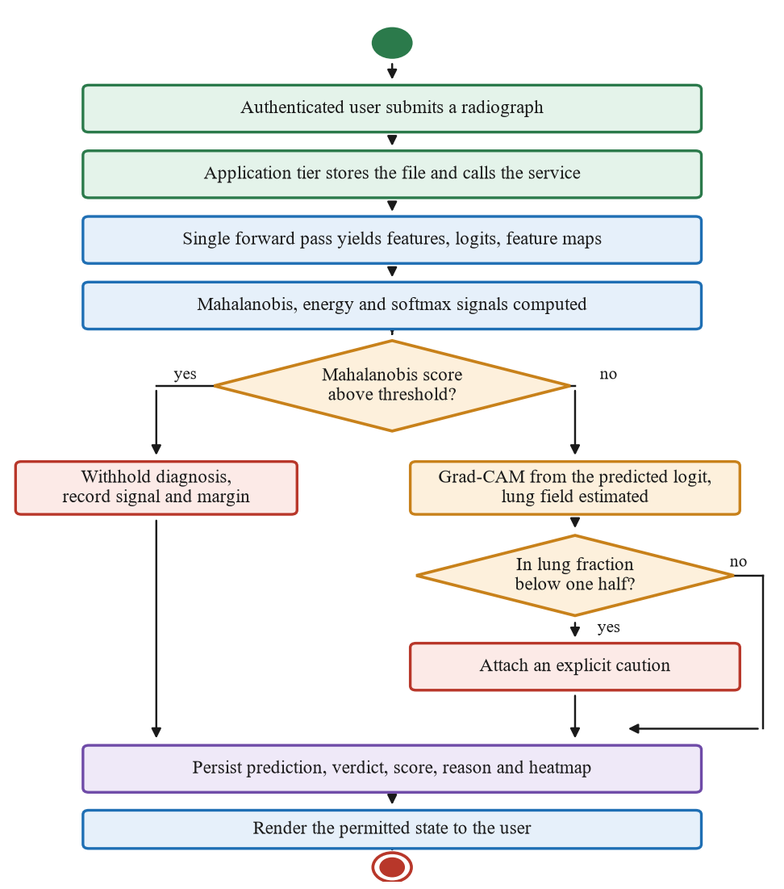
Figure 4.4: Activity diagram of the analysis workflow.

4.9.4 Sequence analysis
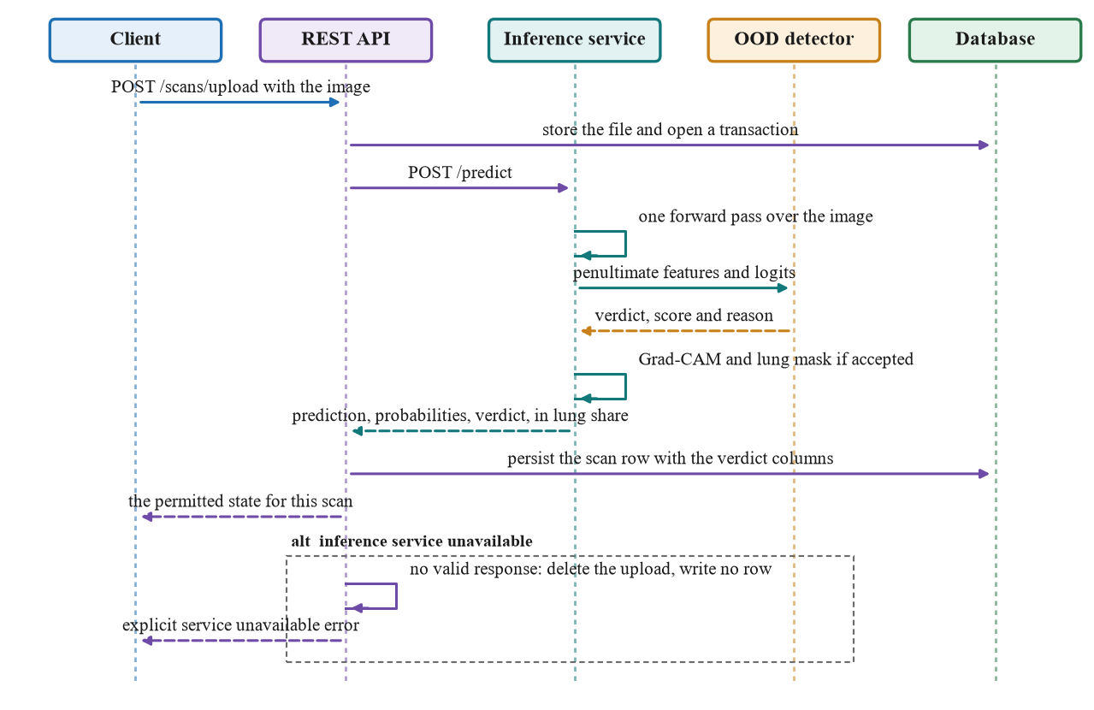
Figure 4.5: Sequence diagram for the upload and analyse use case.
Figure 4.5 maps the interaction for the upload and analyse use case, including the exception flow. The ordering is why the safeguard cannot be bypassed: the application tier reaches a prediction only through the inference service, and the inference service reaches a response only through the detector. No row is written when no genuine prediction exists.

4.9.5 State analysis of the result view
A state analysis is more informative here than a further structural diagram, because the rule following from the research problem is that uncertainty must be at least as visible as the result. The view can occupy five states. Accepted shows the predicted class, a confidence capped below certainty, all four probabilities and the lung restricted heatmap; accepted with caution adds the measured percentage below one half; withheld shows no diagnostic content at all. The last two cover a failed explanation and an unavailable service.

4.10 Proposed system architecture
Figure 4.6 shows the deployment architecture: a web presentation tier, a REST application tier providing authentication, persistence, reporting and orchestration, and a separate inference tier that owns the models and is where the contribution lives. Separating inference was the principal architectural decision, because model loading is expensive and must be amortised by a long lived process, and isolating the models behind a narrow interface makes the safeguard a property of the system rather than of one caller. The application tier treats unavailability as an error rather than degrading to a placeholder. The data design is small: users, an activity log, and a scans table holding one row per analysis with the image paths, predicted class and confidence, four probabilities, model identifier, verdict, score, reason and status. The classifier head ends in a narrow dense layer, 256 units wide on the deployed model, which is the space in which the Gaussians of Section 4.12.1 are fitted.
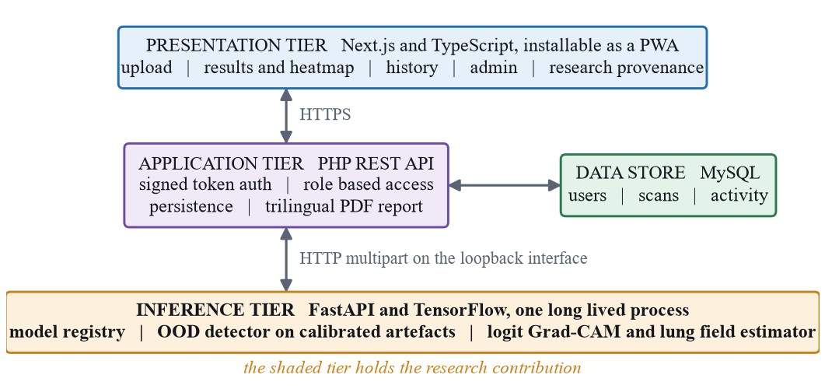
Figure 4.6: Proposed deployment architecture, showing the three tiers, the data store and the location of the research contribution.

4.11 Functional and non functional requirements
Table 4.2 states the functional requirements carrying the contribution and Table 4.3 the non functional requirements with a criterion and a verification location for each. Responsible design controls appear as functional requirements rather than policy statements, which is why FR3, FR4, FR6 and FR10 are verified like any other function.
Table 4.2: Functional requirements.
ID | Requirement | Priority
FR1 | Accept a frontal chest radiograph in JPEG or PNG from an authenticated user | Must
FR2 | Classify into one of the four classes and return all four probabilities | Must
FR3 | Assess every input for validity before the result is returned | Must
FR4 | Withhold the diagnosis and state the reason when the input falls outside the training distribution | Must
FR5 | Generate a Grad-CAM explanation restricted to the estimated lung field | Must
FR6 | Report the attention inside the lung field and warn below one half | Must
FR7 | Persist the prediction, probabilities, verdict, score and reason | Must
FR8 | Generate a report in English, Sinhala or Tamil with the withholding notice | Should
FR9 | Expose model and evaluation provenance to researcher and administrator roles | Should
FR10 | Refuse to fabricate a result if the inference service is unavailable | Must
Table 4.3: Non functional requirements and acceptance criteria.
ID | Quality | Acceptance criterion | Verified in
NFR1 | Diagnostic performance | Test accuracy of the deployed model at or above 85 per cent | Section 5.1
NFR2 | Safety, retention | At least 90 per cent of held out genuine scans accepted | Section 5.2
NFR3 | Safety, sensitivity | At least 95 per cent of far probe images flagged | Section 5.2
NFR4 | Explainability | In lung attention computed wherever a lung field is found | Section 5.3
NFR5 | Performance | Single image response under 5 seconds without an accelerator | Section 5.5.1
NFR6 | Security | Endpoints reject unauthenticated and cross user access | Section 5.5.2
NFR7 | Reliability | Explanation failure must not fail the prediction | Section 5.5.2
NFR8 | Reproducibility | Split, logs, matrices and thresholds persisted | Section 4.5.6

4.12 Implementation of the framework
This section documents how the framework was built, concentrating on the three components that carry the contribution: the safeguard and its calibration, the reconstruction that makes Grad-CAM produce usable gradients, and the lung field estimator. All three operate on an unmodified trained classifier. All three architectures were trained beforehand with a two stage transfer learning protocol on the shared split, with class weights in the loss, Adam optimisation, early stopping and checkpointing on best validation accuracy.

4.12.1 Algorithms and core logic
The trained model ends in a dense softmax layer. To obtain the required signals the implementation takes the kernel and bias of that layer and builds an auxiliary model mapping the input to the penultimate activation. Writing h(x) for that activation and W and b for the kernel and bias, the logits are recovered by the same affine map the trained model would apply, and the probabilities follow from their softmax.
The reconstruction is exact rather than approximate, because it reuses the parameters the model itself would apply, so one evaluation yields the feature vector the detector needs, the logits the energy score needs and the probabilities shown to the user, all describing the same forward pass. Computing them independently would not guarantee that correspondence, and it is the correspondence rather than the saving in computation that motivates the design. Calibration runs once per model and reads the same split file used for training, so only genuine data participates. The class conditional mean is the sample mean of the features of that class, and a single covariance matrix is shared across all four classes, estimated from the pooled within class scatter and regularised before inversion.
A shrinkage term, a coefficient of 0.01 on the identity, is added to the pooled within class covariance to keep it invertible. The fitting sample of 1,200 images is only about 4.7 times the feature dimensionality of 256, so four separately estimated matrices would be rank deficient, and tying the covariance across classes following Lee et al. [16] is the standard response. Each signal is then evaluated on a held out validation subsample and its threshold placed at the quantile retaining a target proportion of genuine scans, set to 0.95.
The direction of the comparison differs by signal: for the Mahalanobis and energy scores a larger value indicates a more anomalous input, whereas for the maximum softmax probability the ordering is reversed. Setting the operating point from genuine data alone is deliberate, because the safeguard then never sees an invalid example during calibration. At runtime the detector computes the Mahalanobis distance to the nearest class conditional mean, the energy score at temperature T fixed at 1.0 [17], and the maximum softmax probability [15].
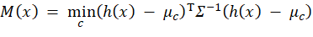 (4.1)
The distinction between these definitions is not presentational. The Mahalanobis score of equation (4.1) measures a distance in the representation the network has learned, whereas the energy and maximum softmax scores measure confidence in the four numbers that representation is collapsed into. The deployed policy uses the Mahalanobis flag alone, for the empirical reason reported in Section 5.2, so the verdict is a single indicator in which a value of one withholds the diagnosis.
Expressing the policy as a function of the flags rather than hard coding one signal is what allows the verdict to be replaced by a conjunction or disjunction over the three flags through configuration alone, without repeating the calibration. The explanation mechanism is a second auxiliary graph over the same weights. The pretrained backbone is a nested layer whose internal feature map is not an output of the outer model, so the forward path is rebuilt explicitly. The numerical problem matters more: Grad-CAM is defined on the class score before the softmax [30]. Writing A superscript k for the k th channel of the final convolutional feature map, Z for the number of spatial positions in it and z sub c for the pre softmax logit of the predicted class, the channel weights are the globally average pooled gradients of that logit, and the map itself is the rectified sum of the feature maps weighted by them.
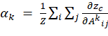 (4.2)
Had the post softmax probability been differentiated instead, the chain rule would have introduced a factor approaching zero exactly when the model is confident. For the COVID-19 and Normal classes, where predicted probabilities routinely exceed 0.97, that factor falls below 0.03 and the map is dominated by numerical noise, whereas differentiating the logit removes the factor entirely. The lung field estimator is classical rather than learned, because a learned segmenter would add a second set of trained weights and a second failure mode to a component meant to make the primary model more trustworthy. On a downscaled, contrast equalised copy it isolates the patient silhouette by Otsu thresholding, finds air filled regions at a low intensity percentile, and accepts at most two plausible components.
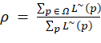 (4.3)
Two properties of equation (4.3) are deliberate. Both numerator and denominator are computed on the unmasked map, so the quantity describes where the model actually looked; a fraction computed after masking would be identically one. And the upsampling precedes the masking, because a fraction evaluated at feature resolution would be biased by the coarseness of the boundary. The fraction is returned with every response and drives the caution described in Section 4.13.

4.12.2 Pipeline workflow
Figure 4.7 shows the inference pipeline as a block series. All three outputs derive from one forward pass: the penultimate feature vector supplies the Mahalanobis distance, multiplying it by the final layer weights reconstructs the logits exactly and so supplies both the energy score and the probabilities, and the last convolutional feature map supplies Grad-CAM.
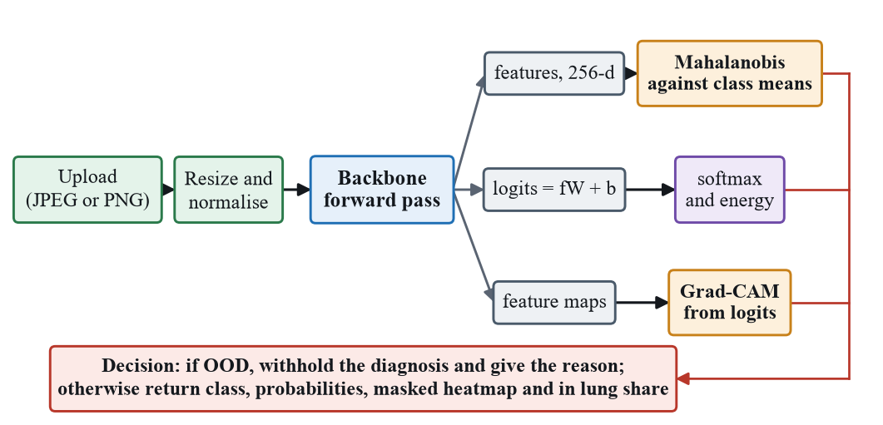
Figure 4.7: Inference pipeline block diagram, showing the single forward pass from which the classification, the validity verdict and the explanation are all derived.

4.13 Significant implementation attempts
Three implementation attempts were changed by the evidence they produced. Grad-CAM was moved from the softmax output to the logits after heatmaps were observed to be degenerate on confident predictions. The decision policy was reduced to Mahalanobis alone once calibration showed that energy barely separated the populations. And the in lung measurement was added because masking made the heatmaps look more plausible without changing the classifier.
Table 4.4 records the realised training configuration, documented here because it constrains what the results can support. Batch size differs, reduced to fit larger resolutions into memory, and EfficientNetV2B3 used a head learning rate an order of magnitude larger. Most consequentially, EfficientNetV2S was trained with simple rescaling to the unit interval, whereas the EfficientNetV2 weights expect the interval from minus one to one. The frozen phase isolates the effect: 83.20 against 68.07 per cent is a gap that capacity does not explain.
Table 4.4: Realised training configuration.
Model | Input | Normalisation | Batch | Head LR | Tune LR | Phase 1 best | Phase 2 best
DenseNet121 | 224 | Rescale 0 to 1 | 32 | 1e-4 | 1e-5 | 84.21 per cent | 85.95 per cent
EfficientNetV2B3 | 300 | Family preprocessing, minus 1 to 1 | 24 | 1e-3 | 1e-5 | 83.20 per cent | 85.66 per cent
EfficientNetV2S | 300 | Rescale 0 to 1 | 16 | 1e-4 | 1e-5 | 68.07 per cent | 81.39 per cent

4.14 Evaluation design and test plan
This section states what is tested, the criteria used and how the results answer the objectives; negative results are reported alongside positive ones. Table 4.5 maps each objective to its evaluation question, method, metric and success criterion.
Table 4.5: Evaluation design mapped to objectives.
Objective | Evaluation question | Method | Metric | Success criterion
RO2 | How do the three architectures perform and where do they fail? | Held out test evaluation on the shared split | Accuracy, per class precision, recall, F1, confusion matrix | At or above 85 per cent, per class behaviour characterised
RO3 | Does the safeguard withhold diagnoses end to end? | Functional test cases through the full stack | Pass or fail | All must priority cases pass
RO4a | Can invalid inputs be separated from genuine scans? | Calibration on genuine data, then held out data and a far probe | AUROC, flag rate, retention | Retention at or above 90 per cent, flag rate at or above 95
RO4b | Where do the explanations place their attention? | Qualitative reading of the lung restricted maps | Regions activated per class; in lung share disclosed | Attention falls on clinically associated regions
NFR5 | Is the system responsive enough? | Timed end to end requests | Seconds per request | Under 5 seconds
Two features of this design were fixed before any result existed. The success criteria are the acceptance criteria of Table 4.3 and were not revised once measurements were available; NFR1 is met by 0.31 of a percentage point, a margin narrow enough that a different seed could plausibly have failed it. RO4b is judged on where the attention falls rather than on reaching a target value.
All experiments were performed on the frozen artefact of Section 4.12. Model evaluation used the held out test partition of 1,382 images, which no model saw during training or checkpoint selection and which took no part in calibration. The probe is sixty generated images of uniform noise, smooth gradients and solid colour fields from a fixed seed. It is a far regime construct only.
Table 4.6 records the ten cases, each exercising behaviour on which a research claim depends; routine authentication and profile cases were executed but are omitted. The set spans positive, negative and boundary conditions: T1 and T5 confirm intended behaviour, T2, T8, T9 and T10 confirm refusal, T3, T4 and T6 confirm that a decision taken inside the service survives persistence, reopening and export, and T7 confirms graceful degradation.
Table 4.6: Test cases.
ID | Type | Test | Expected | Result
T1 | Functional | Upload a genuine test radiograph | One class with four probabilities summing to 100 per cent | Pass
T2 | Functional | Upload a synthetic noise image | Diagnosis withheld, feature space signal named | Pass
T3 | Functional | Reopen a withheld case | Withholding persists, no diagnosis shown | Pass
T4 | Functional | Report a withheld case | Notice occupies the diagnosis position, all three languages | Pass
T5 | Functional | Upload where lung fields are found | Heatmap restricted to the lungs, fraction returned | Pass
T6 | Functional | Scan with low in lung attention | Caution states the measured percentage | Pass
T7 | Non functional | Force the explanation path to fail | Prediction returned, explanation degraded (NFR7) | Pass
T8 | Non functional | Stop the service and upload | Explicit error, upload removed, no record | Pass
T9 | Non functional | Request another user scan | Request refused (NFR6) | Pass
T10 | Non functional | Request provenance as a patient | Access refused (NFR6) | Pass

4.14.1 Testing and evaluation workflow
The evaluation ran in a fixed order, and the order is what makes the numbers reportable. The artefact was frozen at the end of M6 and the probe was generated from a fixed seed. Execution followed in three passes sharing no state, over the test partition, over the held out scans and the probe, and over processed radiographs.
The reference points come from the realised split of Table 4.1 or from the metric definitions, not from other studies. A classifier always predicting Normal would score 35.53 per cent accuracy and a macro F1 of 0.131, and a random ranking scores an AUROC of 0.500.

4.14.2 Justification of the selected evaluation strategies
The methods were selected against the objectives rather than assembled as a checklist. Partition separation is used because the claim is about generalisation, per class metrics because the consequential distinction is one pair of classes, and baseline comparison in two forms, the trivial classifier references and the comparison of the three signals.

5 RESULTS
This section reports what was measured. The interpretation of these figures is deferred to Section 6.

5.1 Classification performance and error structure
Table 5.1 reports overall performance on the held out test set of 1,382 images, with macro averages so that the two smaller classes are not masked by the two larger ones, and Table 5.2 gives the per class breakdown for the deployed model.
Table 5.1: Test set performance on the shared split, with N equal to 1,382.
Model | Accuracy | Macro precision | Macro recall | Macro F1 | Weighted F1 | Errors
DenseNet121 | 85.31 per cent | 0.843 | 0.845 | 0.844 | 0.851 | 203
EfficientNetV2B3 | 84.30 per cent | 0.834 | 0.825 | 0.828 | 0.838 | 217
EfficientNetV2S | 80.54 per cent | 0.798 | 0.812 | 0.798 | 0.803 | 269
Table 5.2: Per class performance of DenseNet121.
Class | Precision | Recall | F1 | Support
COVID-19 | 0.974 | 0.984 | 0.979 | 192
Normal | 0.929 | 0.990 | 0.959 | 491
Bacterial pneumonia | 0.829 | 0.764 | 0.795 | 450
Viral pneumonia | 0.640 | 0.643 | 0.641 | 249
The spread across classes is far larger than the spread across architectures. DenseNet121 separates COVID-19 and Normal almost perfectly, at F1 of 0.979 and 0.959, while viral pneumonia reaches only 0.641, so the 85.31 per cent headline alone would conceal a difference of 0.34 in F1 between the best and worst class.

5.2 Input validity detection
The detector was calibrated on genuine data only, at a target retention of 95 per cent of validation scans. Table 5.3 reports the calibration outcome and the measured separability of each signal: the feature dimensionality and the sample sizes the statistics were fitted and thresholded on, the retention achieved on the validation partition where the threshold was set and on the test partition where it was not, the flag rate on the probe, the AUROC of the Mahalanobis and energy signals against it, and the policy the deployed service applies.
Table 5.3: Out of distribution detection results.
Quantity | Value
Feature dimensionality | 256
Calibration sample | 1,200 training and 600 validation
Retention on validation, where thresholds were set | 95.0 per cent
Retention on the test partition | 92.5 per cent
Far probe flagged | 100 per cent of 60 images
AUROC, Mahalanobis, far probe | 1.000
AUROC, energy, far probe | 0.539
Deployed decision policy | Mahalanobis
Two results matter. The safeguard meets both operating criteria, retaining 92.5 per cent of genuine held out scans against the 90 per cent floor of NFR2 while flagging every probe image against the 95 per cent floor of NFR3. The second result is negative and more informative: Mahalanobis separates the populations perfectly at an AUROC of 1.000 while energy achieves 0.539, barely distinguishable from a random ranking, which is why the deployed policy uses Mahalanobis alone. One limitation is recorded rather than left to be inferred. The maximum softmax probability is computed for every scan and its threshold calibrated, but its separability against the probe was never computed, so DR5 is satisfied for the operating point and not for the separability measure. The omission affects neither the deployed behaviour nor the negative energy result, but the baseline of Hendrycks and Gimpel [15] is present in the system yet absent from the comparison.

5.3 Explanation localisation
The explanation path was examined on processed radiographs. For correctly classified bacterial cases the lung restricted maps concentrate on focal consolidation, viral cases produce the more diffuse bilateral activation consistent with interstitial infiltrate, and normal radiographs show little salient activation. The attention therefore falls on the regions clinically associated with each class rather than on borders or annotation artefacts. That reading is qualitative, and it is paired with a measurement: the system computes the share of unmasked mass lying inside the lung field and raises a caution below one half. On the scan evidenced in Section 5.5.2 that share was 0.350, so the caution fired. That a radiograph classified correctly at 99.9 per cent confidence still places most of its attention outside the lung fields is precisely why the quantity is disclosed: no system in Table 3.1 reports it, and the masked overlay on its own would have concealed it.

5.4 Error analysis
Figures 5.1, 5.2 and 5.3 present the test set confusion matrices of DenseNet121, EfficientNetV2B3 and EfficientNetV2S respectively, which is where the structure of the errors is visible. The diagonal of each matrix carries the correct predictions and the off diagonal cells show which classes are exchanged for which, so the two cells joining bacterial and viral pneumonia can be read directly against the four cells joining either of them to Normal or COVID-19.
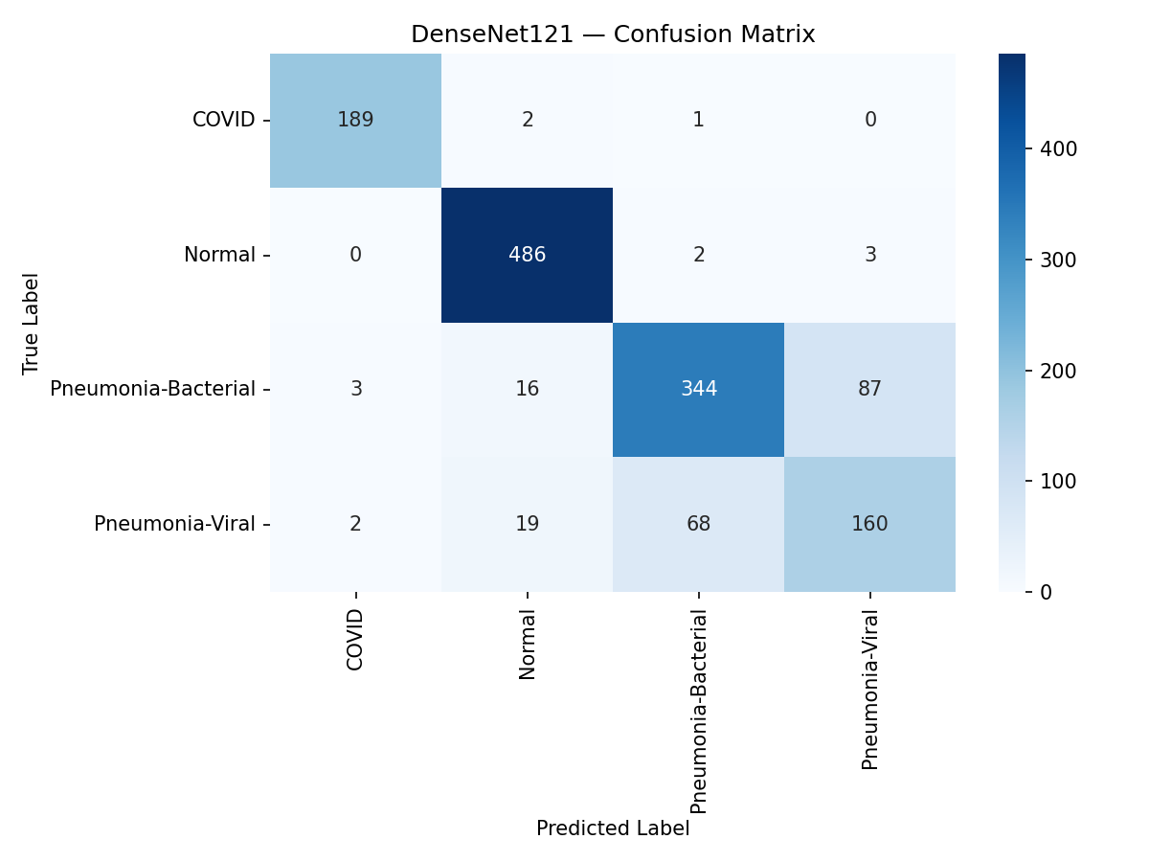 | 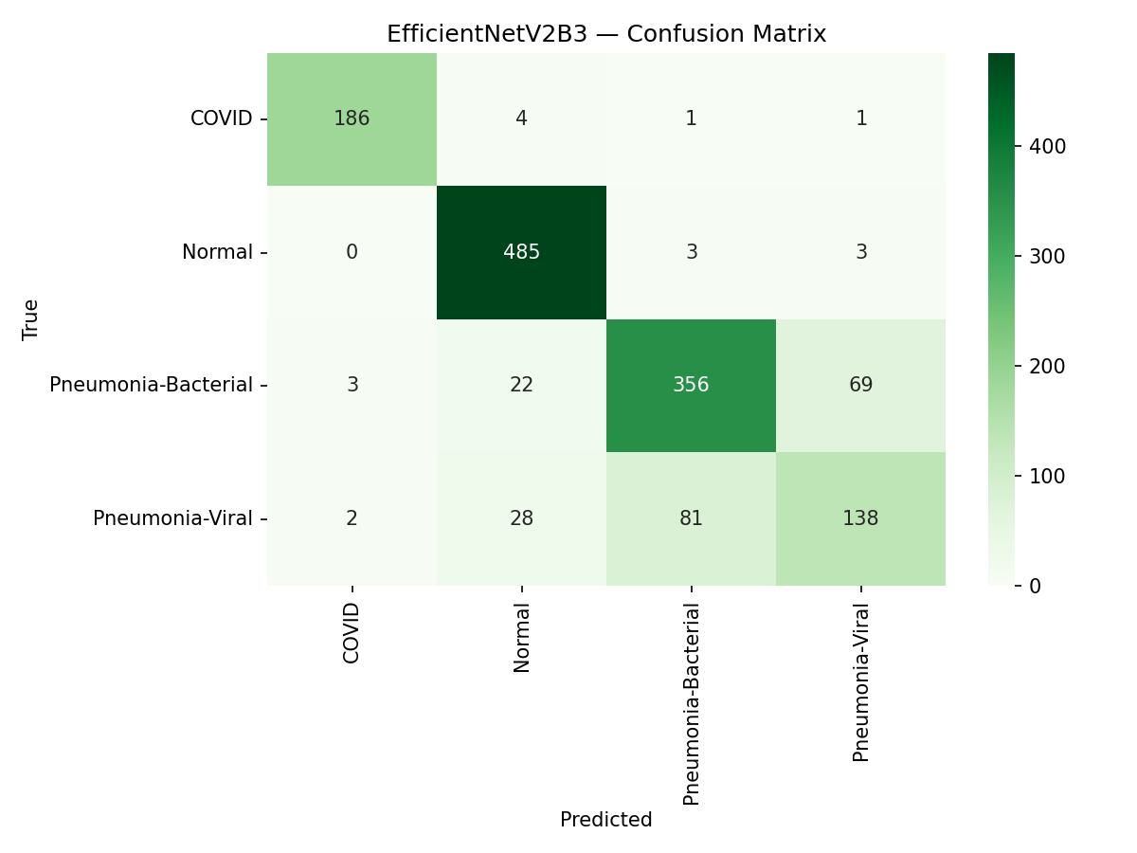 | 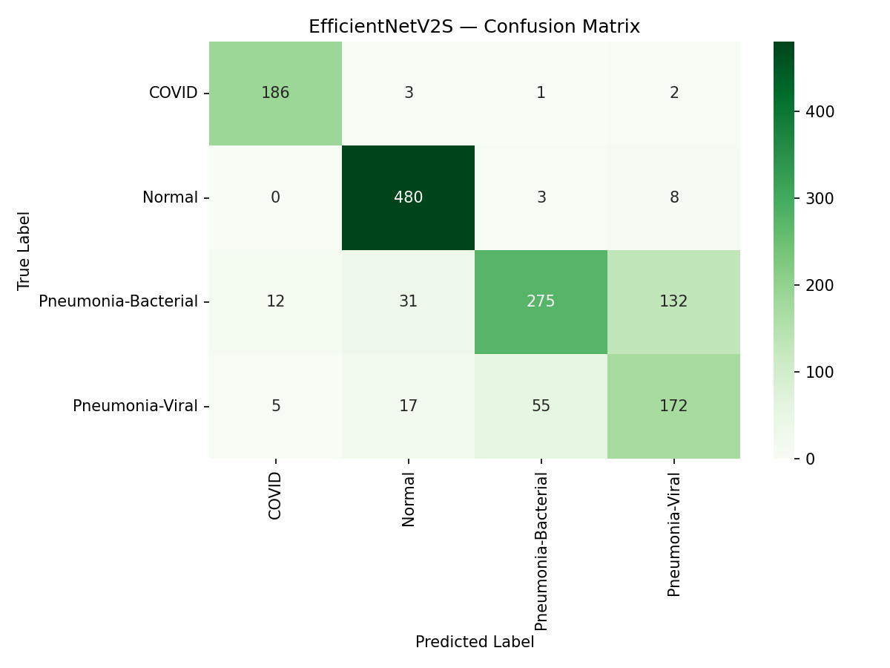
Figure 5.1: DenseNet121 confusion matrix. | Figure 5.2: EfficientNetV2B3 confusion matrix. | Figure 5.3: EfficientNetV2S confusion matrix.

Table 5.4 quantifies that dominant mode. For each model it gives the total number of test errors, the subset falling in the two bacterial and viral cells, and that subset as a share of all errors, so the concentration can be compared across architectures rather than inferred from the matrices by eye.
Table 5.4: Concentration of errors in the bacterial and viral pair.
Model | Total errors | Bacterial and viral confusions | Share of all errors
DenseNet121 | 203 | 155 | 76.4 per cent
EfficientNetV2B3 | 217 | 150 | 69.1 per cent
EfficientNetV2S | 269 | 187 | 69.5 per cent
Between 69 and 76 per cent of the errors of every model are a confusion between bacterial and viral pneumonia, while the remaining classes are largely solved, DenseNet121 misclassifying three of 192 COVID-19 cases and five of 491 Normal cases. Recast as a screening problem it achieves a sensitivity of 95.85 per cent and a specificity of 98.98 per cent. The task is an easy screening problem with one hard discrimination embedded inside it. Figure 5.4 shows that the ordering of class difficulty is stable across the three architectures.
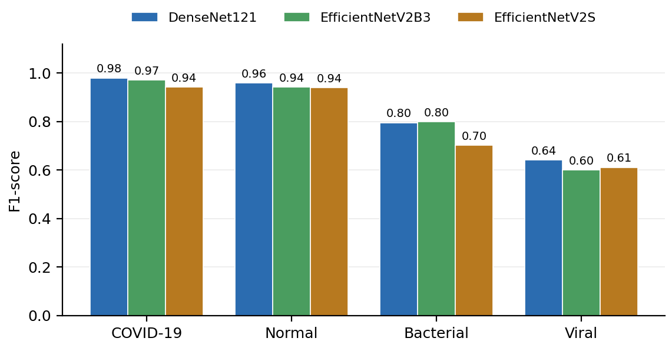
Figure 5.4: Per class F1 for the three architectures, showing a consistent difficulty ordering across models.

5.5 System and performance test results

5.5.1 Non functional test results
Latency was measured on the development machine with all four tiers running and no accelerator. The forward pass is fast, at a median of 0.36 seconds for DenseNet121, but it is not what dominates: a complete inference call takes a median of 2.94 seconds once the Grad-CAM backward pass, the lung field estimation and the encoding of the overlay are added. Over ten uploads the end to end request took a median of 3.18 seconds and a maximum of 3.33 seconds, meeting NFR5 with less margin than the design assumed. Usability and scalability were not measured.

5.5.2 Functional test results
All ten cases passed when executed against the running stack. T2, T3 and T4 matter most, because together they establish that the safeguard is a property of the record rather than of the moment: a synthetic input is refused a diagnosis, reopening the case from history still shows none, and exporting it reproduces the withholding notice in all three languages. T8 confirms that unavailability of the inference tier produces a visible failure rather than a stored record.
Three features embody the contribution at the level the user encounters. Diagnosis withholding implements FR4 from DR4: when the verdict is positive the response carries no diagnosis to be annotated, and every view renders the reason from the persisted columns. Disclosure of explanation quality implements FR6 from DR8, and refusal to fabricate implements FR10: an invalid response deletes the upload and returns an explicit error. Figure 5.5 is execution evidence for the first of those three features, captured from the running platform. A synthetic noise image was submitted through the ordinary upload path, and the response carries no predicted class, no confidence value and no probability bars. The diagnostic result is replaced by a banner naming the feature space signal that fired and stating that no diagnosis has been produced, with the uploaded image retained beside it. Figure 5.6 is the corresponding evidence for the accepted path. A frontal radiograph was submitted through the same route, and the response carries the predicted class, a confidence capped below certainty, all four class probabilities and the lung restricted Grad-CAM overlay beside the original image. For this scan the in lung share was 0.350, below the half threshold, so the caution was raised beside the result and the measured percentage was stated rather than left to be assumed. That is the case FR6 exists for.
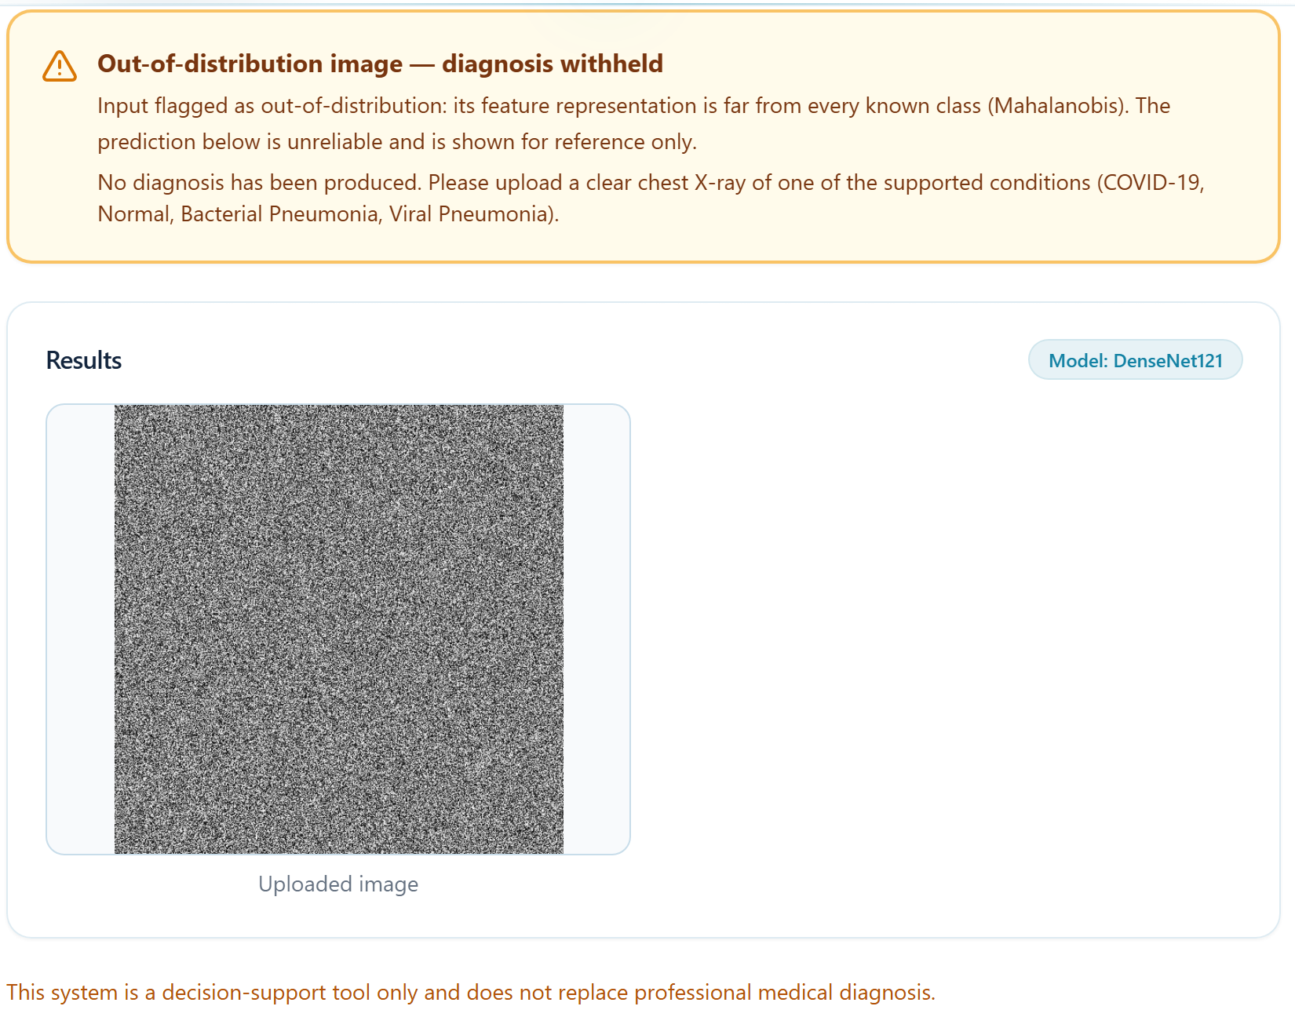
Figure 5.5: Execution evidence for FR4. The analysis view of the running platform after a synthetic noise image was submitted, showing the withheld diagnosis and the reason in place of any diagnostic content.
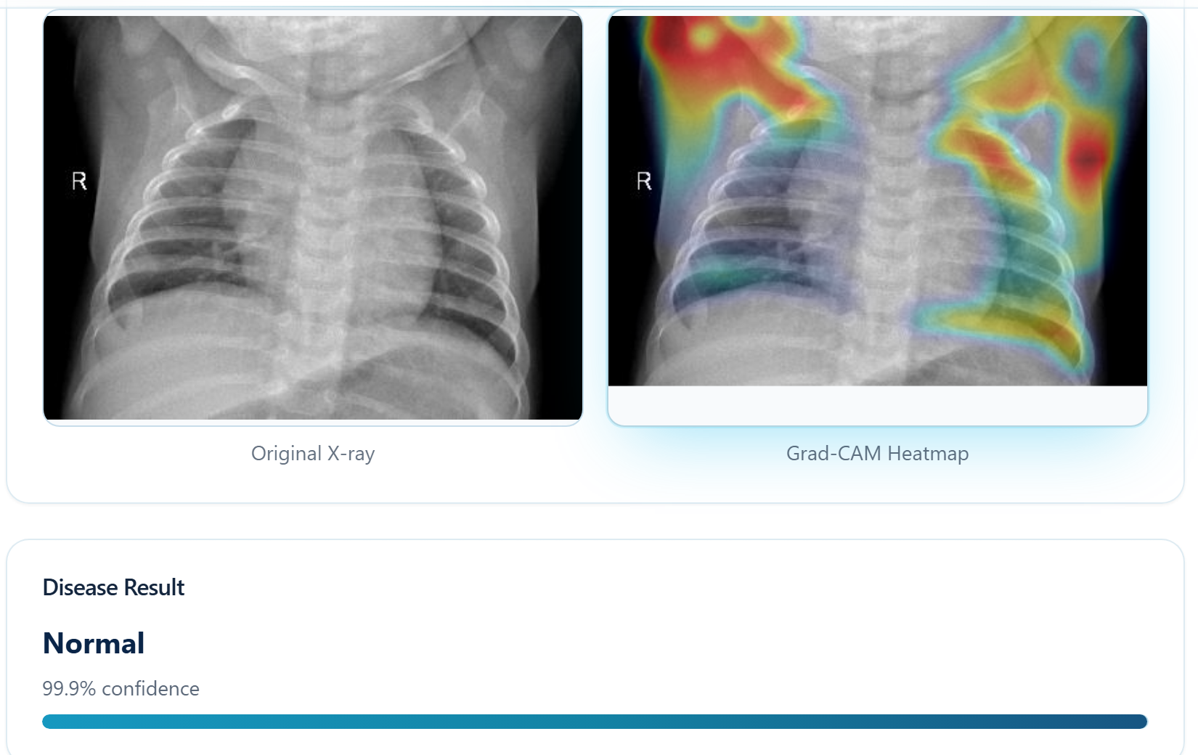
Figure 5.6: Execution evidence for FR2, FR5 and FR6. The analysis view after a frontal radiograph was submitted, showing the predicted class, the original image and the lung restricted Grad-CAM overlay.

6 DISCUSSION AND CONCLUSIONS

6.1 Discussion of the findings
The classification results answer RQ1 with a qualification. DenseNet121 leads on accuracy, and its dense connectivity is a plausible reason for an advantage where texture matters, but the margin of 1.01 points over EfficientNetV2B3 is fourteen images out of 1,382 from a single run, which Section 4.5.6 committed in advance to treating as inconclusive. The EfficientNetV2S result is not an architectural finding at all, because Table 4.4 documents normalisation inconsistent with its pretrained weights. The error analysis carries the most practical weight and inverts the usual framing: the system is close to solved on the distinctions the headline accuracy is composed of, and concentrated in difficulty on the one distinction that drives the antibiotic decision. This matches radiological expectation, and the implication is specific: the system is defensible as a screening aid and not as a classifier of aetiology. The input validity results answer RQ2 affirmatively within the tested regime, and the negative energy result is theoretically informative. Energy is a function of the logits [17], so if a model produces large logits for inputs it has never seen then energy cannot separate them, which is the overconfidence documented in [11] and [10]. Mahalanobis operates before that collapse, so which signal works must be measured [18]. On RQ3 a qualitative reading cannot by itself exclude the shortcut learning DeGrave et al. demonstrate [19].

6.2 Achievement of the research objectives
Each objective is assessed against the evidence of Section 5 rather than against intention, and Table 6.1 records that assessment objective by objective. RO1 was accomplished through the review of Section 3, evidenced by every later design decision tracing to one of the nine derived requirements. RO2 was accomplished by training three architectures on one shared split and reporting the per class breakdown the literature generally omits. RO3 was verified behaviourally by T2, T3 and T4. RO4 divides: detection was accomplished within the far regime only, and the explanation was examined qualitatively.
Table 6.1: Objective achievement against reported evidence.
Objective | Evidence | Outcome
RO1 | Thematic review producing nine derived requirements | Achieved
RO2 | Three architectures on a shared split at 85.31, 84.30 and 80.54 per cent with per class metrics | Achieved, with the EfficientNetV2S run confounded by preprocessing
RO3 | Safeguard integrated end to end, withholding verified by T2, T3 and T4 | Achieved
RO4a | Retention 92.5 per cent, flag rate 100 per cent, Mahalanobis AUROC 1.000 against energy 0.539, Table 5.3 | Achieved for the far regime only
RO4b | Lung restricted maps fall on the regions clinically associated with each class, Section 5.3 | Achieved qualitatively; the in lung share is disclosed
RO5 | Conditions of applicability derived | Achieved
Together these answer the main research question with a bounded affirmative. A safeguard fitted entirely from the genuine data of the model itself converted a silent failure mode into a visible one: every probe image was refused a diagnosis, at a cost of 7.5 per cent of genuine held out scans also being refused. Three boundaries constrain it: the far regime only, dependence on the signal being chosen empirically, and a safety rather than an accuracy improvement.

6.3 Limitations and threats to validity
Four threats bound these conclusions. The architecture comparison is incompletely controlled, since batch size varied, one model used a different head learning rate and one used inconsistent normalisation, the last invalidating the EfficientNetV2S result as an architectural claim. The input validity evaluation is limited by its probe, which is a sanity check and not validation against the near regime. The explanation finding is qualitative and rests on an unsupervised lung field estimator. And generalisability is bounded by the single dataset and the absence of seed replication.
Four difficulties were encountered and each was handled rather than avoided. Grad-CAM produced degenerate heatmaps on confident predictions, resolved by reconstructing the classifier as a linear layer. Calibration showed energy barely separated the populations, so the policy was reduced to a single signal. The audit found duplicates, so it had to precede split generation. And training without an accelerator consumed more of the schedule than planned. These difficulties bounded what the project could do rather than what its results mean.

6.4 Practical implications
The practical value lies in the safeguard rather than in the classifier. Any organisation that has already trained and validated a medical imaging model faces the same problem, namely that the model cannot decline to answer and cannot be casually retrained to acquire that ability. The method demonstrated here requires no retraining, no additional labelled data and no architectural change, so it is applicable to a deployed model rather than only to one still in development.
The realistic deployment is screening and triage where radiologist availability is limited. The measured strength is abnormality screening at 95.85 per cent sensitivity and 98.98 per cent specificity, so the plausible users are primary care and district level facilities needing to know which radiographs warrant urgent expert review. The measured weakness is discrimination of aetiology, where a viral recall of 0.643 cannot guide an antibiotic decision. Adoption would require external validation at the deploying institution and evaluation against the near regime.

6.5 Recommendations for future work
Five lines of work follow from the limitations. The most important is evaluation against the near regime, assembling genuine radiographs of untrained conditions and real photographs and re measuring the detector, because that regime determines whether the safeguard is clinically meaningful. The second is retraining EfficientNetV2S under matched preprocessing and repeating all runs across multiple seeds. The third is targeting the bacterial and viral confusion directly. The fourth is training on lung segmented inputs [33]. The fifth should be first, because it costs almost nothing: computing separability for the maximum softmax probability on the existing probe. In closing, this thesis addressed the gap between a chest radiograph classifier that is accurate and one that is safe to deploy. It built and evaluated a four class explainable framework in which a post hoc safeguard, fitted without retraining, withholds diagnoses for inputs the model cannot assess, and in which the explanation is restricted to the lung fields and its localisation disclosed. The deployed model reached 85.31 per cent test accuracy and the safeguard retained 92.5 per cent of genuine held out scans while refusing every probe image.

6.6 Conclusions
Three conclusions follow from the evidence of Section 5, against the question set in Section 1.3.
The first is that the four class task is within reach of ordinary transfer learning, but that the accuracy figure conceals where the difficulty lies. In all three models the majority of the errors fell in the single bacterial and viral pair, so the per class error structure describes the task far more usefully than a headline accuracy does, and the separation that carries the antibiotic decision is the weakest part of the result.
The second is that the closed world failure of softmax can be addressed after training rather than during it, and that the usable signal lies in the representation rather than in the output. The model is confidently wrong on inputs it has never seen, so its own output confidence cannot police it, whereas the feature space it has learned separates them perfectly at the cost of one matrix product at inference.
The third is that an explanation must be reported together with a statement of how far it can be trusted. Masking Grad-CAM to the lung field changes what is shown and not what the classifier used, and on the scan evidenced here most of the attention lay outside the lungs even though the class was correct. Disclosing that share is what separates an explanation from a decoration.
Taken together these support a bounded claim. The framework is suitable as supervised screening and triage support on frontal radiographs of the kind it was calibrated on, and not as an autonomous diagnostic instrument. The binding constraint is the evaluation rather than the accuracy: one curated dataset, a file level split, and a synthetic probe. Section 6.5 sets out the work needed to lift each.

REFERENCES
[1] E. J. Topol, "High-performance medicine: The convergence of human and artificial intelligence," Nature Medicine, vol. 25, no. 1, pp. 44-56, 2019.
[2] E. H. Shortliffe and M. J. Sepulveda, "Clinical decision support in the era of artificial intelligence," JAMA, vol. 320, no. 21, pp. 2199-2200, 2018.
[3] Y. LeCun, Y. Bengio, and G. Hinton, "Deep learning," Nature, vol. 521, no. 7553, pp. 436-444, 2015.
[4] G. Litjens et al., "A survey on deep learning in medical image analysis," Medical Image Analysis, vol. 42, pp. 60-88, 2017.
[5] X. Wang, Y. Peng, L. Lu, Z. Lu, M. Bagheri, and R. M. Summers, "ChestX-ray8: Hospital-scale chest X-ray database and benchmarks on weakly-supervised classification and localization of common thorax diseases," in Proc. IEEE Conf. Comput. Vis. Pattern Recognit. (CVPR), 2017, pp. 2097-2106.
[6] J. Irvin et al., "CheXpert: A large chest radiograph dataset with uncertainty labels and expert comparison," in Proc. AAAI Conf. Artif. Intell., vol. 33, 2019, pp. 590-597.
[7] M. E. H. Chowdhury et al., "Can AI help in screening viral and COVID-19 pneumonia?," IEEE Access, vol. 8, pp. 132665-132676, 2020.
[8] T. Rahman et al., "Exploring the effect of image enhancement techniques on COVID-19 detection using chest X-ray images," Computers in Biology and Medicine, vol. 132, art. 104319, 2021.
[9] P. Rajpurkar et al., "CheXNet: Radiologist-level pneumonia detection on chest X-rays with deep learning," arXiv preprint arXiv:1711.05225, 2017.
[10] A. Nguyen, J. Yosinski, and J. Clune, "Deep neural networks are easily fooled: High confidence predictions for unrecognizable images," in Proc. IEEE Conf. Comput. Vis. Pattern Recognit. (CVPR), 2015, pp. 427-436.
[11] C. Guo, G. Pleiss, Y. Sun, and K. Q. Weinberger, "On calibration of modern neural networks," in Proc. 34th Int. Conf. Mach. Learn. (ICML), 2017, pp. 1321-1330.
[12] I. D. Apostolopoulos and T. A. Mpesiana, "Covid-19: Automatic detection from X-ray images utilizing transfer learning with convolutional neural networks," Physical and Engineering Sciences in Medicine, vol. 43, no. 2, pp. 635-640, 2020.
[13] T. Ozturk et al., "Automated detection of COVID-19 cases using deep neural networks with X-ray images," Computers in Biology and Medicine, vol. 121, art. 103792, 2020.
[14] A. Narin, C. Kaya, and Z. Pamuk, "Automatic detection of coronavirus disease (COVID-19) using X-ray images and deep convolutional neural networks," Pattern Analysis and Applications, vol. 24, no. 3, pp. 1207-1220, 2021.
[15] D. Hendrycks and K. Gimpel, "A baseline for detecting misclassified and out-of-distribution examples in neural networks," in Proc. Int. Conf. Learn. Representations (ICLR), 2017.
[16] K. Lee, K. Lee, H. Lee, and J. Shin, "A simple unified framework for detecting out-of-distribution samples and adversarial attacks," in Advances in Neural Information Processing Systems (NeurIPS), vol. 31, 2018, pp. 7167-7177.
[17] W. Liu, X. Wang, J. D. Owens, and Y. Li, "Energy-based out-of-distribution detection," in Advances in Neural Information Processing Systems (NeurIPS), vol. 33, 2020, pp. 21464-21475.
[18] J. Yang, K. Zhou, Y. Li, and Z. Liu, "Generalized out-of-distribution detection: A survey," International Journal of Computer Vision, vol. 132, no. 12, pp. 5635-5662, 2024.
[19] A. J. DeGrave, J. D. Janizek, and S.-I. Lee, "AI for radiographic COVID-19 detection selects shortcuts over signal," Nature Machine Intelligence, vol. 3, no. 7, pp. 610-619, 2021.
[20] K. He, X. Zhang, S. Ren, and J. Sun, "Deep residual learning for image recognition," in Proc. IEEE Conf. Comput. Vis. Pattern Recognit. (CVPR), 2016, pp. 770-778.
[21] S. J. Pan and Q. Yang, "A survey on transfer learning," IEEE Transactions on Knowledge and Data Engineering, vol. 22, no. 10, pp. 1345-1359, 2010.
[22] D. S. Kermany et al., "Identifying medical diagnoses and treatable diseases by image-based deep learning," Cell, vol. 172, no. 5, pp. 1122-1131, 2018.
[23] M.-L. Huang and Y.-C. Liao, "Stacking ensemble and ECA-EfficientNetV2 convolutional neural networks on classification of multiple chest diseases including COVID-19," Academic Radiology, vol. 30, no. 9, pp. 1915-1935, 2023.
[24] G. Huang, Z. Liu, L. Van Der Maaten, and K. Q. Weinberger, "Densely connected convolutional networks," in Proc. IEEE Conf. Comput. Vis. Pattern Recognit. (CVPR), 2017, pp. 4700-4708.
[25] M. Tan and Q. V. Le, "EfficientNet: Rethinking model scaling for convolutional neural networks," in Proc. 36th Int. Conf. Mach. Learn. (ICML), 2019, pp. 6105-6114.
[26] M. Tan and Q. V. Le, "EfficientNetV2: Smaller models and faster training," in Proc. 38th Int. Conf. Mach. Learn. (ICML), 2021, pp. 10096-10106.
[27] N. Tajbakhsh et al., "Convolutional neural networks for medical image analysis: Full training or fine tuning?," IEEE Transactions on Medical Imaging, vol. 35, no. 5, pp. 1299-1312, 2016.
[28] J. Deng, W. Dong, R. Socher, L.-J. Li, K. Li, and L. Fei-Fei, "ImageNet: A large-scale hierarchical image database," in Proc. IEEE Conf. Comput. Vis. Pattern Recognit. (CVPR), 2009, pp. 248-255.
[29] B. Zhou, A. Khosla, A. Lapedriza, A. Oliva, and A. Torralba, "Learning deep features for discriminative localization," in Proc. IEEE Conf. Comput. Vis. Pattern Recognit. (CVPR), 2016, pp. 2921-2929.
[30] R. R. Selvaraju, M. Cogswell, A. Das, R. Vedantam, D. Parikh, and D. Batra, "Grad-CAM: Visual explanations from deep networks via gradient-based localization," in Proc. IEEE Int. Conf. Comput. Vis. (ICCV), 2017, pp. 618-626.
[31] E. Tjoa and C. Guan, "A survey on explainable artificial intelligence (XAI): Toward medical XAI," IEEE Transactions on Neural Networks and Learning Systems, vol. 32, no. 11, pp. 4793-4813, 2021.
[32] A. Barredo Arrieta et al., "Explainable Artificial Intelligence (XAI): Concepts, taxonomies, opportunities and challenges toward responsible AI," Information Fusion, vol. 58, pp. 82-115, 2020.
[33] L. O. Teixeira et al., "Impact of lung segmentation on the diagnosis and explanation of COVID-19 in chest X-ray images," Sensors, vol. 21, no. 21, art. 7116, 2021.

