Modelling humanities data with TEI-XML
Scholarly editing and manuscript cataloguing in the digital age

Dr Katarzyna Anna Kapitan (katarzyna.kapitan@chartes.psl.eu)

Transformation scenario

- Open the xml file you want to transform in the Oxygen Editor
- Click on the wrench with a red arrow in the toolbar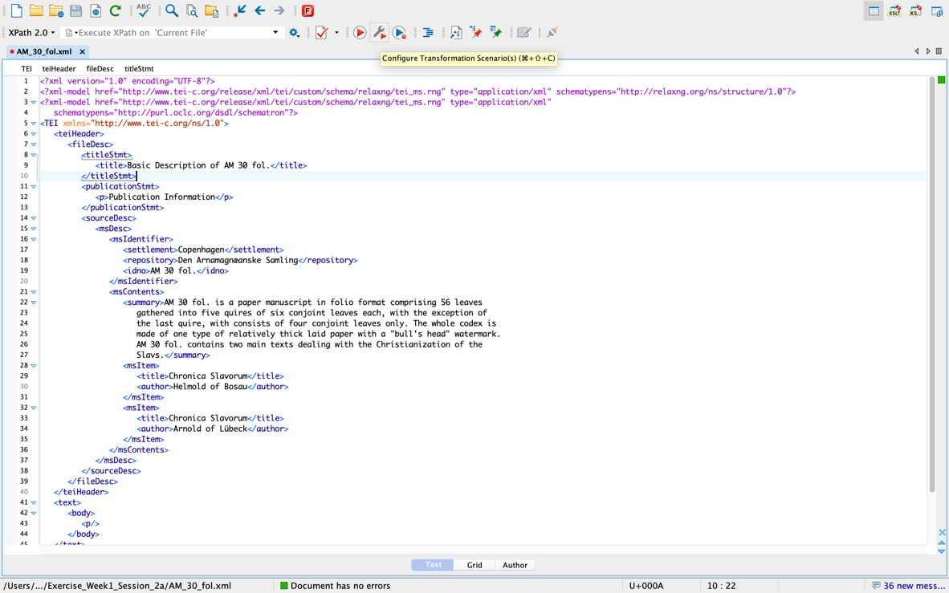

- A pop-up window will open
- Click on the “new” button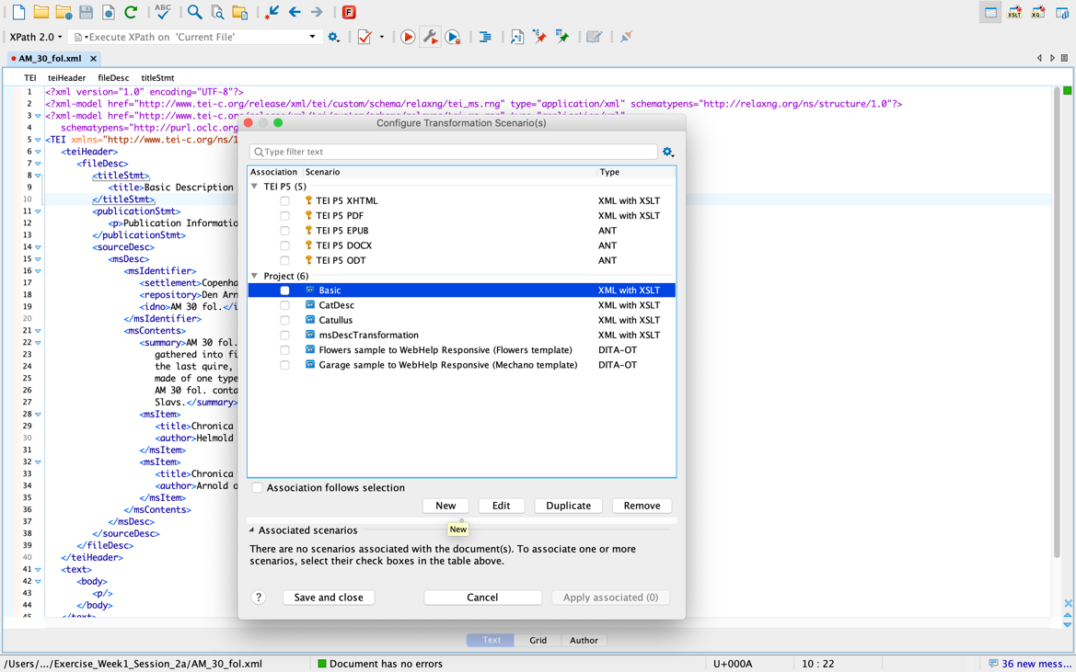

- A drop-down menu will open
- Choose the “XML transformation with XSLT” option
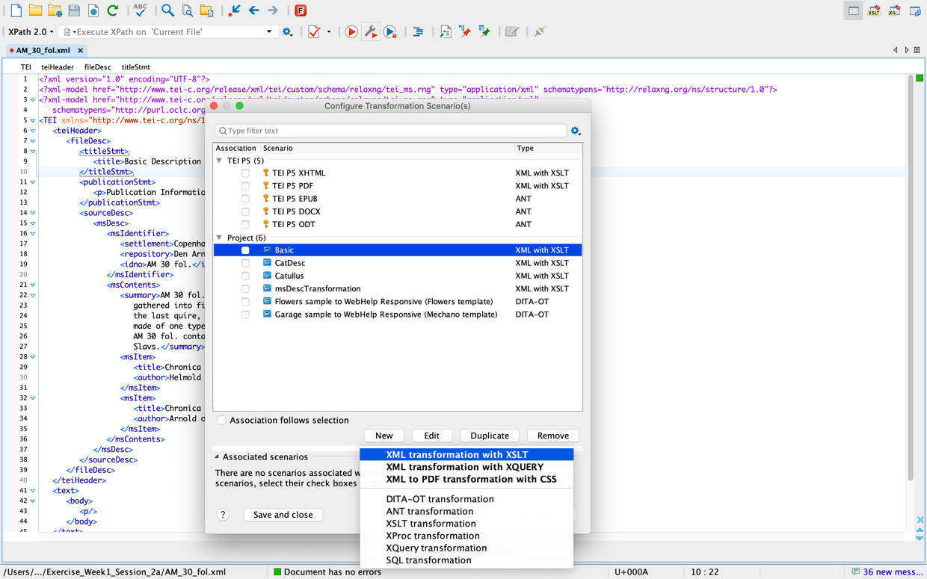

- A new pop-up window will open
- By the field XSL URL click on the browsing icon

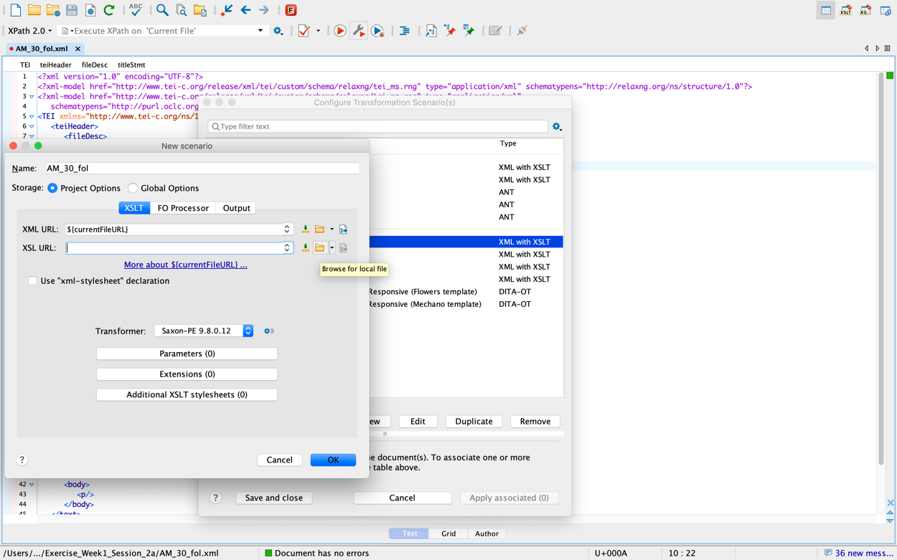

- Select the location of your XSLT
- Click on the “Output” button 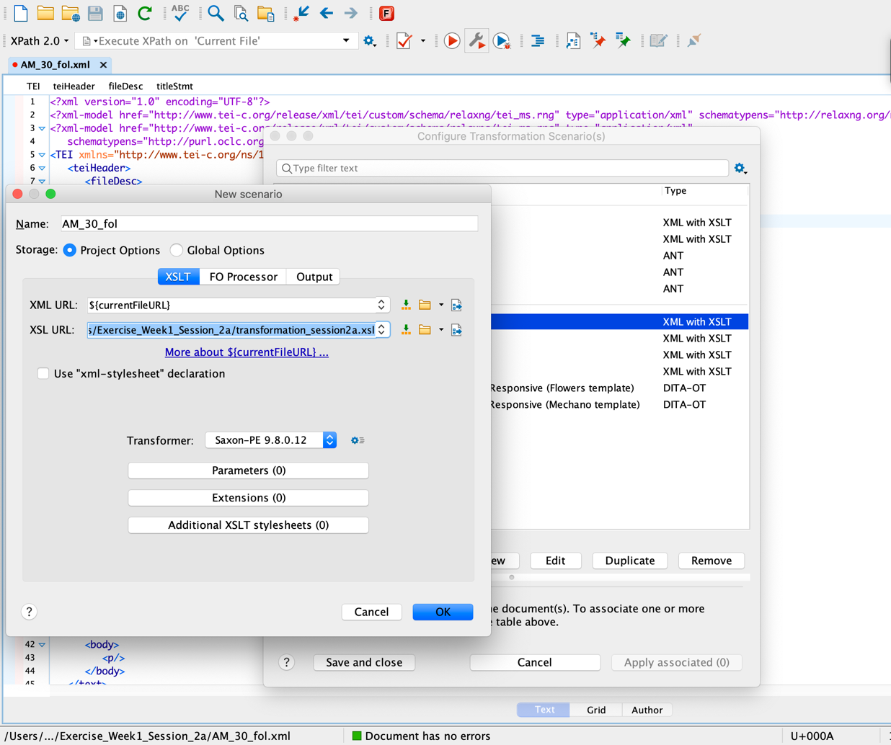

- Tick the “Save as” option and type the name of your output file: out.html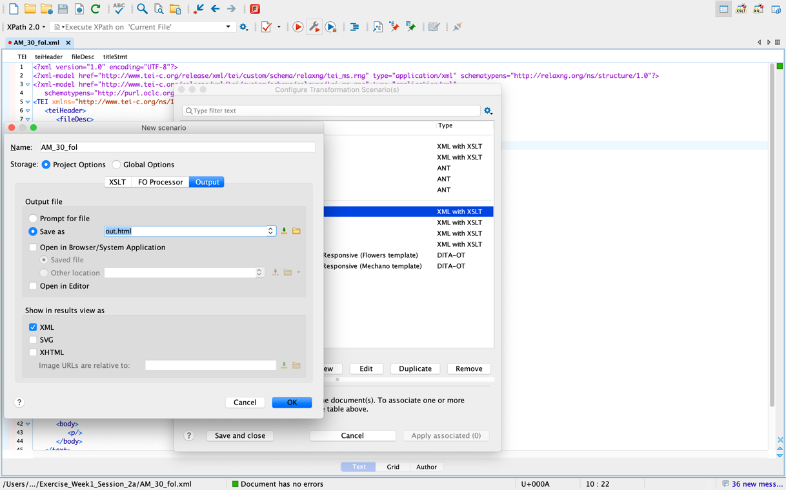

- Tick the “Open in Browser” option
- Click OK
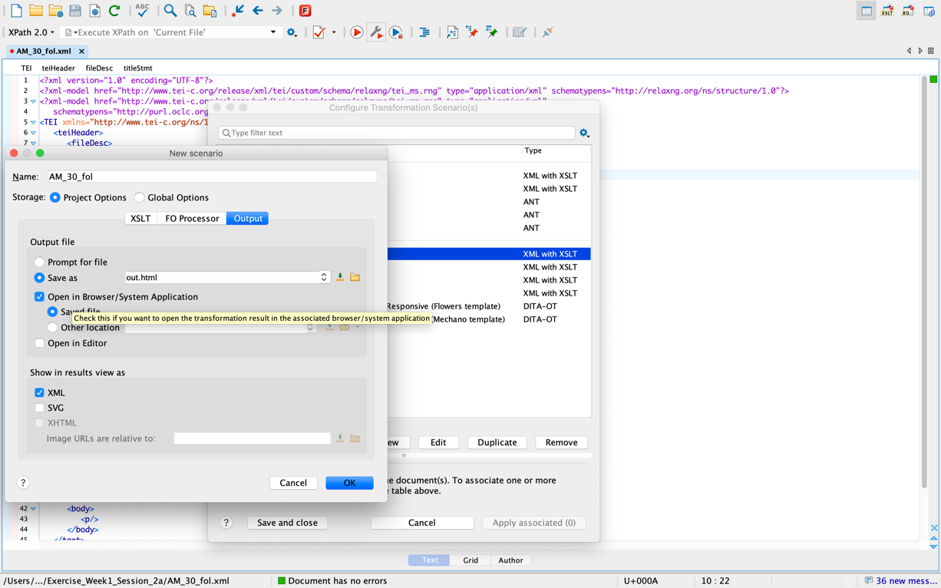

- Now you are back to the first pop-up window
- Tick the transformation scenario you’ve just created “AM_30_fol”
- Click “Apply associated”
- A new html file will appear in your folder and its contents will be displayed in the browser