AI-POWERED PERSONALIZED MATHEMATICS LEARNING PLATFORM FOR ELEMENTARY STUDENTS
Final Group Dissertation Report
Dukduru Pedige Chamith Rathdunu Sarathchandra
(IT22886668)
A.A.M. Fahad
(IT22904928)
Jayathri Tharuka Chamodinee Jayawarana
(IT22921680)
M. N. Janendra de Silva
(IT22318602)

BSc (Hons) degree in Information Technology
Specializing in Information Technology
Department of Information Technology
Sri Lanka Institute of Information Technology
Sri Lanka
April 2026

DECLARATION OF THE CANDIDATE AND SUPERVISOR
We declare that this is our own work and this dissertation does not incorporate without acknowledgement any material previously submitted for a Degree or Diploma in any other University or Institute of higher learning. To the best of our knowledge and belief, it does not contain any material previously published or written by another person except where acknowledgement is made in the text.
Also, we hereby grant to Sri Lanka Institute of Information Technology the non-exclusive right to reproduce and distribute this dissertation, in whole or in part, in print, electronic, or other medium. We retain the right to use this content in whole or part in future works such as articles or books.
Declaration details of the candidates
Name | Student ID | Signature
Dukduru Pedige Chamith Rathdunu Sarathchandra | IT22886668
A.A.M. Fahad | IT22904928
Jayathri Tharuka Chamodinee Jayawarana | IT22921680
M. N. Janendra de Silva | IT22318602

The above candidates have carried out research for the Bachelor's Degree Dissertation under my supervision.

_ _ _ _ _ _ _ _ _ _ _ _ _ _ _ _ _ _ _ _ _ _ _ _ _ _ _ _ _ _ _
Signature of Supervisor Date

_ _ _ _ _ _ _ _ _ _ _ _ _ _ _ _ _ _ _ _ _ _ _ _ _ _ _ _ _ _ _
Signature of Co-Supervisor Date

ABSTRACT
This dissertation presents an integrated AI-powered personalized mathematics learning platform designed for elementary students, with a particular focus on Grades 3, 4, and 5. The platform combines four complementary research components: adaptive difficulty and dynamic question generation, continuous progress monitoring and personalized recommendation, AI-powered content quality and feedback analysis, and emotion-aware engagement with academic integrity monitoring. The adaptive component uses category-level diagnostic evidence from starting papers to recommend difficulty and follow-up question volume, and then produces structured mathematics MCQs using a QLoRA-adapted Qwen2.5-Math model. The progress monitoring component applies competency-oriented learner signals and LSTM-based forecasting to identify future performance trends and recommend appropriate resources. The content quality component fine-tunes Qwen-based models with LoRA to support question-topic matching, teacher-guide analysis, and video-feedback interpretation through structured JSON outputs. The monitoring component specifies privacy-preserving browser-side emotion recognition and YOLOv8-based integrity checks for unauthorized items and multiple human presence. The integrated system uses a React interface, Node.js/Express backend, Flask inference services, and MongoDB persistence to connect assessment, analytics, recommendation, content validation, and teacher dashboards. Experimental and component-level results show 69.20% difficulty recommendation accuracy with 1.59 question-count MAE, LSTM forecasting RMSE of 0.10 with a recommendation click-through rate of 0.48, 70.00% question-topic matching accuracy, and 90.00% video-feedback classification accuracy. The fourth component is documented as a design and prototype specification with target performance thresholds because the uploaded source for that component is a proposal document. Overall, the research demonstrates a practical full-stack approach for making elementary mathematics learning more adaptive, evidence-driven, and instructionally responsive.
Keywords: adaptive learning, learning analytics, mathematics education, large language models, emotion recognition

ACKNOWLEDGEMENT
We express our sincere gratitude to our supervisor, co-supervisor, and academic evaluators for their continuous guidance, constructive feedback, and encouragement throughout this research project. Their direction helped us connect machine learning experiments with a usable web-based educational platform and supported the refinement of our research scope.
We are grateful to the Sri Lanka Institute of Information Technology for providing the academic environment, research supervision, and technical foundation needed to complete this group dissertation. The knowledge gained through the BSc (Hons) Information Technology programme supported the implementation of data processing, deep learning, software architecture, and human-centered system design decisions described in this report.
We also thank the project team members for their collaboration and shared effort in designing an integrated mathematics learning platform. Each component contributed a specific intelligent capability, and the final product became stronger because the modules were designed to operate together rather than as isolated demonstrations.
Finally, we acknowledge our families, friends, and peers for their patience and support during the development, testing, documentation, and revision stages of this project.

TABLE OF CONTENTS
DECLARATION OF THE CANDIDATE AND SUPERVISOR .................................... i
ABSTRACT ...................................................................... ii
ACKNOWLEDGEMENT .............................................................. iii
TABLE OF CONTENTS ............................................................. iv
LIST OF FIGURES ................................................................ v
LIST OF TABLES ................................................................ vi
LIST OF ABBREVIATIONS ........................................................ vii
1. INTRODUCTION ................................................................ 1
1.1 Background and Literature Survey ........................................... 3
1.2 Research Gap ............................................................... 6
1.3 Research Problem ........................................................... 7
1.4 Research Objectives ........................................................ 8
1.5 Scope of the Integrated Project ............................................ 9
2. METHODOLOGY ................................................................ 10
2.1 System Architecture Overview .............................................. 11
2.2 Adaptive Difficulty and Dynamic Question Generation ....................... 12
2.3 Continuous Progress Monitoring and Personalized Recommendation ............ 14
2.4 AI-powered Content Quality and Feedback Analysis .......................... 16
2.5 Emotion-aware Engagement and Academic Integrity Monitoring ................ 18
2.6 Backend, Database, and Integration Design ................................. 20
2.7 Commercialization Aspects of the Product .................................. 21
2.8 Testing and Implementation ................................................ 23
2.9 Tools and Technologies .................................................... 24
2.10 Ethical, Security, and Practical Considerations .......................... 25
3. RESULTS AND DISCUSSION ..................................................... 27
3.1 Results ................................................................... 27
3.2 Research Findings ......................................................... 29
3.3 Discussion ................................................................ 30
3.4 Summary of Each Student's Contribution .................................... 31
3.5 Limitations and Mitigation Strategies ..................................... 32
4. CONCLUSION ................................................................. 33
4.1 Conclusion ................................................................ 33
4.2 Future Work ............................................................... 34
REFERENCES .................................................................... 35
APPENDICES .................................................................... 37
Appendix A: Sample API Payloads ............................................... 37
Appendix B: Component Dataset Summary ......................................... 37
Appendix C: Deployment and Testing Checklist .................................. 37
Appendix D: Project Requirements Summary ...................................... 39
Appendix E: Risk Management and Maintenance Plan .............................. 41

LIST OF FIGURES
Figure 2.1: Integrated AI-powered mathematics learning platform architecture ... 11
Figure 2.2: Adaptive difficulty and dynamic question generation workflow .... 14
Figure 2.3: Continuous progress monitoring and recommendation workflow ...... 16
Figure 2.4: Content quality and feedback analysis workflow .................. 18
Figure 2.5: Emotion, engagement, and academic-integrity monitoring pipelines ... 20
Figure 3.1: Evaluation summary across the four research components .......... 28

LIST OF TABLES
Declaration details of the candidates ........................................ i
Table 1.1: Integrated component mapping and research role .................... 5
Table 1.2: Consolidated research gap mapping ................................. 7
Table 1.3: Main and specific research objectives ............................. 8
Table 2.1: Overall system architecture layers ............................... 11
Table 2.2: Adaptive difficulty and question generation data summary ......... 14
Table 2.3: Recommendation model feature groups .............................. 14
Table 2.4: Continuous progress monitoring data and model design ............. 16
Table 2.5: Content quality and feedback analysis datasets ................... 18
Table 2.6: Emotion and academic integrity monitoring specification .......... 20
Table 2.7: Backend and persistence design ................................... 21
Table 2.8: Commercialization model .......................................... 22
Table 2.9: Testing strategy across the integrated platform .................. 24
Table 2.10: Tools and technologies used ..................................... 24
Table 3.1: Component-level evaluation summary ............................... 28
Table 3.2: Research findings by component ................................... 30
Table 3.3: Summary of each student contribution ............................. 31
Table 3.4: Limitations and mitigation strategies ............................ 32
Table A.1: Sample recommendation API input and output ....................... 37
Table A.2: Sample generated MCQ structure ................................... 37
Table B.1: Consolidated dataset summary ..................................... 37
Table C.1: Deployment and testing checklist ................................. 37

LIST OF ABBREVIATIONS
Abbreviation | Description
AI | Artificial Intelligence
API | Application Programming Interface
ARIMA | Autoregressive Integrated Moving Average
CNN | Convolutional Neural Network
CTR | Click-Through Rate
FER | Facial Emotion Recognition
JSON | JavaScript Object Notation
LLM | Large Language Model
LoRA | Low-Rank Adaptation
LSTM | Long Short-Term Memory
MAE | Mean Absolute Error
MCQ | Multiple Choice Question
ML | Machine Learning
MSE | Mean Squared Error
NLP | Natural Language Processing
QLoRA | Quantized Low-Rank Adaptation
REST | Representational State Transfer
RMSE | Root Mean Squared Error
SLIIT | Sri Lanka Institute of Information Technology
UI | User Interface
YOLO | You Only Look Once

1. INTRODUCTION
Mathematics is a foundational subject for elementary learners because it supports logical reasoning, problem solving, quantitative thinking, and later participation in science and technology disciplines. However, learners do not develop mathematical competence at the same pace. Some students master basic arithmetic quickly, while others require repeated practice, visual explanation, or teacher intervention before progressing to more complex topics such as fractions, ratios, measurement, decimals, algebraic patterns, and geometry.
Traditional classroom and worksheet-based learning environments usually present the same learning activity to every student. This makes administration simple, but it does not reflect the different patterns of prior knowledge, response speed, attention, confidence, and misconception that appear during mathematics learning. A learner who answers correctly after a long pause may need a different type of support from a learner who answers the same question quickly and confidently. Similarly, a learner who uses unauthorized assistance may appear competent even when the underlying skill is weak.
The proposed AI-powered personalized mathematics learning platform was designed to respond to this gap through a collection of intelligent components. Instead of treating marks as the only indicator of learning, the system combines diagnostic performance, time-based behavior, continuous session history, feedback signals, content-quality checks, emotional cues, and academic-integrity metadata. These signals are then used to personalize practice, forecast progress, improve instructional materials, and help teachers understand learner state.
The platform is targeted primarily at elementary mathematics learners in Grades 3, 4, and 5. This grade range was selected because mathematical understanding at this stage is cumulative and highly sensitive to missing prerequisites. Weaknesses in basic operations can later affect word problems, fractions, decimals, measurement conversions, and geometry. At the same time, learners who are ready for greater challenge may lose motivation if practice remains static and repetitive.
The project follows a modular research design. The first component adapts question difficulty and dynamically generates follow-up MCQs after a starting paper. The second component monitors learner progress over repeated sessions and recommends resources using sequence-aware forecasting. The third component evaluates educational content quality by matching questions with topics and analyzing student feedback. The fourth component introduces emotion-aware engagement monitoring and academic-integrity detection through privacy-preserving computer vision.
The importance of integration is central to this dissertation. A platform that only predicts marks does not necessarily improve learning unless predictions lead to meaningful actions. A platform that only generates questions may produce variety but not personalization. A platform that only collects feedback may accumulate text without helping teachers revise materials. Therefore, the research connects the four components into a common architecture with student interfaces, teacher dashboards, backend persistence, and inference services.
Artificial intelligence in education must also be interpreted carefully. The system described in this report is not intended to replace teachers or make irreversible academic judgments. Its purpose is to provide formative support: identifying likely difficulty needs, recommending resources, surfacing content issues, and alerting teachers to engagement or integrity concerns. The final responsibility for instruction, classroom judgment, and learner wellbeing remains with educators and guardians.
The dissertation is organized according to the SLIIT dissertation documentation structure. Chapter 1 explains the background, research gap, research problem, objectives, and scope. Chapter 2 describes the methodology, architecture, component designs, commercialization aspects, implementation, testing, tools, and ethical considerations. Chapter 3 presents results and discussion, including the contribution of each student. Chapter 4 concludes the work and identifies future improvements.

1.1 Background and Literature Survey
Adaptive learning has been widely studied as a way to align instructional materials with the learner's current state. Early intelligent tutoring systems used rule-based models and knowledge tracing to estimate whether learners had mastered particular skills. More recent systems extend this approach by using learning analytics, machine learning, and deep learning to infer patterns from sequences of responses, time spent, attempts, hesitation, and engagement indicators. This shift is important for mathematics because correctness alone does not capture fluency, effort, or uncertainty.
A key idea in learner modelling is that performance evidence must be interpreted at the level of skills or topic categories. In elementary mathematics, topics are related but not interchangeable. A student may be strong in addition and subtraction while struggling with word problems or fractions. Therefore, diagnostic assessment should identify topic-level strengths and weaknesses and convert them into specific follow-up learning actions. The adaptive difficulty component in this research follows that principle by using category-level features from the starting paper.
Multi-task learning provides a useful machine learning framework for the adaptive component because the system must recommend both difficulty and practice volume. Difficulty selection is a classification problem, while question-count estimation is a regression problem. These two outputs are related because both reflect the learner's current readiness, but they are not identical. A shared neural representation can learn common signals such as accuracy, speed, waiting ratio, and attempt rate while producing separate outputs for challenge level and practice quantity.
Large language models have created new possibilities for educational content generation. Instead of depending only on fixed item banks, a model can generate new mathematics MCQs conditioned on topic, difficulty, and grade level. However, unrestricted generation is risky in education because outputs must be correct, grade-appropriate, parseable, and suitable for a young learner. Parameter-efficient fine-tuning methods such as LoRA and QLoRA make it practical to adapt a mathematics-specialized model to a structured MCQ format within limited research-project resources.
Continuous progress monitoring is another important strand of learning analytics. A single assessment score provides a snapshot, but it does not reveal whether the learner is improving, declining, or fluctuating. LSTM networks are relevant because learner progress is temporal: past sessions, study time, waiting behavior, and resource engagement can influence future readiness. In contrast, classical linear forecasting methods such as ARIMA are useful baselines but may be less suitable for nonlinear educational traces.
Recommendation systems in education differ from commercial recommendation systems because their objective is not only user preference but also pedagogical benefit. A learner may prefer easy material, but effective support may require a sequence of remedial explanations followed by appropriate practice. The progress monitoring component therefore uses competency-oriented learner signals and threshold-based resource mapping so that forecasts are translated into learning actions such as foundational lectures, practice papers, or challenge tasks.
Educational content quality is an equally important issue. Even a strong adaptive engine can fail if the questions, teacher guides, or video lessons are poorly aligned with the intended topic or grade level. In mathematics, small mismatches can lead to invalid assessment or unnecessary confusion. Recent NLP and LLM methods can analyze semantic relationships between questions and topics, interpret feedback about pacing or clarity, and convert unstructured comments into structured recommendations for teachers.
Student feedback is often collected in learning platforms but underused. A conventional sentiment label such as positive or negative does not tell a teacher whether a lesson was too fast, too difficult, unclear, or technically problematic. Structured output generation is therefore a practical design choice: if the model returns issue category, severity, weak section, confidence, and recommendation in JSON-like form, the web application can directly display it on dashboards and store it for later analysis.
Affective computing and computer vision add another dimension to adaptive learning. Emotional states such as confusion, frustration, boredom, and concentration influence mathematical problem solving. In a classroom, teachers observe facial expression, posture, and behavior to decide whether to slow down, encourage, or intervene. A digital learning platform cannot replicate a human teacher completely, but it can use privacy-preserving on-device models to provide additional engagement signals.
Academic integrity is especially important in remote or unsupervised digital learning. Adaptive systems depend on accurate evidence of the learner's true ability. If a student uses a calculator or receives live assistance from another person during a diagnostic activity, the platform may recommend an inappropriate level of difficulty. Therefore, the fourth component introduces YOLOv8-based unauthorized item detection and multiple human detection, designed to run in the browser while storing only metadata and not raw video.
Commercial platforms such as Khan Academy, IXL, DreamBox, and local e-learning services show the practical value of digital mathematics support. Nevertheless, many platforms rely on proprietary algorithms, fixed item banks, retrospective dashboards, or broad content delivery. The present project contributes a transparent academic prototype that explains data features, model choices, integration points, and limitations. Its novelty is not one single algorithm, but the combination of adaptive practice, progress forecasting, content analysis, and engagement/integrity monitoring in one elementary mathematics platform.
Table 1.1: Integrated component mapping and research role
Component | Primary research role | Core technologies | Main output
Adaptive difficulty and dynamic question generation | Personalizes follow-up practice after a starting paper | Multi-task neural model, QLoRA, Qwen2.5-Math, Flask, React | Recommended difficulty, question count, generated MCQs
Continuous progress monitoring and personalized recommendation | Tracks learning trajectories and predicts future readiness | LSTM forecasting, competency scoring, hybrid recommender, MongoDB | Forecasted performance, risk state, resource cards
Content quality and feedback analysis | Improves instructional validity and feedback interpretation | Qwen-based LLMs, LoRA, prompt engineering, JSON outputs | Matching score, weak sections, issue categories, recommendations
Emotion-aware engagement and academic integrity monitoring | Adds affective and trust signals to remote learning | MobileNetV2 CNN, YOLOv8, TensorFlow.js, browser workers | Emotion/engagement status, item and human-presence alerts

1.2 Research Gap
The literature and existing platform review reveal that many educational systems still adapt primarily from correctness or final marks. A percentage score is easy to record, but it hides meaningful differences between learners. Two students may obtain the same score even though one answers all questions quickly with minor errors while another leaves many questions unanswered after long pauses. A personalized mathematics platform needs to interpret such patterns rather than rely only on raw marks.
A second gap is the dependence on fixed question banks. Teacher-authored item banks provide reliability, but they can limit the variety of practice available to different learners. If the system needs a Grade 5 hard algebra question or a Grade 3 easy arithmetic question, it must either already contain that item or repeatedly reuse similar questions. A controlled question generator can improve variety when it is constrained by grade, topic, difficulty, and output structure.
A third gap concerns long-term learner monitoring. Many dashboards show completed scores but do not forecast likely future performance. Teachers need to know not only what happened in the last session but also whether the learner is trending toward risk. This requires sequence-aware modelling and an interface that converts forecasts into recommendations rather than merely plotting lines.
A fourth gap concerns content and feedback quality. Learning platforms may collect student feedback and store teacher guides, but they rarely analyze whether a question matches the intended topic, whether a guide lacks examples, or whether video feedback indicates pacing or clarity problems. This creates a burden on teachers and administrators who must manually inspect large volumes of educational text.
A fifth gap concerns engagement and integrity in remote learning. Adaptive learning relies on valid evidence. When the system cannot detect emotional frustration, disengagement, unauthorized devices, or another person assisting the learner, its recommendations can become less trustworthy. Existing proctoring approaches are often cloud-based and privacy-heavy, which is inappropriate for younger learners. This creates a need for lightweight, metadata-only, on-device monitoring.
Table 1.2: Consolidated research gap mapping
Identified gap | Effect on mathematics learning | Implemented or proposed response
Correctness-only adaptation | Learners with different behavior patterns may receive the same practice | Use accuracy, attempt rate, waiting ratio, timing, and mark features for adaptive recommendation
Fixed item-bank dependence | Practice variety becomes limited and repeated items reduce motivation | Generate structured MCQs using a QLoRA-adapted mathematics LLM
Retrospective progress dashboards | Teachers may identify decline only after repeated low scores | Use LSTM forecasting and competency-oriented profiles for early support
Unstructured feedback storage | Teachers receive comments but not actionable instructional insight | Fine-tune LLMs to return weak sections, issue labels, severity, and recommendations
Limited remote engagement and integrity evidence | Adaptive decisions may be based on incomplete or corrupted signals | Use privacy-preserving emotion recognition and YOLOv8-based item/human detection

1.3 Research Problem
The central research problem addressed by this group project is how an elementary mathematics learning platform can transform diverse learner and content evidence into personalized, trustworthy, and actionable learning support. The problem is broader than simply predicting marks. It requires the system to identify what practice a learner needs, generate or select suitable content, monitor progress over time, detect quality issues in learning materials, and preserve the validity of remote learning evidence.
The adaptive learning sub-problem is to convert diagnostic starting-paper behavior into a difficulty level and follow-up practice activity. This requires the platform to process category-level signals, predict difficulty, estimate question volume, generate topic-specific MCQs, and update the learner profile after practice rounds.
The progress monitoring sub-problem is to represent learner readiness across repeated sessions. The system must summarize accuracy, time, waiting behavior, resource engagement, and difficulty history into interpretable profiles and then forecast future performance. The output must be shown in a way that supports intervention rather than only record keeping.
The content quality sub-problem is to evaluate whether platform materials support the intended learning outcome. Assessment questions must align with topics and grades, teacher guides must be understandable and appropriately paced, and student comments must be converted into issue categories that teachers can act on.
The engagement and integrity sub-problem is to ensure that remote learning evidence remains meaningful. A child may become frustrated or bored before performance drops, and unauthorized aids or additional people may distort assessment evidence. The platform therefore needs a way to observe engagement and integrity while respecting child privacy.

1.4 Research Objectives
The main objective of this research is to design, develop, and document an integrated AI-powered personalized mathematics learning platform that supports elementary learners through adaptive practice, continuous progress monitoring, AI-assisted content quality analysis, and privacy-preserving engagement and integrity monitoring.
The specific objectives are organized according to the four research components and the shared platform integration requirements.
Table 1.3: Main and specific research objectives
Objective code | Objective
SO1 | Construct a diagnostic adaptive learning workflow that predicts recommended difficulty and practice volume from category-level behavioral and performance features.
SO2 | Fine-tune a mathematics-specialized LLM using QLoRA to generate grade-aware and difficulty-conditioned MCQs in a structured format.
SO3 | Design a continuous monitoring approach that converts session histories into competency summaries, future performance forecasts, and resource recommendations.
SO4 | Develop AI models for question-topic matching, teacher-guide analysis, and video-feedback interpretation using structured JSON outputs.
SO5 | Specify an emotion-aware engagement and academic-integrity monitoring framework using browser-side CNN and YOLOv8 pipelines.
SO6 | Integrate the components through React interfaces, Node.js/Express backend services, Flask inference services, and MongoDB persistence.
SO7 | Evaluate the component-level outputs and discuss strengths, limitations, ethical implications, and commercialization potential.

1.5 Scope of the Integrated Project
The project scope is limited to elementary mathematics learning, mainly Grades 3, 4, and 5. The adaptive and generator datasets focus on topics such as arithmetic, word problems, percentages, fractions, ratios, algebra, geometry, number patterns, measurement, and decimals. The platform is designed for formative learning support rather than formal high-stakes examination placement.
The group report integrates four student contributions. Three uploaded documents are final individual reports with experimental or implementation results. The fourth uploaded document is a proposal document for the emotion-aware engagement and academic-integrity monitoring component. Therefore, the final group report treats that component as a design and prototype specification with target metrics, rather than fabricating completed experimental results.
The system boundary includes the student-facing learning workflow, teacher/admin dashboard functions, backend APIs, model inference endpoints, database persistence, and component-level testing. It does not claim to provide a nationally validated psychometric assessment system, full production deployment at school scale, or fully reviewed clinical emotion diagnosis.
The platform is designed to be teacher-supportive. Recommendations, alerts, and feedback analysis are intended to assist educators in decision-making. They should be reviewed by teachers, especially where model output affects instructional strategy, content changes, or integrity intervention.

2. METHODOLOGY
The methodology follows an end-to-end software engineering and applied machine learning process. Each component was designed around a clear educational signal, a data or model pipeline, a runtime interface, and an output that can be used in the integrated platform. This structure makes it possible to evaluate components separately while still connecting them in a full learning workflow.
At platform level, the methodology is organized into five layers: the user interaction layer, application service layer, AI/ML inference layer, persistence layer, and analytics/dashboard layer. The student interacts with starting papers, generated practice, lessons, and feedback forms. Teachers and administrators manage papers, view analytics, review content-quality outputs, and receive alerts. Backend services coordinate API calls and MongoDB persistence, while Flask and hosted inference services expose model outputs.
A modular design was selected because the four research components process different evidence types. Adaptive difficulty uses structured numerical category features. Progress monitoring uses time-series learner records. Content analysis uses educational text and feedback. Emotion/integrity monitoring uses webcam frames but stores only metadata. The common backend allows these heterogeneous signals to support one learner profile.
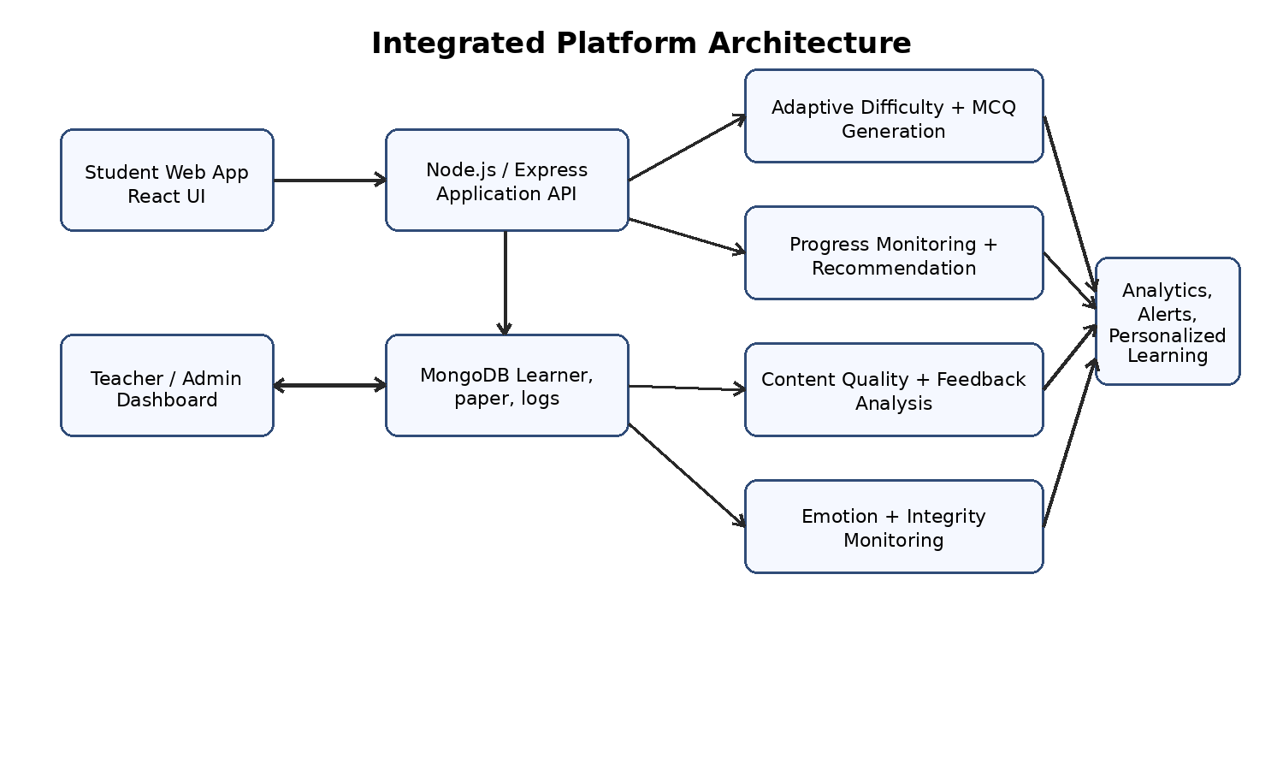
Figure 2.1: Integrated AI-powered mathematics learning platform architecture
Source: Author-generated from integrated project artifacts.
Table 2.1: Overall system architecture layers
Layer | Main responsibility | Representative artifacts
User interaction layer | Provides student and teacher interfaces for practice, dashboards, feedback, and alerts | React student pages, teacher dashboard, admin screens
Application service layer | Coordinates authentication, paper management, profile updates, and component API calls | Node.js/Express controllers, route handlers
AI/ML inference layer | Serves recommendation, forecasting, content analysis, generation, and monitoring outputs | Flask APIs, Qwen/QLoRA models, LSTM model, browser-side CNN/YOLO pipelines
Persistence layer | Stores users, papers, questions, performance histories, feedback records, logs, and alerts | MongoDB collections and schemas
Analytics/dashboard layer | Transforms model outputs into teacher-friendly decisions and learner-facing recommendations | Progress charts, recommendation cards, weak-section reports, integrity notifications

2.1 System Architecture Overview
The integrated architecture starts with a learner selecting a grade and attempting a diagnostic starting paper. The starting paper provides the first evidence for adaptive difficulty. The frontend sends structured answer data to the backend, which calculates category-level performance features and calls the recommendation service. The recommendation output is then used to request follow-up MCQs, and the results are persisted in learner logs.
Across repeated sessions, paper attempts, lecture interactions, and resource usage are stored in the monitoring data model. The progress component reads these histories, creates rolling features, produces current and future performance predictions, and updates risk or difficulty indicators. Recommendations are exposed to learners as cards and to teachers as profile-level analytics.
The content quality component operates on teacher and admin workflows. When a question is created or imported, the question-topic model evaluates whether the item matches the intended grade and topic. When guides or video lessons receive feedback, the relevant analysis model produces structured observations. These outputs help teachers identify weak sections and revise content before learners repeatedly encounter the same problem.
The monitoring component is designed to run in the browser. A single webcam stream is shared by parallel pipelines: emotion recognition, unauthorized item detection, and multiple human detection. The design avoids server-side raw video transfer. Instead, only event metadata such as timestamp, detected class, confidence score, or person count is stored or sent to the teacher dashboard when thresholds are exceeded.
This architecture separates model responsibility from application responsibility. Models produce predictions or structured outputs, while application services decide how those outputs are validated, stored, displayed, and acted upon. This separation is important because educational systems require both intelligent automation and deterministic safeguards.

2.2 Adaptive Difficulty and Dynamic Question Generation
The adaptive difficulty component begins after a student completes a starting paper. The starting paper is treated as diagnostic evidence rather than merely a final score. For each topic category, the system records values such as total questions, answered questions, correct answers, wrong answers, marks, total time, and waiting time. These raw values are transformed into derived features that describe accuracy, error rate, speed, engagement, attempt rate, correct ratio, wrong ratio, time per question, wait ratio, and normalized score.
The recommendation dataset contains 4,998 records balanced across Easy, Medium, and Hard labels, with 1,666 records in each class. Balanced labels reduce the risk that the classifier simply learns the majority class. The final feature vector contains outcome evidence and behavioral evidence, allowing the model to distinguish between learners who have the same score but different interaction patterns.
A multi-task neural model was selected because the component has two outputs: recommended difficulty and recommended question count. The shared layers learn a common representation from the 17 input features. One branch predicts the difficulty class, while the other branch predicts how many follow-up questions should be recommended. This supports a more expressive adaptation than changing difficulty alone.
The question generation sub-component uses a curated dataset of 4,531 mathematics MCQ records covering ten topic categories across Grades 3, 4, and 5. Each record includes a question, options, correct answer, reasoning, verification, topic, difficulty, and grade. The training format encourages the model to return a JSON-style object that can be parsed by the web application.
The selected base model is Qwen2.5-Math-1.5B-Instruct. Instead of full fine-tuning, the project applies QLoRA so that only low-rank adapters are trained on top of a quantized model. This is suitable for a student research project because it reduces computational cost while still adapting the model to the required structured MCQ output. The generator is therefore not a general chatbot; it is a constrained educational content generator.
Runtime integration is handled through a Flask recommendation API, React adaptive practice pages, and backend persistence. The frontend normalizes the generated practice activity to a compact target size so that young learners are not overloaded. After configured practice rounds, the learner's difficulty profile is updated using the observed performance.
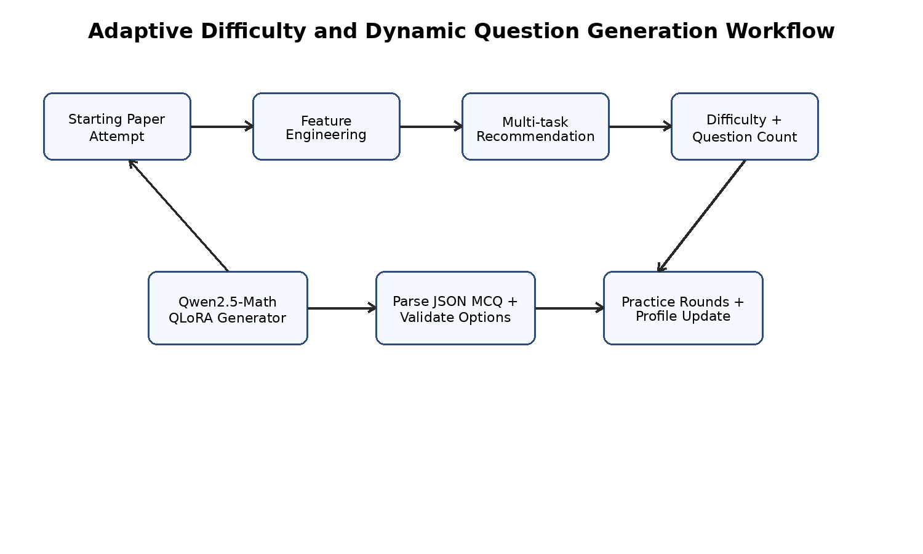
Figure 2.2: Adaptive difficulty and dynamic question generation workflow
Source: Author-generated from integrated project artifacts.
Table 2.2: Adaptive difficulty and question generation data summary
Data/model element | Value or design choice | Purpose
Recommendation dataset | 4,998 category-level records | Train difficulty and count recommendation model
Difficulty balance | 1,666 Easy, 1,666 Medium, 1,666 Hard | Avoid majority-class bias
Input features | 17 numerical features | Capture marks, timing, attempts, waiting, accuracy, and coverage
Generator dataset | 4,531 structured MCQ records | Fine-tune grade-topic-difficulty conditioned MCQ generation
Base generator model | Qwen2.5-Math-1.5B-Instruct | Use mathematics reasoning and instruction-following capability
Fine-tuning method | QLoRA | Adapt the model efficiently under limited training resources
Table 2.3: Recommendation model feature groups
Feature group | Examples | Educational meaning
Outcome features | marks, correct, wrong, normalized_score | Represent visible assessment performance
Attempt features | answered, total_q, attempt_rate | Show whether the learner attempted the available questions
Accuracy features | accuracy, error_rate, correct_ratio, wrong_ratio | Represent mastery and error patterns
Timing features | total_time, speed, time_per_question | Represent fluency and pacing
Engagement features | waited_time, wait_ratio, engagement | Approximate hesitation or inactive behavior

2.3 Continuous Progress Monitoring and Personalized Recommendation
The continuous progress monitoring component addresses the limitation of one-time assessment. Learner performance is observed across repeated sessions, including paper scores, time spent, wait time, resource engagement, difficulty level, and session type. These records are stored so that the platform can track change rather than only the latest mark.
The component uses competency-based thinking. A learner's readiness is not defined solely by score; it is also affected by time efficiency, attempts, and engagement. In the verified design, competency scoring combines accuracy, response-time efficiency, and attempt efficiency into a normalized indicator. In the implementation evidence, the same philosophy appears through rolling score means, wait-time windows, study-time features, and difficulty-aware learner histories.
The forecasting model uses LSTM because learner traces are sequential. The model can learn from ordered histories and represent patterns of improvement, regression, or fluctuation. This is suitable for elementary mathematics because a learner's future performance may depend on multiple prior sessions rather than only the most recent answer.
A baseline ARIMA comparison is documented in the individual component results. The LSTM model achieved a lower RMSE of 0.10 compared with an ARIMA baseline value of 0.16. The component also reports a recommendation click-through rate of 0.48, indicating that a meaningful proportion of delivered recommendations were accessed by learners.
The recommender layer translates forecasted learner state into support actions. Low competency can trigger foundational lectures or remedial explanations. Moderate competency can trigger practice papers. Strong learners can receive challenge tasks. This hybrid approach is educationally safer than a purely opaque recommender because teachers can understand the reason for each category of recommendation.
The component uses Flask APIs, backend controllers, MongoDB learner records, and a React dashboard. Recommendations are displayed as cards, while progress can be shown using charts and risk labels. Each learner profile becomes a living record of performance, difficulty, and recommended support.
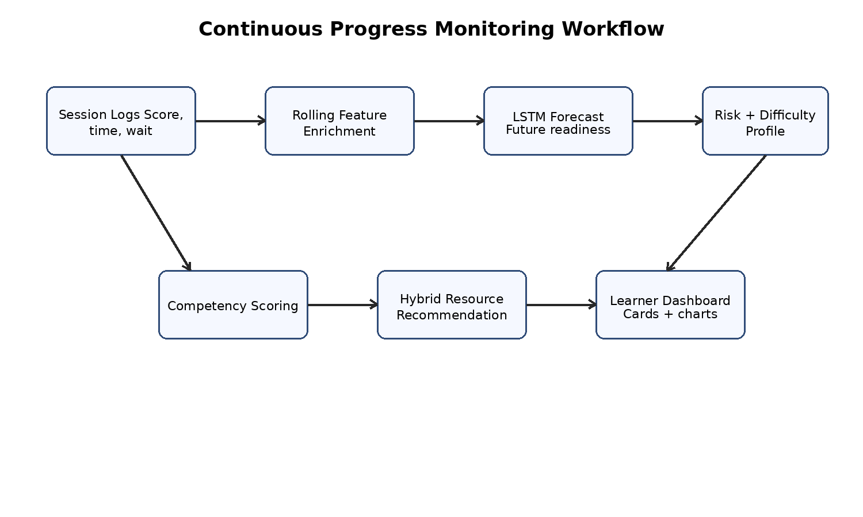
Figure 2.3: Continuous progress monitoring and recommendation workflow
Source: Author-generated from integrated project artifacts.
Table 2.4: Continuous progress monitoring data and model design
Design element | Description | Role in platform
Learner session data | Score, time spent, wait time, resource score, difficulty, session type | Creates longitudinal evidence of learning
Study sample | 60 learners across 4 objective-based 30-minute sessions | Provides controlled monitoring data for evaluation
Forecasting model | LSTM sequence model | Predicts future learner performance and readiness
Baseline | ARIMA forecasting comparison | Checks whether sequence neural modelling adds value
Reported performance | LSTM RMSE 0.10; ARIMA RMSE 0.16 | Supports model selection
Recommendation engagement | CTR 0.48 | Measures learner interaction with recommendations
Persistence | MongoDB learner and history records | Stores cumulative profiles and per-session evidence

2.4 AI-powered Content Quality and Feedback Analysis
The content quality and feedback analysis component focuses on the instructional materials used by the platform. It addresses three tasks: question-topic matching, teacher guide and student feedback analysis, and student video feedback analysis. These tasks were selected because they directly influence the quality of mathematics learning content.
The question-topic matching task uses a dataset of 2,000 records with 1,646 unique questions. Each example represents a relationship between a question, topic, grade, matching score, and reason. The model learns to evaluate whether a question properly tests the intended topic rather than merely containing related keywords.
The teacher guide analysis task uses 2,000 records combining teacher guide text, student feedback, engagement time, allocated guide time, grade, weak sections, and reasons. This design allows the model to interpret both what students say and how their time-on-task compares with expected lesson duration. Weak sections may include pacing, clarity, examples, difficulty, or practice opportunity.
The student video feedback analysis task uses 4,000 records of feedback related to video lessons. Issue labels include audio, confusion, difficulty, pacing, and positive, while severity labels include low, medium, and high. Instead of producing only a sentiment label, the model returns structured outputs that can support instructional decisions.
All three tasks are implemented using instruction-tuned Qwen-based models with LoRA parameter-efficient fine-tuning. Prompt engineering is used to guide each model toward consistent JSON outputs. This is important because the outputs must be consumed by backend services and displayed on dashboards without requiring teachers to read unstructured model text.
Deployment is handled using hosted inference services and a Flask-based integration layer. The backend receives teacher or learner inputs, calls the appropriate model, validates the returned structure, and stores the result for teacher/admin review. This makes the component an operational support tool rather than only an offline NLP experiment.
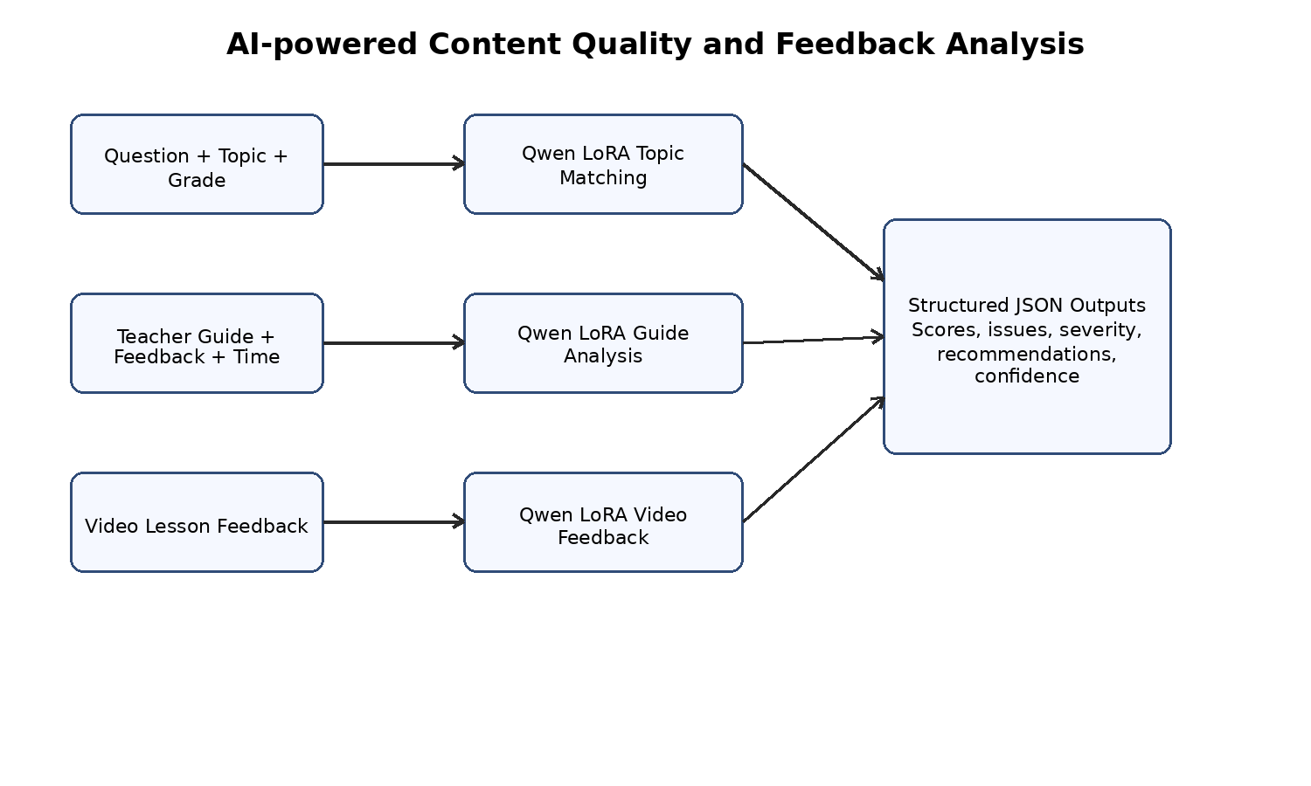
Figure 2.4: Content quality and feedback analysis workflow
Source: Author-generated from integrated project artifacts.
Table 2.5: Content quality and feedback analysis datasets
Task | Dataset size | Main input fields | Structured output
Question-topic matching | 2,000 records; 1,646 unique questions | question, topic, grade | matching_score, reason
Teacher guide and feedback analysis | 2,000 records | teacher_guide, student_feedback, engagement time, allocated time, grade | weak_sections, reason
Student video feedback analysis | 4,000 records | feedback text, grade, lesson, video_content | issue, severity, recommendation, confidence

2.5 Emotion-aware Engagement and Academic Integrity Monitoring
The emotion-aware engagement and academic-integrity monitoring component extends the platform beyond performance analytics. It recognizes that learning outcomes may be affected by frustration, confusion, boredom, concentration, unauthorized physical aids, or direct help from another person. The uploaded source for this component is a proposal document; therefore, the methodology below is presented as the component design and prototype specification.
The emotion pipeline is based on child-oriented facial emotion recognition. A modified MobileNetV2 CNN is proposed for emotion classification from face images, with temporal smoothing to reduce prediction jitter. Engagement classification combines emotion vectors with behavioral and performance features. The target performance is greater than 85% emotion recognition accuracy and greater than 88% engagement classification accuracy.
The unauthorized item detection pipeline uses YOLOv8n to detect prohibited physical aids such as calculators, smartphones, tablets, and smartwatches. The design includes a confidence threshold of 0.75 and a persistence rule so that short accidental detections do not immediately trigger alerts. If an item persists for more than five seconds, the student can receive a warning and the teacher dashboard can receive metadata.
The multiple human detection pipeline uses YOLOv8n trained on a Roboflow human detection dataset. The system counts detected persons in the webcam frame and triggers an alert when the count exceeds one for a sustained period. This addresses proxy assistance, where a parent, sibling, or peer provides live help during a monitored learning session.
The component is designed around privacy preservation. All three pipelines are intended to run on-device in the browser using technologies such as TensorFlow.js or equivalent web inference workers. No raw video frames are transmitted to the backend. The backend stores only event metadata such as timestamp, detected class, confidence score, person count, and session identifier.
Because the target users are children, alerts must be child-friendly and non-stigmatizing. Teacher notifications should be used as prompts for review rather than automatic disciplinary judgments. The monitoring component therefore supports trust and safety while preserving the formative purpose of the learning platform.
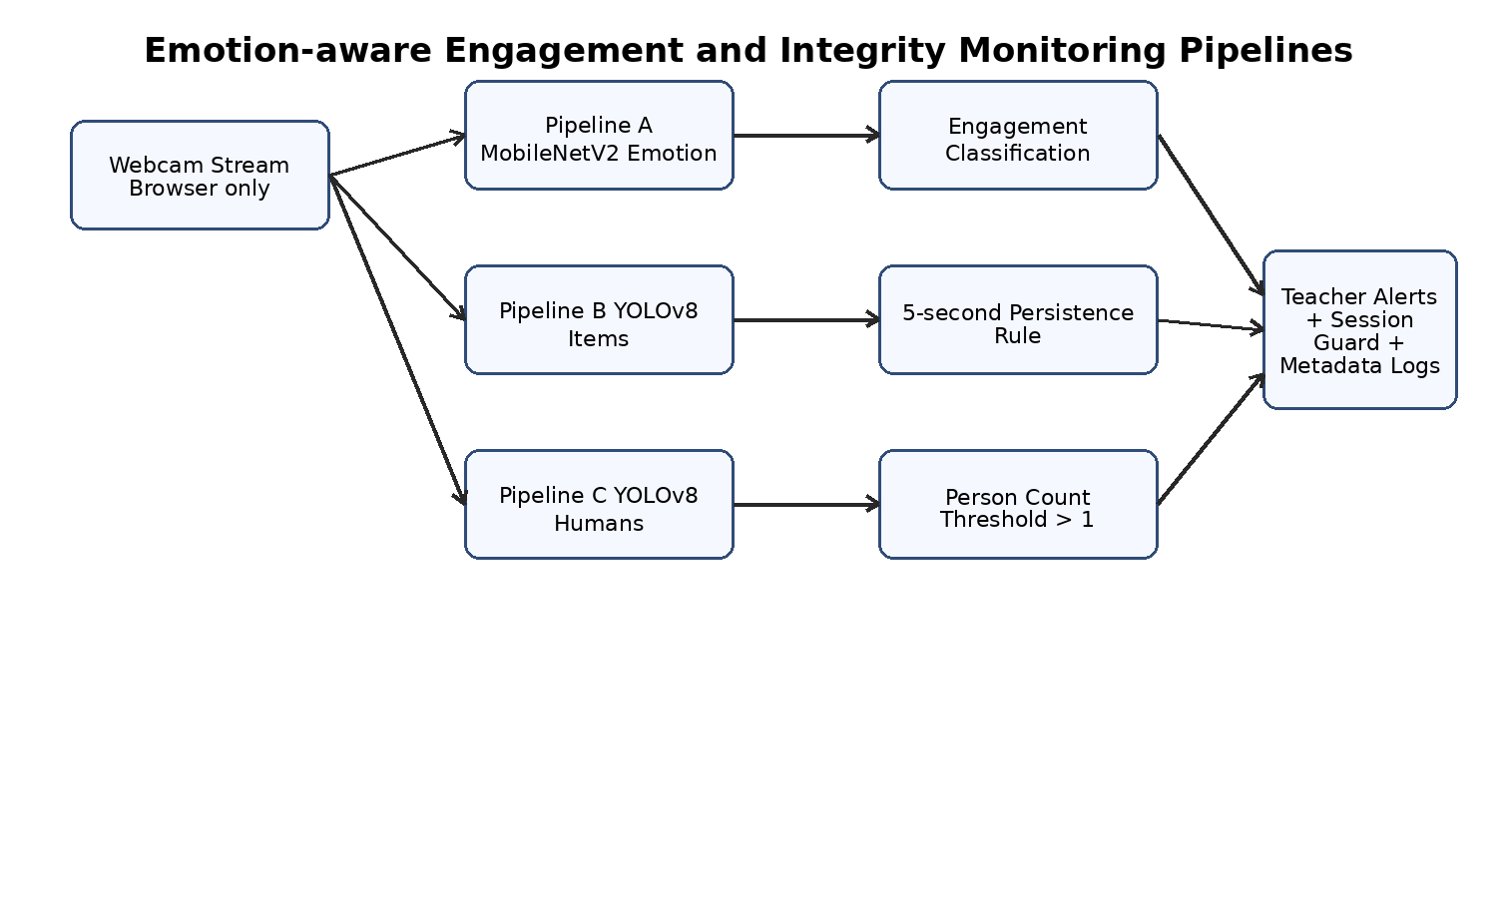
Figure 2.5: Emotion, engagement, and academic-integrity monitoring pipelines
Source: Author-generated from integrated project artifacts.
Table 2.6: Emotion and academic integrity monitoring specification
Pipeline | Core method | Target or rule | Output
Emotion recognition | Modified MobileNetV2 CNN with face detection and temporal smoothing | >85% emotion accuracy; <3s end-to-end latency | Emotion probabilities and engagement evidence
Engagement classification | Multimodal fusion of emotion, behavior, and performance features | >88% engagement classification accuracy | Engagement level and intervention trigger
Unauthorized item detection | YOLOv8n for calculator, smartphone, tablet, smartwatch detection | >90% detection target; confidence threshold 0.75; 5s persistence | Item metadata and teacher alert
Multiple human detection | YOLOv8n trained on Roboflow human detection dataset | >90% target; alert when person count > 1 for >5s | Person-count metadata and session guard
Privacy architecture | Browser-side inference and metadata-only logging | No raw video transmission | Privacy-preserving monitoring record

2.6 Backend, Database, and Integration Design
The integrated platform uses a web-based architecture that separates user interface, backend application logic, machine learning inference, and database persistence. This separation is necessary because each layer has different reliability and maintenance requirements. The React frontend handles learner and teacher interactions, while Node.js/Express services coordinate data access and call model endpoints.
MongoDB is used as the persistence layer because the platform stores heterogeneous records: users, starting papers, generated MCQs, assessment logs, performance histories, feedback entries, recommendations, weak-section reports, and monitoring metadata. A document database is suitable for this type of evolving educational data because each component may add nested fields over time.
Flask APIs are used for model endpoints where Python-based inference is required. The adaptive component exposes recommendation logic through a REST endpoint. The monitoring/progress component uses Flask services for current performance and forecast predictions. The content analysis component uses Flask or hosted inference wrappers to call fine-tuned LLMs and return structured JSON.
The backend also applies deterministic safeguards. For example, generated MCQs must be parsed and validated before display; difficulty updates must be stored consistently; feedback model outputs must contain required fields before appearing on dashboards; and monitoring alerts must satisfy confidence and persistence thresholds before escalation.
The integration design supports maintainability. If a model is improved, its endpoint can be updated without rewriting the entire React interface. If a dashboard view changes, the backend API contract can remain stable. If the database schema evolves, controllers can transform records into the format required by each frontend view.
Table 2.7: Backend and persistence design
Data entity | Example fields | Purpose
User profile | student id, grade, difficulty, risk status, history summary | Stores learner-level personalization state
Starting paper question | topic, grade, difficulty, options, answer | Supports diagnostic assessment and teacher authoring
Paper log | student id, question id, answer, correctness, timing, category | Provides adaptive evidence and performance history
Performance history | session score, time spent, wait time, resource score, difficulty | Feeds progress monitoring and forecasting
Content analysis output | matching score, weak sections, issue, severity, recommendation | Supports teacher content improvement
Integrity event | session id, event type, confidence, timestamp, person count | Supports privacy-preserving monitoring alerts

2.7 Commercialization Aspects of the Product
The product has commercialization potential as a modular mathematics learning platform for primary schools, tuition centers, and parent-supported home learning. The core value proposition is not merely digitizing worksheets; it is providing adaptive practice, predictive monitoring, content quality support, and trustworthy remote learning analytics in one platform.
The primary market consists of schools and educational institutions that require tools to support differentiated instruction. Teachers can benefit from automated starting-paper analysis, learner progress forecasts, and AI-assisted review of content quality. School administrators can benefit from aggregate dashboards that identify classes or topics requiring additional support.
The secondary market consists of tuition centers and after-school mathematics programmes. These organizations often manage learners with varied ability levels and require efficient practice personalization. The platform can help them assign suitable work, track progress, and maintain consistency across instructors.
A direct-to-parent model is also possible, especially for guided home practice. In this setting, the platform should emphasize child-friendly explanations, progress reports, and privacy-preserving monitoring rather than high-pressure assessment. Parents may value early identification of learning gaps and structured recommendations for improvement.
Commercial deployment can follow a subscription model with tiered features. A basic tier may include digital papers and progress tracking. A school tier may include adaptive practice, teacher dashboards, and content analysis. A premium or institutional tier may include monitoring, bulk upload, analytics exports, and professional support.
The platform's competitive advantage comes from integration. Many systems provide either practice questions, dashboards, feedback forms, or proctoring. This project combines these functions around mathematics learning and makes the adaptive loop transparent enough for teachers to understand.
Table 2.8: Commercialization model
Commercial aspect | Description
Target users | Grade 3-5 students, teachers, school administrators, tuition centers, and parents
Core value | Personalized practice, early intervention, content quality improvement, and privacy-preserving engagement/integrity support
Revenue options | Institutional subscription, per-student licensing, freemium home learning tier, and premium analytics services
Competitive advantage | Transparent integration of adaptive learning, forecasting, LLM feedback analysis, and browser-side monitoring
Deployment approach | Cloud-hosted backend with school-level accounts, controlled data access, and model update pipeline
Sustainability | Use of open-source frameworks and parameter-efficient model training reduces ongoing cost

2.8 Testing and Implementation
Testing was planned across model, API, frontend, backend, and integration levels. Each component produces a different type of output, so a single test method is insufficient. Numerical models require metrics such as accuracy, MAE, RMSE, or click-through rate. LLM components require structured output validation and case-based review. Monitoring components require detection accuracy, latency, false-positive control, and privacy checks.
For the adaptive component, notebook evaluation was used to measure difficulty classification accuracy and question-count MAE. Runtime tests verify that the Flask endpoint accepts the expected feature order and returns valid difficulty/count outputs. Generator tests verify whether the produced MCQ can be parsed into question, four choices, correct answer, reasoning, and verification fields.
For the progress component, forecasting quality was assessed using RMSE and comparison with ARIMA. Dashboard tests check that learner histories are saved correctly and that forecast outputs appear in the correct profile and recommendation views. Special attention is required for cold-start cases where the learner does not yet have enough history for a personalized forecast.
For the content analysis component, dataset splits and model outputs were evaluated per task. Question-topic matching uses accuracy-style validation. Teacher-guide analysis is also reviewed by qualitative pedagogical agreement because weak-section identification can be subjective. Video-feedback analysis uses issue and severity classification accuracy together with output-structure checks.
For the monitoring component, the proposal specifies validation against emotion recognition, unauthorized item, and human detection test sets. Since the uploaded source is a proposal, this group report records the target methodology rather than final observed metrics. Future final validation should include browser latency benchmarks, false-positive testing, privacy network audits, and child-friendly usability review.
Table 2.9: Testing strategy across the integrated platform
Test level | What is tested | Representative measures
Model evaluation | Recommendation, forecasting, LLM analysis, detection models | Accuracy, MAE, RMSE, qualitative agreement, detection precision/latency
API testing | Request payloads, response schemas, error handling | HTTP status, JSON field presence, validation failures
Frontend testing | Starting paper flow, generated practice, dashboards, feedback forms | UI state transitions, generated MCQ display, card rendering
Backend testing | Persistence of paper logs, histories, users, recommendations, alerts | Database insert/update correctness, schema consistency
Integration testing | End-to-end student and teacher workflows | Diagnostic-to-practice loop, progress update, content analysis display
Security and privacy testing | Authentication, authorization, raw video handling, sensitive records | Role restrictions, metadata-only logging, no raw webcam upload

2.9 Tools and Technologies
The implementation uses tools selected for compatibility with a full-stack educational web platform. React supports interactive learner flows and teacher dashboards. Node.js and Express provide application APIs and integration with MongoDB. Flask is suitable for Python-based ML inference because the notebooks and models are developed in the Python ecosystem.
Machine learning tools vary by component. The adaptive recommender uses deep learning for numerical features. The generator and content analysis components use Qwen-family language models with LoRA or QLoRA adaptation. The progress component uses LSTM forecasting. The monitoring component specifies MobileNetV2 and YOLOv8 for browser-side computer vision.
The data layer uses JSON, CSV, and MongoDB documents. Structured JSON is especially important because model outputs must be machine-readable. This is visible in the MCQ generator, content analysis outputs, and integrity event records.
Table 2.10: Tools and technologies used
Category | Tools / technologies | Purpose
Frontend | React, JavaScript, CSS | Student learning flows, teacher dashboard, admin views
Backend | Node.js, Express | REST APIs, routing, business logic, database coordination
ML services | Flask, Python | Model inference endpoints and data processing
Database | MongoDB | Flexible storage of learner, content, log, and alert records
Adaptive AI | Multi-task neural network, StandardScaler, Qwen2.5-Math, QLoRA | Difficulty/count prediction and MCQ generation
Monitoring AI | LSTM, ARIMA baseline | Continuous progress forecasting and recommendation
Content AI | Qwen-based LLMs, LoRA, prompt engineering | Topic matching, guide analysis, video feedback analysis
Computer vision | MobileNetV2, YOLOv8, TensorFlow.js design | Emotion, engagement, item, and multiple human detection

2.10 Ethical, Security, and Practical Considerations
Ethical design is essential because the platform targets young learners. The system must avoid over-surveillance, unnecessary stress, and opaque judgments. AI outputs should be presented as support evidence rather than final authority. Teachers should review recommendations, content warnings, and integrity alerts before making consequential decisions.
Data minimization is a major design principle. The platform should store only the data needed for learning support. The monitoring component is designed to avoid raw video transmission and to store only metadata. Feedback and performance records should be protected with access control, and teacher dashboards should expose only information relevant to authorized roles.
Model fairness and reliability must be considered. Adaptive models trained on prepared datasets may not generalize perfectly to all classrooms. Emotion recognition can vary across age, culture, lighting, camera quality, and individual expressiveness. Generated questions can contain errors if not validated. These risks require teacher review, validation rules, and continued dataset improvement.
Security considerations include authentication, role-based access control, secure transport, protection of learner records, and careful logging. Since the platform combines academic records with behavioral metadata, unauthorized access could harm learner privacy. Deployment should therefore include encrypted connections, secure credential storage, and regular audit of API endpoints.
Practical considerations include usability for children and teachers. Young learners should receive simple instructions and limited practice volume. Teachers should see concise summaries rather than raw model details. Administrators should be able to upload papers and inspect content quality outputs without requiring machine learning knowledge.

3. RESULTS AND DISCUSSION
This chapter presents component-level results and discusses the meaning of the integrated system. The four components differ in maturity and evaluation type. The adaptive, progress monitoring, and content analysis components include experimental or implementation results from final individual reports. The emotion-aware engagement and academic-integrity component is based on an uploaded proposal document and is therefore reported through target metrics and design validation requirements rather than fabricated final measurements.
The results should be interpreted as component validation within a student research project context. They demonstrate feasibility and integration, but they do not claim nationwide deployment readiness or psychometric certification. Larger datasets, long-term classroom trials, and independent teacher review would be needed for production-level conclusions.

3.1 Results
The adaptive component achieved 69.20% test difficulty accuracy and a question-count MAE of 1.59. Since the difficulty classes are balanced across Easy, Medium, and Hard, this accuracy is substantially above a random baseline of approximately one third. The count error indicates that the model can estimate follow-up practice volume with moderate precision, although the runtime application still applies safeguards to keep practice sessions manageable for children.
The generator component was fine-tuned using 4,531 structured MCQ records. Its main result is not measured only through free-text fluency but through the ability to produce parseable MCQ objects with question text, options, correct answer, reasoning, and verification. This structured generation is essential because the output must be displayed in the React interface and stored in backend records.
The progress monitoring component reports an LSTM RMSE of 0.10 compared with an ARIMA baseline RMSE of 0.16. This result supports the decision to use a nonlinear sequence model for learner traces. The reported recommendation click-through rate of 0.48 suggests that learners interacted with nearly half of the recommendations, indicating meaningful engagement with the recommender interface.
The content quality component reports 70.00% finalized testing accuracy for question-topic matching and 90.00% finalized testing accuracy for student video feedback analysis. The teacher guide and student feedback model was evaluated through case-based pedagogical agreement, successfully identifying no weak section for positive examples and relevant weak sections such as practice and difficulty when students requested more support.
The monitoring component specifies targets rather than observed final results: greater than 85% child emotion recognition accuracy, greater than 88% engagement classification accuracy, greater than 90% unauthorized item and multiple human detection accuracy, less than 200ms per-frame object/human detection latency, and less than 5% false-positive rate. These targets are appropriate for future validation, but they must be tested before final deployment claims.
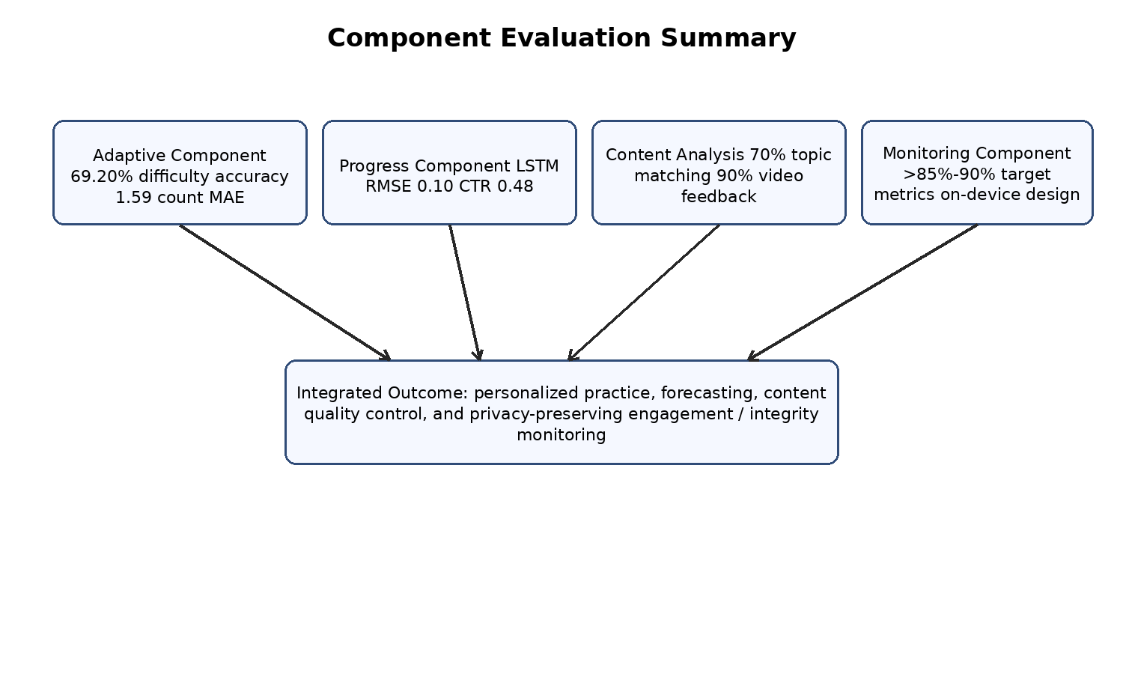
Figure 3.1: Evaluation summary across the four research components
Source: Author-generated from integrated project artifacts.
Table 3.1: Component-level evaluation summary
Component | Main data / model | Reported result or target | Interpretation
Adaptive difficulty | 4,998 balanced category records; multi-task neural model | 69.20% difficulty accuracy; 1.59 question-count MAE | Feasible personalized difficulty and practice-volume prediction
Question generation | 4,531 structured MCQ records; Qwen2.5-Math with QLoRA | Structured MCQ generation workflow | Enables runtime generation when parser/validation safeguards are applied
Progress monitoring | 60 learners; 4 sessions; LSTM forecasting | RMSE 0.10 vs ARIMA 0.16; CTR 0.48 | Sequence-aware forecasting improves predictive monitoring and learner engagement
Content quality | 2,000 topic records; 2,000 guide records; 4,000 video feedback records | 70% topic accuracy; qualitative guide agreement; 90% video feedback accuracy | LLMs can convert educational text and feedback into actionable outputs
Emotion/integrity | MobileNetV2 and YOLOv8 design specification | >85%-90% target accuracy ranges; <200ms detection target | Requires future implementation validation; supports privacy-preserving trust layer

3.2 Research Findings
The first major finding is that adaptive practice becomes more meaningful when behavioral features are combined with marks. The recommendation model does not depend only on correctness; it also uses timing, attempts, waiting ratio, and coverage. This gives the system a richer view of learner state and supports more nuanced practice recommendations.
The second finding is that dynamic content generation can be connected to a recommendation engine if the output is constrained. The generator must produce a structured MCQ object, and the application must validate it before display. This demonstrates a practical relationship between LLM generation and software engineering safeguards.
The third finding is that progress monitoring should be predictive rather than purely descriptive. The LSTM component shows that repeated learner sessions can be used to forecast future readiness, while dashboard recommendations translate those forecasts into support actions. This makes analytics actionable for students and teachers.
The fourth finding is that feedback analysis gains value when it moves beyond sentiment. The content quality component can identify topic mismatches, weak instructional sections, issue categories, severity levels, and recommendations. This supports evidence-based content improvement and reduces the manual workload for teachers.
The fifth finding is that privacy-preserving monitoring is a necessary design direction for child-centered remote learning. The proposed browser-side emotion and integrity pipelines respond to real limitations of remote adaptive platforms, but they also highlight the need for careful consent, transparency, and teacher review.
Table 3.2: Research findings by component
Finding | Evidence from project | Implication
Behavioral features improve adaptation | Adaptive model uses timing, attempts, waiting, and marks | Personalization can distinguish learners with similar scores but different behavior
Structured LLM generation supports integration | MCQ and content models return JSON-style outputs | AI output can be connected directly to web workflows when validated
Sequence modelling improves monitoring | LSTM RMSE lower than ARIMA baseline | Longitudinal learner histories can support early intervention
Feedback can become instructional intelligence | Issue, severity, weak-section, and recommendation outputs | Teachers receive actionable guidance rather than raw comments only
Privacy must shape monitoring design | Browser-side inference and metadata-only logging specification | Trustworthy EdTech requires child-appropriate safeguards

3.3 Discussion
The results show that the platform is strongest when viewed as an integrated educational support system. None of the components alone solves every problem in elementary mathematics learning. However, the combination creates a broader evidence loop: diagnostic behavior informs adaptive practice; session history informs future recommendations; feedback informs content improvement; and engagement/integrity signals protect the quality of remote evidence.
The adaptive component is technically promising because it links recommendation with generation. Many systems either recommend existing exercises or generate questions without knowing learner need. This project connects both actions: first estimating what kind of practice is suitable, then generating MCQs that match that estimate. The reported accuracy is not perfect, but it is sufficient to demonstrate feasibility and justify further dataset expansion.
The progress monitoring component contributes a longitudinal perspective. A learner may have a temporary bad session or a gradual decline. Sequence-aware monitoring helps distinguish these cases. The reported lower RMSE for LSTM suggests that nonlinear temporal models can capture patterns that a simpler baseline may miss. Nevertheless, cold-start handling remains important because new learners have limited history.
The content analysis component is especially valuable for teacher workflows. Educational platforms often focus on students, but teachers also need support managing content quality. Question-topic mismatch, weak teacher guide pacing, and ambiguous video feedback can reduce learning effectiveness. LLM-based structured analysis can help, but it must remain subject to human review because instructional quality involves professional judgment.
The monitoring component raises both opportunities and ethical challenges. Emotion and integrity signals can improve the validity of adaptive recommendations, but continuous camera-based analysis can also create discomfort if designed poorly. The metadata-only, on-device approach is therefore a suitable design direction. Future implementation should include parental consent, child-friendly explanations, opt-in controls, and bias testing.
From a software engineering perspective, the project demonstrates the difficulty of integrating notebooks, trained models, APIs, frontend screens, and database records. Feature order must remain consistent between training and inference. JSON output formats must match parsers. User profile updates must be stored reliably. These details are essential because a working AI system is not only a model but a complete data and interaction pipeline.
Commercially, the strongest positioning is as a teacher-supportive adaptive mathematics platform. Schools and tuition centers need actionable insights, not only automated predictions. Therefore, the product should emphasize explainable recommendations, editable content, teacher dashboards, and strong privacy controls. This could make it more acceptable in educational contexts than systems that present AI decisions as opaque or final.

3.4 Summary of Each Student's Contribution
Table 3.3: Summary of each student contribution
Student | Student ID | Research component | Main contribution
Dukduru Pedige Chamith Rathdunu Sarathchandra | IT22886668 | Adaptive Difficulty and Dynamic Question Generation | Designed and evaluated the adaptive difficulty recommender, feature engineering, question-count prediction, QLoRA MCQ generator, Flask inference, and adaptive practice integration.
A.A.M. Fahad | IT22904928 | Continuous Progress Monitoring and Personalized Recommendation | Developed the continuous monitoring methodology, competency-oriented signals, LSTM forecasting, resource recommendation approach, API/database integration, and dashboard outputs.
Jayathri Tharuka Chamodinee Jayawarana | IT22921680 | AI-powered Content Quality and Feedback Analysis | Developed the AI-powered content analysis component, including question-topic matching, teacher guide and feedback analysis, video feedback classification, LoRA fine-tuning, and structured dashboard outputs.
M. N. Janendra de Silva | IT22318602 | Emotion-aware Engagement and Academic Integrity Monitoring | Specified the tri-pipeline monitoring framework for emotion recognition, unauthorized item detection, and multiple human detection using MobileNetV2/YOLOv8 with privacy-preserving browser-side design.

3.5 Limitations and Mitigation Strategies
The project has several limitations that should be considered before real-world deployment. Some limitations are caused by dataset size, some by model reliability, and some by the difference between individual component maturity levels. Acknowledging these limitations is important because educational AI systems affect children and teachers.
The fourth component is based on a proposal-source document rather than a final experimental report. Therefore, its metrics are stated as targets. This is not a weakness of the design itself, but it means that final validation remains future work. The group report avoids presenting target values as observed results.
Table 3.4: Limitations and mitigation strategies
Limitation | Potential impact | Mitigation strategy
Prepared datasets rather than large classroom-scale datasets | Model performance may not generalize to all schools | Collect more diverse real learner data with consent and teacher review
Generated MCQs may contain errors | Incorrect or unsuitable questions could affect learning | Use parser checks, answer verification, teacher moderation, and item logging
Cold-start learner histories | Forecasting may be unavailable or weak for new learners | Use class averages, diagnostic papers, and conservative recommendations until history grows
Subjectivity in feedback and guide quality | AI may disagree with teacher judgment | Treat outputs as decision support and allow teacher override/editing
Emotion and integrity monitoring sensitivity | False positives or privacy concerns may affect trust | Use on-device inference, metadata-only logging, persistence thresholds, consent, and bias tests
Component maturity mismatch | Not all modules have equal experimental validation | Clearly label target metrics and prioritize future validation of the monitoring component

4. CONCLUSION

4.1 Conclusion
This dissertation presented an integrated AI-powered personalized mathematics learning platform for elementary learners. The project combined four research components that address different but related needs in digital mathematics education: personalized adaptive practice, continuous progress monitoring, AI-based content quality and feedback analysis, and emotion-aware academic-integrity monitoring.
The adaptive component demonstrated that starting-paper behavior can be converted into meaningful follow-up practice through multi-task difficulty and question-count recommendation. The dynamic generator showed how a mathematics-specialized LLM can be adapted with QLoRA to produce structured MCQs for the platform workflow.
The continuous progress monitoring component showed that longitudinal learner evidence can support prediction and recommendation. Its LSTM results outperformed the ARIMA baseline and supported a dashboard-oriented recommendation process. This moves the platform beyond retrospective score tracking toward early intervention.
The content quality component demonstrated the value of structured LLM outputs for educational material improvement. It can support question-topic matching, teacher guide analysis, and video feedback interpretation. By converting unstructured feedback into issue categories and recommendations, it helps teachers improve instructional quality.
The emotion-aware engagement and integrity component broadened the system design by addressing emotional state, unauthorized aids, and multiple human presence in remote learning. Because the uploaded source for this component is a proposal, the report treats it as a design specification with target metrics and future validation requirements. Its privacy-preserving approach remains an important direction for child-centered EdTech.
Overall, the project demonstrates that effective educational AI is not achieved by a single model alone. It requires a full data pipeline, clear API contracts, safe frontend behavior, teacher review, ethical design, and careful integration. The resulting platform provides a strong foundation for adaptive, evidence-driven, and teacher-supportive elementary mathematics learning.

4.2 Future Work
Future work should first focus on larger and more diverse datasets. The adaptive recommender, progress forecaster, content analysis models, and monitoring pipelines would all benefit from data collected across different schools, devices, student backgrounds, and learning conditions. This should be done with formal consent, anonymization, and institutional ethics approval.
The dynamic MCQ generator should be strengthened with automated mathematical verification, duplicate detection, curriculum alignment checks, and teacher moderation workflows. A generated item bank could be built gradually by storing approved generated questions and rejecting unsuitable outputs.
The progress monitoring component should improve cold-start handling. For new learners, the system can combine diagnostic paper results, class averages, and conservative recommendations until enough longitudinal history is available. Future work can also explore transformer-based sequence models or interpretable forecasting methods.
The content analysis component can be extended to Sinhala and Tamil language support, richer grade-suitability scoring, and deeper alignment with local curriculum standards. Teacher dashboards should allow educators to accept, reject, or edit AI-generated recommendations so that the model can learn from human review.
The monitoring component should be implemented and validated through controlled user studies. Accuracy, latency, false-positive rate, demographic fairness, lighting robustness, and child comfort should be tested before school deployment. Clear parental consent and student explanations should be mandatory.
Finally, the integrated platform should be evaluated through a pilot deployment with real teachers and learners. Such a study should measure learning gains, recommendation usefulness, teacher workload reduction, student motivation, and trust in AI-assisted outputs.

REFERENCES
[1] G. Siemens and P. Long, "Penetrating the fog: Analytics in learning and education," EDUCAUSE Review, vol. 46, no. 5, pp. 30-40, 2011.
[2] A. T. Corbett and J. R. Anderson, "Knowledge tracing: Modeling the acquisition of procedural knowledge," User Modeling and User-Adapted Interaction, vol. 4, pp. 253-278, 1995.
[3] S. Hochreiter and J. Schmidhuber, "Long Short-Term Memory," Neural Computation, vol. 9, no. 8, pp. 1735-1780, 1997.
[4] G. E. P. Box, G. M. Jenkins, G. C. Reinsel, and G. M. Ljung, Time Series Analysis: Forecasting and Control, 5th ed. Hoboken, NJ, USA: Wiley, 2015.
[5] H. M. Erdt, A. Fernandez, and C. Rensing, "Evaluating recommender systems for technology enhanced learning: A quantitative survey," IEEE Transactions on Learning Technologies, vol. 8, no. 4, pp. 326-344, 2015.
[6] E. J. Hu et al., "LoRA: Low-Rank Adaptation of Large Language Models," arXiv:2106.09685, 2021.
[7] T. Dettmers, A. Pagnoni, A. Holtzman, and L. Zettlemoyer, "QLoRA: Efficient fine-tuning of quantized LLMs," in Advances in Neural Information Processing Systems, 2023.
[8] Qwen Team, "Qwen2.5 Technical Report," Alibaba Group, Tech. Rep., 2024.
[9] R. W. Picard, Affective Computing. Cambridge, MA, USA: MIT Press, 1997.
[10] M. Sandler, A. Howard, M. Zhu, A. Zhmoginov, and L. C. Chen, "MobileNetV2: Inverted residuals and linear bottlenecks," in Proc. IEEE/CVF CVPR, 2018, pp. 4510-4520.
[11] Ultralytics, "YOLOv8 Documentation," 2024. [Online]. Available: https://docs.ultralytics.com/.
[12] V. LoBue and C. Thrasher, "The Child Affective Facial Expression (CAFE) set: validity and reliability from untrained adults," Frontiers in Psychology, vol. 5, 2015.
[13] S. D'Mello and A. Graesser, "Dynamics of affective states during complex learning," Learning and Instruction, vol. 22, no. 2, pp. 145-157, 2012.
[14] R. Bodily and K. Verbert, "Trends and issues in student-facing learning analytics reporting systems research," in Proc. 7th Int. Conf. Learning Analytics and Knowledge, 2017, pp. 309-318.
[15] Pallets, "Flask Documentation," 2026. [Online]. Available: https://flask.palletsprojects.com/.
[16] MongoDB, Inc., "MongoDB Manual," 2026. [Online]. Available: https://www.mongodb.com/docs/manual/.
[17] Meta Platforms, "React Documentation," 2026. [Online]. Available: https://react.dev/.
[18] D. Lupton and B. Williamson, "The datafied child: The dataveillance of children and implications for their rights," New Media & Society, vol. 19, no. 5, pp. 780-794, 2017.
[19] W. Xu and F. Ouyang, "A conceptual framework of artificial intelligence in education," Computers and Education: Artificial Intelligence, vol. 2, 2021.
[20] G. Hwang, H. Xie, B. W. Wah, and D. Gasevic, "Vision, challenges, roles and research issues of artificial intelligence in education," Computers and Education: Artificial Intelligence, vol. 1, 2020.
[21] J. Sweller, "Cognitive load during problem solving: Effects on learning," Cognitive Science, vol. 12, no. 2, pp. 257-285, 1988.
[22] C. Romero and S. Ventura, "Educational data mining and learning analytics: An updated survey," WIREs Data Mining and Knowledge Discovery, vol. 10, no. 3, 2020.
[23] B. Lika, K. Kolomvatsos, and S. Hadjiefthymiades, "Facing the cold start problem in recommender systems," Expert Systems with Applications, vol. 41, no. 4, pp. 2065-2073, 2014.
[24] J. Cai and S. Hwang, "Making mathematics learning meaningful for students: The role of logical reasoning," Mathematical Thinking and Learning, vol. 22, no. 4, pp. 280-295, 2020.

APPENDICES

Appendix A: Sample API Payloads
This appendix gives simplified examples of the structured data exchanged between components. The examples are included to clarify how model outputs are connected to the application workflow.
Table A.1: Sample recommendation API input and output
Payload type | Example
Input | {"total_time": 300, "waited_time": 42, "total_q": 10, "answered": 9, "correct": 6, "wrong": 3, "marks": 60, "topic": "fractions"}
Output | {"recommended_difficulty": "Medium", "recommended_count": 5, "confidence_note": "category-level practice recommended"}
Table A.2: Sample generated MCQ structure
Field | Example content
question | A rectangle is 8 cm long and 3 cm wide. What is its perimeter?
options | ["11 cm", "22 cm", "24 cm", "30 cm"]
correct_answer | 22 cm
reasoning | Perimeter = 2 x (length + width) = 2 x (8 + 3) = 22
metadata | {"topic": "measurement", "grade": 4, "difficulty": "medium"}

Appendix B: Component Dataset Summary
Table B.1: Consolidated dataset summary
Component | Dataset or evidence | Size / scope | Primary use
Adaptive difficulty | Balanced recommendation dataset | 4,998 records | Difficulty and question-count prediction
Question generation | Structured mathematics MCQ dataset | 4,531 records | QLoRA fine-tuning for generated MCQs
Progress monitoring | Learner session dataset | 60 learners, 4 sessions | LSTM forecasting and recommendation evaluation
Question-topic matching | Mathematics matching dataset | 2,000 records, 1,646 unique questions | Topic alignment scoring
Teacher guide analysis | Teacher guide + feedback dataset | 2,000 records | Weak-section detection
Video feedback analysis | Student video feedback dataset | 4,000 records | Issue/severity classification
Monitoring component | CAFE/custom targets, prohibited item dataset, Roboflow human dataset | Proposal-specified datasets | Emotion, item, and human detection validation

Appendix C: Deployment and Testing Checklist
Table C.1: Deployment and testing checklist
Checklist item | Status to verify before production
Feature-order consistency | Recommendation API uses the same feature ordering and scaling as model training.
Generated MCQ validation | Question, four options, correct answer, reasoning, topic, grade, and difficulty are present.
Forecast cold-start policy | New learners receive conservative recommendations when insufficient history exists.
Content output schema | LLM outputs contain required JSON fields and fallback handling for malformed responses.
Dashboard review controls | Teachers can review, accept, reject, or edit AI recommendations.
Monitoring consent | Parental consent and child-friendly explanation are collected before webcam monitoring.
Privacy audit | No raw video frames are transmitted or stored; only metadata events are logged.
Security checks | Authentication, authorization, TLS, and role-based dashboard access are enabled.
Pilot study | Teacher and learner usability is evaluated in a controlled real-world setting.

Appendix D: Project Requirements Summary
The integrated platform is expected to satisfy both functional and non-functional requirements. Functional requirements describe the user-visible capabilities of the system, while non-functional requirements describe quality attributes such as usability, performance, reliability, maintainability, and privacy. The four research components collectively contribute to these requirements.
The student-facing functional requirements include grade selection, starting paper access, answer submission, generated practice display, recommendation card viewing, progress profile viewing, and feedback submission. These requirements ensure that the learner can move through the platform without needing to understand the underlying models.
The teacher-facing functional requirements include starting paper creation, bulk question upload, learner progress review, recommendation review, content quality review, feedback insight review, and alert monitoring. These capabilities are important because AI output becomes useful only when teachers can interpret and act on it.
The administrator-facing requirements include user management, grade/topic configuration, content oversight, data export, and access control. These requirements support institutional deployment where many learners and teachers use the same platform.
The main non-functional requirements are performance, usability, explainability, privacy, security, and maintainability. Model endpoints should respond within a practical time for classroom use. Dashboards should summarize outputs clearly. Sensitive learner data should be protected with authentication and role-based access. Models and prompts should be maintainable so that improved datasets can be integrated later.
The system also needs resilience. If a model endpoint fails, the platform should display a safe fallback rather than interrupting the learner completely. If a generated question cannot be parsed, it should be rejected and regenerated or replaced with a teacher-approved fallback item. If a monitoring alert is uncertain, it should be logged for review rather than automatically penalizing the student.
- Functional requirement: support diagnostic starting-paper workflows for Grades 3, 4, and 5.
- Functional requirement: recommend follow-up difficulty and practice volume based on learner evidence.
- Functional requirement: generate or retrieve suitable MCQ practice content with answer validation.
- Functional requirement: forecast learner progress and display recommendations in the dashboard.
- Functional requirement: analyze question-topic alignment and feedback-derived instructional issues.
- Functional requirement: provide privacy-preserving engagement and integrity event metadata for teacher review.
- Non-functional requirement: keep learner-facing flows simple, age-appropriate, and not excessively long.
- Non-functional requirement: protect child data through role-based access, secure transport, and data minimization.
- Non-functional requirement: support model replacement without redesigning the full web application.

Appendix E: Risk Management and Maintenance Plan
A maintainable educational AI platform requires planned risk management. The most important risks in this project are incorrect model outputs, unsuitable generated content, privacy concerns, low teacher trust, and inconsistent data between frontend, backend, and ML services. These risks can be reduced through validation, monitoring, and clear ownership of each component.
The recommendation risk is that a learner may be placed at a difficulty level that is too easy or too difficult. This can be mitigated by conservative thresholds, limited practice volumes, teacher override options, and continuous profile updates after practice performance. The system should also record recommendation outcomes so that future models can learn from accepted or rejected recommendations.
The generation risk is that an LLM may produce an invalid or mathematically incorrect question. The mitigation strategy is to enforce JSON schema validation, option-count checks, correct-answer checks, topic and grade metadata checks, and teacher approval for reusable generated questions. Over time, approved generated questions can become part of a reviewed item pool.
The forecasting risk is that a short learner history may produce unreliable trends. This can be handled using diagnostic starting-paper evidence, class-average fallback values, and clear dashboard labels that distinguish observed performance from predicted performance. Teachers should not treat early forecasts as final judgments.
The content analysis risk is that educational quality judgments can be subjective. The AI component should therefore present reasons and confidence values and allow teachers to edit or dismiss suggestions. Teacher actions can be logged to improve future prompt design or fine-tuning examples.
The monitoring risk is that camera-based models may produce false positives or may make learners uncomfortable. The platform should use explicit consent, child-friendly explanations, on-device processing, metadata-only storage, adjustable thresholds, and teacher review. Monitoring should be framed as helping maintain a fair learning environment rather than as punitive surveillance.
Maintenance should follow a versioned model lifecycle. Each trained model should have a dataset version, training configuration, evaluation result, API schema, and rollback option. Any change to model output format should be tested against frontend parsers and backend validators before release.
The project should also maintain documentation for API contracts, database schema changes, user roles, error-handling behavior, and deployment steps. This documentation is necessary because a multi-component AI platform can fail at integration points even when individual models perform well.
- Maintain versioned datasets and model artifacts for reproducibility.
- Use schema validation for all AI outputs consumed by the frontend.
- Provide teacher override mechanisms for recommendations and content warnings.
- Log model errors and fallback usage to support debugging.
- Audit privacy behavior before enabling camera-based monitoring in real classrooms.
- Retest page flows whenever API contracts or database schemas change.

