190501V - Ranathunga R.A.C.D.

BM2101 - Analysis of Physiological Systems – Assignment 04

**Compartment Modelling**

**Part 01 - Question 01**

1. Step input to a normal person

1. Bolus input to a normal person

1. Step input to a diabetic patient

1. Step input to a diabetic patient with glucose infusion

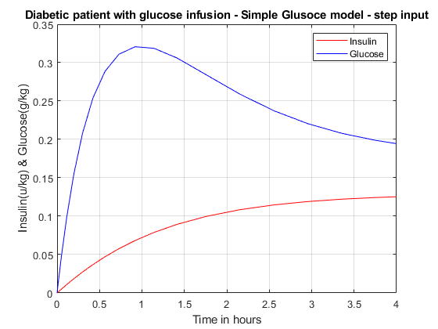

**Question 02**

1. Iodine intake for normal condition – 10 days

1. Iodine intake for normal condition – 300 days

1. Drop in intake – 10 days

1. Drop in intake – 300 days

1. Hyperthyroidism due to autoimmune thyroid disease.

Hypothyroidism is a disease where the thyroid gland can’t produce and release enough thyroid hormone to the blood. When it happens due to autoimmune thyroid disease, the magnitudes of the coefficients related to gland iodine should be reduced.

1. Hypothyroidism due to low iodine intake.

Hypothyroidism can happen also due to low Iodine intake. Then we can change the vector related to intake of iodine.

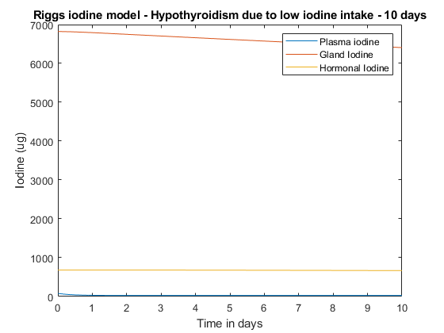

1. Hyperthyroidism due to Grave’s disease

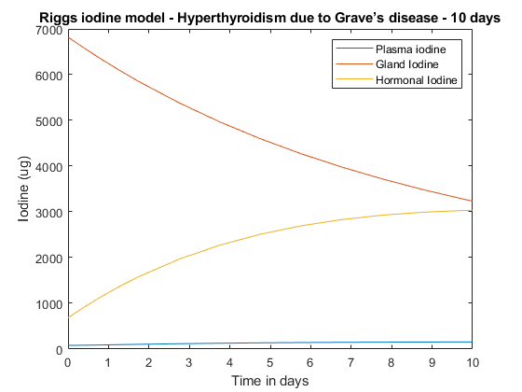Hyperthyroidism is a disease that caused by the over production of thyroxine hormone by thyroid gland. Grave’s disease leads to the above mentioned over production of hormones. It is an immune system disorder. Hence the coefficients related to gland iodine should increase.

1. When a person has a goiter, his/her thyroid gland grows larger. Lack of iodine in the diet is the main reason for goiter. Few of common causes for goiters are Hashimoto’s disease, Grave’s disease, Thyroid nodules. We can reduce the iodine input in the riggs model. Also, goiters can lead to either hyperthyroidism or hypothyroidism. Therefore, we cannot exactly say what should we do for the coefficients related to gland iodine.

Not all thyroid tumors are cancerous. Only a small number of types of thyroid tumors are cancerous. The reason behind these cancers can be Iodine deficiency. It can cause either hyperthyroidism or hypothyroidism. Hence, we can use the riggs model with low iodine input.

**Part 02 - Question 01**

Model 01

Insulin graph

Glucose graph

Model 02

Insulin graph

Glucose graph

Model 03

Insulin graph

Glucose graph

Model 04

Insulin graph

Glucose graph

**Part 02 - Question 02**

Plasma Iodine graph

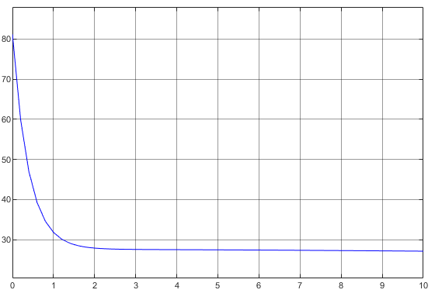

Gland Iodine graph

Hormonal Iodine graph



