

**Elephant Learn**

**A sentimental analysis system for Thai stock market**

Project Management Plan

By

Pakarat Matmarurat 592115022

Chamnol Yin 592115519

Department of Software Engineering

College of Arts, Media and Technology

Chiang Mai University

Project Advisor

__________________________________

Dr.Pree Thiengburanathum

**Document History**

|  |  |  |  |  |  |  |
| --- | --- | --- | --- | --- | --- | --- |
| **History** | **Version** | **status** | **Date** | **Viewable** | **Editable** | **Responsible** |
| Add Chapter I   * Identification * Project overview * Deliverable * Acronyms and Definition   Add Chapter II   * Development tools * Hardware and Material resources   Add Chapter III   * Project Team Structures * Monitoring and Controlling Mechanisms   Add Chapter IV   * Reviews/Responsibility * Testing   Add Chapter VI  Add Chapter VII   * Naming Convention * Change Management * Project Repository * Software Configuration Item Table   Add Chapter VIII   * Risk Identification and Solutions   Add Chapter IX   * Milestone Gantt Chart | ElephantLearn- PMP_v1.0.docx | Draft | June  12nd,  2019 | PT, CY, PM | CY, PK | CY, PK |
| Update Chapter I   * Identification * Project overview   Update Chapter IX   * Milestone Gantt Chart | ElephantLearn- PMP_v1.0.docx | Draft | June  20th,  2019 | PT, CY, PK | CY, PK | CY, PK |

*CY = Mr. Chamnol Yin,

*PK = Miss Pakarat Matmarurat,

*PT = Dr. Pree Thiengburanathum

**Table of Contents**

**Chapter I | Introduction** 6

**1.1 Identification** 6

**1.2 Project Overview** 6

**1.2.1 Purpose** 6

**1.2.2 Scope** 6

**1.3 Work Product to be developed** 7

**1.3.1 Deliverable** 7

**1.3.2 Non-Deliverables** 7

**1.4 Acronyms and Definitions** 8

**1.4.1 Acronyms** 8

**1.4.2 Definitions** 8

**Chapter II | Infrastructure** 10

**2.1 Development Tools** 10

**2.2 Hardware and Material Resources** 10

**Chapter III | Management Procedures** 11

**3.1 Project Team Structures** 11

**3.2 Monitoring and Controlling Mechanisms** 11

**3.2.1 Project Meeting** 11

**3.2.2 Software Development Life Cycle** 12

**Chapter IV| Quality Standard** 13

**4.1 ISO 29110 for Very Small Entity (VSE)** 13

**4.1.1 Project Management (PM) Process** 13

**4.1.2 Software Implementation (SI) Process** 14

**Chapter V | Quality Planning** 15

**5.1 Reviews/Responsibility** 15

**5.2 Testing** 15

**Chapter VI | Estimated Duration of Tasks** 16

**Chapter VII | Software Configuration Management** 17

**7.1 Naming Convention** 17

**7.2 Change Management** 17

**7.3 Project Repository** 18

**7.4 Software Configuration Item Table** 19

**Chapter VIII | Risk Management** 20

**8.1 Risk Identification and Solutions** 20

**Chapter IX | Schedule** 21

**9.1 Milestone Gantt Chart** 21

# **Chapter I | Introduction**

## **1.1 Identification**

Elephant Learn is a web application developed by react JS used as web application and python used to be web service. The core idea of the software is to automatedly scraping text data from sinthorn section’s comments in Pantip and provide the result of sentimental analysis which admin can delete the negative comments. Moreover, Elephant Learn provides responsive interface showing the result of descriptive and predictive analysis the percentage of the comment and the statistic of the information which is the number of users, date and time of comment in the system.

This project plan is the document for planning, scheduling activities, and evaluating overall of the project so that the project will complete as successfully as possible in spite of all risks. The project plan documents the plan before starting the project. When the project starts, the project plan is used to track the progress and monitor whether the project follows the plan.

## **1.2 Project Overview**

Elephant Learn is a web application that uses web service to fulfill its functionality. It let admin view the percentage of the topic on sinthorn section in Pantip. If the comments are negative admin can delete the comments. Admin can view the statistic of information, which is the number of users, date, and time of the comment. Moreover, admin can view all data which is in the system and data that have deleted before.

### **1.2.1 Purpose**

The main purpose of developing Elephant Learn is to help admin to detect the negative comments on sinthorn section in Pantip blog.

### **1.2.2 Scope**

There are eight major parts of Elephant Learn.

**Feature #01:** Retrieve comments

**Feature #02:** Data cleaning, Data preprocessing, Data analysis

**Feature #03:** View percentage

**Feature #04:** View statistic

**Feature #05:** Pending new comments

**Feature #06:** Delete comment

**Feature #07:** Authentication

**Feature #08:** Save data

## **1.3 Work Product to be developed**

### **1.3.1 Deliverable**

|  |  |  |  |  |
| --- | --- | --- | --- | --- |
| **No.** | **Deliverables/Release** | **Media** | **Copies** | **Date** |
| 1 | **Project Proposal**   * Proposal Version 1.0 | Hard Copy | 3 | June 4th,2019 |
| 2 | **Progress Report I**   * Project Management Plan Version 1.0 * Software Requirement Specification   Version 1.0   * Software Design Document Version 1.0 * Test Plan Version 1.0 * Traceability Record Version 1.0 * Software Version 0.1 | Hard Copy | 3  3  3  3  3  1 | July 30th,2019 |
| 3 | **Progress Report II**   * Project Management Plan Version 2.0 * Software Requirement Specification   Version 2.0   * Software Design Document Version 2.0 * Test Plan Version 2.0 * Traceability Record Version 2.0 * Software Version 2.0 | Hard Copy | 3  3  3  3  3  1 | Oct 4th,2019 |
| 4 | **Final Progress**   * Project Management Plan Version 3.0 * Software Requirement Specification   Version 3.0   * Software Design Document Version 3.0 * Test Plan Version 3.0 * Traceability Record Version 3.0 * Software Version 1.0 * Software Source Code | Hard Copy | 3  3  3  3  3  1 | Nov  29th,2019 |

### **1.3.2 Non-Deliverables**

|  |  |  |
| --- | --- | --- |
| **No.** | **Work Product** | **Media** |
| 1 | Video presentation | File |
| 2 | Poster Presentation | Poster |
| 3 | 5 minutes of video Presentation | File |

## **1.4 Acronyms and Definitions**

### **1.4.1 Acronyms**

SRS Software Requirement Specification

SDD Software Design Document

OS Operating System

VSE Very Small Entity

PM Project Management

SI Software Implementation

CY Mr. Chamnol Yin

PK Miss Pakarat Matmarurat

PT Dr. Pree Thiengburanathum

### **1.4.2 Definitions**

|  |  |
| --- | --- |
| **Name** | **Description** |
| **Feature** | Transformation of input parameters to output Parameters based on a specified algorithm. It describes the functionality of a product in the language of the product. Used for requirements analysis, design, coding, testing, or maintenance. |
| **Plan** | A documented series of tasks requires meeting an objective, typically including the associated schedule, budget, resources, organizational description and work breakdown structure. |
| **Project**  **Management** | The application of knowledge, skills, tools, and techniques to project activities in order to meet or exceed stakeholder needs and expectations from a project. |
| **Project Plan** | A formal, approved document used to guide both project execution and project control. The primary uses of the project plan are to document planning assumptions and decision, to facilitate communication among stakeholders, and to document approved scope, cost, and schedule baseline. |
| **Risk** | An uncertain event or condition that, if it occurs, has a positive or negative effect on the project’s objectives. It is a function of the probability of occurrence of a given threat’s occurrence. |
| **Risk Management** | The systematic application of management policies,  procedures and practices to the tasks of identifying,  analyzing, evaluating, treating and monitoring risk. |
| **Traceability** | The ability to trace the history, application or location of an item or activity, or work products or activities, by means of recorded identification. The establishment and maintenance of relationships between such items. Horizontal traceability describes the relationship between work products of the same type (e.g., customer requirements). Vertical traceability describes the relationship between work products which build upon each other or are derived from each other (e.g., from customer requirements to qualification test cases). Bidirectional traceability allows to directly following relationships in both directions. |
| **Unit test** | A test of individual programs or modules in order to remove design or programming errors. |

# **Chapter II | Infrastructure**

## **2.1 Development Tools**

* React JS version 16.8.6
* Visual Studio Code version 1.36.1
* Python version 3.7.3
* GitHub
* Scrapy version 2.4.2

## **2.2 Hardware and Material Resources**

**Laptops**

DELL G3 15 3579 Gaming

* CPU: Intel Core i7-8750H
* GPU: NVIDIA GeForce GTX 1050Ti (4GB GDDR5)
* DISPLAY: 15.6 inch (1920x1080) Full HD IPS
* RAM: 8 GB DDR4, 2666 MHz
* STORAGE: 1 TB 5400 RPM + 128 GB SSD
* OS: Window10

DELL INSPIRON 5559

* CPU: Intel Core i7-6500U
* GPU: Intel HD Graphics 520
* DISPLAY: 15.6”, Full HD (1920 x 1080), TN
* RAM: 8GB DDR3, 1600 MHz
* STORAGE: 240 GB SSD
* OS: Window10

# **Chapter III | Management Procedures**

## **3.1 Project Team Structures**

|  |  |
| --- | --- |
| Participants | Activities |
| Mr. Chamnol Yin  Miss Pakarat Matmarurat | Feasibility Study |
| Project Proposal |
| Project Requirement |
| Project Plan |
| Software Architectural Design |
| Software Detailed Design |
| Implementation |
| Testing |
| Review |

## **3.2 Monitoring and Controlling Mechanisms**

### **3.2.1 Project Meeting**

|  |  |
| --- | --- |
| **Participants** | **Roles** |
| Mr. Chamnol Yin | Development team member |
| Miss Pakarat Matmarurat | Development team member |
| Dr. Pree Thiengburanathum | Project advisor |

### **3.2.2 Software Development Life Cycle**

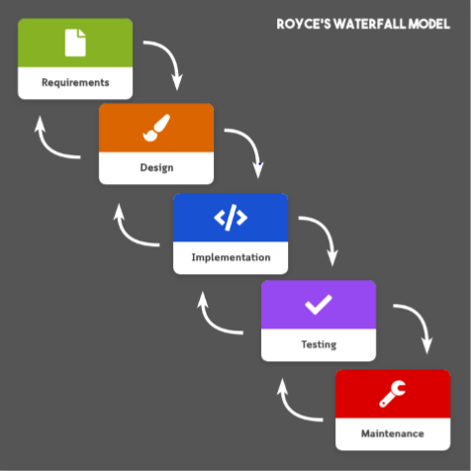

**Figure 1**: Royce’s Waterfall Model

Royce’s Waterfall Model is a software development model that divides the development process into 5 phases, requirement engineering, design, code implementation, testing, and software maintenance. The model states that proceeding phases are required to be completed before moving on to the next phase. Similar to agile methods, Royce’s Waterfall Model also adapts the iterative approach. Feedback from each phase can influence the previous phases, making it flexible for changes (Chowdhury, 2009).

# **Chapter IV| Quality Standard**

## **4.1 ISO 29110 for Very Small Entity (VSE)**

ISO 29110 is the Software Life Cycle Profiles and Guidelines for Very Small Entities (VSEs) standards and technical reports are targeted at Very Small Entities (VSEs). A Very Small Entity (VSE) is an enterprise, organization, department or project having up to 25 people. ISO 29110 concerns on project management process and software implementation process.

### **4.1.1 Project Management (PM) Process**

• **Purpose**

The purpose of the Project Management process is to establish and carry out in a systematic way the tasks of the software implementation project, which allows complying with the project’s objectives in the expected quality, time and costs.

• **Objective**

**PM.O1.** The Project Plan for the execution of the project is developed according to the Statement of Work and validated with the Customer. The tasks and resources necessary to complete the work are sized and estimated

**PM.O2.** Progress of the project is monitored against the Project Plan and recorded in the Progress Status Record. Corrections to remediate problems and deviations from the plan are taken when project targets are not achieved. Appropriate treatment is taken to correct or avoid the impact of risk. Closure of the project is performed to get the Customer acceptance documented in the Acceptance Record.

**PM.O3.** The Change Requests are addressed through their reception and analysis. Changes to software requirements are evaluated for cost, schedule and technical impact.

**PM.O4.** Review meetings with the Work Team and the Customer are held. Agreements are registered and tracked.

**PM.O5.** Risks are identified as they develop and during the conduct of the project.

**PM.O6.** A software Version Control Strategy is developed. Items of Software Configuration are identified, defined and baseline. Modifications and releases of the items are controlled and made available to the Customer and Work Team including the storage, handling and delivery of the items.

**PM.O7.** Software Quality Assurance is performed to provide assurance that work products and processes comply with the Project Plan and Requirements Specification.

• **Activities**

**PM.1** Project Planning

**PM.2** Project Plan Execution

**PM.3** Project Assessment and Control

**PM.4** Project Closure

### **4.1.2 Software Implementation (SI) Process**

**• Purpose**

The purpose of the Software Implementation process is the systematic performance of the analysis, design, construction, integration and tests activities for new or modified software products according to the specified requirements.

• **Objectives**

**SI.O1.** Tasks of the activities are performed through the accomplishment of the current Project Plan.

**SI.O2.** Software requirements are defined, analyzed for correctness and testability, approved by the Customer, baseline and communicated.

**SI.O3.** Software architectural and detailed design is developed and baseline. It describes the software items and internal and external interfaces of them. Consistency and traceability to software requirements are established.

**SI.O4.** Software components defined the are produced. Unit test are defined and performed to verify the consistency with requirements and the design. Traceability to the requirements and design are established.

**SI.O5.** Software is produced performing integration of software components and verified using Test Cases and Test Procedures. Results are recorded at the Test Report. Defects are corrected and consistency and traceability to Software Design are established.

**SI.O6.** A Software Configuration that meets the Requirements Specification as agreed to with the Customer, which includes user, operation and maintenance documentations is integrated, baseline and stored at the Project Repository. Needs for changes to the Software Configuration are detected and related Change Requests are initiated.

**SI.O7.** Verification and Validation tasks of all required work products are performed using the defined criteria to achieve consistency among output and input products in each activity. Defects are identified and corrected; records are stored in the Verification/Validation Results.

• **Activities**

**SI.1** Software Implementation Initiation

**SI.2** Software Requirements Analysis

**SI.3** Software Architectural and Detailed Design

**SI.4** Software Construction

**SI.5** Software Integration and Tests

**SI.6** Product Delivery

# **Chapter V | Quality Planning**

## **5.1 Reviews/Responsibility**

|  |  |  |  |
| --- | --- | --- | --- |
| Stage Exit Review | | | |
| **No.** | **Stage** | **Review Item** | **Responsibility** |
| 1 | Project Planning | Project Plan | Chamnol, Pakarat |
| 2 | Requirement Specification | Software Requirement Specification | Chamnol, Pakarat |
| 3 | Architecture and Detailed Design | Software Design Document | Chamnol, Pakarat |
| 4 | Implementation | Code | Chamnol, Pakarat |
| 5 | Software Testing | Test Plan | Chamnol, Pakarat |
| 6 | Software Testing | Test Record | Chamnol, Pakarat |
| 7 | Project Monitoring and Control | Traceability Record | Chamnol, Pakarat |

## **5.2 Testing**

|  |  |  |
| --- | --- | --- |
| Stage Exit Review | | |
| **No.** | **Test** | **Responsibility** |
| 1 | Unit Testing | Chamnol, Pakarat |
| 2 | System Testing | Chamnol, Pakarat |

# **Chapter VI | Estimated Duration of Tasks**

|  |  |  |
| --- | --- | --- |
| **Task and Estimated Duration** | | |
| **No.** | **Phase** | **Estimated Duration (Days)** |
| 1 | Proposal | 22 |
| 2 | Progress I | 49 |
| 3 | Progress II | 59 |
| 4 | Final Progress | 49 |
| Total | | 179 |

# **Chapter VII | Software Configuration Management**

## **7.1 Naming Convention**

For the filename format that we are using for all documents is:

Elephant Learn-[File Name]_v[Version].[File Type]

* + File Name - This part will depend on substance of that file.
  + Version - This part is the version of file. Version number will be in this format “[Main version].[Sub version]”
  + File Type - This part is type of file.

(I.E., ElephantLearn-ProjectPlan_v1.0.docx)

## **7.2 Change Management**

Change management manages all the changes in the project during development process. All the change requests will be recorded into the change record document.

The procedures for managing changes are:

1. Discuss with advisor about the change.

2. Record the change information to change the document.

3. Send the change request to advisor.

3.1 Request accepted: change document and software follow the change

information.

3.2 Request rejected: continue and find an alternative solution.

## **7.3 Project Repository**

This project uses “GitHub” to manage the version of the document and software. It can be used to store and share code or binary files for software development projects.

The repository’s directories will be created as following;

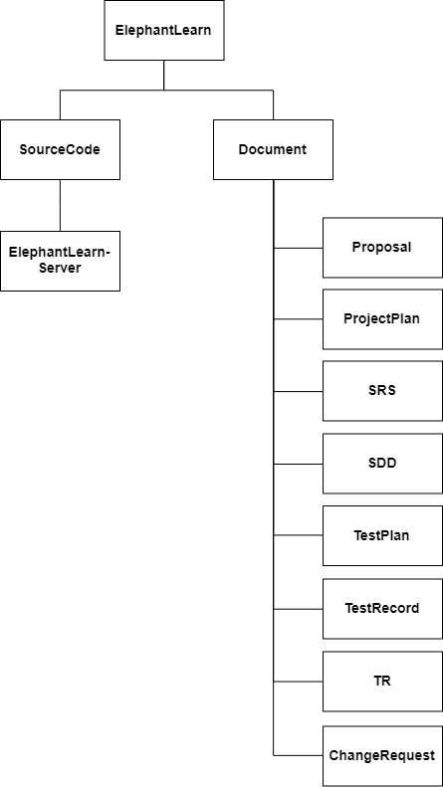

**Figure 2:** Project Repository

## **7.4 Software Configuration Item Table**

|  |  |  |  |  |  |  |
| --- | --- | --- | --- | --- | --- | --- |
| **No.** | **Item** | **Filename** | **File Type** | **Owner** | **Path** | **Baseline Version** |
| 1 | Project Proposal | ElephantLearn-Proposal_v[Version] | .docx | CY, PK | /ElephantLearn/Proposal | 1.0 |
| 2 | Project Management Plan | ElephantLearn- PMP_v[Version] | .docx | CY, PK | /ElephantLearn/ProjectPlan | 1.0 |
| 3 | Software Requirement Specification | ElephantLearn-SRS_v[Version] | .docx | CY, PK | /ElephantLearn/SRS | 1.0 |
| 4 | Software Design Document | ElephantLearn-SDD_v[Version] | .docx | CY, PK | /ElephantLearn/SDD | 1.0 |
| 5 | Test Plan | ElephantLearn- TestPlan_v[Version] | .docx | CY, PK | /ElephantLearn/TestPlan | 1.0 |
| 6 | Test Record | ElephantLearn- TestRecord_v[Version] | .docx | CY, PK | /ElephantLearn/TestRecord | 1.0 |
| 7 | Traceability Record | ElephantLearn-TR_v[Version] | .docx | CY, PK | /ElephantLearn/TR | 1.0 |
| 8 | Change Request | ElephantLearn-CR_v[Version] | .docx | CY, PK | /ElephantLearn/CR | 1.0 |
| 9 | Executive Summary | ElephantLearn-ES_v[Version] | .docx | CY, PK | /ElephantLearn/ES | 1.0 |
| 10 | Software Source Code | ElephantLearn_CodeServer_v[Version] | .zip | CY, PK | /ElephantLearn/ElephantLearn-Server | 1.0 |

# **Chapter VIII | Risk Management**

## **8.1 Risk Identification and Solutions**

|  |  |  |
| --- | --- | --- |
| **No.** | **Risk Statement** | **Solution** |
| 1 | The developer lacks necessary skills for project development. | - Study from the textbook or online resources. |
| 2 | The requirements might change. | - Make change request and discuss  with advisor to reprioritize the  changed requirements. |
| 3 | The process flow might not keep up with the project schedule. | - Start tasks execution before their schedule.  - Prioritize tasks and to do more important works first. |
| 4 | Pantip blog update their website. | - Learn the new changes and adapt to the project as soon as possible. |

# **Chapter IX | Schedule**

## **9.1 Milestone Gantt Chart**

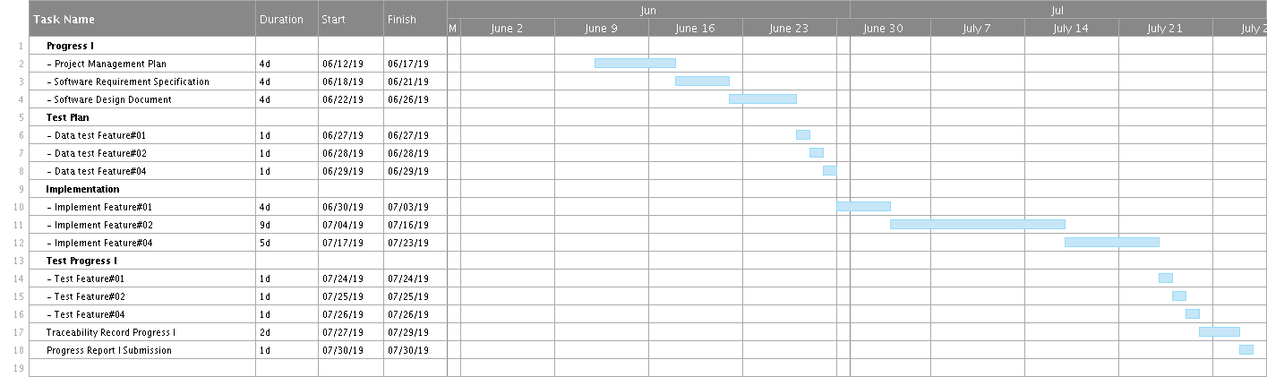

**Figure 3**: Progress I Milestone Plan

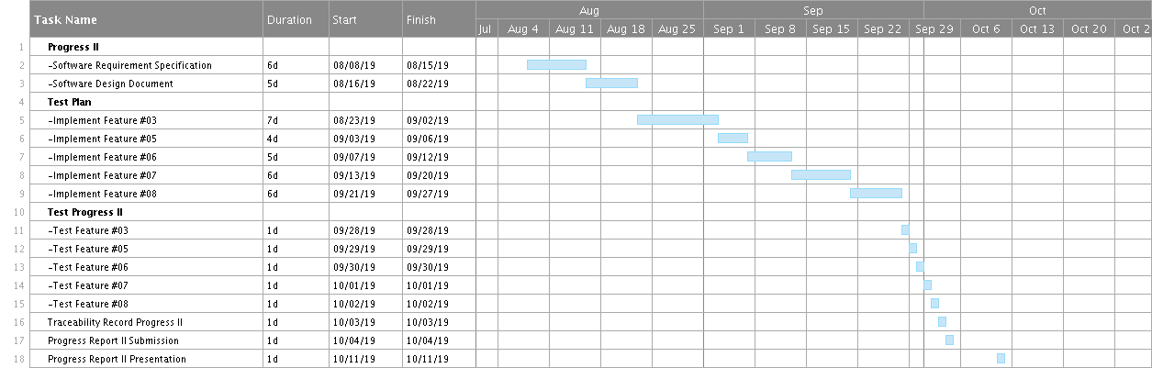

**Figure 4**: Progress II Milestone Plan

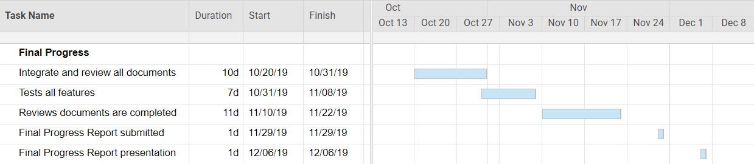

**Figure 5**: Final Progress Milestone Plan