

**Elephant Learn**

**A sentimental analysis system for Thai stock market**

Software Requirement Specification

By

Pakarat Matmarurat 592115022

Chamnol Yin 592115519

Department of Software Engineering

College of Arts, Media and Technology

Chiang Mai University

Project Advisor

__________________________________

Dr.Pree Thiengburanathum

**Document History**

|  |  |  |  |  |  |  |
| --- | --- | --- | --- | --- | --- | --- |
| **History** | **Version** | **Status** | **Date** | **Viewable** | **Editable** | **Responsible** |
| Add Chapter I   * Objective * Project Scope * Acronyms and Definitions   Add Chapter II   * User requirement specification * User requirement specification and Software requirement specification   Add Chapter III   * Use case scenarios   Add Chapter IV   * Specification requirement | Elephant  Learn-SRS_V1.0.docx | Draft | June,  18th,2019 | PT | CY, PM | CY, PM |
| Update Chapter II   * User requirement specification * User requirement specification and Software requirement specification   Update Chapter III   * Use case scenarios   Update Chapter IV   * Specification requirement | Elephant  Learn-SRS_V1.0.docx | Draft | June,  26th,2019 | PT | CY, PM | CY, PM |

*CY = Mr. Chamnol Yin,

*PM = Miss Pakarat Matmarurat,

*PT = Dr. Pree Thiengburanathum

**Table of Contents**

**Chapter I: Introduction** 5

**1.1 Objective** 5

**1.2 Project scope** 5

**1.3 Acronyms and Definitions** 5

**Chapter II: Overall Description** 7

**2.1 Product Perspective** 7

**2.2 Product Feature** 7

**2.3 User classes and Characteristics** 7

**2.4 Development Environment** 8

**Chapter III: Functional Requirement** 9

**3.1 User Requirement Specification** 9

**3.2 User Requirement Specification and Software Requirement Specification** 9

**Chapter IV: Specification Requirement** 10

**4.1 Use Case Scenarios** 10

**4.2 Use case description and Activity diagram.** 11

**4.2.1 UC-01: View the retrieved comments from Pantip blog** 11

**AD-01: View the retrieved comments from Pantip blog** 12

**4.2.2 UC-02: View the result of sentimental analysis** 13

**AD-02: View the result of sentimental analysis** 15

**4.2.4 UC-03: View the statistic of information** 16

**AD-03: View the statistic of information** 17

# **Chapter I: Introduction**

## **1.1 Objective**

The objective of the Software Requirement Specification (SRS) document is to outline all the requirements for Elephant learn. The requirement explains the steps to use the system. This document is based on the project proposal and project plan. Furthermore, it contains a general description of the type of user who will be using the system, how it is going to work, and goals.

This document is intended to be used by the members of the project team and other stakeholders who will participate in the design and implementation phases of the project and verify the correct functionality of the system. In addition, the web application will be designed following this document.

## **1.2 Project scope**

Elephant Learn is a web application, which only has admin as a single type of user of the system, that be able to log in to the system. Admin can see the comments that have been scraped, the result of the sentiment analysis system, delete negative comments of the system. Admin is the highest privilege of the system which can access most of the features of the system.

## **1.3 Acronyms and Definitions**

**1.3.1 Acronyms**

|  |  |
| --- | --- |
| **SRS** | Software Requirement Specification |
| **URS** | User Requirement Specification |
| **UC** | Use Case |
| **AD** | Activity Diagram |
| **CY** | Mr. Chamnol Yin, |
| **PM** | Miss Pakarat Matmarurat |
| **PT** | Dr. Pree Thiengburanathum |

**1.3.2 Definitions**

|  |  |
| --- | --- |
| **Name** | **Description** |
| **Feature** | Transformation of input parameters to output Parameters based on a specified algorithm. It describes the functionality of a product in the language of the product. Used for requirements analysis, design, coding, testing, or maintenance. |
| **Activity Diagram** | Activity diagrams are graphical representations of workflows of stepwise activities and actions with support for choice, iteration, and concurrency. Activity diagrams show the overall flow of control. |
| **Use Case** | A use case is a methodology used in system analysis to identify, clarify, and organize system requirements. The use case is made up of a set of possible sequences of interactions between systems and users in a particular environment and related to a particular goal. It consists of a group of elements (for example, classes and interfaces) that can be used together in a way that will have an effect larger than the sum of the separate elements combined. |
| **Use Case Diagram** | A use case diagram at its simplest is a representation of a user’s interaction with the system and depicting the specifications of a use case. A use case diagram can portray the different types of users of a system and the various ways that they interact with the system. |

# **Chapter II: Overall Description**

## **2.1 Product Perspective**

Elephant Learn is a web application which can help admin solve the negative problem on Pantip inside sinthorn (stock market) section. Admin can see the result of the sentiment analysis. Elephant Learn automatically scrap the comments from Pantip, save retrieved comments as textual data in the format of CSV and JSON file, process data cleaning, preprocessing (tokenizing, POS tagging and Bag of words) and generate the model of vector of words. With the generated model, Elephant Learn provides the percentage of sentimental analysis of all comments on the topic and provide the statistic of information, which is the number of users, date and time of the comments. Moreover, admin can delete the negative comments of the system and view the pending new comments.

## **2.2 Product Feature**

* Feature #01: Retrieve comments
* Feature #02: Data cleaning, Data preprocessing, Data analysis
* Feature #03: View percentage
* Feature #04: View statistic
* Feature #05: Pending new comments
* Feature #06: Delete comment
* Feature #07: Authentication
* Feature #08: Save data

## **2.3 User classes and Characteristics**

|  |  |
| --- | --- |
| **Name** | **Description** |
| Admin | The actor who can see the results of the sentiment analysis system. Admin can delete negative comments of the system. Admin is the highest privilege of the system which can access most of the features of the system. |

## **2.4 Development Environment**

**Laptops**

DELL G3 15 3579 Gaming

* CPU: Intel Core i7-8750H
* GPU: NVIDIA GeForce GTX 1050Ti (4GB GDDR5)
* DISPLAY: 15.6 inch (1920x1080) Full HD IPS
* RAM: 8 GB DDR4, 2666 MHz
* STORAGE: 1 TB 5400 RPM + 128 GB SSD
* OS: Window10

DELL INSPIRON 5559

* CPU: Intel Core i7-6500U
* GPU: Intel HD Graphics 520
* DISPLAY: 15.6”, Full HD (1920 x 1080), TN
* RAM: 8GB DDR3, 1600 MHz
* STORAGE: 240 GB SSD
* OS: Window10

# **Chapter III: Functional Requirement**

## **3.1 User Requirement Specification**

**Feature #01: Retrieve comments**

URS-01: Admin can view the retrieved comments from Pantip blog.

**Feature #02: Data cleaning, Data preprocessing, Data analysis**

URS-02: Admin can view the result of sentimental analysis of each comment in the topic.

**Feature #04: View statistic**

URS-03: Admin can view the statistic of information, which is the number of users, date, and time of the comments.

## **3.2 User Requirement Specification and Software Requirement Specification**

**Feature #01: Retrieve comments**

**URS-01: Admin can view the retrieved comments from Pantip blog.**

SRS-01: The system shall be able to scrap comments from Pantip blog.

SRS-02: The system shall be able to save scraped comments as CSV and JSON file on database.

SRS-03: The system shall be able to display the retrieved comments on Retrieved Comments page.

**Feature #02: Data cleaning, Data preprocessing, Data analysis**

**URS-02: Admin can view the result of sentimental analysis of each comment in the topic.**

SRS-04: The system shall be able to receive the text data.

SRS-05: The system shall be able to do noise removal from text data.

SRS-06: The system shall be able to tokenize word from text data.

SRS-07: The system shall be able to do stop word processing from text data.

SRS-08: The system shall be able to do slang and apprehensive converting from text data.

SRS-09: The system shall be able to do word spelling correction from text data.

SRS-10: The system shall be able to do word stemming from text data.

SRS-11: The system shall be able to do word lemmatization from text data.

SRS-12: The system shall be able to build a model from text data.

SRS-13: The system shall be able to analyze data from the model.

SRS-14: The system shall be able to store the result of sentimental analysis in the database.

SRS-15: The system shall be able to provide a descriptive and predictive analysis result.

**Feature #04: View statistic**

**URS-03: Admin can view the statistic of information which is the number of users, date and time of the comments.**

SRS-16: The system shall be able to receive the information.

SRS-17: The system shall be able to analyze the information.

SRS-18: The system shall be able to store the result of statistic information in the database.

SRS-19: The system shall display the result of the statistic on view statistic page.

# **Chapter IV: Specification Requirement**

## **4.1 Use Case Scenarios**

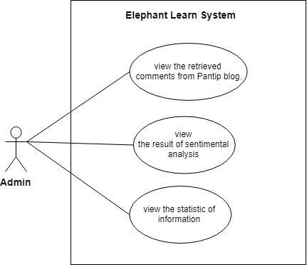

**Figure 1**: Use Case Scenarios

## **4.2 Use case description and Activity diagram.**

### **4.2.1 UC-01: View the retrieved comments from Pantip blog**

|  |  |  |  |  |
| --- | --- | --- | --- | --- |
| Use Case ID | UC-01 | | | |
| Use Case Name | View the retrieved comments from Pantip blog | | | |
| Created By | Pakarat, Chamnol | | Last Update By | Pakarat, Chamnol |
| Date Created | 31/06/19 | | Last Revision Date | 31/06/19 |
| Actors | Admin | | | |
| Description | Admin can view the retrieved comments from Pantip blog. | | | |
| Trigger | Admin must click on View retrieved comments button on the home page. | | | |
| Preconditions |  | | | |
| Use Case Input Specification | | | | |
| Input | type | Constraint | | Example |
|  |  |  | |  |
| Postconditions |  | | | |
| Normal Flows | User | | System | |
|  |  | | 1. The system shall be able to scrap comments from Pantip blog.  2. The system shall be able to save scraped comments as CSV and JSON file on database. [E1: Can’t connect to the database.]  3. The system shall be able to display the retrieved comments on Retrieved Comments page. | |
| Alternative Flow |  | | | |
| Exception Flow | E1: Can’t connect to the database.  1. The system shall be able to display the error message “The database cannot be connected.”  2. End use case | | | |
| Assumption | 1. The system must connect internet. 2. Admin must understand Thai. | | | |

### **AD-01: View the retrieved comments from Pantip blog**

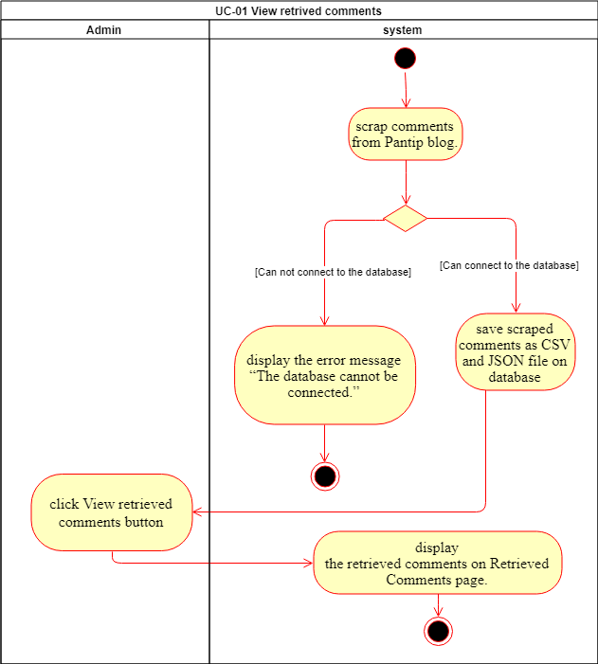

**Figure 2:** AD-01 View the retrieved comments from Pantip blog

### **4.2.2 UC-02: View the result of sentimental analysis**

|  |  |  |  |  |
| --- | --- | --- | --- | --- |
| Use Case ID | UC-02 | | | |
| Use Case Name | View the result of sentimental analysis of each comment in the topic | | | |
| Created By | Pakarat, Chamnol | | Last Update By | Pakarat, Chamnol |
| Date Created | 31/06/19 | | Last Revision Date | 31/06/19 |
| Actors | Admin | | | |
| Description | Admin can view the result of sentimental analysis of each comment in the topic. | | | |
| Trigger | Admin click View Result on the home page which contain on the menu bar. | | | |
| Preconditions |  | | | |
| Use Case Input Specification | | | | |
| Input | type | Constraint | | Example |
|  |  |  | |  |
| Postconditions |  | | | |
| Normal Flows | User | | System | |
|  |  | | 1. The system shall receive the text data.  2. The system shall be able to do noise removal from text data.  3. The system shall be able to tokenize word from text data.  4. The system shall be able to do stop word processing from text data.  5. The system shall be able to do slang and apprehensive converting from text data.  6. The system shall be able to do word spelling correction from text data.  7. The system shall be able to do word stemming from text data.  8. The system shall be able to do word lemmatization from text data.  9. The system shall be able to build a model from cleaned data.  10. The system shall be able to analyze data from the model.  11. The system shall be able to store the result of sentimental analysis in the database. [E1: Can’t connect to the database.]  12. The system shall be able to provide the descriptive and predictive analysis result | |
| Alternative Flow |  | | | |
| Exception Flow | E1: Can’t connect to the database.  1. The system shall be able to display the error message “The database cannot be connected.”  2. End use case | | | |
| Assumption | 1. The system must connect internet. 2. Admin must understand Thai. | | | |

### **AD-02: View the result of sentimental analysis**

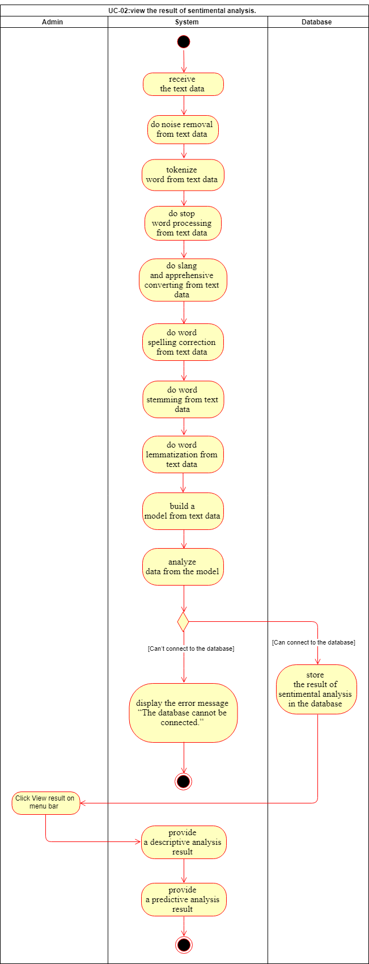

**Figure 3**: AD-02 View the result of sentimental analysis

### **4.2.4 UC-03: View the statistic of information**

|  |  |  |  |  |
| --- | --- | --- | --- | --- |
| Use Case ID | UC-03 | | | |
| Use Case Name | View the statistic of information | | | |
| Created By | Pakarat, Chamnol | | Last Update By | Pakarat, Chamnol |
| Date Created | 2/07/19 | | Last Revision Date | 31/06/19 |
| Actors | Admin | | | |
| Description | Admin can view the statistic of information, which is the number of users, date and time of the comment by showing the result of the statistic. | | | |
| Trigger | Admin click View Statistic on the home page which contains on the menu bar. | | | |
| Preconditions |  | | | |
| Use Case Input Specification | | | | |
| Input | type | Constraint | | Example |
|  |  |  | |  |
| Postconditions | Admin shall view the statistic of information on view statistic page. | | | |
| Normal Flows | User | | System | |
|  |  | | 1. The system shall receive the information.  2. The system shall analyze the information.  3. The system shall be able to store the result of statistic information in the database. [E1: Can’t connect to the database.]  4. The system shall display the result of the statistic on view statistic page. | |
| Alternative Flow |  | | | |
| Exception Flow | E1: Can’t connect to the database.  1. The system shall be able to display the error message “The database cannot be connected.”  2. End use case | | | |
| Assumption | 1. The system must connect internet. 2. Admin must understand Thai. | | | |

### **AD-03: View the statistic of information**

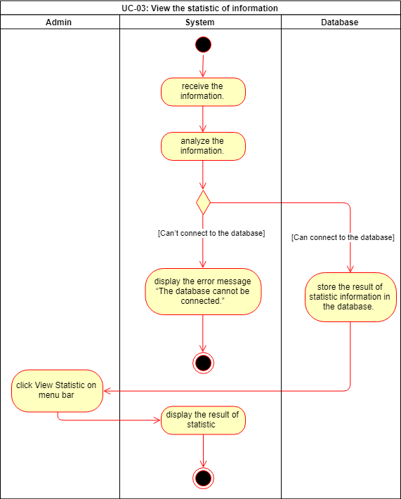

**Figure** **4**: AD-03 View the statistic of information