

**Elephant Learn**

**A sentimental analysis system for Thai stock market**

System Requirement Specification

By

Pakarat Matmarurat 592115022

Chamnol Yin 592115519

Department of Software Engineering

College of Arts, Media and Technology

Chiang Mai University

Project Advisor

__________________________________

Dr.Pree Thiengburanathum

**Document History**

|  |  |  |  |  |  |  |
| --- | --- | --- | --- | --- | --- | --- |
| **History** | **Version** | **Status** | **Date** | **Viewable** | **Editable** | **Responsible** |
| Add Chapter I   * Objective * Project Scope * Acronyms and Definitions   Add Chapter II   * User requirement specification * User requirement specification and Software requirement specification   Add Chapter III   * Use case scenarios   Add Chapter IV   * Specification requirement | Elephant  Learn-SRS_V2.0.docx | Draft | Aug,  21st,2019 | PT | CY, PM | CY, PM |

*CY = Mr. Chamnol Yin,

*PM = Miss Pakarat Matmarurat,

*PT = Dr. Pree Thiengburanathum

# **Chapter III: Functional Requirement**

## **3.1 User Requirement Specification**

**Feature #03: View Percentage**

URS-04: Admin can view the percentage of sentimental analysis of all comments on the topic.

**Feature #05: Pending new comments**

URS-05: Admin can view new comments.

**Feature #06: Delete comment**

URS-06: Admin can delete comment.

**Feature #07: Authentication**

URS-07: Admin can log in.

URS-08: Admin can log out.

**Feature #08: Save data**

URS-09: Admin can view all data in the system (ex…..). // I think we don’t need it because most of our feature are view data

URS-10: Admin can view the data that have deleted before.

## **3.2 User Requirement Specification and Software Requirement Specification**

**Feature #03: View percentage**

**URS-04: Admin can view the percentage of sentimental analysis of all comments on the topic.**

SRS-: The system shall be able to provide the view percentage page.

SRS-: The system shall be able to retrieve the result of sentimental analysis from the database.

SRS-: The system shall be able to display the percentage of the comment on view percentage page.

**Feature #05: Pending new comments**

**URS-05: Admin can view new comments.**

SRS-: The system shall be able to receive the new comments from Pantip blog.

SRS-: The system shall be able to save the new comment in database****can we use the same as feature 1? Feature 1 will be retrieved then save at DB

SRS-0: The system shall be able to show the new comments.

**Feature #06: Delete comment**

**URS-06: Admin can delete comment.**

SRS-0: The system shall be able to provide confirm dialog contain “Are you sure you want to delete?” message, “OK” and “Cancel” button.

SRS-0: The system shall be able to delete the comment from the database.

SRS-: The system shall redirect to

**Feature #07: Authentication**

**URS-07: Admin can log into the web application using email and password which already exist in the system.**

SRS-0: The system shall be able to provide the login page contain navigator bar, “E-mail” text field, “Password” text field, “Login” button.

SRS-0: The system shall be able to validate the username and password.

SRS-0: The system shall be able to redirect to the home page.

**URS-08: Admin can logout.**

SRS-0: The system shall be able to provide the home pagecontain navigator bar and logout text link.

SRS-0: The system shall be able to redirect to the home page.

**Feature #08: Save data**

**URS-09: Admin can view all data in the system.**

//SRS-0: The system shall be able to receive the comment.

//SRS-0: The system shall be able to save the data.

//SRS-0: The system shall be able to save the analyzed result.

**URS-10: Admin can view the data that have deleted before.**

SRS-0: The system shall be able to receive the comment.

SRS-0: The system shall be able to save the data.

SRS-0: The system shall be able to save the deleted comments

# **Chapter IV: Specification Requirement**

## **4.1 Use Case Scenarios**

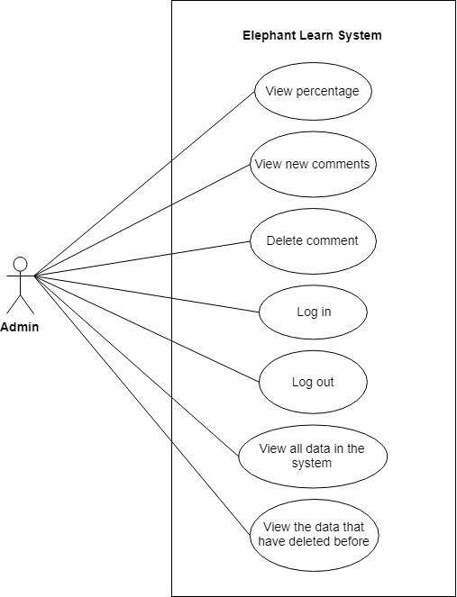

**Figure 1**: Use Case Scenarios

## **4.2 Use case description and Activity diagram.**

**4.2.1 UC-04: View the percentage.**

|  |  |  |  |  |
| --- | --- | --- | --- | --- |
| Use Case ID | UC-04 | | | |
| Use Case Name | View the percentage | | | |
| Created By | Pakarat, Chamnol | | Last Update By | Pakarat, Chamnol |
| Date Created | 22/08/19 | | Last Revision Date | 22/08/19 |
| Actors | Admin | | | |
| Description | Admin can view the percentage of the topic by showing the number of percentages on the scale of 0% - 100%. | | | |
| Trigger | Admin click View Percentage on the home page which contains on the menu bar. | | | |
| Preconditions |  | | | |
| Use Case Input Specification | | | | |
| Input | type | Constraint | | Example |
|  |  |  | |  |
| Postconditions | Admin shall view the percentage of the comment on view percentage page. | | | |
| Normal Flows | User | | System | |
|  | | 1. The system shall provide the view percentage page.  2. The system shall be able to retrieve the result of sentimental analysis from the database. [E1: Can’t connect to the database.]  3. The system shall be able to display the percentage of the comment on view percentage page. | |
| Alternative Flow |  | | | |
| Exception Flow | E1: Can’t connect to the database.  1. The system shall be able to display the error message “The database cannot be connected.”  2. End use case | | | |
| Assumption | 1. The system must connect internet. 2. Admin must understand Thai. | | | |

### **AD-04: View the percentage.**

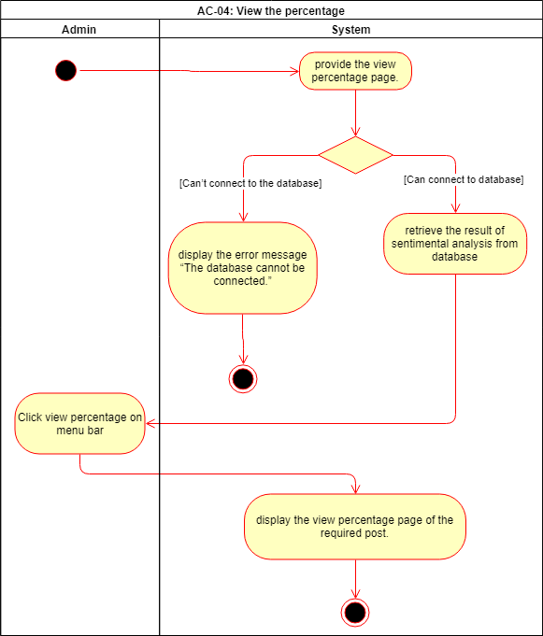

**Figure** **2**: AD-04 View percentage.

**4.2.2 UC-05: View new comments.**

|  |  |  |  |  |
| --- | --- | --- | --- | --- |
| Use Case ID | UC-05 | | | |
| Use Case Name | View new comments | | | |
| Created By | Pakarat, Chamnol | | Last Update By | Pakarat, Chamnol |
| Date Created | 22/08/19 | | Last Revision Date | 22/08/19 |
| Actors | Admin | | | |
| Description | Admin can view the new comments of Pantip blog. | | | |
| Trigger | Admin click View New Comments on the home page which contains on the menu bar. | | | |
| Preconditions |  | | | |
| Use Case Input Specification | | | | |
| Input | type | Constraint | | Example |
|  |  |  | |  |
| Postconditions | Admin shall view the percentage of the comment on view percentage page. | | | |
| Normal Flows | User | | System | |
|  | |  | |
| Alternative Flow |  | | | |
| Exception Flow | E1: Can’t connect to the database.  1. The system shall be able to display the error message “The database cannot be connected.”  2. End use case | | | |
| Assumption | 1. The system must connect internet. 2. Admin must understand Thai. | | | |

### **AD-05: View new comments.**

**Figure 3**: AD-05 View new comment.

### **4.2.3 UC-06: Delete comment.**

|  |  |  |  |  |
| --- | --- | --- | --- | --- |
| Use Case ID | UC-06 | | | |
| Use Case Name | Delete comment. | | | |
| Created By | Pakarat, Chamnol | | Last Update By | Pakarat, Chamnol |
| Date Created | 22/08/19 | | Last Revision Date | 22/08/19 |
| Actors | Admin | | | |
| Description | Admin can delete the comment. | | | |
| Trigger | Admin must click the “Delete” button. | | | |
| Preconditions | Admin must log in into system. | | | |
| Use Case Input Specification | | | | |
| Input | type | Constraint | | Example |
|  |  |  | |  |
| Postconditions | Admin shall view หน้าที่ลบ. | | | |
| Normal Flows | User | | System | |
| 2. Admin click the “OK” button. [E2: Admin click “Cancel” button.] | | 1. The system shall be able to provide confirm dialog contains “Are you sure you want to delete?” message, “OK” and “Cancel” button.  3. The system shall delete the comment from the database. [E1: Can’t connect to the database.]  4. The system shall redirect to | |
| Alternative Flow |  | | | |
| Exception Flow | E1: Can’t connect to the database.  1. The system shall be able to display the error message “The database cannot be connected.”  2. End use case  E2: Admin click “Cancel” button.  1. End use case | | | |
| Assumption | 1. The system must connect internet. 2. Admin must understand Thai. | | | |

### **AD-06: Delete comment.**

**Figure 4**: AD-06: Delete comment.

### **4.2.4 UC-07: Login. *****go back to see ICVS or AMS again **senior project**

|  |  |  |  |  |
| --- | --- | --- | --- | --- |
| Use Case ID | UC-07 | | | |
| Use Case Name | Login | | | |
| Created By | Pakarat, Chamnol | | Last Update By | Pakarat, Chamnol |
| Date Created | 22/08/19 | | Last Revision Date | 22/08/19 |
| Actors | Admin | | | |
| Description | Admin can log in to the system. | | | |
| Trigger | Admin click “login” button which contains on navigator bar. | | | |
| Preconditions |  | | | |
| Use Case Input Specification | | | | |
| Input | type | Constraint | | Example |
| E-mail | String |  | | pakarut@gmail.com |
| Password | String |  | | 123456 |
| Postconditions | Admin shall view the home page. | | | |
| Normal Flows | User | | System | |
| 2.Admin input E-mail.  3.Admin input password.  4.Admin click “Login” button. | | 1.  The system shall be able to provide the login page contain navigator bar, “E-mail” text field, “Password” text field, “Login” button.  5. The system shall be able to validate the username and password.  Do we have criteria for email and password? [A1: E-mail is invalid with the given criteria.], [A2: Password is invalid with the given criteria.]  6.  The system shall be able to redirect to the home page. | |
| Alternative Flow | A1: E-mail is invalid with the given criteria.  1. The system shall be able to display “The input invalid” message.  2. The system shall resume at normal flow step 2.  A2: Password is invalid with the given criteria.  1. The system shall be able to display “The input invalid” message.  2. The system shall resume at normal flow step 3. | | | |
| Exception Flow | E1: Can’t connect to the database.  1. The system shall be able to display the error message “The database cannot be connected.”  2. End use case | | | |
| Assumption | 1. The system must connect internet. 2. Admin must understand Thai. | | | |

### **AD-07: Login.**

**Figure 5**: Login.

### **4.2.5 UC-08: Logout. **** Do we have notification before logout?? ex Do you want to logout of the system??**

|  |  |  |  |  |
| --- | --- | --- | --- | --- |
| Use Case ID | UC-08 | | | |
| Use Case Name | Logout | | | |
| Created By | Pakarat, Chamnol | | Last Update By | Pakarat, Chamnol |
| Date Created | 22/08/19 | | Last Revision Date | 22/08/19 |
| Actors | Admin | | | |
| Description | Admin can log out of the system. | | | |
| Trigger | Admin click “Logout” button which contains on navigator bar. | | | |
| Preconditions | Admin must log in to the system. | | | |
| Use Case Input Specification | | | | |
| Input | type | Constraint | | Example |
|  |  |  | |  |
| Postconditions | Admin shall view the home page. | | | |
| Normal Flows | User | | System | |
| 2.Admin click “Logout” button. | | 1. The system shall be able to provide the home pagecontain navigator bar and logout text link.  3. The system shall be able to redirect to the home page. | |
| Alternative Flow |  | | | |
| Exception Flow | E1: Can’t connect to the database.  1. The system shall be able to display the error message “The database cannot be connected.”  2. End use case | | | |
| Assumption | 1. The system must connect internet. 2. Admin must understand Thai. | | | |

### **AD-08: Logout.**

**Figure 6: Logout.**

### **4.2.6 UC-09: View all data in the system.**

|  |  |  |  |  |
| --- | --- | --- | --- | --- |
| Use Case ID | UC-07 | | | |
| Use Case Name | View all data in the system. | | | |
| Created By | Pakarat, Chamnol | | Last Update By | Pakarat, Chamnol |
| Date Created | 22/08/19 | | Last Revision Date | 22/08/19 |
| Actors | Admin | | | |
| Description | Admin can | | | |
| Trigger | Admin click | | | |
| Preconditions |  | | | |
| Use Case Input Specification | | | | |
| Input | type | Constraint | | Example |
|  |  |  | |  |
| Postconditions | Admin shall | | | |
| Normal Flows | User | | System | |
|  | |  | |
| Alternative Flow |  | | | |
| Exception Flow | E1: Can’t connect to the database.  1. The system shall be able to display the error message “The database cannot be connected.”  2. End use case | | | |
| Assumption | 1. The system must connect internet. 2. Admin must understand Thai. | | | |

### **AD-09: View all data in the system.**

**Figure 7: View all data in the system.**

### **4.2.7 UC-10: View the data that have deleted before.**

|  |  |  |  |  |
| --- | --- | --- | --- | --- |
| Use Case ID | UC-07 | | | |
| Use Case Name | View the data that have deleted before. | | | |
| Created By | Pakarat, Chamnol | | Last Update By | Pakarat, Chamnol |
| Date Created | 22/08/19 | | Last Revision Date | 22/08/19 |
| Actors | Admin | | | |
| Description | Admin can | | | |
| Trigger | Admin click | | | |
| Preconditions |  | | | |
| Use Case Input Specification | | | | |
| Input | type | Constraint | | Example |
|  |  |  | |  |
| Postconditions | Admin shall | | | |
| Normal Flows | User | | System | |
|  | |  | |
| Alternative Flow |  | | | |
| Exception Flow | E1: Can’t connect to the database.  1. The system shall be able to display the error message “The database cannot be connected.”  2. End use case | | | |
| Assumption | 1. The system must connect internet. 2. Admin must understand Thai. | | | |

### **AD-10: View the data that have deleted before.**

**Figure 8: View the data that have deleted before.**