

**Elephant Learn**

**A sentimental analysis system for Thai stock market**

Project Proposal

By

Pakarat Matmarurat 592115022

Chamnol Yin 592115519

Department of Software Engineering

College of Arts, Media and Technology

Chiang Mai University

Project Advisor

__________________________________

Dr.Pree Thiengburanathum

**Elephant Learn**

Pakarat Matmarurat 592115022

Chamnol Yin 592115519

**THIS REPORT HAS BEEN APPROVED TO BE A**

**PARTIAL FULFILLMENT OF THE REQUIREMENTS**

**FOR THE SOFTWARE ENGINEERING PROGRAM:**

**COLLEGE OF ARTS MEDIA AND TECHNOLOGY**

**………………………………………………….. ADVISOR**

Dr. PREE THIENGBURANATHUM

**…………………………………………………...MEMBER**

PAKARAT MATMARURAT

**…………………………………………………...MEMBER**

CHAMNOL YIN

**Document History**

|  |  |  |  |  |  |
| --- | --- | --- | --- | --- | --- |
| **History** | **Status** | **Date** | **Viewable** | **Editable** | **Responsible** |
| Add Chapter 1   * Abstract * Rationale | Draft | May, 13th2019 | PT | CY,PM | CY,PM |
| Updated Chapter 1   * Abstract * Rationale   Add Chapter 2   * Business Review * Technology Review * Development Tools Review   Add Chapter 3   * Quality Standard   Add Chapter 4   * Motivation * Aims and Objectives * Software Architecture * Deliverables and Limitations * Schedule and Milestone | Draft | May, 15th2019 | PT | CY,PM | CY,PM |
| Updated Chapter 1   * Abstract * Rationale   Updated Chapter 2   * Business Review * Technology Review * Development Tools Review   Updated Chapter 4   * Motivation * Aims and Objectives * Software Architecture * Deliverables and Limitations * Schedule and Milestone | Draft | May,  24th2019 | PT | CY,PM | CY,PM |
| Updated Chapter 1   * Abstract * Rationale   Updated Chapter 2   * Business Review * Technology Review * Development Tools Review   Updated Chapter 4   * Motivation * Aims and Objectives * Software Architecture * Deliverables and Limitations * Schedule and Milestone | Draft | May,  30th2019 | PT | CY,PM | CY,PM |
| Updated Chapter 1   * Abstract * Rationale   Updated Chapter 2   * Technology Review   Updated Chapter 4   * Motivation * Aims and Objectives * Software Architecture * Deliverables and Limitations * Schedule and Milestone | Draft | June,  2th2019 | PT | CY,PM | CY,PM |
| Updated Chapter 1   * Abstract * Rationale   Updated Chapter 2   * Technology Review   Updated Chapter 4   * Software Architecture | Draft | June,  4th2019 | PT | CY,PM | CY,PM |

*CY = Mr. Chamnol Yin,

*PM = Miss. Pakarat Matmarurat,

*PT = Dr.Pree Thiengburanathum

**Abstract**

In Thailand, Pantip website is one of the most popular sites which is well known and widely used by Thai people. Sinthorn (stock market) is a category inside Pantip, which consists of thousands of comments from numerous users. Thus, for admin of Pantip website to have read is an intolerable painful task. Hence, the sentiment analysis is the most suitable emerging research in natural language processing (NLP) field that is useful for automatically grasping the text data. Undoubtedly, most of the potential works on sentiment analysis focus on analyzing the opinions in English textual data. In term of NLP in Thai, there is lacking reliable works such as tokenizing, stemming, lemmatization, normalization, noise removal, and text enrichment/argument.

In order to solve the above problem, we propose a text analysis system in the form of the website application, which is called Elephant Learn. Elephant Learn will help admin automatedly retrieving text data of Sinthorn from Pantip and get sentimental analytic with the reliable result, by using the three main tasks such as (1) scraping text data from Pantip website, (2) data preprocessing, and (3) data analysis. Additionally, the system will provide a simple website interface to display the result from the sentimental analysis of Pantip's textual data and engage the admin's interaction with the system.

**Table of Contents**

**Chapter I: Rationale** 9

**Chapter II: Business Review** 11

**2.1 Business Review** 11

**Textal** 11

**Text Analysis** 12

**Social media text analysis** 13

**MonkeyLearn** 14

**Free sentiment analyzer** 15

**2.2 Technology Review** 16

**2.2.1 Firebase** 16

**2.3 Development Tool Review** 16

**2.3.1 React JS** 16

**2.3.2 Visual Studio Code** 17

**2.3.4 Python** 17

**2.3.5 GitHub** 18

**2.3.6 Scrapy** 18

**Chapter III: Quality Standard** 19

**3.1 ISO 29110 for Very Small Entity (VSE)** 19

**3.1.1 Project Management process** 19

**3.1.2 Software Implementation process** 19

**Chapter IV: Project Plan** 20

**4.1 Motivation** 20

**4.2 Aim and Objectives** 20

**4.2.1 Aim** 20

**4.2.2 Objectives** 20

**4.3 System Architecture** 20

**4.4 Deliverables and Limitations** 21

**4.4.1 Type of actor** 21

**Admin** 21

**4.4.2 Deliverables** 21

**Feature #01: Retrieve comments** 21

**Feature #02: Data cleaning, Data preprocessing, Data analysis** 21

**Feature #03: View percentage** 21

**Feature #04: View statistic** 21

**Feature #05: Pending new comments** 22

**Feature #06: Delete comment** 22

**Feature #07: Authentication** 22

**Feature #08: Save data** 22

**4.4.3 Limitations** 22

**4.5 Schedule and Milestone** 23

**4.5.1 Schedule Plan** 23

**4.5.2 Milestone Gantt Chart** 24

**References** 27

**Table of figures**

|  |  |
| --- | --- |
|  | Page |
| Figure 1: Textal application | 11 |
| Figure 2: Text Analysis application | 12 |
| Figure 3: Social media text analysis application | 13 |
| Figure 4: MonkeyLearn | 14 |
| Figure 5: Free sentiment analyzer | 15 |
| Figure 6: Firebase | 16 |
| Figure 7: React JS | 16 |
| Figure 8: Visual Studio Code | 17 |
| Figure 9: Python | 17 |
| Figure 10: GitHub | 18 |
| Figure 11: Scrapy | 18 |
| Figure 12: System Architecture | 20 |
| Figure 13: Proposal period milestone | 24 |
| Figure 14: Progress I | 25 |
| Figure 15: Progress II | 26 |
| Figure 16: Final Progress | 26 |

# **Chapter I: Rationale**

Stock market has become popular and rapidly increase since it first introduces to the world of economics. It has been called the future market, which now consists of 250 market infrastructure providers, 48000 listed companies, and with the estimated size of 70.2 trillion US dollars [12]. With this popularity, it has been the topic talked by numerous of people around the world. As in Thailand, this topic has been widely discussing in one of the country’s most popular site, “Pantip”. Pantip is a Thai-language website, which provides the discussion forum for its users to express their opinions.

In Pantip, for a popular topic like Sinthorn (stock market), the number of its reviews/comment can be thousands or even millions. This is not an easy task for the administrator who responsible for that topic to read all of them. Henceforth, the automatic extraction and summarization of the comments which in the form of text data are required. The goal of that system is to detect the opinionated text inside the large volume of textual data, then determine whether that opinion is negative or positive and make the summary.

Hence, sentimental analysis has been invented to fulfill this task. Sentiment Analysis also known as Opinion Mining is a field within NLP that builds systems that try to identify and extract opinions within text. With the help of sentiment analysis systems, this unstructured information could be automatically transformed into structured data of public opinions about products, services, brands, politics, or any topic that people can express opinions about. This data can be very useful for commercial applications like marketing analysis, public relations, product reviews, net promoter scoring, product feedback, and customer service. Undoubtedly, most of the potential works on sentiment analysis focus on analyzing the opinions in English textual data. In term of NLP in Thai, there is lacking reliable works such as tokenizing, stemming, lemmatization, normalization, noise removal, and text enrichment/argument. As an example, for most of the Thai-language online store websites, there is no sentimental analysis in users’ reviews in the products. Thus, it will be helpful for sellers and buyers to make the decision based on the worse and best reviews in the particular products if the sentimental analysis has been implemented. With the good reviews, buyers will easily be convinced to buy the product, and with the bad reviews, sellers will find out the lack of their products.

Thai alphabet consists of 44 consonants representing 21 distinct consonants sound and 18 vowels and 10 numerals. Thai language is a unique language which has several special features that make it vary from the most popular and most widely usage in the world now, English. First, there is no space between words, instead space in Thai text indicates the end of sentence or clause. Second, the 18 vowels, diphthongs and triphthongs are indicated using diacritics which appear in front of, above, below of after the consonants they modify [13]. Third, the compound words and compound vowels system. Forth, the special letters **อ** and **ห** are used as silent letters before other consonants to produce the correct tone. Fifth, the special letter and word such as letter **ทร** are pronounce like **ซ**, and royal words, which can make many people confuse. And the last one is region language and slang.

In this project, we propose to help solving the problem of sentimental analysis in Thai. The creation of Elephant Learn come from the desire to have the automatedly retrieving comments from Thai-language website and generating text sentimental analysis with reliable result.

The project has three main phases as follow:

* Scraping Text data. This is process of automatedly scraping textual data from users’ comments in forum of Pantip website. This process will provide the text data of comments related to sinthorn (stock market) that will be stored in database.
* Data preprocessing. This is our main phase, which will mainly work on the scope of the sentence and sub-sentence level by using tokenizing, pos tagging and bag of words. This process will work on data that get from scraping data process which stored in system’s database and then provide the model for doing sentimental analysis.
* Data analysis. This is the process of providing the descriptive and predictive sentimental analysis data from model that get from data preprocessing process.

The proposed system will be the system built for assisting admin to save time on reviewing numerous comments. Elephant Learn will provide admin the descriptive of data such as view data analytic of Thai textual data, view the percentage of comments, save data, and make the decision over data whether to keep or delete the comment. Additionally, the system will provide a simple website interface to display the result from the sentimental analysis of Pantip's textual data and engage the admin's interaction with the system. Due to the size of the project is a small one, this application will conform to the ISO 29110 standard.

# **Chapter II: Business Review**

## **2.1 Business Review**

### **Textal**

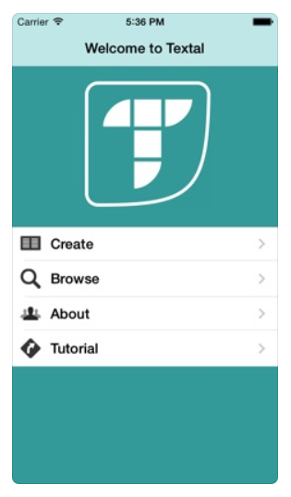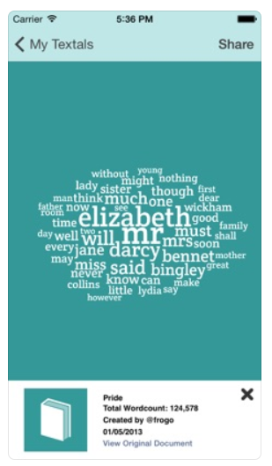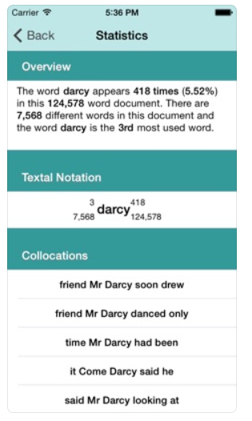

**Figure 1**: Textal application [3]

Textal is a free app for analyzing websites documents and social networks streams. The application allows defining relationships between words via a cloud interface. The analysis results can be exported, shared via social media. Textal supports English, French, German, Italian, and Spanish [3].

**Pros**

* + Textal application can help to create clickable word clouds from a website, tweet stream, or document, to explore the relationships between words in the text.
  + Textal application can explore your text by click on individual words in the Textal to view statistics.
  + User can share you Textal via twitter and view your wordclouds online.

**Cons**

* + Textal application is can’t working.
  + User can't import books nor tweets into the Textal application.
  + Textal application support on ios only.
  + Textal application export your analysis for use in research, reports, or writing.
  + Textal application invades privacy.

### **Text Analysis**

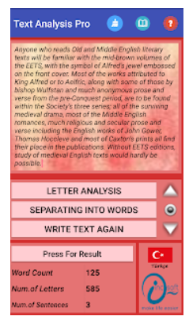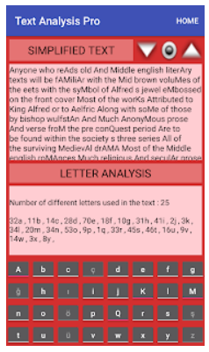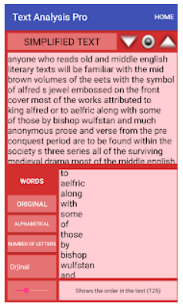

**Figure 2**: Text Analysis application [1]

This program examines entered text by formal; analyzes on the basis of letters, words and sentences. You can use the "copy-paste" technique from any source, or the ready-made texts in the library by pressing the "Result" button on the homepage, you can find the letters, words and sentence numbers in the text and the letter analysis feature can also be used to determine how many letters are used. The Text Analysis app is available on Android [1].

**Pros**

* + This application can analyze the basic letter, word and sentences and give the result to the user.
  + The program allows you to sort words in the text one by one and sort them by their original order in the text.
  + Text Analysis application has Turkish and English options.

**Cons**

* + This application needs to download first before using the application.
  + This application can’t work for some feature.
  + This application support on android only.
  + In very large texts (depending on the phone feature) there may be slowing or locking the program.

### **Social media text analysis**

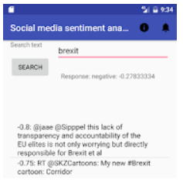

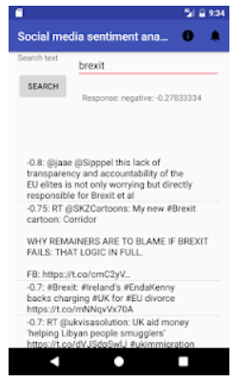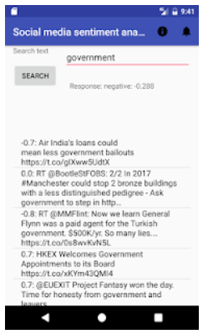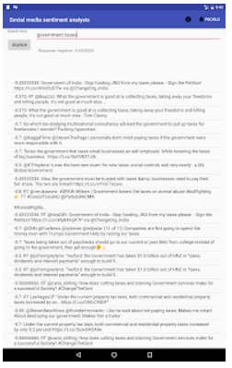

**Figure 3**: Social media text analysis application [2]

Social media text analysis is available on Android. It’s concerned with text analysis and using technique for sentiment analysis using text mining (Natural Language Processing) to process social media posts by the software use the sentiment text analysis and can show me ‘emotion’ of each entry posted by users in scale from -1.0 to 1.0. The -1.0 means that the user was terrible experience or feeling about the given subject or product [2].

**Pros**

* + Social media text analysis application is can analysis social media posts.
  + Social media text analysis application gives the emotion to show the user’s scale.

**Cons**

* + Social media text analysis application needs to pay for 34 baths for download.
  + Social media text analysis application support on android only.
  + Not support in many language.

### **MonkeyLearn**



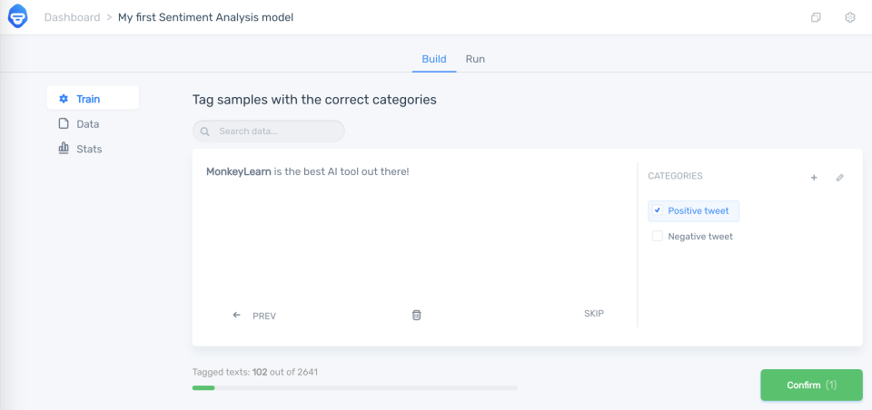

**Figure 4**: MonkeyLearn [6]

MonkeyLearn is a Machine Learning platform for Text Analysis. It allows our users to easily get actionable data from raw text. For example, you can detect topic or sentiment expressed in texts like tweets, chats, reviews, articles and more [6].

**Pros**

* + MonkeyLearn provides a great user interface and is flexible.
  + MonkeyLearn has a well-documented API that is user-friendly.
  + MonkeyLearn has provided tutorials that turns handy when required.
  + MonkeyLearn is contaminated with many models for performing various tasks like text analysis.
  + Their online dashboard and integrations are so readable.
  + The ease of the API use makes the learning curve very convenient to be used at anywhere.

**Cons**

* + There is a limitation provided on the number of queries one can make as per their current plan.
  + The models require training, so accuracy isn't perfect at first but that's to be expected as part of the process.
  + The ML pricing structure does not always fit the business budget. Some opportunities are passed because the pricing is too high.

### **Free sentiment analyzer**

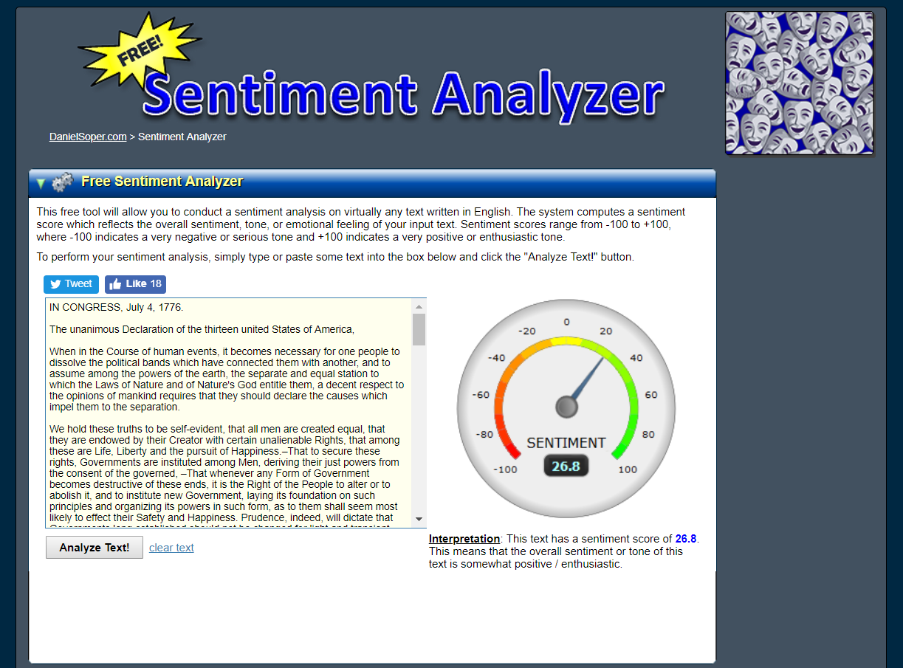

**Figure 5**: Free sentiment analyzer [7]

This free tool will allow you to conduct a sentiment analysis on virtually any text written in English. The system computes a sentiment score which reflects the overall sentiment, tone, or emotional feeling of your input text. Sentiment scores range from -100 to +100, where -100 indicates a very negative or serious tone and +100 indicates a very positive or enthusiastic tone [7].

**Pros**

* This Sentiment Analyzer tool is free tool. We can compute a sentiment score of the sentence.
* Sentiment Analyzer is a free tool.
* Sentiment Analyzer is works best with American English post-1990.

**Cons**

* Sentiment Analyzer is providing English language only.
* Sentiment Analyzer doesn’t get sarcasm at all.

## **2.2 Technology Review**

### **2.2.1 Firebase**



**Figure 6**: Firebase [8]

Firebase is a Backend-as-a-Service (BaaS) that started as a YC11 startup and grew up into a next-generation app-development platform on Google Cloud Platform [8].

**The selection of this technology**

Firebase is free developers and doesn’t need to manage servers. Firebase gives many tools to develop high-quality apps. The purpose of using firebase are for user authentication and system’s database.

**Alternative**

* EC2 (amazon aws)
* Alibaba cloud

## **2.3 Development Tool Review**

### **2.3.1 React JS**



**Figure 7**: React JS **[4]**

ReactJS basically is an open-source JavaScript library which is used for building user interfaces specifically for single page applications. It’s used for handling view layer for web and mobile apps. React also allows us to create reusable UI components [4].

**The selection of this technology**

React JS is easy to build user interfaces and handling view layer for web and mobile apps also. The purpose of using react JS are for building responsive website interface and linking frontend with system’s backend.

**Alternative**

- Angular

- Vue.js

### **2.3.2 Visual Studio Code**



**Figure 8**: Visual Studio Code [9]

Visual Studio Code is a lightweight but powerful source code editor which runs on your desktop and is available for Windows, macOS, and Linux. It comes with built-in support for JavaScript, TypeScript, and Node.js and has a rich ecosystem of extensions for other languages (such as C++, C#, Java, Python, PHP, Go) and runtimes (such as .NET and Unity) [9].

**The selection of this technology**

Visual Studio Code can use to source code editor easier and it provides many of language to use. The purpose of using VS code is for developing code of system. This ide is the most popular and supporting many programming languages.

**Alternative**

* Atom
* IntelliJ
* Sublime

### **2.3.4 Python**



**Figure 9**: Python [10]

Python is an object-oriented, high-level programming language with integrated dynamic semantics primarily for web and app development. It is extremely attractive in the field of Rapid Application Development because it offers dynamic typing and dynamic binding options. Python is relatively simple, so it's easy to learn since it requires a unique syntax that focuses on readability [10].

**The selection of this technology**

The Python can use for web and app development. It’s easy to learn since it requires a unique syntax that focuses on readability. The purpose of using Python are for system’s backend work. This programming language is the best so far for doing text mining and sentimental analysis.

**Alternative**

- R program

### **2.3.5 GitHub**



**Figure 10**: GitHub [11]

GitHub is a project management and code versioning system as well as a social network platform made for developers. It allows you to work collaboratively with other people around the world, plan your projects and track your work. GitHub is also one of the largest online storehouses of collaborative work around the world [11].

**The selection of this technology**

The GitHub is can hosting of source code project in variety of different programming language and it keeps track of the various changes made to every iteration. GitHub can make team implement project source code together**.** The purpose of using GitHub is for system developing version control.

**Alternative**

* Gitlab

### **2.3.6 Scrapy**



**Figure 11**: Scrapy [5]

An open source and collaborative framework for extracting the data you need from websites. Scrapy is an application framework for crawling web sites and extracting structured data which can be used for a wide range of useful applications, like data mining, information processing or historical archivaln [5].

**The selection of this technology**

Scrapy is a Python framework for web scraping that provides a complete package for developers without worrying about maintaining code. The purpose of using Scrapy is for scraping text data from Pantip website.

**Alternative**

* Beautiful Soup

# **Chapter III: Quality Standard**

## **3.1 ISO 29110 for Very Small Entity (VSE)**

ISO 29110 is the Software Life Cycle Profiles and Guidelines for Very Small Entities (VSEs) standards and technical reports are targe3te3d at Very Small Entities (VSEs). A Very Small Entity (VSE) is an enterprise, organization, department or project having up to 25 people. ISO 29110 concerns on the project management process and software implementation process.

### **3.1.1 Project Management process**

The purpose of the Project Management process is to establish and carry out in a systematic way the tasks of the software implementation project, which allows complying with the project’s objectives in the expected quality, time and cost. There are 4 activities as following:

1. Project Planning Process

2. Project Plan Execution Process

3. Project Assessment and Control Process

4. Project Closure Process

### **3.1.2 Software Implementation process**

The purpose of the Software Implementation process is the systematic performance of the analysis, design, construction, integration and tests activities for new or modified software products according to the specified requirements. There are 6 activities as following:

1. Software Implementation Initiation Process

2. Software Requirements Analysis Process

3. Software Architectural and Detailed Design Process

4. Software Construction Process

5. Software Integration and Test Process

6. Software Delivery Process

# **Chapter IV: Project Plan**

## **4.1 Motivation**

Pantip is one of the most popular blogs in Thailand. On it, the number of comments on sinthorn (stock market) section is various which come from each user. Hot topics like sinthorn may have thousands of comments on it. This won’t be the easy task for the administrator who responsible for the system to read them all. Moreover, there is lacking work on Thai text sentimental analysis. As a result, we create our Elephant Learn system to solve the problem. Elephant Learn will help administrator to retrieve the website’s comments in form of textual data, get the analytic result and reduce the negative comments on Pantip.

## **4.2 Aim and Objectives**

### **4.2.1 Aim**

The aim of this system is to develop Elephant Learn for Pantip admin that can help admin to the automatedly retrieve text data of comment in sinthorn section, get statistic of textual data and detect the negative comment problems on Pantip in sinthorn section by using sentiment analysis.

### **4.2.2 Objectives**

* The system provides the automatedly scraping text data from sinthorn section’s comments in Pantip.
* The system provides the analysis processing on comments on Pantip.
* The system provides responsive interface showing the result of descriptive and predictive analysis the percentage of the comment on Pantip by providing the percentage from 0-100%. If the comments are very good the system will show 100% if the comments are very bad the system will show 0%. The system provides the statistic of the information which is the number of users, date and time of comment in the system.

## **4.3 System Architecture**

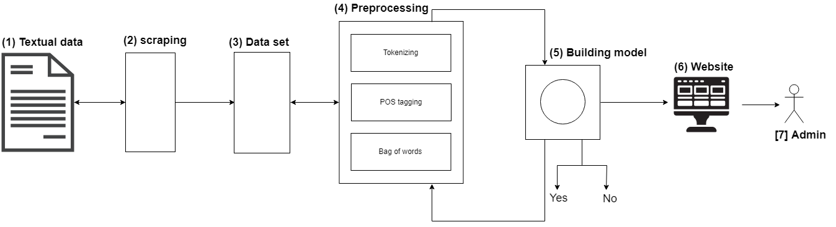

**Figure 12**: System Architecture

According to figure 12, system has been illustrated as follow: (1) we retrieve the raw data from sinthorn section on Pantip blog and (2) scraping the data. Once get the data then put it to (3) preprocessing in this part it’s will going to convert the data by basic tokenizing which typing the word and remove outliner which is white space. POS tagging to extracting relations between words. After using the bag of words, the data will represent as a number in matrix form then data analysis and got (4) model. When we finish the back end then connected with (5) front end.

## **4.4 Deliverables and Limitations**

### **4.4.1 Type of actor**

### **Admin**

Admin is the actor who can see the result of the sentiment analysis system. Admin is can delete negative comments of the system. Admin is the highest privilege of the system which can access most of features of system.

### **4.4.2 Deliverables**

### **Feature #01: Retrieve comments**

**Actor:**Admin

**Description:** Admin can get the comments from Pantip blog.

**Details:**

* 1. The system shall retrieve comments from Pantip blog.

### **Feature #02: Data cleaning, Data preprocessing, Data analysis**

**Actor:**

**Description:** System can do the textual data cleaning, making model from data preprocessing and analysis data from model**.**

**Details:**

2.1 The system shall receive the text data.

2.2 The system shall clean text data.

2.3 The system shall build model from cleaned data.

2.4 The system shall analyze data from model.

2.5 The system shall provide the descriptive and predictive analysis result

### **Feature #03: View percentage**

**Actor:**Admin

**Description:** The system shall show the percentage of the comments that is good or not. By showing the number of percentages in scale of 0% - 100%

**Details:**

3.1 The system shall receive the comment.

3.2 The system shall analyze the comment.

3.3 The system shall show the percentage of the comment.

### **Feature #04: View statistic**

**Actor:**Admin

**Description:** The system shall show the statistic of information which is the number of users, date and time of the comment by showing the result of the statistic.

**Details:**

4.1 The system shall receive the information.

4.2 The system shall analyze the information.

4.3 The system shall show the result of statistic.

### **Feature #05: Pending new comments**

**Actor:**Admin

**Description:** The system shall show pending new comments.

**Details:**

5.1 The system shall receive the comments.

5.2 Admin can view new comments.

### **Feature #06: Delete comment**

**Actor:**Admin

**Description:** Admin can delete the comment if the result of the comment is bad**.**

**Details:**

6.1 The system shall receive the comment.

6.2 The system shall analyze the comment.

6.3 The system shall show the result of comments.

6.4 Admin can click to delete the comment.

### **Feature #07: Authentication**

**Actor:**Admin

**Description:** Admin can log in to the system.

**Details:**

* 1. Admin can log in to the system.
  2. The system shall validate the username and password.
  3. Admin can log out of the system.
  4. The system shall logout of system.

### **Feature #08: Save data**

**Actor:** Admin

**Description:** Admin can view all data which is in the system and data that have deleted before.

**Details:**

8.1 The system shall receive the comment.

8.2 The system shall save the data.

8.3 The system shall save the analyzed result.

### **4.4.3 Limitations**

- The system needs an internet connection.

- The system supports Thai language only.

- The system can't generate highly accuracy due to the limitation of time and resources of NLP in Thai.

## **4.5 Schedule and Milestone**

### **4.5.1 Schedule Plan**

The schedule and milestones of the working. During the period, there are work terminologies, and the description is shown below that:

|  |  |  |  |
| --- | --- | --- | --- |
| **Milestone** | **Task** | **Milestone Criteria** | **Planed** |
| 1 | Proposal | Topic defined | April, 2019 |
| 2 | Proposal | - Proposal reviewed  - Proposal submitted  - Proposal presentation | June, 2019 |
| 3 | Progress 1 | - Software requirement specification  - Feature #01, Feature #02, Feature #03, Feature #04 (Retrieve comments, View Data Analytic, View percentage and View statistic)  - Feature designed  - Test Planned  - Feature implemented  - Feature tested  - Integrate and review all documents  - Progress report presentation | July, 2019 |
| 4 | Progress 2 | - Software requirement specification  - Feature#05, Feature#06, Feature#07, Feature#08 (Pending new comments, Delete comment, Authentication and Save data)  - Feature designed  - Test Planned  - Feature implemented  - Feature tested  - Tests all features  - Test Recorded  - Progress Report II submitted  - Progress Report II presentation | October, 2019 |
| 5 | Show Pro | - Overall of the system should be nearest for 100 percentages | November, 2019 |
| 6 | Final Progress | - Integrate and review all documents  - Tests all features  - Reviews documents are completed  - Final Progress Report submitted  - Final Progress Report presentation | December, 2019 |

### **4.5.2 Milestone Gantt Chart**

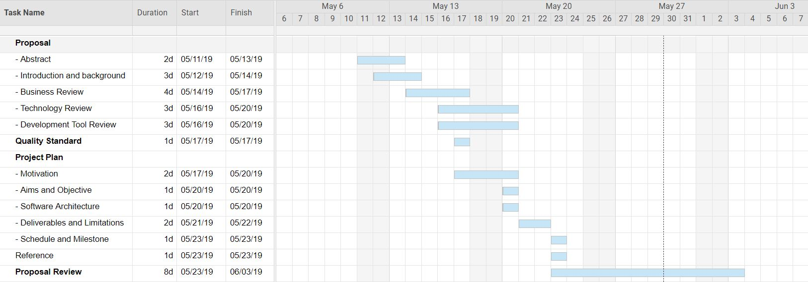

**Figure 13**: Proposal period milestone

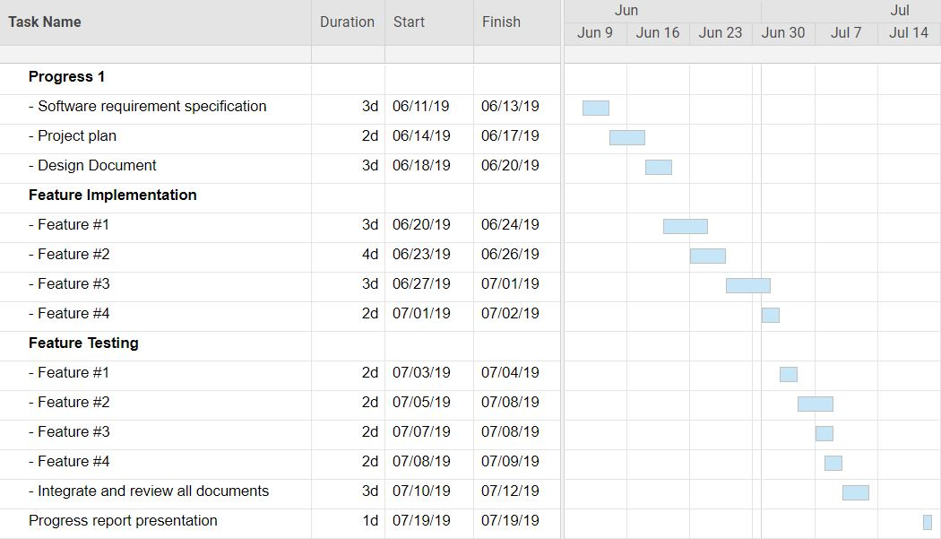

**Figure 14**: Progress I

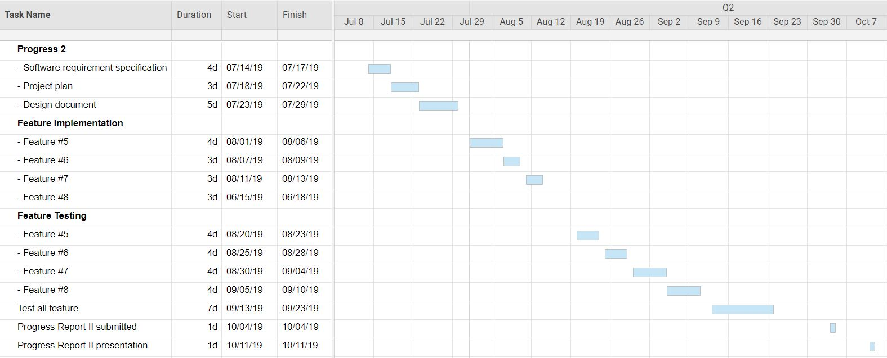

**Figure 15**: Progress II

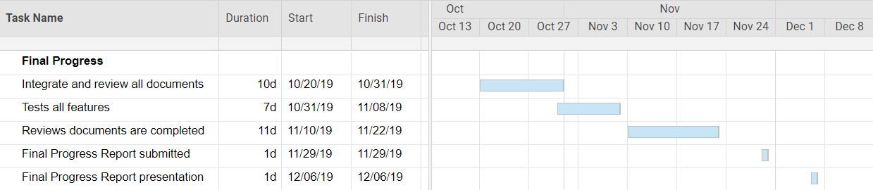

**Figure 16**: Final Progress

# **References**

[1] *Play.google.com*, 2019. [Online]. Available: https://play.google.com/store/apps/details?id=tr.com.incisoft.kelimografi.

[Accessed: 12- May- 2019]

[2] *Play.google.com*, 2019. [Online]. Available: <https://play.google.com/store/apps/details?id=com.madartsoft.sentimentanalysis.sentimentanalysis>. [Accessed: 12- May- 2019]

[3] "Top 8 Mobile Apps For Text Analysis - eLearning Industry", *eLearning Industry*, 2019. [Online]. Available: <https://elearningindustry.com/top-8-mobile-apps-for-text-analysis>.

[Accessed: 12- May- 2019]

[4] "What Is ReactJS and Why Should We Use It?", *C-sharpcorner.com*, 2019. [Online]. Available: <https://www.c-sharpcorner.com/article/what-and-why-reactjs/>.

[Accessed: 14- May- 2019]

[5] "What is Scrapy ?", *Medium*. [Online]. Available: https://medium.com/@omeryazir/what-is-scrapy-b996c68586b7. [Accessed: 1- June- 2019]

[6] "What is MonkeyLearn?", *Help.monkeylearn.com*, 2019. [Online]. Available: <http://help.monkeylearn.com/frequently-asked-questions/what-is-monkeylearn>.

[Accessed: 16- May- 2019]

[7] D. Soper, "Free Sentiment Analyzer", *Danielsoper.com*, 2019. [Online]. Available: <https://www.danielsoper.com/sentimentanalysis/default.aspx>. [Accessed: 16- May- 2019]

[8] "What is Firebase?", *How To Firebase*, 2016. [Online]. Available: <https://howtofirebase.com/what-is-firebase-fcb8614ba442>. [Accessed: 16- May- 2019]

[9] V. Code, "Documentation for Visual Studio Code", *Code.visualstudio.com*, 2019. [Online]. Available: <https://code.visualstudio.com/docs>. [Accessed: 16- May- 2019]

[10] "What is Python?", *Python For Beginners*, 2019. [Online]. Available: <https://www.pythonforbeginners.com/learn-python/what-is-python/>.

[Accessed: 17- May- 2019]

[11] "What Is GitHub? What Is It Used For?", *Hostinger Tutorials*, 2019. [Online]. Available: <https://www.hostinger.com/tutorials/what-is-github>. [Accessed: 25- May- 2019]

[12] T. Exchanges, "Welcome to the future of markets | The World Federation of Exchanges", *World-exchanges.org*, 2019. [Online]. Available: https://www.worldexchanges.org/?fbclid=IwAR16vdMyxNZVU10L4rDzHB4xu3bKF3akKYTDlbxc3F7RGaH2oGw3FI8luXM. [Accessed: 02- Jun- 2019]

[13] "Thai Language Information - Thai alphabet, Thai grammar, Thai pronunciation rules and more.", *Lingvozone.com*. [Online]. Available: http://www.lingvozone.com/Thai. [Accessed: 28- May- 2019]