# **Documentation Flow**

1. Flow chart for main stock: -

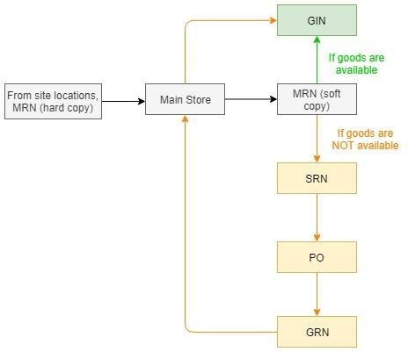

1. Flow chart for concrete: -

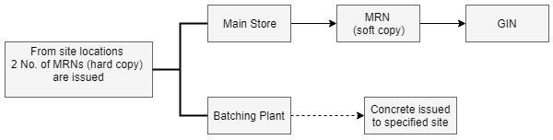

When cement, sand, aggregate and other chemicals (retarders, accelerators etc.) are low in stock in the batching plant, MRN shall be issued from the batching plant to the main stores.

1. Flow chart for accommodation camp: -



1. Flow chart for explosives: -

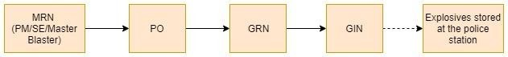

*GIN issued by main stores to Master Blaster.

*GRN should indicate expiry date of material

1. Flow chart for medical center: -



*GIN issued by main stores to Medical Officer/Nurse.