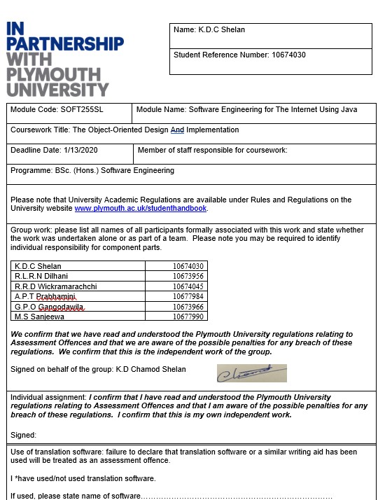

|  |
| --- |
| **Overall mark _____% Assessors Initials ______ Date_________** |

Contents

Scenario 4

Use Case Diagram 5

Class Diagram 6

Screenshots of the Software 7

9

9

11

11

Work Load Matrix 12

Turnitin Receipt 12

**Library Management System**

# Scenario

**Library management is a task that needs so much man power in order to keep up with the time. But with a good computerized system Library management will be much easier. However, with this system, we provide basic functionalities that can accomplish daily tasks of library management**.

# Use Case Diagram

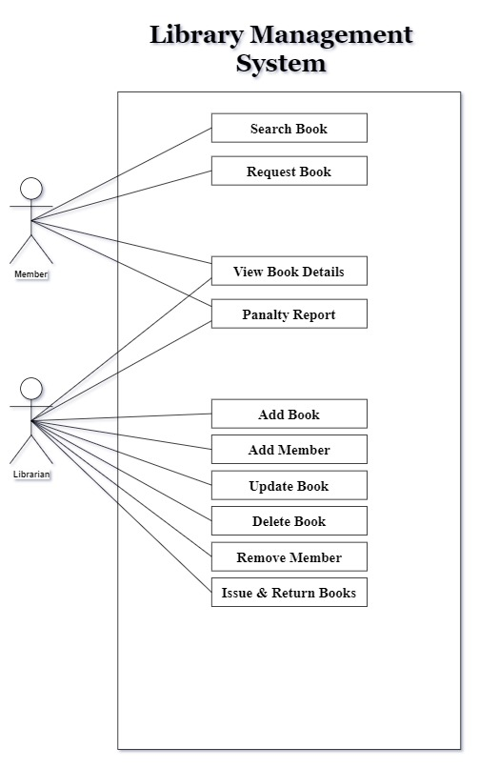

# Class Diagram

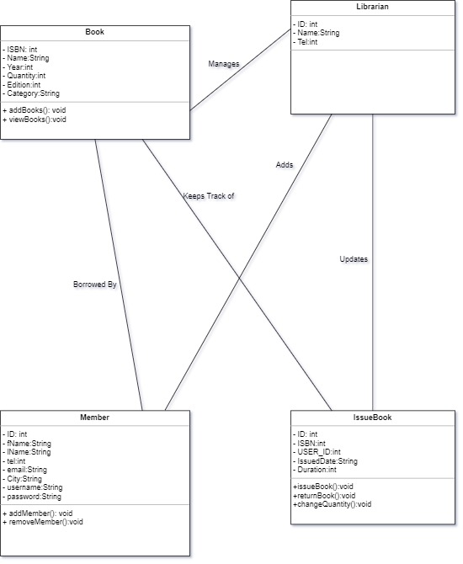

# Screenshots of the Software

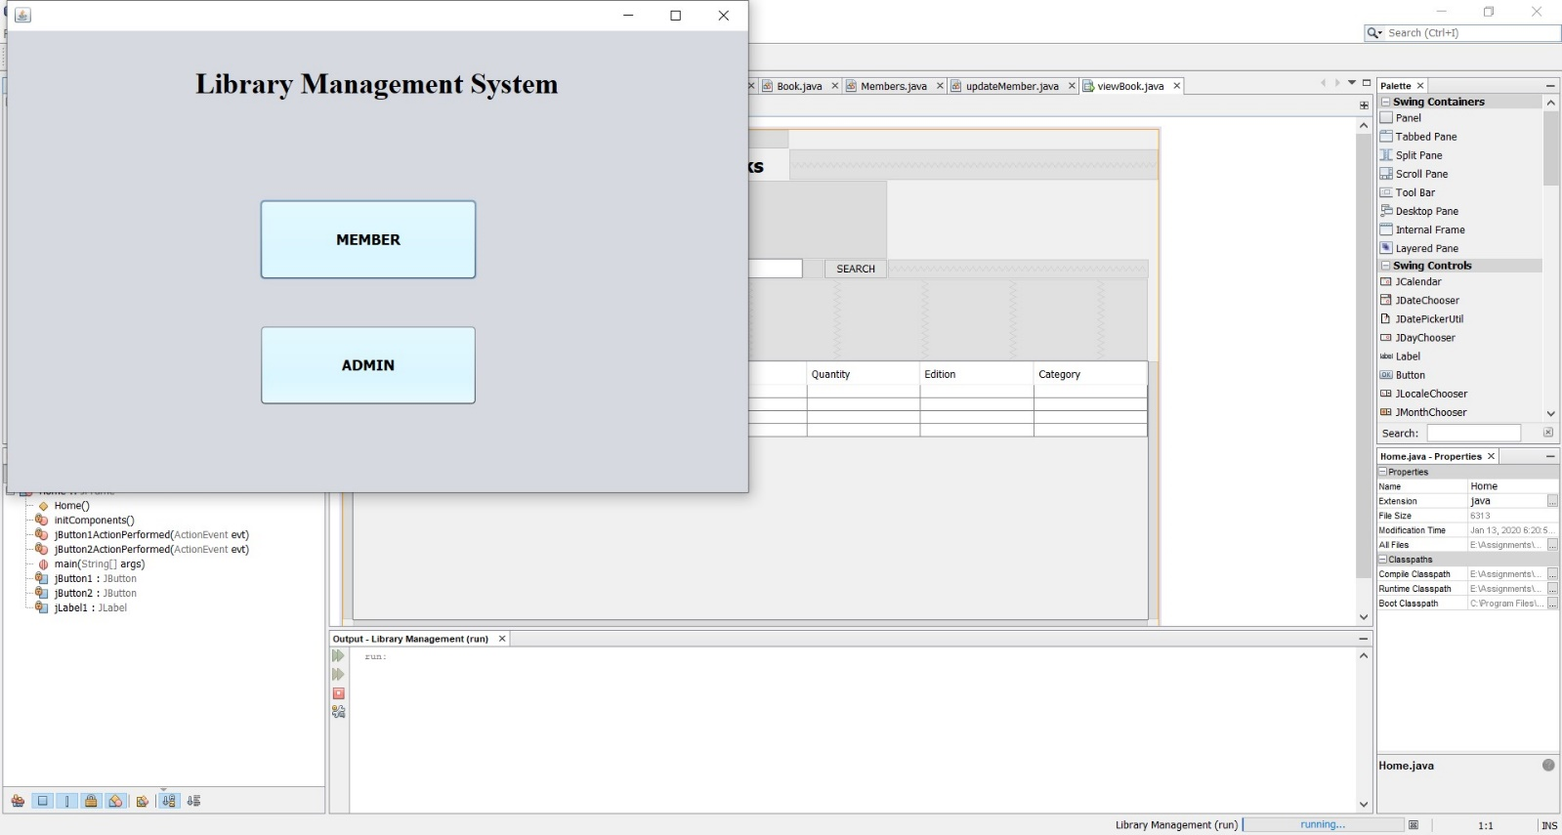

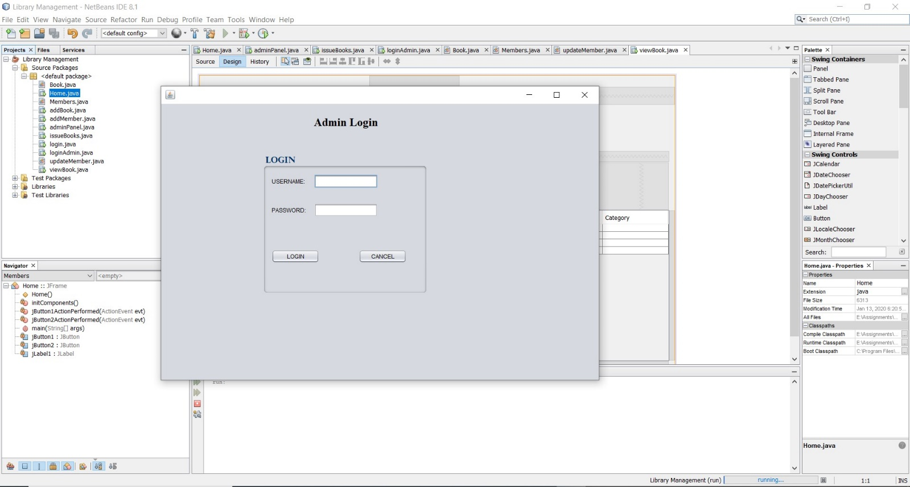

# 

# 

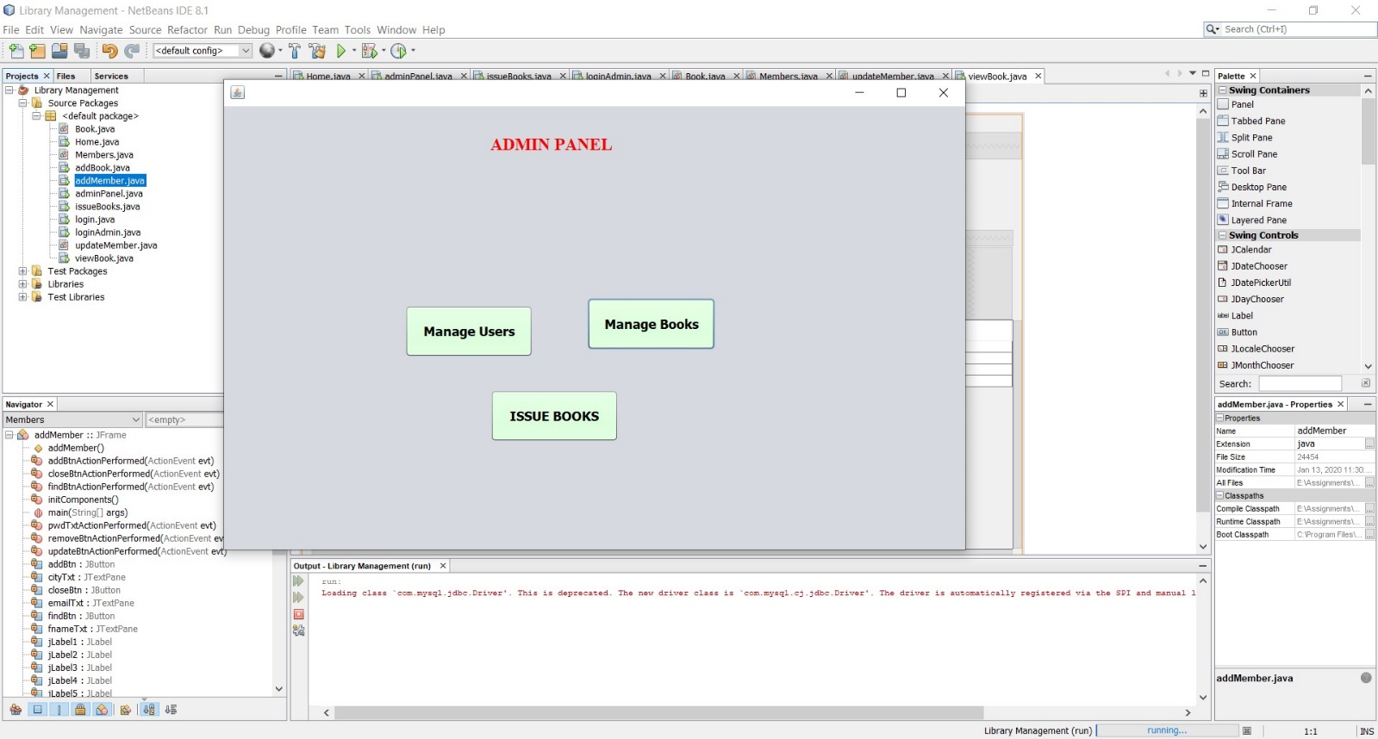

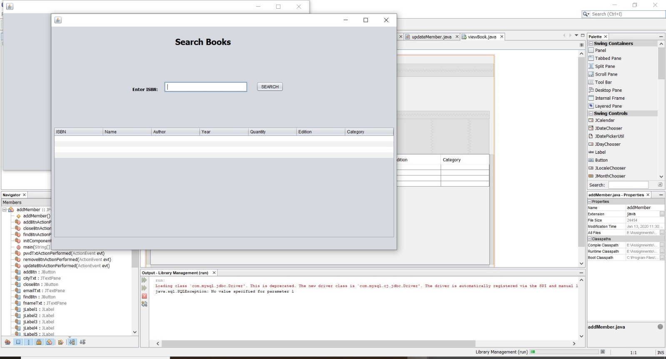

# 

# 

# Work Load Matrix

|  |  |  |  |  |  |  |
| --- | --- | --- | --- | --- | --- | --- |
| Member  Activity | Member 01 ID: 10614030 | Member 02 ID: 10673956 | Member 03  ID:10673966 | Member 04  ID:10677990 | Member 05  ID:10677984 | Member 06  ID: 10674045 |
| Use Case Diagram |  | ✔ |  |  |  |  |
| Class Diagram |  |  | ✔ | ✔ |  |  |
| Database Design |  |  |  |  | ✔ | ✔ |
| Design GUI | ✔ | ✔ |  |  |  |  |
| Develop the System | ✔ | ✔ | ✔ | ✔ | ✔ | ✔ |
| Total Contribution- (100%) | 24% | 19% | 12% | 14% | 13% | 18% |

# 

# Turnitin Receipt

