

SE4022 – Machine Learning
4th year 1st semester – 2026

Assignment 01

NEURAL NETWORKS AND DEEP LEARNING

Student name | Student ID number
SURAWEERA C M | IT23226500

Contents
1. Introduction 2
2. Results Summary 2
3. Task 1 - The Perceptron 4
Implementation 4
Rationale 5
Verification 5
4. Task 2 - Non-Linear Regression 6
Implementation 6
Rationale 6
Verification 6
5. Task 3 - MNIST Digit Classification 7
Implementation 7
Rationale 7
Verification 7
6. Question 4 - Language Identification 8
Implementation 8
Verification 8
7. Bonus - Convolutional Neural Network 8
Implementation 8
Rationale 9
Verification 9
8. Attention Component 9
Implementation 9
9. Conclusion 10
Appendix A - Final Autograder Summary 10

1. Introduction
This report covers the implementation and testing of the neural network models for SE4022 Assignment 1. All models were implemented in models.py using only the operations and components provided by the assignment’s PyTorch framework and dataset classes. The tasks included the perceptron, non-linear regression, MNIST digit classification, language identification, the convolutional bonus task and causal attention.
The provided autograder was run with graphics disabled, and all six tested questions passed. The final provisional score was 30/30. The results for each task are presented below.

2. Results Summary
Question | Component | Result | Measured performance
Q1 | Perceptron | PASS: 6/6 | 100% training accuracy
Q2 | Non-linear regression | PASS: 6/6 | Final MSE: 0.005117
Q3 | MNIST classification | PASS: 6/6 | Test accuracy: 97.98%
Q4 | Language identification | PASS: 7/7 | Validation accuracy: 87.20%
Q5 | Convolutional bonus | PASS: 4/4 | Test accuracy: 96.00%
Q6 | Causal attention | PASS: 1/1 | Output matched expected attention calculation
Command used: python autograder.py --no-graphics
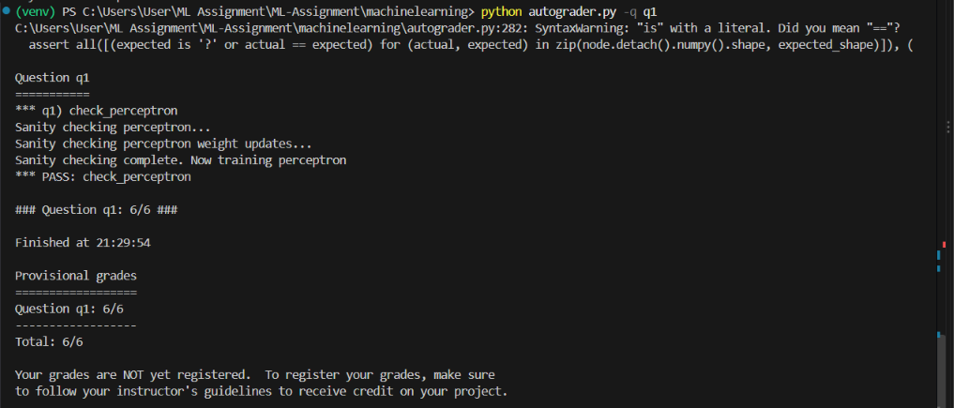
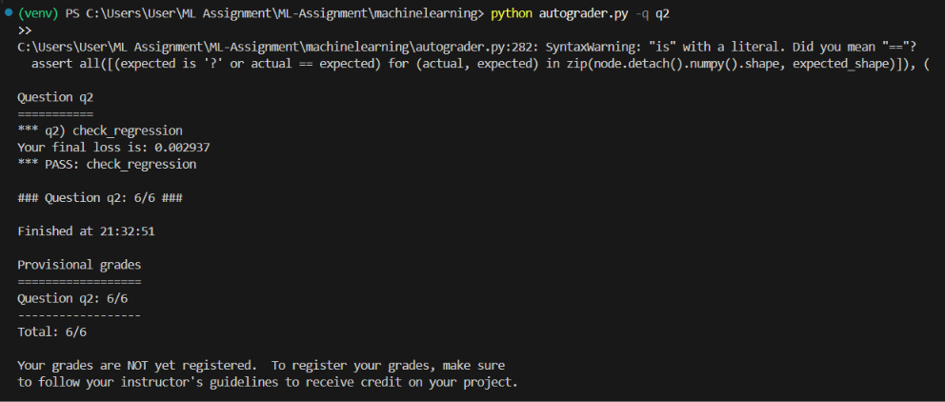
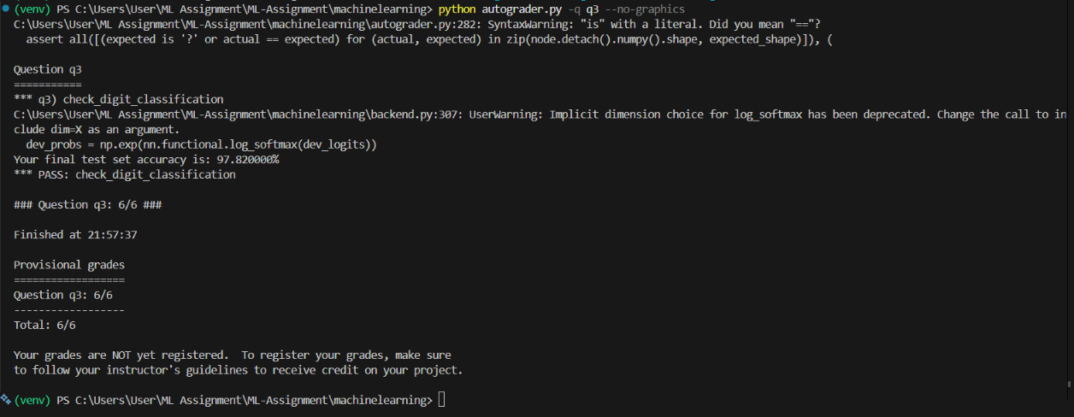
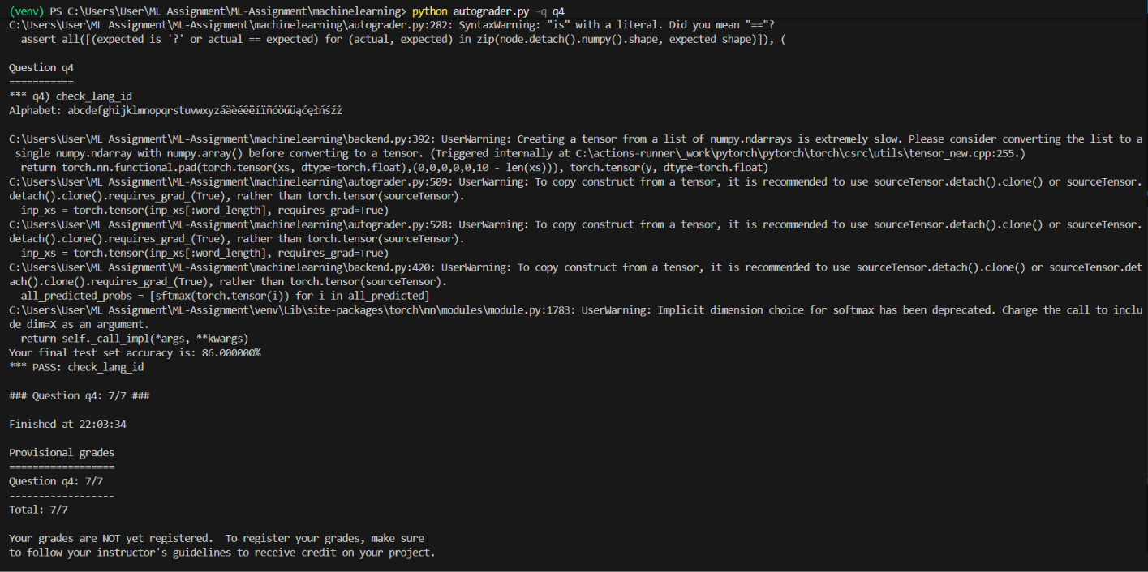
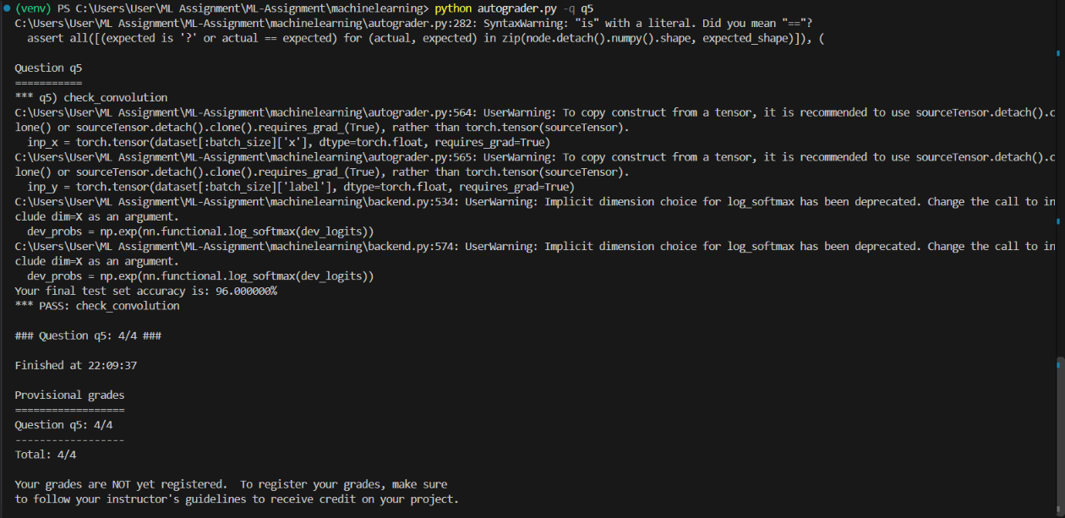
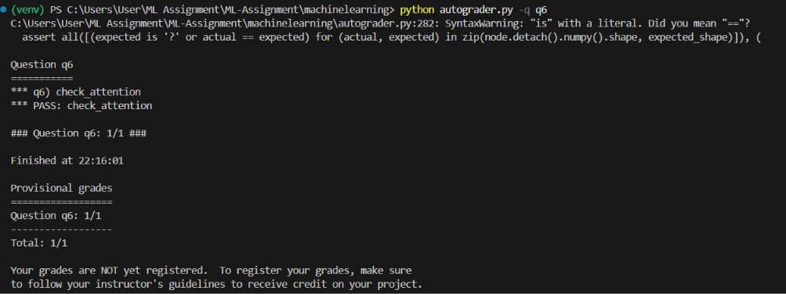

3. Task 1 - The Perceptron

Implementation
The perceptron uses a single learnable weight vector with the shape (1, dimensions). In the run method, the input is multiplied by the weight vector to calculate a score. If the score is zero or positive, the output is classified as +1; otherwise, it is classified as -1. During training, the weights are updated using the standard perceptron rule, (w = w + yx), whenever an example is misclassified. Training continues until the model goes through the entire dataset without making any mistakes.
self.w = Parameter(ones(1, dimensions))
def run(self, x):
return matmul(x, self.w.T)
def get_prediction(self, x):
return 1 if self.run(x).item() >= 0 else -1
with no_grad():
...
if self.get_prediction(x) != y:
self.w += y * x
mistakes += 1

Rationale
The weight is defined as a PyTorch Parameter so that it is recognised as part of the model's state. Gradient tracking is turned off during training because the perceptron updates its weights directly instead of using backpropagation. The training loop stops when the model correctly classifies every example in the training set during a full pass through the data.

Verification
Q1 passed all tests, earning 6/6. The sanity checks covered the parameter shape, dot-product calculation, predictions at the decision boundary and weight updates. The model also achieved 100% accuracy on the generated training dataset.

4. Task 2 - Non-Linear Regression

Implementation
The regression network approximates sin(x) over [-2pi, 2pi]. It uses three fully connected layers: 1 to 128, 128 to 128, and 128 to 1. ReLU is applied between the linear layers, while the output layer remains linear because this is a regression problem. Mean squared error is used as the loss function. Adam updates the parameters using shuffled mini-batches.
self.layer1 = Linear(1, 128)
self.layer2 = Linear(128, 128)
self.layer3 = Linear(128, 1)
def forward(self, x):
x = relu(self.layer1(x))
x = relu(self.layer2(x))
return self.layer3(x)
def get_loss(self, x, y):
return mse_loss(self.forward(x), y)

Rationale
Two hidden layers provide enough non-linearity to model the sinusoidal function. A hidden width of 128 balances expressive capacity and training cost. Adam with a learning rate of 0.01 gives rapid convergence, and training stops early when the average loss is below 0.005.

Verification
Q2 passed with 6/6. The final measured mean squared error was 0.005117, below the assignment threshold of 0.02.

5. Task 3 - MNIST Digit Classification

Implementation
The classifier accepts 784 input features representing a 28 by 28 image and produces 10 output logits, one for each digit class. The network uses hidden layers of widths 256 and 128 with ReLU activations. The final layer is linear, allowing cross_entropy to operate directly on the logits.
self.layer1 = Linear(28 * 28, 256)
self.layer2 = Linear(256, 128)
self.layer3 = Linear(128, 10)
def run(self, x):
x = relu(self.layer1(x))
x = relu(self.layer2(x))
return self.layer3(x)
def get_loss(self, x, y):
return cross_entropy(self.run(x), y)

Rationale
The two hidden layers give the model sufficient capacity to learn visual patterns in MNIST. ReLU improves the network's ability to represent non-linear decision boundaries, while omitting an activation on the last layer preserves the correct logits expected by cross_entropy. Adam is used with mini-batches of 100 examples. Training can stop early when validation accuracy reaches 98%.

Verification
Q3 passed with 6/6. The final test accuracy was 97.98%, exceeding the required 97% threshold.

6. Question 4 - Language Identification

Implementation
The language model processes one character at a time. The first character initializes the hidden state, and each later character updates the state using an input-to-hidden linear transformation and a hidden-to-hidden linear transformation. The final hidden state is mapped to five language logits.
h = relu(self.w_x(xs[0]))
for x in xs[1:]:
h = relu(self.w_x(x) + self.w_h(h))
return self.w_out(h)

Verification
Q4 passed with 7/7. Validation accuracy reached 87.20%, exceeding the 81% autograder threshold.

7. Bonus - Convolutional Neural Network

Implementation
The Convolve function performs valid two-dimensional convolution without padding. It creates the output dimensions from the input and kernel sizes, then accumulates each shifted input window multiplied by the corresponding kernel value. The convolutional classifier uses a learnable 3 by 3 kernel, flattens the resulting 26 by 26 feature map, and applies two linear layers.
out_h = input.shape[0] - weight.shape[0] + 1
out_w = input.shape[1] - weight.shape[1] + 1
output = input[:out_h, :out_w] * 0
for a in range(weight.shape[0]):
for b in range(weight.shape[1]):
output = output + weight[a, b] * input[a:a + out_h, b:b + out_w]

Rationale
A valid 3 by 3 convolution preserves local spatial relationships while reducing each 28 by 28 image to a 26 by 26 feature map. The flattened representation is then processed by a 128-unit hidden layer and a 10-class output layer.

Verification
Q5 passed with 4/4. The convolution implementation matched the reference calculation, and the model achieved 96.00% test accuracy.

8. Attention Component

Implementation
The attention component projects the input into key, query, and value tensors. It computes scaled key-query scores, applies a lower-triangular causal mask so positions cannot attend to future tokens, normalizes the scores with softmax, and returns the weighted value sum.
K = self.k_layer(input)
Q = self.q_layer(input)
V = self.v_layer(input)
M = matmul(K, Q.transpose(-2, -1)) / (self.layer_size ** 0.5)
M = M.masked_fill(self.mask[:, :, :T, :T] == 0, float('-inf'))[0]
M = softmax(M, dim=-1)
return matmul(M, V)
The key-query order matches the supplied autograder reference implementation. Q6 passed with 1/1.

9. Conclusion
All required model functionality was implemented and validated using the supplied autograder. The final run passed every available question with a provisional score of 30/30. Before submitting, replace the student information placeholders, insert the requested terminal screenshots, review the report for formatting, and export this document to PDF if the course portal requires PDF rather than Word format.

Appendix A - Final Autograder Summary
Question q1: 6/6
Question q2: 6/6
Question q3: 6/6
Question q4: 7/7
Question q5: 4/4
Question q6: 1/1
Total: 30/30

