Zenith Database Reference
SQLite schema, diagrams, and field catalog
This document describes the Zenith / ChequeMate SQLite database (database/invoice_cheque.db). Schema source: database/schema.sql. Rebuild with python scripts/init_db.py.
The entity-relationship diagram is large and may not fit a printed page. Use the mermaid.live link under that figure to zoom, pan, and export PNG/SVG for teammates.

Shareable diagram links

High-level domain map
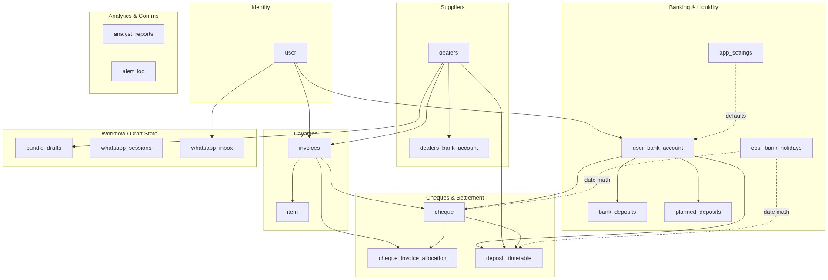
High-level domain map
Open, zoom, and share: mermaid.live — High-level domain map

Entity-relationship diagram
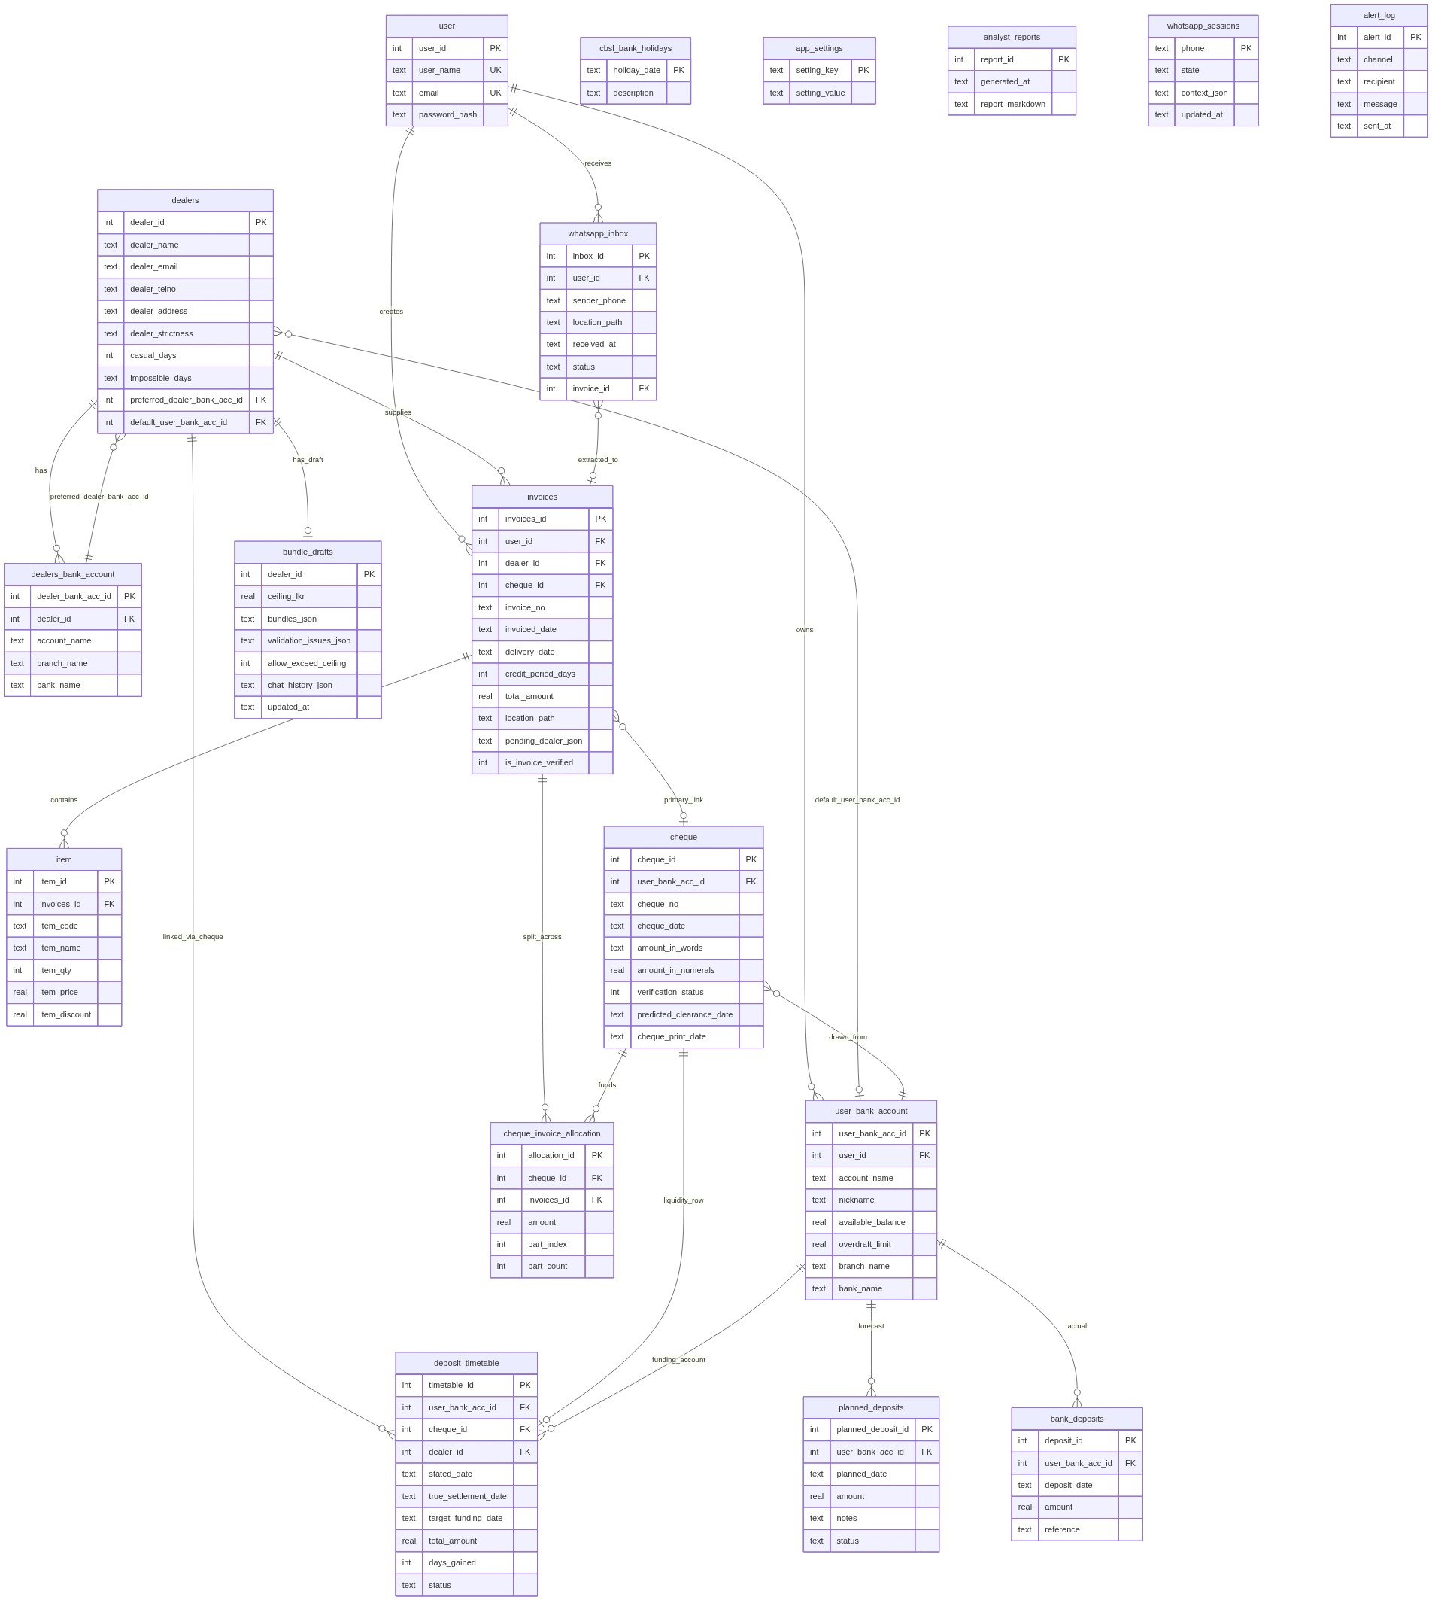
Entity-relationship diagram
Open, zoom, and share: mermaid.live — Entity-relationship diagram

Business lifecycle
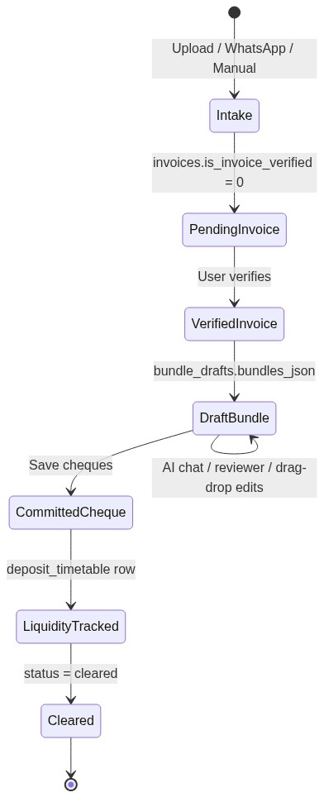
Business lifecycle
Open, zoom, and share: mermaid.live — Business lifecycle

WhatsApp intake pipeline
WhatsApp intake pipeline
Open, zoom, and share: mermaid.live — WhatsApp intake pipeline

How invoices link to cheques
A. Simple link — invoices.cheque_id. One invoice points at one primary cheque (classic bundling).
B. Split link — cheque_invoice_allocation. One invoice can fund multiple cheques (or partial amounts). Committed cheques use both: cheque_id on the invoice plus allocation rows for splits.

Relationship summary
From | To | Cardinality | Meaning
user | user_bank_account | 1:N | Merchant owns bank accounts
user | invoices | 1:N | Merchant owns invoices
dealers | invoices | 1:N | Supplier has many invoices
invoices | item | 1:N | Invoice has line items
invoices | cheque | N:1 (nullable) | Many invoices on one cheque
invoices | cheque via allocation | N:M | Invoice can split across cheques
cheque | user_bank_account | N:1 | Cheque drawn from one account
cheque | deposit_timetable | 1:1-ish | Liquidity tracking per cheque
dealers | bundle_drafts | 1:1 | One active bundling session per supplier
whatsapp_inbox | invoices | N:1 | Image becomes an invoice

Table catalog
Each table lists Column, SQLite type, Key (PK / FK / UNIQUE), Null/default, and notes. Types come from schema.sql. Notes come from database/DATABASE.md.

user
Single merchant account used for login.
Column | Type | Key | Null / default | Notes
user_id | INTEGER | PK | NOT NULL
user_name | TEXT | UNIQUE | NOT NULL | Merchant display name
email | TEXT | UNIQUE | NOT NULL | Contact email
password_hash | TEXT |  | NOT NULL | Werkzeug hash (set by `init_db.py` from `APP_PASSWORD`)

user_bank_account
Your bank accounts.
Column | Type | Key | Null / default | Notes
user_bank_acc_id | INTEGER | PK | NOT NULL
user_id | INTEGER | FK → user(user_id) | NOT NULL
account_name | TEXT |  | NOT NULL | Legal account name
nickname | TEXT |  | NULL ok | Short label for UI
available_balance | REAL |  | NOT NULL; default 0.00 | Current ledger balance (updated via Cash Flow UI)
overdraft_limit | REAL |  | NOT NULL; default 0.00 | Cheque overdraft facility (0 = none). Usable funds = balance + overdraft
branch_name | TEXT |  | NULL ok
bank_name | TEXT |  | NOT NULL

dealers
Special row: **"Pending Supplier"** — placeholder for invoices from unknown/new suppliers during WhatsApp intake.
Column | Type | Key | Null / default | Notes
dealer_id | INTEGER | PK | NOT NULL
dealer_name | TEXT |  | NOT NULL | Matched during invoice ingestion
dealer_email | TEXT |  | NULL ok
dealer_telno | TEXT |  | NULL ok
dealer_address | TEXT |  | NULL ok
dealer_strictness | TEXT |  | NULL ok | High / Medium / Low
casual_days | INTEGER |  | NULL ok; default 0 | Extra days before cheque date
impossible_days | TEXT |  | NULL ok | Comma-separated weekdays (e.g. `Sunday`)
preferred_dealer_bank_acc_id | INTEGER |  | NULL ok | Preferred supplier bank for interbank clearing (+1 day)
default_user_bank_acc_id | INTEGER | FK → user_bank_account(user_bank_acc_id) | NULL ok | Which of your accounts pays this supplier by default

dealers_bank_account
Supplier bank details (reference only).
Column | Type | Key | Null / default | Notes
dealer_bank_acc_id | INTEGER | PK | NOT NULL
dealer_id | INTEGER | FK → dealers(dealer_id) | NOT NULL
account_name | TEXT |  | NOT NULL
branch_name | TEXT |  | NULL ok
bank_name | TEXT |  | NOT NULL

cheque
Issued cheques.
Column | Type | Key | Null / default | Notes
cheque_id | INTEGER | PK | NOT NULL
user_bank_acc_id | INTEGER | FK → user_bank_account(user_bank_acc_id) | NOT NULL | Account debited
cheque_no | TEXT |  | NOT NULL
cheque_date | TEXT |  | NOT NULL | YYYY-MM-DD
amount_in_words | TEXT |  | NULL ok
amount_in_numerals | REAL |  | NOT NULL
verification_status | INTEGER |  | NOT NULL; default 0 | 0 = draft, 1 = committed
predicted_clearance_date | TEXT |  | NULL ok | Used by cash-flow projection
cheque_print_date | TEXT |  | NULL ok; default (datetime('now') | Timestamp

invoices
**Unique constraint:** `idx_invoices_user_dealer_invoice_no` on `(user_id, dealer_id, invoice_no)` — same invoice number can exist for different suppliers, but not twice for the same supplier.
Column | Type | Key | Null / default | Notes
invoices_id | INTEGER | PK | NOT NULL
user_id | INTEGER | FK → user(user_id) | NOT NULL
dealer_id | INTEGER | FK → dealers(dealer_id) | NOT NULL
cheque_id | INTEGER | FK → cheque(cheque_id) | NULL ok | NULL until bundled / committed
invoice_no | TEXT |  | NOT NULL | Unique per `(user_id, dealer_id)`
invoiced_date | TEXT |  | NOT NULL | YYYY-MM-DD
delivery_date | TEXT |  | NULL ok | Goods received date (aging)
credit_period_days | INTEGER |  | NOT NULL | Due = invoiced_date + days
total_amount | REAL |  | NOT NULL | LKR
location_path | TEXT |  | NULL ok | Path to scanned image
pending_dealer_json | TEXT |  | NULL ok | Temp supplier setup / WhatsApp metadata
is_invoice_verified | INTEGER |  | NOT NULL; default 0 | 0 = pending review, 1 = verified

item
Invoice line items.
Column | Type | Key | Null / default | Notes
item_id | INTEGER | PK | NOT NULL
invoices_id | INTEGER | FK → invoices(invoices_id) | NOT NULL
item_code | TEXT |  | NOT NULL
item_name | TEXT |  | NOT NULL
item_qty | INTEGER |  | NOT NULL
item_price | REAL |  | NOT NULL
item_discount | REAL |  | NOT NULL; default 0 | Default 0

cheque_invoice_allocation
Split funding: one invoice may fund multiple cheques via amount parts.
Column | Type | Key | Null / default | Notes
allocation_id | INTEGER | PK | NOT NULL
cheque_id | INTEGER | FK → cheque(cheque_id) | NOT NULL
invoices_id | INTEGER | FK → invoices(invoices_id) | NOT NULL
amount | REAL |  | NOT NULL | Portion of invoice on this cheque
part_index | INTEGER |  | NOT NULL; default 1 | e.g. part 1 of 3 (default 1)
part_count | INTEGER |  | NOT NULL; default 1 | Total parts (default 1)

cbsl_bank_holidays
**Populate / refresh** from the official CBSL pages (defaults 2025–2027): ```bash pip install -r requirements.txt python scripts/sync_cbsl_holidays.py python scripts/sync_cbsl_holidays.py --dry-run python scripts/sync_cbsl_holidays.py --years 2025,2026,2027 ``` `scripts/init_db.py` runs the sync automatically after a fresh database create (best-effort if CBSL is unreachable). Source: [CBSL bank holidays](https://www.cbsl.gov.lk/en/about/about-the-bank/bank-holidays)
Column | Type | Key | Null / default | Notes
holiday_date | TEXT | PK | NOT NULL | YYYY-MM-DD
description | TEXT |  | NULL ok | CBSL holiday name, or `Saturday` / `Sunday`

bank_deposits
Historical actual deposits into an account.
Column | Type | Key | Null / default | Notes
deposit_id | INTEGER | PK | NOT NULL
user_bank_acc_id | INTEGER | FK → user_bank_account(user_bank_acc_id) | NOT NULL
deposit_date | TEXT |  | NOT NULL | YYYY-MM-DD
amount | REAL |  | NOT NULL | LKR
reference | TEXT |  | NULL ok | Optional note

planned_deposits
Future expected deposits (cash-flow forecasting).
Column | Type | Key | Null / default | Notes
planned_deposit_id | INTEGER | PK | NOT NULL
user_bank_acc_id | INTEGER | FK → user_bank_account(user_bank_acc_id) | NOT NULL
planned_date | TEXT |  | NOT NULL | Target deposit-by date
amount | REAL |  | NOT NULL | LKR
notes | TEXT |  | NULL ok
status | TEXT |  | NOT NULL; default 'planned' | `planned` or `done`

app_settings
Key-value app configuration.
Column | Type | Key | Null / default | Notes
setting_key | TEXT | PK | NOT NULL
setting_value | TEXT |  | NOT NULL

analyst_reports
Cached Agent 3 markdown reports.
Column | Type | Key | Null / default | Notes
report_id | INTEGER | PK | NOT NULL
generated_at | TEXT |  | NULL ok; default (datetime('now') | Timestamp
report_markdown | TEXT |  | NOT NULL | Full markdown report

bundle_drafts
Per-dealer working session (1 row per dealer). **Not** committed payment data — when user saves cheques, data flows into `cheque`, `invoices.cheque_id`, `cheque_invoice_allocation`, and `deposit_timetable`.
Column | Type | Key | Null / default | Notes
dealer_id | INTEGER | PK, FK → dealers(dealer_id) | NOT NULL
ceiling_lkr | REAL |  | NOT NULL | Max cheque amount limit
bundles_json | TEXT |  | NOT NULL | Proposed cheque groups (persisted in-memory structure)
validation_issues_json | TEXT |  | NULL ok | Guardrail warnings
allow_exceed_ceiling | INTEGER |  | NOT NULL; default 0 | 0/1 flag
chat_history_json | TEXT |  | NULL ok | AI assistant + reviewer chat
updated_at | TEXT |  | NULL ok; default (datetime('now') | Last update timestamp

deposit_timetable
Max-liquidity funding schedule for pending cheque outflows. Bridges **cheque planning** → **daily cash-flow view**.
Column | Type | Key | Null / default | Notes
timetable_id | INTEGER | PK | NOT NULL
user_bank_acc_id | INTEGER | FK → user_bank_account(user_bank_acc_id) | NOT NULL | Merchant account debited
cheque_id | INTEGER | FK → cheque(cheque_id) | NULL ok | NULL until committed
dealer_id | INTEGER | FK → dealers(dealer_id) | NULL ok | For interbank detection
stated_date | TEXT |  | NOT NULL | Cheque stated date
true_settlement_date | TEXT |  | NULL ok | Forward-rolled CBSL business day
target_funding_date | TEXT |  | NULL ok | Latest legal fund-by date
total_amount | REAL |  | NOT NULL | LKR outflow
days_gained | INTEGER |  | NULL ok; default 0 | Holiday/weekend lag days
status | TEXT |  | NOT NULL; default 'pending' | `pending` \

whatsapp_sessions
Conversation state machine per phone number.
Column | Type | Key | Null / default | Notes
phone | TEXT | PK | NOT NULL | Sender phone
state | TEXT |  | NOT NULL | Current conversation state
context_json | TEXT |  | NULL ok | Session context payload
updated_at | TEXT |  | NULL ok; default (datetime('now') | Last activity

whatsapp_inbox
Incoming invoice images before extraction.
Column | Type | Key | Null / default | Notes
inbox_id | INTEGER | PK | NOT NULL
user_id | INTEGER | FK → user(user_id) | NOT NULL
sender_phone | TEXT |  | NULL ok
location_path | TEXT |  | NOT NULL | Stored image path
received_at | TEXT |  | NULL ok; default (datetime('now') | Timestamp; often used as `delivery_date` on invoice
status | TEXT |  | NOT NULL; default 'pending' | `pending` → `extracted`
invoice_id | INTEGER | FK → invoices(invoices_id) | NULL ok | Set after Agent 1 extraction

alert_log
Outbound alerts audit trail (WhatsApp, email, etc.).
Column | Type | Key | Null / default | Notes
alert_id | INTEGER | PK | NOT NULL
channel | TEXT |  | NOT NULL | e.g. whatsapp, email
recipient | TEXT |  | NOT NULL
message | TEXT |  | NOT NULL
sent_at | TEXT |  | NULL ok; default (datetime('now') | Timestamp

app_settings keys
Key-value rows stored in app_settings (not columns).
setting_key | Default | Purpose
min_cash_buffer_lkr | 500000 | Minimum safe balance
default_bank_acc_id | 1 | Default account for Cash Flow / bundling

Indexes
Index | Table | Columns | Kind
idx_user_bank_account_user_id | user_bank_account | user_id | INDEX
idx_cheque_user_bank_acc_id | cheque | user_bank_acc_id | INDEX
idx_cheque_predicted_clearance | cheque | predicted_clearance_date | INDEX
idx_invoices_user_id | invoices | user_id | INDEX
idx_invoices_dealer_id | invoices | dealer_id | INDEX
idx_invoices_cheque_id | invoices | cheque_id | INDEX
idx_invoices_invoice_no | invoices | invoice_no | INDEX
idx_item_invoices_id | item | invoices_id | INDEX
idx_item_item_code | item | item_code | INDEX
idx_dealers_bank_account_dealer_id | dealers_bank_account | dealer_id | INDEX
idx_cheque_cheque_no | cheque | cheque_no | INDEX
idx_dealers_dealer_name | dealers | dealer_name | INDEX
idx_bank_deposits_date | bank_deposits | deposit_date | INDEX
idx_planned_deposits_date | planned_deposits | planned_date | INDEX
idx_deposit_timetable_account | deposit_timetable | user_bank_acc_id | INDEX
idx_deposit_timetable_status | deposit_timetable | status | INDEX
idx_deposit_timetable_stated | deposit_timetable | stated_date | INDEX
idx_whatsapp_sessions_updated | whatsapp_sessions | updated_at | INDEX
idx_whatsapp_inbox_status | whatsapp_inbox | status | INDEX
idx_whatsapp_inbox_user | whatsapp_inbox | user_id | INDEX
idx_alert_log_sent_at | alert_log | sent_at | INDEX
idx_invoices_user_dealer_invoice_no | invoices | user_id, dealer_id, invoice_no | UNIQUE

Liquidity formula (conceptual)
usable_funds = available_balance + overdraft_limit + planned_deposits
outflows = deposit_timetable rows (status = pending)
safe_to_issue = usable_funds - outflows - min_cash_buffer_lkr
Date calculations for cheque clearance and funding use cbsl_bank_holidays plus each dealer’s casual_days and impossible_days.

