Zenith Vector Pattern Engine Reference
ChromaDB pattern memory, diagrams, and operations catalog
This document describes the Vector Pattern Engine in Zenith / ChequeMate — semantic memory of how each supplier (dealer) was paid in the past. SQLite remains the source of truth; ChromaDB stores searchable pattern summaries.
Diagrams are embedded below. Blue links open a picture in any web browser — no draw.io, no login, no special software.

Shareable diagram links
Share the Word file, the image files in docs/diagrams/vector/, or the browser links below.

High-level domain map
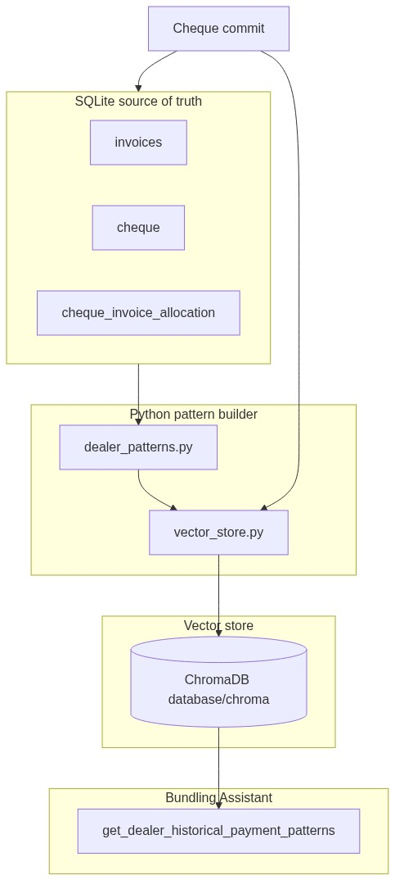
High-level domain map
Open in any browser (image): High-level domain map — view now
After git push, GitHub copy: https://raw.githubusercontent.com/ChamodiMadurasinghe/Zenith/main/docs/diagrams/vector/01-system-overview.jpg
Local file: docs/diagrams/vector/01-system-overview.jpg — attach to WhatsApp, email, or Slack.

Business lifecycle
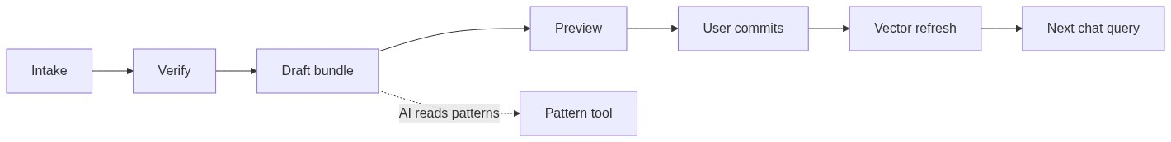
Business lifecycle
Open in any browser (image): Business lifecycle — view now
After git push, GitHub copy: https://raw.githubusercontent.com/ChamodiMadurasinghe/Zenith/main/docs/diagrams/vector/02-data-lifecycle.jpg
Local file: docs/diagrams/vector/02-data-lifecycle.jpg — attach to WhatsApp, email, or Slack.

Guardrails boundary
Guardrails boundary
Open in any browser (image): Guardrails boundary — view now
After git push, GitHub copy: https://raw.githubusercontent.com/ChamodiMadurasinghe/Zenith/main/docs/diagrams/vector/03-guardrails-boundary.jpg
Local file: docs/diagrams/vector/03-guardrails-boundary.jpg — attach to WhatsApp, email, or Slack.

Introduction
Aspect | Detail
What it is | One ChromaDB text summary per dealer, refreshed on cheque commit
What it is not | Not source of truth, not auto-commit, not date/ceiling math
One-line summary | SQLite = facts; ChromaDB = searchable pattern summaries for AI

Why a vector database?
Plain SQL lists history; the AI needs natural-language context. ChromaDB + OpenAI embeddings retrieve a pre-written pattern document. All dates and ceilings still pass through core/guardrails.py.

Payment classification
Type | Rule | Aging in document
Bundled | Cheque has 2+ distinct invoices | Average aging across bundled rows
Unbundled | Exactly 1 invoice, single part | Exact per-invoice lines — no average
Split | Same invoice on 2+ cheques | Per-part aging + payment pattern line
Mixed | Both bundled and unbundled history | Both sections appear

Aging rules
Formula: aging_days = clearance_date - invoiced_date
Clearance: predicted_clearance_date → deposit_timetable.target_funding_date → cheque_date

Example pattern document
Dealer: ABD Traders (ID: 1)
Bundling History: mixed
Aging Analysis:
- Bundled Invoices Average Aging: 38 days (4 multi-invoice cheques).
- Unbundled Invoice Records: Inv #101 (21 days), Inv #104 (14 days).
Preferred Paying Account: Commercial Bank — 12 of 15 cheques (80%).
Payment Pattern: Bills over 500k LKR split into 2 parts, 7-day gap.

ChromaDB storage model
Setting | Value
Path | database/chroma/
Collection | dealer_payment_patterns
Document ID | dealer-{dealer_id}
Embeddings | OpenAI text-embedding-3-small

Configuration (.env)
Variable | Default | Purpose
ENABLE_VECTOR_PATTERNS | true | Master switch
CHROMA_PERSIST_DIR | database/chroma | Storage path
OPENAI_EMBEDDING_MODEL | text-embedding-3-small | Embedding model
PATTERN_LARGE_BILL_LKR | 500000 | Split-pattern threshold
OPENAI_API_KEY | — | Required for embeddings
USE_FAKE_AI | false | Mock patterns; skips Chroma

Setup and operations
pip install -r requirements.txt
python scripts/backfill_dealer_patterns.py
Auto-refresh on every successful cheque commit.

Guardrails boundary
Vector DB CANNOT set dates, override ceiling, skip holidays, or commit without user Save.

File reference
File | Purpose
core/dealer_patterns.py | Build pattern text
core/vector_store.py | Chroma upsert / query
agents/bundling_tools.py | Historical patterns tool
docs/diagrams/vector/*.jpg | Shareable diagram images

Regenerate: python scripts/generate_vector_docs_docx.py

