**Comparison of Peak Incident Pressure Prediction from Different Approaches**

**Attempt 1**

Explosive type – Composition B

Explosive mass – 17.7 kg

Maximum Standoff Distance Considered – 8 m

|  |  |
| --- | --- |
| **Source** | **Prediction** |
| **LS-DYNA** |  |
| **ANN** |  |
| **XGBoost** |  |
| **Random Forest** |  |
| **Decision Tree** |  |

Peak Incident Pressure values were predicted at 40 cm intervals.

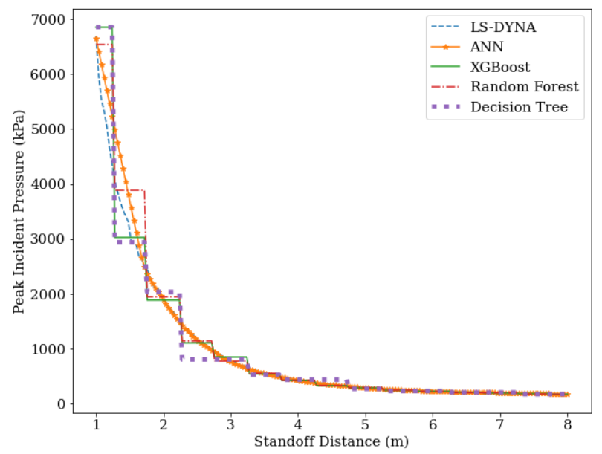

**Attempt 2**

Explosive type – Composition B

Explosive mass – 23.6 kg

Maximum Standoff Distance Considered – 2 m

Peak Incident Pressure values were predicted at 20 cm intervals.

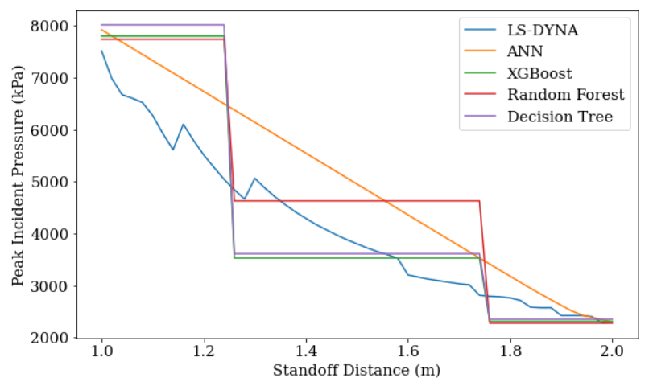

|  |  |
| --- | --- |
| **Source** | **Prediction** |
| **LS-DYNA** |  |
| **ANN** |  |
| **XGBoost** |  |
| **Random Forest** |  |
| **Decision Tree** |  |