SOC+ HYBRID LAB
Project Report
Network Setup and Coordination
Member | Member A – Fathima Shakkeer
Role | Network Setup and Coordination
Project | SOC+ Hybrid Lab
Tools Used | VMware Workstation, pfSense, Tailscale
Report Date | 13 July 2026

1. Role Overview
My role in the SOC+ Hybrid Lab project was to set up and manage the network so that all team members could work together in a shared, controlled environment. This involved building the local virtual infrastructure, deploying and configuring the network gateway, extending connectivity across remote team members using a VPN overlay, and coordinating with the rest of the team to ensure every machine could communicate successfully before the SOC tools were deployed.

2. Purpose of the Network Setup
The purpose of the network setup was to create a secure environment where all the machines in our SOC lab could communicate with each other. Before deploying tools such as Wazuh or performing attack simulations, we needed a properly configured network. My responsibility was to build that network by creating the virtual network, configuring pfSense as the gateway, and ensuring that communication between systems was possible.

3. Local Network Infrastructure (VMnet2 and pfSense)
I first created a VMnet2 host-only network in VMware because it provides a private network where virtual machines can communicate with each other without being exposed to the internet. This helped us simulate an internal organizational network, similar to what would be found in a real SOC environment.
I then installed and configured pfSense, which acts as the gateway/firewall for this network. The setup included assigning the WAN and LAN interfaces, configuring the LAN settings, verifying connectivity between interfaces, and completing the initial configuration so that the infrastructure was ready for the rest of the team to build on.
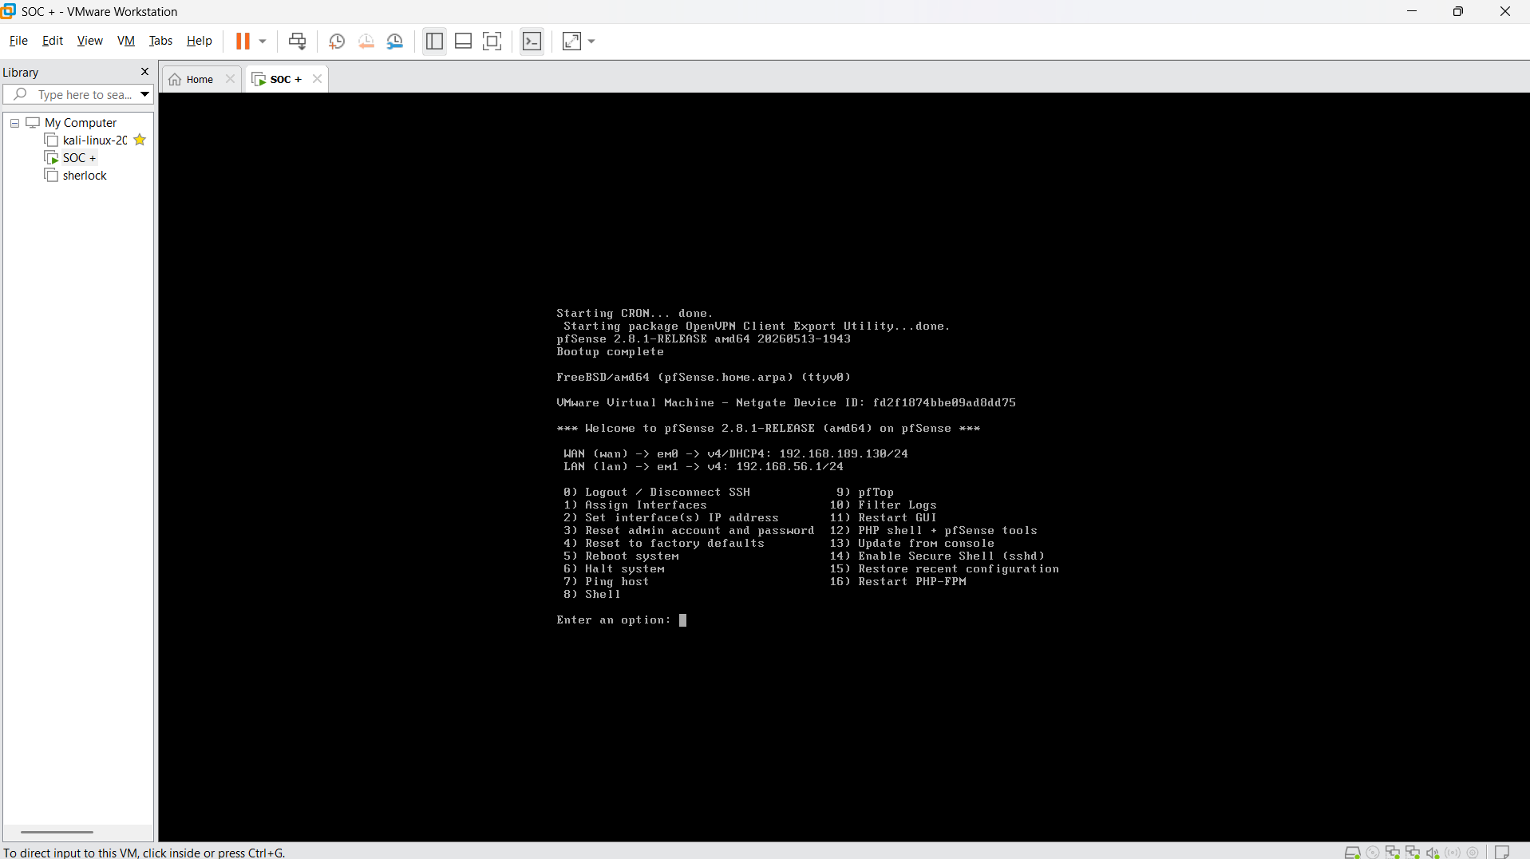
Figure 1: pfSense console after boot-up, showing WAN (192.168.189.130/24) and LAN (192.168.56.1/24) interface assignment.
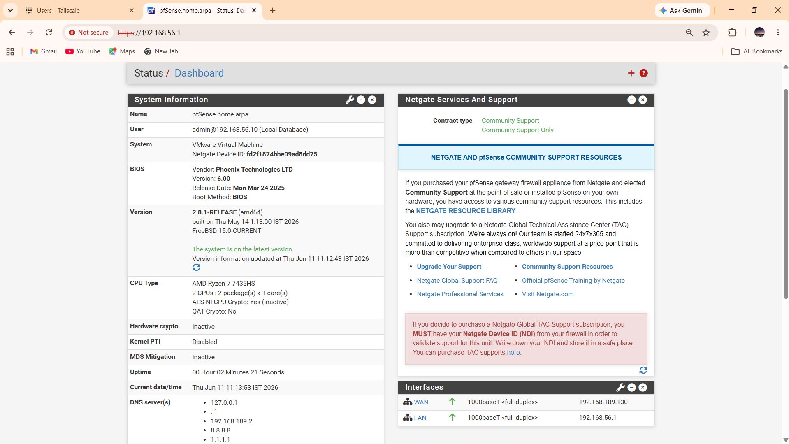
Figure 2: pfSense web administration dashboard confirming the system version, uptime, and configured WAN/LAN interfaces.

4. Extending Connectivity with Tailscale
Since each team member was working on a different laptop and from a different location, the VMnet2 host-only network alone was not enough — VMnet2 only connects virtual machines running on a single host. To solve this, I used Tailscale, which creates a secure VPN mesh connection between all our systems. It allowed everyone to connect as if we were on the same local network, even though we were working remotely.
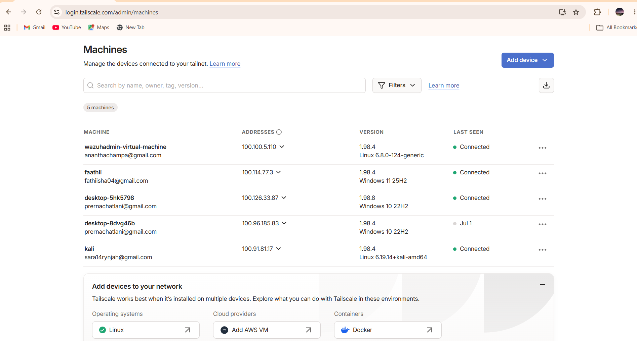
Figure 3: Tailscale admin console showing all five team machines connected to the shared tailnet.

5. Team Coordination
Alongside the technical setup, I coordinated with the rest of the team throughout the process. This included:
- Helping team members install Tailscale and join the same tailnet.
- Checking whether each machine could connect and communicate properly.
- Troubleshooting connectivity issues as they arose.
- Confirming that all systems could reach each other before the next phase of the project began.
Once connectivity was verified, the rest of the SOC setup was able to continue smoothly. With the network infrastructure ready, the other team members were able to deploy the Wazuh server, the victim machine, and the Kali attack machine on the network I had configured.

6. Design Summary: VMnet2 and Tailscale Together
The project was initially designed to simulate an enterprise network using pfSense and VMnet2. As the project progressed and the team needed to collaborate remotely, Tailscale was added because it made remote connectivity significantly easier. VMnet2 was still used to build and configure the local SOC lab environment, while Tailscale solved the practical challenge of connecting everyone's systems across different locations.
In short, VMnet2 provided the local virtual network foundation for the lab, while Tailscale provided secure remote connectivity between the different hosts — together forming the hybrid network architecture that gives the project its name.

7. Conclusion
The network setup and coordination work established the foundation for the entire SOC+ Hybrid Lab project. By combining a locally virtualized network secured with pfSense and a remote VPN overlay via Tailscale, all team members were able to operate as though on a single unified network. This enabled the successful deployment of the Wazuh server, victim machine, and Kali machine, and allowed the SOC lab exercises to proceed without connectivity issues.

