Level:0 to 1: ZjLjTmM6FvvyRnrb2rfNWOZOTa6ip5If

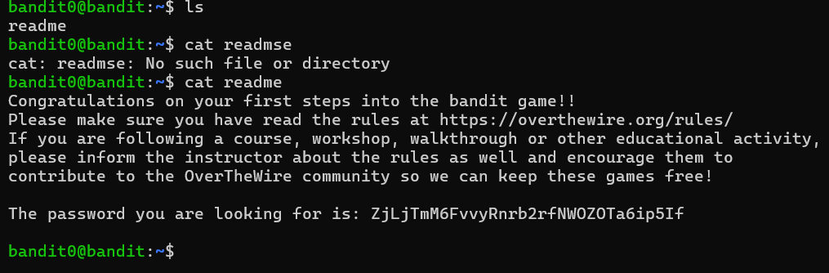

Level: 1 to 2: 263JGJPfgU6LtdEvgfWU1XP5yac29mFx

Level: 2 to 3: MNk8KNH3Usiio41PRUEoDFPqfxLPlSmx

Level: 3 to 4: 2WmrDFRmJIq3IPxneAaMGhap0pFhF3NJ

Level: 4 to 5: 4oQYVPkxZOOEOO5pTW81FB8j8lxXGUQw

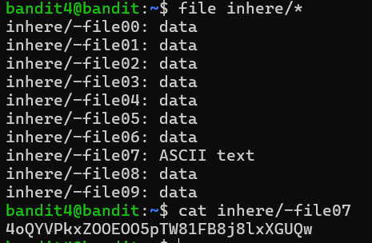

Level: 5 to 6: HWasnPhtq9AVKe0dmk45nxy20cvUa6EG

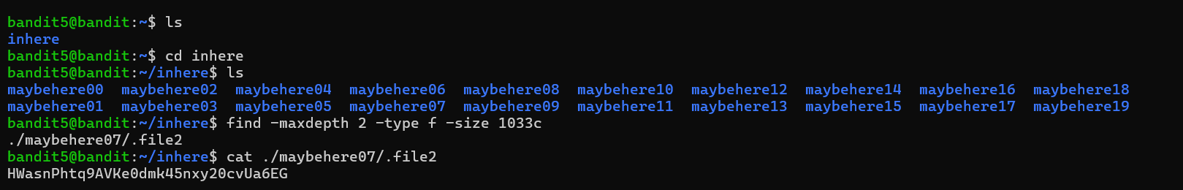

Level: 6 to 7: morbNTDkSW6jIlUc0ymOdMaLnOlFVAaj

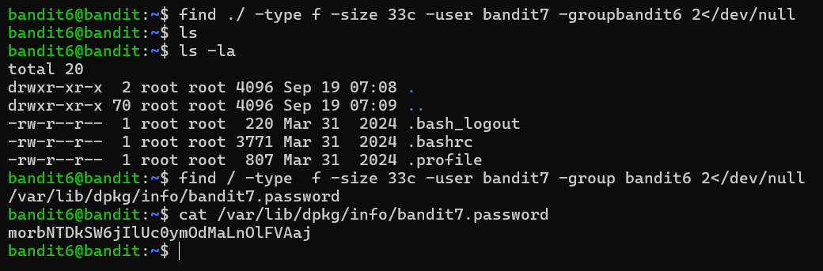

Level: 7 to 8 : dfwvzFQi4mU0wfNbFOe9RoWskMLg7eEc

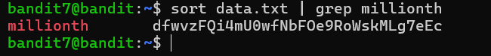

Level: 8 to 9: 4CKMh1JI91bUIZZPXDqGanal4xvAg0JM

Level: 9 to 10: FGUW5ilLVJrxX9kMYMmlN4MgbpfMiqey

Level: 10 to 11: dtR173fZKb0RRsDFSGsg2RWnpNVj3qRr

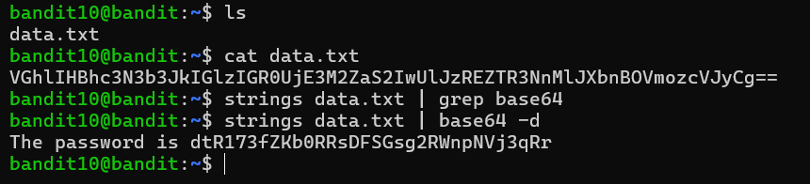

Level: 11 to 12 : 7x16WNeHIi5YkIhWsfFIqoognUTyj9Q4

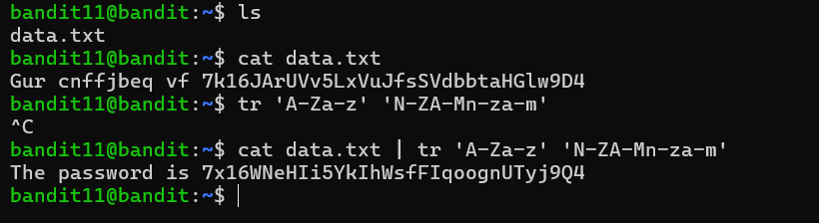

Level: 12 to 13: FO5dwFsc0cbaIiH0h8J2eUks2vdTDwAn

Level: 13 to 14: MU4VWeTyJk8ROof1qqmcBPaLh7lDCPvS

Level: 14 to 15: 8xCjnmgoKbGLhHFAZlGE5Tmu4M2tKJQo

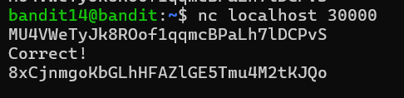

Level: 15 to 16: kSkvUpMQ7lBYyCM4GBPvCvT1BfWRy0Dx

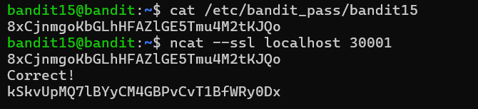

Level:16 to 17: