**VISVESVARAYA TECHNOLOGICAL UNIVERSITY**

**“JnanaSangama”, Belgaum -590014, Karnataka.**



**LAB REPORT**

**on**

Analysis and Design of Algorithms

***Submitted by***

**Aditi Raghunandan (1BM21CS005)**

***in partial fulfillment for the award of the degree of***

**BACHELOR OF ENGINEERING**

***in***

**COMPUTER SCIENCE AND ENGINEERING**



**B.M.S. COLLEGE OF ENGINEERING**

**(Autonomous Institution under VTU)**

**BENGALURU-560019**

**May-2023 to July-2023**

**B. M. S. College of Engineering,**

**Bull Temple Road, Bangalore 560019**

(Affiliated To Visvesvaraya Technological University, Belgaum)

**Department of Computer Science and Engineering**



**CERTIFICATE**

This is to certify that the Lab work entitled “**Analysis and Design of Algorithms**” carried out by **Aditi Raghunandan (1BM21CS005),** who is bonafide student of **B.M.S. College of Engineering.** It is in partial fulfillment for the award of **Bachelor of Engineering in Computer Science and Engineering** of the Visvesvaraya Technological University, Belgaum during the academic semester May-2023 to July-2023. The Lab report has been approved as it satisfies the academic requirements in respect of an **Analysis and Design of Algorithms (22CS4PCADA)** work prescribed for the said degree.

Name of the Lab-In charge: **Sneha S Bagalkot Dr. Jyothi S Nayak**

Assistant Professor Professor and Head

Department of CSE Department of CSE

BMSCE, Bengaluru BMSCE, Bengaluru

**Index Sheet**

|  |  |  |
| --- | --- | --- |
| **Lab Program No.** | **Program Details** | **Page No.** |
| 1 | Write program to do the following:   1. Print all the nodes reachable from a given starting node in a digraph using BFS method. 2. Check whether a given graph is connected or not using DFS method. | 1 |
| 2 | Write program to obtain the Topological ordering of vertices in a given digraph. | 5 |
| 3 | Implement Johnson Trotter algorithm to generate permutations. | 7 |
| 4 | Sort a given set of N integer elements using Merge Sort technique and compute its time taken. Run the program for different values of N and record the time taken to sort. | 12 |
| 5 | Sort a given set of N integer elements using Quick Sort technique and compute its time taken. | 16 |
| 6 | Sort a given set of N integer elements using Heap Sort technique and compute its time taken. | 19 |
| 7 | Implement 0/1 Knapsack problem using dynamic programming. | 24 |
| 8 | Implement All Pair Shortest paths problem using Floyd’s algorithm. | 27 |
| 9 | Find Minimum Cost Spanning Tree of a given undirected graph using Prim’s and Kruskal’s algorithm. | 29 |
| 10 | From a given vertex in a weighted connected graph, find shortest paths to other vertices using Dijkstra’s algorithm. | 36 |
| 11 | Implement “N-Queens Problem” using Backtracking. | 40 |

**Course Outcome**

|  |  |
| --- | --- |
| CO1 | Analyze time complexity of Recursive and Non-recursive algorithms using asymptotic notations. |
| CO2 | Apply various design techniques for the given problem. |
| CO3 | Apply the knowledge of complexity classes P, NP, and NP-Complete and prove certain  problems are NP-Complete |
| CO4 | Design efficient algorithms and conduct practical experiments to solve problems. |

**Write program to do the following:**

* 1. **Print all the nodes reachable from a given starting node in a digraph using BFS method.**

#include<stdio.h>

int n,i,j,visited[10],queue[10],front=0,rear=-1; int adj[10][10];

void bfs(int v)

{

for(i=1;i<=n;i++)

if(adj[v][i] && !visited[i])

queue[++rear]=i; if(front<=rear)

{

}

}

int main()

{

visited[queue[front]]=1; bfs(queue[front++]);

int v;

printf("Enter the number of vertices\n"); scanf("%d",&n);

for(i=1;i<=n;i++)

{

queue[i]=0; visited[i]=0;

}

printf("Enter graph data in the form of adjacency matrix\n"); for(i=1;i<=n;i++)

{

for(j=1;j<=n;j++)

{

scanf("%d",&adj[i][j]);

}

}

printf("\nEnter the starting vertex\n"); scanf("%d",&v);

bfs(v);

printf("The nodes which are reachable are:\n"); for(i=1;i<=n;i++)

{

if(visited[i])

{

}

else

{

}

}

printf("%d\t",i);

printf("node not visited");

return 1;

}

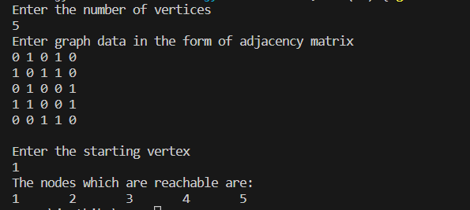**Output:**

**b. Check whether a given graph is connected or not using DFS method.**

#include<stdio.h>

int a[20][20],visited[20],n; void dfs(int v)

{

int i; visited[v]=1; for(i=0;i<n;i++)

{

if(a[v][i] && !visited[i])

{

printf("\n%d->%d",v,i); dfs(i);

}

}

}

int main()

{

int i,j,count=0;

printf("Enter number of vertices "); scanf("%d",&n);

for(i=0;i<n;i++)

{

for(j=0;j<n;j++)

{

visited[i]=0; a[i][j]=0;

}

}

for(i=0;i<n;i++)

{

for(j=0;j<n;j++)

{

scanf("%d",&a[i][j]);

}

}

dfs(0);

for(i=0;i<n;i++)

{

if(visited[i])

count++;

}

if(count==n)

{

printf("\nGraph is connected\n");

}

else

{

printf("Graph is disconnected");

}

return 1;

}

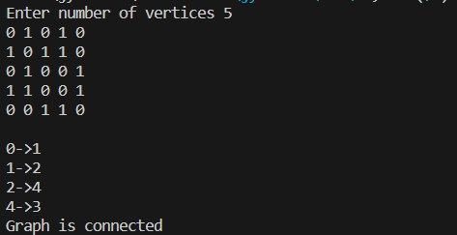**Output:**

**Write a program to obtain the Topological ordering of vertices in a given digraph.**

#include<stdio.h> void dfs(int);

int a[10][10],vis[10],exp[10],n,j,m;

void main()

{

int i,x,y;

printf("enter the number of vertices\n"); scanf("%d",&n);

for(i=1;i<=n;i++)

{

for(j=1;j<=n;j++)

{

a[i][j]=0;

}

vis[j]=0;

}

printf("Enter the number of edges\n"); scanf("%d",&m);

for(i=1;i<=m;i++)

{

printf("Enter an edge\n"); scanf("%d%d",&x,&y);

a[x][y]=1;

}

j=0;

for(i=1;i<=n;i++)

{

if(vis[i]==0)

dfs(i);

}

printf("The topological sort\n"); for(i=n-1;i>=0;i--)

{

printf("%d\t",exp[i]);

}

}

void dfs(int v)

{

int i; vis[v]=1;

for(i=1;i<=n;i++)

{

if(a[v][i]==1 && vis[i]==0)

{

dfs(i);

}

}

exp[j++]=v;

}

**Output:**

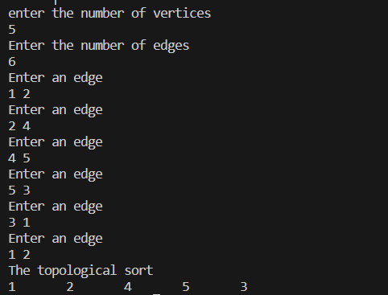

**Implement Johnson Trotter algorithm to generate permutations.**

#include<stdio.h>

#define RIGHT_TO_LEFT 0

#define LEFT_TO_RIGHT 1

int searchArr(int a[],int n,int mobile)

{

int i; for(i=0;i<n;i++)

{

if(a[i]==mobile) return i+1;

}

return -1;

}

int getMobile(int a[],int dir[],int n)

{

int i,mobile_prev=0,mobile=0; for(i=0;i<n;i++)

{

if(dir[a[i]-1]==RIGHT_TO_LEFT && i!=0)

{

if(a[i]>a[i-1] && a[i]>mobile_prev)

{

mobile=a[i]; mobile_prev=mobile;

}

}

if(dir[a[i]-1]==LEFT_TO_RIGHT && i!=n-1)

{

if(a[i]>a[i+1] && a[i]>mobile_prev)

{

mobile=a[i]; mobile_prev=mobile;

}

}

}

return mobile;

}

void swap(int *a,int *b)

{

int temp;

temp=*a;

*a=*b;

*b=temp;

}

void printOnePerm(int a[],int dir[],int n)

{

int i;

int mobile=getMobile(a,dir,n); int pos=searchArr(a,n,mobile);

if(dir[a[pos-1]-1]==RIGHT_TO_LEFT) swap(&a[pos-1],&a[pos-2]);

else if(dir[a[pos-1]-1]==LEFT_TO_RIGHT) swap(&a[pos],&a[pos-1]);

for(i=0;i<n;i++)

{

if(a[i]>mobile)

{

if(dir[a[i]-1]==LEFT_TO_RIGHT) dir[a[i]-1]=RIGHT_TO_LEFT;

else if(dir[a[i]-1]==RIGHT_TO_LEFT) dir[a[i]-1]=LEFT_TO_RIGHT;

}

}

for(i=0;i<n;i++)

{

printf("%d",a[i]);

}

printf(" ");

}

int fact(int n)

{

int i, res=1; for(i=1;i<=n;i++)

res*=i; return res;

}

void printPermutations(int n)

{

int i, a[n]; int dir[n];

for(i=0;i<n;i++)

{

a[i]=i+1;

printf("%d",a[i]);

}

printf("\n"); for(i=0;i<n;i++)

{

dir[i]=RIGHT_TO_LEFT;

}

for(i=1;i<fact(n);i++)

{

printOnePerm(a,dir,n);

}

}

int main()

{

int n;

printf("Enter the number of digits\n"); scanf("%d",&n);

printf("Permutations of the seqeuence :"); printPermutations(n);return 0;

}

**Output:**



**Sort a given set of N integer elements using Merge Sort technique and compute its time taken. Run the program for different values of N and record the time taken to sort.**

#include<stdio.h> #include<time.h> #include<stdlib.h>

void merge(int arr[],int l,int r,int m)

{

int i,j,k;

int n1=m-l+1; int n2=r-m;

int left[n1], right[n2]; for(i=0;i<n1;i++)

{

left[i]=arr[l+i];

}

for(j=0;j<n2;j++)

{

right[j]=arr[m+1+j];

}

i=0; j=0;

k=l;

while(i<n1 && j<n2)

{

if(left[i]<=right[j])

{

arr[k]=left[i]; i++;

}

else

{

arr[k]=right[j]; j++;

}

k++;

}

while(i<n1)

{

arr[k]=left[i]; i++;

k++;

}

while(j<n2)

{

arr[k]=right[j]; j++;

k++;

}

}

void mergesort(int arr[], int l, int r)

{

int mid; if(l<r)

{

mid=l+(r-l)/2; mergesort(arr,l,mid); mergesort(arr,mid+1,r); merge(arr,l,r,mid);

}

}

void print(int arr[],int n)

{

int i; for(i=0;i<n;i++)

{

printf("%d\t",arr[i]);

}

}

void main()

{

int arr[200000],n,i; clock_t st,et;

float ts;

printf("Enter the size of the array\n"); scanf("%d",&n);

for(i=0;i<n;i++)

{

arr[i]=rand();

}

if(n<=20)

{

printf("before sorting \n"); print(arr,n);

}

st=clock(); mergesort(arr,0,n-1);

et=clock();

ts=(float)(et-st)/CLOCKS_PER_SEC; if(n<=20)

{

printf("\nafter sorting using mergesort\n"); print(arr,n);

}

//print(arr,n);

printf("\nTime taken \t %f ",ts);

}

**Output:**

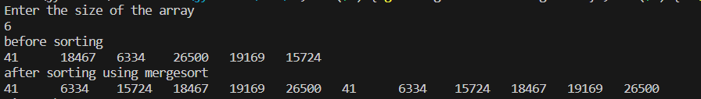

**Table of values:**

|  |  |
| --- | --- |
| Input size(n) | Time taken |
| 10000 | 0.002114 |
| 20000 | 0.00418 |
| 30000 | 0.005486 |
| 40000 | 0.007019 |
| 50000 | 0.00969 |
| 60000 | 0.011191 |
| 70000 | 0.013704 |
| 80000 | 0.014539 |
| 90000 | 0.019828 |
| 100000 | 0.024749 |

**Graph:**



Merge sort

0.03

0.025

0.02

0.015

0.01

0.005

0

0

20000

40000

60000

80000

100000 120000

|  |  |  |  |  |  |
| --- | --- | --- | --- | --- | --- |
|  |  |  |  |  |  |
|  |  |  |  |  |  |
|  |  |  |  |  |  |
|  |  |  |  |  |  |
|  |  |  |  |  |  |
|  |  |  |  |  |  |

**Sort a given set of N integer elements using Quick Sort technique and compute its time taken.**

#include<stdio.h> #include<time.h> #include<stdlib.h>

void swap(int *a,int *b)

{

int temp; temp=*a;

*a=*b;

*b=temp;

}

int partition(int arr[],int l,int r)

{

//ascending order int pivot=arr[r]; int i=l-1,j; for(j=l;j<=r-1;j++)

{

if(arr[j]<pivot)

{

i++;

swap(&arr[i],&arr[j]);

}

}

swap(&arr[i+1],&arr[r]); return (i+1);

}

void quicksort(int arr[],int l,int r)

{

int split; if(l<r)

{

split=partition(arr,l,r); quicksort(arr,l,split-1); quicksort(arr,split+1,r);

}

}

void print(int arr[],int n)

{

int i; for(i=0;i<n;i++)

{

printf("%d\t",arr[i]);

}

}

void main()

{

int arr[200000],n,i; clock_t st,et;

float ts;

printf("Enter the size of the array\n"); scanf("%d",&n);

for(i=0;i<n;i++)

{

arr[i]=rand();

}

if(n<=20)

{

printf("before sorting \n"); print(arr,n);

}

st=clock();

//print(arr,n); quicksort(arr,0,n-1); et=clock();

ts=(float)(et-st)/CLOCKS_PER_SEC; if(n<=20)

{

printf("\nafter sorting using quicksort\n"); print(arr,n);

}

printf("\nTime taken \t %f ",ts);

}

**Output:**

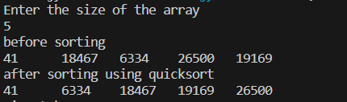

Table of values:

|  |  |
| --- | --- |
| Input size(n) | Time taken |
| 10000 | 0.001908 |
| 20000 | 0.003618 |
| 30000 | 0.004931 |
| 40000 | 0.005698 |
| 50000 | 0.00735 |
| 60000 | 0.008865 |
| 70000 | 0.012559 |
| 80000 | 0.012323 |
| 90000 | 0.013631 |
| 100000 | 0.015273 |

**Graph:**



Quick sort

0.018

0.016

0.014

0.012

0.01

0.008

0.006

0.004

0.002

0

0

20000

40000

60000

80000

100000 120000

|  |  |  |  |  |  |
| --- | --- | --- | --- | --- | --- |
|  |  |  |  |  |  |
|  |  |  |  |  |  |
|  |  |  |  |  |  |
|  |  |  |  |  |  |
|  |  |  |  |  |  |
|  |  |  |  |  |  |
|  |  |  |  |  |  |
|  |  |  |  |  |  |
|  |  |  |  |  |  |

**Sort a given set of N integer elements using Heap Sort technique and compute its time taken.**

#include <stdio.h>

#include <time.h> #include <stdlib.h>

void swap(int *a, int *b) { int temp = *a;

*a = *b;

*b = temp;

}

void heapify(int a[], int n, int i) {

int largest = i, l = 2 * i + 1, r = 2 * i + 2; while (l < n && a[l] > a[largest]) {

largest = l;

}

while (r < n && a[r] > a[largest]) { largest = r;

}

if (largest != i) { swap(&a[i], &a[largest]); heapify(a, n, largest);

}

}

void print(int a[], int n) { int i;

for (i = 0; i < n; i++) { printf("%d\t", a[i]);

}

printf("\n");

}

void heapsort(int a[], int n) { int i;

// Create max heap

for (i = n / 2 - 1; i >= 0; i--) { heapify(a, n, i);

}

// Sort using deletion for (i = n - 1; i >= 0; i--) {

swap(&a[0], &a[i]); heapify(a, i, 0);

}

}

int main() {

int n, i; clock_t st, et; float ts;

printf("Enter the number of elements\n"); scanf("%d", &n);

// Dynamically allocate the array

int *a = (int *)malloc(n * sizeof(int)); if (a == NULL) {

printf("Memory allocation failed.\n"); return 1;

}

// Generate random values and place them in the array for (i = 0; i < n; i++) {

a[i] = rand();

}

st = clock(); heapsort(a, n); et = clock();

ts = (float)(et - st) / CLOCKS_PER_SEC;

if (n <= 20) {

printf("\nAfter sorting elements are\n"); print(a, n);

}

// Free dynamically allocated memory free(a);

printf("\nTime taken: %f seconds\n", ts); return 0;

}

**Output:**

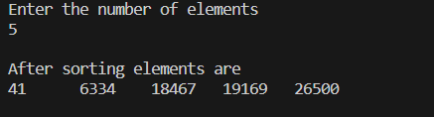

**Table of values:**

|  |  |
| --- | --- |
| Input size(n) | Time taken |
| 10000 | 0.002324 |
| 20000 | 0.004903 |
| 30000 | 0.009185 |
| 40000 | 0.010584 |
| 50000 | 0.017871 |
| 60000 | 0.016515 |
| 70000 | 0.019496 |
| 80000 | 0.022587 |
| 90000 | 0.025799 |
| 100000 | 0.029185 |

**Graph:**



Heap sort

0.035

0.03

0.025

0.02

0.015

0.01

0.005

0

0

20000

40000

60000

Time taken

80000

100000

120000

**Implement 0/1 Knapsack problem using dynamic programming.** #include<stdio.h>

void main()

{

int i,j,w[10],p[10],opt[10][10],x[10],n,m; printf("Enter the number of items\n"); scanf("%d",&n);

printf("enter the weight and profit of each item\n"); for(i=1;i<=n;i++)

{

scanf("%d %d",&w[i],&p[i]);

}

printf("enter the knapsack capacity\n"); scanf("%d",&m);

for(i=0;i<=n;i++)

{

for(j=0;j<=m;j++)

{

if(i==0 || j==0)

{

opt[i][j]=0;

}

else if(j-w[i]<0)

{

opt[i][j]=opt[i-1][j];

}

else

{

opt[i][j]=opt[i-1][j-w[i]]+p[i]>(opt[i-1][j])?opt[i-1][j-w[i]]+p[i]:(opt[i-1][j]);

}

}

}

//output

printf("\nknapsack table\n"); for(i=0;i<=n;i++)

{

for(j=0;j<=m;j++)

{

printf("%d\t",opt[i][j]);

}

printf("\n");

}

for(i=n;i>=1;i--)

{

if(opt[i][m]!=opt[i-1][m])

{

x[i]=1;

m=m-w[i];

}

else

{

x[i]=0;

}

}

printf("\nitems selected are designated 1\n"); for(i=1;i<=n;i++)

{

printf("%d ",x[i]);

}

}

**Output:**

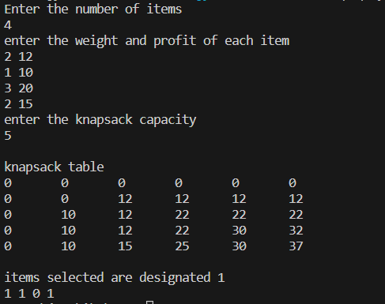

**Implement All Pair Shortest paths problem using Floyd’s algorithm.** #include<stdio.h>

void main()

{

int adj[10][10],n,i,j,k; int result[10][10];

printf("Floyd's algorithm\n"); printf("enter the number of vertices\n"); scanf("%d",&n);

printf("Enter the distance matrix for %d vertices\n",n); for(i=0;i<n;i++)

{

for(j=0;j<n;j++)

{

scanf("%d",&adj[i][j]);

result[i][j]=adj[i][j];

}

}

for(k=0;k<n;k++)

{

for(j=0;j<n;j++)

{

for(i=0;i<n;i++)

{

result[i][j]=result[i][j]<(result[i][k]+result[k][j])?result[i][j]:(result[i][k]+result[k][j]);

}

}

}

printf("\nResult\n"); for(i=0;i<n;i++)

{

for(j=0;j<n;j++)

{

printf("%d\t",result[i][j]);

}

printf("\n");

}

}

**Output:**

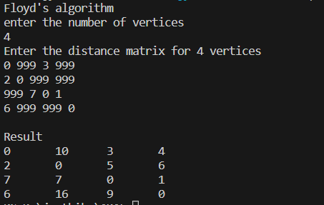

**Find Minimum Cost Spanning Tree of a given undirected graph using Prim’s and Kruskal’s algorithm.**

**Prim’s algorithm:**

#include <stdio.h>

int cost[10][10], vt[10], et[10][10], vis[10], j, n; int sum = 0;

int x = 1; int e = 0;

void prims();

void main()

{

int i;

printf("enter the number of vertices\n"); scanf("%d", &n);

printf("enter the cost adjacency matrix\n"); for (i = 1; i <= n; i++)

{

for (j = 1; j <= n; j++)

{

scanf("%d", &cost[i][j]);

}

vis[i] = 0;

}

prims();

printf("edges of spanning tree\n"); for (i = 1; i <= e; i++)

{

printf("%d,%d\t", et[i][0], et[i][1]);

}

printf("weight=%d\n", sum);

}

void prims()

{

int s, min, m, k, u, v; vt[x] = 1;

vis[x] = 1;

for (s = 1; s < n; s++)

{

j = x;

min = 999; while (j > 0)

{

k = vt[j];

for (m = 2; m <= n; m++)

{

if (vis[m] == 0)

{

if (cost[k][m] < min)

{

min = cost[k][m]; u = k;

v = m;

}

}

}

j--;

}

vt[++x] = v; et[s][0] = u;

et[s][1] = v; e++;

vis[v] = 1;

sum = sum + min;

}

}

**Output:**

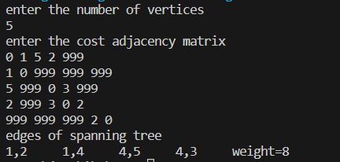

**Kruskal’s algorithm:**

#include <stdio.h>

int find(int v, int parent[10])

{

while (parent[v] != v)

{

v = parent[v];

}

return v;

}

void union1(int i, int j, int parent[10])

{

if (i < j) parent[j] = i;

else

parent[i] = j;

}

void kruskal(int n, int a[10][10])

{

int count, k, min, sum, i, j, t[10][10], u, v, parent[10]; count = 0;

k = 0;

sum = 0;

for (i = 0; i < n; i++) parent[i] = i;

while (count != n - 1)

{

min = 999;

for (i = 0; i < n; i++)

{

for (j = 0; j < n; j++)

{

if (a[i][j] < min && a[i][j] != 0)

{

min = a[i][j]; u = i;

v = j;

}

}

}

i = find(u, parent); j = find(v, parent); if (i != j)

{

union1(i, j, parent); t[k][0] = u;

t[k][1] = v; k++;

count++;

sum = sum + a[u][v];

}

a[u][v] = a[v][u] = 999;

}

if (count == n - 1)

{

printf("spanning tree\n"); for (i = 0; i < n - 1; i++)

{

printf("%d %d\n", t[i][0], t[i][1]);

}

printf("cost of spanning tree=%d\n", sum);

}

else

printf("spanning tree does not exist\n");

}

void main()

{

int n, i, j, a[10][10];

printf("enter the number of nodes\n"); scanf("%d", &n);

printf("enter the adjacency matrix\n"); for (i = 0; i < n; i++)

for (j = 0; j < n; j++) scanf("%d", &a[i][j]);

kruskal(n, a);

}

Output:

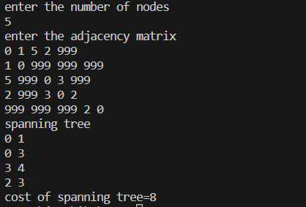

**From a given vertex in a weighted connected graph, find shortest paths to other vertices using Dijkstra’s algorithm.**

#include <stdio.h> #define INFINITY 9999

#define MAX 10

void dijkstra(int G[MAX][MAX], int n, int startnode); int main()

{

int G[MAX][MAX], i, j, n, u; printf("Enter no. of vertices:"); scanf("%d", &n);

printf("\nEnter the adjacency matrix:\n"); for (i = 0; i < n; i++)

for (j = 0; j < n; j++) scanf("%d", &G[i][j]);

printf("\nEnter the starting node:"); scanf("%d", &u);

dijkstra(G, n, u); return 0;

}

void dijkstra(int G[MAX][MAX], int n, int startnode)

{

int cost[MAX][MAX], distance[MAX], pred[MAX]; int visited[MAX], count, mindistance, nextnode, i, j;

for (i = 0; i < n; i++) for (j = 0; j < n; j++)

if (G[i][j] == 0) cost[i][j] = INFINITY;

else

cost[i][j] = G[i][j];

for (i = 0; i < n; i++)

{

distance[i] = cost[startnode][i]; pred[i] = startnode;

visited[i] = 0;

}

distance[startnode] = 0;

visited[startnode] = 1;

count = 1;

while (count < n - 1)

{

mindistance = INFINITY;

for (i = 0; i < n; i++)

if (distance[i] < mindistance && !visited[i])

{

mindistance = distance[i]; nextnode = i;

}

visited[nextnode] = 1; for (i = 0; i < n; i++)

if (!visited[i])

if (mindistance + cost[nextnode][i] < distance[i])

{

distance[i] = mindistance + cost[nextnode][i]; pred[i] = nextnode;

}

count++;

}

for (i = 0; i < n; i++) if (i != startnode)

{

printf("\nDistance of node%d = %d", i, distance[i]); printf("\nPath = %d", i);

j = i; do

{

j = pred[j]; printf("<-%d", j);

} while (j != startnode);

}

}

**Output:**

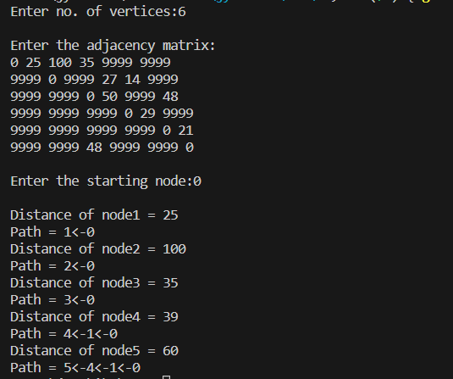

**Implement “N-Queens Problem” using Backtracking.** #include <stdio.h>

#include <math.h> int board[20], count; int main()

{

int n, i, j;

void queen(int row, int n);

printf(" - N Queens Problem Using Backtracking -"); printf("\n\nEnter number of Queens:"); scanf("%d", &n);

queen(1, n); return 0;

}

// function for printing the solution void print(int n)

{

int i, j;

printf("\n\nSolution %d:\n\n", ++count);

for (i = 1; i <= n; ++i) printf("\t%d", i);

for (i = 1; i <= n; ++i)

{

printf("\n\n%d", i);

for (j = 1; j <= n; ++j) // for nxn board

{

if (board[i] == j)

printf("\tQ"); // queen at i,j position else

printf("\t-"); // empty slot

}

}

}

/*funtion to check conflicts

If no conflict for desired postion returns 1 otherwise returns 0*/ int place(int row, int column)

{

int i;

for (i = 1; i <= row - 1; ++i)

{

// checking column and digonal conflicts if (board[i] == column)

return 0;

else if (abs(board[i] - column) == abs(i - row)) return 0;

}

return 1; // no conflicts

}

// function to check for proper positioning of queen void queen(int row, int n)

{

int column;

for (column = 1; column <= n; ++column)

{

if (place(row, column))

{

board[row] = column; // no conflicts so place queen if (row == n) // dead end

print(n); // printing the board configuration else // try queen with next position queen(row + 1, n);

}

}

}

**Output:**

