Light of the World × B2M
Limited edition character goods: an idea to consider together
Proposal for discussion | Limited Edition | Draft | October 2026 | Prepared by Johan
1. Why we are sharing this idea
We are two groups with different gifts and a shared heart. The film maker tells a story that can open people's hearts. The Malaysian business owners know manufacturing and distribution, and they already use their businesses to bless churches and Christians. We would like to suggest a simple idea and hear what you think: could a limited edition collection of everyday goods carrying the film's artwork help the story travel further, reach people who may never enter a cinema, and generate resources to serve churches and the next generation?
2. Concept mockups
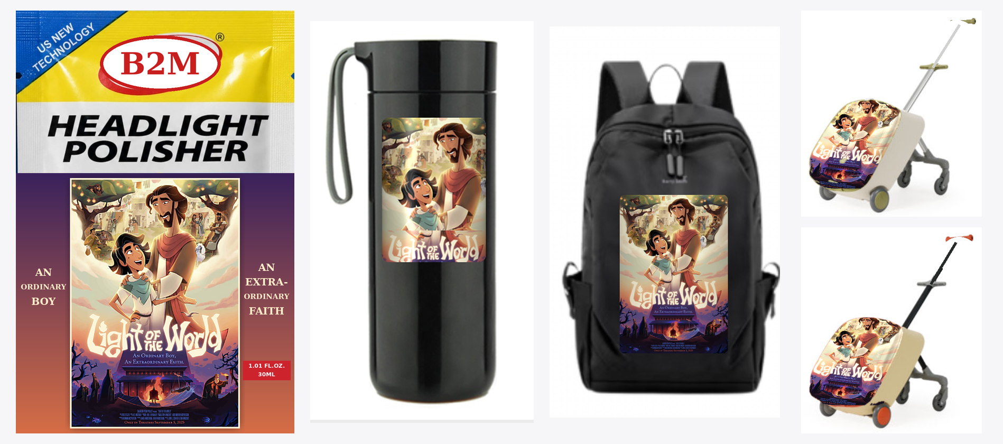
Limited edition mockups, for discussion only. The film poster is used as a placeholder, and base product designs and brand marks will change.
Product | Everyday use | Why it could fit
Headlight polisher (30 ml sachet) | Restores a clear, bright headlight | Echoes the film's theme of light; low cost and easy to give away at screenings and church events.
Vacuum tumbler | Carried and used every day | Keeps the story visible daily; works as a gift or a fan item.
Backpack | School, youth groups, travel | Lets young people carry the story with them.
Kids ride-on suitcase (two colors) | Family travel | Appeals to families and children, the natural audience of an animated film.
3. Why a limited edition
- One-time run: a fixed quantity per item (for example 500–1,000 pieces, to be agreed), with no reprints once the run is complete.
- Collectible: each piece individually numbered (for example 001/500) and packaged with a short message card.
- Tied to the film: released around the film's launch or special screenings, with pre-orders used to size production and limit inventory risk.
4. How it could work (for discussion)
- Film side: grant permission to use selected artwork, provide high-resolution files, and approve each design.
- Malaysian business owners: explore sourcing and manufacturing, prepare samples, and open sales channels.
- B2M: help both sides coordinate, and design how part of the proceeds could support churches and scholarships.
5. Possible next steps (low commitment)
- This Thursday: share the idea, listen to the film maker's thoughts, and learn what is and is not possible.
- If there is interest: discuss licensing terms and request high-resolution artwork and supplier quotes.
- Then: make a few samples and try a small pilot at church or film events before deciding on anything larger.
6. Points to confirm
- Scope, term, territory and royalty terms for using the film artwork (a written agreement with the rights holder is required).
- Use of brands and designs on the base products, plus safety, labeling and import rules by country.
- Local regulations in Malaysia on selling goods connected to film content.
We would be grateful for your thoughts and look forward to praying and exploring this together.

