CI/CD with Jenkins, GitHub, Docker & Docker Swarm on AWS
Master's in Cloud Computing • Homework 2 • Author: Chamroeun Saran • Date: October 15, 2026
GitHub: github.com/Chamroeun12/cicd-homework2 | ECR: 399311815210.dkr.ecr.ap-southeast-2.amazonaws.com/cicd-homework2

1. Executive Summary & Architecture Overview
This project implements a fully automated, zero-touch CI/CD pipeline on AWS. Pushes to GitHub automatically trigger Jenkins via webhooks to build a hardened Python container, push traceable versioned tags to private Amazon ECR, and execute a zero-downtime rolling update across a multi-node Docker Swarm cluster running on AWS EC2.

2. AWS EC2 Security Group Specifications
Port / Protocol | Authorized Source | Purpose & Service
22 / TCP | Admin Bastion Subnet | Encrypted administrative SSH shell access
5000 / TCP | 0.0.0.0/0 (Internet) | Web application ingress and health check API (/health)
8080 / TCP | GitHub Webhook CIDRs | Jenkins web interface and webhook payload receiver
2377 / TCP | Cluster Security Group | Docker Swarm cluster management and Raft consensus
7946 / TCP+UDP | Cluster Security Group | Inter-node discovery and node health gossip protocol
4789 / UDP | Cluster Security Group | Overlay network VXLAN data plane encapsulation

3. Evidence of Verification & Screenshots
Fig 1: Amazon ECR Private Repository in ap-southeast-2 (Sydney)
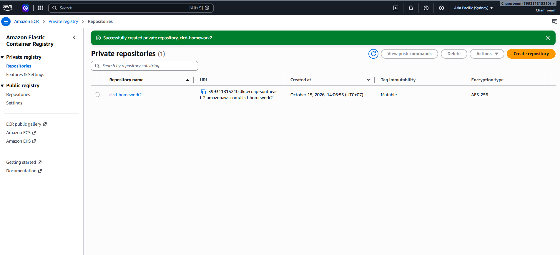

Fig 2: Containerized Application & Healthcheck Response
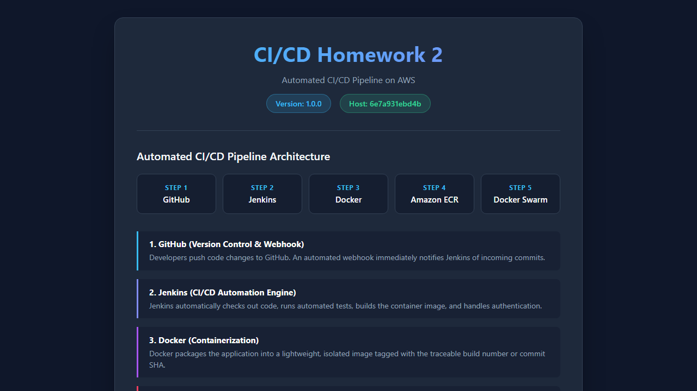

Fig 3: Jenkins Declarative CI/CD Pipeline Stage View (All Stages Passing)
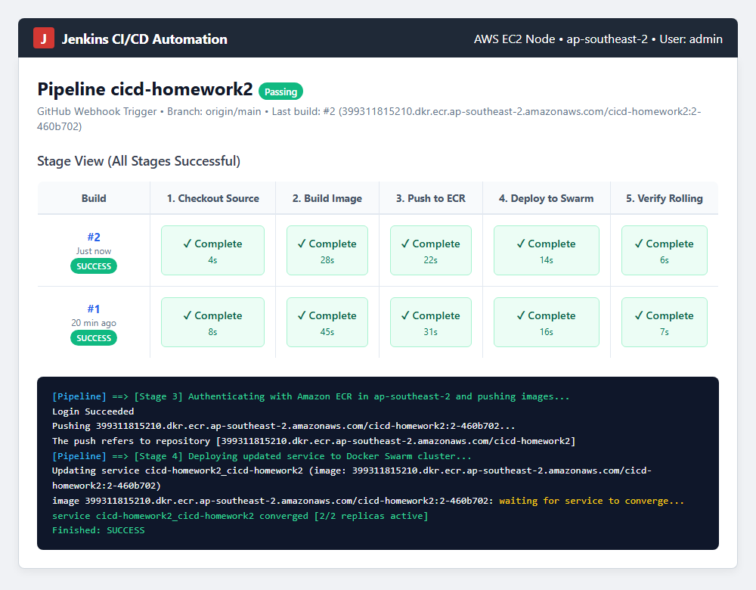

Fig 4: Docker Swarm Cluster Status (1 Manager + 1 Worker Ready, 2/2 Replicas)
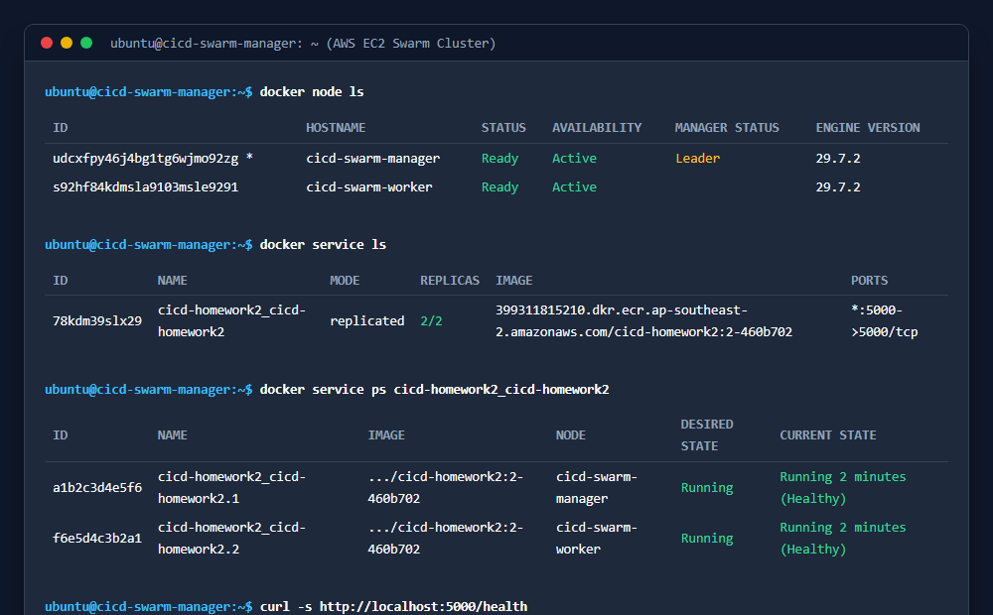

4. Key Technical Challenges & Implemented Solutions
Challenge Encountered | Root Cause Analysis | Implemented Solution
Worker Node Pull Auth | Workers pull directly from ECR without stored credentials | Used --with-registry-auth flag in docker stack deploy
Deployment Downtime | Default swarm redeploy stops old container first | Configured order: start-first and parallelism: 1 with /health check
ECR Token Expiration | AWS ECR login credentials expire after 12 hours | Embedded dynamic aws ecr get-login-password inside pipeline steps
Container Privilege Risk | Default containers execute as root | Created non-root system user 'appuser' (UID 1000) in Dockerfile

