**Role based User Management System:**

This web designed to give interface for role-based management system in web UI.

This is Homepage for this project:

It contains below:

* Users
* Roles
* Permissions

Select **“Users”**:

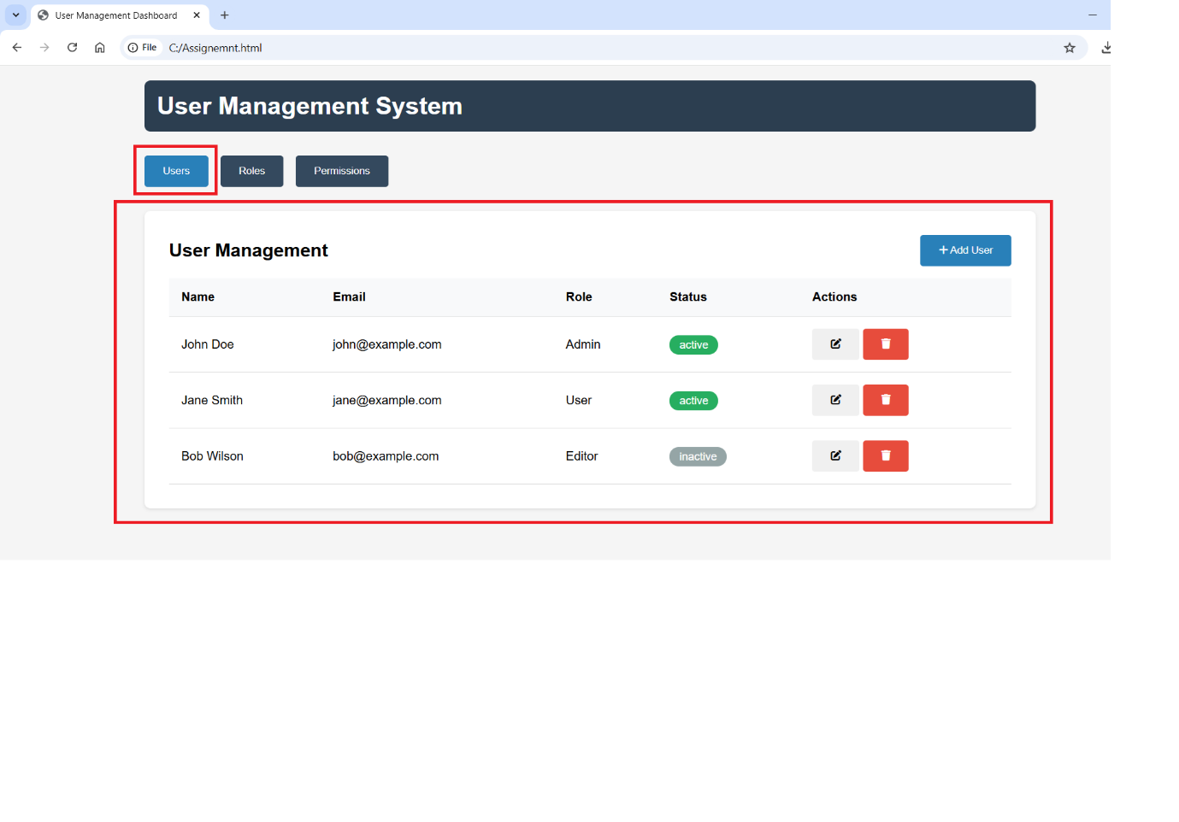

* It’s will display all users info on web home.
* Users info contains: Name, Email ID, Role, Status and also delete and edit button for respective user.

Select **“Roles”**:

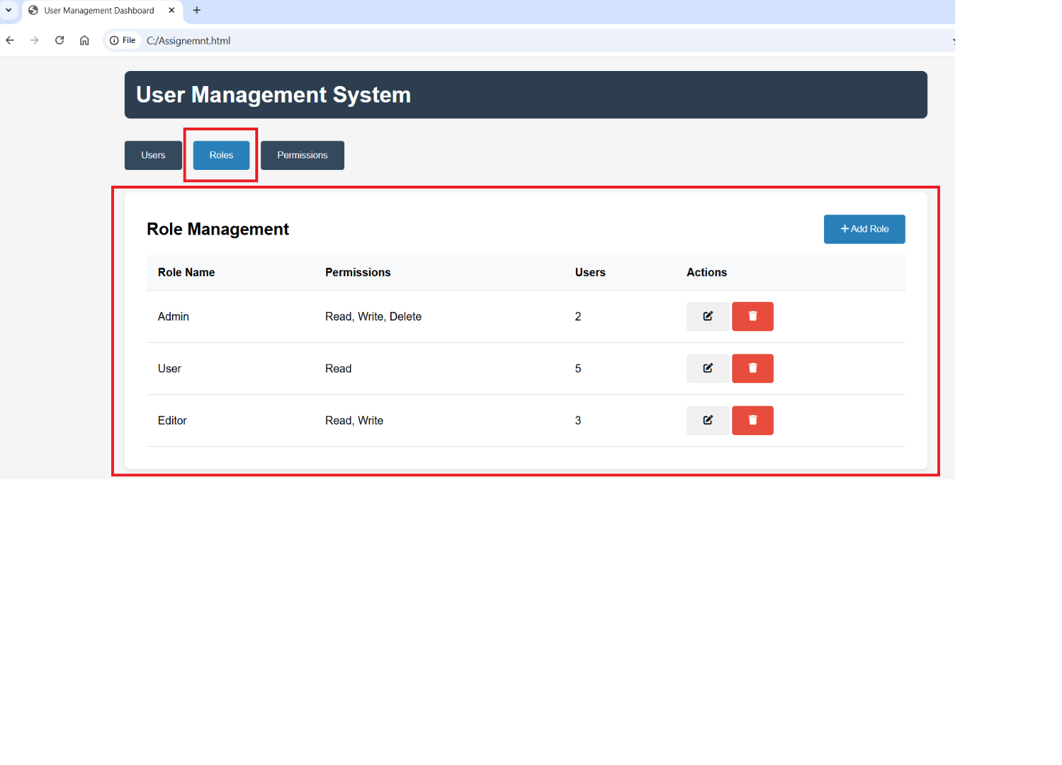

* This home page contains: Role name, types of permission, Users, Action button (Edit or delete the permissions)
* Role name: It’s indicating name of user role (like: Admin, User, Edit)
* Roles management Permission have different type like below:

Read, Write, Delete

Read, Write

Read, Delete

Read

* + At list one permission type we need select while creating the Role.
* Users: It will be showing user’s count of respective roles.
* Action Botton: it’s use change the permission of any role at any time.
* Note: If you want to delete any user role, Users count should be zero else it will through an error like **“cannot delete role with assigned users”.**

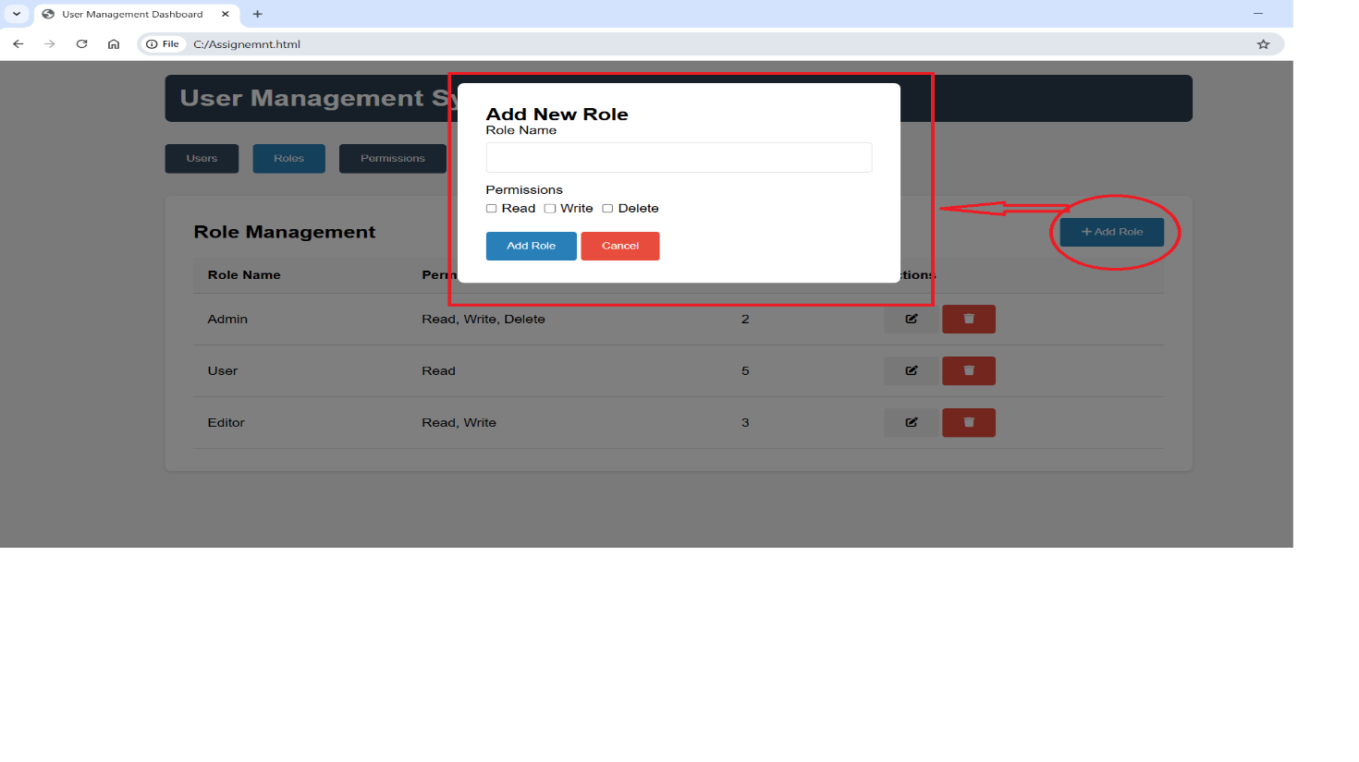

* **Add new Role**:

If you want to add any New role user. Then, click on “Add Role “ :

* Enter name of “role name “. It is mandatory filed.
* Empty “Role name” not allowed to create “Add Role” and display message like snapshot.

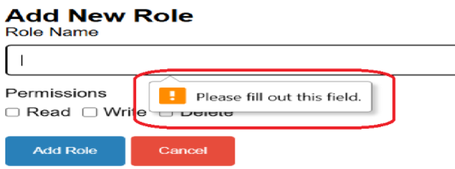

* Select the Permission based on role.
* Click on “Add Role” for create new User role

Example:

Select **“Permissions “**:

-> This Session details with types of Permissions, related Description, assigned to user-based roles.

-> Permissions have 3 types:

Read: This possible only for view, these permissions can be assigned for all users

Write: User can be possible to create and edit using this permission, these permissions can

assigned only for Admin and editor roles.

Delete: This option use to delete the any user from web site. Admin role only have

permission to access this permission.

* **Adding new user:**

* If admin want to create new user, click on new “Add User”.
* Add new user popup display web page. Waiting for user entry.
* Admins need to entry details of: Name, Email.
* Role, Status need to select from drop down.
* All fields are compulsory to update. if not fill, not allow to create new user and notify like **“Please fill out this field”**

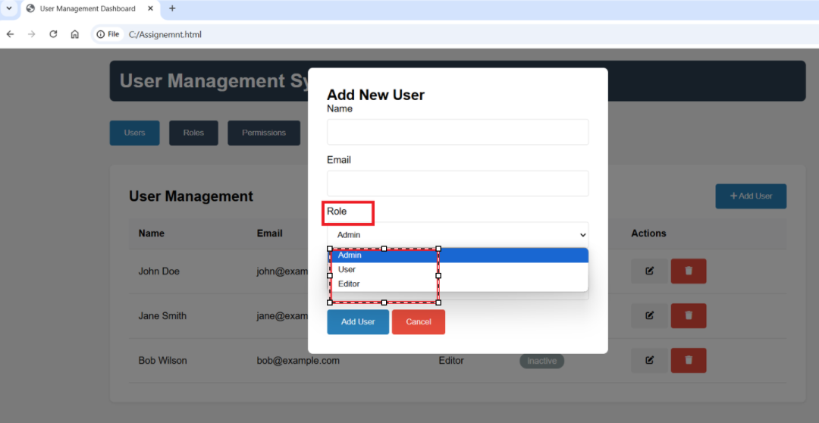

* While create new user, admin can assign 3 types of roles based on user position.
* **Status:**

Status: This tells the user status is “Active” or “In- Active”.

* Click on “Add User”, it will update details in the web site and also, It will display the user info under “User Management” tab.

Example:

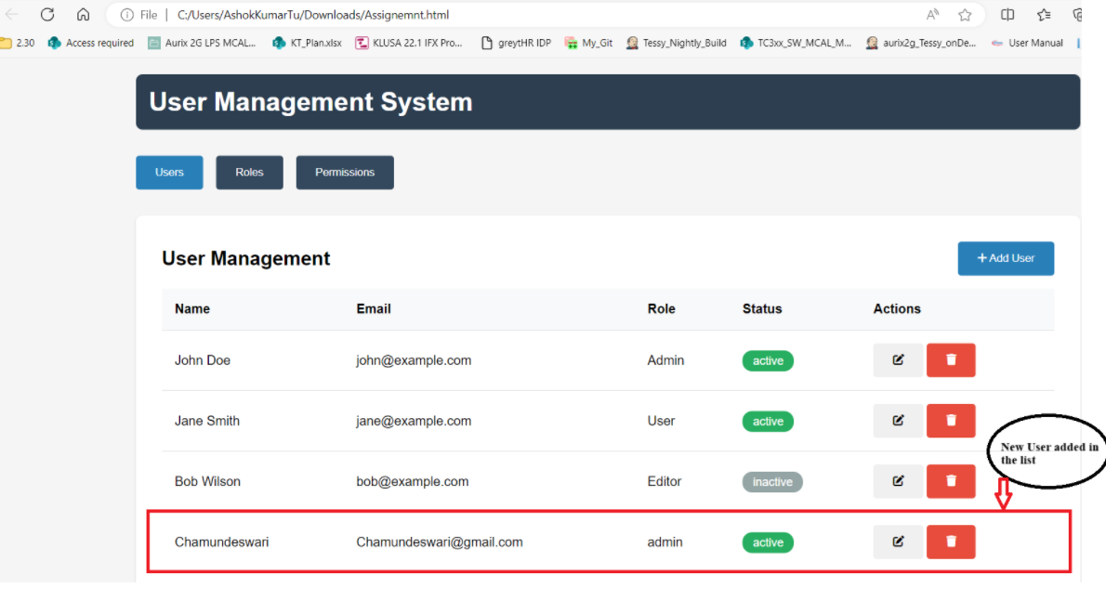

**Construction info:**

* For build this project I have used: Html, CSS, Java script

1. **Html**: HTML code has been used is used to create and structure the web page. The HTML script has been further used to create different sections for Users, Roles and Permissions. Also, to create buttons to add new users and capture their information. It also displays the information captured of each user in the Users section.
2. **Java Script:** Javascript has been used to create the functions for the following purposes:
   1. updateUsersTable(); -> To add new users or to edit existing users.
   2. updateRolesTable(); -> To add new users or to edit existing roles.
   3. updatePermissionsTable(); -> To add new users or to edit existing permissions..
   4. switchTab(); -> To switch the tabs between users, roles and permissions.
   5. showModal(); -> To show the modal categorizing them as per their Id.
   6. hideModal(); -> To hide the modal categorizing them as per their Id.
   7. showNotification(); -> To show notification as “success” on successfully creating a new user.
   8. editUser(); -> To edit an existing user based on their user Id.
   9. deleteUser(); -> To delete an existing user
   10. editRole(); -> To edit an exiting role
   11. deleteRole(); -> To delete an existing role
3. **CSS:** The CSS code is used to styling purpose of web site page to make the page more user-friendly. Herein, we have used CSS to give different colors and distinguish between active and inactive users, to create different action buttons to edit and delete existing users, to provide color and design to the user, role and permission table.

****** Thank you ******

Name : T Chamundeswari

Email id : ychamu2627@gmail.com