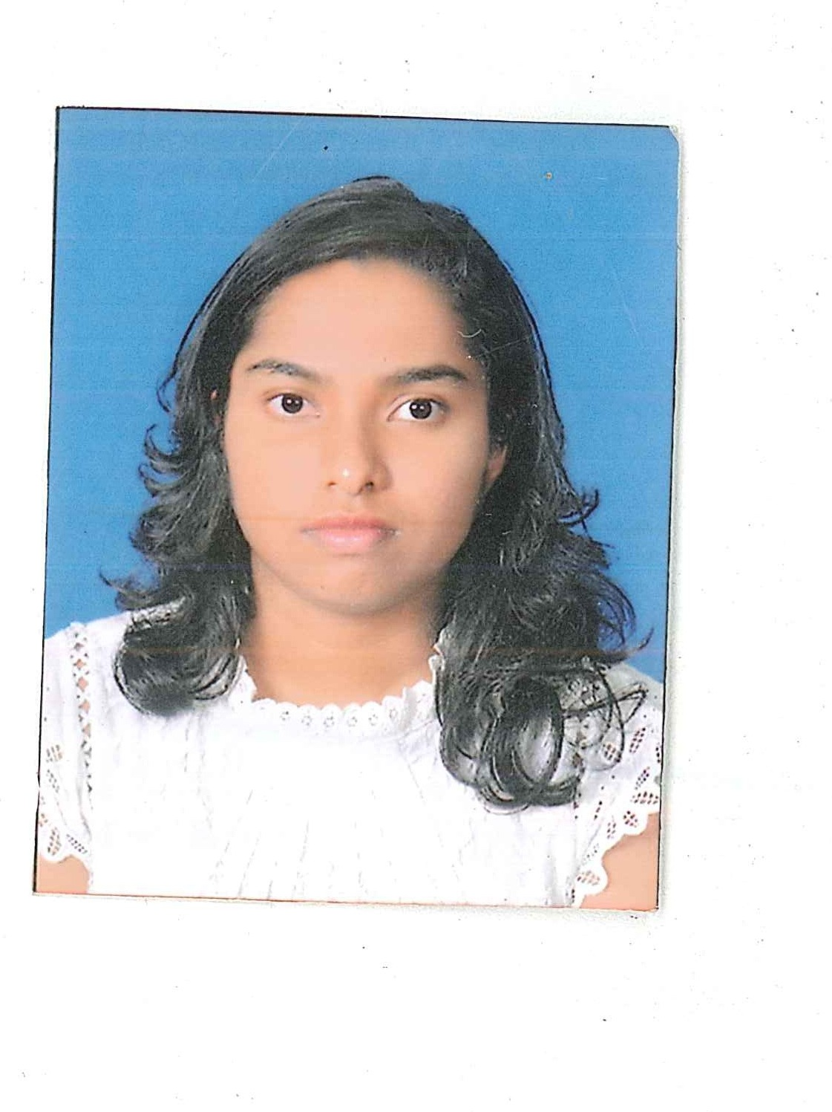

K.L.K.U.Dhananjani Jayasena

**G.C.E. Ordinary Level (**St. Joseph’s Balika Maha Vidyalaya**)**

Mathematics – A

English – A

Information Communication and Technology _ A

Science _ A

HTML/JavaScript/PHP

Python

C++

C



Temple Road, Marapena,

Kegalle.



(+94) 71 998 3 456

(+94) 35 222 3 456



[upsalajayasena@gmail.com](mailto:upsalajayasena@gmail.com)

Leadership

Member of Western Brass Band – St. Joseph’s Balika Maha Vidyalaya

Junior prefect – St. Joseph’s Balika Maha Vidyalaya - Kegalle

Good team working skills

Other

Languages

**G.C.E. Advanced Level (**St. Joseph’s Balika Maha Vidyalaya**)**

Chemistry – C

Physics – S

Combined Mathematics – S

Z-Score: 0.6868

**B.Sc. Special (Hons) in Information Technology** (Specialization-Information Technology)

CGPA: 3.29 (Up to 2nd year 2nd semester)

**Key Skills & Competencies**

I am a determined, enthusiastic, hardworking information technology undergraduate at Sri Lanka Institute of Information Technology, a good communicator with proven inter personal skills and ability to work in a team whilst being capable of using my own initiative.

Having developed good planning and organizational skills, being enthusiastic to learn and undertake new challenges, I seek employment that will make best use of my skills for the betterment of your company.

**Dec 2012**

**Aug 2016**

Engaged in sports activities (basketball and Athletics)

Java

**Internship**

**Education**

**Expected Graduation-Feb 2021**

**OOP**

Feb 2018 – Jun 2018

Employee Management System as a SLIIT assignment. (Web Application)

Technologies used

Java

MySQL

JavaScript

HTML

**Mobile Application**

**Development**

Jul 2018 – Oct 2018

Online Music Application as a SLIIT assignment.

(Mobile Application)

Technologies used

Java

SQLite

**ITP**

Jul 2018 – Oct 2018

Point of Sales System as a SLIIT assignment.

(Desktop Application)

Technologies used

Java

MySQL

iReports

Jul 2018 – Oct 2018

Online bookstore system as a SLIIT assignment.

(Web Application)

Technologies used

PHP

HTML

JavaScript

CSS

**IWT**

Jul 2017 – Nov 2017

I do hereby certify that above particular are true and correct to the best of my knowledge.

Dhananjani Jayasena

18.12.2018

**References**

**Mr.Gihan Kuruppu**

B.Sc., PhD (Reading)

SCJP, SCMAD, SCWCD, MBCS

Academic & Student’s Affairs Manager, Sri Lanka Institute of Information Technology,

Kandy Center.

Mobile: +94 71 323 9 517

E-mail:gihansoft@gmail.com

**Mrs.R.P.A.M.Rajapaksha**

Principle,

Rahala Nagenahira Primary school.

Mobile: +94 71 385 4 649

**Projects**