

|  |
| --- |
| Close-up image showing the leaf-sides of two oversized books side-by-side on a bookshelf, with additional books in soft focus background |
| Proposal  User-Centric Blogging Platform with Advanced Article Management |
| |  |  |  | | --- | --- | --- | | Chamuditha Dhanaranjana | 8/16/2023 | Internship | |

Table of Contents

**Executive Summary:** 1

**Key Features:** 1

**Feature Enhancement: User Contributions and Article Tagging:** 2

**Technical Implementation:** 3

**Conclusion:** 3

**Use-Case Diagram** 4

**Sequence Diagram** 5

**State transition diagram** 6

**Class diagram** 7

**ER diagram** 8

**Gantt chart** 9

# **Executive Summary:**

We propose the creation of an innovative blogging platform that delivers a robust and tailored experience for guest users, registered users, and administrators. This platform will facilitate guest users' access to all articles, empower registered users to manage their own articles effectively, and grant administrators fine-grained control over users and articles, including restrictions. By combining advanced user roles, article management, and administrator controls, this platform will fulfill a wide range of needs and aspirations.

# **Key Features:**

**User Registration and Authentication**:

* Implement a secure and streamlined user registration process via email or social media credentials.

**Role-Based Features:**

**Admin:**

* Exercise comprehensive control by viewing and managing articles platform-wide.
* Administer restrictions and unrestricting on specific articles for designated users.
* Manage user accounts with the authority to restrict or unrestricted users.

**User:**

* Cultivate personal expression by creating, editing, viewing, and deleting self-authored blog articles.
* Embrace a "Draft Save" feature that safeguards works in progress before publication.
* Explore a wealth of knowledge by viewing all articles available on the platform.

**Guest:**

* Access the treasure trove of content by viewing all published articles.
* Discover the benefits of enhanced engagement by creating a guest account.
* Advanced Article Management: Employ a sophisticated rich text editor to streamline article creation and editing.
* Organize content intuitively through categorization and tagging options.
* Enable authors to safeguard their creative process with the "Draft Save" feature.
* Empower users to publish or update their articles at their convenience.

**Administrator Control:**

* Deliver a comprehensive dashboard tailored for administrators to manage users and articles with precision.
* Grant administrators the authority to restrict or unrestricted certain articles for designated users.
* Ensure effective governance by enabling administrators to control the restriction or unrestricting of user accounts.

**Restriction Mechanism:**

* Implement an automatic restriction feature: if a user accumulates five or more articles marked as "RESTRICTED" by administrators, the system will automatically restrict that user's access.

**Guest Account Creation:**

* Extend the platform's capabilities by allowing guest users to create accounts, granting them enhanced functionality while retaining the ability to access all articles.

# **Feature Enhancement: User Contributions and Article Tagging:**

**Registered Users:**

* Whenever a registered user's article receives a new comment, an automated email notification will be sent to the article's author.
* The email notification will include the commenter's name, the article's title, and the comment text.
* Registered users will have the option to enable or disable these email notifications in their account settings.

**Registered User Contributions:**

* Allow registered users to submit contributions (e.g., edits, additions) to articles authored by others.
* Contributions can be in the form of text, images, or media, depending on the article's content type.

**Author Permissions:**

* Implement a permission system that enables authors to grant or deny permission for others to contribute to their articles.
* Authors can choose to allow contributions from specific users or open contributions to all registered users.

**Article Tagging:**

* Enable authors to tag contributions with a label indicating that they are contributions to the article.
* Display clear attribution for contributions, showing the contributor's name and the nature of the contribution.

# **Technical Implementation:**

**Backend**: Utilize a robust backend framework (Spring-Boot) to manage user authentication, article storage, and interactions.

**Frontend**: Develop an intuitive and responsive frontend using modern technologies like Angular.js. Implement a user-friendly interface for article creation, editing, and management.

**Database**: Utilize a scalable database solution (Mongo dB) to efficiently store user data, articles, and comments.

**Security**: Implement proper security measures, including data encryption, secure authentication, and protection against common vulnerabilities.

**Hosting and Deployment**: Choose a reliable hosting platform and deploy the application using best practices to ensure stability and performance.

# **Conclusion:**

The envisioned blogging platform aims to foster inclusivity and versatility, catering to the diverse needs of users with distinct roles. By amalgamating advanced article management, role-based functionalities, and meticulous administrator controls, this platform aspires to emerge as a vibrant hub for content creators, avid readers, and administrators seeking a sophisticated and holistic blogging ecosystem.

# **Use-Case Diagram**

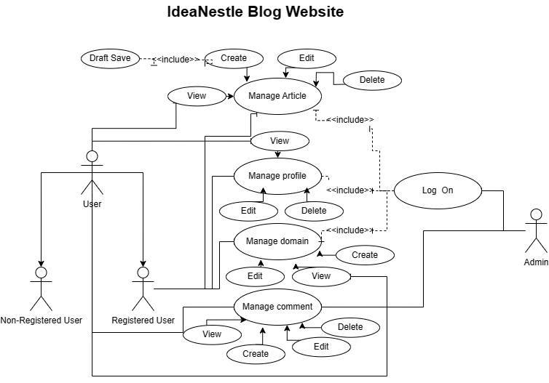

# **Sequence Diagram**

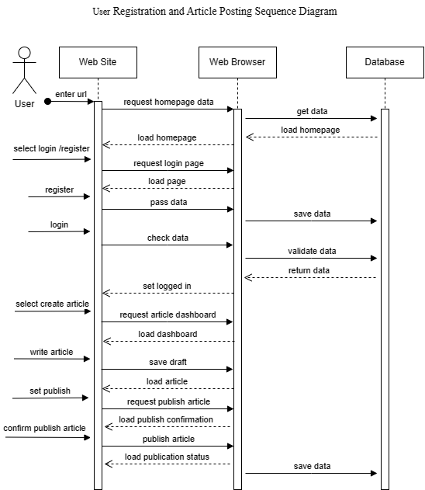

# **State transition diagram**

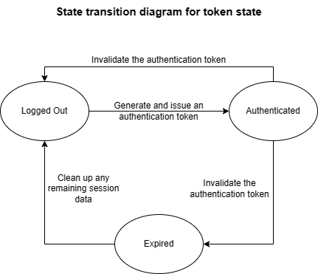

# **Class diagram**

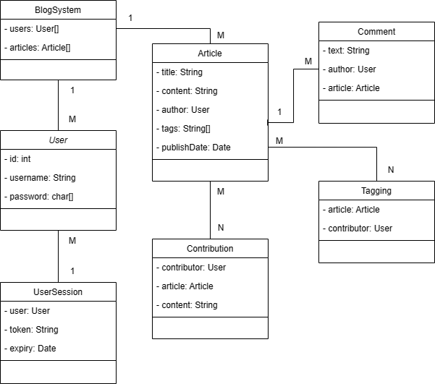

# **ER diagram**

# **Gantt chart**

|  |  |  |  |
| --- | --- | --- | --- |
| Task | Start Date | End Date | Duration |
| Proposal Preparation | 2023-08-16 | 2023-08-18 | 3 days |
| Research and Planning | 2023-08-19 | 2023-08-20 | 2 days |
| Design and Wire framing | 2023-08-21 | 2023-08-24 | 4 days |
| Backend Development | 2023-08-25 | 2023-08-30 | 6 days |
| Frontend Development | 2023-08-31 | 2023-09-04 | 5 days |
| Testing and Bug Fixes | 2023-09-05 | 2023-09-08 | 4 days |
| Documentation and Training | 2023-09-09 | 2023-09-11 | 3 days |
| Final Review and Approval | 2023-09-12 | 2023-09-14 | 3 days |
| Deployment and Launch | 2023-09-15 | 2023-09-16 | 2 days |