**BARANGAY CLEARANCE**

To whom it may concern:

This is to certify that john erickson r. sulit of legal age, a resident of Buklod Diwa (Relocation 1), Barangay Pulong Sta. Cruz, City of Santa Rosa, Laguna is known to me of good moral character and reputation and has “No Derogatory/Criminal Records” within this office as of this date.

This certification is being issued upon request of the above named for his/her loan application purposes.

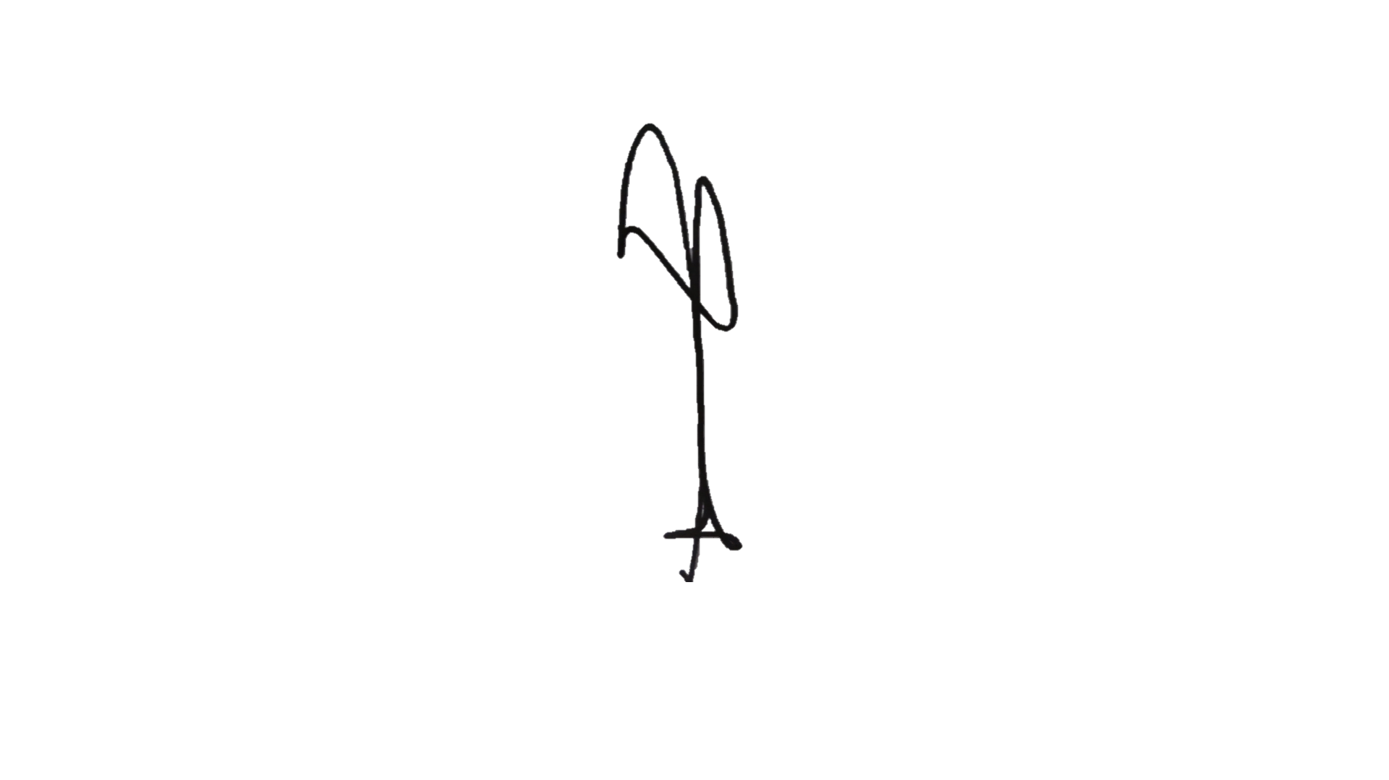Issued this 19th day of December 2023 at the Office of Punong Barangay, Brgy. Pulong Sta. Cruz, City of Santa Rosa, Laguna.

Hon. Christopher S. Sarmiento

Punong Barangay

LEFT

RIGHT

NOT VALID WITHOUT BARANGAY

OFFICIAL SEAL

john erickson r. sulit

Print Name and Signature

*This clearance is valid only for ninety (90) days upon date of issuance.*