**Development Part 2**

|  |  |
| --- | --- |
| **Date** | **27-10-2023** |
| **Team ID** | **3869** |
| **Project Name** | **Future Sales Prediction** |

**Table of Contents**

|  |  |
| --- | --- |
| 1 | Load Data |
| 2 | Data Preprocessing |
| 3 | Data Normalization |
| 4 | Modelling And Evaluation |
| 4.1 | Linear Regression |
| 4.2 | Ridge Regression |
| 4.3 | Lasso Regression |
| 4.4 | Decision Tree |

# Load Data

import pandas as pd  
  
df = pd.read_csv(r"C:\Users\thamb\Downloads\archive (1)\Sales.csv")  
df.head()

TV Radio Newspaper Sales  
0 230.1 37.8 69.2 22.1  
1 44.5 39.3 45.1 10.4  
2 17.2 45.9 69.3 12.0  
3 151.5 41.3 58.5 16.5  
4 180.8 10.8 58.4 17.9

Features explanation:

* **TV**: this feature represents the amount of advertising budget spent on television media for a product or service in a certain period, for example in thousands of dollars (USD).
* **Radio**: this feature represents the amount of advertising budget spent on radio media in the same period as TV.
* **Newspaper**: this feature represents the amount of advertising budget spent in newspapers or print media in the same period as TV and Radio.
* **Sales**: This feature represents product or service sales data in the same period as advertising expenditure on TV, Radio and Newspaper.

df.shape

(200, 4)

df.info()

<class 'pandas.core.frame.DataFrame'>  
RangeIndex: 200 entries, 0 to 199  
Data columns (total 4 columns):  
 # Column Non-Null Count Dtype   
--- ------ -------------- -----   
 0 TV 200 non-null float64  
 1 Radio 200 non-null float64  
 2 Newspaper 200 non-null float64  
 3 Sales 200 non-null float64  
dtypes: float64(4)  
memory usage: 6.4 KB

df.describe().T

count mean std min 25% 50% 75% max  
TV 200.0 147.0425 85.854236 0.7 74.375 149.75 218.825 296.4  
Radio 200.0 23.2640 14.846809 0.0 9.975 22.90 36.525 49.6  
Newspaper 200.0 30.5540 21.778621 0.3 12.750 25.75 45.100 114.0  
Sales 200.0 15.1305 5.283892 1.6 11.000 16.00 19.050 27.0

# Calculate the correlation  
correlation = df.corr()  
sales_correlation = correlation["Sales"].sort_values(ascending=False)  
  
# Format and style the correlation values  
styled_sales_correlation = sales_correlation.apply(lambda x: f'{x:.2f}')  
styled_sales_correlation = styled_sales_correlation.reset_index()  
styled_sales_correlation.columns = ["Feature", "Correlation with Sales"]  
styled_sales_correlation.style.background_gradient(cmap='coolwarm', axis=0)

<pandas.io.formats.style.Styler at 0x23785318950>

# Data Preprocessing

#### Outlier detection

import seaborn as sns  
import matplotlib.pyplot as plt  
  
# Create the box plot  
plt.figure(figsize=(8, 6))  
sns.boxplot(x='TV', data=df, palette='Blues')  
plt.title('Box Plot of TV Advertising')  
plt.xlabel('TV Advertising Spending')  
plt.grid(axis='x', linestyle='--', alpha=0.6)  
  
# Show the plot  
plt.show()

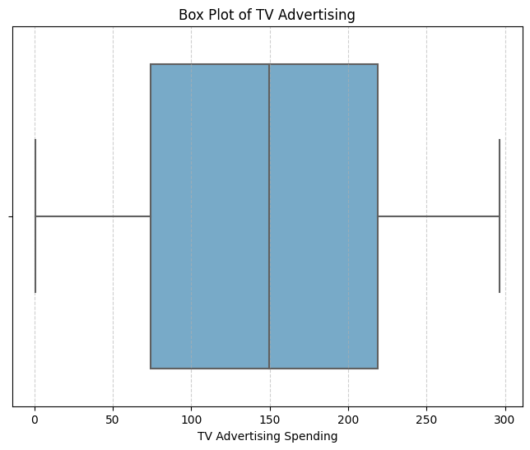

Fig.1 Box Plot of TV Advertising

plt.figure(figsize=(8, 6))  
sns.boxplot(x='Radio', data=df, palette='Oranges')  
plt.title('Box Plot of Radio Advertising')  
plt.xlabel('Radio Advertising Spending')  
plt.grid(axis='x', linestyle='--', alpha=0.6)  
  
# Show the plot  
plt.show()

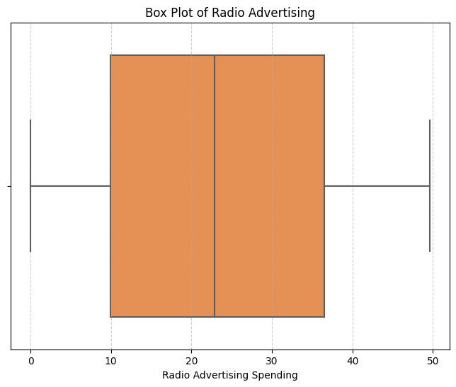

Fig.2 Box Plot of Radio Advertising

# Create the box plot  
plt.figure(figsize=(8, 6))  
sns.boxplot(x='Newspaper', data=df, palette='YlGnBu')  
plt.title('Box Plot of Newspaper Advertising')  
plt.xlabel('Newspaper Advertising Spending')  
plt.grid(axis='x', linestyle='--', alpha=0.6)  
  
# Show the plot  
plt.show()

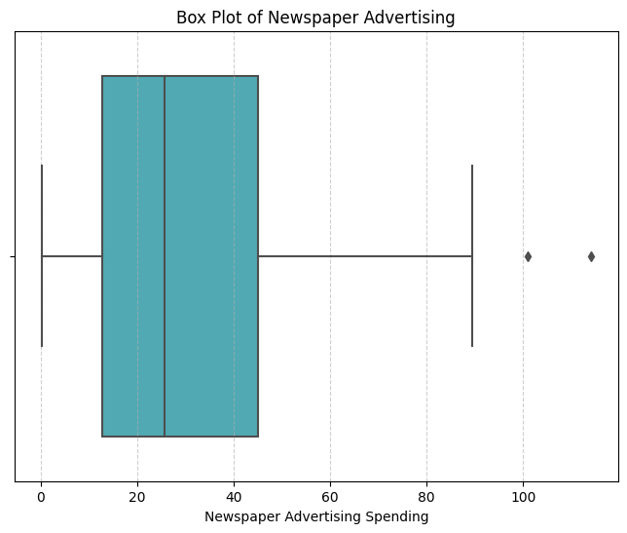

Fig.3 Box Plot of Radio Advertising

There are outliers in the Newspaper feature. To overcome this, we use the Winsorizing technique. Winsorizing is a technique that replaces outlier values with certain predetermined threshold values. We set the threshold value for the Newspaper feature at 2.

import numpy as np  
  
# Ambang batas atas (threshold) untuk Winsorizing  
upper_threshold = 2 * np.std(df['Newspaper']) + np.mean(df['Newspaper'])  
  
# Menerapkan Winsorizing pada kolom 'Newspaper'  
df['Newspaper'] = np.where(df['Newspaper'] > upper_threshold, upper_threshold, df['Newspaper'])

# Create the box plot  
plt.figure(figsize=(8, 6))  
sns.boxplot(x='Newspaper', data=df, palette='YlGnBu')  
plt.title('Box Plot of Newspaper Advertising')  
plt.xlabel('Newspaper Advertising Spending')  
plt.grid(axis='x', linestyle='--', alpha=0.6)  
  
# Show the plot  
plt.show()

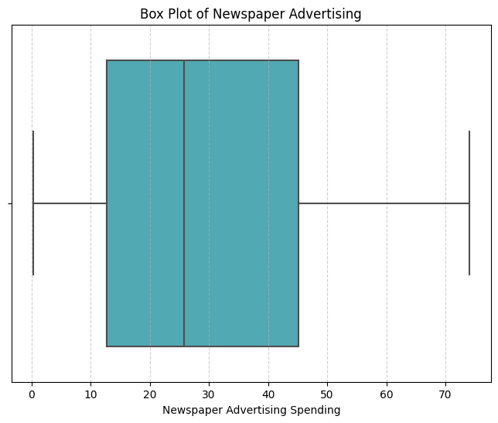

Fig.4 Box Plot of Radio Advertising

#### **Data normalization**

At this stage, we use the min-max technique. Min-Max is a data preprocessing technique used in data analysis and machine learning to convert values in a dataset into a certain range, usually between 0 and 1.

from sklearn.preprocessing import MinMaxScaler  
  
# Create a MinMaxScaler object  
scaler = MinMaxScaler()  
  
# Columns to be normalized (e.g., TV, Radio, Newspaper)  
columns_to_normalize = ['TV', 'Radio', 'Newspaper']  
  
# Apply Min-Max normalization to the selected columns  
df[columns_to_normalize] = scaler.fit_transform(df[columns_to_normalize])  
df.head()

TV Radio Newspaper Sales  
0 0.775786 0.762097 0.934843 22.1  
1 0.148123 0.792339 0.607851 10.4  
2 0.055800 0.925403 0.936200 12.0  
3 0.509976 0.832661 0.789664 16.5  
4 0.609063 0.217742 0.788307 17.9

# Modelling and Evaluation

At the modeling stage, we use 5 algorithms for comparison, namely Linear Regression, Ridge Regression, Lasso Regression, Decision Tree, and Random Forest.

And for evaluation using MSE, RMSE, MAE and R-Squared.

X = df[['TV', 'Radio', 'Newspaper']]  
y = df['Sales']

from sklearn.model_selection import cross_val_score  
  
num_folds = 5  
def perform_cross_validation(model, X, y, num_folds):  
 mse_scores = -cross_val_score(model, X, y, cv=num_folds, scoring='neg_mean_squared_error')  
 rmse_scores = np.sqrt(mse_scores)  
 mae_scores = -cross_val_score(model, X, y, cv=num_folds, scoring='neg_mean_absolute_error')  
 r2_scores = cross_val_score(model, X, y, cv=num_folds, scoring='r2')  
   
 return mse_scores, rmse_scores, mae_scores, r2_scores

# Linear Regression

In machine learning, a method called linear regression is used to predict a continuous outcome variable, also known as a dependent variable, from one or more predictor factors, also known as independent variables. It makes the assumption that the inputs and the output have a linear relationship. The best-fit line that minimizes the variation between the expected and actual values is the one to be found. For jobs like price forecasting, trend analysis, and sales forecasting, this method is frequently employed.

from sklearn.linear_model import LinearRegression, Ridge, Lasso  
linear_model = LinearRegression()  
linear_mse, linear_rmse, linear_mae, linear_r2 = perform_cross_validation(linear_model, X, y, num_folds)  
print("Linear Regression:")  
print(f"Average MSE: {np.mean(linear_mse) / np.mean(y) * 100:.2f}%")  
print(f"Average RMSE: {np.mean(linear_rmse) / np.mean(y) * 100:.2f}%")  
print(f"Average MAE: {np.mean(linear_mae) / np.mean(y) * 100:.2f}%")  
print(f"Average R-squared: {np.mean(linear_r2) * 100:.2f}%")  
print("\n")

Linear Regression:  
Average MSE: 18.90%  
Average RMSE: 11.01%  
Average MAE: 8.38%  
Average R-squared: 89.53%

# Ridge Regression

In machine learning, ridge regression is a regularization approach that keeps linear regression models from overfitting. In order to discourage large coefficients for the input features, it adds a penalty term (L2 regularization) to the linear regression cost function. This facilitates the handling of multicollinearity and yields a more accurate and stable model, particularly in the case of high dimensionality datasets. Ridge regression is a crucial component in enhancing the generalization and performance of models on intricate datasets.

ridge_model = Ridge(alpha=1.0)  
ridge_mse, ridge_rmse, ridge_mae, ridge_r2 = perform_cross_validation(ridge_model, X, y, num_folds)  
print("Ridge Regression:")  
print(f"Average MSE: {np.mean(ridge_mse) / np.mean(y) * 100:.2f}%")  
print(f"Average RMSE: {np.mean(ridge_rmse) / np.mean(y) * 100:.2f}%")  
print(f"Average MAE: {np.mean(ridge_mae) / np.mean(y) * 100:.2f}%")  
print(f"Average R-squared: {np.mean(ridge_r2) * 100:.2f}%")  
print("\n")

Ridge Regression:  
Average MSE: 19.67%  
Average RMSE: 11.20%  
Average MAE: 8.54%  
Average R-squared: 89.19%

# Lasso Regression

A machine learning method called lasso regression is employed for regularization as well as variable selection. It encourages sparsity in the coefficient values by adding a penalty term (L1 regularization) to the linear regression cost function, much like ridge regression. Lasso works to reduce overfitting by setting the coefficients of less significant features to zero, which is especially helpful in high-dimensional datasets. It is useful for selecting features and creating more straightforward, understandable models when there are a lot of input variables.

lasso_model = Lasso(alpha=1.0)   
lasso_mse, lasso_rmse, lasso_mae, lasso_r2 = perform_cross_validation(lasso_model, X, y, num_folds)  
print("Lasso Regression:")  
print(f"Average MSE: {np.mean(lasso_mse) / np.mean(y) * 100:.2f}%")  
print(f"Average RMSE: {np.mean(lasso_rmse) / np.mean(y) * 100:.2f}%")  
print(f"Average MAE: {np.mean(lasso_mae) / np.mean(y) * 100:.2f}%")  
print(f"Average R-squared: {np.mean(lasso_r2) * 100:.2f}%")  
print("\n")

Lasso Regression:  
Average MSE: 115.55%  
Average RMSE: 27.51%  
Average MAE: 22.39%  
Average R-squared: 35.98%

# Decision Tree

In machine learning, a decision tree is a predictive model that associates features with results. It divides the data recursively according to features, forming a structure like a tree, with each internal node denoting a choice made in response to a feature and each leaf node denoting the expected result. Decision trees are useful tools in machine learning for decision-making processes because they are adaptable, comprehensible, and frequently utilized for classification and regression problems.

from sklearn.tree import DecisionTreeRegressor  
tree_model = DecisionTreeRegressor(max_depth=None, random_state=0)   
tree_mse, tree_rmse, tree_mae, tree_r2 = perform_cross_validation(tree_model, X, y, num_folds)  
print("Decision Trees:")  
print(f"Average MSE: {np.mean(tree_mse) / np.mean(y) * 100:.2f}%")  
print(f"Average RMSE: {np.mean(tree_rmse) / np.mean(y) * 100:.2f}%")  
print(f"Average MAE: {np.mean(tree_mae) / np.mean(y) * 100:.2f}%")  
print(f"Average R-squared: {np.mean(tree_r2) * 100:.2f}%")  
print("\n")

Decision Trees:  
Average MSE: 16.73%  
Average RMSE: 10.40%  
Average MAE: 7.56%  
Average R-squared: 90.65%

# Random Forest

A machine learning ensemble learning technique called Random Forest uses several decision trees. By training each tree on a different subset of the data and features, it creates a forest of trees. When making predictions, it either uses a majority vote (for classification) or averages the outcomes from individual trees (for regression). For ML applications like feature selection, regression, and classification, Random Forests are frequently utilized due to their robustness and ability to manage intricate relationships in data.

from sklearn.ensemble import RandomForestRegressor  
forest_model = RandomForestRegressor(n_estimators=100, random_state=0)   
forest_mse, forest_rmse, forest_mae, forest_r2 = perform_cross_validation(forest_model, X, y, num_folds)  
print("Random Forest:")  
print(f"Average MSE: {np.mean(forest_mse) / np.mean(y) * 100:.2f}%")  
print(f"Average RMSE: {np.mean(forest_rmse) / np.mean(y) * 100:.2f}%")  
print(f"Average MAE: {np.mean(forest_mae) / np.mean(y) * 100:.2f}%")  
print(f"Average R-squared: {np.mean(forest_r2) * 100:.2f}%")

Random Forest:  
Average MSE: 10.32%  
Average RMSE: 8.09%  
Average MAE: 5.99%  
Average R-squared: 94.27%