**Future Sales Prediction**

|  |  |
| --- | --- |
| **Date** | **10-10-2023** |
| **Team ID** | **3869** |
| **Project Name** | **Future Sales Prediction** |

**Table of Contents**

|  |  |
| --- | --- |
| 1 | Introduction |
| 2 | Problem Statement |
| 3 | Design and Innovation Strategies |
| 3.1 | Data Collection and Feature Engineering |
| 3.2 | Data Pre-processing |
| 3.3 | Model Selection and Training |
| 3.4 | Visualization Analysis |
| 3.5 | Customer Analysis |
| 3.6 | Continuous Learning |
| 3.7 | Forecasting Techniques |
| 4 | Conclusion |

**1. Introduction**

The goal of this project is to forecast future sales, which is an important task for companies looking to optimize inventory, boost profitability, and boost customer pleasure. This project aims to estimate sales patterns using data-driven insights and sophisticated machine learning algorithms, enabling firms to make wise decisions and maintain their competitiveness in a changing market environment.

**2. Problem Statement**

Businesses are hampered by ineffective sales forecasting, which results in excess inventory or stockouts. Accurately anticipating future sales patterns while taking into account diverse elements including seasonality, market demand, and promotional activities is a problem. The goal of this project is to construct a precise and scalable predictive model that will help organizations predict demand patterns, allocate resources more effectively, and boost overall operational effectiveness.

**3. Design and Innovation Strategies**

**3.1. Data Collection and Feature Engineering**

Historical sales data collection is essential; we gather specific data on previous transactions, such as timestamps, product specifications, and sales volume. By using lag features to capture patterns and external events like vacations or economic indicators, feature engineering turns raw data into useful predictions. This phase is essential because it increases the model's accuracy by giving the prediction process useful input variables.

**3.2. Data Pre-processing**

The crucial step of data preparation is where unclean, unstructured data is removed and made ready for analysis. Handling missing values, getting rid of duplicates, and spotting outliers are among the tasks. Additionally, categorical variables are encoded for interoperability with machine learning methods, and numerical features may be scaled. When data is properly preprocessed, it is dependable and ideal for building precise predictive models.

**3.3. Model Selection and Training**

**1. Algorithm Exploration:**

Examine and investigate time-series forecasting techniques that are appropriate given the complexity and specifications of the dataset.

**2. Data Splitting and Preparation:**

Ensure chronological order while dividing the data into training and testing sets.For model compatibility, preprocess features, handle scaling, and encode categorical variables.

**3.Hyperparameter Optimization:**

Using methods like grid search, adjust the model hyperparameters for precision and generality.

**4. Training and Validation:**

Utilize the training set to train the selected model, then use the testing set to evaluate its performance. Use the right criteria to evaluate, and adjust the model as necessary for the best possible forecast of future sales.

**3.4. Visualization Analysis:**

To understand sales trends over time, use exploratory data analysis using visualizations like line charts, histograms, and heatmaps. Investigate subtle trends like seasonality or product-specific behaviours by using interactive tools like Tableau or Matplotlib. Businesses may effectively strategize using visual insights to make informed decisions and comprehend large amounts of data.

**3.5. Customer Analysis**

**1. Segmentation:**

To identify different buyer groups, segment clients based on their demographics, region, or shopping habits.

**2. Behavioural Patterns:**

Analyze purchasing patterns, tastes, and product affinities to comprehend consumer behavior and adjust marketing plans accordingly.

**3. Lifetime Value (CLV):**

To determine the profitability of each customer category and to direct resource allocation and targeted marketing initiatives, determine Customer Lifetime Value.

**4. Feedback Integration:**

To learn more about customer satisfaction levels, identify pain points, and improve the entire customer experience, integrate customer feedback and surveys.

**3.6. Continuous Learning**

To succeed in today's changing marketplace, organizations must continuously develop new skills. Companies may efficiently change their strategy to meet changing market demands by keeping up with industry trends and technology developments. By funding employee skill development through workshops and training programs, employers can be guaranteed that their team is competent and up to the task of taking on new challenges. Organizations can also benefit from the insightful feedback provided by both consumers and workers, using this information to improve services, hone goods, and raise overall customer satisfaction. Businesses can take informed decisions and expand sustainably in the face of dynamic business environments by adopting an iterative improvement culture that carefully considers lessons learned from the past.

**3.7. Forecasting Techniques**

Time Series Analysis, which models patterns in sales data over time, Regression Analysis, which takes into account different factors affecting sales, Machine Learning Algorithms like Random Forest and XGBoost for complex, non-linear relationships, Deep Learning Models like Long Short-Term Memory (LSTM) networks for sequential data analysis, and Ensemble Methods, which combine predictions from multiple models for more accurate forecasting, are some forecasting techniques for future sales prediction. The individual characteristics of the sales data and the desired level of accuracy and complexity are important factors for choosing the right technique.

**FLOW DIAGRAM**

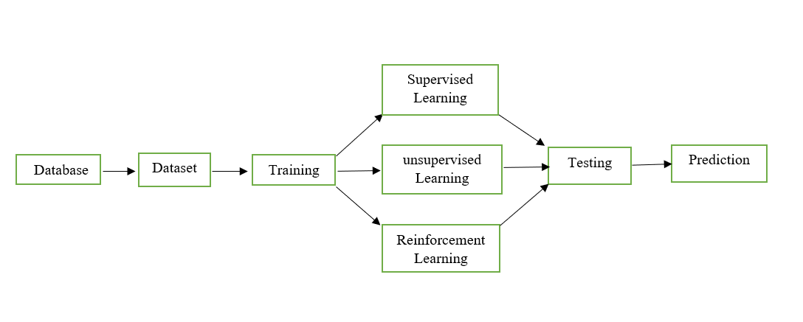

Fig.1 Flow Diagram For Future Sales Prediction

**4. Conclusion**

Future sales forecasting is a difficult task that depends on a number of variables. Businesses should use historical data, market trends, and cutting-edge analytics tools to improve accuracy. Adopting digital marketing and e-commerce tactics will be essential for accelerating future sales growth. For continued success, it will be essential to monitor customer input and adjust to shifting consumer preferences. To remain competitive in a dynamic industry, collaboration with data-driven professionals and ongoing improvement of predictive models are crucial. In the end, being able to innovate and adapt will be crucial for effectively forecasting and increasing future sales.