**CNN-LSTM spatio-temporal Features**

**with Partial Expression Sequences**

**and on-the-Fly Prediction**

**CNN**

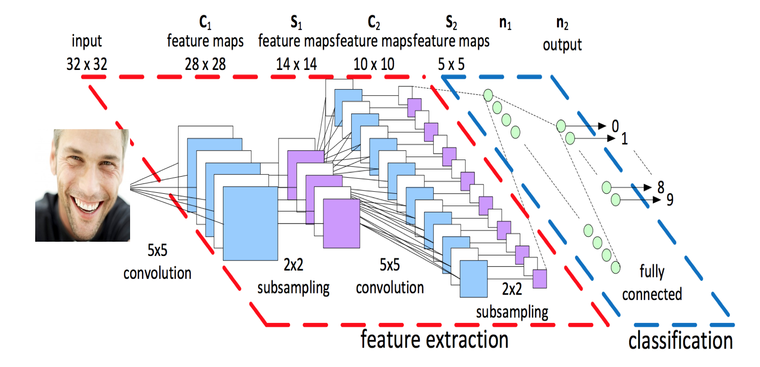

Convolution Neural Networks is said to be the best methodology to learn vast quantity of data(images) with minimal pre-processing and classify them into different categories that too with great accuracy and in real time.

The whole model is divided into sections:

1. Feature extraction
2. Classification

Feature extraction is implemented by arranging series of layers which subsamples the images and perform operations such as convolutional, batch normalization, ReLU activation, pooling, dropout, etc. And finally all the channels are flattened into array of feature vectors. These are done with equations of weights and bias matrices (cost function).

Classification Section, further dense the fully connected layer into classified categories.

**Formulating the classification section (manipulating weights and bias) according to required needs, increases the classification accuracy.**

**LSTM**

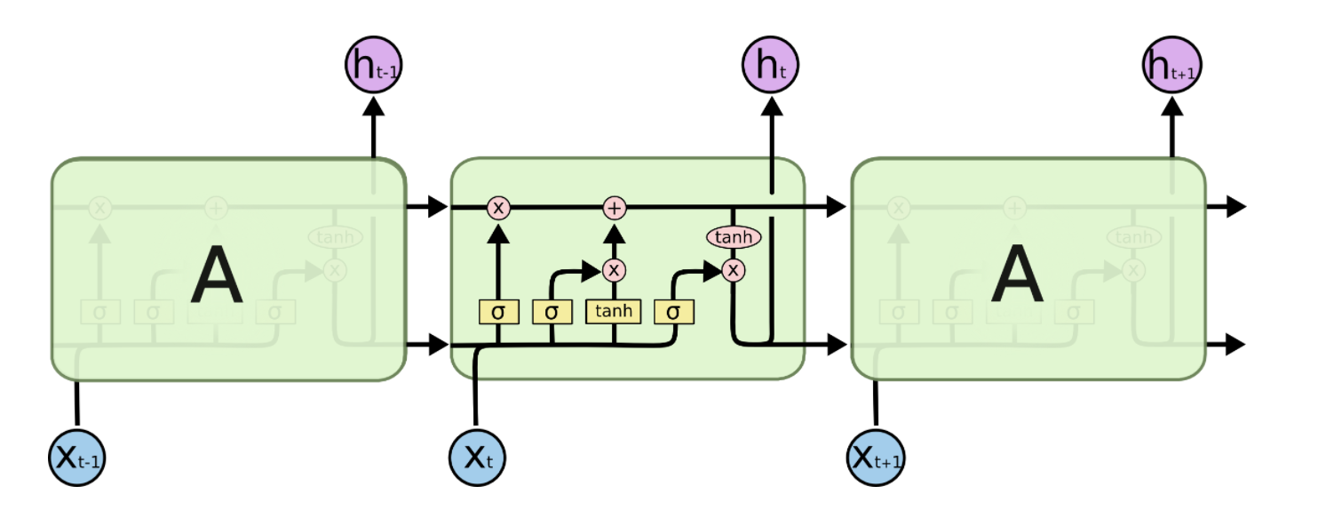

* Long Short Term Memory(LSTM) networks are capable of learning long-term dependencies. Each block in the sequence is called cell state.
* Each cell state stores the processed data of previous states. Which helps in predicting present scenario.
* In each cell, using previous information they perform operation such as select, forget, store, combine, etc over present data. This enhances the feature vector of present data. Hence, gives dynamic approach.
* LSTM is implemented in scenarios where the dataset is sequence of images(video), sequence of words(sentences), to predict the upcoming image or word.

Applications:

Weather forecasting, word prediction, video frame prediction, language modelling, image captioning, question answering, video to text, etc.

**Overview:**

CNN-LSTM spatio-temporal Features with Partial Expression Sequences and on-the-Fly Prediction can be implemented for emotion detection of camera captured facial images. This algorithm is proposed for dynamic classification of expression in real time based on previous rescent expressions.

The video captured by the camera is **sequence of frames(images)**, having human faces showing emotions. Humans poses emotion expressions on their face for atleast a desirable period of time (say atleast 50 frames), thus forming a sequence of frames (increasing happiness, decreasing happiness, inc anger, dec anger). Expressions don’t change drastically per frame.

So, based on previous frames knowledge we can more accurately classify present frame’s emotion.

We know, CNN features extraction is performed by adjusting weights and bias (cost function) between layers. So features vectors are derived for each frame. These feature vectors are used for further classification.

Formulating the weights and bias further, based on previous classifications (previous weights and biases) we can easily and accurately classify present frames expression.

**Comparison:**

Overcomes anomalies of other models.(CNN, 3d-CNN, Inception, simple CNN-LSTM, Deeper CNN)

Fast, simple, accurate, dynamic and very flexible.

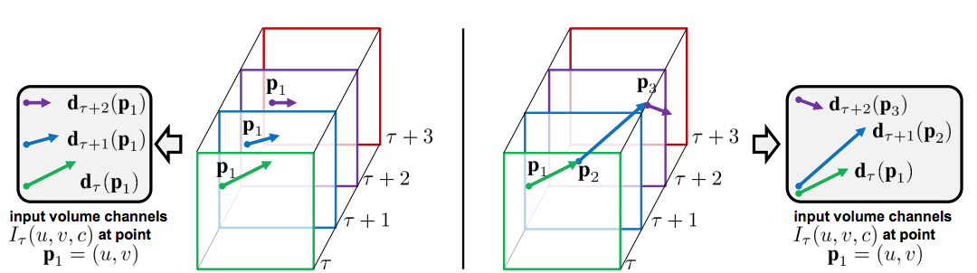

**CNN CNN-LSTM**

**Methodology:**

**Facial emotion detection:**

1. Camera captures frames of images.
2. Haar Cascade xmls are used for detecting faces and cropping. (haarcascade_frontalface_default.xml)
3. Multi- Face tracking or single-face (most near) detection.
4. Pre – processing the image:

* Reshaping into (64,64,3)
* Data augmentation (angle, pixel value, etc) [optional]
* Using keras pre-processor ImageDataGenerator

(featurewise_center, featurewise_std_normalization, flip, rotate)

1. Create dynamic sequence of frames (eg.: set max. limit = 100 frames)
2. Sequence of frames feed into our CNN-LSTM core model (next page please)
3. Predicted emotion label is output

Libraries: keras, numpy, python, opencv, panda (versions and additional lib is to be updated).

**Dataset**:

MMI, Oulu-CASIA, youtube, etc [not yet arranged]

**Other Implementations:**

Features to Learbot…..[to be discussed]

**Core Model Flowchart**

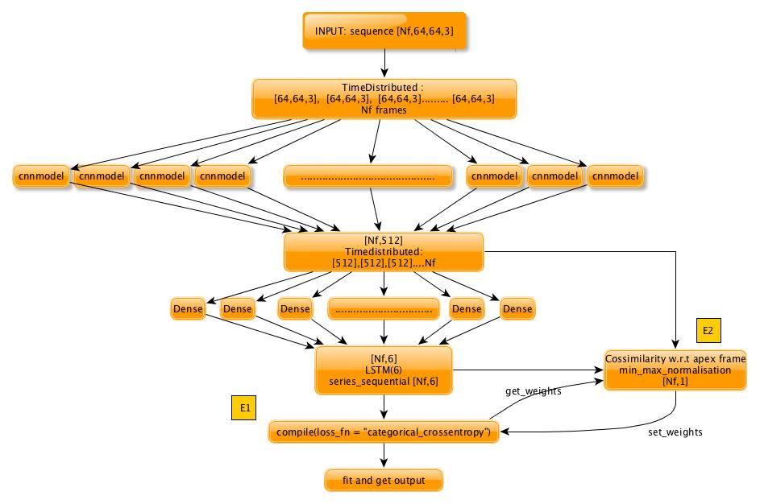

Nf: number of frames

Frame shape: 64x64x3

LSTM(6): 6 is number of classes

**Architecture of code for above methodology:**

<https://github.com/shreyashk09/CNN-LSTM-RNN-with-spatio-temporal-feature-representation/blob/master/Experiments/lstmcnn%20copy-Copy1.ipynb>

CNN Model: <https://github.com/shreyashk09/Emotion-Recognition---Neural-Networks> In the code, I’ve tried to display model.summary() of some models (cnnmodel, LSTM). Connection between these models and structure of implementation objectives E1 and E2 are also shown.

**Core Model Explanation**

* The training set consists of “sequences of frames” (video clips).
* The input to model consists of only a sequence of frames at a time
* Each “sequence of frames” represents only one expression and assigned single label for whole sequence.(reduce efforts for labelling each frame)
* The intensity of expression increases across the sequence (neutral to highly expressive)

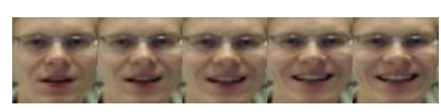

* Thus, the input is [Nf,64,64,3], where Nf is number of frames
* All frames are simultaneously processed by CNN((64,64,3)->(512,1)) using TimeDistributed function
* The cumulative output [Nf,512] is our **spatial intensity vector** of each frame.

Based on these intensity vectors we can improve the classification, by fulfilling 2 objectives:

**E1**: minimizing expression sequence classification error

**E2**: minimizing the expression intensity prediction error

We know, relation between layers and classification is done by weight matrix. So, we try updating weight matrix efficiently (cost function).

Achieving E1:

* The intensity vectors are TimeDistributed Densed into [Nf,6].(each frame is densed into 6 parallely)
* LSTM is added to map [Nf,6] to [6] for each frame, based on previous frames prediction. This done by applying “categorical_crossentropy” loss function (also defines gradient descent in cost function).

The gradient of this function(based on entropy of each class ([6])) updates weights of LSTM layer.

Thus, classifies into 6 classes.

The optimization by E1 highly affects the spatio-temporal feature at the last frame of sequence

Achieving E2:

Due to E1 miss-classification could occur when prediction is performed at early frames of the sequence.

The prediction of the correct expression could be delayed until the end frames of the sequence. To mitigate the aforementioned delay problem, we propose the second objective term (E2), which minimizes expression intensity prediction error.

So, in a separate function,

* Taking spatial feature vectors([512,1]) from cnnmodel, we perform cossimilarity over them where the last frame is always taken as apex frame.

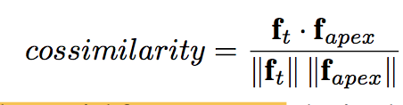

* Further min_max_normalisation is applied over them and Euclidean loss function is implemented.

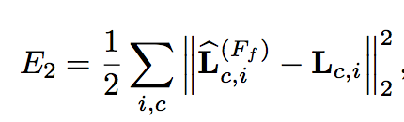(inbuilt function)

* Weights are taken form E1 final layer (last LSTM layer) and are updated and set back into the layer.
* Weights here are updated by gradient of Euclidean loss function in a separate model

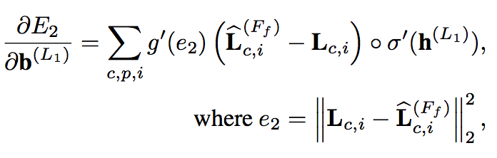

(dot product of gradient and LSTM value)

Thus weights are updated multiple times for better classification of sequence after each epoch.

The working model input consists of only a sequence of frames at a time (sequence is updated as soon as new frame is captured by camera)

**ALTERNATIVE MODELS ( if accuracy not met or delays output):**

Two-Stream Convolutional Networks with LSTM

ConvLSTM2D model

**Thank You**

**Similar codes(CNN-LSTM Video Classifier):**

<https://github.com/keras-team/keras/blob/master/examples/imdb_cnn_lstm.py>

<https://github.com/topics/video-classification>

**Related research papers:**

Learning Spatio-temporal Features with Partial Expression Sequences for on-the-Fly Prediction [ <https://arxiv.org/pdf/1711.10914.pdf> ]

Differential Generative Adversarial Networks: Synthesizing Non-linear Facial Variations with Limited Number of Training Data [ <https://arxiv.org/pdf/1711.10267v4.pdf> ]

Dynamics Transfer GAN: Generating Video by Transferring Arbitrary Temporal Dynamics from a Source Video to a Single Target Image [ <https://arxiv.org/pdf/1712.03534v1.pdf> ]

Modeling Spatial-Temporal Clues in a Hybrid Deep Learning Framework for Video Classification [ <https://arxiv.org/pdf/1504.01561.pdf> ]

Two-Stream Convolutional Networks for Action Recognition in Videos [ <https://arxiv.org/pdf/1406.2199v2.pdf> ]

Modeling Spatial-Temporal Clues in a Hybrid Deep Learning Framework for Video Classification [ <https://arxiv.org/pdf/1504.01561v1.pdf> ]