**Assignment I**

1. Create the following LIST.

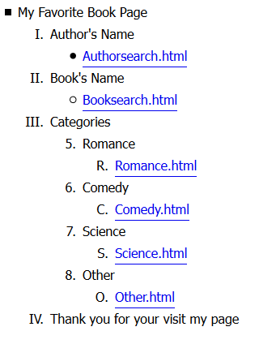

2. Write the HTML page to create the following. The heading should display Car Rental. After heading, the image (desired image) should display align centered. The form should have the following fields.

Text boxes to accept user's name and email.

Radio button with name and value attributes:

Round Trip

One Way

Checkbox with name and value attributes for select company:

Hertz

For Rent a Car

Select box with name and value attributes:

5 basic car types

Economy

Compact

Intermediate

Mid size

Standard

Submit control