# CMSC 150 PYTHON PROJECT

An app that has a diet solver as its main features and generic solver as its additional feature. The diet solver involves the use of Simplex Method in minimization with mixed constraints. The generic solver on the other hand, has a feature to generate a polynomial regression function based on given data points and another feature that involves quadratic spline interpolation.

## Diet Solver

The objective of this feature is to identify the most cost-effective and nutritious combination of foods that will fulfill all daily nutritional requirements. The combination of foods will be based upon the food options selected by the user. This problem is formulated as a linear program with the objective of minimizing cost under specified constraints and ensuring nutritional adequacy. These constraints control factors such as number of calories and amounts of vitamins, minerals, fats, sodium and cholesterol in the diet. Additionally, each food option is restricted to a range of 0-10 servings. The program employs simplex method set up as a dual problem to solve for the optimal combination of foods.

## Polynomial Regression

Polynomial regression is a statistical method used to model the relationship between a dependent variable and one or more independent variables. This calculator employs polynomial regression to generate precise polynomial equations based on user-provided data points. Users can input their datasets and specify the desired polynomial degree, allowing the calculator to determine the optimal polynomial equation that best fits the given data. The result is an accurate polynomial equation that can be utilized for predictive purposes. This tool is invaluable for tasks where a more complex relationship between variables needs to be captured, offering a higher degree of accuracy in modeling.

## Quadratic Spline Interpolation

Polynomial regression is a statistical method used to model the relationship between a dependent variable and one or more independent variables. This calculator employs polynomial regression to generate precise polynomial equations based on user-provided data points. Users can input their datasets and specify the desired polynomial degree, allowing the calculator to determine the optimal polynomial equation that best fits the given data. This tool is invaluable for tasks where a more complex relationship between variables needs to be captured, offering a higher degree of accuracy in modeling. Quadratic spline interpolation is particularly useful when dealing with real-world data that may exhibit non-linear patterns within specific ranges.

## Downloading Resources

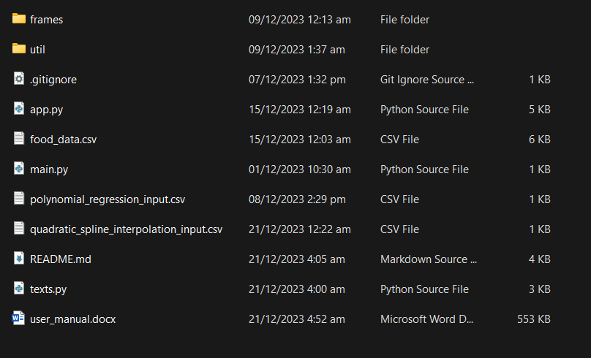Upon downloading all resources for the project, it should contain all the following files:

## Utils and Frames Folders

The utils folders contains all the logic and necessary functions for various methods and return the necessary outputs for the user to see through an interface. The frames folders on the other hand contains all the UI for the program. It contains different pages and also handles the error prompts and calls the corresponding util function needed.

## 

## 

## Installing External Modules

Make sure you have Python and pip installed on your system before running these commands.

pip install tk

pip install ttkbootstrap

pip install numpy

If you're using a virtual environment, activate it before running the commands.

# Create a virtual environment

python -m venv myenv

# Activate the virtual environment (Windows)

myenv\Scripts\activate

# Activate the virtual environment (Unix or MacOS)

source myenv/bin/activate

## Running the Program

Once you are in the correct directory, run your Python script using the python command followed by the script's filename. If you are using Python 3, you might need to use python3 instead:

# Navigate through file directory

cd path/to/your/script/directory

# Run the main python application

python main.py

## Main Menu

Upon running the main application, we are greeted with the app overview and its available functions such as a diet solver, polynomial regression calculator and quadratic spline interpolation. Clicking the corresponding buttons will send the user to corresponding solver.

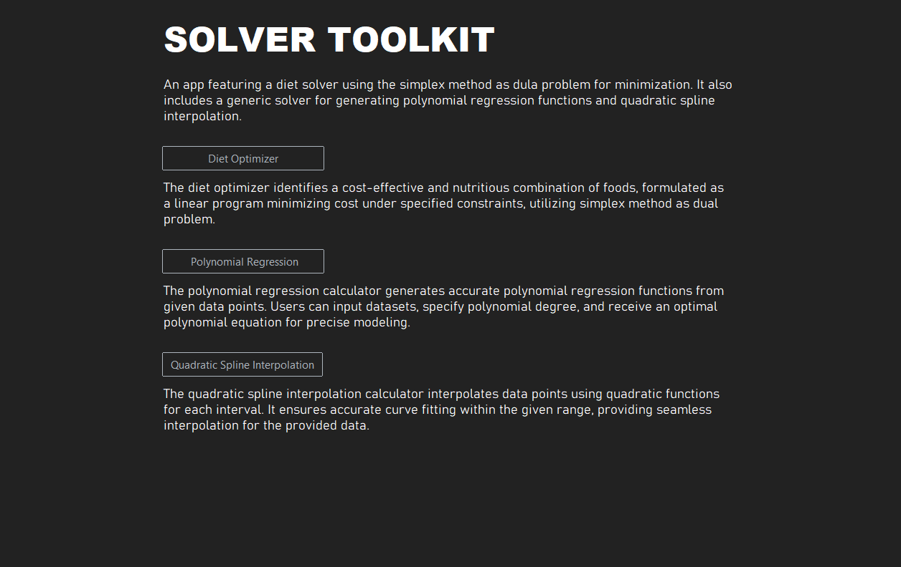

## Diet Optimizer

Clicking the Diet Optimizer button will send user to the diet solver where they have the option to select foods.

The program has a built-in search function to make selection easier in addition to the default checkboxes.

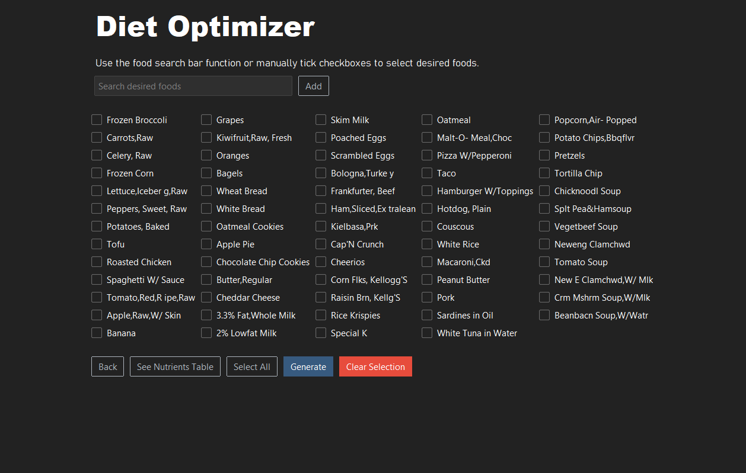

Clicking the *SEE NUTRIENTS* button will show a pop-up window of all the food data with corresponding nutritional values and its price per serving.

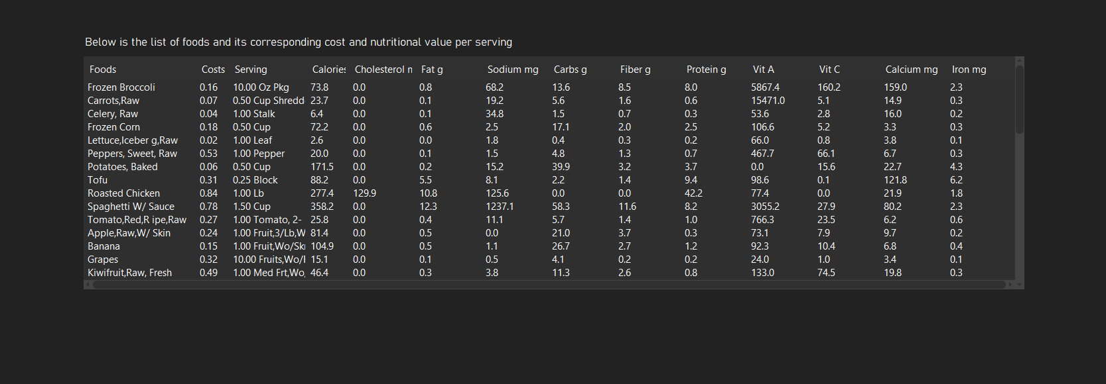

The program also has a *SELECT ALL* function if user chooses to have a wide variation of foods and for easier testing of the program’s simplex method set up as a dual problem.

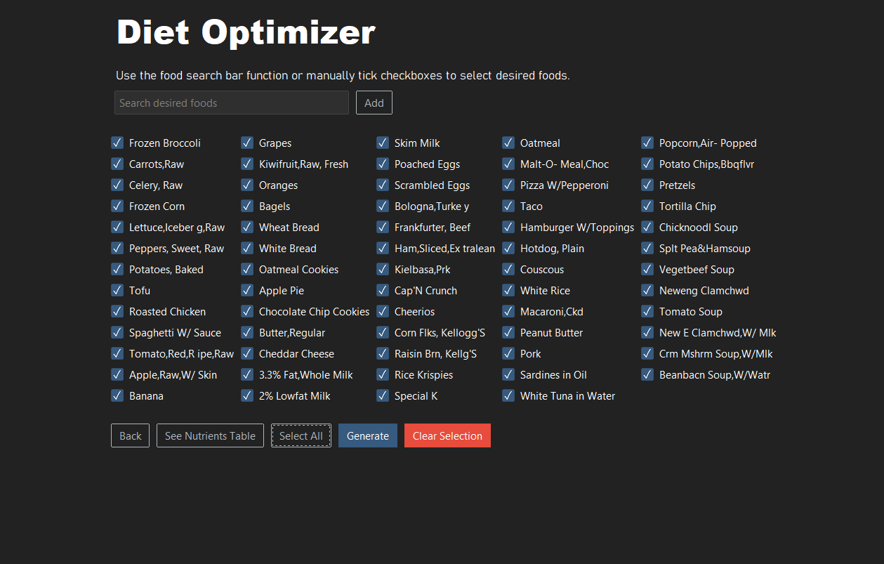

Upon clicking the *GENERATE* button the program will generate the optimal combination of foods that would meet the daily nutritional requirements at the cheapest cost. The *CLEAR SELECTION* enables clear all previous selection.

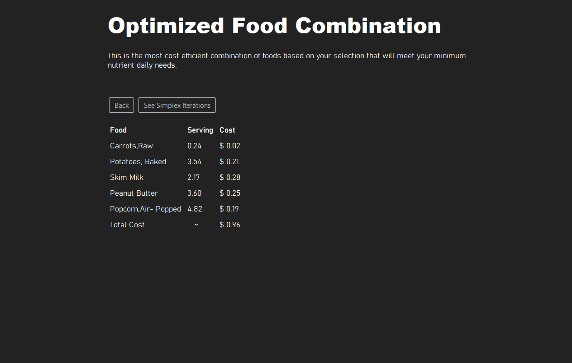

Upon clicking the *GENERATE* button without a food selected proper error prompts would be display and the *SEE SIMPLEX ITERATION* button would be disable as there is not food selection to optimize

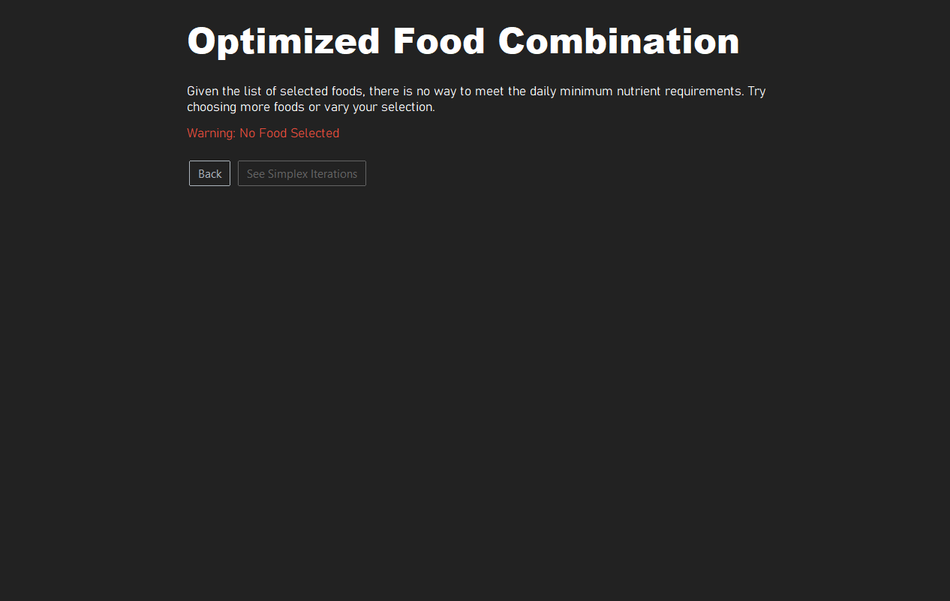

However, upon choosing a variation of foods with feasible solution, users can choose to see each simplex iteration with its corresponding basic solution. They can select the specific iteration they want to see and generate the iteration by clicking the *GENERATE ITERATION* BUTTON

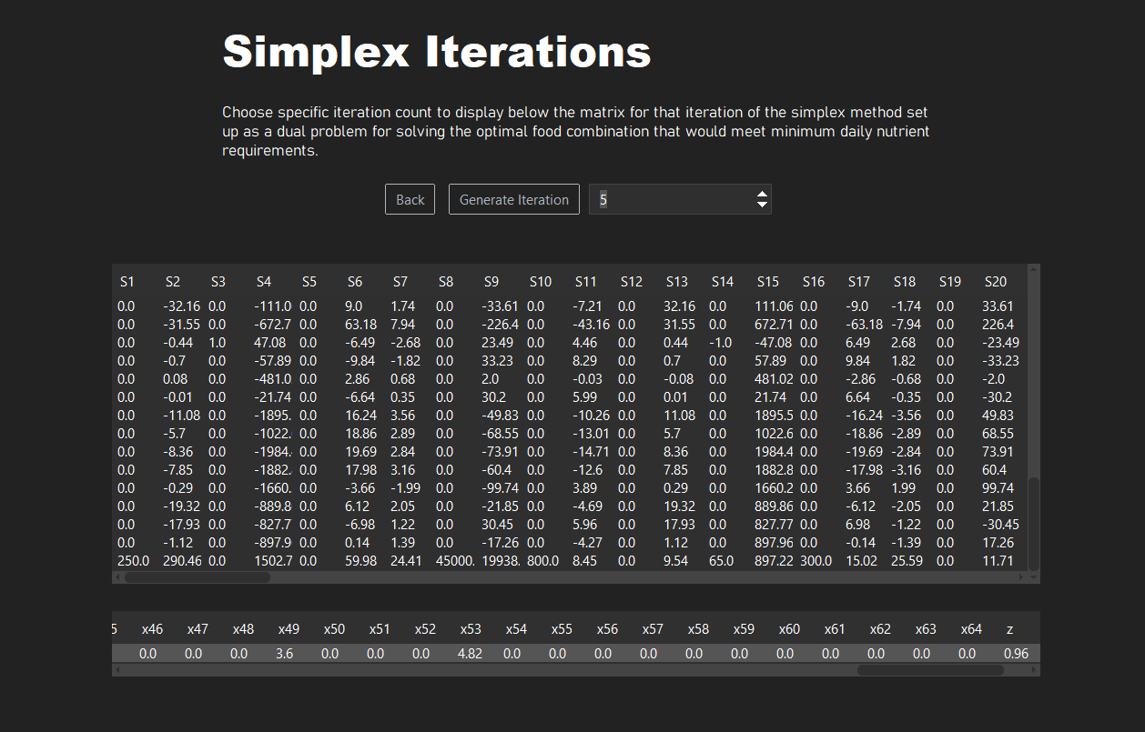

This also includes proper error prompts if invalid iteration count was inputted by the user or if the user did not specify the iteration count upon clicking the *GENERATE* button

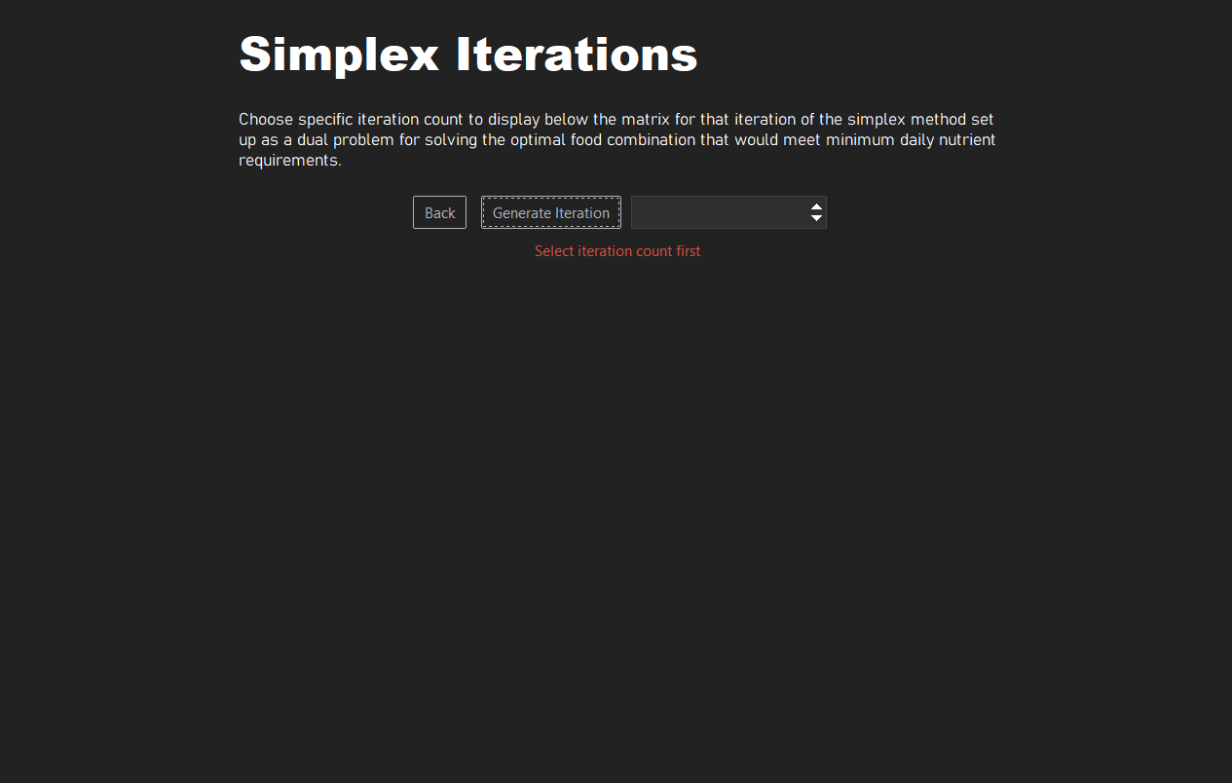

Upon navigating to the polynomial regression calculator through the main menu, the user may have the option of manually typing each data points following the format specified. A *RESET* button is also included for user to easily try new estimates and datapoints.

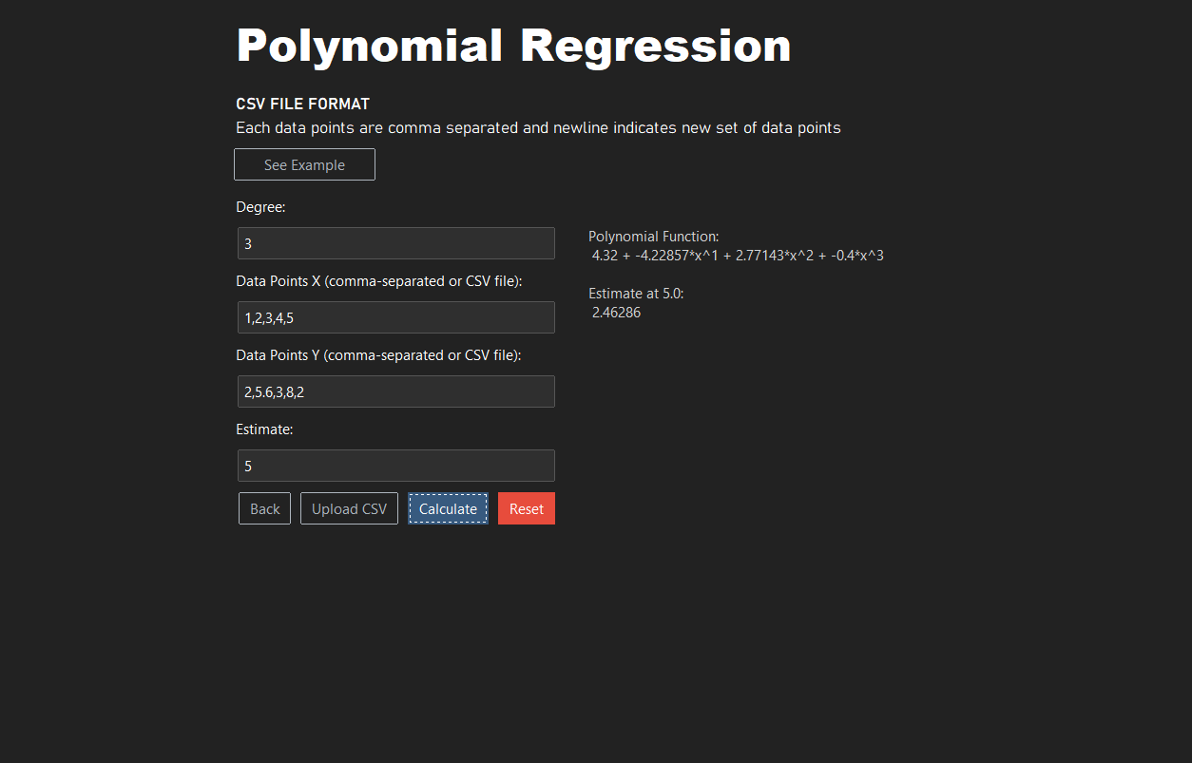

If data set is large, there is also an option of uploading a csv file following the example format that can be seen by clicking the *SEE EXAMPLE* button. Upon filling in the parameter such as degree and estimate, the program will generate a polynomial regression function and the estimate at that point.

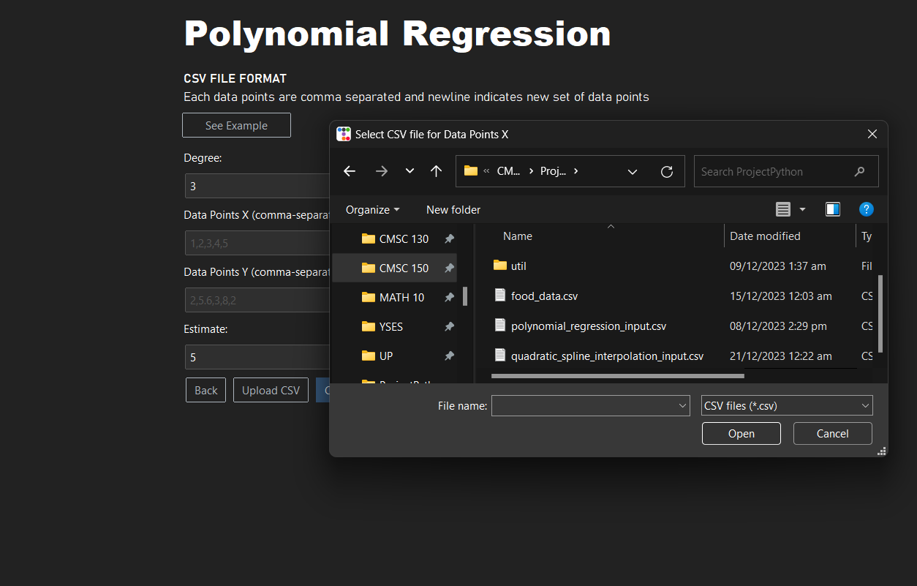

CSV File format example

This can be accessed

Upon clicking the see

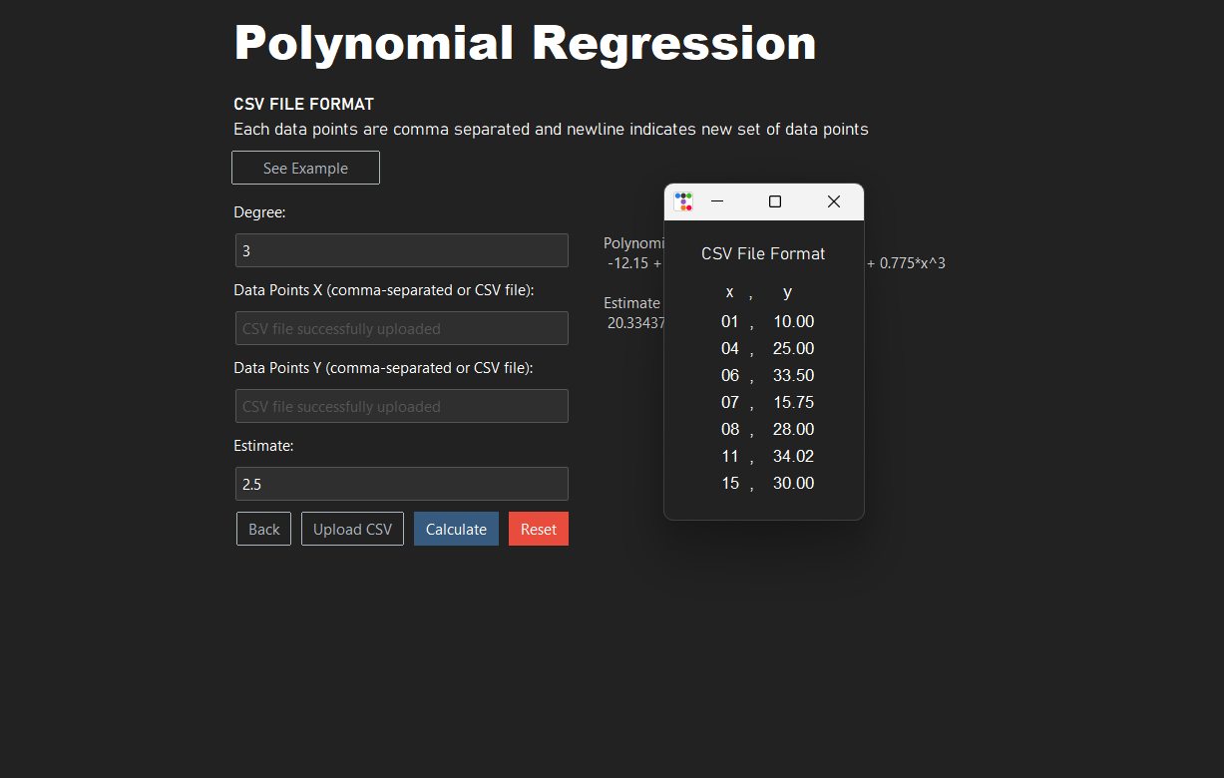Example button

Upon navigating to the quadratic spline interpolation page, similar to the polynomial regression page, the user may also manually type each datapoints or upload a csv file following the specified format. The program will then generate each function for each interval and estimate at a specific point, this is upon clicking the *CALCULATE* button. Ther is also a *RESET* button to make testing eaiser.

