Chapter 1
INTRODUCTION

A Hospital Management System (HMS) is a comprehensive software solution designed to streamline and automate the operations of healthcare facilities. It provides features such as patient registration, appointment scheduling, medical record management, billing, and inventory control. The system enhances the quality of patient care by offering healthcare professionals quick and secure access to patient information, enabling accurate diagnosis and treatment. Additionally, it empowers hospital administrators to efficiently manage resources, track inventory, and generate detailed reports for better decision-making. In the fast-evolving healthcare industry, this system plays a vital role in ensuring smooth hospital operations, enhancing patient satisfaction, and maintaining compliance with healthcare regulations.

  - Motivation of Project

The healthcare industry is rapidly evolving, and hospitals are facing increasing challenges in managing patient data, appointments, billing, and inventory. Manual systems are prone to errors, inefficiencies, and delays. A Hospital Management System (HMS) is essential to streamline operations, improve patient care, and enhance overall hospital efficiency. This project aims to address these challenges by developing a robust and user-friendly system.

1.2 Project Objectives

- To maintain detailed patient records, including medical history, appointments, and billing.
- To organize schedules, assign duties and track performance.
- To allow patients to book appointments online and reduce waiting times.
- To implement functionalities for both administrators and users.
- To improve patient care through better record management.

1.3 Advantages of Project

- Efficiency: Reduces manual work and automates repetitive tasks.
- Accuracy: Minimizes errors in patient records, billing, and inventory management.
- Accessibility: Provides easy access to patient data for authorized personnel.
- Cost-Effective: Reduces operational costs by optimizing resource utilization.
- Scalability: Can be expanded to accommodate larger hospitals or additional features.

1.4 Overview of System

The Hospital Management System (HMS) is a robust software platform designed to streamline and automate the operations of healthcare facilities. It provides a centralized solution for managing patient records, appointments, billing, and inventory, ensuring seamless coordination between doctors, staff, and patients. The system's frontend is developed using React.js, offering a dynamic and user-friendly interface for easy navigation and interaction. The backend is powered by Node.js and Express.js, ensuring efficient handling of server-side logic and API requests. For secure and structured data storage, the system utilizes MySQL integrated with Sequelize ORM, enabling smooth management of patient information, medical records, and hospital resources. Additionally, the HMS supports role-based access control, ensuring data security and privacy. By automating critical healthcare processes, the system enhances operational efficiency, reduces manual effort, and improves the overall quality of patient care, making it an indispensable tool for modern healthcare facilities.

Chapter 2
SYSTEM REQUIREMENTS

Functional Requirements

- Patient Management
- Register new patients and store their personal and medical details.
- Update and retrieve patient records.
- Track patient medical history and treatment plans.

- Appointment Scheduling
- Schedule, reschedule, or cancel appointments.
- Send reminders to patients about upcoming appointments.
- Manage doctor availability and time slots.

- Billing and Payments
- Generate bills for consultations, treatments, and medications.
- Process payments and maintain payment records.
- Provide invoices and receipts to patients.

- Inventory and Pharmacy Management
- Track medicine stock levels and reorder when necessary.
- Manage supplier details and purchase orders.
- Record medicine dispensing to patients.

- Doctor and Staff Management
- Maintain records of doctors and staff.
- Assign roles and permissions to users.
- Track attendance and working hours.

- Reporting and Analytics
- Generate reports on patient statistics, revenue, and inventory.
- Provide insights into hospital performance and trends.
2.2 Non-Functional Requirements

- Performance
- The system should handle up to 1,000 concurrent users without performance degradation.
- Response time for any operation should not exceed 2 seconds.

- Security
- Implement role-based access control to ensure data privacy.
- Encrypt sensitive patient data during storage and transmission.
- Regularly backup data to prevent loss.

- Usability
- The system should have an intuitive and user-friendly interface.
- Provide training and documentation for hospital staff.

- Reliability
- The system should have 99.9% uptime.
- Implement error handling and recovery mechanisms.

- Scalability
- The system should be able to scale to support additional hospitals or clinics.
- Support integration with third-party systems (e.g., lab systems, insurance providers).

- Compliance
- Ensure compliance with healthcare regulations such as HIPAA (Health Insurance Portability and Accountability Act).
- Maintain audit logs for all system activities.

Chapter 3

STATIC AND DYNAMICS DIAGRAMS

The software design model for the Hospital Management System (HMS) is divided into static diagrams and dynamic diagrams. Static diagrams represent the structural organization of the system, such as class diagrams and object diagrams. Dynamic diagrams represent the behavior and interactions of the system, such as use case diagrams, sequence diagrams, collaboration diagrams, and state chart diagrams.
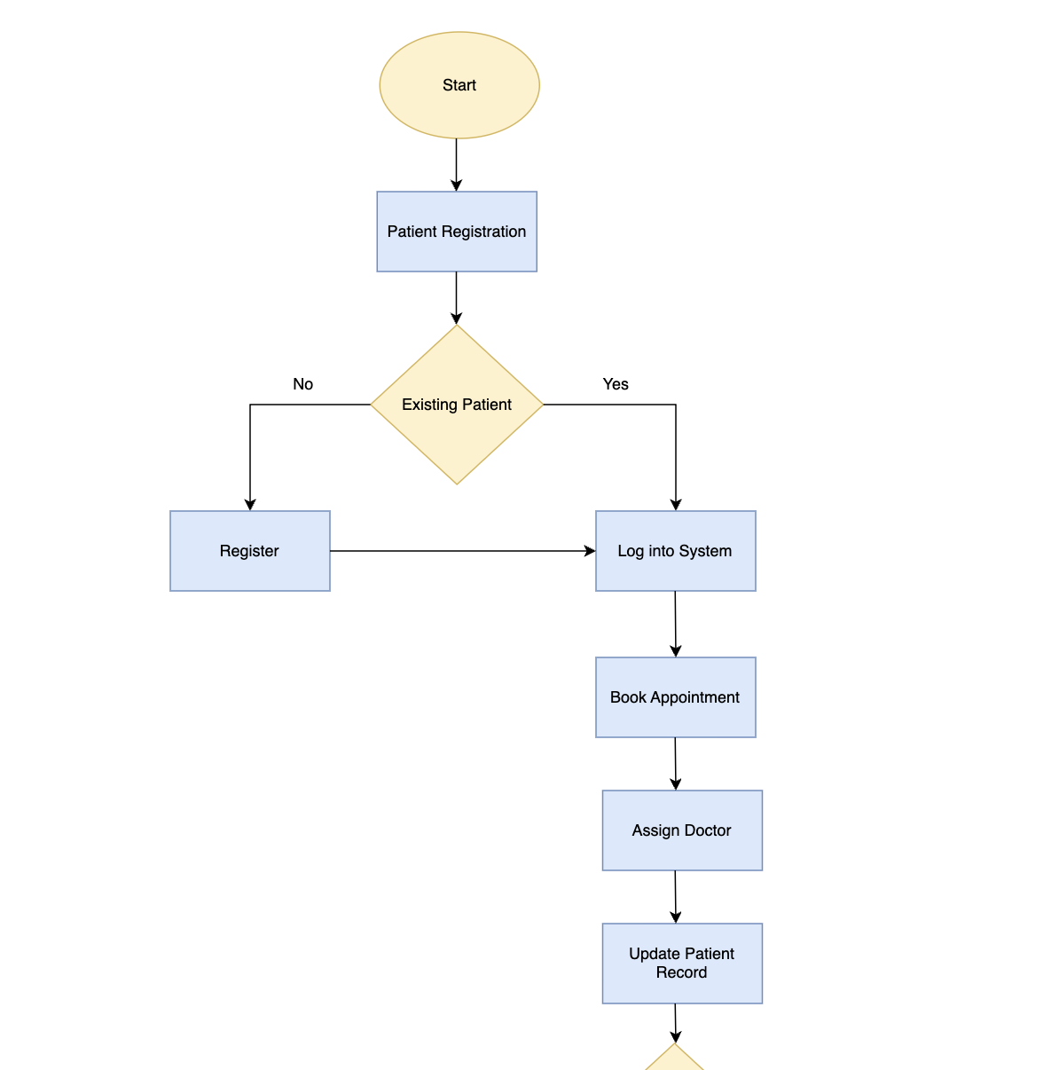
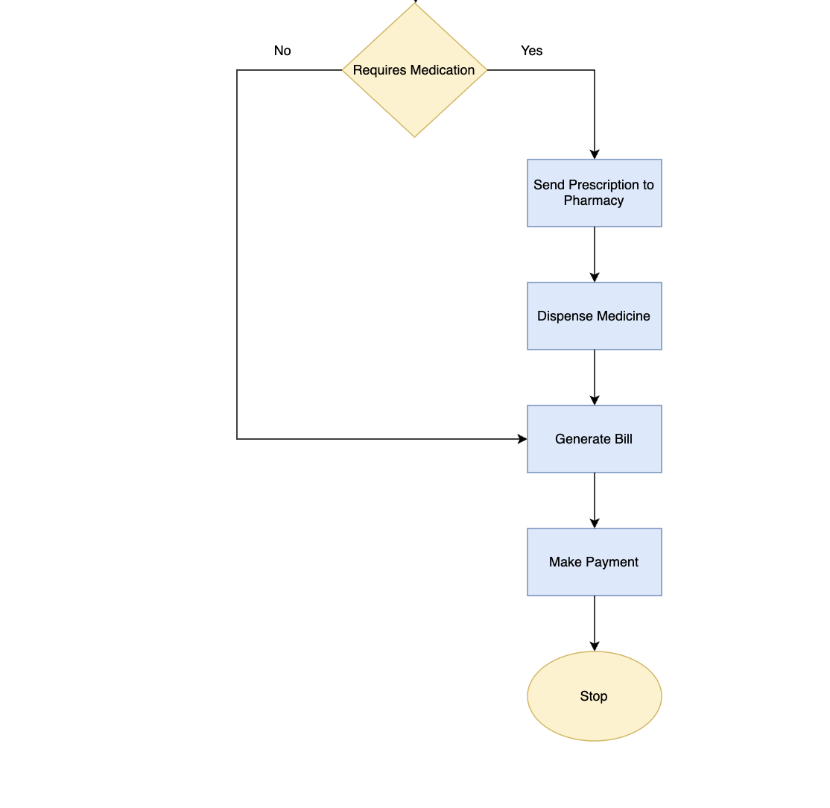
Figure 3.1 Flowchart for Hospital Management System

3.1 Class Diagram

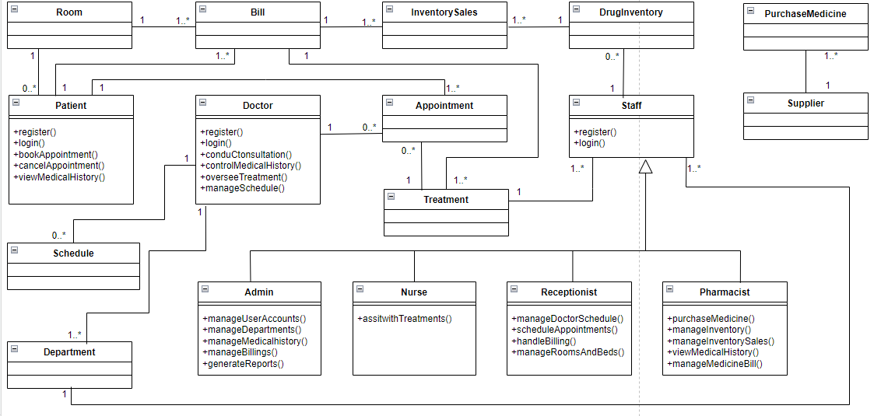

Figure 3.2 Class Diagram for Hospital Management System

This class diagram illustrates a hospital management system, depicting interactions between various entities such as Patient, Doctor, Appointment, Treatment, Bill, Room, Staff, and Pharmacist. Patients can register, log in, and manage appointments, while doctors oversee consultations and medical history. Receptionists handle scheduling, billing, and room assignments, whereas nurses assist with treatments. Pharmacists manage drug inventory and medicine sales, and suppliers provide medical supplies. Admins oversee departments, user accounts, and billing processes. The relationships between these objects reflect real-world hospital workflows, ensuring efficient medical and administrative operations.

3.2 Object Diagram
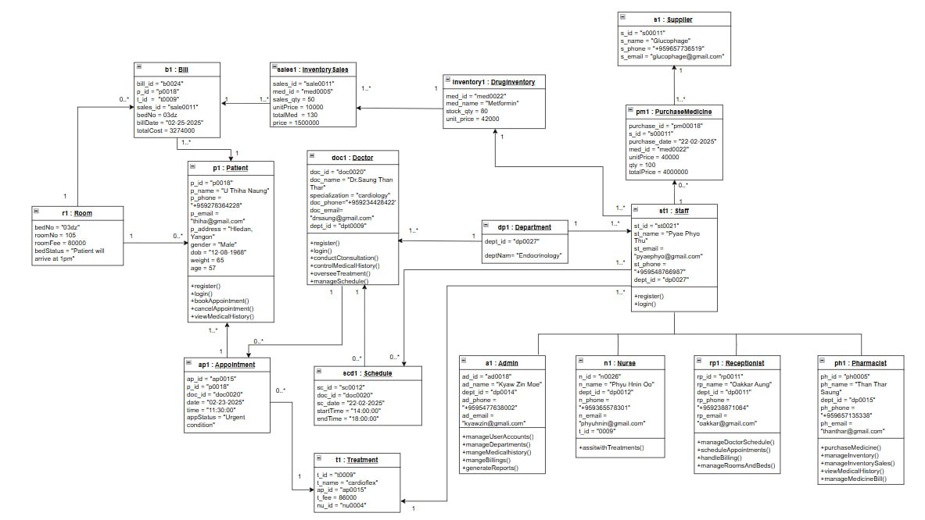

Figure 3.3 Object Diagram for Hospital Management System

This object diagram represents a hospital management system by showing instances of classes and their relationships. It includes objects like Patient, Doctor, Appointment, Room, Treatment, and Bill, each with specific attributes and behaviors. Patients can book appointments, doctors manage schedules and treatments, and receptionists handle room assignments. Nurses assist with treatments, while pharmacists manage drug inventory and sales. Admins oversee schedules, billing, and records. The system also tracks medicine purchases from suppliers and sales through inventory. This diagram provides a simplified view of how hospital entities interact in real-world scenarios.

3.3 Use Case Diagram
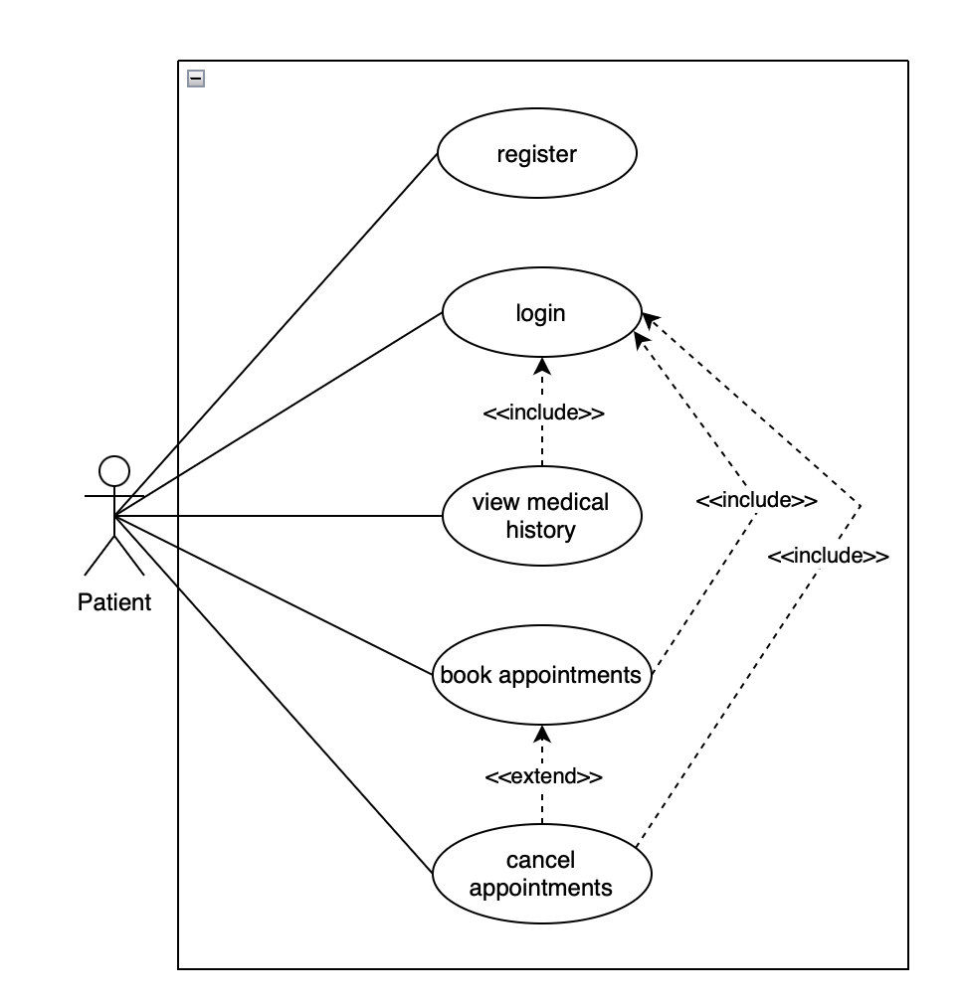

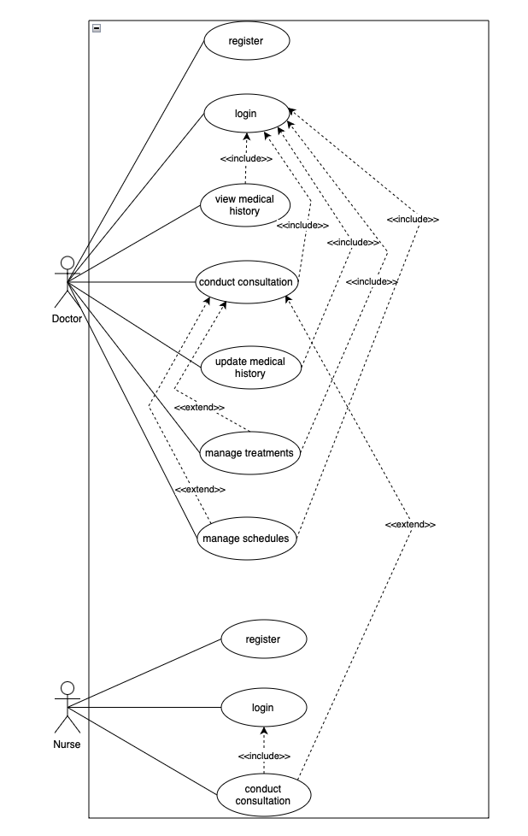

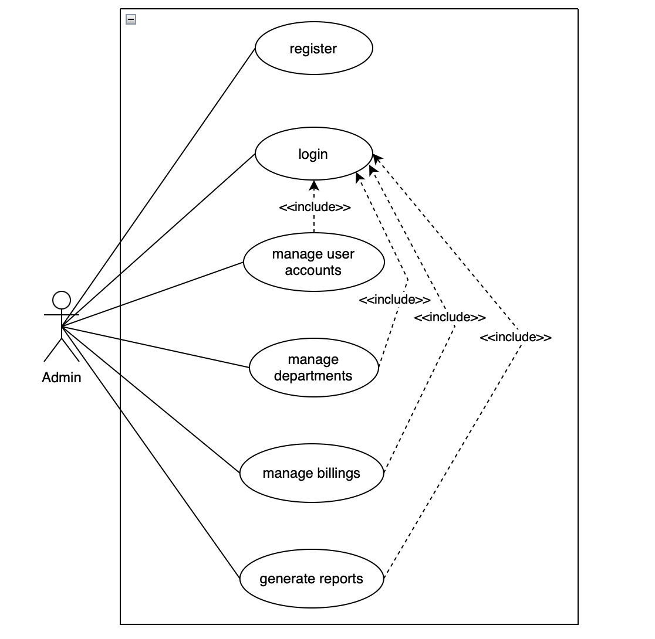
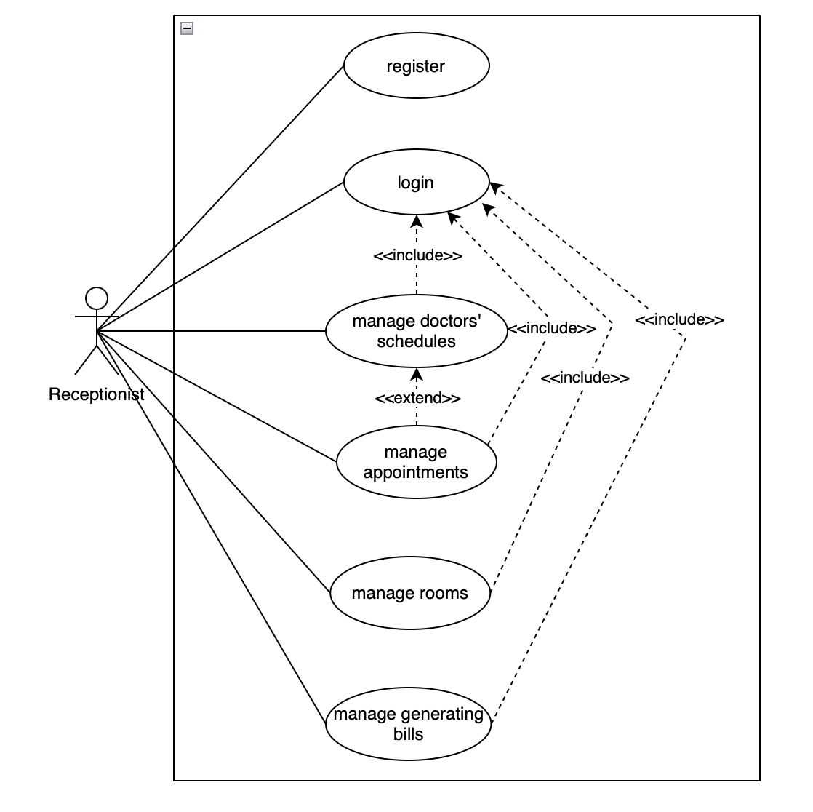
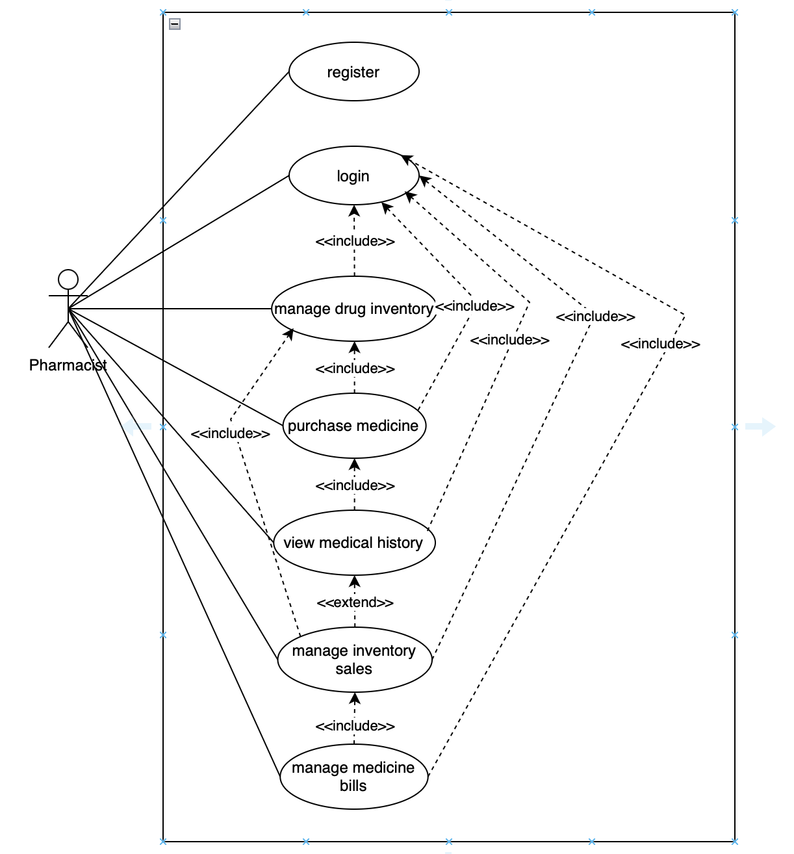

Figure 3.4 Use Case Diagram for Hospital Management System

Use Case Descriptions

Patient
- Register: The patient can create a new account by providing personal details like name, contact information, and medical history.
- Login: Once registered, the patient can log in to access the system securely.
- View Medical History: Patients can access their past medical records, diagnoses, treatments, and prescriptions.
- Book Appointments: Patients can book appointments with doctors based on availability.
- Cancel Appointment: Patients can cancel previously booked appointments if needed.

Doctor
- Register: Doctors can create their accounts by providing professional credentials and specialties.
- Login: Once registered, doctors can log into their profile to manage their schedules and consultations.
- View Medical History: Doctors can view the medical history of patients they are treating, including past consultations, treatments, and medications.
- Conduct Consultation: Doctors can consult with patients, provide diagnoses, and recommend treatments.
- Update Medical History: After consultation, doctors can update the patient's medical record with new findings, diagnoses, and treatment plans.
- Manage Treatments: Doctors can manage and update treatment plans and prescriptions for patients.
- Manage Schedules: Doctors can set and modify their availability and consultation hours.

Nurse
- Register: Nurses can create their profiles by submitting personal and professional information.
- Login: Once registered, nurses can log into the system for access to their duties.
- Conduct Consultation: Nurses assist doctors in patient care, monitor vital signs, and help in basic consultations or routine check-ups.

Admin
- Register: The admin creates the accounts for all users (patients, doctors, nurses, etc.) in the system.
- Login: Admins have secure access to the backend of the system for managing users and operations.
- Manage User Accounts: Admins can create, update, or delete user accounts across all categories (patients, doctors, nurses, etc.).
- Manage Departments: Admins can create or manage hospital departments (e.g., cardiology, pediatrics) and allocate resources.
- Manage Billings: Admins have access to billing systems, overseeing the creation and management of invoices for patient treatments.
- Generate Reports: Admins can generate various reports for hospital performance, financials, patient outcomes, and staff activities.

Receptionist
- Register: Receptionists can register by entering their professional information.
- Login: Receptionists log in to access their schedule management and appointment systems.
- Manage Doctors' Schedules: Receptionists help manage and update doctors' appointment schedules, ensuring no overlap or conflicts.
- Manage Appointments: Receptionists book, reschedule, and cancel patient appointments with doctors.
- Manage Rooms: Receptionists oversee the availability of hospital rooms, assigning rooms to patients as needed.
- Generate Bills: Receptionists assist in generating bills for services provided to patients, including consultation fees and room charges.

Pharmacist
- Register: Pharmacists can create accounts by providing their professional details and credentials.
- Login: Pharmacists log into their profile to manage inventory and sales.
- Manage Drug Inventory: Pharmacists can track and manage the availability of medicines, including stock levels and expiration dates.
- Purchase Medicine: Pharmacists can order medicine to replenish stock, ensuring necessary medications are available.
- View Medical History: Pharmacists have access to patients' medical history related to prescriptions and treatments.
- Manage Inventory Sales: Pharmacists can oversee and process the sales of medicines, ensuring the proper recording of transactions.
- Manage Medicine Bills: Pharmacists generate bills for medications dispensed to patients, and ensure payment is recorded.

3.4 Sequence Diagram
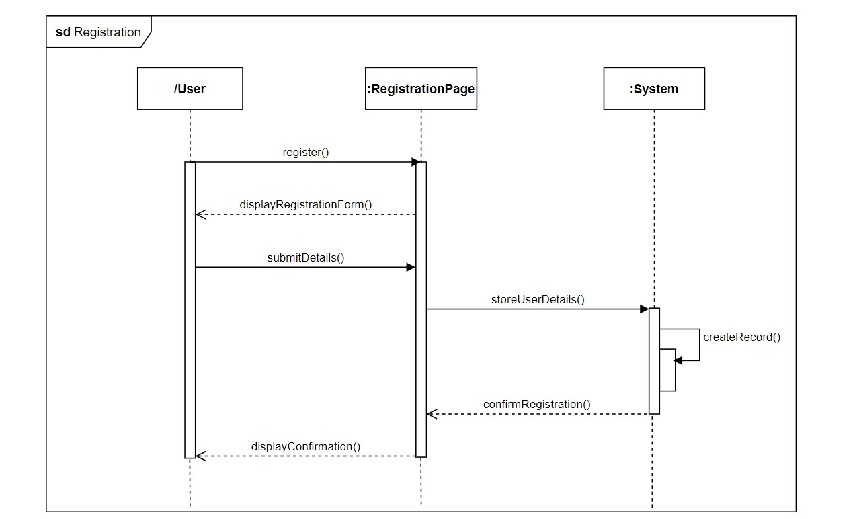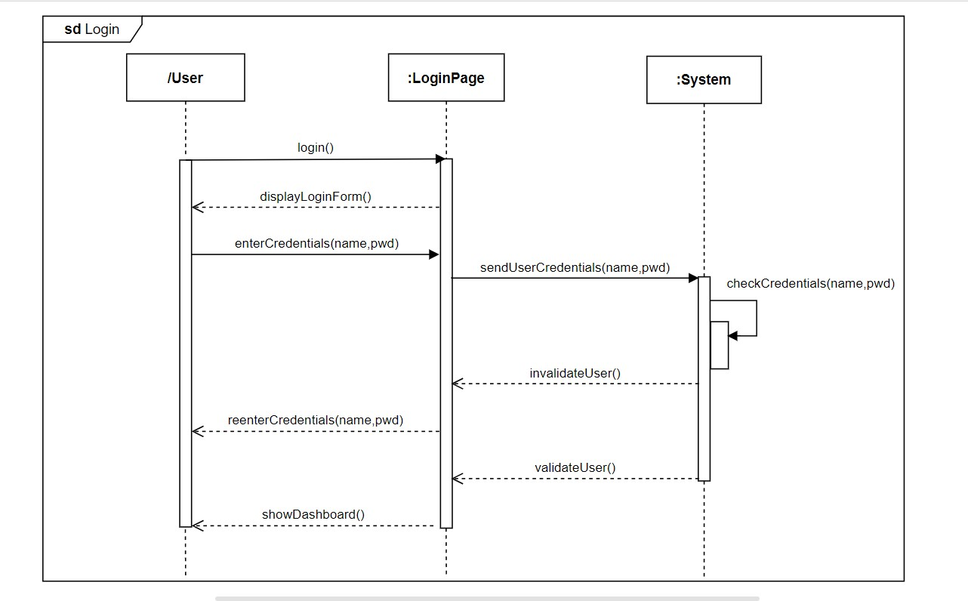
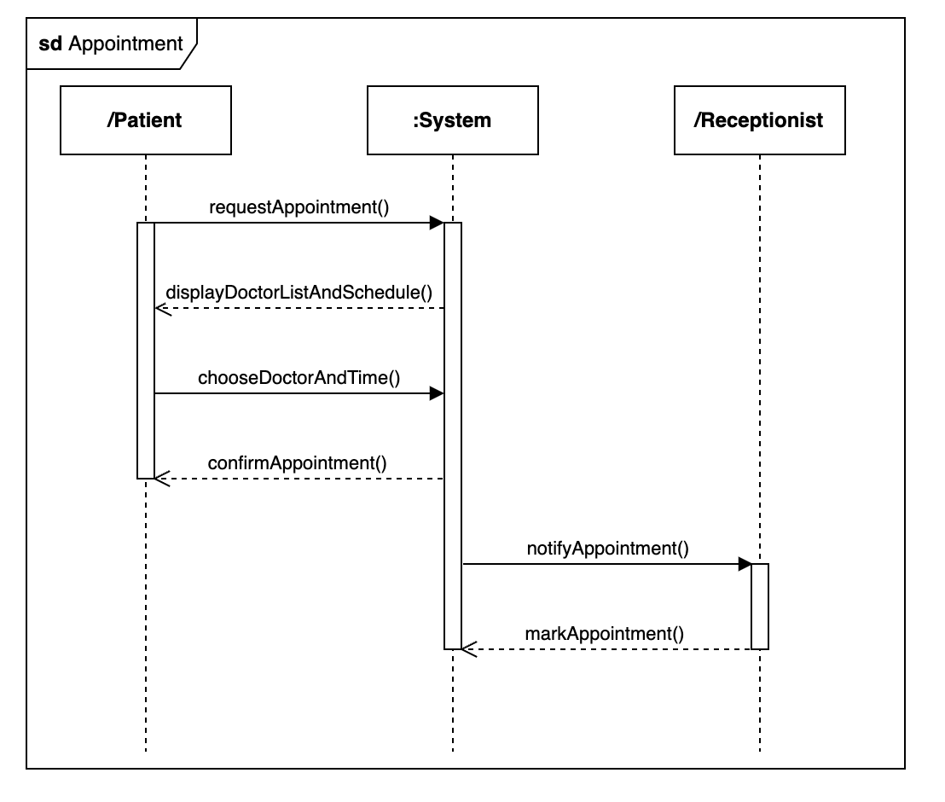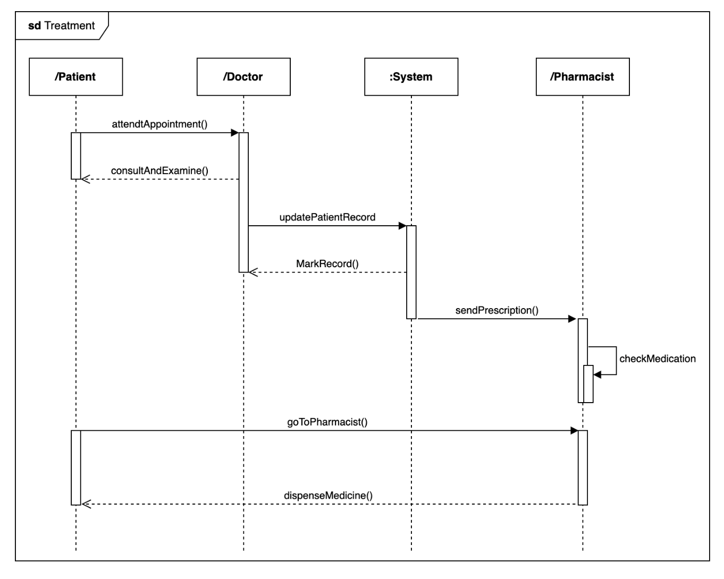
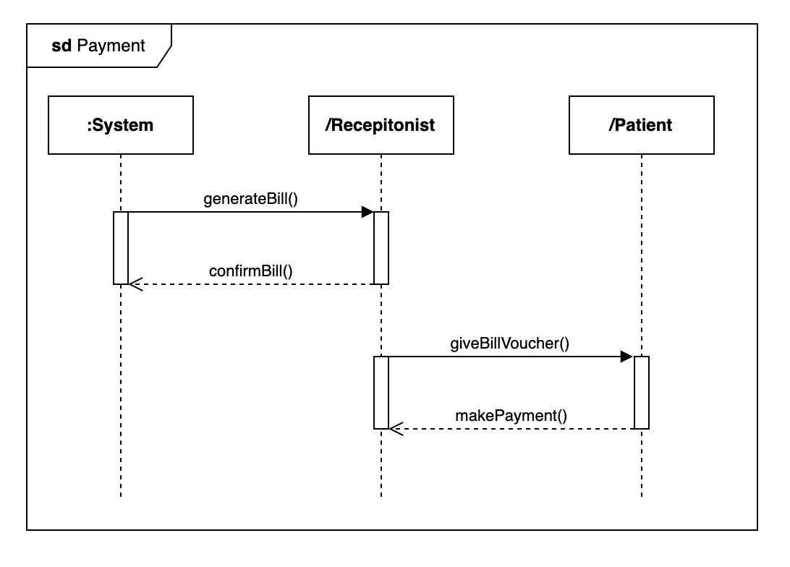
Figure 3.5 Sequence Diagram for Hospital Management System

The login sequence diagram for the login process illustrates the interaction between the user, the login page, and the system. The user initiates the process by accessing the login page, which displays the login form. The user then enters their credentials (username and password). The system sends these credentials for verification, checks their validity, and either validates or invalidates the user. If the credentials are valid, the system renders the user's credentials and displays the dashboard. This sequence ensures a secure and efficient login process.
The registration sequence diagram outlines the steps a new user follows to create an account. The user starts by accessing the registration form, which is displayed by the system. After filling in the required details, the user submits the form. The system then stores these details, creates a new user record, and confirms the registration. Finally, a confirmation message is displayed to the user, indicating that the registration process is complete. This sequence ensures a smooth and user-friendly registration experience.

The appointment sequence diagram depicts the process of scheduling a medical appointment. The patient initiates the process by requesting an appointment. The system displays a list of available doctors and their schedules. The patient selects a preferred doctor and time slot. The system then confirms the appointment and notifies the patient. The receptionist marks the appointment in the system, ensuring that the schedule is updated. This sequence facilitates efficient appointment management and communication.
The treatment sequence diagram illustrates the workflow from patient attendance to medication dispensing. The patient attends the scheduled appointment, where the doctor conducts an examination and updates the patient's medical record. The doctor then marks the record and sends a prescription to the pharmacist. The pharmacist checks the prescribed medication and dispenses it to the patient. This sequence ensures that the treatment process is well-coordinated and that the patient receives the necessary care and medication.
The payment sequence diagram shows the steps involved in processing a payment. The system generates a bill based on the services provided. The receptionist confirms the bill and provides a bill voucher to the patient. The patient then makes the payment using the preferred method. This sequence ensures that the billing and payment process is clear and straightforward for both the patient and the receptionist.

3.5 Collaboration Diagram
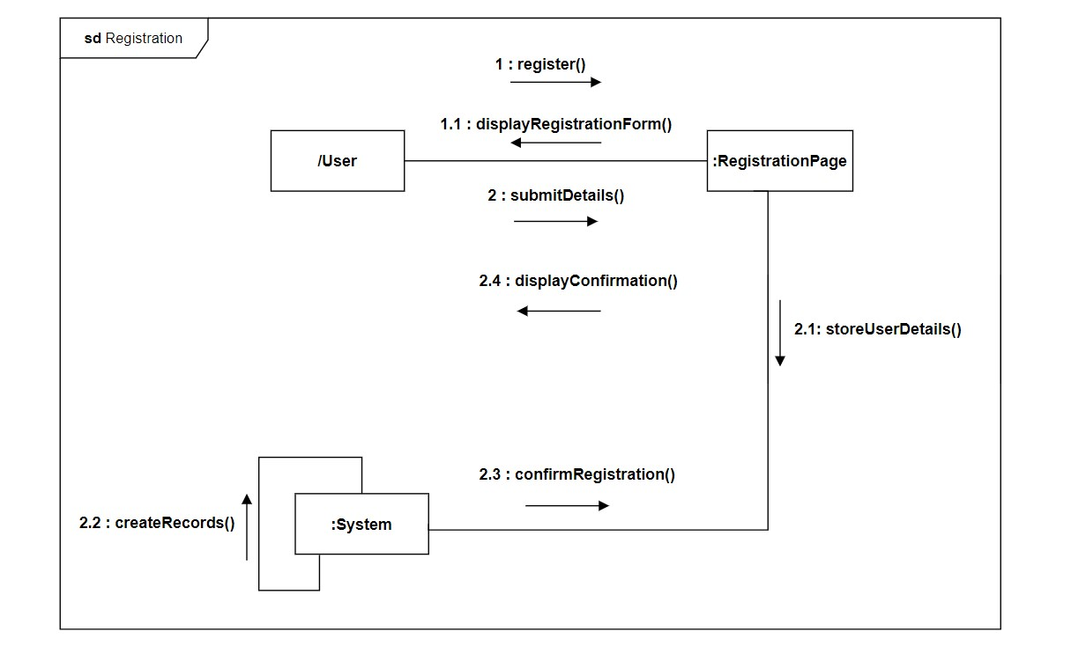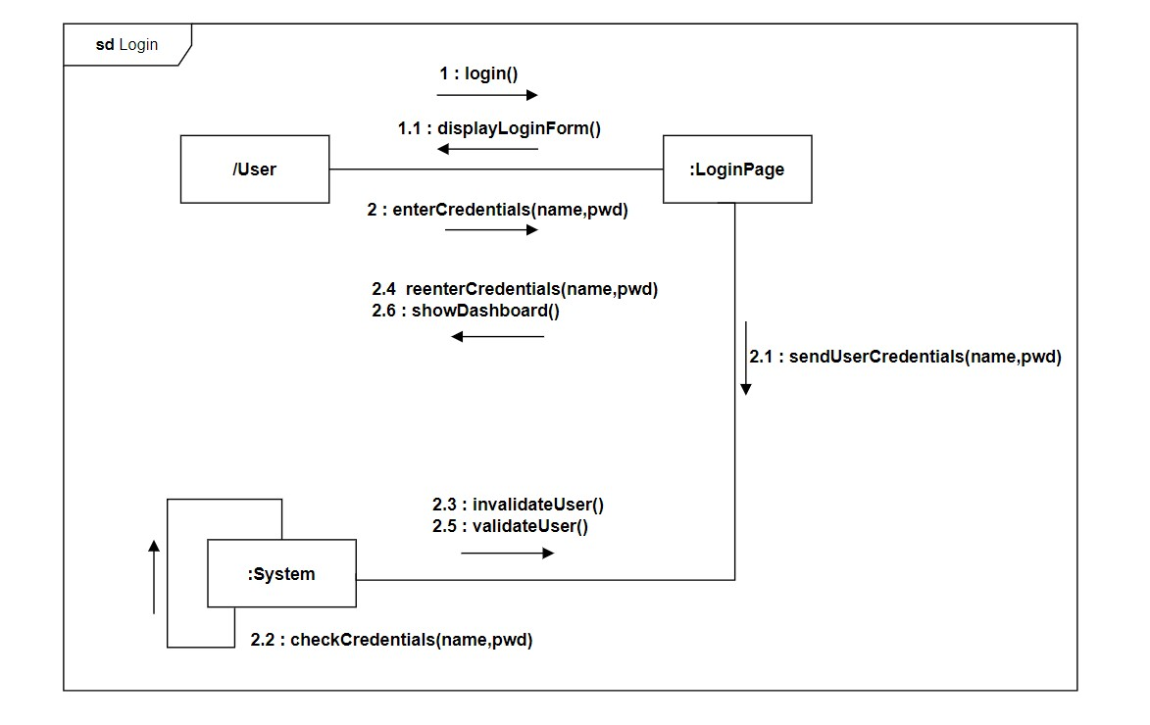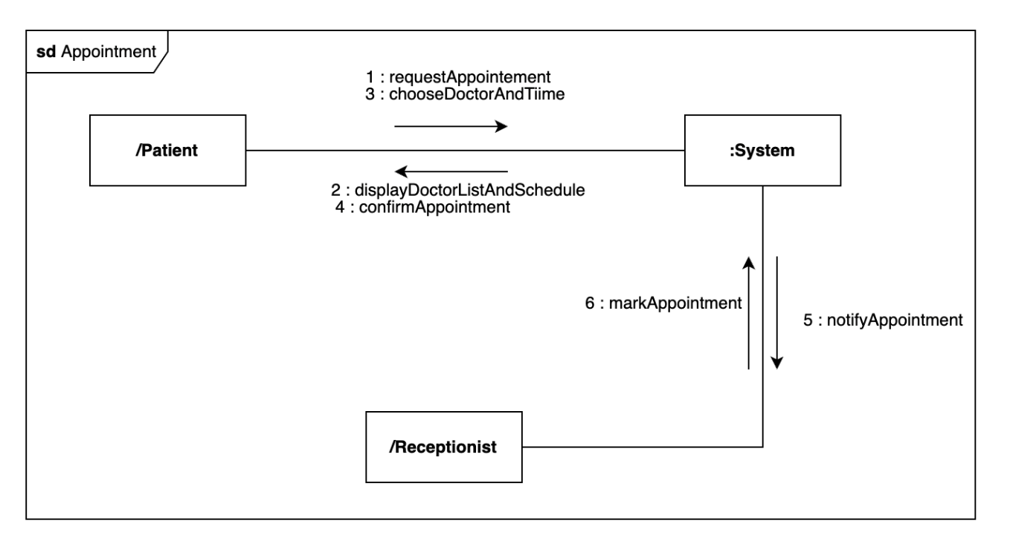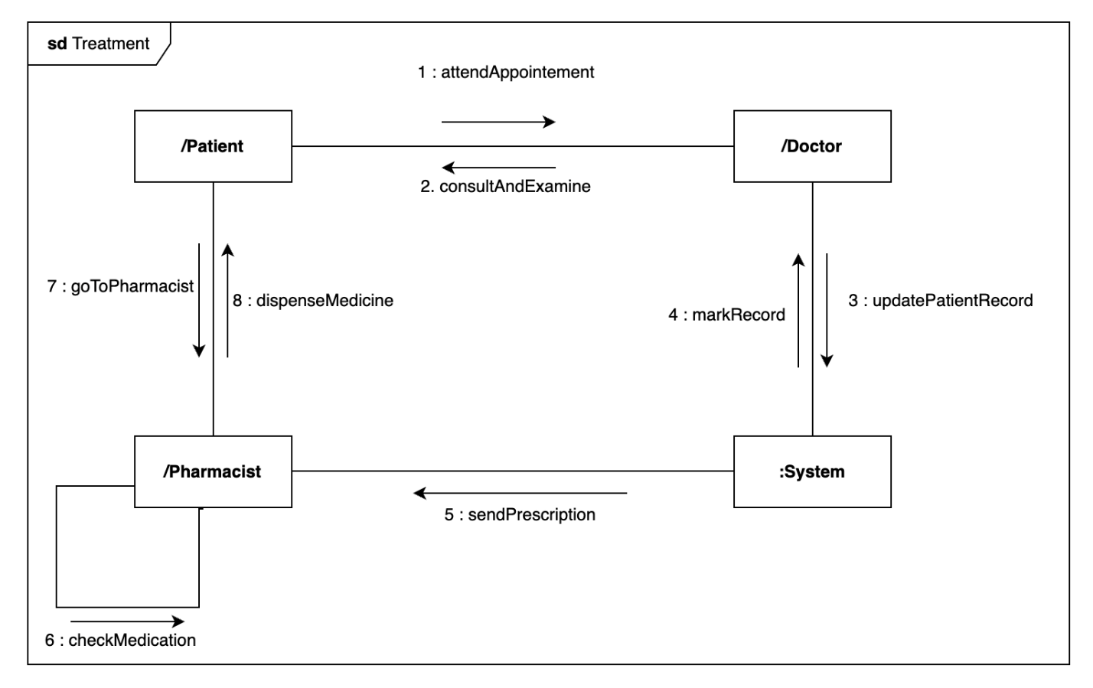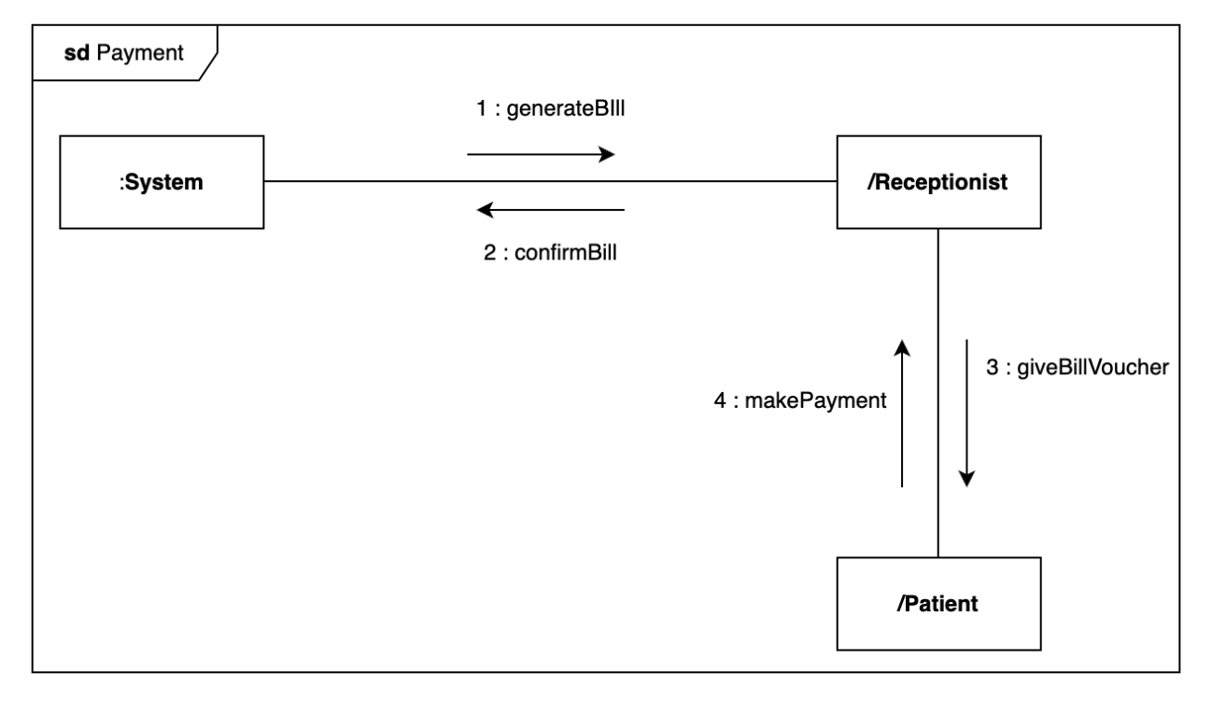
Figure 3.6 Collaboration Diagram for Hospital Management System

The login diagram represents a collaboration model for the login process in the Hospital Management System. It illustrates the interaction between the User, Login Page, and System. The process begins with the User initiating the login process (login()), which prompts the system to display the login form (displayLoginForm()). The User enters their credentials (enterCredentials(name, pwd)), which are sent to the system for validation (sendUserCredentials(name, pwd)). The system checks the credentials (checkCredentials(name, pwd)) and either validates (validateUser()) or invalidates (invalidateUser()) the User. If the credentials are invalid, the User is prompted to re-enter them (reenterCredentials(name, pwd)). Upon successful validation, the system displays the dashboard (showDashboard()), allowing the User to proceed with their activities. This collaboration ensures a secure and efficient login process for hospital staff and patients.
The registration diagram represents a collaboration model for the registration process in the Hospital Management System. It illustrates the interaction between the User, Registration Page, and System. The process begins with the User initiating the registration process (register()), which prompts the system to display the registration form (displayRegistrationForm()). The User submits their details (submitDetails()), which are stored by the system (storeUserDetails()). The system then creates a record (createRecords()) and confirms the registration (confirmRegistration()). Finally, a confirmation message is displayed to the User (displayConfirmation()), completing the registration process. This collaboration ensures a smooth and user-friendly account creation process for new patients or staff members.
The appointment diagram represents a collaboration model for the appointment scheduling process in the Hospital Management System. It illustrates the interaction between the Patient, System, and Receptionist. The process begins with the Patient requesting an appointment (requestAppointment()). The system displays a list of available doctors and their schedules (displayDoctorListAndSchedule()). The Patient selects a preferred doctor and time slot (chooseDoctorAndTime()), and the system confirms the appointment (confirmAppointment()). The Receptionist marks the appointment in the system (markAppointment()), ensuring that the schedule is updated. This collaboration facilitates efficient appointment management and clear communication between patients, doctors, and receptionists.
The treatment diagram represents a collaboration model for the treatment process in the Hospital Management System. It illustrates the interaction between the Patient, Doctor, System, and Pharmacist. The process begins with the Patient attending the scheduled appointment (attendAppointment()). The Doctor conducts an examination (consultAndExamine()) and updates the Patient’s medical record (updatePatientRecord()). The Doctor then marks the record (markRecord()) and sends a prescription to the Pharmacist (sendPrescription()). The Pharmacist checks the medication (checkMedication()) and dispenses it to the Patient (dispenseMedicine()). This collaboration ensures a well-coordinated treatment process, from diagnosis to medication delivery, providing the Patient with the necessary care.
The payment diagram represents a collaboration model for the payment process in the Hospital Management System. It illustrates the interaction between the System, Receptionist, and Patient. The process begins with the system generating a bill (generateBill()), which is confirmed by the Receptionist (confirmBill()). The Receptionist provides a bill voucher to the Patient (giveBillVoucher()), who then makes the payment (makePayment()). This collaboration ensures a transparent and straightforward billing process for both the Patient and the Receptionist, facilitating smooth financial transactions within the hospital system.

3.6 Statechart Diagram
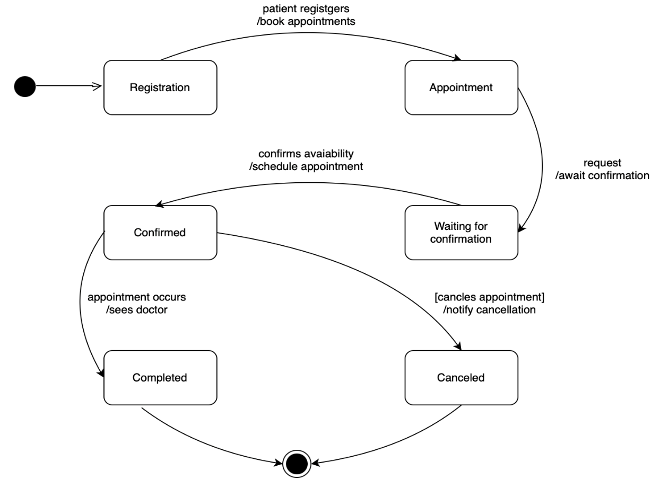
Figure 3.7 Statechart Diagram for Patient Appointment
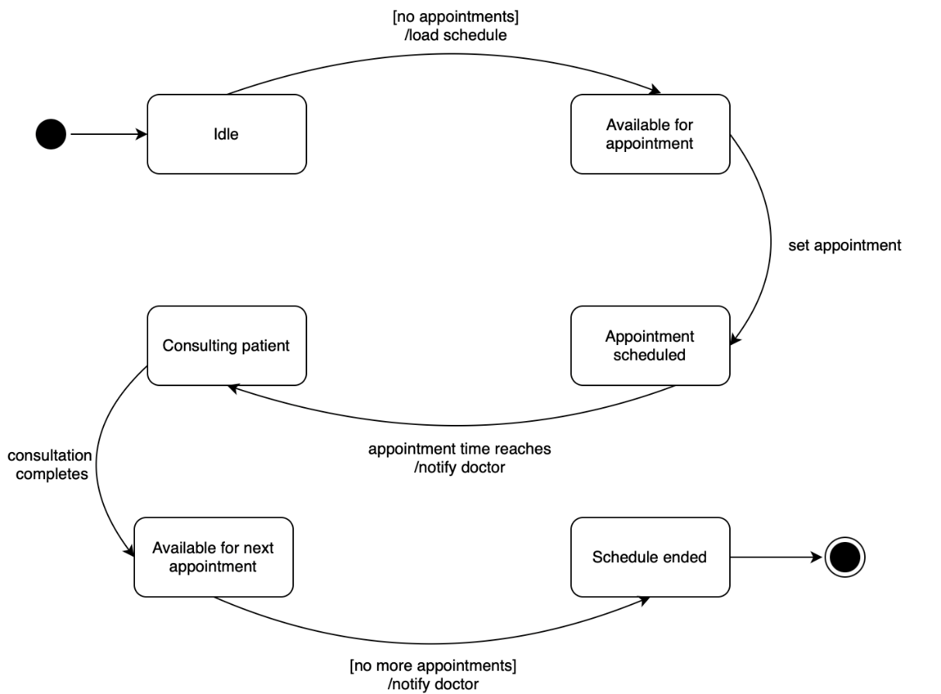
Figure 3.8 Statechart Diagram for Doctor Scheduling
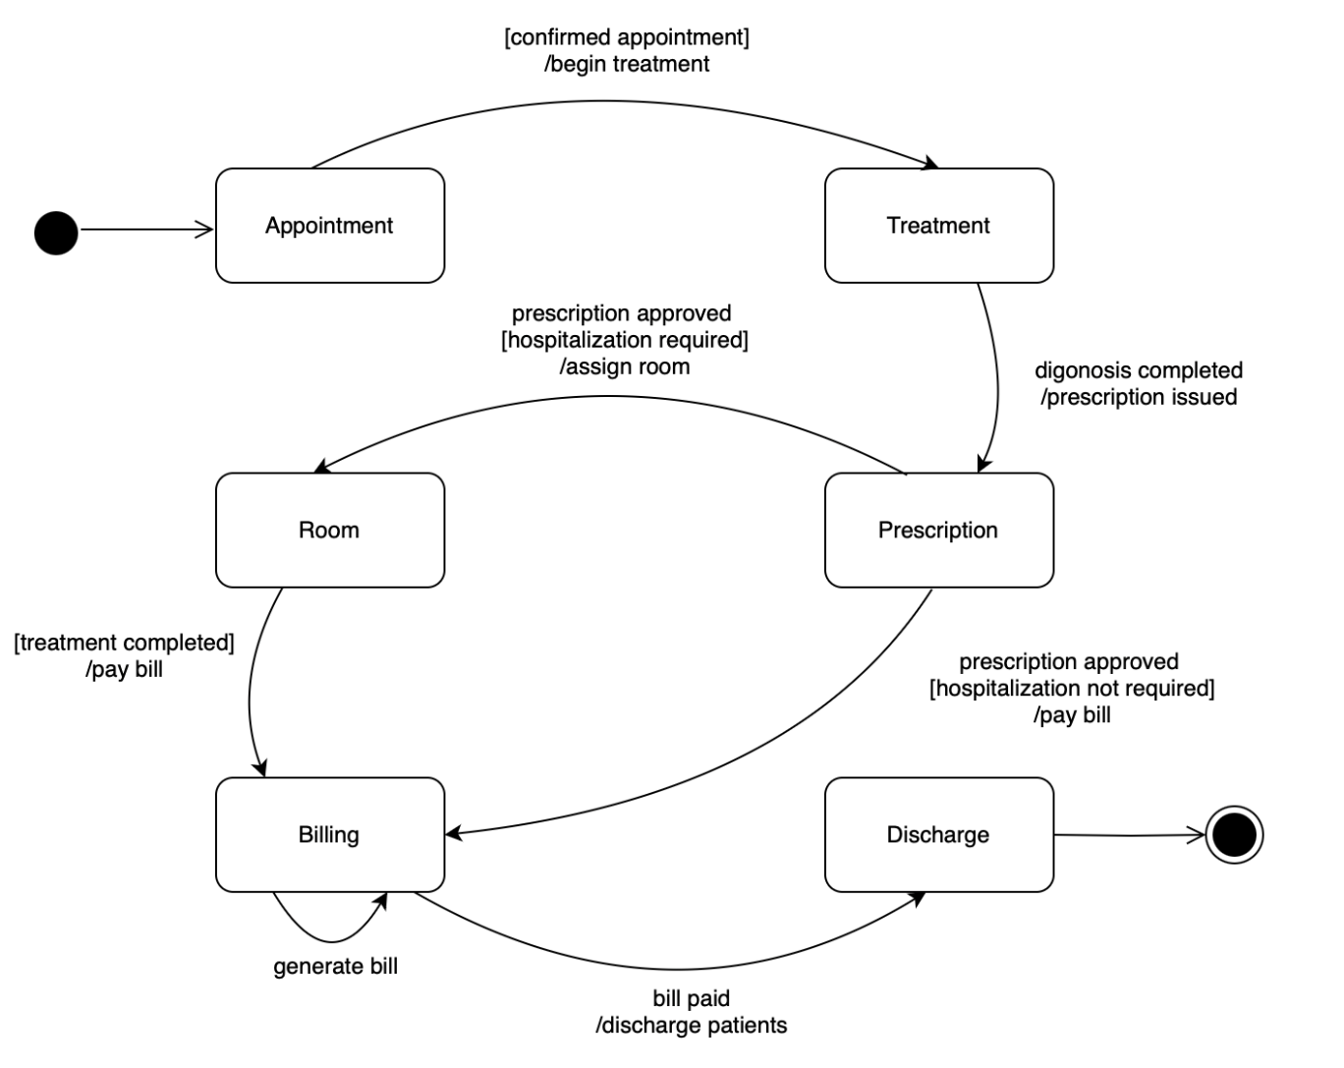
Figure 3.9 State Chart Diagram for Billing

This registration diagram depicts a state machine for a patient appointment system, likely created using draw.io, as indicated in the browser tab. The process begins with Registration, where a patient registers and books an appointment. This transitions to the Appointment state, where the system confirms availability and schedules the appointment, or the patient requests and awaits confirmation. Upon confirmation, the appointment moves to the Confirmed state. If the appointment occurs and the patient sees the doctor, it progresses to Completed. Alternatively, if the appointment is canceled, the system notifies the patient and moves to the Canceled state. The diagram illustrates the various stages and transitions a patient appointment goes through, from initial registration to completion or cancellation.
This doctor scheduling state diagram, created in draw.io, illustrates the lifecycle of a doctor's schedule and appointments. It begins with the Idle state, transitioning to Available for Appointment when there are no appointments and the schedule is loaded. Once an appointment is set, the state moves to Appointment Scheduled. When the appointment time arrives, the doctor is notified, and the state changes to Consulting Patient. Upon completion of the consultation, the doctor becomes Available for Next Appointment. The process continues until the schedule ends, moving to the Schedule Ended state, marking the termination of the doctor's appointment cycle. This diagram effectively visualizes the flow of states and transitions in a doctor's daily appointment schedule.
This billing state chart diagram, created in draw.io, illustrates the lifecycle of a patient's bill within a healthcare system. It begins with an Appointment, transitioning to Treatment upon confirmation and initiation. If hospitalization is required, the patient moves to the Room state after the prescription is approved and a room is assigned. Following treatment completion, the patient enters Billing, where a bill is generated. Simultaneously, a Prescription state is entered after diagnosis, leading to Discharge if hospitalization is not required, or back to Room if it is. From both Billing and Discharge, the process converges at the end state once the bill is paid and the patient is discharged. The diagram effectively visualizes the sequential flow and conditional branching based on hospitalization needs, highlighting key stages from appointment to final discharge and billing.

Chapter 4

IMPLEMENTATION DIAGRAMS

4.1 Component Diagram
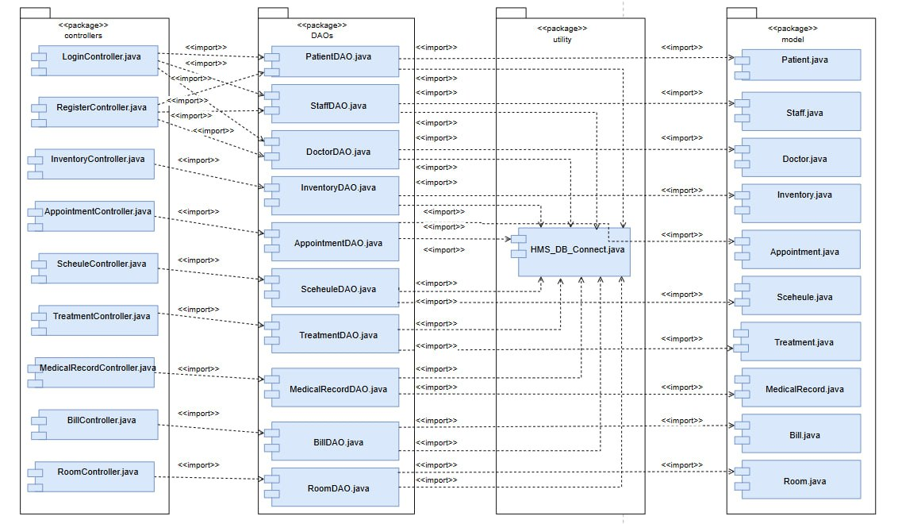
Figure 4.1 Component Diagram for Hospital Management System

This diagram illustrates the architectural structure of a Hospital Management System (HMS) application, showcasing its division into four main packages: controllers, DAOs (Data Access Objects), utility, and model. The controllers package contains classes that handle user interactions and application logic, such as LoginController and AppointmentController, each importing necessary classes from other packages. The DAOs package provides an abstraction layer for database operations, with classes like PatientDAO and BillDAO facilitating data retrieval and manipulation. The utility package includes supporting classes like HMS_DB_Connect, which manages database connections and is utilized by various DAOs. The model package defines the application's data structures, such as Patient, Doctor, and Appointment, representing the entities within the system. The diagram highlights the dependencies between these packages, with controllers relying on DAOs for data access, DAOs using the utility for database connectivity, and both controllers and DAOs interacting with the model for data representation. This structure promotes modularity, maintainability, and clear separation of concerns within the HMS application.

Chapter 5

CONCLUSION

In conclusion, the Hospital Management System (HMS) enhances healthcare efficiency by streamlining patient records, appointment scheduling, billing, and inventory management. It reduces administrative workload, minimizes errors, and improves communication between departments, ensuring better patient care. By digitizing records and automating processes, HMS enhances data security and optimizes hospital resources. As technology advances, integrating AI and telemedicine can further revolutionize healthcare, making HMS an essential tool for modern hospitals. Despite challenges such as implementation costs and data security concerns, a well-designed HMS significantly enhances hospital operations, ensuring seamless healthcare delivery and improved patient satisfaction.

REFERENCES
- https://www.softwareideas.net/
- https://www.uml-diagrams.org/
- https://www.softwareideas.net/uml-diagram-hospital-management-system
- https://www.diva-portal.org/smash/get/diva2:1852404/FULLTEXT01.pdf

