Project Title
Project Recommendation and Learning Platform

Semester IX
Capstone Project (IS-112)
B.C.Sc. (Software Engineering)

Diagrams

Submitted by: Group 7
Section : A

Roll No | Name | Role
YKPT-22276 | Chan Myae Kyaw | Leader
YKPT-21382 | Pan Phyu Sin | Member
YKPT-21415 | Mon Han Khin | Member
YKPT-22283 | Thant Tee Kyi Zaw | Member
YKPT-22307 | Yoon Nandar Moe | Member

Use Case Diagram
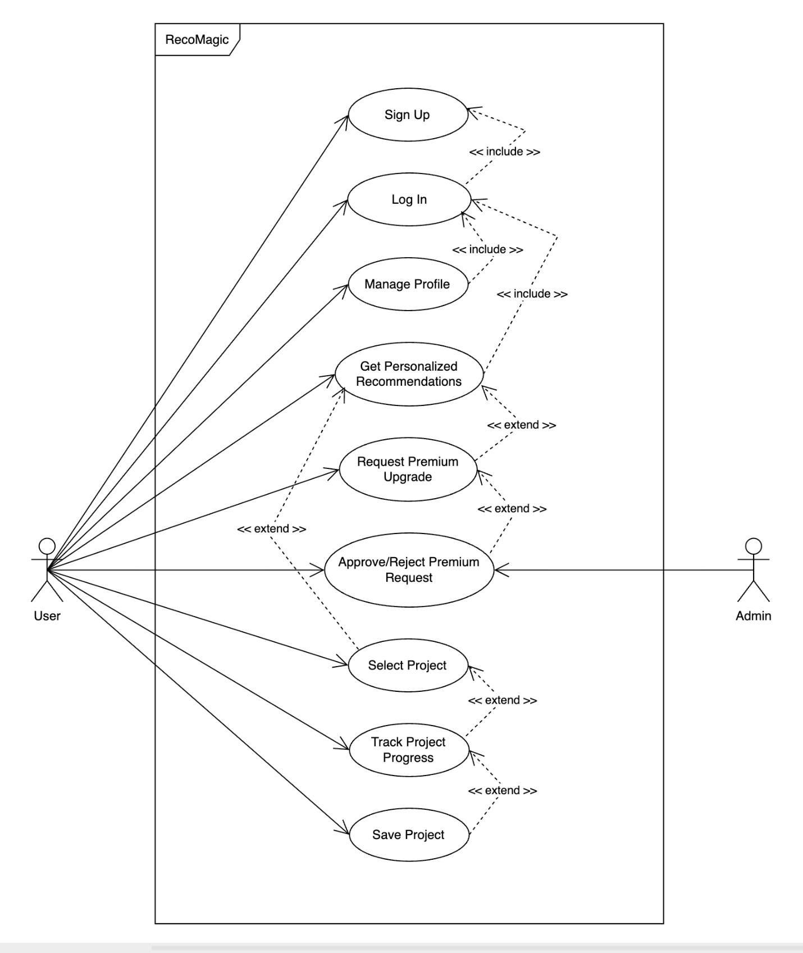

Flowchart Diagram
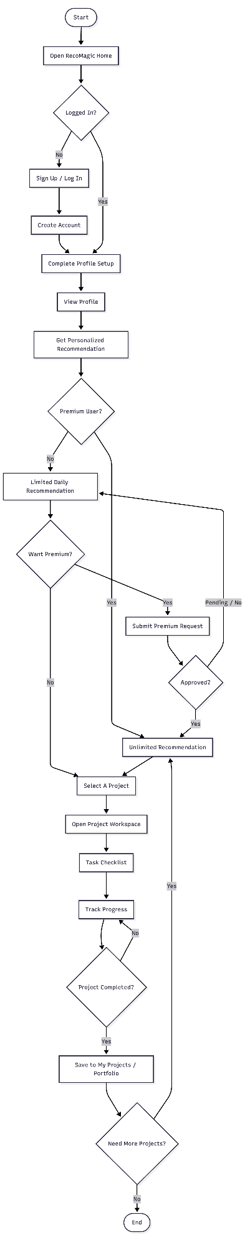
Entity Relationship Diagram

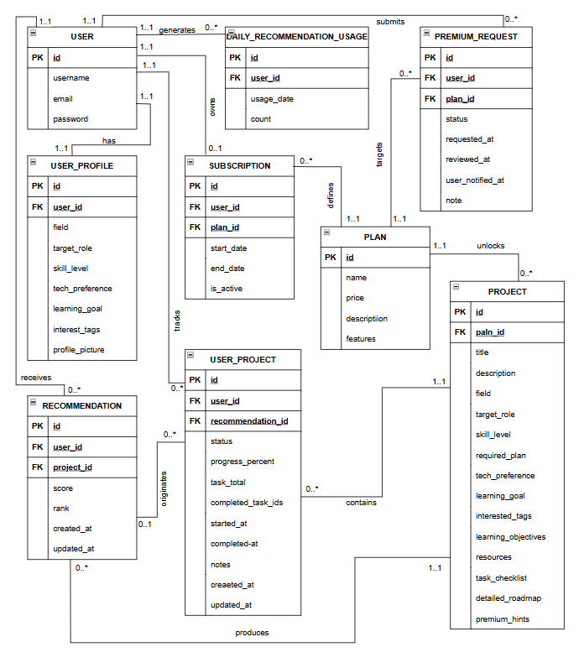

Class Diagram

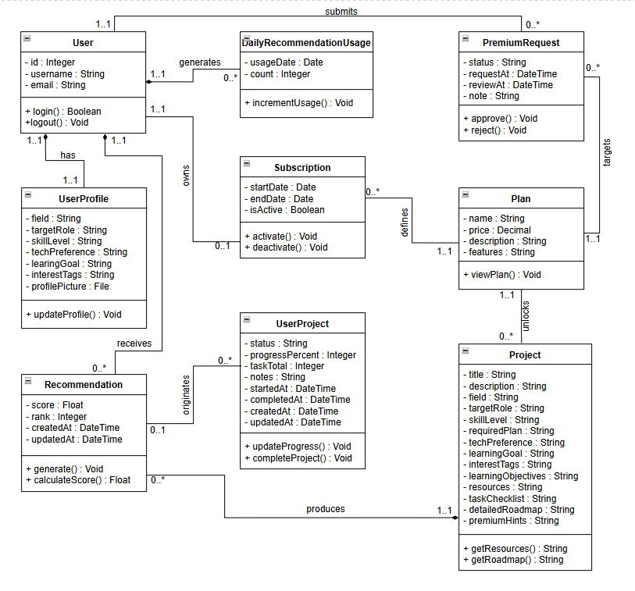

Sequence Diagrams

- User Login

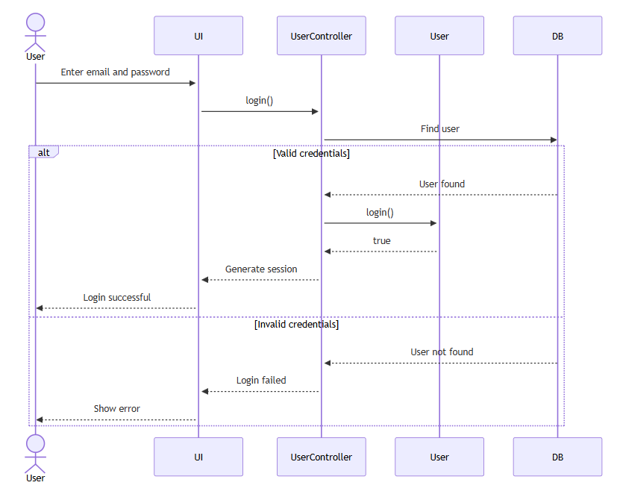

- Personalized Recommendation

  - Get Personalized Recommendation – Limit still left and request allowed

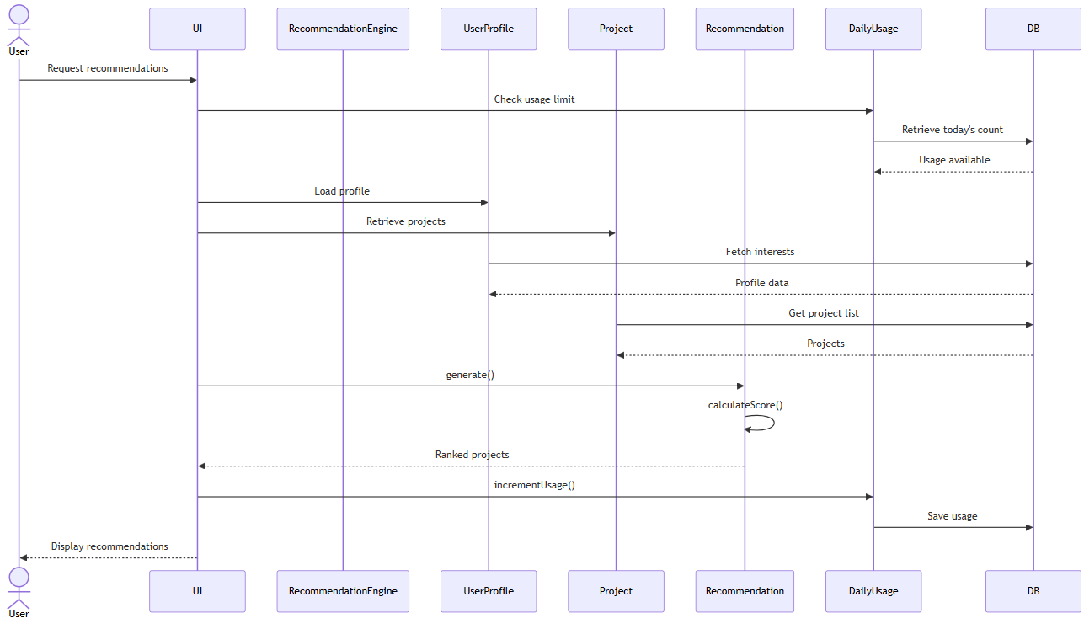

  - Get Personalized Recommendation – Limit exceeded and request denied

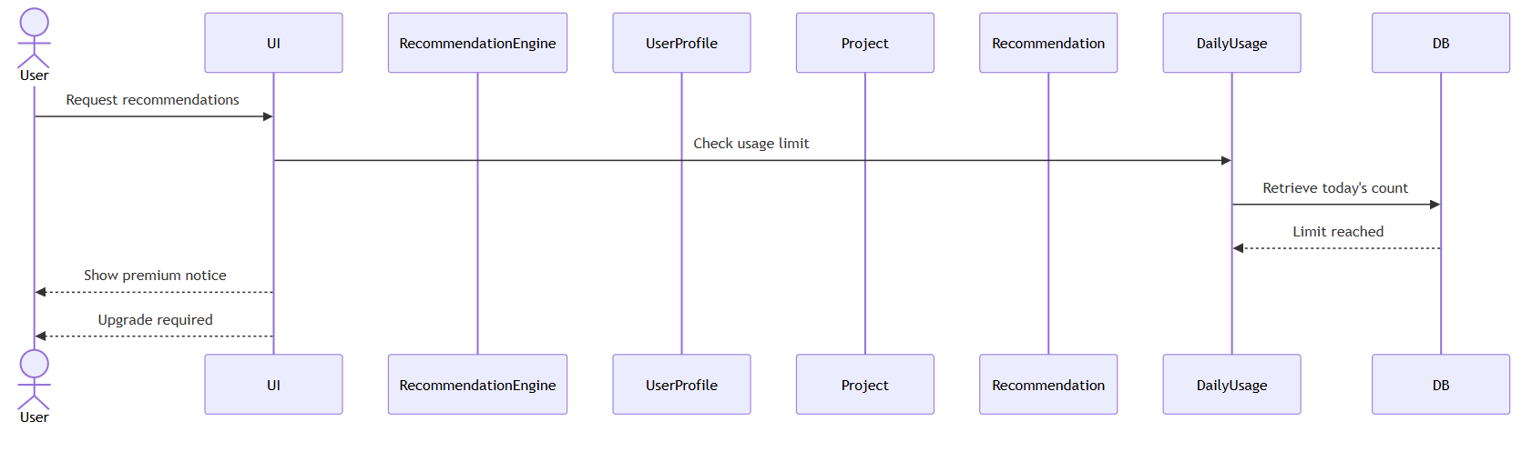

- Tack Project Progress

