**VIETNAM - KOREA UNIVERSITY OF INFORMATION AND COMMUNICATION TECHNOLOGY**

**Department of Computer and Electronics Engineering**



**CLOUD COMPUTING  
PROJECT REPORT**

**TOPIC: Write a NodeJS+MongoDB+Railway application with at least 2 functions. Write a guide: how to deploy to the Railway and connect to MongoDB.**

|  |  |
| --- | --- |
| **Students perform:** | **Dinh Huu Duc**  **Nguyen Viet Tan**  **Ha Viet Hung** |
| **Instructor:** | **Dang Quang Hien** |

***Da Nang, March 2024***

**VIETNAM - KOREA UNIVERSITY OF INFORMATION AND COMMUNICATION TECHNOLOGY**

**Department of Computer and Electronics Engineering**



**CLOUD COMPUTING  
PROJECT REPORT**

**TOPIC: Write a NodeJS+MongoDB+Railway application with at least 2 functions. Write a guide: how to deploy to the Railway and connect to MongoDB.**

|  |  |
| --- | --- |
| **Students perform:** | **Dinh Huu Duc**  **Nguyen Viet Tan**  **Ha Viet Hung** |
| **Instructor:** | **Dang Quang Hien** |

***Da Nang, March 2024***

**COMMENT**

(Instructor)

………………………………………………………………………………………………………………………………………………………………………………………………………………………………………………………………………………………………………………………………………………………………………………………………………………………………………………………………………………………………………………………………………………………………………………………………………………………………………………………………………………………………………………………………………………………………………………………………………………………………………………………………………………………………………………………………………………………………………………………………………………………………………………………………………………………………………………………………………………………………………………………………………………………………………………………………………………………………………………………………………………………………………………………………………………………………………………………………………………………………………………………………………………………………………………………………………………………………………………………………………………………………………………………………………………………………………………………………………………………………………………………………………………………………………………………

**Confirmed by instructors**

**Dr. Dang Quang Hien**

**THANK YOU**

First, my team would like to send our sincere thanks to Vietnam - Korea University of Information and Communications Technology for including the subject " **Cloud Computing"** in the curriculum. In particular, we would like to express our deep gratitude to the subject lecturer - **Dr. Dang Quang Hien** has taught and imparted valuable knowledge to us during our recent study period. During the time participating in his class, we gained a lot of useful knowledge and a spirit of effective and serious learning. This will certainly be valuable knowledge and a basis for us to be able to move forward firmly in the future.

The subject **"Cloud Computing"** is an interesting, extremely useful and highly practical subject. Ensure to provide enough knowledge, linked to the practical needs of students. However, because knowledge is still limited and the ability to absorb reality is still confusing. Although we have tried our best, it is certainly difficult for the essay to avoid shortcomings and many inaccuracies. We hope that teachers will review and give suggestions to improve our essay. than.

We sincerely thank you!

TABLE OF CONTENTS

Chapter 1 OVERVIEW OF THE TOPIC 8

1.1. Reason For Choosing The Topic 8

1.2. Objectives And Scope 8

1.2.1. Learn about cloud computing and Railway 8

1.2.2. Analyze resource provisioning models in cloud computing 8

1.2.3. Building a case study on Railway 8

1.2.4. Design and build a resource provisioning tool based on the analyzed model 8

1.2.5. Evaluate and compare the effectiveness of the built tool 8

1.2.6. Conclusion and suggestions 8

1.3. Research Methods 9

1.3.1. Learn and analyze existing cloud resource models 9

1.3.2. Detailed research on Railway 9

1.3.3. Determine requirements and design tools 9

1.3.4. Develop and deploy tools on Railway 9

1.3.5. Perform performance testing and evaluation 9

1.4. Scientific significance 9

1.4.1. Improve performance and efficiency in using cloud resources 9

1.4.2. Enhanced security and reliability 9

1.4.3. Promoting cloud technology development 9

1.4.4. Contribute to global advancement in technology 10

Chapter 2 OVERVIEW OF RESOURCE PROVISIONING IN CLOUD AND RAILWAY COMPUTING 11

2.1. Introduction to cloud computing 11

2.1.1. What is cloud computing? 11

2.1.2. How does cloud computing work? 11

2.1.3. Benefits of cloud computing 11

2.1.4. Basic knowledge about Cloud Computing Services 12

2.1.5. Introduction to classification 12

2.1.6. Cloud translation model 16

2.2. Resource provisioning model 17

2.2.1. (nVM – out – of – 1PM) 17

2.2.2. (nVM – out – of – NPM) 17

2.3. Railways 17

2.3.1. Introduction to Railways 17

2.3.2. Case Study 19

2.3.3. Reasons to choose Railway 20

2.3.4. Railway structure 20

2.3.5. Railway service 20

2.3.6. Railway environment 21

Chapter 3 PRODUCT DEMO 22

3.1. Introducing The Experimental Environment 22

3.2. Installation Steps 22

3.3 Installation results 26

RESULTS AND DISCUSSION 28

REFERENCES 30

**LIST OF IMAGES**

Figure 1 What is cloud computing? 11

Figure 2 Introduction to Railway Services 18

Figure 3 Railway 's resource provisioning service 18

Figure 4 Prepare source code on github 22

Figure 5 Mongo db 23

Figure 6 mongodb environment variables 23

Figure 7 Deploying the application using github 24

Figure 8 Application environment variables 24

Figure 9 Application environment variables 25

Figure 10 Deploying the application and viewing logs 25

Figure 11 Creating a domain for the application 26

Figure 12 Product creation page 26

Figure 13 Product view and search page 27

# OVERVIEW OF THE TOPIC

## Reason For Choosing The Topic

Cloud computing, especially the convenience of public cloud, is growing rapidly and becoming one of the primary platforms for cloud services. Research on how to provision resources in the cloud and build tools based on Railway will provide a lot of additional knowledge and career opportunities.

## Objectives And Scope

### Learn about cloud computing and Railway

Definition, operating principles, advantages and applications of cloud computing.

About Railway and the services and resources it provides.

### Analyze resource provisioning models in cloud computing

Survey of popular resource provisioning models in cloud computing.

Learn how the models work and the advantages and limitations of each model.

### Building a case study on Railway

Select a specific application or service on Railway to study in detail.

Learn how to provision resources for this application/service on Railway and how to manage resources effectively.

### Design and build a resource provisioning tool based on the analyzed model

Build a tool or interface to provide resources for applications/services on Railway based on the learned model.

Optimize and ensure tool effectiveness.

### Evaluate and compare the effectiveness of the built tool

Conduct testing and evaluate the effectiveness of the tool compared to traditional resource provisioning methods.

Compare the effectiveness and benefits that the tool brings.

### Conclusion and suggestions

Summarize the research, evaluate the results, and propose directions for developing and improving the performance of the resource provisioning tool.

## Research Methods

### Learn and analyze existing cloud resource models

Review and analyze widely adopted cloud resource provisioning models, focusing on aspects such as flexibility, performance, security, and cost.

### Detailed research on Railway

Learn about Railway's engineering and infrastructure, including resource provisioning services, pricing models, and related policies.

### Determine requirements and design tools

Identify functional and non-functional requirements for Railway based service delivery engine.

Design the tool's architecture and user interface.

### Develop and deploy tools on Railway

Build cloud resource provisioning tools using Railway services such as construction, transportation and monitoring applications.

Deploy and ensure tool stability on Railway environment.

### Perform performance testing and evaluation

- Perform performance tests to evaluate the tool's scalability, response time, and peak load.

- Record and analyze test results to improve performance.

## Scientific significance

### Improve performance and efficiency in using cloud resources

This research helps improve cloud resource utilization, optimize performance, and reduce waste. This has great implications for organizations and businesses that want to optimize costs and increase flexibility in resource management.

### Enhanced security and reliability

By understanding and building a cloud resource provisioning model, this topic can play an important role in increasing the security and reliability of cloud systems, protecting important data and information. user's personal information.

### Promoting cloud technology development

Researching models and building management tools based on the foundation of a leading cloud service like Railway helps promote the development of cloud technology, create new innovations and applications, thereby bringing benefits to customers. Great benefits for the user and business community.

### Contribute to global advancement in technology

By creating advanced and effective cloud resource management models and tools, this project contributes to global advancement in technology, promotes sustainable development and fosters competition in the industry. information technology and telecommunications sector.

# OVERVIEW OF RESOURCE PROVISIONING IN CLOUD AND RAILWAY COMPUTING

## Introduction to cloud computing

### What is cloud computing?

[**Cloud Computing**](https://bizflycloud.vn/tin-tuc/tim-hieu-ve-dien-toan-dam-may-cloud-computing-193.htm) , also known as virtual server computing, provides technology and computer resources linked to the Internet. With the cloud computing model, users will have access to resources from technology, computing power, and database storage from cloud service providers.

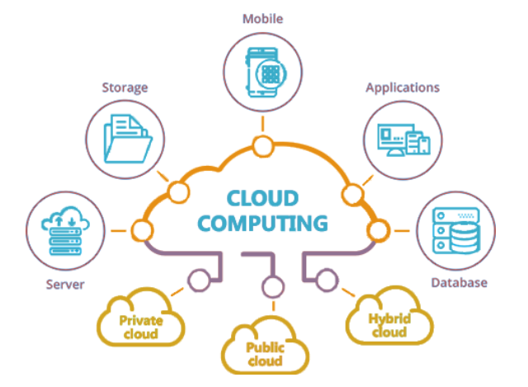

Figure 1 What is cloud computing?

### How does cloud computing work?

Cloud computing gives us a simple way to access servers, storage, databases and a variety of application services on the Internet. A cloud service platform like Amazon Web Services owns and maintains the networked hardware needed for these application services, while we deliver and consume what we need through a web application. .

### Benefits of cloud computing

**Cost savings:** Instead of having to invest in private server infrastructure, users only need to pay a small amount to maintain cloud computing services.

**Flexibility:** Users can scale up or down the scale of cloud computing resources according to need.

**High performance**: Cloud computing services run on secure data centers around the world, which are regularly upgraded for increased performance and security.

### Basic knowledge about Cloud Computing Services

Cloud Computing is a computing model that uses computer technologies and developments. It allows the provision of computing services entirely over the Internet. Cloud computing helps users access resources that suit their needs through the Internet. Cloud computing services can include servers, storage, and software.

### Introduction to classification

#### IaaS (Infrastructure as a Service) model

IaaS cloud is considered a type of development service that is best invested in cloud computing technology, application developers provide customers with a virtual space to store and develop services.

With Infrastructure as a Service (IaaS), we can rent and access computer network system hardware.

IaaS provides many resources such as firewalls, load balancers, IP addresses, but the operating system and applications are installed and updated by the user. This gives more flexibility in what resources are used for.

IaaS appears widely by providers like Amazon, Memset, Google, Windows, etc. One way to make IaaS management easier is to develop templates for cloud services to create a blueprint for building ready-to-use systems, and avoid migration between different clouds. .

Rather than renting a server, centralized storage space or network equipment, instead of investing in buying everything, you can rent a full service from outside. These services are typically costed on the basis of function and resource usage (and hence costs) which will reflect the level of activity. This is an evolution of web hosting solutions and virtual private servers.

Typical features:

* Providing resources as services: including servers, network devices, suites memory, CPU, hard disk space, data center equipment.
* Flexible expansion capabilities
* Costs vary depending on reality
* Multiple tenants can share the same resource
* Enterprise level: benefits the company by a resource aggregate calculation

*Featured service providers:*

* Amazon Web services

Amazon Web service is currently the most potential IaaS cloud service provider, however they are currently competing for market share with two technology giants, Microsoft and Google. Amazon Web Services IaaS is a collection of services that provide programmers with access to Amazon's ready-to-use computing architecture infrastructure. Amazon's solid computing platform that has been built and refined over the years is now possible allowing anyone to have access to the Internet.

We can build applications that are complex and consist of many different parts by using tiered functions with reliable, block-efficient services provided by Amazon. Users will pay only based on what they use without having to pay upfront costs and initial investments. Additionally, users do not need to pay for maintenance because the hardware is maintained and serviced by Amazon.

* Microsoft Azure

In this IaaS service industry, Microsoft Azure is truly a serious competitor of AWS. With strengths in analysis, personal storage and especially disaster resolution such as data recovery and application error recovery with their extended service packages.

Microsoft Azure is an open and flexible cloud computing platform that allows us to quickly build, deploy, and manage applications through a global network of Microsoft data centers.

Microsoft Azure always ensures availability and has a load-balanced design and is capable of self-healing when hardware fails. Users can use any language, tool or platform to build applications. And they can integrate their public cloud applications with existing IT environments.

#### PaaS (Platform as a Service) model

PaaS services provide customers with a set of tools to develop, test and deploy cloud-based applications. The built application can be used internally within the organizational unit, business or provided external services to third parties. Typical customers of PaaS services are ISVs (Independent Software Vendors), who build software applications and provide services to end-user customers.

Due to the nature of cloud computing services providing applications over the Internet, most PaaS platforms provide a set of tools to build Web-based applications. Today's popular PaaS services allow application development on popular application development platforms and languages such as .NET (Microsoft Windows Azure); Java, Python, Ruby (Google App Engine, Amazon), ... However, supported languages, development tools as well as application programming interfaces (API - Application Programming Interface) can be said on the one hand. is very rich, but the downside is the lack of standardization and uniformity. Incompatibility between PaaS service providers will be a limitation that needs to be overcome in the future, to ensure openness, allowing cloud applications to migrate or communicate with each other between providers. Service Provider. Provides a computing platform and a set of multi-layer solutions. It supports application deployment without regard to the cost or complexity of equipping and managing the underlying hardware and software layers, providing all the features needed to support the life cycle. Live the full life of building and delivering an Internet-ready web application and service without any software downloads or installations for developers, IT managers, or end users. It is also known by another name cloudware.

Platform as a Service (PaaS) includes the requirements for the application design, development, testing, deployment, and hosting processes that provide value as application services such as team collaboration, Web service stacking and integration, database integration, security, scalability, state management, application versioning, benefits to the application development and research community. These services are prepared as an integrated web-based solution.

Typical features:

* Serves for developing, testing, deploying and operating applications as an integrated development environment
* Initialization tools with web-based interface.
* Integrate web services and databases
* Support development team collaboration

Featured service providers:

* **Red Hat OpenShift**

The software running the service is open source and available on GitHub under the name “OpenShift Origin”.

Software developers can use Git to deploy applications in different languages on the platform.

binary software web applications, as long as it can run on RHEL Linux. This increases the system's customization, supporting many languages and frameworks.

Open Shift maintains application underlying services and application statistics if necessary.

#### SaaS model (Software as a Service)

Software as a Service (SaaS) is the most suitable choice when we want to focus on the end user. Helps us access cloud-based software without needing to manage the infrastructure and platform it is running on. Before cloud computing was widely discussed in the IT world today, software services (SaaS) actually appeared a long time ago, the most popular of which are email services such as hotmail, yahoo mail, gmail. ... These services also provide organizations with email services with their own domain names at a relatively cheap fee. SaaS software services for businesses have been growing more recently: for example, Microsoft's Office 365 office application services with email, collaboration, and internal communications applications; SalesForce's customer management (CRM) applications, Amazon's e-commerce applications...

SaaS application services bring many benefits to organizations and businesses. Units pay fees based on weekly and monthly usage without having to pay the full license fee from the beginning. The business budget does not have to bear a large initial investment but will pay gradually and increase when there is really a need. Besides, organizations and businesses also have the opportunity to try and choose suitable SaaS software, minimizing costs.

SaaS providers can host the application on their servers or download the application to the customer device, deactivating it after the end of the term. On-demand functions can be controlled internally to share with a third-party application provider.

Typical features:

* Available software requires access and management over the network.
* Manage operations from a centralized location rather than at the customer's location, allowing customers to access remotely via the web. Provides common application close to one or more mapping models including architectural, pricing and management features.
* Upgraded focused features, helping users get rid of downloads
* patches and updates.
* Regularly integrate communication software on wide area networks.

Featured service providers:

**Salesforce.com**

Salesforce is a comprehensive set of CRM software solutions, providing a series of CRM applications specializing in sales and customer service on a cloud computing platform for many different specialized industries.

Salesforce has won the trust of global customers thanks to a series of outstanding features.

### Cloud translation model

#### Private Cloud

* Private Cloud is a cloud environment built and maintained privately or for a specific organization.
* Only authorized employees and partners can access and use resources in this environment.
* Private Cloud provides independent control, security and management, often deployed in an internal or external data center with a virtualized and automated environment.

#### Public Cloud (Public Cloud)

* Public Cloud is a cloud environment where services and resources are provided via the internet and shared with everyone.
* This service is managed and maintained by cloud service providers and customers only pay based on their actual usage.
* Public Cloud brings flexibility, easy expansion and reduces infrastructure costs.

#### Hybrid Cloud

* Hybrid Cloud combines both of the above models (Private and Public Cloud) and allows moving data and applications between them flexibly.
* Organizations use Hybrid Cloud to take advantage of the benefits of both environments, while maintaining control and security of important data.
* Deciding which application to put into a Private or Public Cloud environment depends on the specific requirements and technical characteristics of the application.

## Resource provisioning model

### (nVM – out – of – 1PM)

nVM: stands for "number of Virtual Machines" - number of virtual machines.

IPM: abbreviation for "Infrastructure as Pool Model" - infrastructure model like a swimming pool.

This model provides resources based on the number of virtual machines (nVM). Resources are organized and provisioned as a "pool", where additional analytics resources can be provisioned to virtual machines on demand.

### (nVM – out – of – NPM)

nVM: stands for "number of Virtual Machines" - number of virtual machines.

NPM: stands for "Network Performance Model" - network performance model.

This model focuses on resource provisioning based on the number of virtual machines (nVM), and considers and applies a performance model to ensure good performance and networking for virtual machines.

## Railways

## Introduction to Railways

Railway is one of the leading cloud service providers in public cloud and remote teams that are solving interesting problems at the edge of computing, distributed systems, languages and compilers.

**

Figure 2 Introduction to Railway Services

Railway provides a range of flexible and powerful cloud services that enable organizations and individuals to build, transport and monitor. No need for Platform Engineers.

The main services and resources that railway provides include:

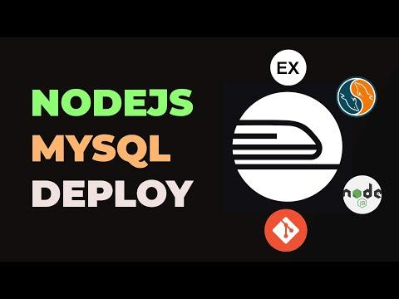

Figure 3 Railway 's resource provisioning service

* Application Development and Deployment Environment: Railway provides an environment for developing, deploying, and managing applications. This includes support for multiple programming languages and frameworks.
* Database Management: Easy integration with popular database types such as PostgreSQL, MySQL, and Redis. Railway provides the ability to create and manage databases quickly and securely.
* Resource Management and Automatic Scaling: Railway provides the ability to manage and scale resources (such as memory and CPU) based on application needs.
* Integration with Git and GitHub: Easily deploy applications from Git repositories, especially GitHub.
* Logging and Monitoring: Provides tools to monitor application activity and record events, helping in detecting and resolving problems .

### Case Study

Analyze and evaluate the effectiveness of using Railway services

A case study on analyzing and evaluating the effectiveness of using Railway's service, a cloud computing and application development platform, requires consideration of important factors such as deployment capabilities, facility management database, integration with other tools and services, and overall performance and cost.

* Application Deployment:
  + Simple and Fast: Railway is appreciated for its quick and easy deployment, helping to save development time.
  + Integration with GitHub: Automate deployment from GitHub repositories, making development and deployment seamless.
* Database Management:
  + Supports Multiple DB Types: Provides the ability to create and manage popular database types such as PostgreSQL and MySQL.
  + Easy Management: Intuitive and easy-to-use user interface, supporting efficient database management.
* Resource Expansion and Management:
  + Flexible Resource Management: Allows users to easily scale up or down hardware resources according to need.
  + Diverse Development Environments: Supports multiple development environments, from development to production.
* Performance and Reliability:
  + Performance: Fast processing speed and response time.
  + Reliability: Easy-to-use monitor and debugger, easy to detect when application crashes.
* Cost and Economics:
  + Pricing Model: In general, the pricing model is quite cheap compared to other services, starting from only $20 a month for developers and professional teams to release products.

### Reasons to choose Railway

Software development goes beyond deploying code. Rail's feature set is tailor-made and continuously evolving to deliver the best developer experience imaginable.

**Configuration management**

Variables & Secrets: Easily manage configuration values and sensitive data with variable management tools.

**Environment and work process**

Environment management: Create both static and temporary environments to create workflows that complement your processes.

Orchestration & Tools: Build Rail into any workflow using our CLI or API.

**Implementation monitoring**

Observability: Monitor your deployment with Rail's built-in observability tools.

### Railway structure

Point the rail to your deployment source and let the platform handle the rest.

* **Flexible deployment sources**

Code repository: With or without Dockerfiles. The railroad will build an image of OCI compliance based on what you provide.

Docker Images: Directly from Docker Hub or GitHub Container Register.

* **Easy setup**

Healthy defaults: From the beginning, your project is deployed with healthy defaults to get you up and running as quickly as possible.

Fine-tune the configuration: When you're ready, there are plenty of knobs and switches to optimize as needed.

### Railway service

**Railway service** is the deployment target for your deployment source. The deployment source can be a code repository or a Docker Image. After you create a service and select the source, Rail parses the source, builds a Docker image (if the source is a code repository), and deploys it to the service.

Out of the box, your service is deployed with a set of default configurations that can be overridden as needed.

### Railway environment

The rail environment gives you a separate instance of all the databases and services in a single project. You can use them to

Have a development environment for each team member that is identical to the production environment

Have separate staging and production environments

Within a service and environment, you can specify which branch to automatically deploy to that environment when changes are merged.

# PRODUCT DEMO

## Introducing The Experimental Environment

* **Operating system:** Windows
* **CPU:** x64

## Installation Steps

Overview, in this project we use Railway services such as “Application Deployment” to deploy nodejs application, Mongodb to store and retrieve data, Lambda to handle events, DynamoDB to store and data retrieval, “Secrets Management” to maintain and synchronize various environment variables from development to production.

**Step 1:** Prepare a nodejs application source code and upload to github.

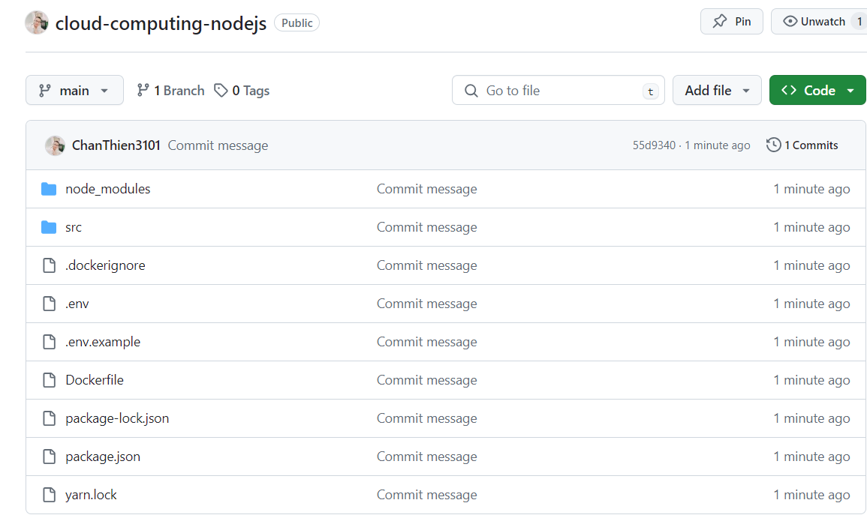

Figure 4 Prepare source code on github

**Step 2:** Create a new MongoDB database.

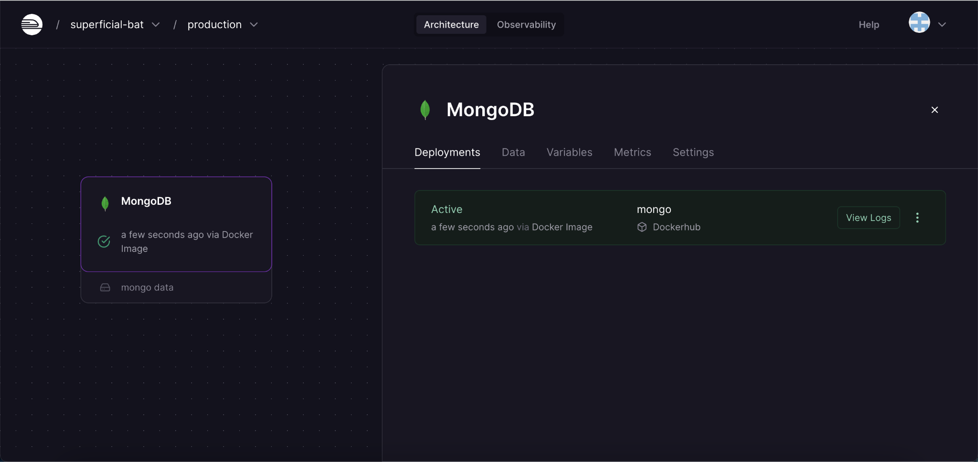

Figure 5 Mongo db

**Step 3:** Mongodb's environment variables are on the Variables page.

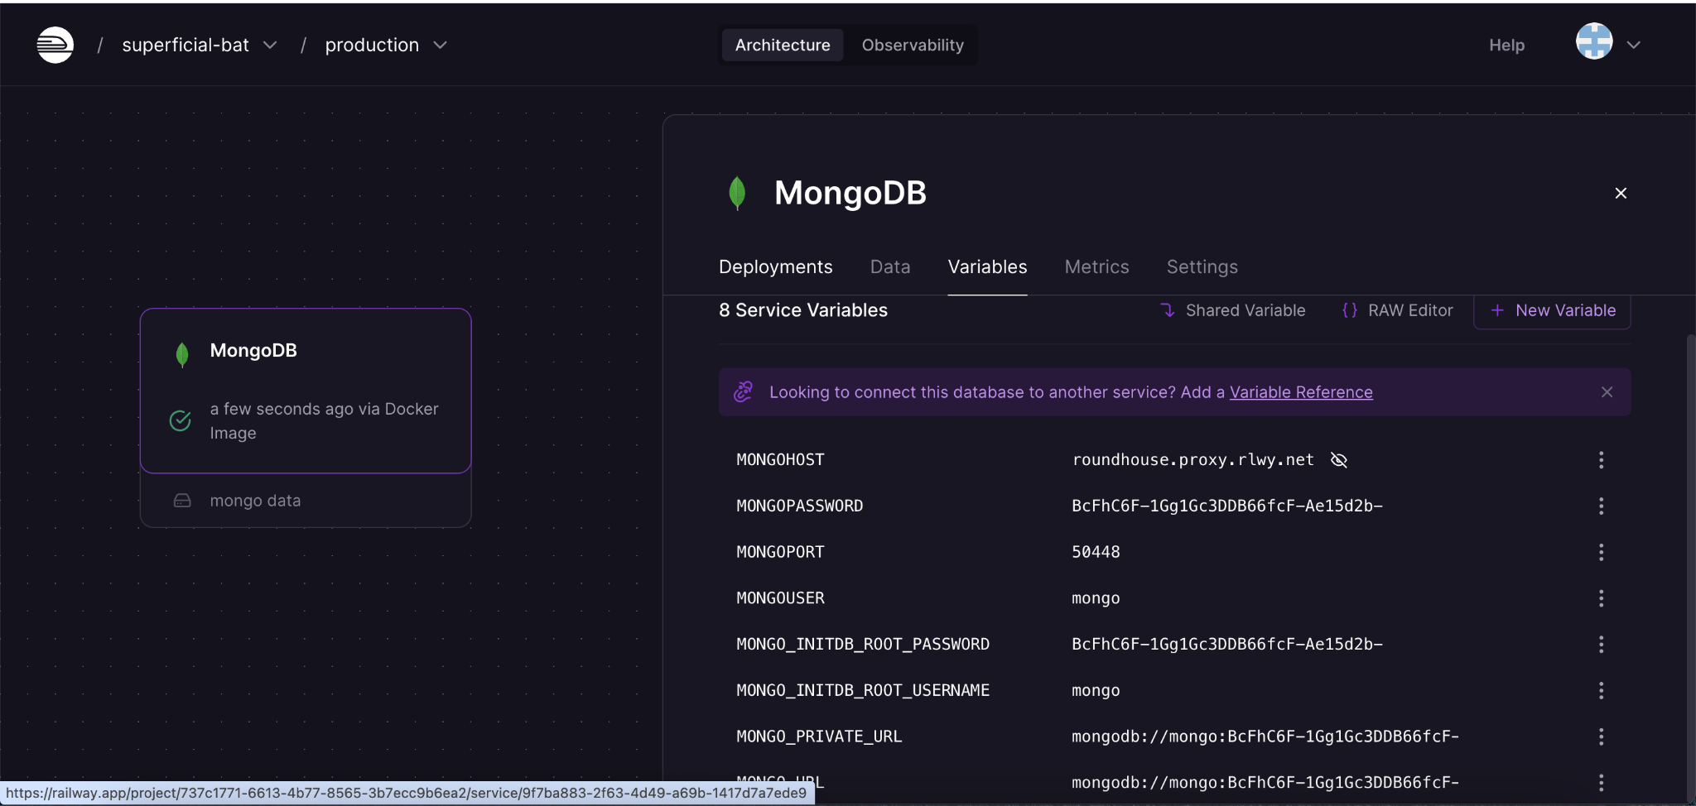

Figure 6 mongodb environment variables

**Step 4:** Deploy the application by connecting to github and selecting the source code to deploy.

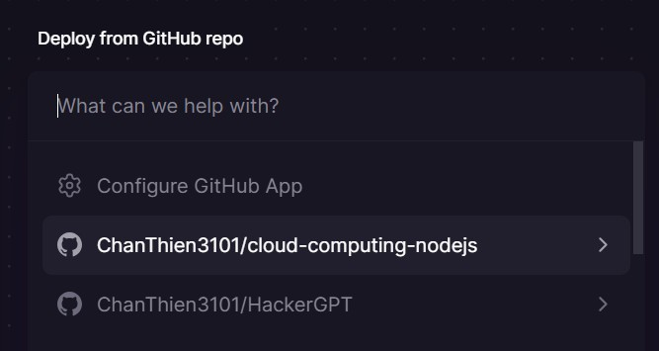

Figure 7 Deploying the application using github

**Step 5:** Add the application's environment variables in the Variables navigation, here the application needs some environment variables such as application port, mongodb connection url (taken from mongodb's environment variables in step 3).

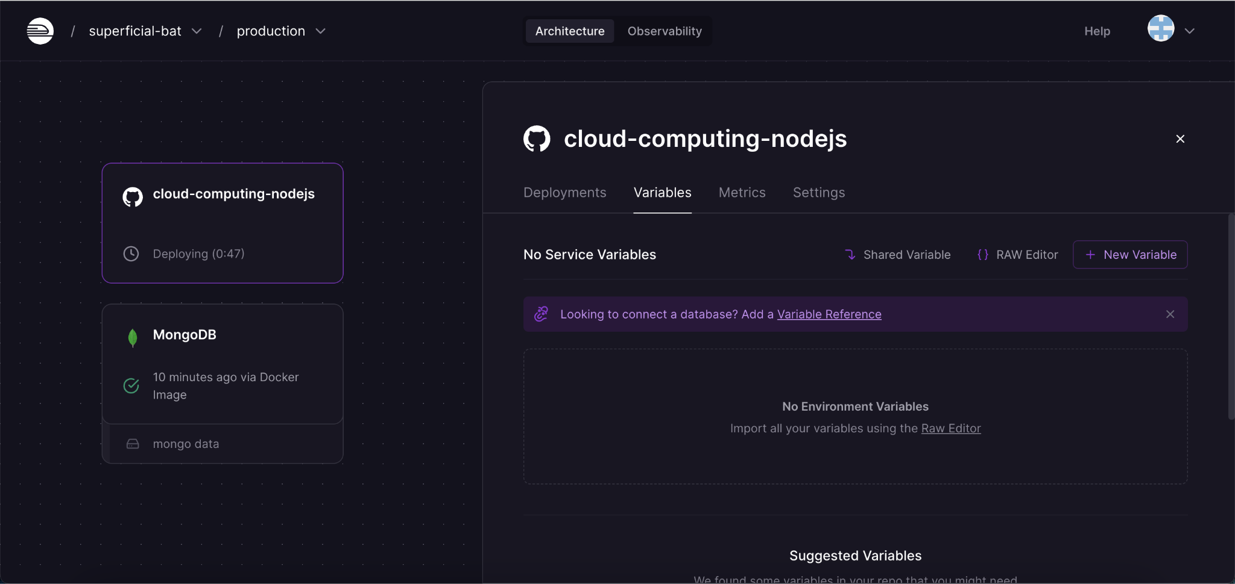

Figure 8 Application environment variables

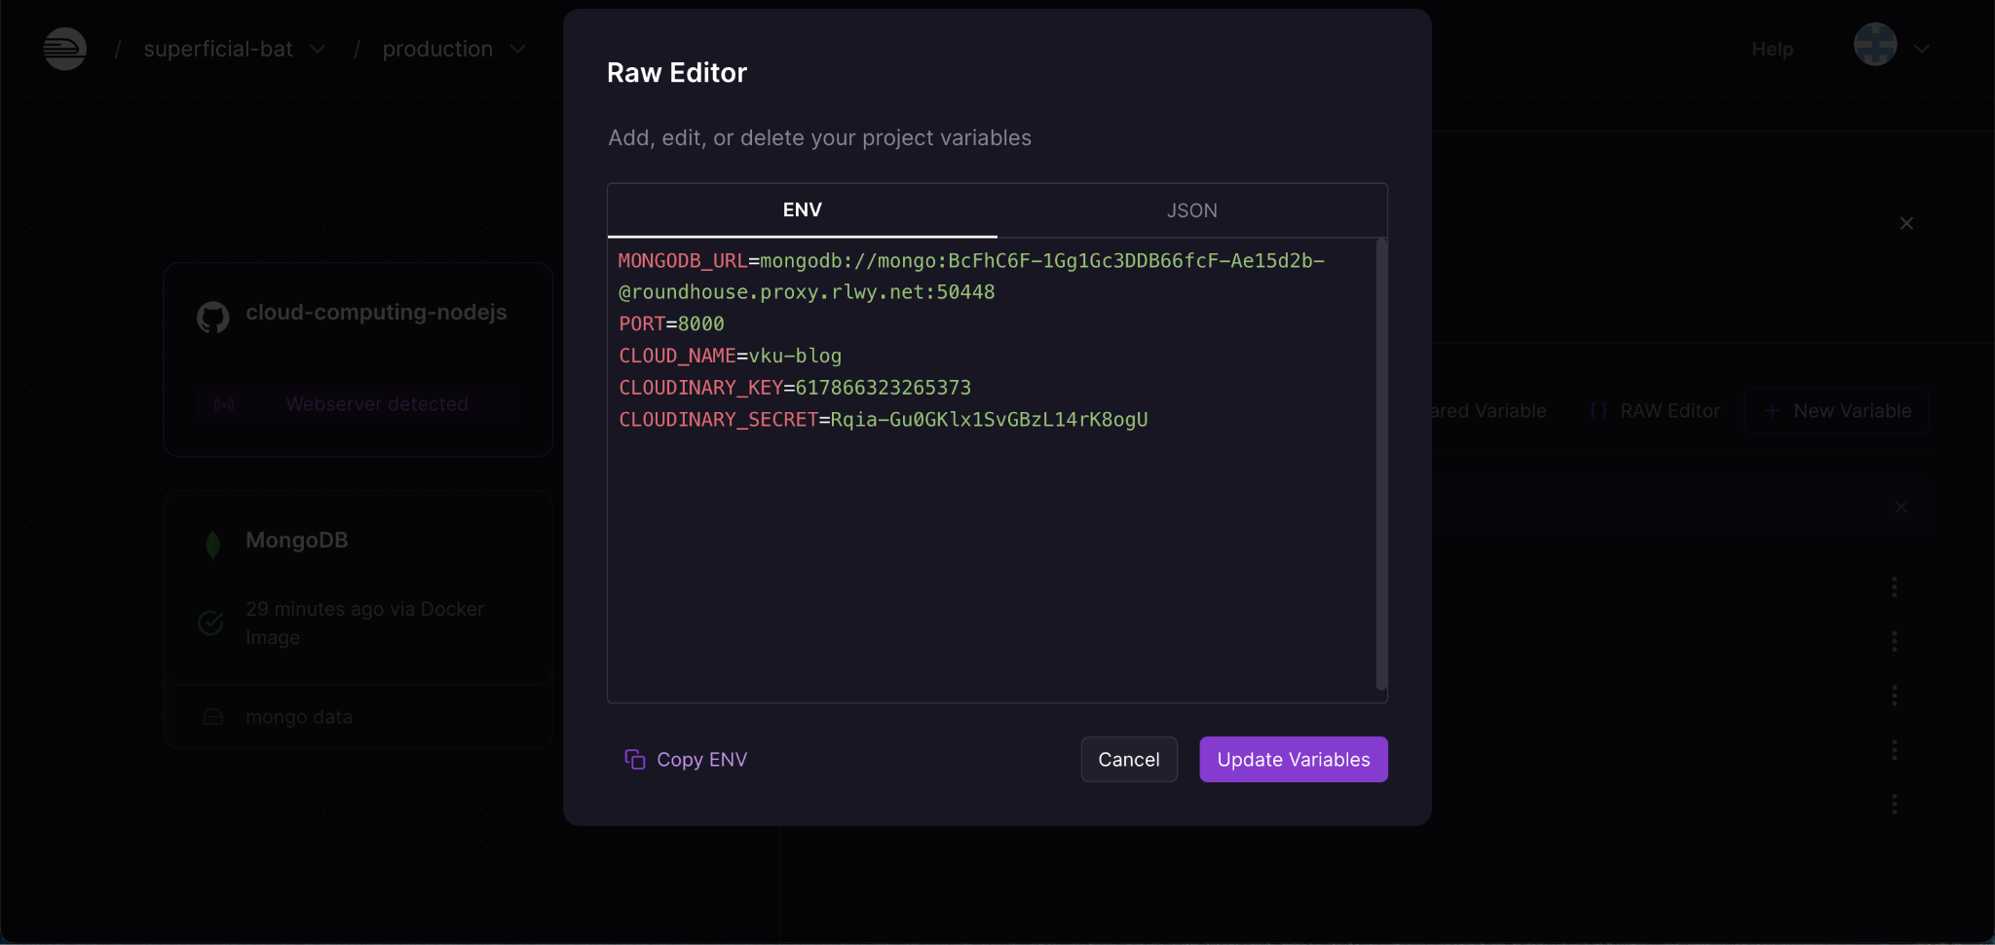

Figure 9 Application environment variables

**Step 6:** The application will be automatically deployed when there are changes in github or environment variables. While the application is deployed, users can view the application's log in the Build Logs and Deploy logs tab.

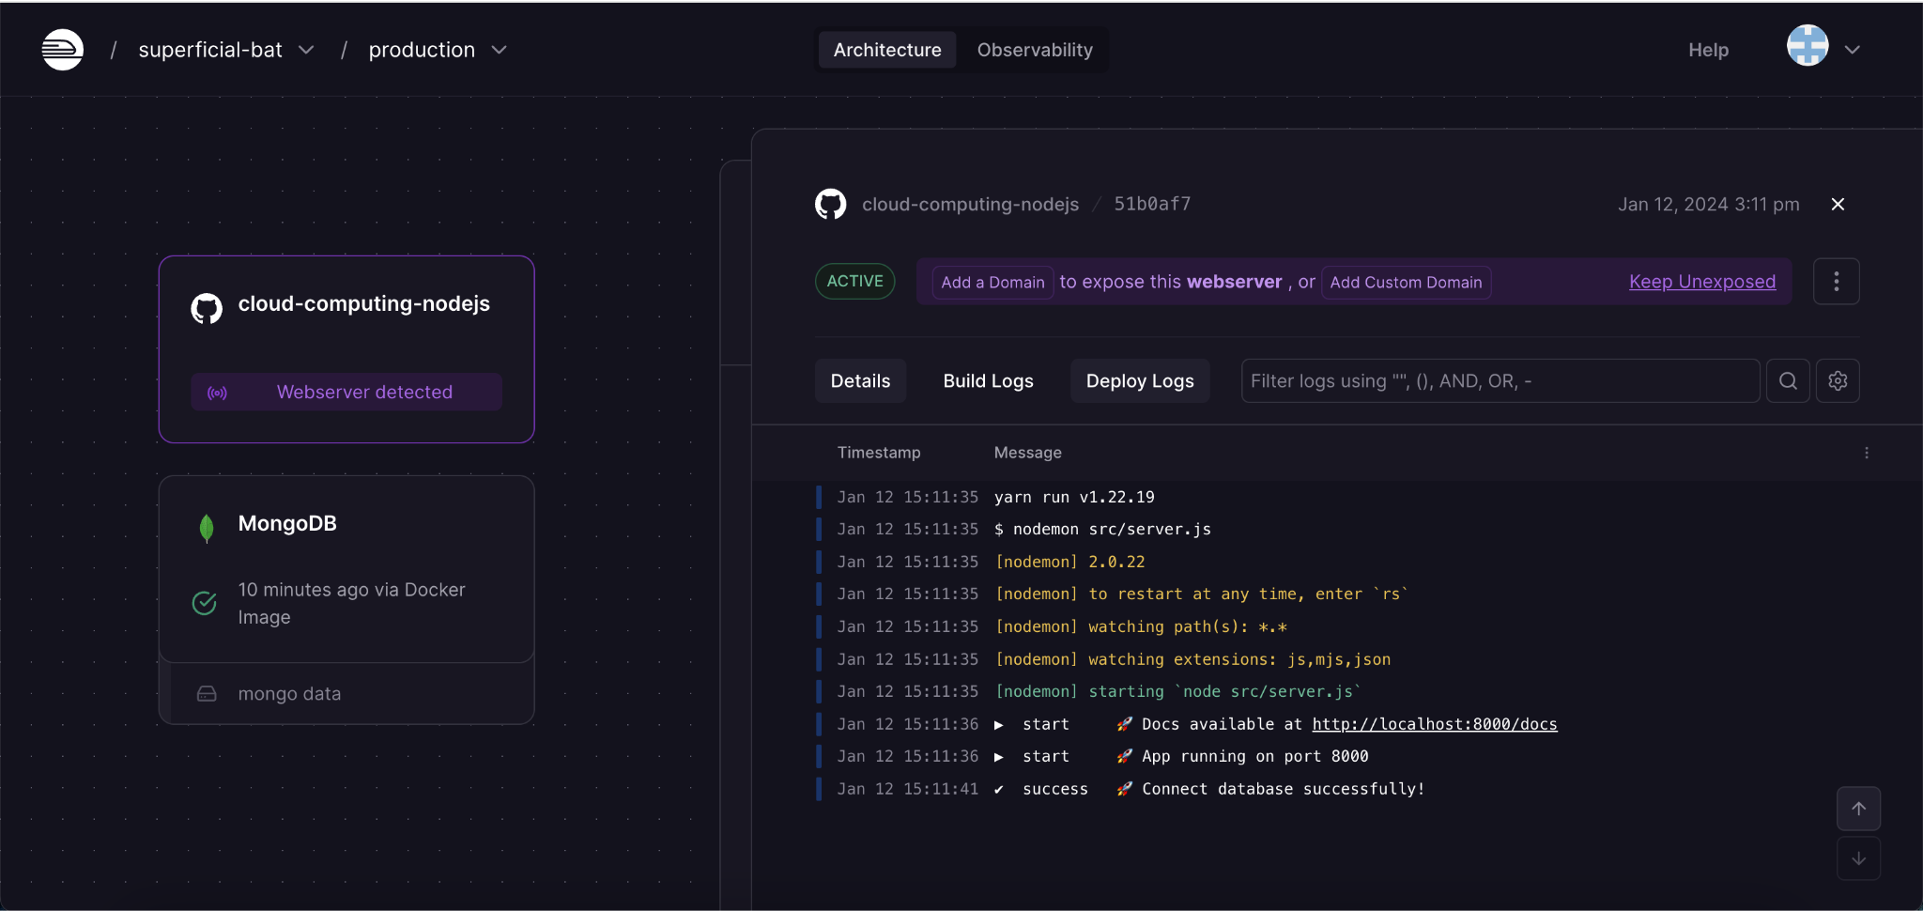

Figure 10 Deploying the application and viewing logs

**Step 7:** Create a domain for the application so it can be accessed from the internet.

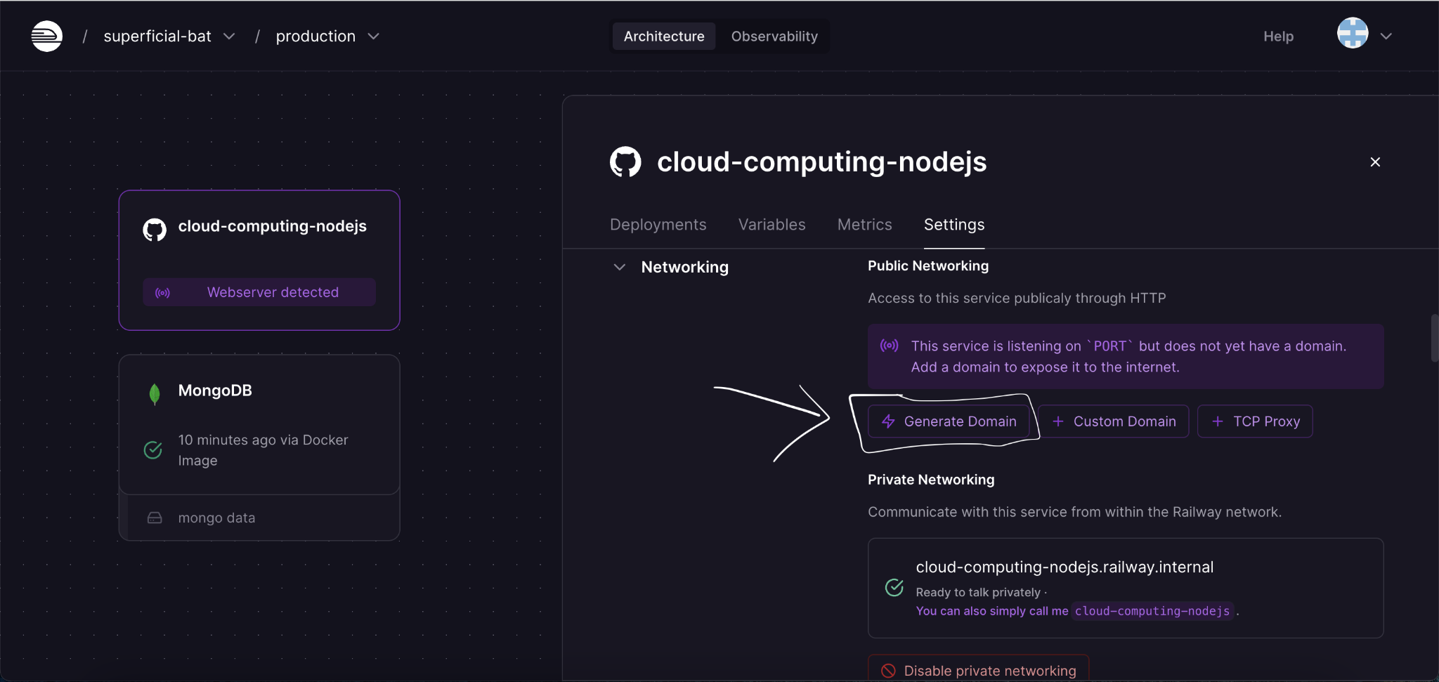

Figure 11 Creating a domain for the application

## 3.3 Installation results

The result after performing the steps will be a website with functions for creating products, viewing and searching for products.

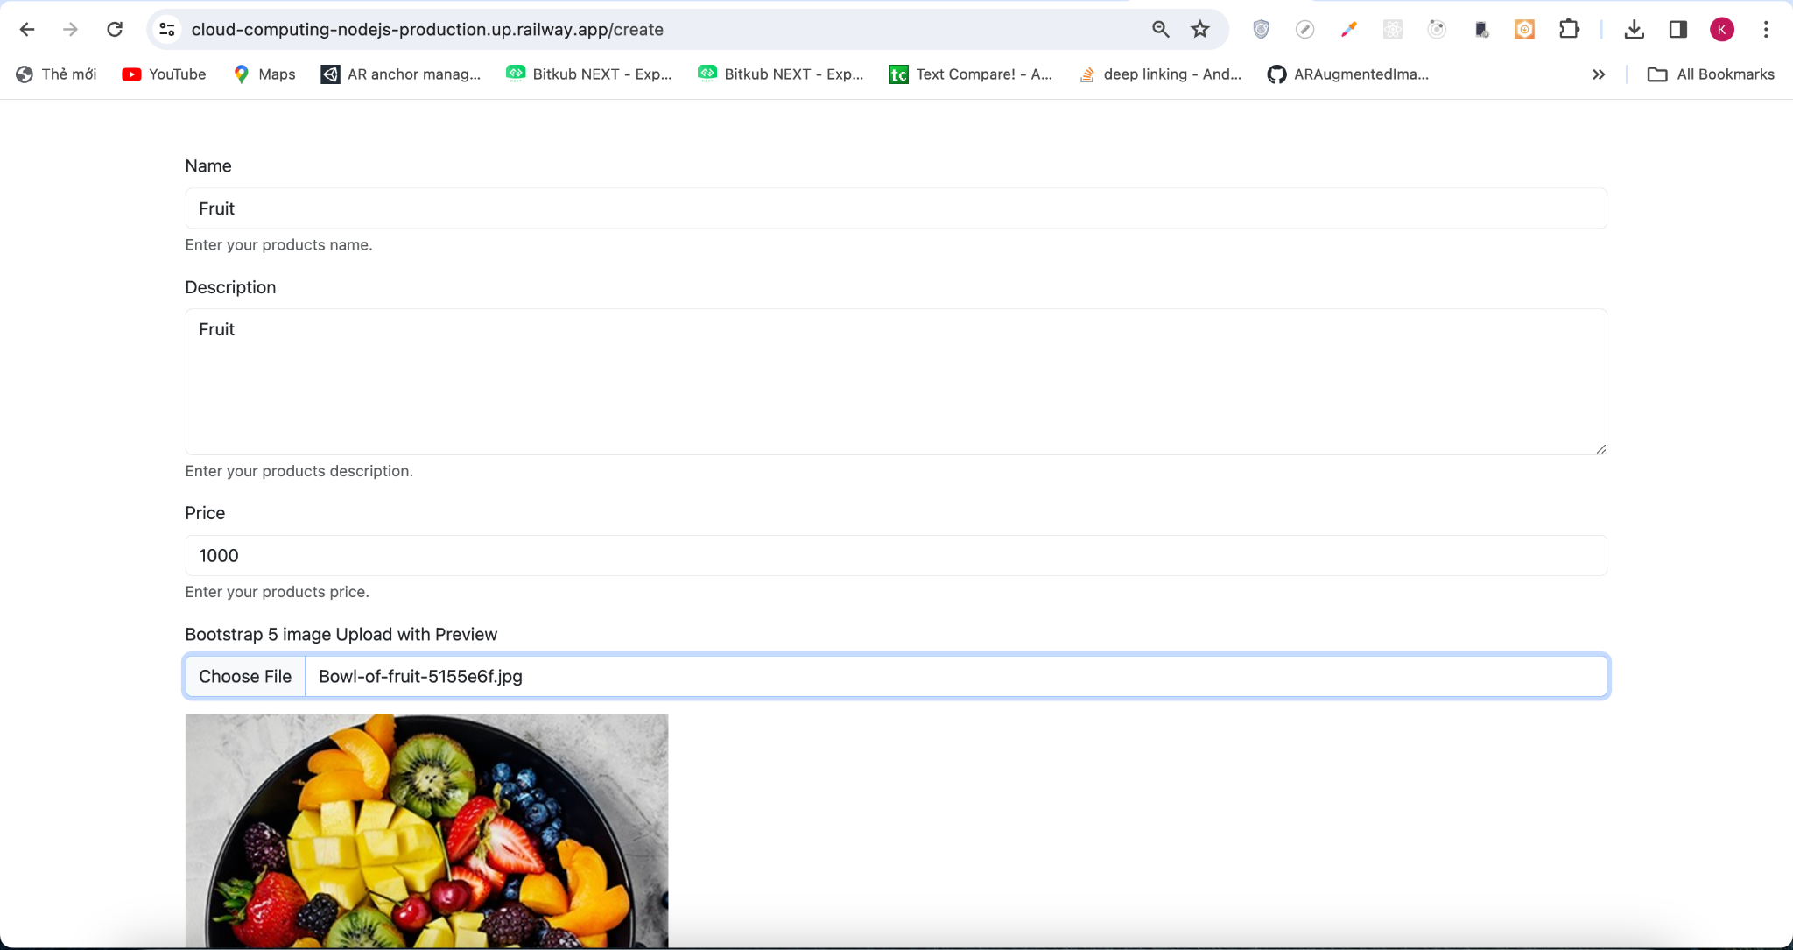

Figure 12 Product creation page

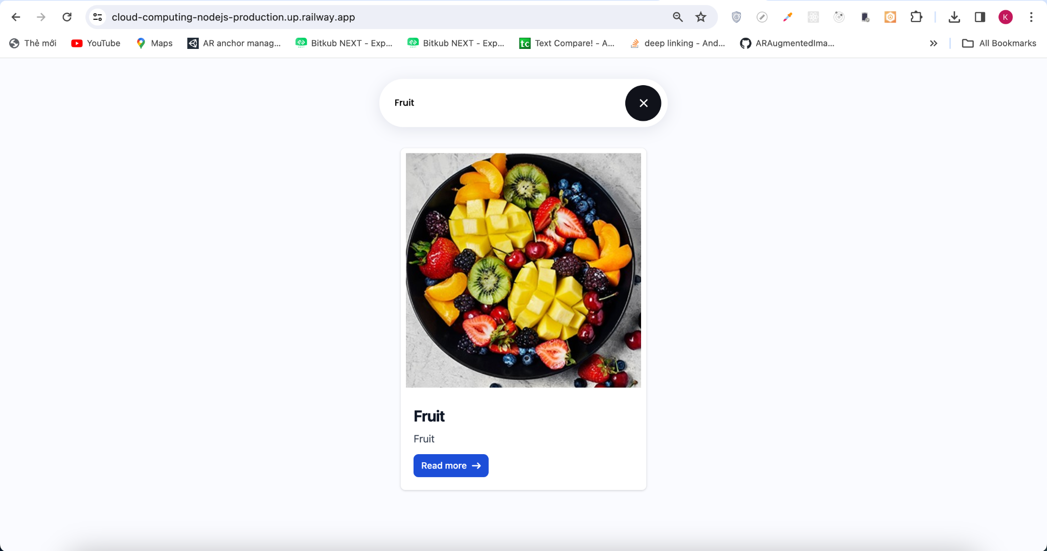

Figure 13 Product view and search page

# RESULTS AND DISCUSSION

**Result**

The result is a website that can run on the internet, whose main functions are to create new products, view and search for products. Thanks to services such as database and application deployment, the website has the following features:

* Create new product: Users can visit the website and create a new product, the product will be stored in mongodb.
* View and search products: Users can access to view and search products, data is retrieved from mongodb.

In summary, the result is a website running on the internet, allowing users to create and view products, store and retrieve data from railway mongodb.

**Propose Improvements And Future Development Directions**

* Product information management: The website can provide features for more versatile product management with mongodb database that can store complex data with scalability .
* Build into mobile application.

**Some Security Solutions For Data Applications On Cloud Systems**

* Data Encryption:

At-rest encryption: Encrypt your data when it's stored in the cloud. This makes it unreadable even if someone gains access to the cloud storage.

In-transit encryption: Encrypt your data while it's being transferred between your application and the cloud storage. This protects it from eavesdropping on the network.

Key Management: Use strong encryption algorithms and employ a robust key management strategy. Rotate your encryption keys regularly.

* Identity and Access Management (IAM):

Implement IAM controls to restrict access to your application data.

Use strong authentication methods like multi-factor authentication (MFA) to verify user identities before granting access.

Implement the principle of least privilege, granting users only the minimum access permissions required for their specific roles.

* Cloud Provider Security Features:

Leverage the security features offered by your cloud provider. These may include firewalls, intrusion detection systems (IDS), and vulnerability scanning tools.

Regularly update your cloud resources with the latest security patches provided by the cloud provider.

* Data Backup and Recovery:

Implement a robust data backup and recovery plan. Regularly back up your application data to a separate location outside the cloud storage.

Test your backup and recovery procedures regularly to ensure they work as expected.

* Security Monitoring:

Continuously monitor your cloud environment for suspicious activity.

Use security information and event management (SIEM) tools to centralize log data from your cloud resources and applications for easier analysis.

Implement security alerts to notify you of potential security incidents.

* Additional Measures:

Regular Penetration Testing: Conduct regular penetration testing to identify vulnerabilities in your cloud environment and application code.

Employee Training: Train your employees on cloud security best practices to avoid social engineering attacks and phishing attempts.

Compliance: Follow relevant industry standards and data privacy regulations that apply to your application and data.

Remember: Security is an ongoing process. Regularly review and update your security measures to stay ahead of evolving threats.

# REFERENCES

1. <https://gdata.com.vn/blog/cloud-security-bao-mat-dien-toan-dam-may-la-gi/>
2. <https://vdigital.vn/giai-phap-cloud-security/>
3. <https://cloud.z.com/vn/news/cloud-security/>
4. <https://getdeploying.com/railway>