**Task 1 (1) Simulating Geometric Brownian Motion**

By running the code of typed “gbm.py”, we obtain the result below.

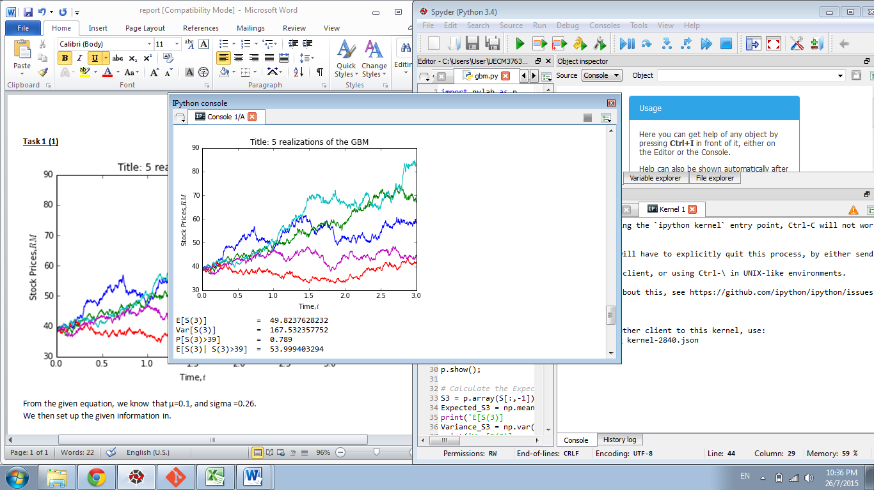

From the given equation, we know that µ=0.1, and sigma =0.26.  
We then set up the given information in.   
**n_path** is the number of simulations, while **n** is the number of partitions within the interval 0 to 3, which are both equals to 1000.

After that, we generate a row vector, and set the first column of dB as zero, and sum over rows for each of the column. Then, we calculate the stock price, and plot 5 realizations of the GBM.

To find the expected value of S(3), E[S(3)], we use the numpy function “np.mean()” by substituting the last price into the bracket of the function.  
To find the variance of S(3), Var[S(3)], we use the numpy function “np.var()” by substituting the last price into the bracket of the function.

To calculate P[S(3)>39], we find out the number of S3 > 39, stored in ‘x’.   
Then we calculate its probability by using the commands: sum(X)/len(X), which is the total value of “S3 > 39” divided by its “length”- total number in the array.

Finally, we calculate E[S(3)| S(3)>39] by summing up the number of ‘S3’ intersect ‘x’, divided by total “length” of ‘x’.

**Task 1 (2) Simulating Mean Reversal Process**

By running the code of typed “mr.py”, we obtain the result below.

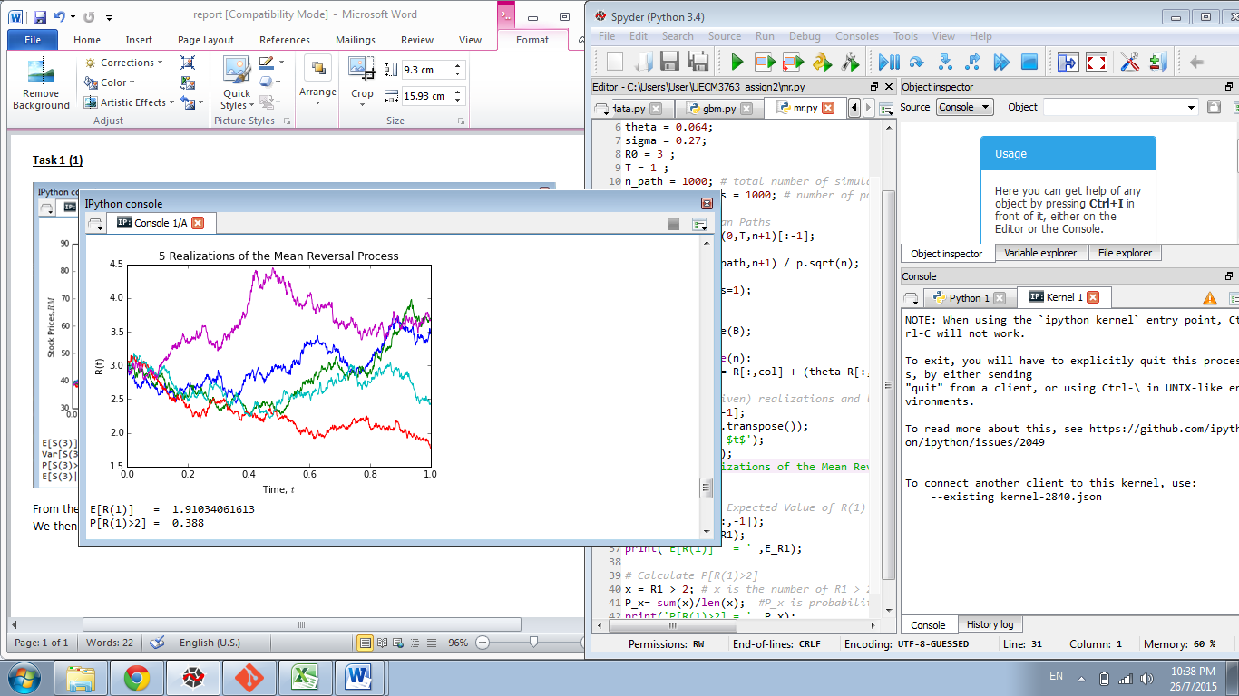

The code of this part is similar to Task1 (1), the difference is we used the command below to make it into mean reversal process.

for col in range(n):

R[:,col+1] = R[:,col] + (theta-R[:,col])*dt + sigma*R[:,col]*dB[:,col+1]

Then, we also calculate the E[R(1)] and P[R(1)>2] by using the similar way.

**Task 2 (1) FTSE Bursa Malaysia KLCI Index**

There are 30 components stocks in FTSE Bursa Malaysia KLCI Index.  
The sources of the data in table bellows are:   
<file:///C:/Users/User/Downloads/FBMKLCIRCO_20150612.pdf>  
<http://quotes.wsj.com/MY/XKLS/PBBANK>

|  |  |  |  |  |  |  |
| --- | --- | --- | --- | --- | --- | --- |
| **FTSE Bursa Malaysia KLCI Index** | | | | | | |
|  | | | | | | |
|  |  |  |  | [as@ 12JUNE2015](mailto:as@%2012JUNE2015) | [as@ 24JULY2015](mailto:as@%2024JULY2015) | |
| **NO.** | **STOCK NAME** | **STOCKE CODE** | **STOCK SECTOR** | **WEIGHTAGE IN FTSEKLCI (%)** | **P/E RATIO** | **NET MARKET CAPITAL (Billion)** |
| 1 | Public Bank BHD | 1295 | Banks | 11.60 | 15.33 | 73.840 |
| 2 | Malayan Banking | 1155 | Banks | 9.32 | 12.47 | 87.660 |
| 3 | Tenaga Nasional | 5347 | Alternative Electricity | 9.28 | 9.15 | 69.420 |
| 4 | CIMB Group Holdings | 1023 | Banks | 5.76 | 17.42 | 46.690 |
| 5 | Axiata Group Bhd | 6888 | Mobile Telecommunications | 5.62 | 24.27 | 55.440 |
| 6 | Sime Darby Bhd | 4197 | Diversified Industrials | 5.51 | 21.76 | 52.420 |
| 7 | Digi.com | 6947 | Mobile Telecommunications | 4.16 | 21.02 | 41.290 |
| 8 | Genting | 3182 | Hotels | 3.68 | 19.54 | 30.880 |
| 9 | PETRONAS Chemicals Group Bhd | 5183 | Commodity Chemicals | 3.55 | 21.83 | 51.520 |
| 10 | Maxis Bhd | 6012 | Mobile Telecommunications | 3.45 | 30.05 | 49.480 |
| 11 | Petronas Gas | 6033 | Exploration & Production | 3.40 | 22.79 | 42.820 |
| 12 | IHH Healthcare | 5225 | Health Care Providers | 3.28 | 63.42 | 48.760 |
| 13 | IOI | 1961 | Farming & Fishing | 2.99 | 73.91 | 27.450 |
| 14 | Telekom Malaysia | 4863 | Fixed Line Telecommunications | 2.96 | 32.34 | 25.140 |
| 15 | Genting Malaysia Bhd | 4715 | Hotels | 2.50 | 20.21 | 25.530 |
| 16 | MISC | 3816 | Marine Transportation | 2.45 | 15.99 | 35.440 |
| 17 | AMMB Holdings | 1015 | Banks | 2.38 | 8.82 | 17.090 |
| 18 | Kuala Lumpur Kepong | 2445 | Farming & Fishing | 2.28 | 29.21 | 24.020 |
| 19 | SapuraKencana Petroleum | 5218 | Oil Equipment & Services | 1.98 | 12.08 | 14.260 |
| 20 | PBB Group | 4065 | Food Products | 1.80 | 18.13 | 17.830 |
| 21 | British American Tobacco (Malaysia) | 4162 | Tobacco | 1.70 | 20.06 | 18.500 |
| 22 | Hong Leong Bank | 5819 | Banks | 1.67 | 11.19 | 25.680 |
| 23 | YTL Corp | 4677 | Multiutilities | 1.63 | 14.95 | 17.380 |
| 24 | UMW Holdings | 4588 | Automobiles | 1.37 | 20.41 | 11.960 |
| 25 | Astro Malaysia Holdings | 6399 | Broadcasting & Entertainment | 1.22 | 28.32 | 15.970 |
| 26 | Petronas Dagangan Bhd | 5681 | Intrgrated Oil & Gas | 1.21 | 37.05 | 20.430 |
| 27 | RHB Capital | 1066 | Banks | 1.06 | 9.18 | 19.520 |
| 28 | Westports Holdings | 5246 | Transportation Services | 0.93 | 26.60 | 14.050 |
| 29 | Hong Leong Financial | 1082 | Banks | 0.64 | 9.94 | 16.320 |
| 30 | KLCC Prop & Reits - Stapled Sec | 5235SS | Real Estate Holding & Development | 0.63 | 28.20 | 12.710 |

**Task 2 (2) Downloading data**

By running the code of typed “downloading_data.py”, we obtain the result below.

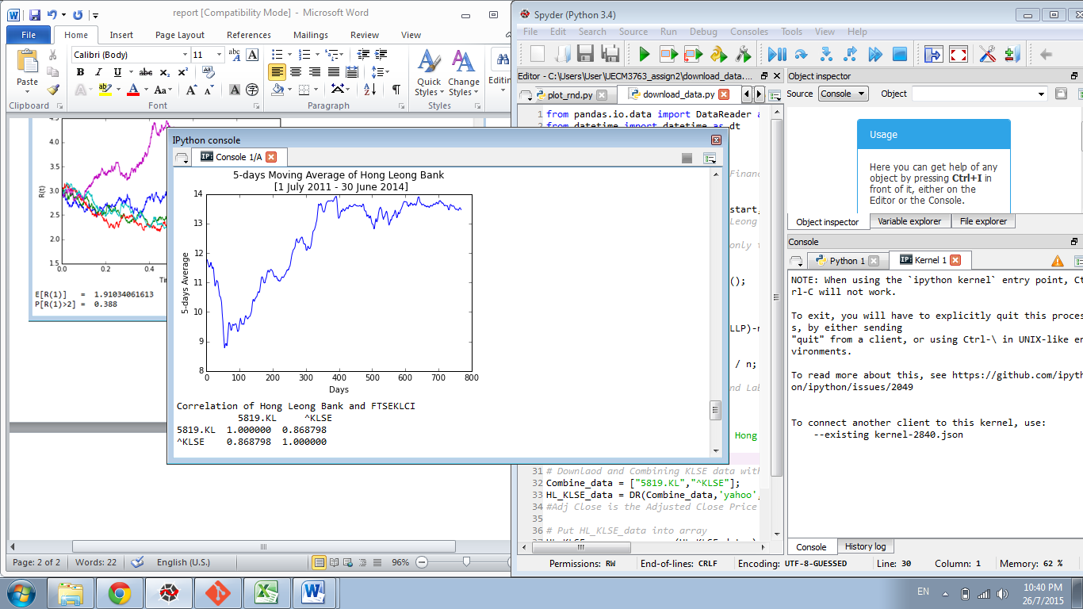

The company that I had chosen with index number 5819 is Hong Leong Bank.  
The financial year of Hong Leong Bank is 30 June; therefore, I download the data of Hong Leong Bank from 1 July 2011 to 30 June 2014 (3years).

The data is downloaded by using the function ‘DR()’ – Data Reader from Yahoo Finance.  
After that, we calculate the 5-Days moving average of the data, and plot the graph.

Then, we download and combine FTSE KLCI index with Hong Leong Bank and calculate the correlation of them. The correlation calculated was 0.868798, which means Hong Leong Bank is highly correlated with FTSE KLCI Index.