

SRI LANKA INSTITUTE OF INFORMATION TECHNOLOGY

[**Enterprise Standards and Best Practices for IT Infrastructure**](http://courseweb.sliit.lk/course/view.php?id=137)

**4thYear 2nd Semester 2016**

**Assignment 6**

Name: Sugathapala M. R. C. L. V

Reg No: IT13006044

**What is Vmotion**

VMware VMotion enables the live migration of running virtual machines from one physical server to another with zero downtime, continuous service availability, and complete transaction integrity. It is transparent to users.

VMotion lets you:

* Automatically optimize and allocate entire pools of resources for maximum hardware utilization and availability.
* Perform hardware maintenance without any scheduled downtime.
* Proactively migrate virtual machines away from failing or underperforming servers.

**vMotion Migration**

When you migrate virtual machines with vMotion and choose to change only the host, the entire state of the virtual machine is moved to the new host. The associated virtual disk remains in the same location on storage that is shared between the two hosts.

**vMotion Migration process**

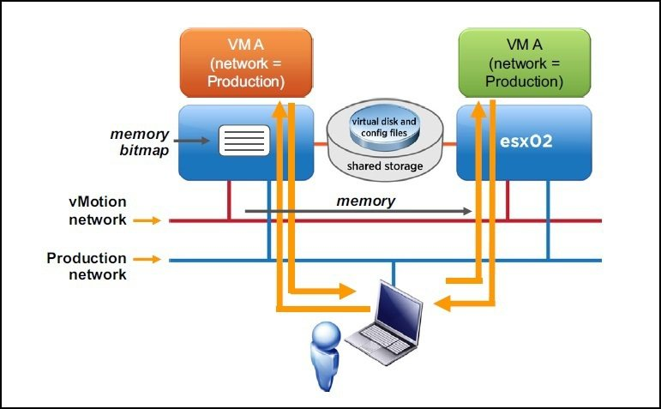

# Hardware Requirements

* Virtual machine must not have a connection to an internal vSwitch (vSwitch with zero upload adapters)
* A virtual machine must not have CPU affinity configured.
* Virtual machine must have a connection to a virtual device (such as a CD ROM or floppy drive) with a local image mounted.

# Software Requirements for vMotion Migration

* vCenter Server requires the Microsoft .NET 3.5 SP1 Framework. If it is not installed on your system, the vCenter Server installer installs it.
* Server requires a 64-bit operating system, and the 64-bit system DSN is required for vCenter Server to connect to its database.
* The .NET 3.5 SP1 installation might require Internet connectivity to download more files.

# Host Requirements for vMotion Migration

Source and destination host must have

* Access on the same physical network compatible CPU.
* The hosts must be licensed for vMotion.
* The hosts must be running ESXi 5.1 or later.
* The hosts must meet the networking requirement for vMotion.
* The host on which the virtual machine is running must have a license that includes Storage vMotion.
* Visibility to all storage( fiber channel,iSSCI or NAS) used by the virtual machine
* At least a Gigabit Ethernet network,
  1. Four concurrent vMotion migrations on a 1 Gbps network.
  2. Eight concurrent vMotion Migrations on a 10 Gbps network.

# Storage Requirements for vMotion Migration

* Migration of virtual machines during VMware Tools installation is not supported.
* The host on which the virtual machine is running must have a license that includes Storage vMotion.
* The host on which the virtual machine is running must have access to both the source and target data stores.
* Virtual machines with snapshots cannot be migrated using Storage vMotion.
* Virtual machine disks must be in persistent mode or be raw device mappings (RDMs).

# Advantages of the vMotion Migration

* Move VM’s from failing or underperforming priorities.
* Minimizes scheduled Downtime.
* Automatically optimize and allocate entire pools of resources.

# Disadvantages of the vMotion Migration

* Swivel is often deployed in the DMZ and a VM infrastructure may not be present.
* VM type type may not be part of organization standard.

**Vmotion VMware**

Select the tab **Configuration-> Network Adapters** and we can see new connections.

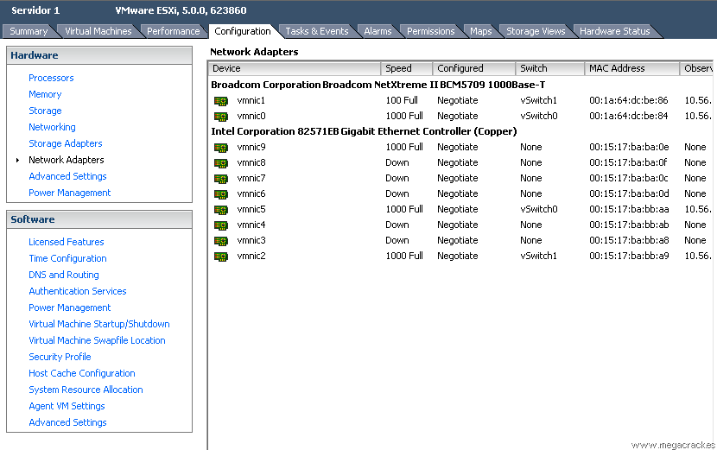

Now go to the tab **Configuration-> Networking**

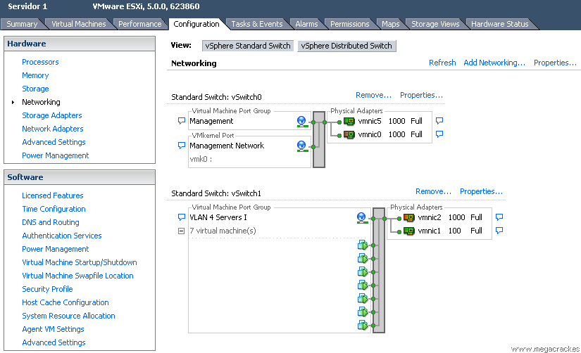

To create the vSwitch click on **Add Networking**

 Select **VMKernel** and click on **Next**

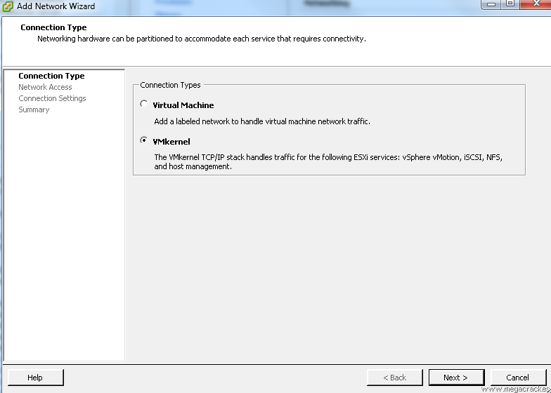

To make a network card have connected from one server to another and click on **Next**

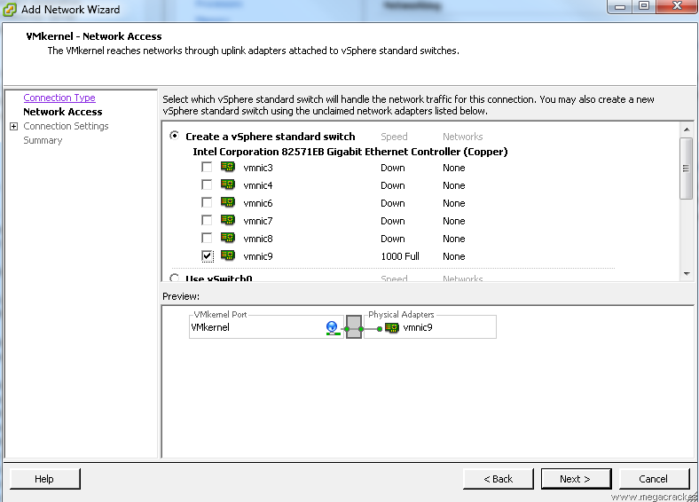

Select **Use this port group for vMotion.**

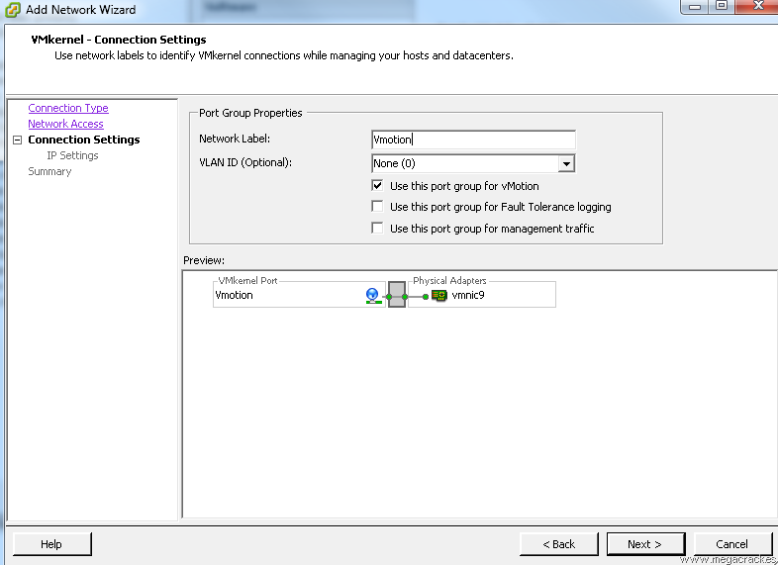

We wrote a **Label Network** different if you want (optional) and click on **Next.** We for example we put **Vmotion**

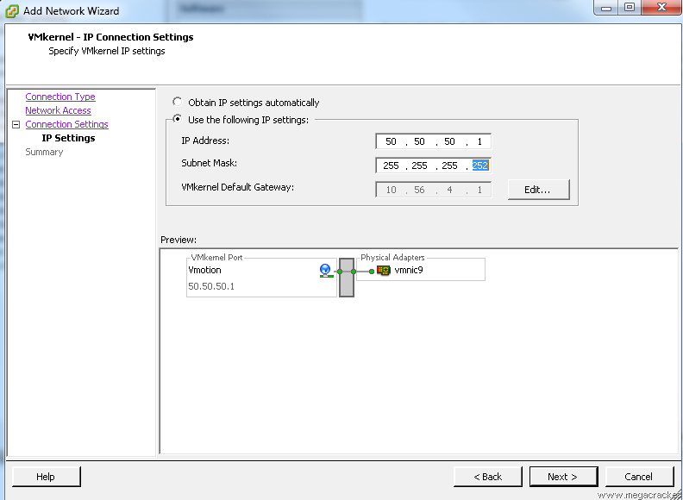

**Use the following IP settings:**

**IP Address: 50.50.50.1**

**Subnet Mask: 255.255.255.252** Click on **Next.**

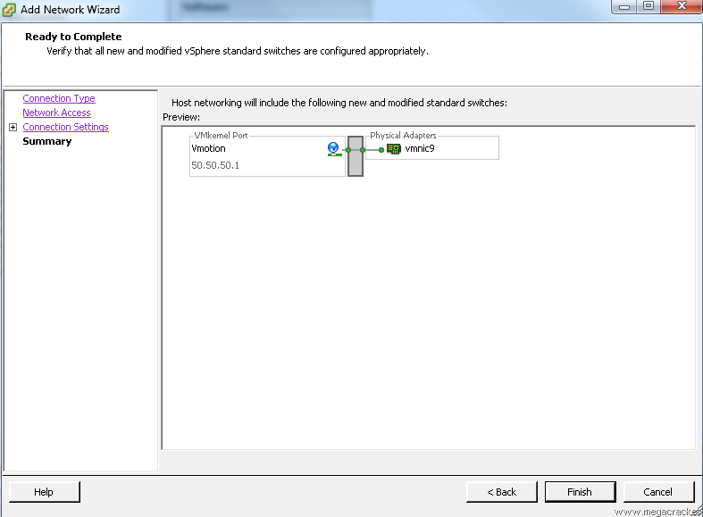

Click on **Finish**

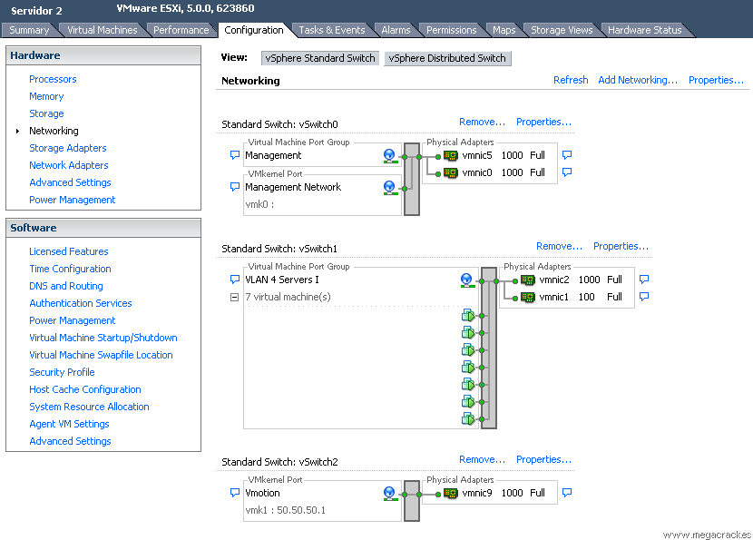

Select the tab **Configuration-> Network Adapters** and we see that we have visibility of the new connections

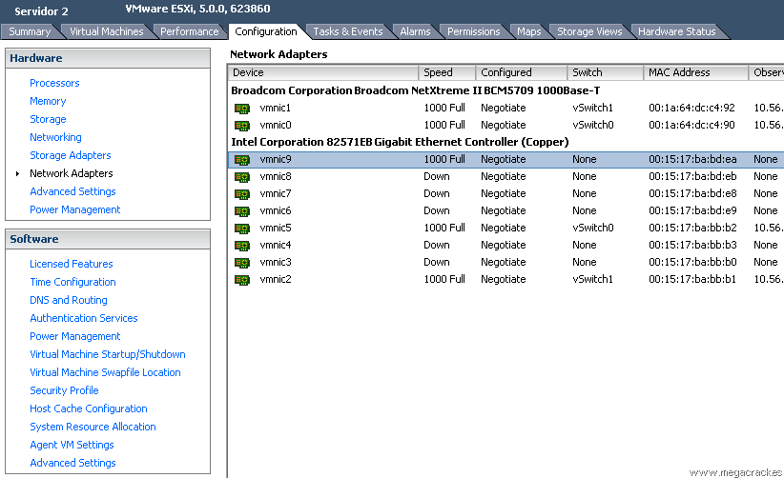

Now go to the tab **Configuration-> Networking**

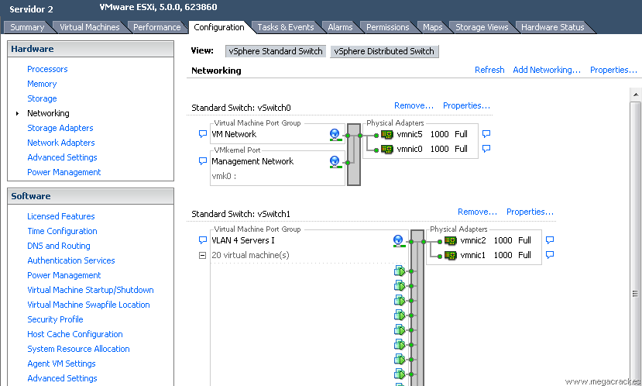

Click on **Add Networking** to create the vSwitch. Select **VMKernel** and click on **Next.**



Making a network card or cards that have connected from one server to another (in our case **vmnic9**) And click on **Next.**





**Use the following IP settings:**

**IP Address: 50.50.50.2**

**Subnet Mask: 255.255.255.252**

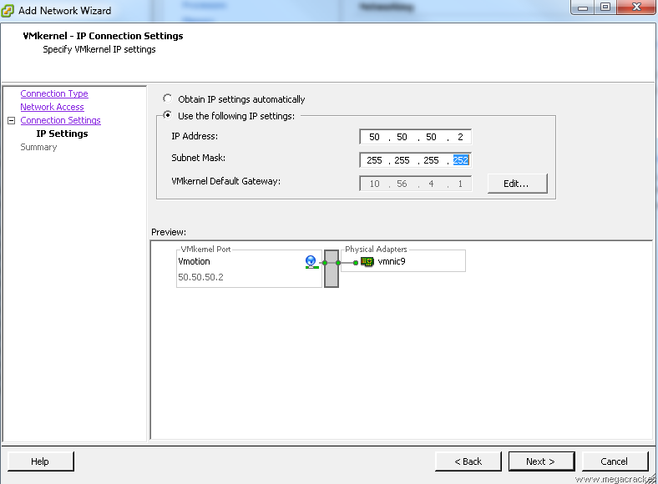

Click on **Next.**

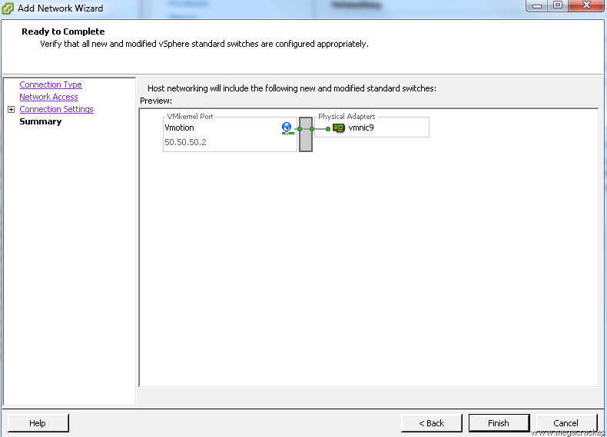

Click on **Finish**.

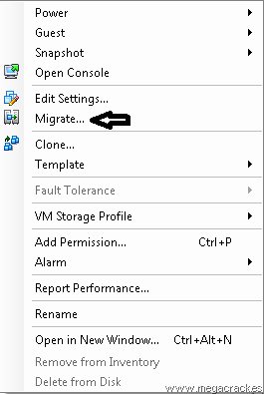

Click on **Migrate**

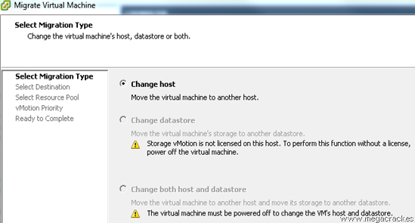

Click on **Next**

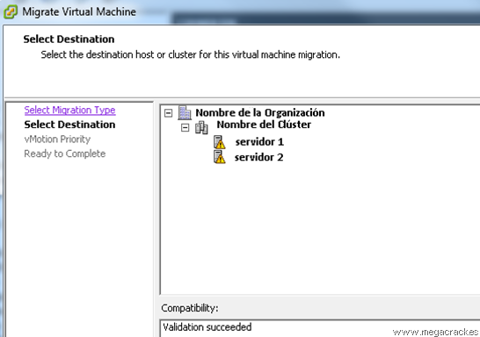

Select the target server where we will move the virtual machine.

Click on **Next**

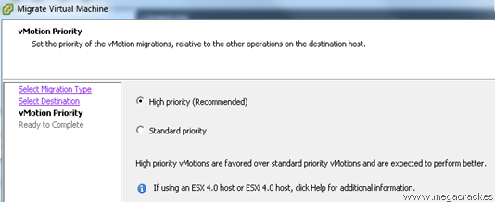

Click on **Next**

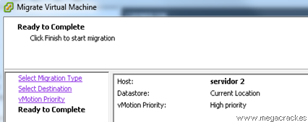

Click on **Finish** to start the migration

ESXi Vmotion 17