

SRI LANKA INSTITUTE OF INFORMATION TECHNOLOGY

[**Enterprise Standards and Best Practices for IT Infrastructure**](http://courseweb.sliit.lk/course/view.php?id=137)

**4thYear 2nd Semester 2016**

**Assignment 4**

Name: Sugathapala M. R. C. L. V

Reg No: IT13006044

**Vmotion VMware**

Select the tab **Configuration-> Network Adapters** and we can see new connections.

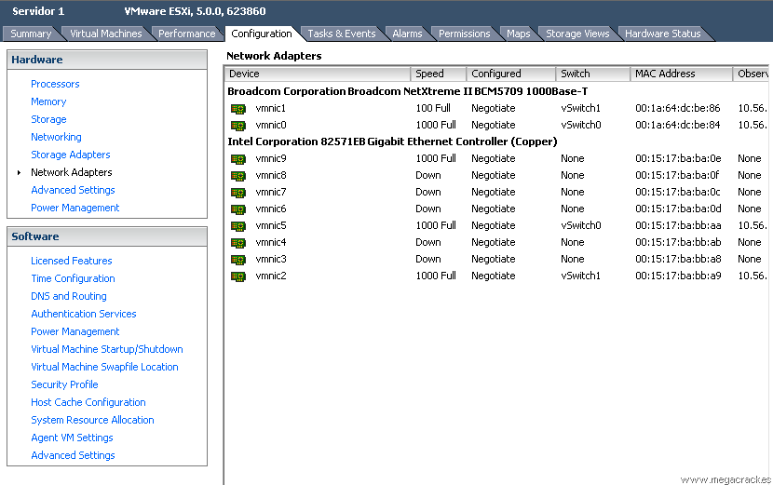

Now go to the tab **Configuration-> Networking**

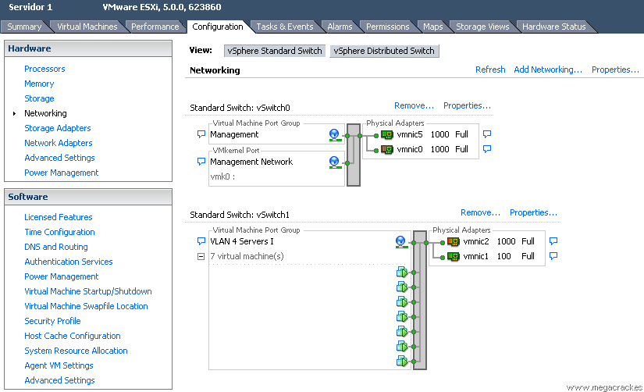

To create the vSwitch click on **Add Networking**

 Select **VMKernel** and click on **Next**

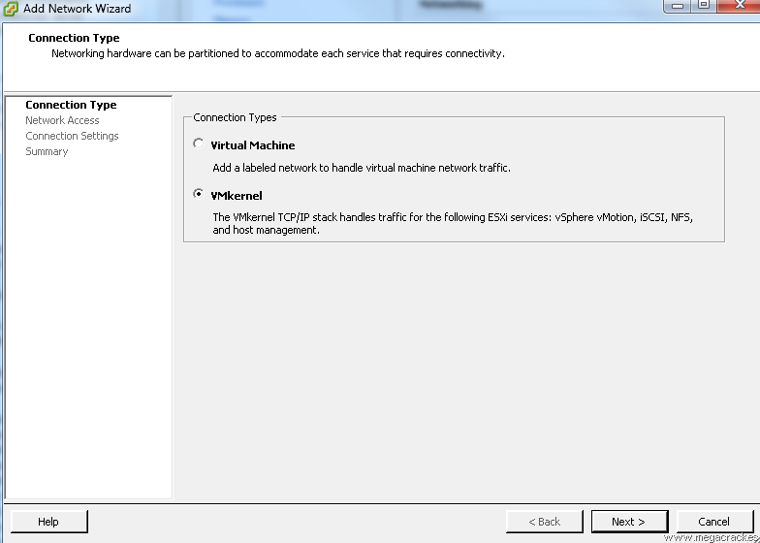

To make a network card have connected from one server to another and click on **Next**

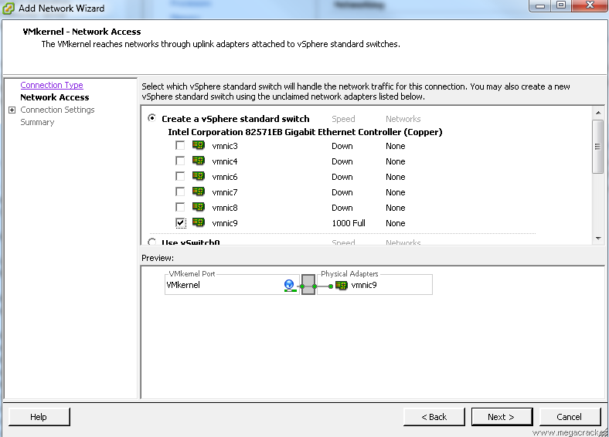

Select **Use this port group for vMotion.**

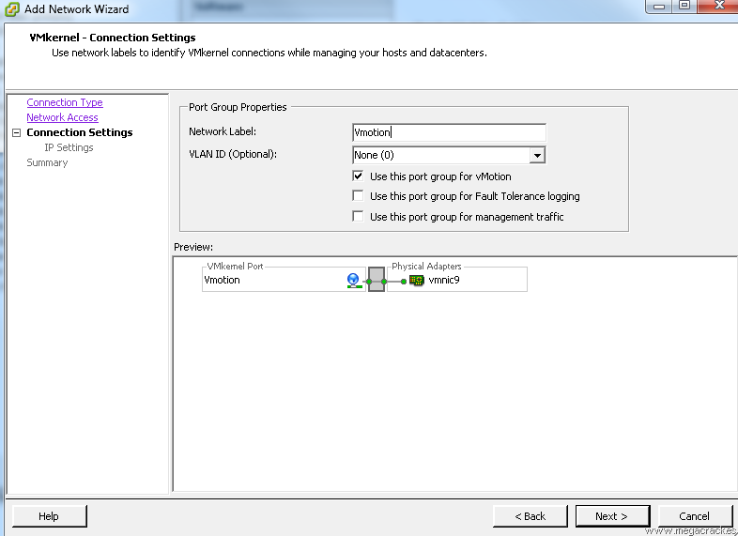

We wrote a **Label Network** different if you want (optional) and click on **Next.** We for example we put **Vmotion**

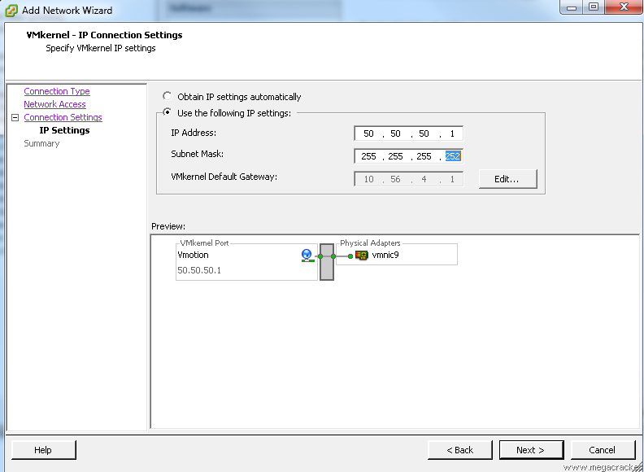

**Use the following IP settings:**

**IP Address: 50.50.50.1**

**Subnet Mask: 255.255.255.252** Click on **Next.**

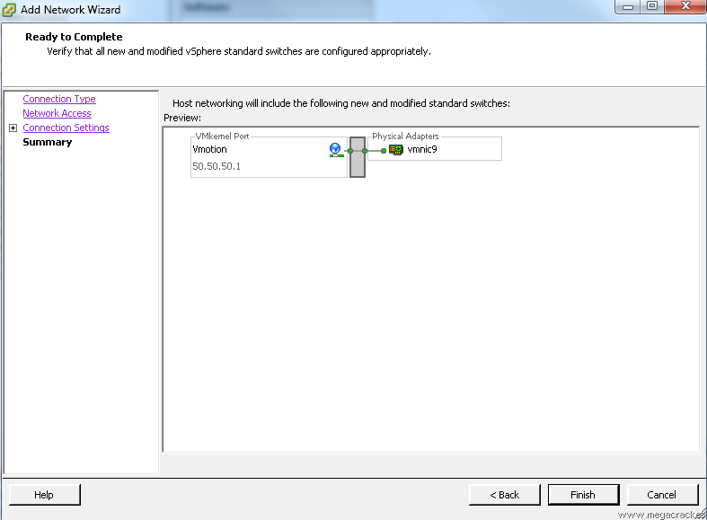

Click on **Finish**

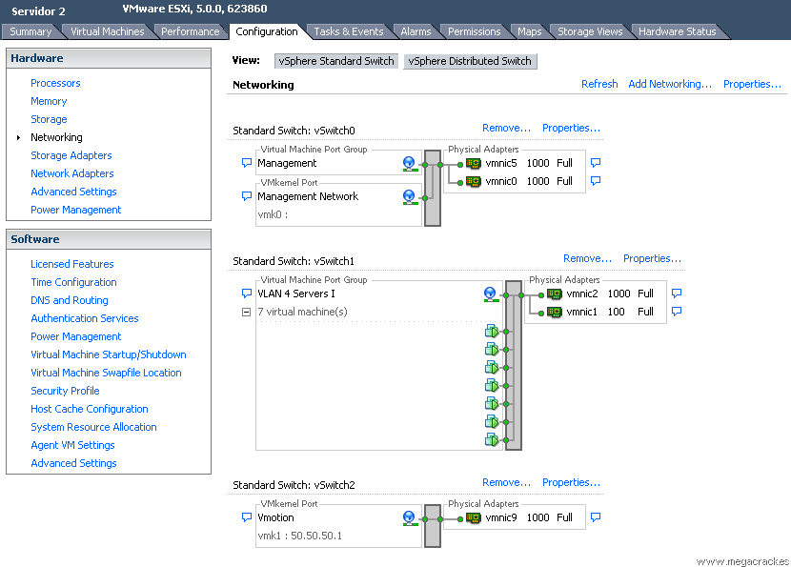

Select the tab **Configuration-> Network Adapters** and we see that we have visibility of the new connections

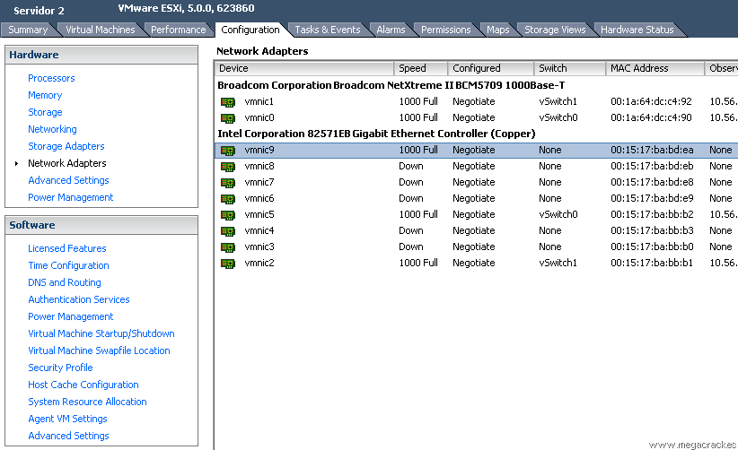

Now go to the tab **Configuration-> Networking**

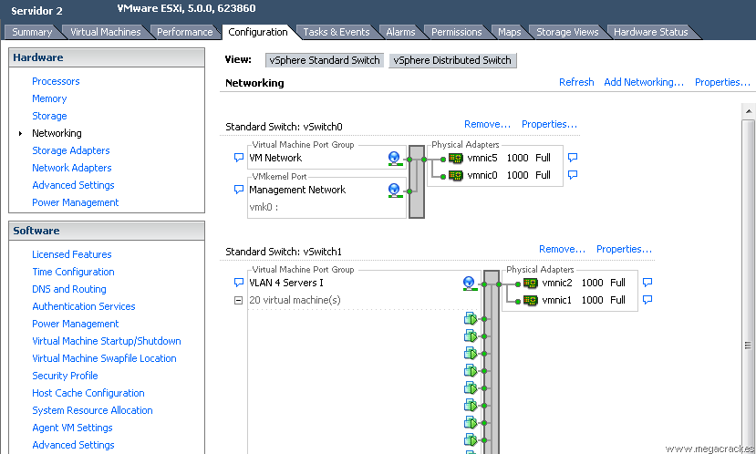

Click on **Add Networking** to create the vSwitch. Select **VMKernel** and click on **Next.**



Making a network card or cards that have connected from one server to another (in our case **vmnic9**) And click on **Next.**





**Use the following IP settings:**

**IP Address: 50.50.50.2**

**Subnet Mask: 255.255.255.252**

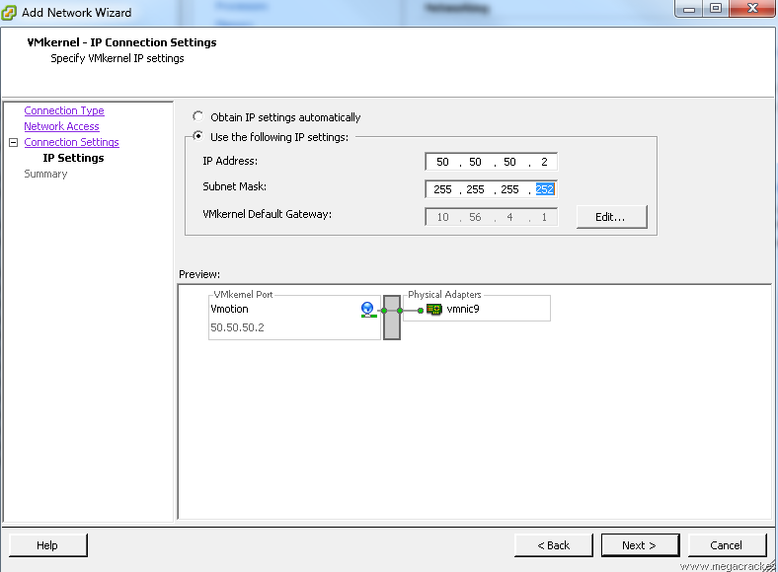

Click on **Next.**

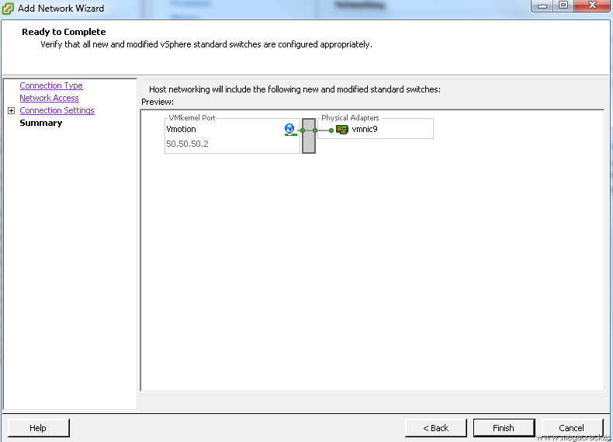

Click on **Finish**.

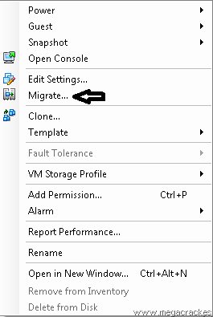

Click on **Migrate**

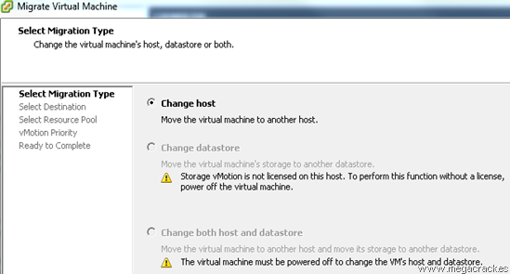

Click on **Next**

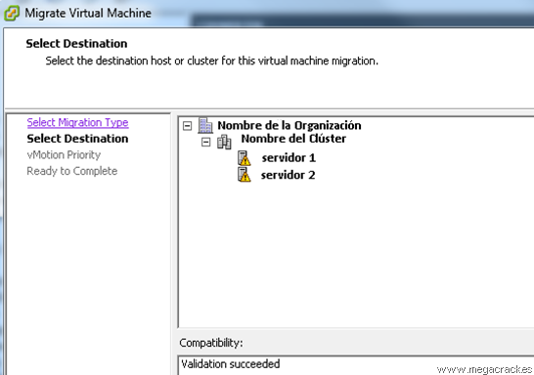

Select the target server where we will move the virtual machine.

Click on **Next**

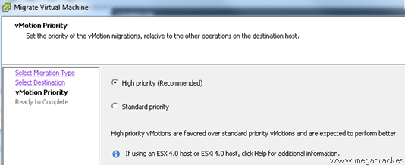

Click on **Next**

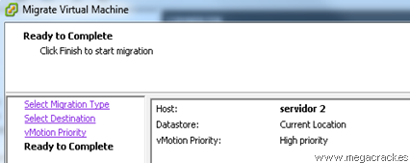

Click on **Finish** to start the migration

ESXi Vmotion 17