PROGRAM:

#include <stdio.h>
struct MinMax {
int min;
int max;
};
struct MinMax getMinMax(int arr[], int low, int high) {
struct MinMax result, left, right;
int mid;
// If there is only one element
if (low == high) {
result.max = arr[low];
result.min = arr[low];
return result;
}
// If there are two elements
if (high == low + 1) {
if (arr[low] > arr[high]) {
result.max = arr[low];
result.min = arr[high];
} else {
result.max = arr[high];
result.min = arr[low];
}
return result;
}
// If there are more than two elements
mid = (low + high) / 2;
left = getMinMax(arr, low, mid);
right = getMinMax(arr, mid + 1, high);
result.max = (left.max > right.max) ? left.max : right.max;
result.min = (left.min < right.min) ? left.min : right.min;
return result;
}
int main() {
int n, i;
printf("Enter number of elements: ");
scanf("%d", &n);
int arr[n];
printf("Enter elements:\n");
for (i = 0; i < n; i++)
scanf("%d", &arr[i]);
struct MinMax ans = getMinMax(arr, 0, n - 1);
printf("Minimum = %d\n", ans.min);
printf("Maximum = %d\n", ans.max);
return 0;
}

OUTPUT:

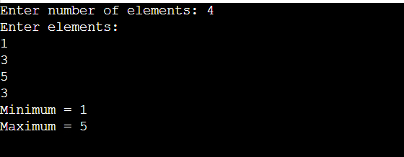

PROGRAM:\

#include <stdio.h>
void merge(int arr[], int l, int m, int r) {
int i, j, k;
int n1 = m - l + 1;
int n2 = r - m;
int L[n1], R[n2];
for (i = 0; i < n1; i++) L[i] = arr[l + i];
for (j = 0; j < n2; j++) R[j] = arr[m + 1 + j];
i = 0; j = 0; k = l;
while (i < n1 && j < n2) {
if (L[i] <= R[j]) arr[k++] = L[i++];
else arr[k++] = R[j++];
}
while (i < n1) arr[k++] = L[i++];
while (j < n2) arr[k++] = R[j++];
}
void mergeSort(int arr[], int l, int r) {
if (l < r) {
int m = l + (r - l) / 2;
mergeSort(arr, l, m);
mergeSort(arr, m + 1, r);
merge(arr, l, m, r);
}
}
int main() {
int n, i;
printf("Enter number of elements: ");
scanf("%d", &n);
int arr[n];
printf("Enter elements:\n");
for (i = 0; i < n; i++) scanf("%d", &arr[i]);
mergeSort(arr, 0, n - 1);
printf("Sorted array: ");
for (i = 0; i < n; i++) printf("%d ", arr[i]);
return 0;
}

OUTPUT:

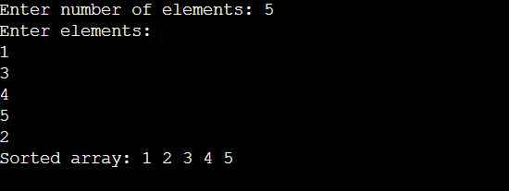

PROGRAM:

#include <stdio.h>
#define MAX 10
int board[MAX][MAX];
int N;
int isSafe(int row, int col) {
int i, j;
for (i = 0; i < col; i++)
if (board[row][i]) return 0;
for (i = row, j = col; i >= 0 && j >= 0; i--, j--)
if (board[i][j]) return 0;
for (i = row, j = col; j >= 0 && i < N; i++, j--)
if (board[i][j]) return 0;
return 1;
}
int solveNQ(int col) {
if (col >= N) return 1;
for (int i = 0; i < N; i++) {
if (isSafe(i, col)) {
board[i][col] = 1;
if (solveNQ(col + 1)) return 1;
board[i][col] = 0; // Backtrack
}
}
return 0;
}
int main() {
printf("Enter value of N: ");
scanf("%d", &N);
for (int i = 0; i < N; i++)
for (int j = 0; j < N; j++) board[i][j] = 0;
if (solveNQ(0)) {
for (int i = 0; i < N; i++) {
for (int j = 0; j < N; j++) printf("%d ", board[i][j]);
printf("\n");
}
} else printf("No solution exists\n");
return 0;
}

OUTPUT:

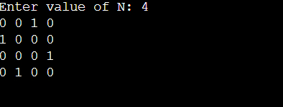

PROGRAM:

#include <stdio.h>
#include <limits.h>
#define MAX 10
int main() {
int n, i, j, graph[MAX][MAX], visited[MAX] = {0};
int cost = 0, current = 0;
printf("Enter number of cities: ");
scanf("%d", &n);
printf("Enter cost matrix:\n");
for (i = 0; i < n; i++)
for (j = 0; j < n; j++) scanf("%d", &graph[i][j]);
visited[0] = 1;
printf("Path: 0 ");
for (i = 0; i < n - 1; i++) {
int min = INT_MAX, next = -1;
for (j = 0; j < n; j++) {
if (!visited[j] && graph[current][j] < min && graph[current][j] != 0) {
min = graph[current][j];
next = j;
}
}
if (next != -1) {
visited[next] = 1;
cost += min;
current = next;
printf("-> %d ", current);
}
}
cost += graph[current][0];
printf("-> 0\nTotal cost: %d\n", cost);
return 0;
}

OUTPUT:

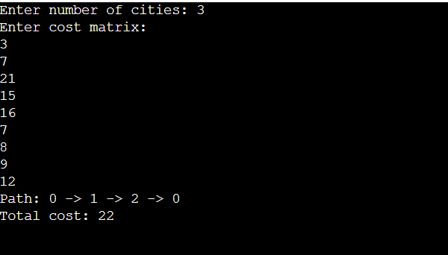

PROGRAM:

#include <stdio.h>
void swap(int* a, int* b) {
int t = *a;
*a = *b;
*b = t;
}
int partition(int arr[], int low, int high) {
int pivot = arr[high];
int i = low;
for (int j = low; j < high; j++) {
if (arr[j] <= pivot) {
swap(&arr[i], &arr[j]);
i++;
}
}
swap(&arr[i], &arr[high]);
return i;
}
int quickSelect(int arr[], int low, int high, int k) {
if (k > 0 && k <= high - low + 1) {
int pi = partition(arr, low, high);
if (pi - low == k - 1) return arr[pi];
if (pi - low > k - 1) return quickSelect(arr, low, pi - 1, k);
return quickSelect(arr, pi + 1, high, k - (pi - low + 1));
}
return -1;
}

int main() {
int n, k, i;
printf("Enter number of elements: ");
scanf("%d", &n);
int A[n];
printf("Enter elements:\n");
for (i = 0; i < n; i++) scanf("%d", &A[i]);
printf("Enter k: ");
scanf("%d", &k);
int result = quickSelect(A, 0, n - 1, k);
if (result != -1) printf("The %d-th smallest element is: %d\n", k, result);
else printf("Invalid k\n");
return 0;
}

OUTPUT:

