

COLLEGE OF ENGINEERING

Department of Computer Engineering and Computer Science

**I2C Protocol On FPGA**

By

Chanartip Soonthornwan (014353883)

On October 24, 2018

Intentionally left blank.

Table of Contents

1 Introduction 4

2 Features 4

3 General I2C Operation 4

4 Data Validity 5

5 Design Methodology 6

6 Verilog 6

7 I2C for Garbage Collector 7

8 I2C With a TramelBlaze 8

9 Externally Developed Blocks 8

9.1 TramelBlaze 8

10 Internally Developed Blocks 9

10.1 I2C Top Level Design 9

10.2 I2C_Core 12

10.3 I2C Interface 15

Table of Appendices

Appendix a: I2C Top Level Source Code 18

Appendix b: I2C_Core Source Code 21

Appendix c: I2C_Interface Source Code 28

Appendix d: I2C_Top_Level Testbench 31

Appendix e: I2C_Core Testbench 33

Appendix f: I2C_Interface Testbench 35

Table of Figures

Figure 1: Example of I2C Bus 4

[Figure 2: START and STOP condition 4](https://d.docs.live.net/95182daea981e71a/2018Fall_CSULB/CECS490B/Current_Project/Document/I2C_Document.docx#_Toc528155952)

Figure 3: I2C master to slave communication 5

[Figure 5: Acknowledge from a slave 5](https://d.docs.live.net/95182daea981e71a/2018Fall_CSULB/CECS490B/Current_Project/Document/I2C_Document.docx#_Toc528155954)

[Figure 4: SDA is set while SCL is LOW and remain stable while SCL is HIGH. 5](https://d.docs.live.net/95182daea981e71a/2018Fall_CSULB/CECS490B/Current_Project/Document/I2C_Document.docx#_Toc528155955)

[Figure 6: I2C simple state diagram 6](https://d.docs.live.net/95182daea981e71a/2018Fall_CSULB/CECS490B/Current_Project/Document/I2C_Document.docx#_Toc528155956)

[Figure 7: I2C Timing Diagram with States 7](https://d.docs.live.net/95182daea981e71a/2018Fall_CSULB/CECS490B/Current_Project/Document/I2C_Document.docx#_Toc528155957)

[Figure 7: TramelBlaze Block Diagram 8](https://d.docs.live.net/95182daea981e71a/2018Fall_CSULB/CECS490B/Current_Project/Document/I2C_Document.docx#_Toc528155958)

[Figure 9: Top Level Detail Block Diagram 9](https://d.docs.live.net/95182daea981e71a/2018Fall_CSULB/CECS490B/Current_Project/Document/I2C_Document.docx#_Toc528155959)

[Figure 8: Top Level Block Diagram 9](https://d.docs.live.net/95182daea981e71a/2018Fall_CSULB/CECS490B/Current_Project/Document/I2C_Document.docx#_Toc528155960)

Figure 11: Top Level Verification 10

Figure 12: Top Level Complete Transmission 10

[Figure 12: Top Level Complete Transmission Explanation 11](https://d.docs.live.net/95182daea981e71a/2018Fall_CSULB/CECS490B/Current_Project/Document/I2C_Document.docx#_Toc528155963)

Figure 14: Top Level Incomplete Transmission 11

[Figure 14: I2C Core State Diagram 12](https://d.docs.live.net/95182daea981e71a/2018Fall_CSULB/CECS490B/Current_Project/Document/I2C_Document.docx#_Toc528155965)

[Figure 15: I2C Core Block Diagram 12](https://d.docs.live.net/95182daea981e71a/2018Fall_CSULB/CECS490B/Current_Project/Document/I2C_Document.docx#_Toc528155966)

[Figure 16: I2C_Core Verification with Simulated Acknowledgement 13](https://d.docs.live.net/95182daea981e71a/2018Fall_CSULB/CECS490B/Current_Project/Document/I2C_Document.docx#_Toc528155967)

Figure 18: I2C_Core Timing Diagram 14

[Figure 18: I2C_Interface Block Diagram 15](https://d.docs.live.net/95182daea981e71a/2018Fall_CSULB/CECS490B/Current_Project/Document/I2C_Document.docx#_Toc528155969)

Figure 20: I2C_Interface Reading and Writing phrase 16

[Figure 20: I2C_Interface debouncing button input and clearing registers 17](https://d.docs.live.net/95182daea981e71a/2018Fall_CSULB/CECS490B/Current_Project/Document/I2C_Document.docx#_Toc528155971)

Table of Tables

Table 1: Bidirectional Verilog code and Diagram 6

Table 2: TramelBlaze I/O 8

Table 3: I2C Top Level I/O Table 10

Table 4: I2C Core I/O table 13

Table 5: I2C_Interface I/O Table 16

**I2C Protocol**

# Introduction

I2C or Two-wire interface (TWI) is very popular and power protocol for communication between multiple masters and slaves which only require two wires, SCL and SDA, connected on each device. A master initiates all communication on the wires which means to supply the clock to slaves, and the slave will never initiate a communication. The I2C interface can operate up to 400Kbits/second, but for this project there would be a master and it will operate to the standard of 100Kbits/ second.

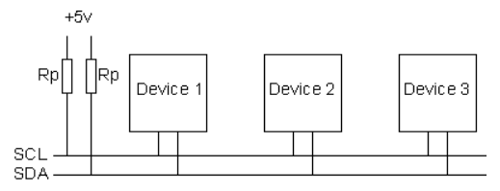

Figure 1: Example of I2C Bus

# Features

* A master and multiple slave operation
* Requires only two pins to interface I2C bus (SCL and SDA)
* Support standard rate 100 Kbps

# General I2C Operation

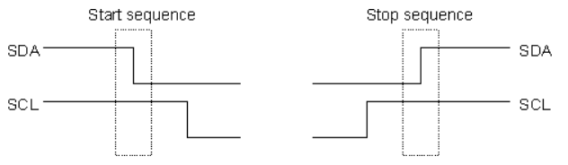 When the I2C master demands to communicate to a slave, the master initiates transmission by pulling the SDA bus LOW while SCL is still HIGH to indicating the START condition (Figure 2). Then, shifting one bit at the time from the most significant bit (MSB) to the least significant bit (LSB) of the address of the slave that the master wants to communicate following by a read or write bit. For this I2C version, the master will be only writing. After shifting the address and the write bit, the master will wait for an acknowledge from the slave by releasing control of the SDA line. On the other hands, the slave receiving the address and check if it is its address, then the slave will seize the SDA control and output LOW as an acknowledge. Once the master receives the acknowledge, the master transmits an 8-bit data then waits for another acknowledge before ending the communication by sending a STOP condition. The writing communication is shown in Figure 3.

Figure 2: START and STOP condition

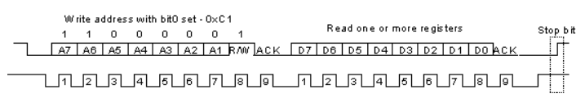

Figure 3: I2C master to slave communication

# Data Validity

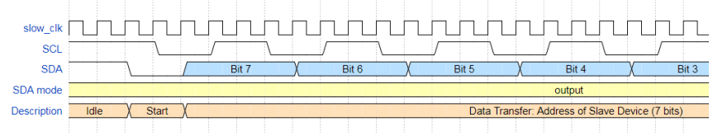 A bit of data (either address or data) is transmitting during a SCL clock pulse. Therefore, the data to be transmitted must be ready while SCL is LOW and has to be stable during HIGH time (Figure 4). In other words, the SDA line should be set when SCL is LOW because if SDA is LOW when SCL is HIGH, it will trigger a START or STOP condition instead. After sending 8-bit data, an acknowledge should be sent from

a slave under the same condition, the acknowledge should be ready before the rising edge of SCL and stable while SCL is HIGH (Figure 5).

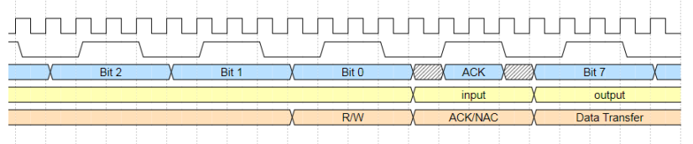

Figure 4: Acknowledge from a slave

Figure 5: SDA is set while SCL is LOW and remain stable while SCL is HIGH.

# Design Methodology

I2C module implements a Moore State Machine to control the inputs, outputs, and changes at the right event. The intermediate module interprets and translates the controls or commands into bit-level data for sending SCL and SDA lines. The state diagram in figure 6 below explains an understandable chart while the state is more complex behind the scene.

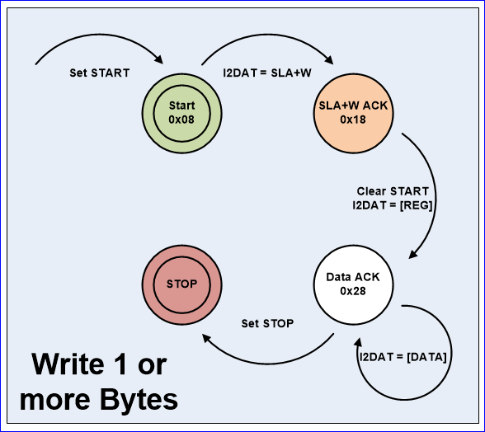

Figure 6: I2C simple state diagram

# Verilog

I2C wires traditionally are bidirectional pins, but only SCL are commonly used as an output pin since multi-master device case is rare, such that SDA is the only bidirectional pin used for outputting and receiving data. Since SDA is operating serially (one-bit at the time), the FPGA must be able to switch the characteristic of the pin between output and input state. In Verilog, it could be done by utilizing an output enable variable. The output-enable variable acts like a tri-state buffer which takes control of the SDA pin when it is enable or releases the control the pin by setting high impedance to the pin to allow another device to take control over the SDA line.

|  |  |
| --- | --- |
| **Sample snippet code**  input sda_pad_oen; inout SDA;  reg sda_pad_o; assign SDA = (sda_pad_oen) ? sda_pad_o : 1'bz; assign sda_pad_i = (~sda_pad_oen) ? SDA : 1'bz; |  |

Table 1: Bidirectional Verilog code and Diagram

SDA is an output when sda_pad_oen is set. Meaning the program takes controls the SDA line and transmit data from sda_pad_o out. Otherwise, the program sets SDA on high impedance state. Meanwhile, when sda_pad_oen is disable and the SDA is at high impedance state, the program allows any change on SDA line to store to sda_pad_i, so a user could utilize the value on sda_pad_i (i.e. the value on SDA).

# I2C for Garbage Collector

The I2C for Garbage Collector is customized specifically for this project as the requirement of the project is to use the I2C master on a FPGA to be a half-duplex protocol which only transmitting data to a destination slave that does not have a special register on it. In other words, whatever data input to the slave will be the data that it uses on their process right away. The SCL clock provides 100KHz or 10 us period times while transmitting the data. Since the FPGA has on-board a 100 MHz oscillator, a clock divider is implemented to create a slow clock which is four times faster than the required SCL clock or 400KHz slowed clock. The reason that slowed clock has to be four times faster than a period of SCL is that a state on the state diagram above could be divided into four states, therefore, the state machine has a full control over data path and control path for the I2C device (Figure 7).

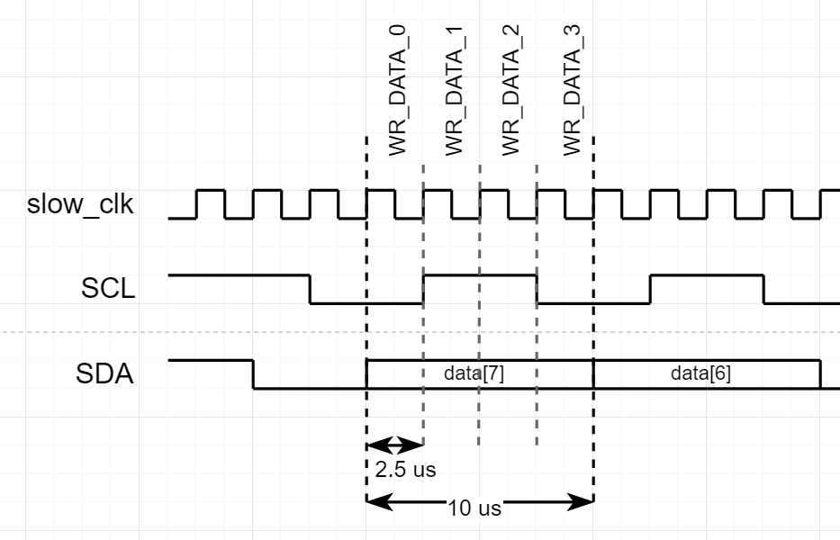

Figure 7: I2C Timing Diagram with States

# I2C With a TramelBlaze

TramelBlaze is a 16-bit emulator of an 8-bit software microprocessor, PicoBlaze. The TramelBlaze will collect 7-MSB-bit on a FPGA, Nexys4, switches as an address and 8-LSB-bit of the switches as an 8-bit data for the I2C to transmit to a slave device. Since the switches are inputs from the FPGA, the inputs go through the microprocessor before transmitting out to a slave through I2C. The switches will be stored in the microprocessor’s scratchpad RAM in order which are the address and then the data, and the microprocessor will output an address, a data, and a write command respectively.

To make the design less complicated, I2C_Interface is implemented to reduce the intermediate connection wires between FPGA’s inputs, microprocessor’s I/O, I2C’s I/O, and other small modules. The interface contains registers that hold immediate values of a slave’s address, data, and i2C start bit. Moreover, it sets and reset interrupt request for the microprocessor, and selects an input for the microcontroller to read.

# Externally Developed Blocks

## TramelBlaze

**Description**

A 16-bit microcontroller that emulates the 8-bit PicoBlaze utilizing 4Kx16 bit ROM as instruction memory where the processor reads and performs the assembly program. In this application, TramelBlaze utilizes UART engine to communicate with a Serial Terminal as to display and receive an ASCII value according to which port_id the processor preferred.

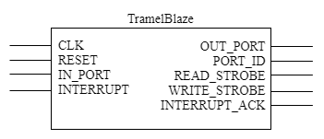

Figure 8: TramelBlaze Block Diagram

**I/O**

|  |  |  |  |
| --- | --- | --- | --- |
| **Signal** | **Size (bit)** | **I/O** | **Connected to** |
| CLK | 1 | I | 100MHz Crystal Oscillator |
| RESET | 1 | I | AISO_RST |
| INTERRUPT | 1 | I | RS_FLOP |
| IN_PORT | 16 | I | UART_TOP |
| OUT_PORT | 16 | O | UART_TOP |
| PORT_ID | 16 | O | Address Decoder |
| INTERRUPT_ACK | 1 | O | RS_FLOP |
| READ_STROBE | 1 | O | UART_TOP |
| WRITE_STROBE | 1 | O | UART_TOP |

Table 2: TramelBlaze I/O

# Internally Developed Blocks

## I2C Top Level Design

**Description**

The top level demonstrates interconnections of controls and data paths through a I2C core, a microprocessor (TramelBlaze), a I2C interface, and an Asynchronized-In-Synchronized-Out Reset signal module (AISO_RST). The switches input will be sent through the I2C interface before sending to the microprocessor and then sending to the I2C core through the interface.

**Block Diagrams**

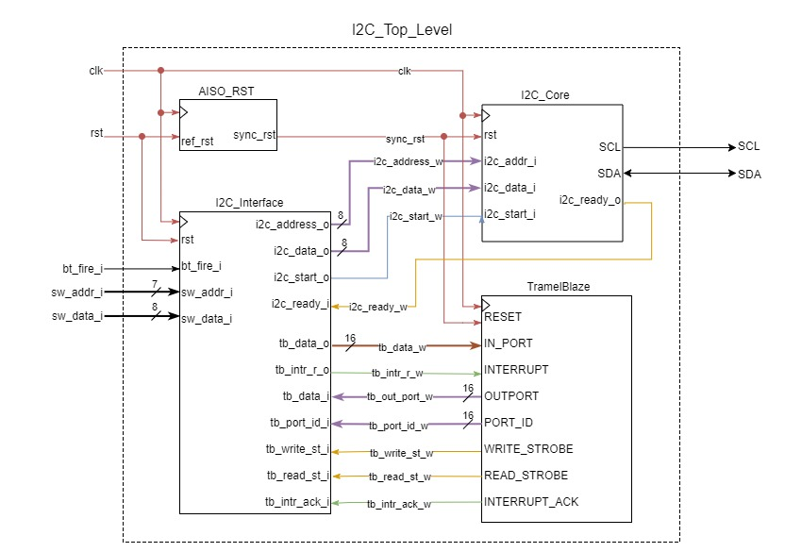

Figure 9: Top Level Detail Block Diagram

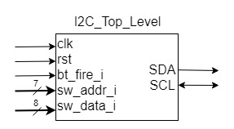

Figure 10: Top Level Block Diagram

**I/O**

|  |  |  |  |  |  |
| --- | --- | --- | --- | --- | --- |
| **Signals** | **I/O** | **Size (bits)** | **Type** | **Description** | **Operation** |
| clk | I | 1 | Digital | Provide 100 MHz clock frequency to the design | Generate 100 MHz clock |
| rst | I | 1 | Digital | Reset signal | Press button up to active |
| bt_fire_i | I | 1 | Analog | Start I2C transmission | Press button down to active |
| sw_addr_i | I | 7 | Analog | Slave address input | Toggle switches [15:9] |
| sw_data_i | I | 8 | Analog | Slave data input | Toggle switches [7:0] |
| SCL | O | 1 | Digital | Serial Clock Line | A bus line to slaves |
| SDA | IO | 1 | Digital | Serial Data Line | A bus line to slaves |

Table 3: I2C Top Level I/O Table

**Source Code:** Appendix a: I2C Top Level Source Code

**Verification**

To verify, the top level will be provided different switches input for the master to communicate on multiple slave devices. Then, the top level will receive bt_fire_i signal to simulate a physical push button on a FPGA, and the signal will be stabilized by a debounced module to create a digital pulse signal to operate the I2C Core. The slave addresses are, 7’h01, 7’h72, 7’h55, and 7’h12. The slave devices were programmed by other designer which could successfully verify the communication because the slaves could response to the protocol as expected.

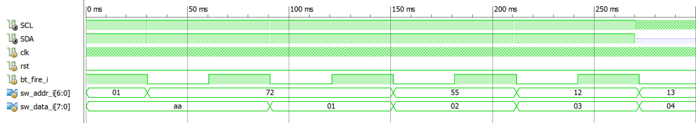

Figure 11: Top Level Verification

The bt_fire_i button is pushed for 30 ms before generating a one-pulse shot signal to The Tramelblaze to start the I2C transmission. Each time a transmission is done, there is a change on switches for address and data to simulate that the I2C master can communicate to multiple slaves, but there is a limit of this module which is the transmission would fall into a state of reading an acknowledge forever if the address that the I2C is transmitted to an unknown slave device around the end of the simulation.

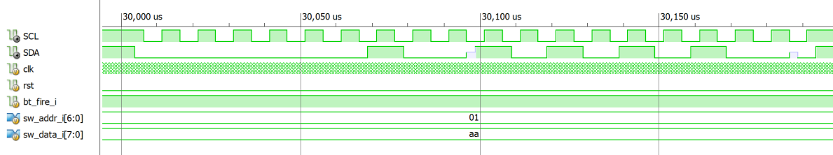

Figure 12: Top Level Complete Transmission

According to the state diagram (Figure 6), a complete transmission begins with a START condition which SDA line is pulled LOW following by SCL line, then transmits 7-bit data with a write bit (LOW) before waiting for an acknowledge from a slave. Since the slave is not created for specifically for this project, then there is a little red spike in the diagram, but the acknowledge bit from the slave has been read while the SCL is on HIGH time. Therefore, the Top Level could move to the next steps which are sending 8-bit of data, reading for another acknowledge, send a STOP bit, and come back to idle state 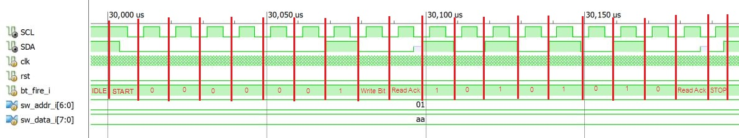as expected (show in Figure 12 ).

Figure 13: Top Level Complete Transmission Explanation

On the other hands, when the master fails by sending an address to a known slave, the master will be waiting for an acknowledge forever which could be fixed by adding a function to scope the reading for acknowledge duration in the next version.

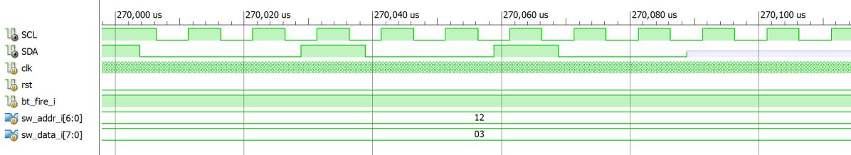

Figure 14: Top Level Incomplete Transmission

**Verification Source Code:** Appendix d: I2C_Top_Level Testbench

## I2C_Core

**Description**

A master module of I2C protocol which can initiate a communication between itself to other devices on the Two Wire Interface (TWI) buses. It contains a clock divider which generates a slow clock from on-board oscillator. The slow clock is used for driving states of a state machine that controls the input and output of the I2C Core since the SCL and SDA line must be setup in sequences of each other.

**Block Diagrams**

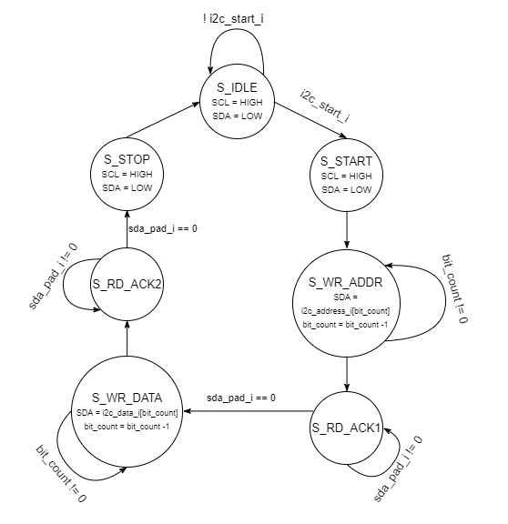

Figure 15: I2C Core State Diagram

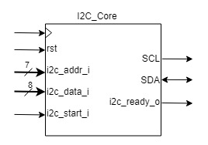

Figure 16: I2C Core Block Diagram

**I/O**

|  |  |  |  |  |  |
| --- | --- | --- | --- | --- | --- |
| **Signals** | **I/O** | **Size (bits)** | **Type** | **Description** | **Operation** |
| clk | I | 1 | Digital | Provide 100 MHz clock frequency to the design | Generate 100 MHz clock |
| rst | I | 1 | Digital | Reset signal | Receive synchronous reset signal from AISO_RST |
| i2c_addr_i | I | 7 | Digital | Address to transmit | Receive Address from I2C_Interface |
| i2c_data_i | I | 8 | Digital | Data to transmit | Receive Data from I2C_Interface |
| i2c_start_i | I | 1 | Digital | I2C_Core Start signal | Receive Start signal from I2C_Interface |
| i2c_ready_o | O | 1 | Digital | I2C_Core Ready signal | Send Ready to I2C_Interface  1: ready / 0: busy |

Table 4: I2C Core I/O table

**Source Code:** Appendix b: I2C_Core Source Code

**Verification**

The I2C_Core will be provided an address, data, and a start signal to start the communication, and it will be provided a simulated acknowledgement from a slave at the READ_ACK state, such that the state machine, SCL and SDA signals transition, and the clock divider could be observed and verified.

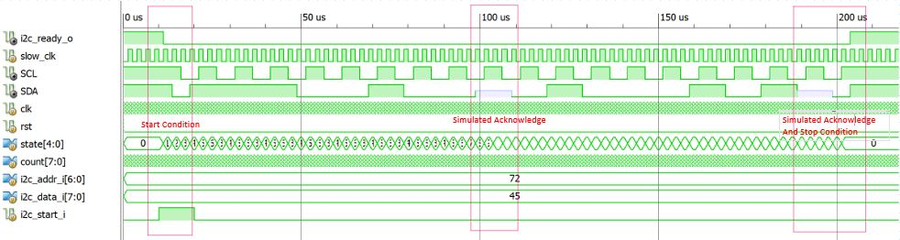

Figure 17: I2C_Core Verification with Simulated Acknowledgement

As shown in Figure 16, the I2C_Core completes a communication to a slave that has the address of 7’h72 by sending a start condition, sending the 7’h72 address, receiving simulated acknowledge, sending data, receiving another simulated acknowledge, and then sending a stop condition. This could verify that I2C_Core’s state machine is successfully transitioning from START to STOP states.

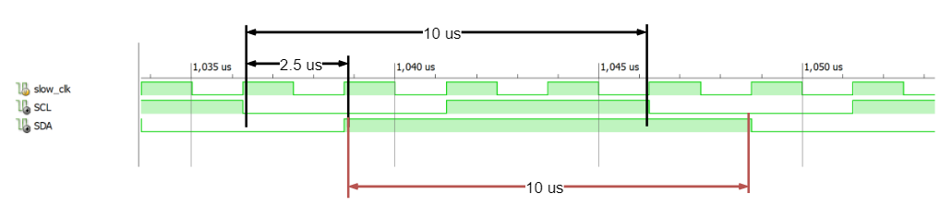

Figure 18: I2C_Core Timing Diagram

According to the timing calculation, slow clock should have 2.5 us period as this equation:

Also, I2C timing standard requirement is 100Kbit per second or 10 us that can be calculated by this equation:

Then, the slow clock, SCL, and SDL timings are verified as they are 2.5 us, 10 us, and 10 us period times respectively according to the simulation.

**Verification Source Code:** Appendix e: I2C_Core Testbench

## I2C Interface

**Description**

The module which is an interface of on-board inputs, outputs, and interconnection wires between I2C_Core and TramelBlaze. I2C Interface holds immediate I2C address, data, and start signal for I2C_Core. The signals are reset when I2C_Core is ready for the next operation. The interface also debounce (or stabilize) a physical on-board push button’s signal and select which source of input for the TramelBlaze when it reads an input.

**Block Diagrams**

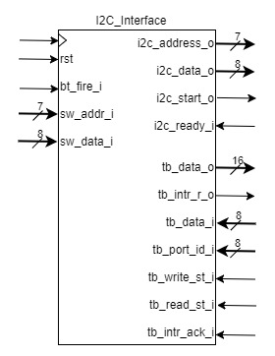

Figure 19: I2C_Interface Block Diagram

**I/O**

|  |  |  |  |  |  |
| --- | --- | --- | --- | --- | --- |
| **Signals** | **I/O** | **Size (bits)** | **Type** | **Description** | **Operation** |
| clk | I | 1 | Digital | Provide 100 MHz clock frequency to the design | Generate 100 MHz clock |
| rst | I | 1 | Digital | Reset signal | Press button up to active |
| bt_fire_i | I | 1 | Analog | Start I2C transmission | Press button down to active |
| sw_addr_i | I | 7 | Analog | Slave address input | Toggle switches [15:9] |
| sw_data_i | I | 8 | Analog | Slave data input | Toggle switches [7:0] |
| i2c_addr_o | O | 8 | Digital | Address to transmit | Send Address to I2C_Core |
| i2c_data_o | O | 8 | Digital | Data to transmit | Send Data to I2C_Core |
| i2c_start_o | O | 1 | Digital | I2C_Core Start signal | Send Start signal to I2C_Core |
| i2c_ready_i | I | 1 | Digital | I2C_Core Ready signal | Receive Ready from I2C_Core  1: ready / 0: busy |
| tb_port_id_i | I | 16 | Digital | Port ID input | Receive Port ID from TB |
| tb_data_i | I | 16 | Digital | Data input | Receive Data from TB |
| tb_write_st_i | I | 1 | Digital | Write Strobe input | Receive Write Strobe from TB |
| tb_read_st_i | I | 1 | Digital | Read Strobe input | Receive Read Strobe from TB |
| tb_intr_ack_i | I | 1 | Digital | Interrupt acknowledge input | Receive interrupt acknowledge from TB |
| tb_intr_r_o | O | 1 | Digital | Interrupt request output | Send interrupt request to TB |
| tb_data_o | O | 16 | Digital | Data output | Send data to TB |

Table 5: I2C_Interface I/O Table

**Source Code:** Appendix c: I2C_Interface Source Code

**Verification**

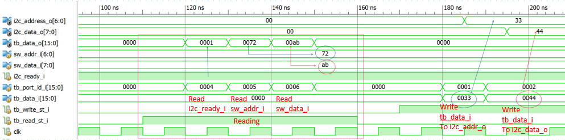I2C_Interface typically operates by combinational logic from inputs and outputs from TrambelBlaze(TB), I2C_Core, and the FPGA. It is difficult to simulate the output without them, but I2C_Interface could be breakdown to three parts; reading to TB, writing from TB, and clearing registers.

Figure 20: I2C_Interface Reading and Writing phrase

Reading to TB, when TramelBlaze’s read strobe (tb_read_st_i) is HIGH, it is indicating that the TB wants to read the address and data from switch inputs or reading the I2C_Core status through the port ID of the input it wants to read. As shown in Figure 20, when Read Strobe is HIGH and the port ID state 16’h0004, it means the TB is reading i2c_ready_i. Since the ready signal is HIGH, then data output to TB (tb_data_o) is HIGH at LSB (16’h0001). Then, port id is 16’h0005 means that TB is reading sw_addr_i, so tb_data_o gets 16’h0072. After that, tb_data_o gets 16’h00ab when port id is 16’h0006.

Writing from TB, similar fashion to the reading part, if port id is 16’h0001, I2C_Interface will pass the input from TB (tb_data_i) to I2C_Core address input (i2c_addr_i). If port id is 16’h0002, it will pass tb_data_i to I2C_Core data input (i2c_data_i). Lastly, if port id is 16’h 0003, it will write a start signal to the I2C_Core (i2c_start_i).

Clearing registers, the data in i2c_addr_i and i2c_data_i will be cleared at the rising edge of the Ready signal. In other word, the data is cleared when I2C_Core finishes a transmission. In order to set the I2C_Core busy, the write button (bt_fire_i) will be HIGH for some amount of time in digital circuit, but it is roughly 30 milliseconds. During the times, there is a debounce module to stabilize the button input and pulse a clock-period long signal indicating that the button is pressed. When the pulse is set, it will trigger an interrupt request (tb_intr_r_o) to TB to call its software interrupt service routine.

Since the switch inputs are sent to TB and registers read data from TB regarding on the port_id successfully, the interrupt request is corresponded to the push button and the debounce module correctly, and the registers are reset when I2C_Core is become ready, then I2C_Interface is verified.

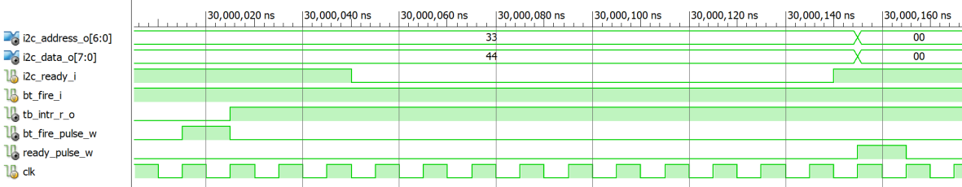

Figure 21: I2C_Interface debouncing button input and clearing registers

**Verification Source Code:** Appendix f: I2C_Interface Testbench

Appendix a: I2C Top Level Source Code

`timescale 1ns **/** 1ps

//*****************************************************************************//

// Class: CECS490B Senior Projects //

// Project name: Garbage Collector //

// File name: I2C_Top_Level.v //

// //

// Created by Chanartip Soonthornwan on October 3, 2018. //

// Copyright @ 2018 Chanartip Soonthornwan. All rights reserved. //

// //

// Abstract: Display structural of Microprocessor (Tramel Blaze) //

// and Communication Protocol Device (I2C Core) //

// utilizing Interface for complex design. //

//*****************************************************************************//

// Version 1.1 (October 12, 2018)

// - Added sw_addr_i and sw_data_i for interacting to a user input

// to select slave address and data to send

// - Added tb_port_i to allow input into INPORT of TramelBlaze

//

// Version 1.0 (October 3, 2018)

//

**module** I2C_Top_Level**(**

**input** **wire** clk**,** // System clock (100MHz)

**input** **wire** rst**,** // System reset (from button up)

**output** **wire** SCL**,** // I2C Clock wire

**inout** **wire** SDA**,** // I2C Data wire

**input** **wire** bt_fire_i**,** // button down to fire a transmission

**input** **wire** **[**6**:**0**]** sw_addr_i**,** // switches[15:9] for 7-bit address input

**input** **wire** **[**7**:**0**]** sw_data_i // switches[7:0] for 8-bit data input

**);**

**wire** sync_rst**;** // Synchronized reset signal wire

**wire** tb_intr_r_w**;** // Interrupt Request from I2C_Interface to TB

**wire** tb_intr_ack_w**;** // Interrupt Acknowledge from TB to I2C_Interface

**wire** **[**15**:**0**]** tb_out_port_w**;** // Output from TB to I2C_Interface

**wire** **[**15**:**0**]** tb_port_id_w**;** // PortID from TB to I2C_Interface

**wire** tb_wr_st_w**;** // Write Strobe from TB to I2C_Interface

**wire** tb_rd_st_w**;** // Read Strobe from TB to I2C_Interface

**wire** **[**15**:**0**]** tb_data_w**;** // Data output from I2C_Interface to TB

**wire** **[** 6**:**0**]** i2c_addr_w**;** // Address from I2C_Interface to I2C_Core

**wire** **[** 7**:**0**]** i2c_data_w**;** // Data from I2C_Interface to I2C_Core

**wire** i2c_start_w**;** // Start signal from I2C_Interface to I2C_Core

**wire** i2c_ready_w**;** // Ready signal from I2C_Core to I2C_Interface

// Communication Protocol Device

// Generating output clock signal on SCL line with frequency of 100KHz

// while transmitting 8-bit address and data. Also indicating a ready

// signal to microprocessor before initiating the next transmission.

I2C_Core i2c_core **(**

**.**clk **(**clk **),**

**.**rst **(**sync_rst **),**

**.**i2c_addr_i **(**i2c_addr_w **),**

**.**i2c_data_i **(**i2c_data_w **),**

**.**i2c_start_i **(**i2c_start_w **),**

**.**i2c_ready_o **(**i2c_ready_w **),**

**.**SCL **(**SCL **),**

**.**SDA **(**SDA **)**

**);**

// Interface

// Wrapping all wires, generating ready pulse signal, setting/resetting

// interrupt request, and holding Address and Data in registers

// to be ready before initiating an I2C transmission.

I2C_Interface i2c_interface**(**

**.**clk **(**clk **),**

**.**rst **(**sync_rst **),**

**.**bt_fire_i **(**bt_fire_i **),**

**.**sw_addr_i **(**sw_addr_i **),**

**.**sw_data_i **(**sw_data_i **),**

// I2C I/O

**.**i2c_ready_i **(**i2c_ready_w **),**

**.**i2c_address_o**(**i2c_addr_w **),**

**.**i2c_data_o **(**i2c_data_w **),**

**.**i2c_start_o **(**i2c_start_w **),**

// Tramel Blaze I/O

**.**tb_port_id_i **(**tb_port_id_w **),**

**.**tb_data_i **(**tb_out_port_w**),**

**.**tb_write_st_i**(**tb_wr_st_w **),**

**.**tb_read_st_i **(**tb_rd_st_w **),**

**.**tb_intr_ack_i**(**tb_intr_ack_w**),**

**.**tb_intr_r_o **(**tb_intr_r_w **),**

**.**tb_data_o **(**tb_data_w **)**

**);**

// Microprocessor

// Created by John Tramel

// Utilizing Scratch RAM to load instructions

// and execute them before initiates the transmission

// *note: In this version, there is only writing to

// but not reading from other devices.

tramelblaze_top tb_top**(**

**.**CLK **(**clk **),**

**.**RESET **(**sync_rst **),**

**.**IN_PORT **(**tb_data_w **),**

**.**INTERRUPT **(**tb_intr_r_w **),**

**.**OUT_PORT **(**tb_out_port_w**),**

**.**PORT_ID **(**tb_port_id_w **),**

**.**READ_STROBE **(**tb_rd_st_w **),**

**.**WRITE_STROBE **(**tb_wr_st_w **),**

**.**INTERRUPT_ACK**(**tb_intr_ack_w**)**

**);**

// Asynchronize-In-Synchronize-Out Reset

// In used for initiating synchronous reset signal

// to the whole design.

AISO_RST aiso_rst**(**

**.**clk **(**clk **),**

**.**ref_rst **(**rst **),**

**.**sync_rst **(**sync_rst**)**

**);**

**endmodule**

//_________________________ ASIO Reset _____________________________________

// Receives reset signal input from a reset button then generates

// synchronized output at rising edge to other module in the design.

// input: clk - reference clock (on-board clock)

// input: ref_rst - reference reset (Asynchronized reset signal input)

// output: sync_rst - synchronized reset

**module** AISO_RST**(**

**input** **wire** clk**,** ref_rst**,**

**output** **wire** sync_rst

**);**

**reg** r1**,**r2**;**

**assign** sync_rst **=** **~**r2**;** // one-clock impulsive reset signal

**always@(posedge** clk**,** **posedge** ref_rst**)** **begin**

**if(**ref_rst**)** **{**r1**,** r2**}** **<=** 2'b00**;**

**else** **{**r1**,** r2**}** **<=** **{**1'b1**,** r1**};**

**end**

**endmodule**

//_______________________ End ASIO Reset ___________________________________

Appendix b: I2C_Core Source Code

`timescale 1ns **/** 1ps

//*****************************************************************************//

// Class: CECS490B Senior Projects //

// Project name: Garbage Collector //

// File name: I2C_Core.v //

// //

// Created by Chanartip Soonthornwan on October 3, 2018. //

// Copyright @ 2018 Chanartip Soonthornwan. All rights reserved. //

// //

// Abstract: I2C at bit operation controlling data path and controls //

// via a state machine with eight states. //

//*****************************************************************************//

// Version 2.0 (October 21, 2018)

// - Remodeled Clock Divider to generate 400khz clock

// - Remodeled State Machine with more states

//

// Version 1.1 (October 12, 2018)

// - Added sw_addr_i and sw_data_i for interacting to a user input

// to select slave address and data to send

// - Added tb_port_i to allow input into INPORT of TramelBlaze

//

// Version 1.0 (October 3, 2018)

//

**module** I2C_Core**(**

**input** **wire** clk**,** // On-board Clock 100MHz

**input** **wire** rst**,** // Reset signal

**input** **wire** **[**6**:**0**]** i2c_addr_i**,** // Incoming Address

**input** **wire** **[**7**:**0**]** i2c_data_i**,** // Incoming Data

**input** **wire** i2c_start_i**,** // Start signal

**output** **reg** i2c_ready_o**,** // Ready Status Register

**output** **wire** SCL**,** // I2C SCL (clock) output

**inout** **wire** SDA // I2C SDA (data) input/output

**);**

//_____________________________ IO Padder __________________________________

//

// The middle ground for SDA and SCL bus to stop by since bidirectional

// bus cannot be directly assigning the value. Therefore, there should be a

// pad or middle ground taking place to make open-drain-like circuit.

// The bus will be high impedance when no one takes control of the bus.

// In order to control the bus, an output enable seize the control of

// the bus. Once output is done, the output enable will be released, and

// the bus from this device perspective will be high-impedance.

// High-impedance is like open-drain which will allow incoming input when

// there is an input from other devices.

//

**reg** scl_pad_o**;** // i2c_clock output

**reg** scl_pad_oen**;** // i2c_clock output enable

**wire** sda_pad_i**;** // i2c_data input

**reg** sda_pad_o**;** // i2c_data output

**reg** sda_pad_oen**;** // i2c_data output enable

**assign** SCL **=** **(**scl_pad_oen**)** **?** scl_pad_o **:** 1'bz**;**

**assign** SDA **=** **(**sda_pad_oen**)** **?** sda_pad_o **:** 1'bz**;**

**assign** sda_pad_i **=** **(~**sda_pad_oen**)?** SDA **:** 1'bz**;**

//____________________________ Clk Divider _________________________________

//

// Generates slow clock (400khz) by ticking every 2.5 us, and each tick

// will toggle the slow clock level from low to high and vice versa.

// Calculation: DELAY = 100Mhz / 400Khz = 250

// DELAY/2 = 125

**parameter** DELAY **=** 125**;** // Constant for toggleling a clock at 1.25 us

**reg** **[** 7**:**0**]** count**;** // Time counter

**reg** slow_clk**;** // slow_clock from on_board clk

**wire** tick**;** // Toggling the clock indicator

**assign** tick **=** **(**count **==** **(**DELAY **-**1**));** // Tick at 5us

**always@(posedge** clk**,** **posedge** rst**)** **begin**

**if(**rst**)** **begin**

count **<=** 0**;**

slow_clk **<=** 0**;**

**end** **else**

**if(**tick**)** **begin** // got a tick signal

count **<=** 0**;** // reset the counter

slow_clk **<=** **~**slow_clk**;** // switch the slow clock edge

**end** **else** **begin**

count **<=** count **+** 8'b1**;** // increment the counter

slow_clk **<=** slow_clk**;** // slow clock edge stay the same.

**end**

**end**

//____________________________ State Machine _________________________________

//

// Generates controls and outputs according to an events of each state.

// There are 20 states in total, but the main states are

// IDLE -> START -> WRITE_ADDR -> READ_ACK

// -> WRITE_DATA -> READ_ACK2 -> STOP -> IDLE

// Explain:

// IDLE - Both SCL and SDA are HIGH, and ready is HIGH indicating that the

// I2C is ready for i2c_start_i signal. When i2c_start_i is HIGH,

// ready is low as the I2C is busy.

// slow_clk: /~~\__/~~\__

// SCL: ~~~~~~~~~~~~

// SDA: ~~~~~~~~~~~~

//

// START - First clock will pull SDA LOW while SCL HIGH. Second clock, both

// SCL and SDA are LOW, and set the data register by concentrating

// Address and Write bit before shifting on the next clock.

// slow_clk: /~~\__/~~\__/~~\__/

// SCL: ~~~~~~~~~~~~\______

// SDA: ~~~~~~\____________

//

// WRITE - Shifting the data register from MSB to LSB. Each 4 clocks will

// decrement the register index by one, and check if it is the LSB.

// by utilizing command(CMD). If so, move to the read acknowledge.

// slow_clk: /~~\__/~~\__/~~\__/~~\__/

// SCL: ______/~~~~~~~~~~~\_____/

// SDA: ==X=======================X==

//

// READ - Wait for acknowledge input from a slave device. The input should be

// ready before the rising edge of SCL and should not change while

// the SCL is HIGH.

// slow_clk: /~~\__/~~\__/~~\__/~~\__/

// SCL: ______/~~~~~~~~~~~\_____/

// SDA: ==X=====\___________/======X==

//

// STOP - First clock will pull both SCL and SDA LOW, then SCL HIGH while

// SDA LOW.

// slow_clk: /~~\__/~~\__/~~\__/

// SCL: ~~~~~~\_____/~~~~~~

// SDA: ~~~~~~\___________/

//

**localparam**

S_IDLE **=** 0**,**

S_START_0 **=** 1**,** S_START_1 **=** 2**,**

S_WR_ADDR_0 **=** 3**,** S_WR_ADDR_1 **=** 4**,** S_WR_ADDR_2 **=** 5**,** S_WR_ADDR_3 **=** 6**,**

S_RD_ACK1_0 **=** 7**,** S_RD_ACK1_1 **=** 8**,** S_RD_ACK1_2 **=** 9**,** S_RD_ACK1_3 **=** 10**,**

S_WR_DATA_0 **=** 11**,** S_WR_DATA_1 **=** 12**,** S_WR_DATA_2 **=** 13**,** S_WR_DATA_3 **=** 14**,**

S_RD_ACK2_0 **=** 15**,** S_RD_ACK2_1 **=** 16**,** S_RD_ACK2_2 **=** 17**,** S_RD_ACK2_3 **=** 18**,**

S_STOP_0 **=** 19**,** S_STOP_1 **=** 20**,**

CMD_IDLE **=** 1**,** CMD_START **=** 2**,**

CMD_WR_ADDR **=** 3**,** CMD_RD_ACK **=** 4**,**

CMD_WR_DATA **=** 5**,** CMD_STOP **=** 6**,**

WRITE_BIT **=** 1'b0**,**

HIGH **=** 1'b1**,**

LOW **=** 1'b0**;**

// Registers

**reg** **[**7**:**0**]** data_reg**;** // Holding immediate data(address or data)

**reg** **[**2**:**0**]** bit_count**;** // Index for data_reg

**reg** **[**2**:**0**]** cmd**;** // Special command on some states

**reg** **[**4**:**0**]** state**;** // Present State

**reg** **[**4**:**0**]** next_state**;** // Next State

// Update Present State on fast clock

**always@(posedge** clk**,** **posedge** rst**)** **begin**

**if(**rst**)** state **<=** S_IDLE**;**

**else** state **<=** next_state**;**

**end**

// State Machine

**always@(posedge** slow_clk**,** **posedge** rst**)** **begin**

**if(**rst**)** **begin**

cmd **<=** CMD_IDLE**;**

scl_pad_oen **<=** HIGH**;**

sda_pad_oen **<=** HIGH**;**

scl_pad_o **<=** HIGH**;**

sda_pad_o **<=** HIGH**;**

data_reg **<=** 0**;**

bit_count **<=** 0**;**

next_state **<=** S_IDLE**;**

i2c_ready_o **<=** HIGH**;**

**end**

**else** **begin**

**case(**state**)**

// IDLE STATE

// SCL and SDA are high until recieve a start signal

S_IDLE**:** **begin**

**if(**i2c_start_i**)** **begin** // recieve start signal

cmd **<=** CMD_START**;**

scl_pad_oen **<=** HIGH**;**

sda_pad_oen **<=** HIGH**;**

scl_pad_o **<=** HIGH**;**

sda_pad_o **<=** HIGH**;**

data_reg **<=** data_reg**;**

bit_count **<=** bit_count**;**

next_state **<=** S_START_0**;**

i2c_ready_o **<=** LOW**;** // now i2c is busy

**end**

**else** **begin** // still idleling

cmd **<=** CMD_IDLE**;**

scl_pad_oen **<=** HIGH**;**

sda_pad_oen **<=** HIGH**;**

scl_pad_o **<=** HIGH**;**

sda_pad_o **<=** HIGH**;**

data_reg **<=** data_reg**;**

bit_count **<=** bit_count**;**

next_state **<=** S_IDLE**;**

i2c_ready_o **<=** HIGH**;**

**end**

**end**

// START STATE

// SDA is LOW while SCL is HIGH,

// then SCL is LOW on the next clock

S_START_0**:** **begin**

cmd **<=** CMD_START**;**

scl_pad_oen **<=** HIGH**;**

sda_pad_oen **<=** HIGH**;**

scl_pad_o **<=** HIGH**;**

sda_pad_o **<=** LOW**;**

data_reg **<=** data_reg**;**

bit_count **<=** bit_count**;**

next_state **<=** S_START_1**;**

**end**

S_START_1**:** **begin**

cmd **<=** CMD_WR_ADDR**;**

scl_pad_oen **<=** HIGH**;**

sda_pad_oen **<=** HIGH**;**

scl_pad_o **<=** LOW**;**

sda_pad_o **<=** LOW**;**

data_reg **<=** **{**i2c_addr_i**,** WRITE_BIT**};** // Loading data

bit_count **<=** 3'd7**;** // MSB Index

next_state **<=** S_WR_ADDR_0**;**

**end**

// WRITE STATE

// Shifting MSB to LSB,

// data in data_reg remains the same from clock 0 to 4,

// decrement bit_count and move to the new state at

// clock 4.

S_WR_ADDR_0**:** **begin**

cmd **<=** cmd**;**

scl_pad_oen **<=** HIGH**;**

sda_pad_oen **<=** HIGH**;**

scl_pad_o **<=** LOW**;**

sda_pad_o **<=** data_reg**[**bit_count**];**

data_reg **<=** data_reg**;**

bit_count **<=** bit_count**;**

next_state **<=** S_WR_ADDR_1**;**

**end**

S_WR_ADDR_1**:** **begin**

cmd **<=** cmd**;**

scl_pad_oen **<=** HIGH**;**

sda_pad_oen **<=** HIGH**;**

scl_pad_o **<=** HIGH**;**

sda_pad_o **<=** sda_pad_o**;**

data_reg **<=** data_reg**;**

bit_count **<=** bit_count**;**

next_state **<=** S_WR_ADDR_2**;**

**end**

S_WR_ADDR_2**:** **begin**

cmd **<=** **(**bit_count **==** 0**)?** CMD_RD_ACK **:** cmd**;**

scl_pad_oen **<=** HIGH**;**

sda_pad_oen **<=** HIGH**;**

scl_pad_o **<=** HIGH**;**

sda_pad_o **<=** sda_pad_o**;**

data_reg **<=** data_reg**;**

bit_count **<=** bit_count**;**

next_state **<=** S_WR_ADDR_3**;**

**end**

S_WR_ADDR_3**:** **begin**

cmd **<=** cmd**;**

scl_pad_oen **<=** HIGH**;**

sda_pad_oen **<=** HIGH**;**

scl_pad_o **<=** LOW**;**

sda_pad_o **<=** sda_pad_o**;**

data_reg **<=** data_reg**;**

bit_count **<=** bit_count **-**1**;**

next_state **<=** **(**cmd **==** CMD_RD_ACK**)?** S_RD_ACK1_0**:** S_WR_ADDR_0**;**

**end**

// READ STATE

// Waiting for an acknowledge from a slave device.

// Expected the ack signal to be ready before rising edge

// of SCL clock. If the signal is valid, set data_reg with

// i2c_data_i, and move to the next state.

// Otherwise, come back to wait again.

// **Note: This version doesn't have Artibute Lost**

S_RD_ACK1_0**:** **begin**

cmd **<=** cmd**;**

scl_pad_oen **<=** HIGH**;**

sda_pad_oen **<=** LOW**;**

scl_pad_o **<=** LOW**;**

sda_pad_o **<=** sda_pad_o**;**

data_reg **<=** data_reg**;**

bit_count **<=** bit_count**;**

next_state **<=** S_RD_ACK1_1**;**

**end**

S_RD_ACK1_1**:** **begin**

cmd **<=** **(**sda_pad_i **==** LOW**)?** CMD_WR_DATA**:** CMD_RD_ACK**;**

scl_pad_oen **<=** HIGH**;**

sda_pad_oen **<=** LOW**;**

scl_pad_o **<=** HIGH**;**

sda_pad_o **<=** sda_pad_o**;**

data_reg **<=** data_reg**;**

bit_count **<=** bit_count**;**

next_state **<=** S_RD_ACK1_2**;**

**end**

S_RD_ACK1_2**:** **begin**

cmd **<=** **(**sda_pad_i **==** LOW**)?** cmd**:** CMD_RD_ACK**;**

scl_pad_oen **<=** HIGH**;**

sda_pad_oen **<=** LOW**;**

scl_pad_o **<=** HIGH**;**

sda_pad_o **<=** sda_pad_o**;**

data_reg **<=** data_reg**;**

bit_count **<=** bit_count**;**

next_state **<=** S_RD_ACK1_3**;**

**end**

S_RD_ACK1_3**:** **begin**

cmd **<=** cmd**;**

scl_pad_oen **<=** HIGH**;**

sda_pad_oen **<=** LOW**;**

scl_pad_o **<=** LOW**;**

sda_pad_o **<=** sda_pad_o**;**

**if(**cmd **==** CMD_WR_DATA**)** **begin**

data_reg **<=** i2c_data_i**;**

bit_count **<=** 3'd7**;**

next_state **<=** S_WR_DATA_0**;**

**end**

**else** **begin**

data_reg **<=** data_reg**;**

bit_count **<=** bit_count**;**

next_state **<=** S_RD_ACK1_0**;**

**end**

**end**

// WRITE STATE

// Similar to above state, but outputing data instead of

// the concentration of {slave address, write bit}

S_WR_DATA_0**:** **begin**

cmd **<=** cmd**;**

scl_pad_oen **<=** HIGH**;**

sda_pad_oen **<=** HIGH**;**

scl_pad_o **<=** LOW**;**

sda_pad_o **<=** data_reg**[**bit_count**];**

data_reg **<=** data_reg**;**

bit_count **<=** bit_count**;**

next_state **<=** S_WR_DATA_1**;**

**end**

S_WR_DATA_1**:** **begin**

cmd **<=** cmd**;**

scl_pad_oen **<=** HIGH**;**

sda_pad_oen **<=** HIGH**;**

scl_pad_o **<=** HIGH**;**

sda_pad_o **<=** sda_pad_o**;**

data_reg **<=** data_reg**;**

bit_count **<=** bit_count**;**

next_state **<=** S_WR_DATA_2**;**

**end**

S_WR_DATA_2**:** **begin**

cmd **<=** **(**bit_count **==** 0**)?** CMD_RD_ACK **:** cmd**;**

scl_pad_oen **<=** HIGH**;**

sda_pad_oen **<=** HIGH**;**

scl_pad_o **<=** HIGH**;**

sda_pad_o **<=** sda_pad_o**;**

data_reg **<=** data_reg**;**

bit_count **<=** bit_count**;**

next_state **<=** S_WR_DATA_3**;**

**end**

S_WR_DATA_3**:** **begin**

cmd **<=** cmd**;**

scl_pad_oen **<=** HIGH**;**

sda_pad_oen **<=** HIGH**;**//(cmd == CMD_RD_ACK)? LOW: HIGH;

scl_pad_o **<=** LOW**;**

sda_pad_o **<=** sda_pad_o**;**

data_reg **<=** data_reg**;**

bit_count **<=** bit_count **-**1**;**

next_state **<=** **(**cmd **==** CMD_RD_ACK**)?** S_RD_ACK2_0**:** S_WR_DATA_0**;**

**end**

// READ STATE

// Similar to above state, but destination is STOP State

S_RD_ACK2_0**:** **begin**

cmd **<=** cmd**;**

scl_pad_oen **<=** HIGH**;**

sda_pad_oen **<=** LOW**;**

scl_pad_o **<=** LOW**;**

sda_pad_o **<=** sda_pad_o**;**

data_reg **<=** data_reg**;**

bit_count **<=** bit_count**;**

next_state **<=** S_RD_ACK2_1**;**

**end**

S_RD_ACK2_1**:** **begin**

cmd **<=** **(**sda_pad_i **==** LOW**)?** CMD_STOP**:** CMD_RD_ACK**;**

scl_pad_oen **<=** HIGH**;**

sda_pad_oen **<=** LOW**;**

scl_pad_o **<=** HIGH**;**

sda_pad_o **<=** sda_pad_o**;**

data_reg **<=** data_reg**;**

bit_count **<=** bit_count**;**

next_state **<=** S_RD_ACK2_2**;**

**end**

S_RD_ACK2_2**:** **begin**

cmd **<=** **(**sda_pad_i **==** LOW**)?** cmd**:** CMD_RD_ACK**;**

scl_pad_oen **<=** HIGH**;**

sda_pad_oen **<=** LOW**;**

scl_pad_o **<=** HIGH**;**

sda_pad_o **<=** sda_pad_o**;**

data_reg **<=** data_reg**;**

bit_count **<=** bit_count**;**

next_state **<=** S_RD_ACK2_3**;**

**end**

S_RD_ACK2_3**:** **begin**

cmd **<=** cmd**;**

scl_pad_oen **<=** HIGH**;**

sda_pad_oen **<=** LOW**;**

scl_pad_o **<=** LOW**;**

sda_pad_o **<=** sda_pad_o**;**

data_reg **<=** data_reg**;**

bit_count **<=** bit_count**;**

next_state **<=** **(**cmd **==** CMD_STOP**)?** S_STOP_0 **:** S_RD_ACK2_0**;**

**end**

// STOP STATE

// Both SCL and SDA are LOW, then SCL HIGH and SDA LOW

// before moving to IDLE STATE

S_STOP_0**:** **begin**

cmd **<=** CMD_STOP**;**

scl_pad_oen **<=** HIGH**;**

sda_pad_oen **<=** HIGH**;**

scl_pad_o **<=** LOW**;**

sda_pad_o **<=** LOW**;**

data_reg **<=** data_reg**;**

bit_count **<=** bit_count**;**

next_state **<=** S_STOP_1**;**

**end**

S_STOP_1**:** **begin**

cmd **<=** CMD_IDLE**;**

scl_pad_oen **<=** HIGH**;**

sda_pad_oen **<=** HIGH**;**

scl_pad_o **<=** HIGH**;**

sda_pad_o **<=** LOW**;**

data_reg **<=** data_reg**;**

bit_count **<=** bit_count**;**

next_state **<=** S_IDLE**;**

**end**

**endcase**

**end**

**end**

**endmodule**

Appendix c: I2C_Interface Source Code

`timescale 1ns **/** 1ps

//*****************************************************************************//

// Class: CECS490B Senior Projects //

// Project name: Garbage Collector //

// File name: I2C_Interface.v //

// //

// Created by Chanartip Soonthornwan on October 10, 2018. //

// Copyright @ 2018 Chanartip Soonthornwan. All rights reserved. //

// //

// Abstract: Interconnection of Tramel Blaze and I2C. //

// This module contains register for holding //

// I2C address and I2C data to be ready before //

// the I2C Core initiates the transmission. //

//*****************************************************************************//

**module** I2C_Interface **(**

**input** **wire** clk**,** // System Clock Input

**input** **wire** rst**,** // Synchronous Reset input

**input** **wire** bt_fire_i**,** // Button Down for firing next Transmission

**input** **wire** **[**6**:**0**]** sw_addr_i**,** // Switch[15:9] address input

**input** **wire** **[**7**:**0**]** sw_data_i**,** // Switch[7:0] data input

// From/To I2C

**input** **wire** i2c_ready_i**,** // Ready status from I2C Core

**output** **reg** **[**6**:**0**]** i2c_address_o**,** // Address output to I2C Core

**output** **reg** **[**7**:**0**]** i2c_data_o**,** // Data output to I2C Core

**output** **reg** i2c_start_o**,** // Start signal to I2C Core

// From/To Tramel Blaze

**input** **wire** **[**15**:**0**]** tb_port_id_i**,** // Port ID from Tramel Blaze

**input** **wire** **[**15**:**0**]** tb_data_i**,** // Out-port data from Tramel Blaze

**input** **wire** tb_write_st_i**,** // Write Strobe from Tramel Blaze

**input** **wire** tb_read_st_i**,** // Read Strobe from Tramel Blaze

**input** **wire** tb_intr_ack_i**,** // Interrupt Acknowledge from Tramel Blaze

**output** **reg** tb_intr_r_o**,** // Interrupt Request to Tramel Blaze

**output** **reg** **[**15**:**0**]** tb_data_o // ready status to Tramel Blaze

**);**

// Parameters for reserved I2C PORTs

**localparam** I2C_ADDR_PORT **=** 16'h01**;**

**localparam** I2C_DATA_PORT **=** 16'h02**;**

**localparam** I2C_CMD_PORT **=** 16'h03**;**

**localparam** I2C_STATUS_PORT **=** 16'h04**;**

**localparam** SW_ADDR_PORT **=** 16'h05**;**

**localparam** SW_DATA_PORT **=** 16'h06**;**

// Reset signal for all flops

**wire** reset**;**

**wire** ready_pulse_w**;**

**assign** reset **=** rst **|** ready_pulse_w**;**

**wire** bt_fire_db**;**

**wire** bt_fire_pulse_w**;**

// Positive Edge Detector

// Generate an impulsive signal from

// the edge changing from LOW to HIGH.

PED

ready_pulse_ped**(**

**.**clk **(**clk **),**

**.**rst **(**rst **),**

**.**d_in **(**i2c_ready_i **),**

**.**pulse **(**ready_pulse_w**)**

**),**

button_ready_pulse_ped**(**

**.**clk **(**clk **),**

**.**rst **(**rst **),**

**.**d_in **(**bt_fire_db **),**

**.**pulse **(**bt_fire_pulse_w**)**

**);**

// Debounce Module

// to stabilize firing input from the button down

// because the button is a mechanical input which might cause

// an unstable input in a short period of time,

// such that this module will generate a stable signal.

Debounce db_mod**(**

**.**clk**(**clk**),**

**.**rst**(**rst**),**

**.**db_in**(**bt_fire_i**),**

**.**db_out**(**bt_fire_db**)**

**);**

// Tramel Blaze Data_input

// Assign a 16-bit TB input either input data or I2C status.

// If port_id is I2C_STATUS_PORT and read strobe is HIGH,

// TB input is 15'b0 with i2c_ready signal, otherwise 16'b0.

// **Note: it will be only I2C status for this project

**always@(*)** **begin**

**if(**tb_read_st_i**)** **begin**

**case(**tb_port_id_i**)**

I2C_STATUS_PORT**:** tb_data_o **=** **{**15'b0**,** i2c_ready_i**};**

SW_ADDR_PORT**:** tb_data_o **=** **{** 9'b0**,** sw_addr_i**};**

SW_DATA_PORT**:** tb_data_o **=** **{** 8'b0**,** sw_data_i**};**

**default** **:** tb_data_o **=** 16'b0**;**

**endcase**

**end**

**else**

tb_data_o **=** 16'b0**;**

**end**

// RS-Flop for resetting the interrupt request

// for the Tramel Blaze when I2C is ready

**always@(posedge** clk**,** **posedge** rst**)** **begin**

**if(**rst**)** tb_intr_r_o **<=** 1'b0**;**

**else** **if(**tb_intr_ack_i**)** tb_intr_r_o **<=** 1'b0**;**

**else** **if(**bt_fire_pulse_w**)** tb_intr_r_o **<=** 1'b1**;**

**else** tb_intr_r_o **<=** tb_intr_r_o**;**

**end**

// I2C Address Register

// Change output when port id is I2C_ADDR_PORT,

// otherwise output stays the same.

**always@(posedge** clk**,** **posedge** reset**)** **begin**

**if(**reset**)**

i2c_address_o **<=** 7'b0**;**

**else** **if(**tb_write_st_i **&(**tb_port_id_i **==** I2C_ADDR_PORT**))**

i2c_address_o **<=** tb_data_i**[**6**:**0**];**

**else**

i2c_address_o **<=** i2c_address_o**;**

**end**

// I2C Data Register

// Change output when port id is I2C_DATA_PORT,

// otherwise output stays the same.

**always@(posedge** clk**,** **posedge** reset**)** **begin**

**if(**reset**)**

i2c_data_o **<=** 8'b0**;**

**else** **if(**tb_write_st_i **&(**tb_port_id_i **==** I2C_DATA_PORT**))**

i2c_data_o **<=** tb_data_i**[**7**:**0**];**

**else**

i2c_data_o **<=** i2c_data_o**;**

**end**

// I2C Start signal Register

// Change output when port id is I2C_CMD_PORT,

// data in[0] is high, and write_strobe is high,

// otherwise output stays the same.

**wire** i2c_write_w**;**

**assign** i2c_write_w **=** tb_data_i**[**0**]** **&** tb_write_st_i

**&** **(**tb_port_id_i **==** I2C_CMD_PORT**);**

**always@(posedge** clk**,** **posedge** reset**)** **begin**

**if(**reset**)** i2c_start_o **<=** 1'b0**;**

**else** **if(!**i2c_ready_i**)** i2c_start_o **<=** 1'b0**;**

**else** **if(**i2c_write_w**)** i2c_start_o **<=** tb_data_i**[**0**];**

**else** i2c_start_o **<=** i2c_start_o**;**

**end**

**endmodule**

//___________________ Positive Edge Detector_____________________________________

// A module to detect Positive Edge input then returns one-shot pulse

// output. If the input is HIGH at the first clock and second clock period,

// PED would detect this and output HIGH for one clock period.

**module** PED**(**clk**,** rst**,** d_in**,** pulse**);**

**input** clk**,** rst**;** // on-board clock, and AISO reset signal

**input** d_in**;** // input signal

**output** **wire** pulse**;** // one-shot pulse

**reg** q1**,**q2**;** // registers

**always@(posedge** clk**,** **posedge** rst**)**

**if(**rst**)** **{**q1**,** q2**}** **<=** 2'b00**;** // reset

**else** **{**q1**,** q2**}** **<=** **{**d_in**,** q1**};** // q2 gets q1, and q1 get new signal

// output at the moment of input change

// q1 ____------------_________

// q2 ________------------_____

// pulse ____----_________________

**assign** pulse **=** q1 **&** **~**q2**;**

**endmodule**

//______________________________ End of PED _____________________________________

Appendix d: I2C_Top_Level Testbench

`timescale 1ns **/** 1ps

**module** I2C_Top_Level_tb**;**

// Inputs

**reg** clk**;**

**reg** rst**;**

**reg** bt_fire_i**;** // button down input

**reg** **[**6**:**0**]** sw_addr_i**;** // switches[15:9] for 7-bit address input

**reg** **[**7**:**0**]** sw_data_i**;** // switches[7:0] for 8-bit data input

// Outputs

**wire** SCL**;**

// Bidirs

**wire** SDA**;**

**localparam** DB_TIME **=** 6050000**\***5**;** // 30 ms debounce time

// Instantiate the Unit Under Test (UUT)

I2C_Top_Level master **(**

**.**clk**(**clk**),**

**.**rst**(**rst**),**

**.**SCL**(**SCL**),**

**.**SDA**(**SDA**),**

**.**bt_fire_i**(**bt_fire_i**),**

**.**sw_addr_i**(**sw_addr_i**),**

**.**sw_data_i**(**sw_data_i**)**

**);**

// Instantiate a Slave unit with address of 7'h72

I2CTest **#(** **.**slaveaddress**(**7'h72**)** **)**

slave1**(**

**.**CLCK**(**clk**),**

**.**SCL**(**SCL**),**

**.**SDA**(**SDA**)**

**);**

// Instantiate a Slave unit with address of 7'h55

I2CTest **#(** **.**slaveaddress**(**7'h55**)** **)**

slave2**(**

**.**CLCK**(**clk**),**

**.**SCL**(**SCL**),**

**.**SDA**(**SDA**)**

**);**

// Instantiate a Slave unit with address of 7'h01

I2CTest **#(** **.**slaveaddress**(**7'h01**)** **)**

slave3**(**

**.**CLCK**(**clk**),**

**.**SCL**(**SCL**),**

**.**SDA**(**SDA**)**

**);**

**always** **#**5 clk **=** **~**clk**;** // Toggle on-board clock every 5 ns

**initial** **begin**

// Initialize Inputs

clk **=** 0**;**

rst **=** 1**;**

bt_fire_i **=** 0**;**

sw_addr_i **=** 7'h01**;**

sw_data_i **=** 8'hAA**;**

// Reset the design to a known state

**@(negedge** clk**)** rst **=** 0**;**

**#**100 bt_fire_i **=** 1**;**

**#**DB_TIME bt_fire_i **=** 0**;**

// Setting switches input and press the fire button, then release

sw_addr_i **=** 7'h72**;**

sw_data_i **=** 8'hAA**;**

**#**DB_TIME bt_fire_i **=** 1**;**

**#**DB_TIME bt_fire_i **=** 0**;**

// Setting switches input and press the fire button, then release

sw_addr_i **=** 7'h72**;**

sw_data_i **=** 8'h01**;**

**#**DB_TIME bt_fire_i **=** 1**;**

**#**DB_TIME bt_fire_i **=** 0**;**

// Setting switches input and press the fire button, then release

sw_addr_i **=** 7'h55**;**

sw_data_i **=** 8'h02**;**

// Setting switches input and press the fire button, then release

sw_addr_i **=** 7'h12**;**

sw_data_i **=** 8'h03**;**

**#**DB_TIME bt_fire_i **=** 1**;**

**#**DB_TIME bt_fire_i **=** 0**;**

// Setting switches input and press the fire button, then release

sw_addr_i **=** 7'h13**;**

sw_data_i **=** 8'h04**;**

**#**DB_TIME bt_fire_i **=** 1**;**

**#**DB_TIME bt_fire_i **=** 0**;**

// Note: this time, the master will wait for slave's acknowledge forever.

**#**DB_TIME $finish**;**

**end**

**endmodule**

Appendix e: I2C_Core Testbench

`timescale 1ns **/** 1ps

**module** I2C_Core_tb**;**

// Inputs

**reg** clk**;**

**reg** rst**;**

**reg** **[**6**:**0**]** i2c_addr_i**;**

**reg** **[**7**:**0**]** i2c_data_i**;**

**reg** i2c_start_i**;**

// Outputs

**wire** i2c_ready_o**;**

**wire** SCL**;**

// Bidirs

**wire** SDA**;**

**localparam**

S_RD_ACK2_0 **=** 15**,** S_RD_ACK2_1 **=** 16**,** S_RD_ACK2_2 **=** 17**,** S_RD_ACK2_3 **=** 18**;**

// Instantiate the Unit Under Test (UUT)

I2C_Core uut **(**

**.**clk**(**clk**),**

**.**rst**(**rst**),**

**.**i2c_addr_i**(**i2c_addr_i**),**

**.**i2c_data_i**(**i2c_data_i**),**

**.**i2c_start_i**(**i2c_start_i**),**

**.**i2c_ready_o**(**i2c_ready_o**),**

**.**SCL**(**SCL**),**

**.**SDA**(**SDA**)**

**);**

**always** **#**5 clk **=** **~**clk**;** // Toggle on-board clock every 5 ns

// Simulate acknowledge bit from a slave at Read Acknowledge State

**assign** uut**.**sda_pad_i **=** **(**uut**.**next_state **==** S_RD_ACK1_0**)?** 1 **:**

**(**uut**.**next_state **==** S_RD_ACK1_1**)?** 0 **:**

**(**uut**.**next_state **==** S_RD_ACK1_2**)?** 0 **:**

**(**uut**.**next_state **==** S_RD_ACK1_3**)?** 1 **:**

**(**uut**.**next_state **==** S_RD_ACK2_0**)?** 1 **:**

**(**uut**.**next_state **==** S_RD_ACK2_1**)?** 0 **:**

**(**uut**.**next_state **==** S_RD_ACK2_2**)?** 0 **:**

**(**uut**.**next_state **==** S_RD_ACK2_3**)?** 1 **:** 1**;**

**initial** **begin**

// Initialize Inputs

clk **=** 0**;**

rst **=** 1**;**

i2c_addr_i **=** 0**;**

i2c_data_i **=** 0**;**

i2c_start_i **=** 0**;**

// Reset signal brings the design to a known state

**@(negedge** clk**)** rst **=** 0**;**

// Setup inputs from I2C_Interface and then wait for some time

**@(negedge** clk**)** i2c_addr_i **=** 7'h72**;**

**@(negedge** clk**)** i2c_data_i **=** 8'h45**;**

**#**10000

**@(negedge** clk**)** i2c_start_i **=** 1'b1**;**

**#**10000

**@(negedge** clk**)** i2c_start_i **=** 1'b0**;**

**#**1000000

// Setup inputs from I2C_Interface and then wait for some time

**@(negedge** clk**)** i2c_addr_i **=** 7'h41**;**

**@(negedge** clk**)** i2c_data_i **=** 8'h92**;**

**#**10000

**@(negedge** clk**)** i2c_start_i **=** 1'b1**;**

**#**10000

**@(negedge** clk**)** i2c_start_i **=** 1'b0**;**

**#**1000000 $stop**;**

**end**

**endmodule**

Appendix f: I2C_Interface Testbench

`timescale 1ns **/** 1ps

**module** i2c_interface_tb**;**

// Inputs

**reg** clk**;**

**reg** rst**;**

**reg** bt_fire_i**;**

**reg** **[**6**:**0**]** sw_addr_i**;**

**reg** **[**7**:**0**]** sw_data_i**;**

**reg** i2c_ready_i**;**

**reg** **[**15**:**0**]** tb_port_id_i**;**

**reg** **[**15**:**0**]** tb_data_i**;**

**reg** tb_write_st_i**;**

**reg** tb_read_st_i**;**

**reg** tb_intr_ack_i**;**

// Outputs

**wire** **[**6**:**0**]** i2c_address_o**;**

**wire** **[**7**:**0**]** i2c_data_o**;**

**wire** i2c_start_o**;**

**wire** tb_intr_r_o**;**

**wire** **[**15**:**0**]** tb_data_o**;**

**localparam** DB_TIME **=** 6050000**\***5**;** // 30 ms debounce time

// Instantiate the Unit Under Test (UUT)

I2C_Interface uut **(**

**.**clk**(**clk**),**

**.**rst**(**rst**),**

**.**bt_fire_i**(**bt_fire_i**),**

**.**sw_addr_i**(**sw_addr_i**),**

**.**sw_data_i**(**sw_data_i**),**

**.**i2c_ready_i**(**i2c_ready_i**),**

**.**i2c_address_o**(**i2c_address_o**),**

**.**i2c_data_o**(**i2c_data_o**),**

**.**i2c_start_o**(**i2c_start_o**),**

**.**tb_port_id_i**(**tb_port_id_i**),**

**.**tb_data_i**(**tb_data_i**),**

**.**tb_write_st_i**(**tb_write_st_i**),**

**.**tb_read_st_i**(**tb_read_st_i**),**

**.**tb_intr_ack_i**(**tb_intr_ack_i**),**

**.**tb_intr_r_o**(**tb_intr_r_o**),**

**.**tb_data_o**(**tb_data_o**)**

**);**

**always** **#**5 clk **=** **~**clk**;** // Toggle on-board clock every 5 ns

**initial** **begin**

// Initialize Inputs

clk **=** 0**;**

rst **=** 1**;**

bt_fire_i **=** 0**;**

sw_addr_i **=** 7'h72**;**

sw_data_i **=** 8'hAB**;**

i2c_ready_i **=** 1**;**

tb_port_id_i **=** 0**;**

tb_data_i **=** 0**;**

tb_write_st_i **=** 0**;**

tb_read_st_i **=** 0**;**

tb_intr_ack_i **=** 0**;**

// Reset the design to a known state

**@(negedge** clk**)** rst **=** 0**;**

// Fire a start signal for I2C_Core,

// but it needs DB_TIME (30ms) to stabilize

// the push button signal, then bt_db_pulse

// will be generated for launching the I2C_Core

**#**100 bt_fire_i **=** 1**;**

**@(negedge** clk**)** tb_read_st_i **=** 1**;** // start read

**@(negedge** clk**)** tb_port_id_i **=** 16'h0004**;** // read status

**@(negedge** clk**)** tb_port_id_i **=** 16'h0005**;** // read sw_address

**@(negedge** clk**)** tb_port_id_i **=** 16'h0006**;** // read sw_data

**@(negedge** clk**)** tb_port_id_i **=** 16'h0000**;** // reset port_id

**@(negedge** clk**)** tb_read_st_i **=** 0**;** // stop read

**@(negedge** clk**)** tb_write_st_i **=** 1**;** // start write

**@(negedge** clk**)**

tb_data_i **=** 16'h0033**;** // write '33' to i2c_addr_o

tb_port_id_i **=** 16'h0001**;** // write address

**@(negedge** clk**)**

tb_data_i **=** 16'h0044**;** // write '44' to i2c_data_o

tb_port_id_i **=** 16'h0002**;** // write data

**@(negedge** uut**.**bt_fire_pulse_w**)** tb_port_id_i **=** 16'h03**;** // write start

**@(negedge** clk**)** tb_port_id_i **=** 16'h0000**;** // reset port_id

**@(negedge** clk**)** tb_write_st_i **=** 0**;** // stop write

// Simulating that I2C_Core Receive the start signal

// and move to Start condition state and set the

// ready signal to low indicating that it is busy.

**@(negedge** clk**)** i2c_ready_i **=** 0**;**

**#**100 i2c_ready_i **=** 1**;**

**#**DB_TIME bt_fire_i **=** 0**;**

**#**500 $finish**;**

**end**

**endmodule**

Intentionally left blank.