1. **效果**

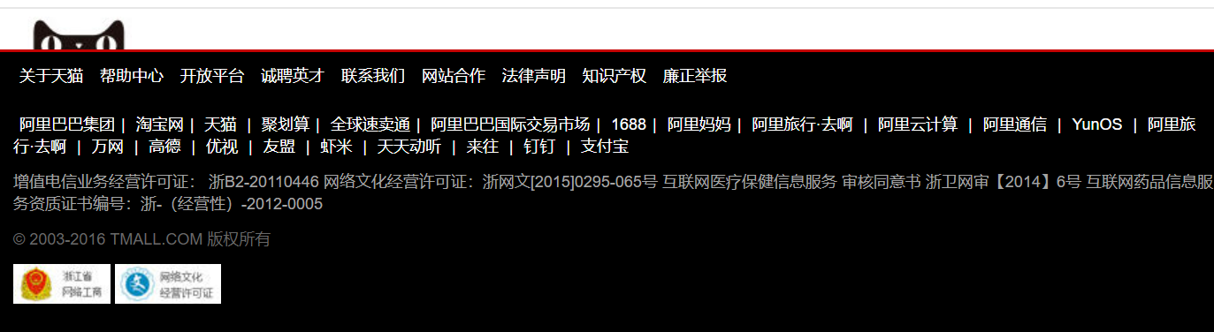

1. **布局**

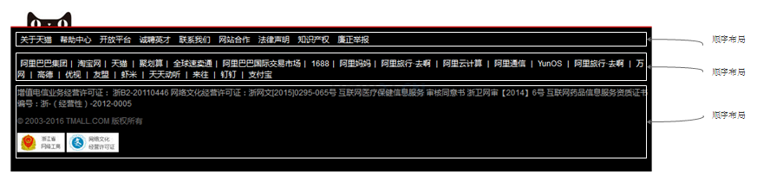

1. **纯html**

<!DOCTYPE html>

<html>

<head>

<meta charset="UTF-8">

<title></title>

<script src="../js/jquery-3.3.1.min.js"></script>

<link rel="stylesheet" href="../bootstrap-3.3.7-dist/css/bootstrap.min.css" />

<script src="../bootstrap-3.3.7-dist/js/bootstrap.min.js"></script>

</head>

<div class="footer" id="footer">

<img src="../img/cateye.png" class="cateye" id="cateye" />

<div class="copyright" id="copyright">

<div class="white_link">

<a href="#nowhere">关于天猫</a>

<a href="#nowhere">帮助中心</a>

<a href="#nowhere">开放平台</a>

<a href="#nowhere">诚聘英才</a>

<a href="#nowhere">练习我们</a>

<a href="#nowhere">网站合作</a>

<a href="#nowhere">法律声明</a>

<a href="#nowhere">隐私权政策</a>

<a href="#nowhere">知识产权</a>

<a href="#nowhere">廉政举报</a>

<a href="#nowhere">规则意见征集</a>

</div>

<div class="white_link">

<a href="#nowhere">阿里巴巴集团</a><span class="slash">|</span>

<a href="#nowhere">淘宝网</a><span class="slash">|</span>

<a href="#nowhere">天猫</a><span class="slash">|</span>

<a href="#nowhere">聚划算</a><span class="slash">|</span>

<a href="#nowhere">全球速卖通</a><span class="slash">|</span>

<a href="#nowhere">阿里巴巴国际交易市场</a><span class="slash">|</span>

<a href="#nowhere">1688</a><span class="slash">|</span>

<a href="#nowhere">阿里妈妈</a><span class="slash">|</span>

<a href="#nowhere">飞猪</a><span class="slash">|</span>

<a href="#nowhere">阿里云计算</a><span class="slash">|</span>

<a href="#nowhere">AliOS</a><span class="slash">|</span>

<a href="#nowhere">阿里通信</a><span class="slash">|</span>

<a href="#nowhere">万网</a><span class="slash">|</span>

<a href="#nowhere">高德</a><span class="slash">|</span>

<a href="#nowhere">UC</a><span class="slash">|</span>

<a href="#nowhere">友盟</a><span class="slash">|</span>

<a href="#nowhere">虾米</a><span class="slash">|</span>

<a href="#nowhere">钉钉</a><span class="slash">|</span>

<a href="#nowhere">支付宝</a>

</div>

<div class="license">

<span>增值电信业务经营许可证： 浙B2-20110446</span>

<span>网络文化经营许可证：浙网文[2015]0295-065号</span>

<span>互联网医疗保健信息服务 审核同意书 浙卫网审【2014】6号 </span>

<span>互联网药品信息服务资质证书编号：浙-（经营性）-2012-0005</span>

<div class="copyRightYear">@ 2003-2018 TMALL.COM 版权所有</div>

<div>

<img src="../img/copyRight1.jpg" />

<img src="../img/copyRight2.jpg" />

</div>

</div>

</div>

</div>

</html>



1. **加上样式**

<style>

div.footer {

margin: 0px 0px;

border-top-style: solid;

border-top-width: 1px;

border-top-color: #E7E7E7;

}

div.copyright {

background-color: black;

border-top-style: solid;

border-top-width: 2px;

border-top-color: #C40000;

}

div.copyright span.slash {

color: white;

}

div.footer div.copyright div.white_link a {

color: white;

padding: 0px 5px;

}

div.footer div.copyright div.white_link {

padding: 10px 0px;

margin-left: 10px;

}

div.license {

margin-left: 10px;

padding-bottom: 30px;

}

div.license span {

color: #A4A4A4;

}

div.license div.copyRightYear {

margin: 10px 0px;

color: #686868;

}

img.cateye {

margin-left: 20px;

}

body {

font-size: 12px;

font-family: arial;

}

a:hover {

text-decoration: none;

}

div.license span {

margin-right: 20px;

}

</style>

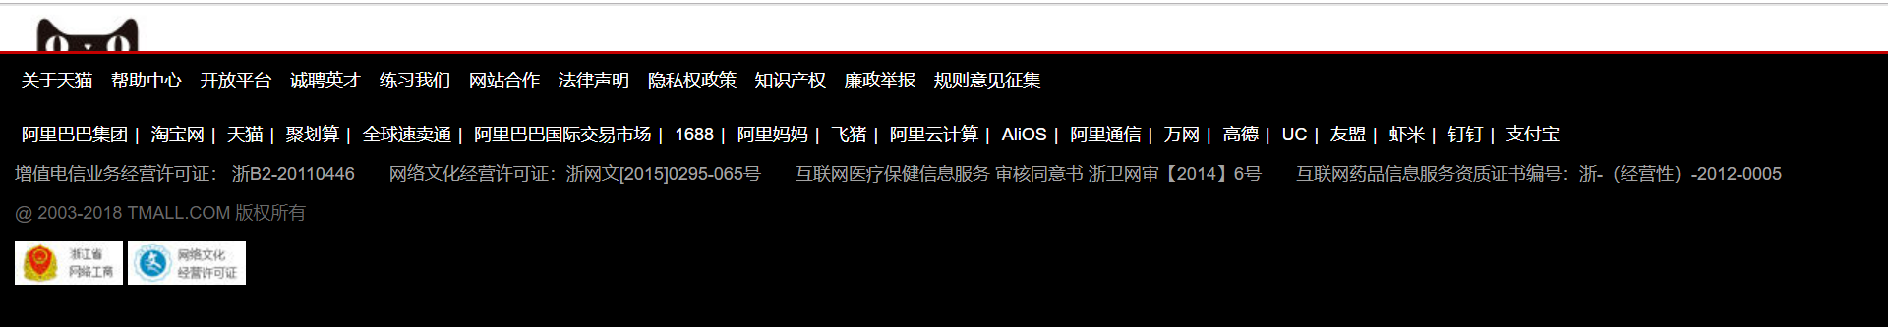

1. **样式讲解**

参考footer2.html

1. **再整合在一起**