1. **效果**



1. **布局**

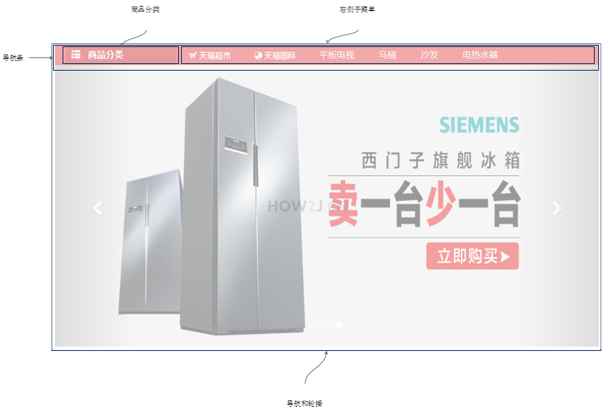

1. **纯html**

轮播是直接使用的BootStrap的轮播样式，所以直接就可以看到效果。

菜单部分是一些超链和图片。

<!DOCTYPE html>

<html>

<head>

<meta charset="UTF-8">

<title>首页</title>

<!-- Jquery 核心JavaScript文件 -->

<script src="../js/jquery-3.3.1.min.js"></script>

<!-- Bootstrap 核心 CSS 文件 -->

<link rel="stylesheet" href="../bootstrap-3.3.7-dist/css/bootstrap.min.css" />

<!-- Bootstrap 核心 JavaScript 文件 -->

<script type="text/javascript" src="../bootstrap-3.3.7-dist/js/bootstrap.min.js"></script>

</head>

<div class="categoryWithCarousel">

<div class="headbar">

<div class="head">

<span class="glyphicon glyphicon-th-list" style="margin-left: 10px;"></span>

<span style="margin-left: 10px;">商品分类</span>

</div>

<div class="rightMenu">

<span><a href="#nowhere"><img src="../img/chaoshi.png"></a></span>

<span><a href="#nowhere"><img src="../img/guoji.png"></a></span>

<span><a href="#nowhere">天猫会员</a></span>

<span><a href="#nowhere">电器城</a></span>

<span><a href="#nowhere">喵鲜生</a></span>

<span><a href="#nowhere">医药馆</a></span>

<span><a href="#nowhere">营业厅</a></span>

<span><a href="#nowhere">魅力惠</a></span>

<span><a href="#nowhere">飞猪旅行</a></span>

<span><a href="#nowhere">苏宁易购</a></span>

</div>

</div>

<!-- Bootstrap轮播（Carousel）插件 -->

<div data-ride="carousel" class="carousel-of-product carousel slide" id="carousel-of-product">

<!-- 轮播(Carousel)指标(indicators) -->

<ol class="carousel-indicators">

<li class="active" data-slide-to="0" data-target="#carousel-of-product"></li>

<li data-slide-to="1" data-target="#carousel-of-product" class=""></li>

<li data-slide-to="2" data-target="#carousel-of-product" class=""></li>

<li data-slide-to="3" data-target="#carousel-of-product" class=""></li>

</ol>

<!-- Wrapper for slides(幻灯片包装) -->

<div role="listbox" class="carousel-inner">

<div class="item active">

<img src="http://how2j.cn/tmall/img/lunbo/1.jpg" class="carousel carouselImage">

</div>

<div class="item">

<img src="http://how2j.cn/tmall/img/lunbo/2.jpg" class="carouselImage">

</div>

<div class="item">

<img src="http://how2j.cn/tmall/img/lunbo/3.jpg" class="carouselImage">

</div>

<div class="item">

<img src="http://how2j.cn/tmall/img/lunbo/4.jpg" class="carouselImage">

</div>

</div>

</div>

<div class="carouselBackgroundDiv"></div>

</div>

</html>



1. **加上样式**

<style>

div.categoryWithCarousel {

width: 100%;

position: relative;

}

div.categoryWithCarousel div.headbar {

background-color: #DD2727;

}

div.categoryWithCarousel div.head {

width: 200px;

background-color: #C60A0A;

height: 36px;

line-height: 36px;

font-size: 16px;

font-weight: bold;

color: white;

margin-left: 20px;

display: inline-block;

}

div.categoryWithCarousel div.rightMenu {

display: inline-block;

}

div.categoryWithCarousel div.rightMenu a {

font-size: 16px;

color: white;

text-decoration: none;

}

div.categoryWithCarousel div.rightMenu span {

margin: 0px 20px 0px 20px;

}

div.categoryWithCarousel div.rightMenu img {

height: 30px;

}

div.carousel-of-product {

height: 510px;

width: 1024px;

margin: 0px auto;

}

imag.carouselImage {

height: 510px !important;

}

div.carouselBackgroundDiv {

width: 100%;

height: 510px;

background-color: #E8E8E8;

position: absolute;

top: 36px;

z-index: -1;

}

</style>



1. **样式讲解**

参考index.html

1. **再整合在一起**