1. **效果**

完整的首页产品列表是在模仿天猫首页中，每个分类有五种首页推荐产品，一共17中分类。为了讲解方便，只选择其中的两个分类来分析样式。

**如果屏幕分辨率比较小的话，会看到5个产品换行了，这是因为为了演示实际效果，放在了步骤栏里，压缩了宽度。相同的代码，放在整个页面就不会换行了**。

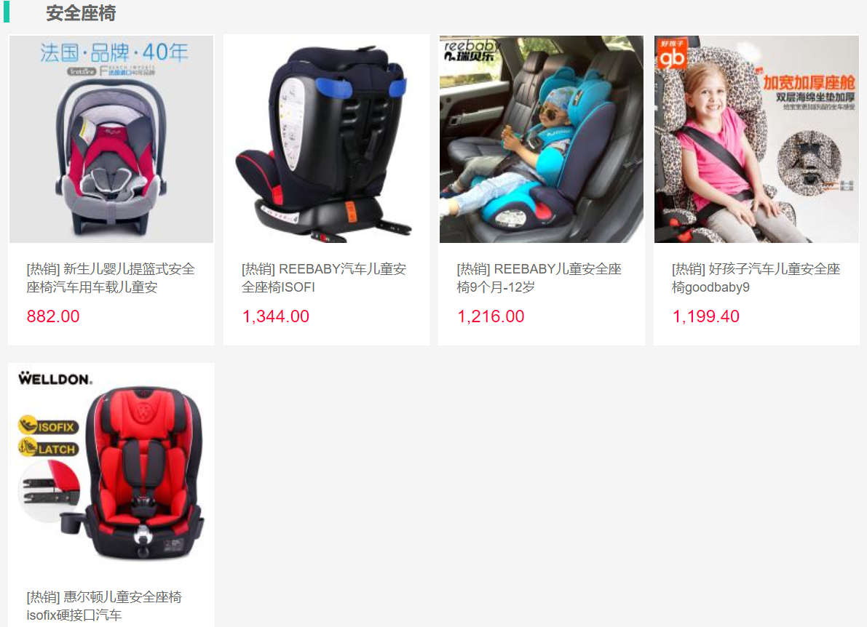

1. **布局**

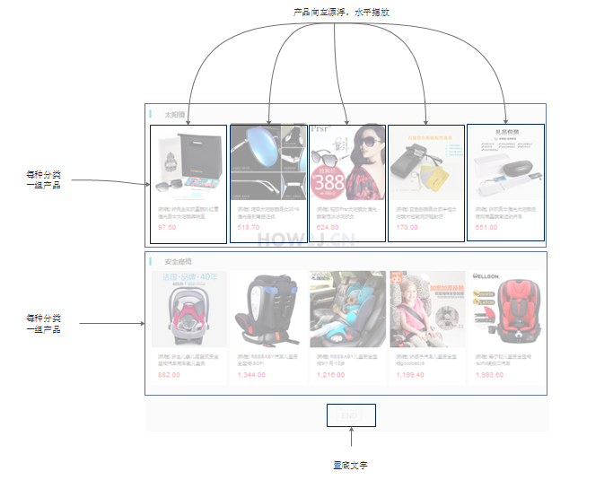

1. **纯html**

<!DOCTYPE html>

<html>

<head>

<meta charset="UTF-8">

<title>产品列表</title>

<!-- Jquery 核心JavaScript文件 -->

<script src="../js/jquery-3.3.1.min.js"></script>

<!-- Bootstrap 核心 CSS 文件 -->

<link rel="stylesheet" href="../bootstrap-3.3.7-dist/css/bootstrap.min.css" />

<!-- Bootstrap 核心 JavaScript 文件 -->

<script type="text/javascript" src="../bootstrap-3.3.7-dist/js/bootstrap.min.js"></script>

</head>

<div class="homepageCategoryProducts">

<div class="eachHomepageCategoryProducts">

<div class="left-mark"></div>

<span class="categoryTitle"> 太阳镜</span>

<br>

<div class="productItem">

<a href="#nowhere"><img width="100px" src="http://how2j.cn/tmall/img/productSingle_middle/9543.jpg"></a>

<a href="#nowhere" class="productItemDescLink">

<span class="productItemDesc">[热销]好先生同款墨镜孙红雷偏光男士太阳镜韩明星</span>

</a>

<span class="productPrice">97.50</span>

</div>

<div class="productItem">

<a href="#nowhere"><img width="100px" src="http://how2j.cn/tmall/img/productSingle_middle/9532.jpg"></a>

<a href="#nowhere" class="productItemDescLink">

<span class="productItemDesc">[热销]陌森太阳眼镜男女2016偏光定制驾驶近视</span>

</a>

<span class="productPrice">518.70</span>

</div>

<div class="productItem">

<a href="#nowhere"><img width="100px" src="http://how2j.cn/tmall/img/productSingle_middle/9521.jpg"></a>

<a href="#nowhere" class="productItemDescLink">

<span class="productItemDesc">[热销]帕莎Prsr太阳镜女偏光镜潮范冰冰同款女</span>

</a>

<span class="productPrice">624.00</span>

</div>

<div class="productItem">

<a href="#nowhere"><img width="100px" src="http://how2j.cn/tmall/img/productSingle_middle/9510.jpg"></a>

<a href="#nowhere" class="productItemDescLink">

<span class="productItemDesc">[热销]变色眼镜男女款半框太阳镜大框潮流防辐射防</span>

</a>

<span class="productPrice">170.00</span>

</div>

<div class="productItem">

<a href="#nowhere"><img width="100px" src="http://how2j.cn/tmall/img/productSingle_middle/9499.jpg"></a>

<a href="#nowhere" class="productItemDescLink">

<span class="productItemDesc">[热销]新款男士偏光太阳镜日夜两用墨镜潮运动开车</span>

</a>

<span class="productPrice">551.00</span>

</div>

<div style="clear:both"></div>

</div>

<div class="eachHomepageCategoryProducts">

<div class="left-mark"></div>

<span class="categoryTitle">安全座椅</span>

<br>

<div class="productItem">

<a href="#nowhere"><img width="100px" src="http://how2j.cn/tmall/img/productSingle_middle/10192.jpg"></a>

<a href="#nowhere" class="productItemDescLink">

<span class="productItemDesc">[热销]新生儿婴儿提篮式安全座椅汽车用车载儿童安</span>

</a>

<span class="productPrice">882.00</span>

</div>

<div class="productItem">

<a href="#nowhere"><img width="100px" src="http://how2j.cn/tmall/img/productSingle_middle/10181.jpg"></a>

<a href="#nowhere" class="productItemDescLink">

<span class="productItemDesc">[热销]REEBABY汽车儿童安全座椅ISOFI</span>

</a>

<span class="productPrice">1,344.00</span>

</div>

<div class="productItem">

<a href="#nowhere"><img width="100px" src="http://how2j.cn/tmall/img/productSingle_middle/10170.jpg"></a>

<a href="#nowhere" class="productItemDescLink">

<span class="productItemDesc">[热销]REEBABY儿童安全座椅9个月-12岁</span>

</a>

<span class="productPrice">1,216.00</span>

</div>

<div class="productItem">

<a href="#nowhere"><img width="100px" src="http://how2j.cn/tmall/img/productSingle_middle/10159.jpg"></a>

<a href="#nowhere" class="productItemDescLink">

<span class="productItemDesc">[热销]好孩子汽车儿童安全座椅goodbaby9</span>

</a>

<span class="productPrice">1,199.40</span>

</div>

<div class="productItem">

<a href="#nowhere"><img width="100px" src="http://how2j.cn/tmall/img/productSingle_middle/10148.jpg"></a>

<a href="#nowhere" class="productItemDescLink">

<span class="productItemDesc">[热销]惠尔顿儿童安全座椅isofix硬接口汽车</span>

</a>

<span class="productPrice">1,993.60</span>

</div>

<div style="clear:both"></div>

</div>

<img src="../img/end.png" id="endpng">

</div>

</html>

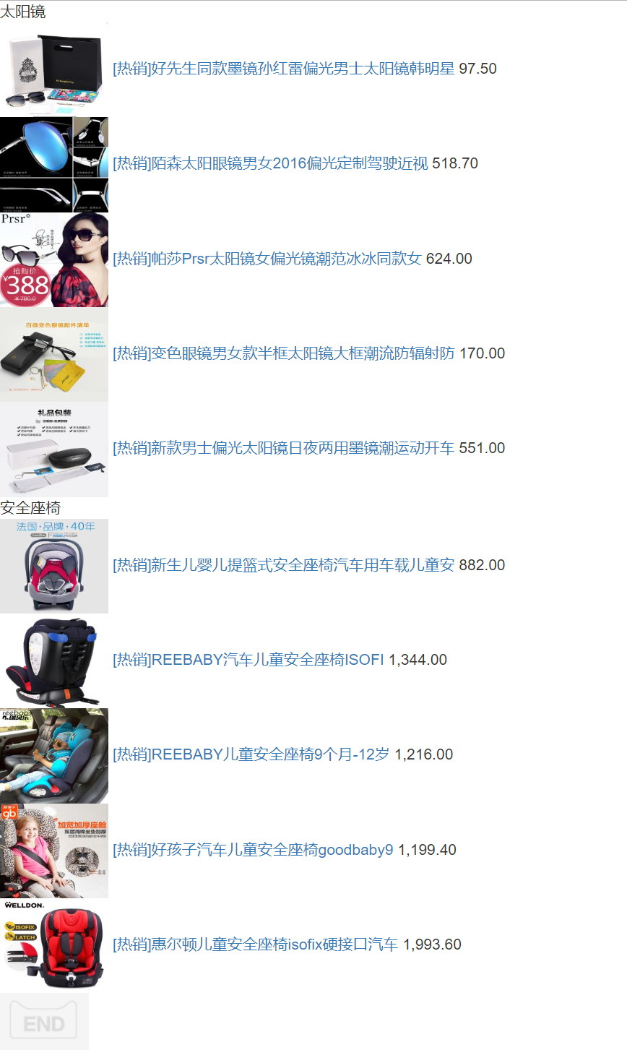

1. **加上样式**

<style>

div.homepageCategoryProducts {

background-color: #F5F5F5;

padding: 50px 10px 50px 10px;

margin: 10px auto;

max-width: 1013px;

}

div.productItem {

width: 189px;

height: 285px;

border: 1px solid white;

background-color: white;

margin: 8px 4px;

float: left;

cursor: pointer;

}

div.productItem span.productItemDesc {

font-size: 12px;

color: #666666;

display: block;

padding: 16px;

}

div.productItem span.productPrice {

font-size: 16px;

color: #FF003A;

display: block;

padding-left: 16px;

margin-top: -10px;

}

div.productItem img {

width: 187px;

height: 190px;

}

div.productItem img:hover {

opacity: 0.7;

filter: alpha(opacity=70);

}

div.eachHomepageCategoryProducts {

margin: 0px 0px 40px 0px;

}

a.productItemDescLink {

display: inline-block;

height: 66px;

text-decoration: none;

}

span.categoryTitle {

font-size: 16px;

margin-left: 30px;

color: #646464;

font-weight: bold;

}

div.left-mark {

display: inline-block;

height: 20px;

vertical-align: top;

width: 5px;

background-color: #19C8A9;

}

img.endpng {

display: block;

width: 82px;

margin: 0 auto;

}

</style>

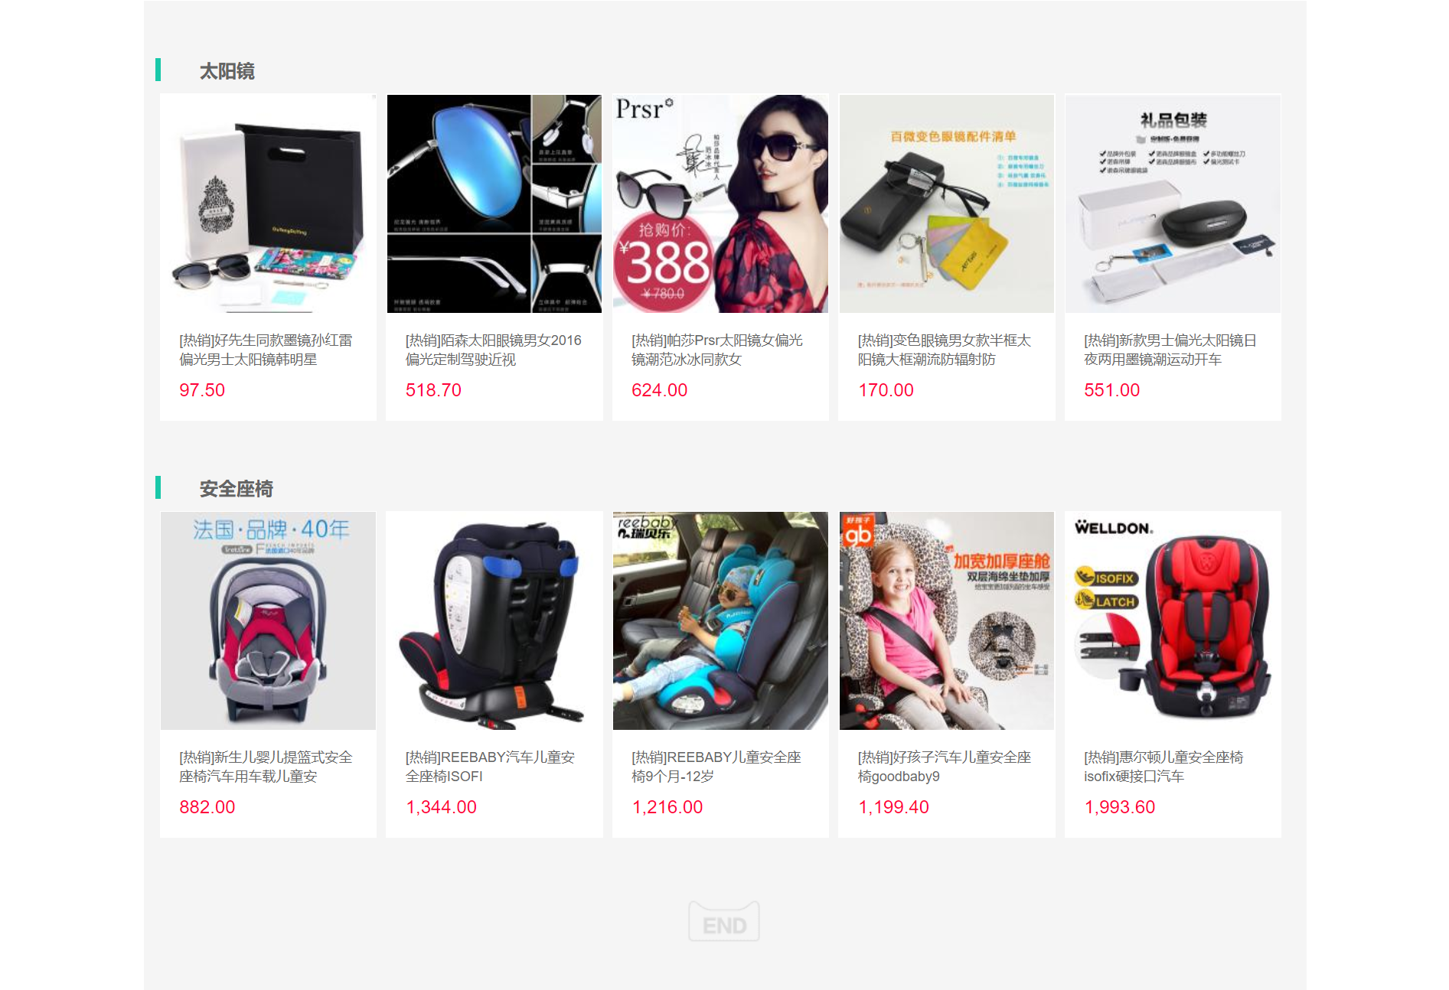

1. **样式详解**

参考product_list.html。

1. **再整合在一起**