下图展示了 LEFT JOIN、RIGHT JOIN、INNER JOIN、OUTER JOIN 相关的 7 种用法。

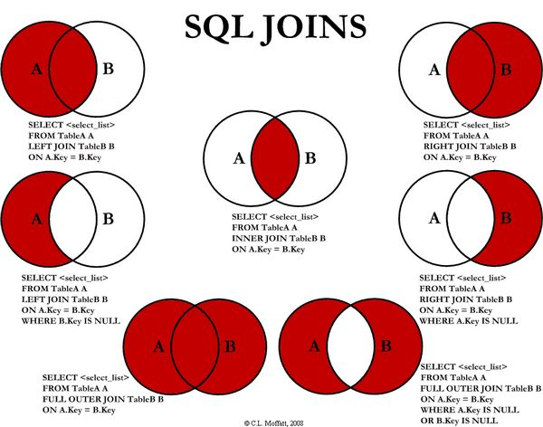

### 1、INNER JOIN（内连接）



SELECT <select_list>

FROM Table_A A

INNER JOIN Table_B B

ON A.Key = B.Key

### 2、LEFT JOIN（左连接）



SELECT <select_list>

FROM Table_A A

LEFT JOIN Table_B B

ON A.Key = B.Key

### 3、RIGHT JOIN（右连接）



SELECT <select_list>

FROM Table_A A

RIGHT JOIN Table_B B

ON A.Key = B.Key

### 4、OUTER JOIN（外连接）



SELECT <select_list>

FROM Table_A A

FULL OUTER JOIN Table_B B

ON A.Key = B.Key

### 5、LEFT JOIN EXCLUDING INNER JOIN（左连接-内连接）



SELECT <select_list>

FROM Table_A A

RIGHT JOIN Table_B B

ON A.Key = B.Key

WHERE A.Key IS NULL

### 6、RIGHT JOIN EXCLUDING INNER JOIN（右连接-内连接）



SELECT <select_list>

FROM Table_A A

RIGHT JOIN Table_B B

ON A.Key = B.Key

WHERE A.Key IS NULL

### 7、OUTER JOIN EXCLUDING INNER JOIN（外连接-内连接）



SELECT <select_list>

FROM Table_A A

FULL OUTER JOIN Table_B B

ON A.Key = B.Key

WHERE A.Key IS NULL OR B.Key IS NULL