CSC / MIS Spring 2025 Capstone Project
The Team
Brady Mullins Chance Womack
Creed Warf Kaylee Scarce
Professor David Frazier
Table of Contents
Product Concept pg 1
Stakeholders & User Groups pg 1
Software Requirements pg 2
Website Requirements pg 2
Security Requirements pg 2
Hardware Components pg 3
Design Information pg 4 - 10
Theoretical Future Plans pg 11
Bibliography pg 12
Project Overview
Throughout the Spring 2025 semester, our team worked collaboratively to develop a wildfire detection system powered by AI and the Raspberry Pi 5 platform. The primary objective was to create a functional prototype capable of detecting fires through real-time video analysis and sending alerts to users and authorities.
We divided responsibilities based on individual strengths: Brady handled hardware development, helped with documentation, and led with scheduling; Creed focused on data processing, programming, AI model training, and integration; Chance took the lead position with documentation and security requirements for the project; and Kaylee, as team lead, coordinated team efforts, documentation, presentations, and system architecture.
During the project, we successfully assembled the hardware components, trained a fire detection AI model using a publicly available dataset, integrated real-time video feeds, and developed a functional website prototype. However, we encountered limitations in certain areas. Due to time constraints and the inability to conduct live fire testing, the AI model’s accuracy was not as thoroughly validated as we intended. Full implementation of secure authentication and camera management on the website was partially completed but would require further development for production use.
Overall, the project was a strong success in achieving the core functionality we set out to demonstrate. We learned valuable lessons about project scoping, hardware/software integration, and team coordination under tight deadlines.
Product Concept
We are developing a weather detection system using the Raspberry Pi 5, Halo HAT+ kit, and AI camera to identify specific weather conditions such as floods, fires, and other natural hazards. The system will process real-time data and send alerts when a threat is detected.

Refined Scope
For the purposes of this project, we have limited the scope of the product to only be used to identify ‘fires’. In theory, if this project works to the degree we are wanting from it, the AI should be able to be trained for other hazards for broader applications of the technology.

Stakeholders & User Groups
The following parties have been identified by the team as those most involved in the applications of the product of the project. This is not a comprehensive list and is lacking in those parties that would be needed for legal reasons, instead focusing on the groups directly connected with our product’s use within the United States of America.

Forestry Departments & other responding agencies
Those Departments tasked with responding to and the prevention of forest fires, this group serves as a solid baseline for the federal requirements for a product such as ours.

Fire Watch Towers & Lookouts
Fire Watch is a profession of people who spend long periods of time at dedicated watch towers throughout the United States various forested regions and national parks. Any technology that could assist in the monitoring of wildfires and forest fires, such as our product, would fall within their domain of interest.

Fire Departments
While not necessarily a responding party for forest fires (according to cursory searches on the subject), local fire departments would likely be those who would respond to instances of wildfires in regards to private users.

Private Users
Private citizens and organizations with a vested interest in monitoring for fires on their property, such as Farmers, are considered an important stakeholder in our product.

Software Requirements
The following are the core requirements we went into this project understanding that we needed by the end of it.
- AI neural network capable of accurately identifying images of ‘fire’
- AI Integration into a physical Camera
- Camera capable of feeding video into the AI neural network for identification
- Ability to send alerts when a ‘fire’ is detected to…
  - registered SMS receivers (Such as Private Users and Fire Watch Lookouts)
  - Local emergency services (such as the Fire and Forestry Departments)
Website Requirements
The following were the core requirements we established for the website component of the project:
- Ability to display a live video feed from the physical camera to authorized users.
- Ability to support multiple camera feeds and allow users to switch between them.
- Display on-screen alert notifications when a fire is detected by the system.
- User authentication system allowing users to log in and securely manage their devices and account settings.
- Ability for users to register, name, and manage linked cameras from their account dashboard.
- Ability for users to configure how they receive alerts (e.g., email) and view historical alert logs.
- Mobile responsiveness, ensuring the website functions properly on desktop.
- Clean and intuitive user interface focused on emergency usability.
- Dashboard view giving users quick access to live feeds, alert status, and camera management.
- Secure communication protocols (HTTPS) to protect user information and video transmissions.
- Clear error handling and user-friendly messages for connection issues or login problems.
Security Requirements
While security was not something we were able to properly commit to during this project, detailed here are the primary security concerns that we identified in regards to our product.
- As our Camera would have access to user contact information for its Alert System, this information would need to be properly secured.
- The Video Stream from the Camera to the Website should be secure from any form of inception or tampering.
- The Alert System should be protected from any “false flag” notifications from malicious actors.
- The Website should also feature an Account System with Direct Users being able to link multiple cameras to stream their video feed into Account Specific setups. This means User Login information will need to be secured.

Hardware Components
- Raspberry Pi 5 - (CanaKit version) - Central processing unit for running AI models
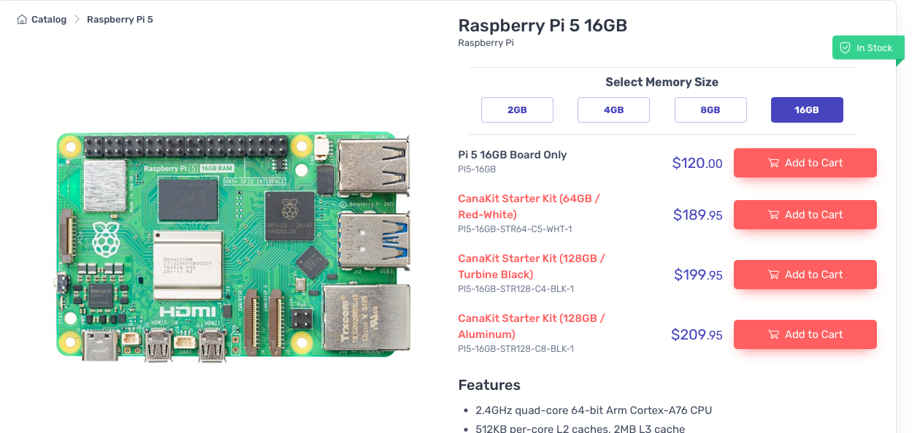
- Raspberry Pi AI HAT+ - Provides additional computational capabilities and connectivity
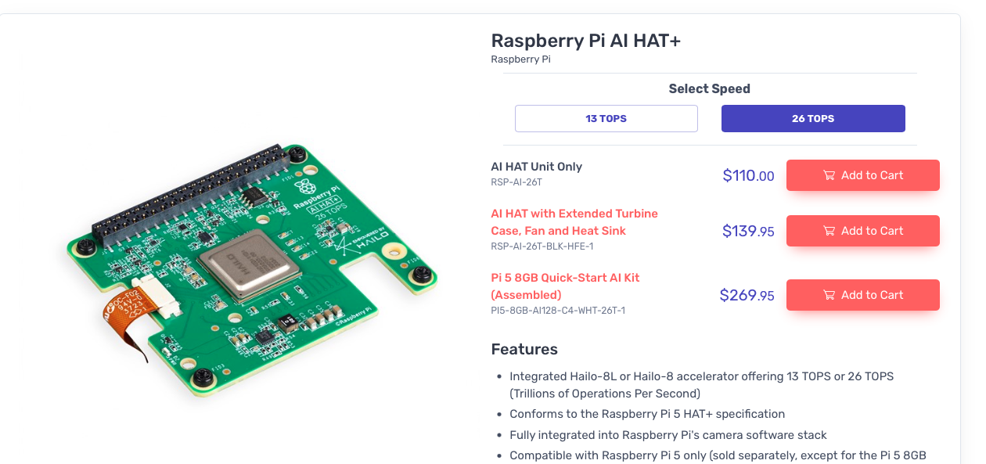
- Raspberry AI Camera - Captures live video/images for weather condition analysis
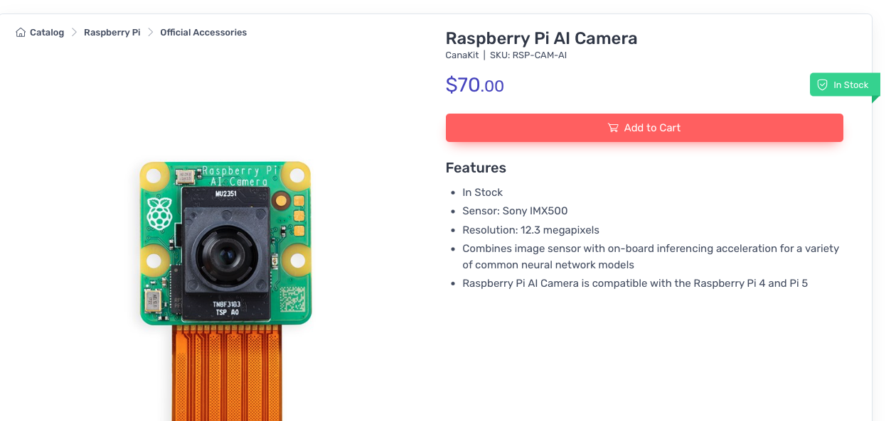

Design Information
Detailed in this section are various topics related to the overall design of the project.

GitHud Repository
This link should provide access to the github for the project containing the code and all assets pertaining to the operation of the product.
- https://github.com/cwarf5/SemProject

Wildfire Detection by AI Deep Learning
Data Acquisition:
- Large dataset consisting of 2,700 aerial and ground-based images was acquired
- It consists of a diverse collection of environmental scenarios, forest variants, geographical locations, and ecosystems with and without fire events.
- Directory Structure & Distribution:
  - Training (70%): Comprising 1888 images, this set serves as the foundation for model learning. It is further subclassified into aspects of wildres and potential confounders.
  - Validation (15%): With 402 images, this directory aids in model parameter ne-tuning.
  - Testing (15%): Containing 410 images, it facilitates the final model evaluation.
- Source:
  - Data set: https://www.kaggle.com/datasets/elmadafri/the-wildre-dataset/data
  - Research article: https://doi.org/10.3390/f14091697
Data Flow: (Diagram on next page)
- Data placed in project directory in specific location
  - [main directory]/data/train/[fire] or [no_fire]
- Image loaded from disk
- Image goes through preprocessing to normalize images
- Preprocessed image passes through the model (Neural Network)
- The neural network makes a prediction based on the threshold of the model’s confidence that a fire is present.
- The prediction is then returned as ‘fire’ or ‘no fire’
- That prediction is validated through validation images that are pre-determined to be in either ‘fire’ or ‘no fire’ class
- That determines model’s accuracy and helps refine it over time

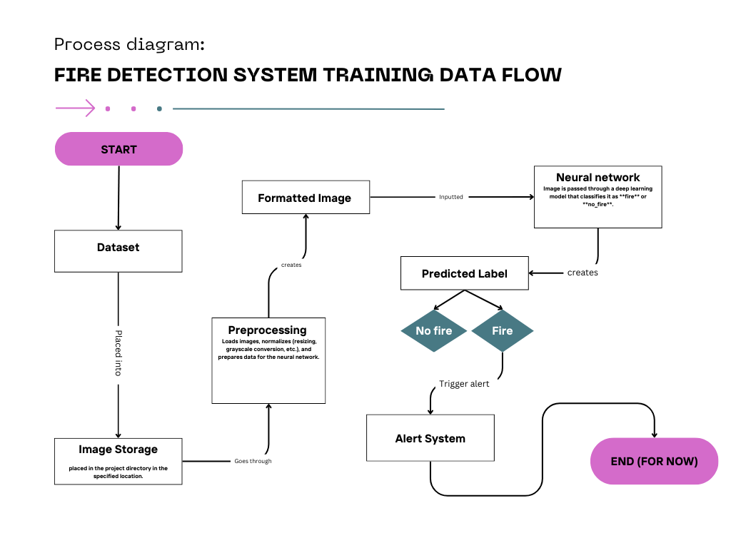

Component Diagram
Providing an overview of which system components interface with each other.
- Test Image Database feeds into the Training Model
- The Training Model and Video Interpreter operate in a cyclical fashion
  - The Training Model provides the “logic” behind the interpretation of the video feed
  - The Video Interpreter then adds interpreted images back into the Training Model to reinforce it
- If the Video Interpreter detects Fire, it sends a message via the Alert System
  - The Alert System then notifies the Authorities and registered Direct Users
- The Physical Camera provides a video feed to both the Video Interpreter and the Website
- Direct Users can physically interact with the Physical Camera and may access the Website

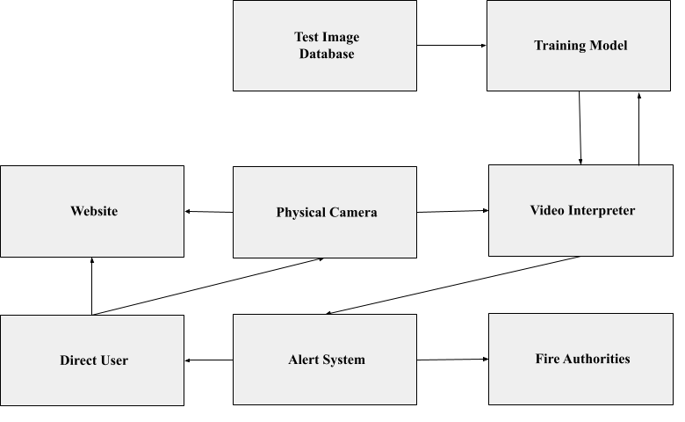

UML Diagrams
WildfireDataLoader  (Data.py) | Comments
data_dir: string
img_size: tuple
batch_size: integer
load_data_generators()
process_single_image()
validate_data_directory()

WildfirePredictor  (inference.py) | Comments
model_path: string
img_size: tuple
predict_image()
main()

WildfireVisualizer  (visualize.py) | Comments
data_dir: string  model: .h5  history; .h5 | .h5 is the data type for the neural network
plot_dataset_distrobution()  plot_sample_images()  plot_training_history()  plot_confusion_matrix()  plot_prediction_confidence()  generate_evaluation_report() | .h5 is the data type for the neural network

WildfireDetectionModel  (model.py) | Comments
img_size: tuple
build_model()
load_model()
save_model()
predict()
get_model_summary()

User Stories
Access Live Video on the Website
As a User, I want to be able to directly view the camera’s video feeds from a user friendly website.

View Live Video from multiple Cameras on the Website
As a User, I want to be able to switch between cameras’ video feeds while on a user friendly website.

Trust in the video interpreter to detect fire
As a User, I want to be able to trust in the system to monitor for fire.

Receive alerts from the system
As a User, I want to be able to receive alerts in a timely and accurate fashion in the event of a detected fire.

Use Cases
Use Case ID structure; <Test Type> - <Number of test of that type>
- SF = System Functionality
- UE = User Experience
ID | SF-1 | Title | Fire Detected!
Priority | 5/5 | Frequency of Use | Rarely (Ideally)
Description | The Video Feed has detected a fire and will activate the Alert System.
Preconditions | - Physical Camera is set up  - Neural Network/Video Interpreter is Live  - Video Interpreter has detected fire from the Camera’s video feed
Postconditions | - Alerts are sent to all registered direct users and the authorities
Success Scenario | The following steps and outcomes would accompany a successful scenario;  - The Physical Camera is functioning properly  - A fire starts within view of the camera  - The Video Interpreter accurately detects the fire  - The Video Interpreter successfully triggers the Alert System  - Registered Users and Authorities are notified of the fire
Error Cases | Noted failure points that could occur during this use case;  - Physical complications could lead to the camera not functioning properly  - Video Interpreter could fail to accurate detect the fire  - Alert System could sail to be triggered  - Alert System could fail to properly relay the alert to Registered users and Authorities
Comments | Core Feature of the project and is the top priority.  Largely implemented but limited due to the scope of the training set, our time constraints, and testing restrictions (Sadly we cannot really set things on fire on Campus).  Fails to detect smaller fires, likely due to a limited amount of training images that provide such examples.

ID | UE-2 | Title | View Video Feed
Priority | 3/5 | Frequency of Use | Often
Description | Direct User wishes to access the Website to view the video feed from the Camera.
Preconditions | - Physical Camera is set up  - Direct user has access to the Website  - Website is live (no connection issues)
Postconditions | - Direct User is able to view the video feed on the website
Success Scenario | The following steps and outcomes would accompany a successful scenario;  - The Direct User logs into the Website  - The Website then displays the video feed from the linked cameras  - User is able to view said video feeds
Error Cases | Noted failure points that could occur during this use case;  - Network connection issues could lead to the Video Feed not to be properly streamed to the website  - Network connection issues could lead to the User being unable to access the website  - Physical complications could lead to the camera not functioning properly
Comments | Currently the Website has multiple panels for video displays, but as we only have the one camera it just shows the same feed in all displays.

Theoretical Future Plans
These following plans were those that we would go on to do in the hypothetical continuation of this project's development or those that we had wanted to implement, but lacked the ability, time, or resources.

Alert Integration into the Pi
The current alert system is a proof of concept and is tied to the Website itself, not the Pi. Ideally, we would use the same structure, replacing the button triggered alert test with an event scanner that would be flagged by the “Fire Detected” signal from the Pi’s interpreter. Additionally, SMS functionality would need to be integrated.

Independent Power Supply
The Camera/Pi is currently dependent on a secondary power supply to function. In a more “deployment ready” prototype would require some way to power itself, such as a battery pack or mini-solar panel like those used by trail cameras.

Website Improvements
The current website is very much a prototype meant for showing basic concepts and layout. We would want more functionality, such as the video feeds providing more details when inspected, and user customization.

Link Video Feeds to User Accounts
Alongside improvements to the website, we want the ability for specific accounts to be made that will have only their registered camera’s feeds being displayed.

Cloud Computing
To improve the deployment costs, some effort into developing central interpreter units that could each handle the feeds of multiple cameras should be considered. For a private user (like a Farmer) this could look like a small server that would house the AI and multiple cameras would be linked to it, but would be placed across the property. This central unit would handle video interpretation and the alert system, rather than every camera needing its own AI system.

Bibliography
- Aneeshamol. (n.d.). OpenCV Based Fire Detection System with Blues. Hackster.io. Retrieved from https://www.hackster.io/aneeshamol88488/opencv-based-fire-detection-system-with-blues-864387
- CanaKit. (n.d.). Raspberry Pi 5 16GB Complete Starter Kit. CanaKit.com. Retrieved from https://www.canakit.com/raspberry-pi-5-16gb.html?cid=USD&src=raspberrypi
- CanaKit. (n.d.). Raspberry Pi AI HAT+ for Raspberry Pi 5. CanaKit.com. Retrieved from https://www.canakit.com/raspberry-pi-ai-hat-26.html?cid=USD&src=raspberrypi
- CanaKit. (n.d.). Raspberry Pi AI Camera. CanaKit.com. Retrieved from https://www.canakit.com/raspberry-pi-ai-camera.html?cid=USD&src=raspberrypi
- El-Madany, T.S. (2023). The Wildfire Dataset. Kaggle. Retrieved from https://www.kaggle.com/datasets/elmadafri/the-wildfire-dataset/data
- El-Madany, T.S. (2023). Research article: Wildfire Smoke Detection from Satellite Images Using Deep Learning Approaches. Forests. Retrieved from https://doi.org/10.3390/f14091697
- Raspberry Pi Foundation. (n.d.). Raspberry Pi Documentation. Retrieved from https://www.raspberrypi.com/documentation/

